KABOOM'S KITCHEN
Web Technologies Lab: Project Guide
How every page works, what is inside each file, and how it maps to the 14-week syllabus, with test results from running every screen.
Project folder | EWP/ (18 files: 11 HTML pages, 1 CSS, 2 JS, 1 TS, XML + DTD, JSON, TXT)
Syllabus coverage | Weeks 1 to 14, all covered
Screens tested | 53 checks in headless Chrome + XML/DTD validator + TypeScript compiler
Test outcome | 50 passed · 1 bug · 2 notes (details in Section 15)
Date tested | 12 October 2026

Contents
1. Project overview 3
2. How to run the project 4
3. Week 1: Home page and Login page 6
4. Week 2: Registration page with HTML5 validation 9
5. Week 3: Inline, internal and external CSS 11
6. Week 4: JavaScript validation of the registration page 13
7. Week 5: Catalogue page (HTML + CSS + JavaScript) 16
8. Week 6: XML file and DTD 19
9. Week 7: Review and Skill Test 1 22
10. Week 8: Fetch API: loading text asynchronously 24
11. Week 9: Fetch API: parsing JSON and XML 27
12. Week 10: Fetch API: sending data with POST 29
13. Week 11: TypeScript classes, interfaces and functions 31
14. Weeks 12–14: Angular single-page application 33
15. Test summary and findings 37
16. Quick revision: one line per concept 39

Right-click the contents and choose Update Field if page numbers are missing.

1. Project overview
The syllabus asks for an online book store website. This project builds the same set of pages for a restaurant, Kaboom's Kitchen. Every syllabus task is still covered; only the subject changes. If an examiner asks, use this mapping:
Syllabus asks for | This project has | Page / file
Book store Home page | Restaurant Home page | index.html
Login page | Customer Login page | login.html
Student Registration page | Customer Registration page (same fields: name, email, phone, password) | register.html + script.js
Book catalogue page | Food menu (catalogue) + table booking form | menu.html
XML file with Book information + DTD | XML file with Menu item information + DTD | menu.xml + menu.dtd

All pages share one look: a cream background, orange (#D84315) headings and buttons, and dark-brown (#3E2723) text, all from the shared style.css. Every page repeats the same header, navigation bar and footer.

Site map
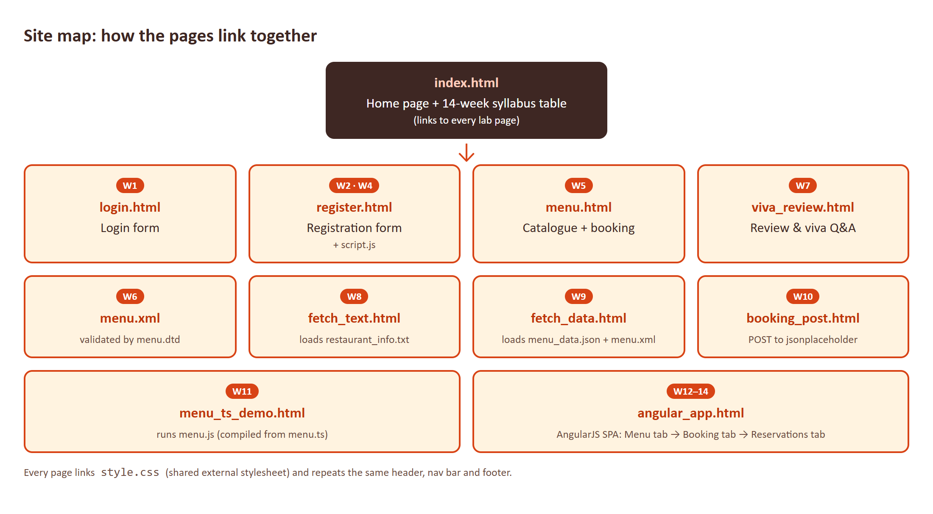
Figure 1. How the pages link. index.html is the hub: its syllabus table links to every lab page.

2. How to run the project
Weeks 1 to 7 work if you just double-click the HTML file. From Week 8 onwards you must run the site through a web server, because browsers block fetch() on pages opened from file://. Testing confirmed this: opened by double-click, the Week 8 page shows "Error loading file: Failed to fetch".

Option A: VS Code Live Server (easiest)
- Open the EWP folder in VS Code.
- Install the Live Server extension.
- Right-click index.html and choose Open with Live Server.

Option B: Python
cd EWP
python -m http.server 8000
# then open http://localhost:8000/index.html
Internet needed for two pages
booking_post.html (Week 10) sends data to jsonplaceholder.typicode.com. Offline it falls back to showing the JSON it would have sent.
angular_app.html (Weeks 12–14) loads AngularJS from Google's CDN. Offline the page shows raw {{ }} placeholders.

File-by-file map
File | Type | Week | What it does
index.html | HTML | 1, 3 | Home page: welcome text, highlights table, syllabus table linking every lab
login.html | HTML | 1, 3 | Login form (username + password)
register.html | HTML | 2, 3, 4 | Registration form with HTML5 validation; calls script.js
style.css | CSS | 3 | Shared external stylesheet used by every page
script.js | JavaScript | 4 | validateRegistrationForm(): 5 JS checks on the registration form
menu.html | HTML + CSS + JS | 5 | Menu catalogue in a table + table-booking form
menu.xml | XML | 6 | 6 menu items as structured data
menu.dtd | DTD | 6 | Rules that menu.xml must follow
viva_review.html | HTML | 7 | Weeks 1–6 summary, 8 viva Q&As, 4 practice exercises
fetch_text.html | HTML + JS | 8 | Loads restaurant_info.txt with fetch()
restaurant_info.txt | Text | 8 | Restaurant story, hours and contact details
fetch_data.html | HTML + JS | 9 | Loads menu_data.json and parses menu.xml
menu_data.json | JSON | 9 | 4 menu items as a JSON array
booking_post.html | HTML + JS | 10 | Sends a booking with fetch() POST
menu.ts | TypeScript | 11 | Interfaces, class RestaurantMenu, typed functions
menu.js | JavaScript | 11 | Compiled (ES5) version of menu.ts that the browser runs
menu_ts_demo.html | HTML + JS | 11 | Shows the TS code and runs the compiled class
angular_app.html | HTML + AngularJS | 12–14 | Single-page app: menu, booking form, reservations

3. Week 1: Home page and Login page
Syllabus says
Develop the static web pages required for an online book store web site: Home Page, Login Page.

Files: index.html, login.html

What's inside the files

index.html
- <head>: sets charset, the mobile viewport, the page <title>, links style.css, and holds a small <style> block.
- <header>: restaurant name in <h1> and tagline in <p>.
- <nav>: four links (Home, Menu & Booking, Login, Register). The current page's link has class active-link so it is underlined in orange.
- <main>: welcome text, a "highlights" <table> of three signature dishes, and the 14-week syllabus table that links to every lab file.
- <footer>: copyright line.

login.html
- Same header, nav and footer, so the site feels like one website.
- A <form action="#" method="get"> with a text input (username), a password input (password), a Login submit button and a Clear reset button.
- Both inputs have required, so the browser refuses to submit empty fields.
- <label for="..."> is linked to each input's id: clicking the label focuses the box.

Flow: what happens, step by step
- The browser opens index.html and reads the <head>, which tells it to download style.css.
- It builds the page top to bottom: header → nav → main → footer.
- The user clicks Login in the nav and the browser loads login.html.
- The user clicks Login with empty boxes: the browser stops the submit and shows "Please fill out this field."
- With both boxes filled, the form submits to # (the same page) using GET, so the values appear in the URL.

Tested screen
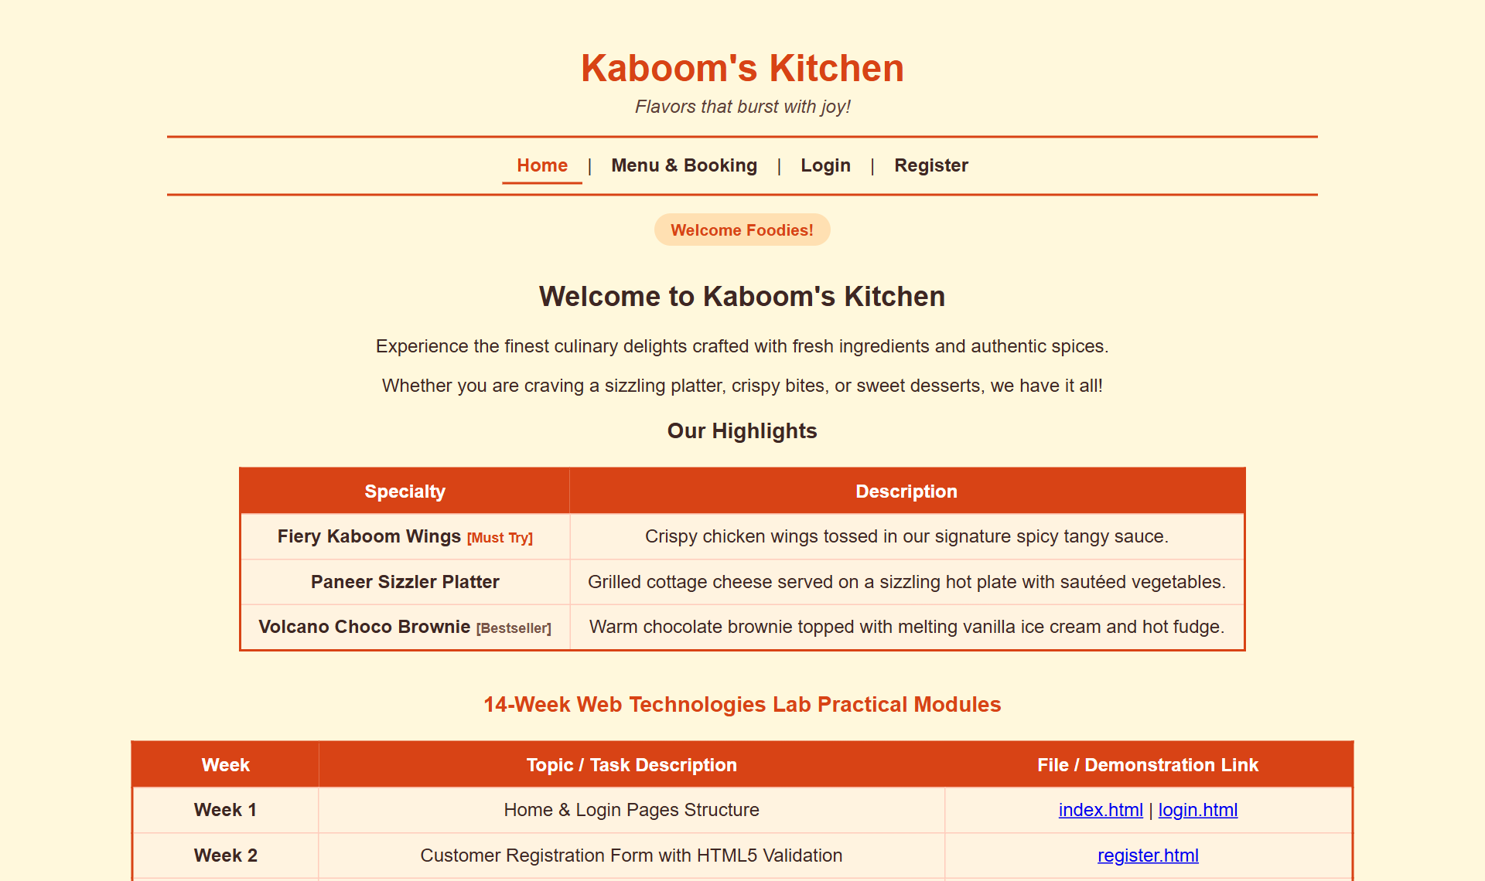
Figure 2. Home page (index.html)
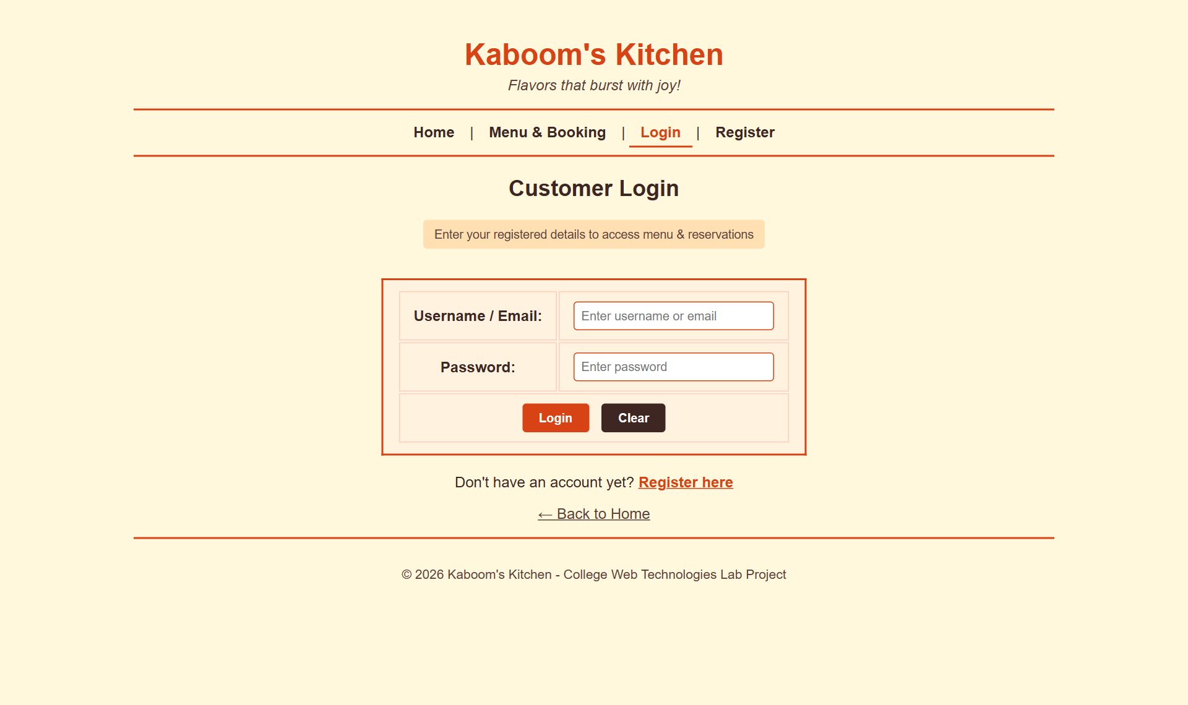
Figure 3. Login page (login.html)

Test results
Test performed | Expected | Actual result | Result
Home page nav links | index, menu, login, register | index.html, menu.html, login.html, register.html | PASS
Syllabus table rows on home page | 12 rows (W1..W12-14) | 12 | PASS
All links on home page resolve (HTTP 200) | 0 broken | 17 links, 0 broken | PASS
Login submit with empty fields | Browser blocks submit (required) | Blocked: "Please fill out this field." | PASS
Login submit with values (method="get") | note: GET puts form data in the URL | login.html?username=priya&password=secret123# | NOTE

Concepts to remember
- Semantic tags (header, nav, main, footer) describe the meaning of each part of the page, not just its look.
- <a href> links pages; relative paths like menu.html work because all files sit in one folder.
- <form> attributes: action = where to send the data, method = GET (in URL) or POST (in request body).
- type="reset" clears the form without any JavaScript.

4. Week 2: Registration page with HTML5 validation
Syllabus says
Create the student Registration Page using HTML forms with basic input validations.

Files: register.html
The registration form validates input without any JavaScript, using HTML5 input types and attributes. The browser does the checking.

What's inside the files
Field | Input type | Validation attributes | What the browser checks
Full Name | text | required | Not empty
Email | email | required | Has an @ and text on both sides
Phone | tel | required pattern="[0-9]{10}" title="..." | Exactly 10 digits; title text appears in the error bubble
Password | password | required minlength="6" | At least 6 characters; typing is hidden
Confirm Password | password | required | Not empty (matching is checked in Week 4)

Under some fields there is a small <div class="helper-text"> that tells the user the expected format before they make a mistake.

Flow: what happens, step by step
- The user fills in the form and clicks Register.
- Before anything else runs, the browser checks each field's attributes from top to bottom.
- At the first failing field it stops, focuses that field, and shows a tooltip bubble (e.g. "Please match the requested format.").
- Only when every field passes does the browser fire the form's onsubmit event (used in Week 4).

Tested screen
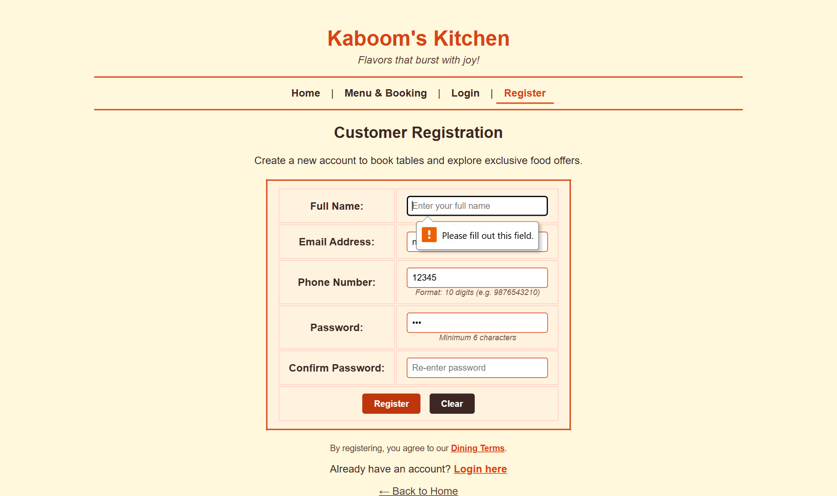
Figure 4. Submitting with an empty name: the browser's built-in "Please fill out this field." bubble

Test results
Test performed | Expected | Actual result | Result
type="email" with "notanemail" | invalid | Please include an '@' in the email address. 'notanemail' is missing an '@'. | PASS
pattern="[0-9]{10}" with "12345" | invalid (pattern mismatch) | Please match the requested format. | PASS
minlength="6" with "abc" | invalid (too short) | Please lengthen this text to 6 characters or more (you are currently using 3 characters). | PASS
required Full Name left empty | invalid (value missing) | Please fill out this field. | PASS
Submit with invalid fields | no JS alert - HTML5 stops it first | alerts shown: 0 | PASS

Concepts to remember
- HTML5 validation is free (no code) but limited: it can't compare two fields.
- pattern takes a regular expression: [0-9]{10} means "exactly ten characters, each 0–9".
- Client-side validation is for user experience only. A real server must check again, because users can turn validation off.

5. Week 3: Inline, internal and external CSS
Syllabus says
Apply internal, external and inline CSS for week 1 and week 2 pages.

Files: style.css (external), the <style> block in each page (internal), style="..." attributes (inline)

What's inside the files
Type | Where it is written | Example in this project | Scope
External | Separate file, linked with <link rel="stylesheet" href="style.css"> | body background #FFF8DC, .content-box tables, .btn-submit buttons, nav a:hover | Every page that links it
Internal | <style> tag in the page's <head> | .promo-badge (home), .login-note (login), .helper-text (register), .active-link | Only that page
Inline | style="..." on one element | The orange "[Must Try]" label on the home page; "Register here" link on login | Only that element

Inside style.css
- body: Arial font, cream background, dark-brown text, centred.
- header h1, header p: orange title, italic tagline (these are descendant selectors).
- hr: turns the plain line into a 2px orange bar, 80% wide, centred with margin: auto.
- nav a and nav a:hover: bold links; on hover they turn orange and underline (a pseudo-class).
- .content-box: the bordered card look for tables; th gets an orange background and white text.
- input[type="text"], etc.: attribute selectors style only those input types.
- .btn-submit / .btn-reset: orange and brown buttons with a darker hover colour.

The cascade: which rule wins?
When the same property is set in more than one place, the more specific or closer rule wins: inline beats internal and external. Between internal and external, whichever is written later in the page wins (here the <style> comes after the <link>, so internal wins). !important overrides all of these, which is why .active-link uses it.

Tested screen
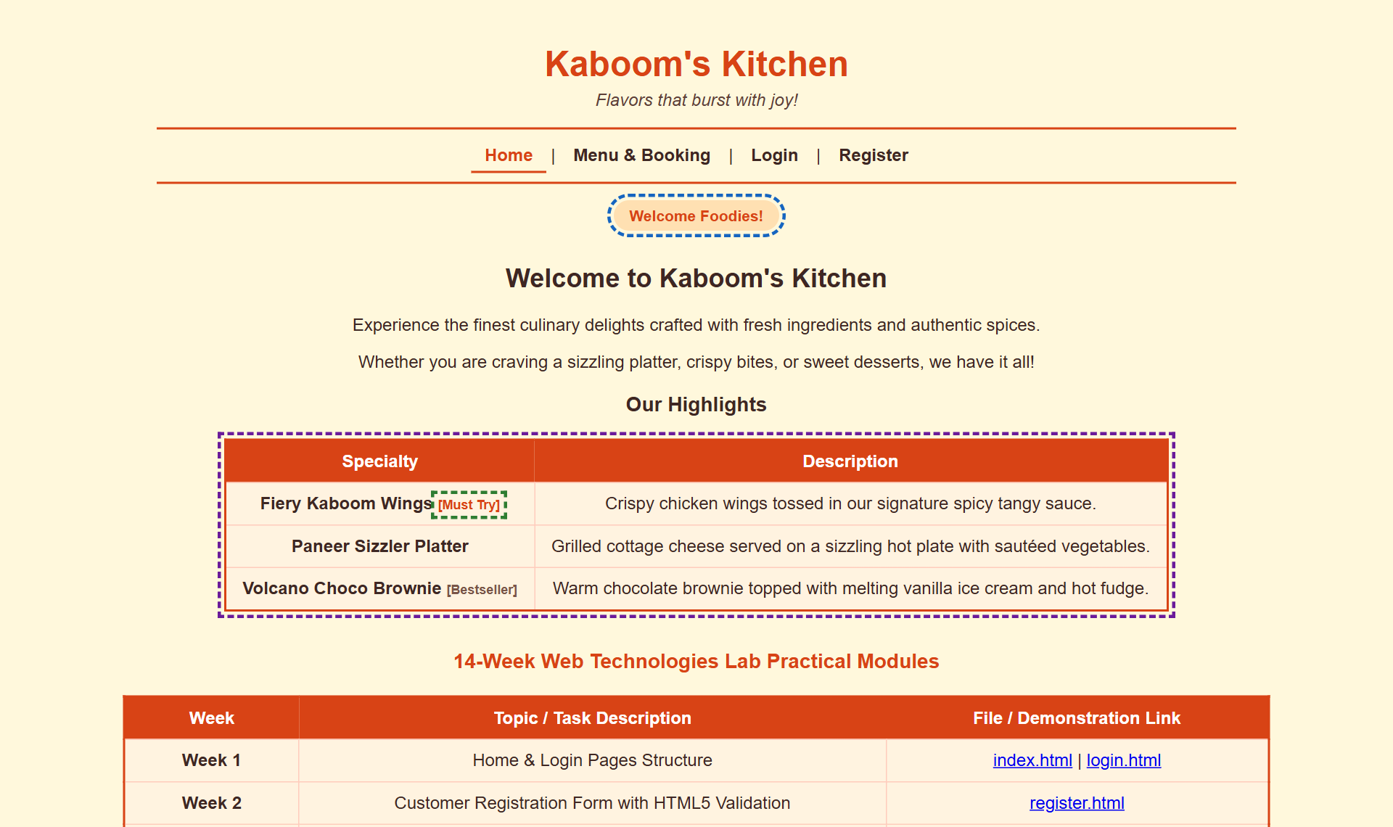
Figure 5. Home page with the three CSS types outlined: purple = external (.content-box), blue = internal (.promo-badge), green = inline ([Must Try])

Test results
Test performed | Expected | Actual result | Result
External CSS (style.css) applied | body background #FFF8DC = rgb(255, 248, 220) | rgb(255, 248, 220) | PASS
Internal CSS (.promo-badge in <style>) | background #FFE0B2 = rgb(255, 224, 178) | rgb(255, 224, 178) | PASS
Inline CSS ([Must Try] span) | color #D84315 = rgb(216, 67, 21) | rgb(216, 67, 21) | PASS
Stylesheets loaded on page | one external + one internal | external:style.css + internal <style> | PASS
nav a:hover rule | hover colour turns orange rgb(216, 67, 21) | rgb(216, 67, 21) | PASS

6. Week 4: JavaScript validation of the registration page
Syllabus says
Write JavaScript programs to validate the fields of the student registration page.

Files: script.js, loaded at the bottom of register.html with <script src="script.js"></script>
The form tag has onsubmit="return validateRegistrationForm()". If the function returns false the submit is cancelled; if it returns true the form submits.

What's inside the files

validateRegistrationForm(): the five checks, in order
# | Check | How the code does it | Error alert
1 | Name not blank | fullName.trim() === "" | Please enter your full name.
2 | Email looks valid | indexOf("@") ≥ 1 and the last . is at least 2 characters after the @ and not at the end | Please enter a valid email address
3 | Phone = 10 digits | phone.length !== 10 || isNaN(phone) | Phone number must be exactly 10 numeric digits.
4 | Password ≥ 6 | password.length < 6 | Password must be at least 6 characters long.
5 | Passwords match | password !== confirmPassword | Password and Confirm Password do not match.

On each failure the function shows an alert(), calls .focus() on the bad field so the cursor jumps there, and returns false. If all checks pass it shows "Registration Successful! Welcome to Kaboom's Kitchen, <name>!" and returns true.
// shape of every check in script.js
if (password !== confirmPassword) {
alert("Error: Password and Confirm Password do not match.");
document.getElementById("confirmpassword").focus();
return false; // cancels the submit
}

How Week 2 and Week 4 work together
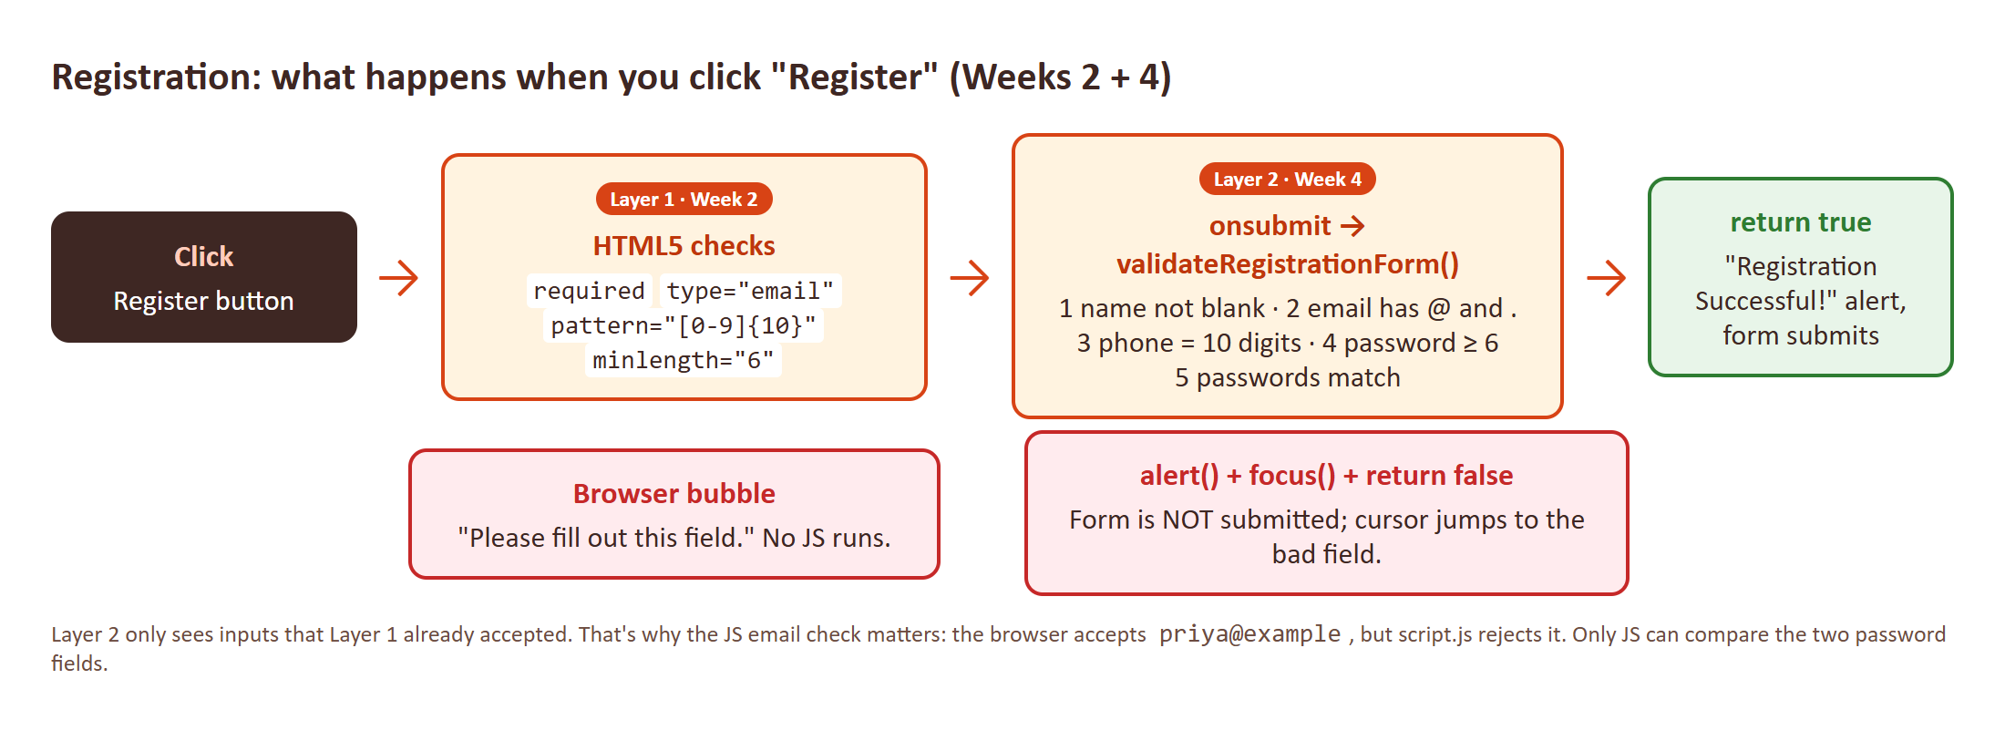
Figure 6. Two layers of validation. HTML5 runs first; JavaScript only sees input the browser already accepted.
Because HTML5 runs first, some JS alerts are only reachable for input the browser lets through. Testing showed two cases where only JavaScript catches the problem: an email like priya@example (the browser accepts it, script.js rejects it), and mismatched passwords (HTML5 cannot compare two fields).

Tested screen
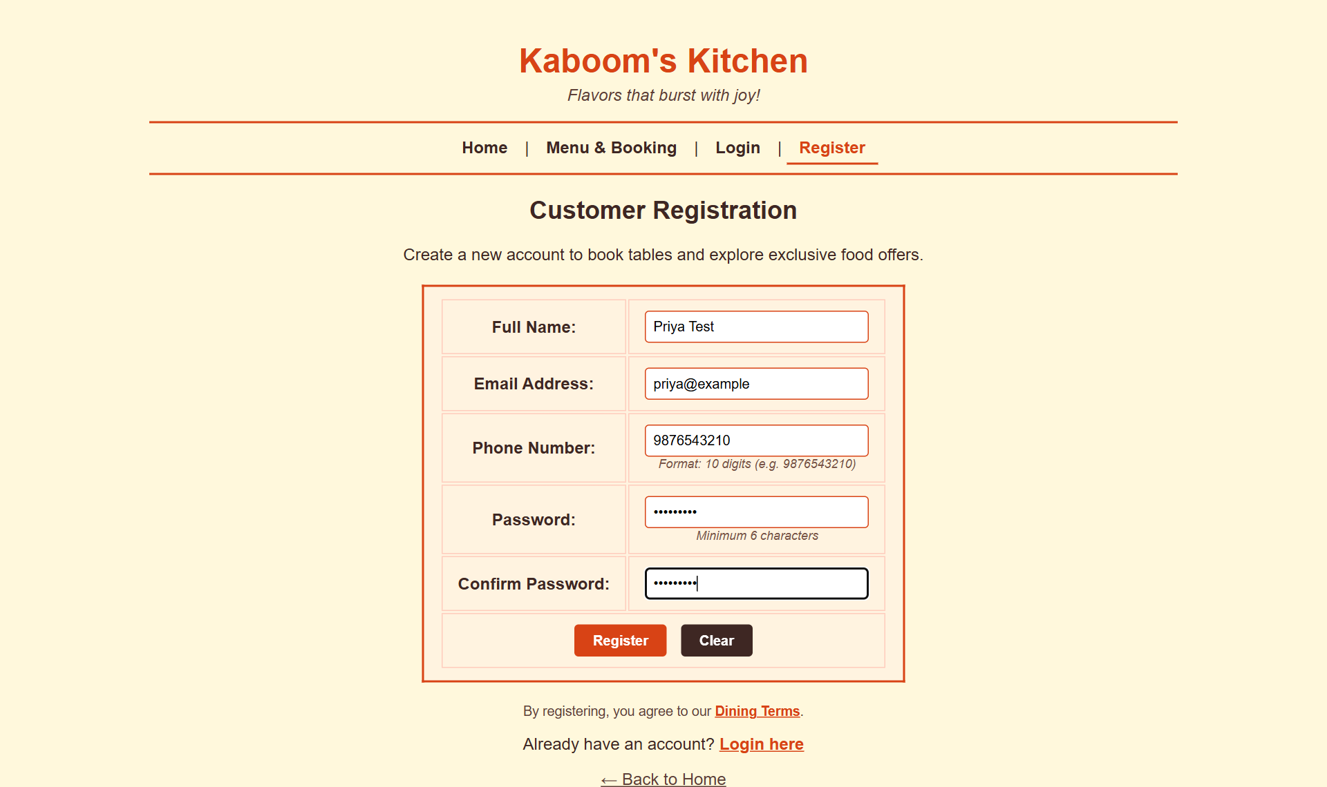
Figure 7. Form filled with "priya@example": HTML5 accepts it, then script.js shows the email alert

Test results
Test performed | Expected | Actual result | Result
validateRegistrationForm(): Empty full name | alert contains "Please enter your full name" | Error: Please enter your full name. | returned false | PASS
validateRegistrationForm(): Email without dot after @ ("priya@example") | alert contains "valid email address" | Error: Please enter a valid email address (e.g., student@example.com). | returned false | PASS
validateRegistrationForm(): Phone with letters ("98765abcde") | alert contains "exactly 10 numeric digits" | Error: Phone number must be exactly 10 numeric digits. | returned false | PASS
validateRegistrationForm(): Password of 4 characters | alert contains "at least 6 characters" | Error: Password must be at least 6 characters long. | returned false | PASS
validateRegistrationForm(): Passwords do not match | alert contains "do not match" | Error: Password and Confirm Password do not match. | returned false | PASS
validateRegistrationForm(): All fields valid | alert contains "Registration Successful" | Registration Successful! Welcome to Kaboom's Kitchen, Priya Test! | returned true | PASS
Real submit: "priya@example" passes HTML5 but JS catches it | HTML5 valid, JS alert blocks | HTML5 valid=true; alert="Error: Please enter a valid email address (e.g., student@example.com)." | PASS
Real submit: mismatched passwords (HTML5 cannot check this) | JS alert "do not match" | Error: Password and Confirm Password do not match. | PASS

Concepts to remember
- document.getElementById(id).value reads what the user typed.
- .trim() removes spaces, so " " counts as empty.
- return false from an onsubmit handler cancels the submit.
- isNaN("98765abcde") is true, which is how letters in the phone number are caught.

7. Week 5: Catalogue page (HTML + CSS + JavaScript)
Syllabus says
Design the catalogue page for the online book store using HTML, CSS, and JavaScript.

Files: menu.html
The catalogue is the restaurant's menu. It uses all three technologies: HTML for the structure, CSS for the look, and JavaScript for interaction.

What's inside the files
- HTML: one <table class="content-box"> with three category header rows (colspan="3"): Starters & Appetizers, Main Course, Desserts & Beverages. That makes 6 dishes, each with name, description and price.
- CSS: internal classes .category-header (orange band), .price-tag (bold dark-orange price) and .book-section (booking card).
- JavaScript scrollToBooking(): the "Reserve a Table Now ↓" button smoothly scrolls down (scrollIntoView({behavior:"smooth"})) and puts the cursor in the Customer Name box.
- Booking form: type="date", type="time" and type="number" (min="1" max="20") give the user a date picker, time picker and number spinner.
- JavaScript handleBooking(e): calls e.preventDefault() so the page doesn't reload, reads the four values, checks none is empty, shows a confirmation alert with all the details, then calls form.reset().

Flow: what happens, step by step
- The page loads and shows the menu table.
- The user clicks Reserve a Table Now → scrollToBooking() scrolls to the form and focuses the name box.
- The user fills name, date, time and guests and clicks Confirm Booking.
- HTML5 checks required and the 1–20 guest range.
- handleBooking() stops the reload, shows "Table Reserved Successfully!" with the details, and clears the form.

Tested screen
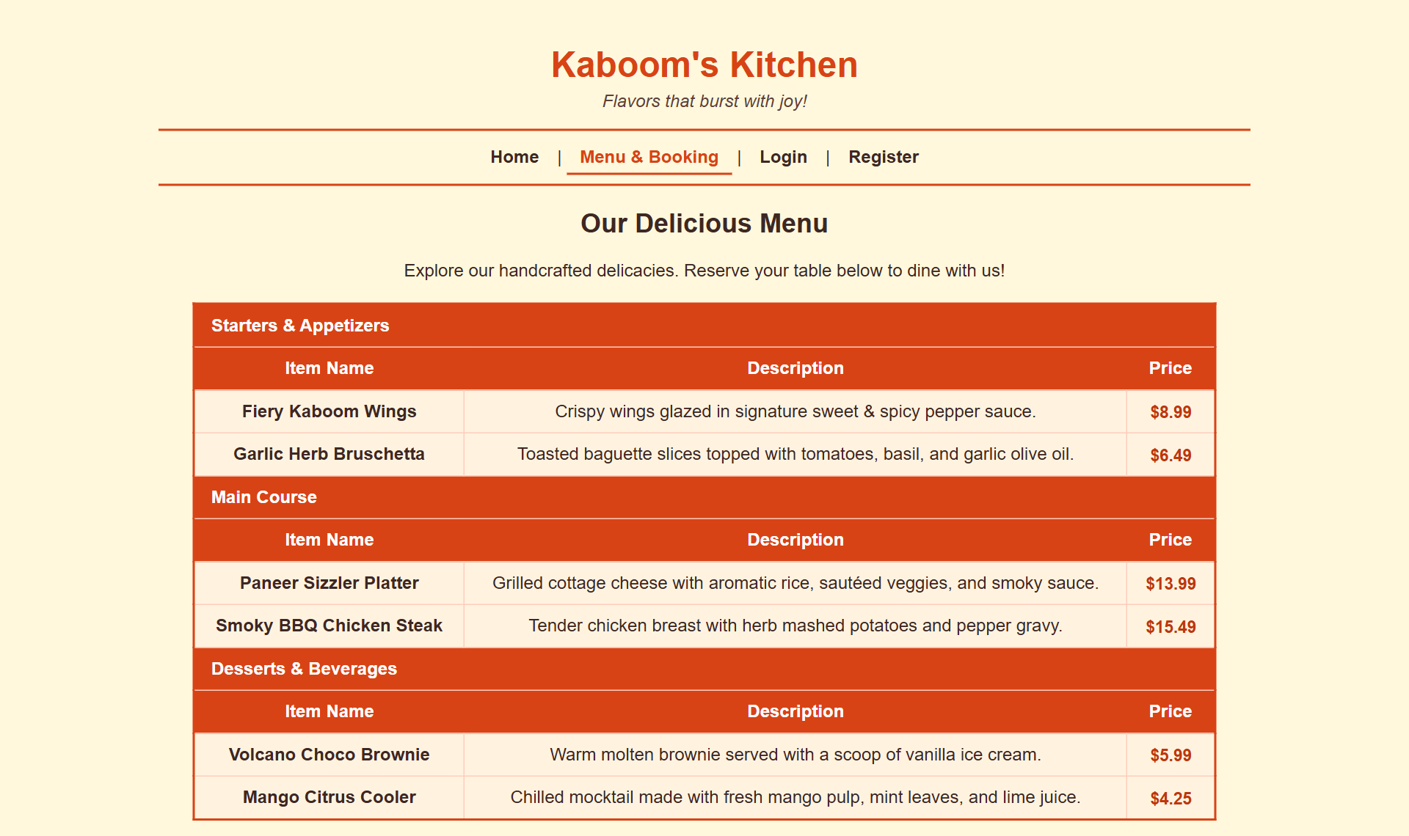
Figure 8. Menu catalogue (menu.html)
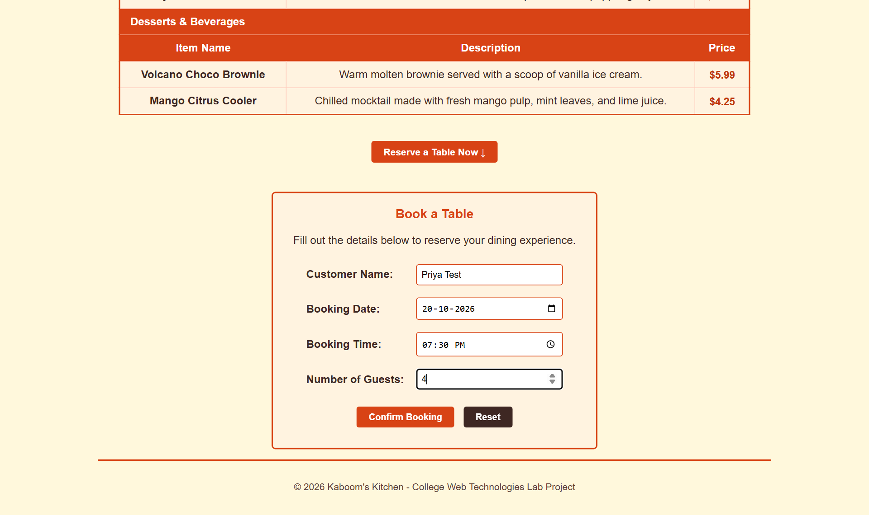
Figure 9. Booking form filled in, just before Confirm Booking

Test results
Test performed | Expected | Actual result | Result
Catalogue renders dishes with prices | 6 dishes in 3 categories | 6 dishes; Starters & Appetizers / Main Course / Desserts & Beverages | PASS
"Reserve a Table Now" button (scrollToBooking) | scrolls to form and focuses Customer Name | focused #custName | PASS
Submit booking form (handleBooking) | confirmation alert + form reset | Table Reserved Successfully!; form reset=true | PASS

8. Week 6: XML file and DTD
Syllabus says
Write an XML file which will display the Book information. Write a Document Type Definition (DTD) to validate the XML file.

Files: menu.xml, menu.dtd

What's inside the files

menu.xml: the data
Line 1 is the XML declaration. <!DOCTYPE menu SYSTEM "menu.dtd"> links the file to its rules. The root <menu> holds one <restaurant> name and 6 <item> elements, each with an id attribute and four children:
<item id="item1">
<name>Fiery Kaboom Wings</name>
<category>Starters</category>
<price>$8.99</price>
<description>Crispy wings glazed in ...</description>
</item>

menu.dtd: the rules
DTD line | Meaning
<!ELEMENT menu (restaurant, item+)> | menu must contain one restaurant, then one or more (+) items, in that order
<!ELEMENT item (name, category, price, description)> | Every item must have exactly these four children, in this order
<!ATTLIST item id ID #REQUIRED> | Every item needs an id; type ID means no two items may share one
<!ELEMENT name (#PCDATA)> (and category, price, description) | These hold plain text (Parsed Character Data)

How it was tested
The XML was parsed and validated against the DTD with a validating parser (Python lxml). Then two broken copies were checked to prove the DTD actually enforces its rules: one with a <price> removed, one with a duplicate id. Both were rejected with the error messages shown in the table below.

Tested screen
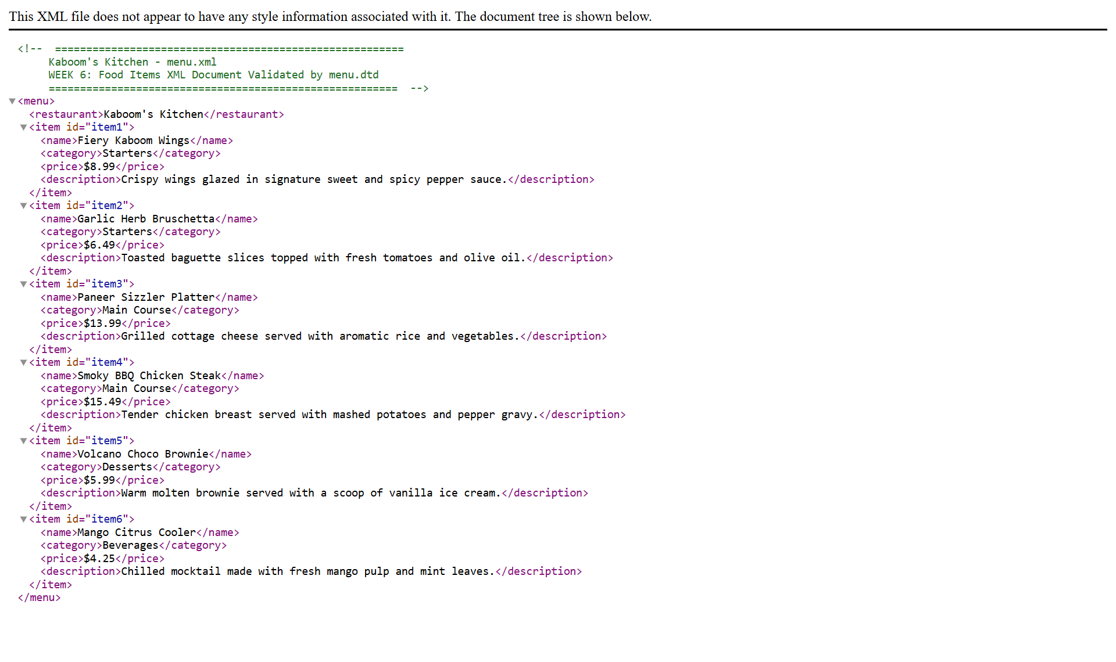
Figure 10. menu.xml opened in Chrome: the browser shows the element tree because no stylesheet is attached

Test results
Test performed | Expected | Actual result | Result
menu.xml opens in browser as an XML tree | 6 <item> nodes | 6 | PASS
menu.xml is well-formed | parses without error | parsed, root <menu>, 6 items | PASS
menu.xml validated against menu.dtd | valid | valid | PASS
Negative test: remove <price> from item1 | DTD rejects it | Element item content does not follow the DTD, expecting (name , category , price , description), got (name category description ) | PASS
Negative test: duplicate id="item1" (ID must be unique) | DTD rejects it | ID item1 already defined | PASS

Concepts to remember
- Well-formed = follows XML syntax (one root, every tag closed, properly nested). Valid = well-formed and obeys its DTD.
- Browsers only check well-formedness; they do not enforce the DTD. A validator (VS Code XML extension, xmllint, online validators) is needed for that.
- Symbols in a DTD: + one or more, * zero or more, ? optional, , in this order, | choice.

9. Week 7: Review and Skill Test 1
Syllabus says
Review and Skill Test-1.

Files: viva_review.html
A study page for the mid-term practical. It has three cards:

What's inside the files
- Summary of Weeks 1 to 6: one line per week naming the key tags, attributes and files.
- Top 8 viva questions with answers: HTML vs XML, CSS priority, why client-side validation, what a DTD is, #PCDATA, preventDefault(), GET vs POST, linking external CSS/JS.
- 4 hands-on exercises: add an age field (18–100) with JS validation, add a drink to menu.xml, change the button hover colour, add a character counter to the booking form.
Exam tip
Practise Exercise 1 before the skill test. It touches HTML (new input), JS (new check in script.js) and the Week 2/Week 4 layering all at once.

Tested screen
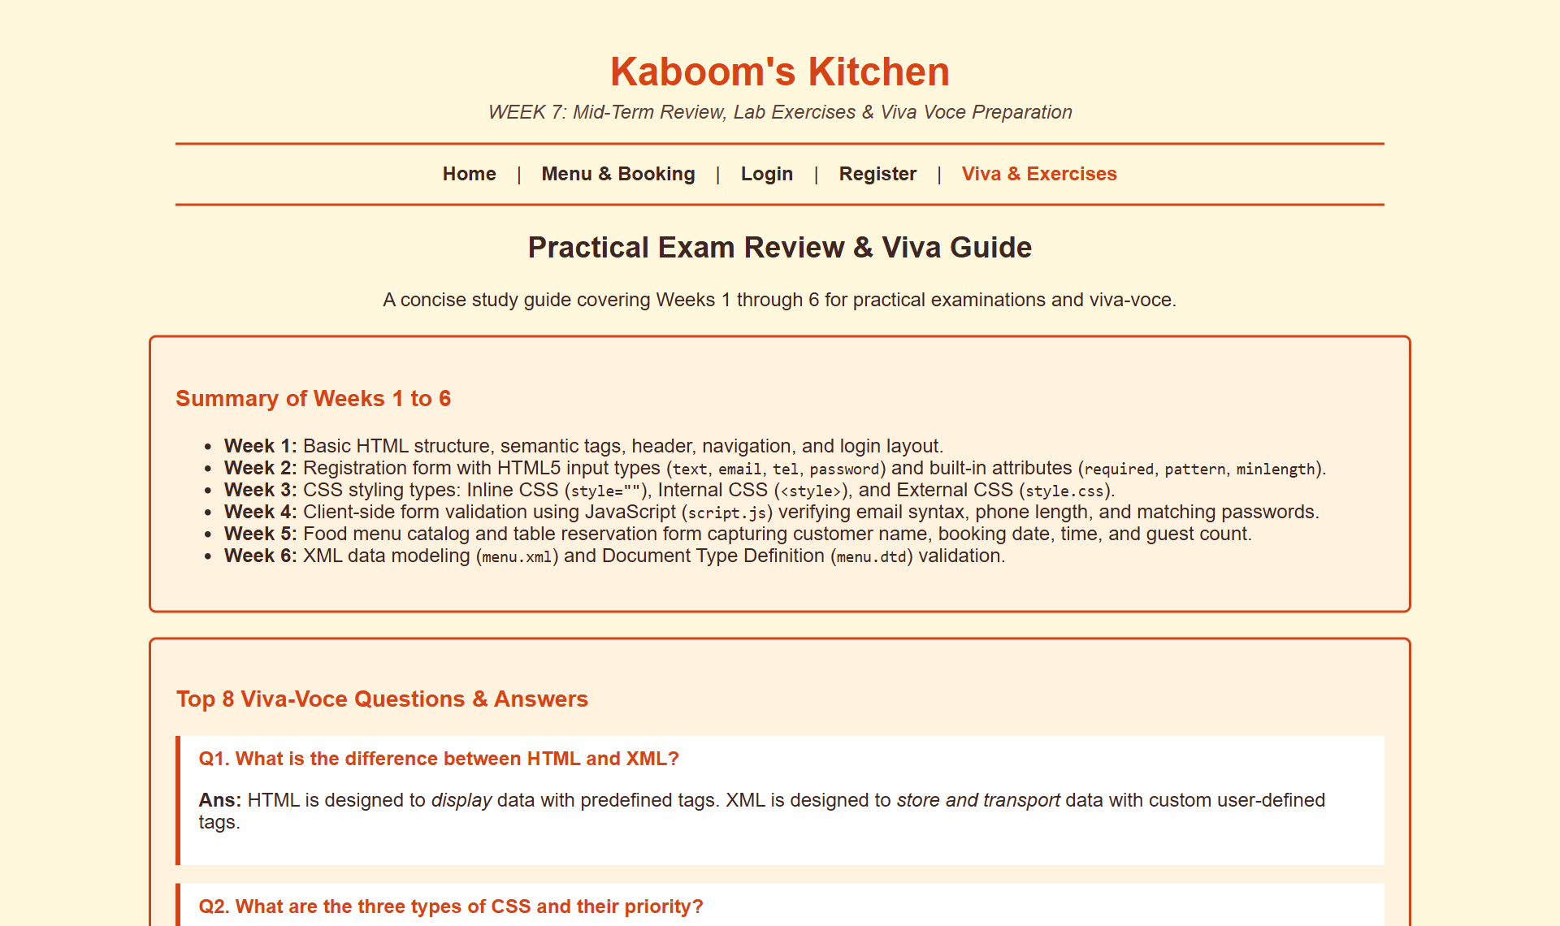
Figure 11. Review and viva guide (viva_review.html)

Test results
Test performed | Expected | Actual result | Result
Viva guide content | 8 Q&A + 4 lab exercises | 8 Q&A, 4 exercises | PASS

10. Week 8: Fetch API: loading text asynchronously
Syllabus says
Write an Ajax / Fetch API program to load text data asynchronously.

Files: fetch_text.html, restaurant_info.txt
"Asynchronous" means the page asks the server for data and keeps working while it waits. When the data arrives, a callback updates just one part of the page, with no full reload.

What's inside the files
fetch("restaurant_info.txt") // 1. send GET request, get a Promise
.then(function(response) {
if (!response.ok) throw new Error(...); // 2. 404/500 -> jump to catch
return response.text(); // 3. read body as plain text
})
.then(function(data) {
display.innerText = data; // 4. put text into the page
})
.catch(function(error) { // 5. any failure ends up here
display.innerHTML = "Error loading file: " + error.message;
});

The Fetch pattern used in Weeks 8, 9 and 10
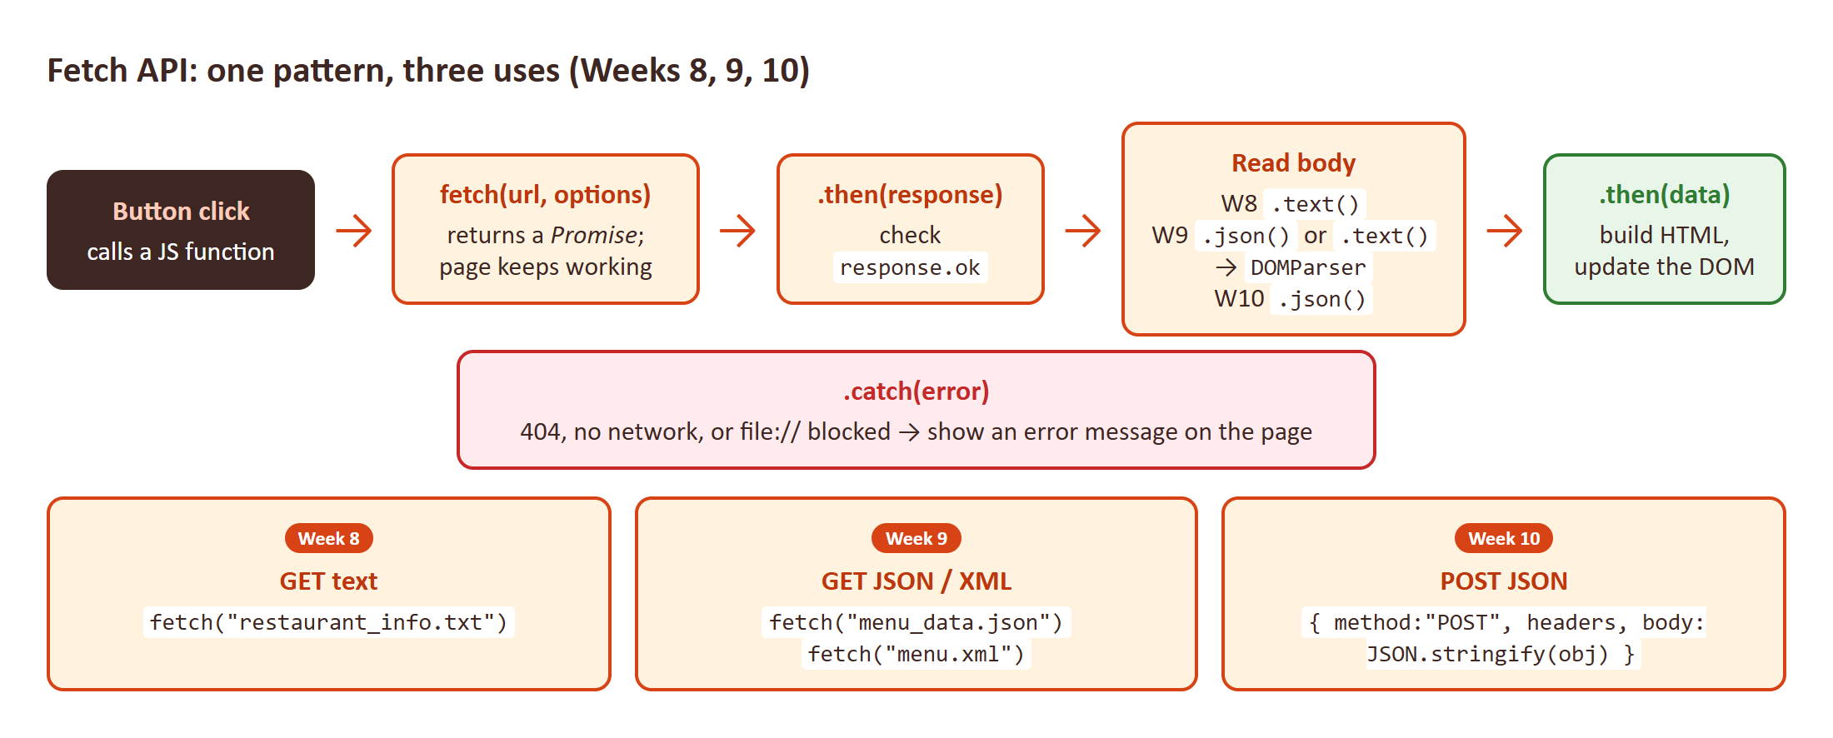
Figure 12. Every Fetch page in the project follows this chain; only the "read body" step changes.

Tested screen
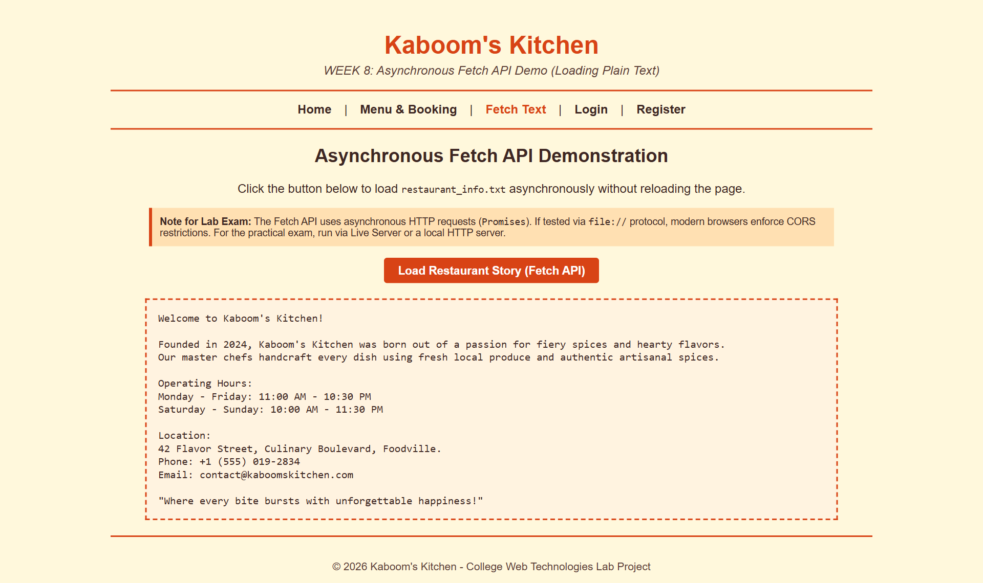
Figure 13. After clicking "Load Restaurant Story": text loaded with no page reload
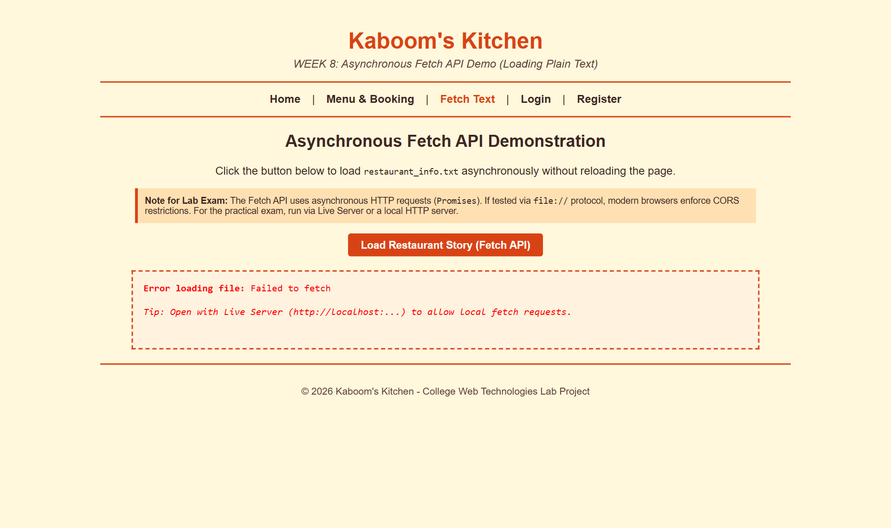
Figure 14. The same page opened by double-click (file://): the browser blocks fetch and the catch() message appears

Test results
Test performed | Expected | Actual result | Result
fetch("restaurant_info.txt") over http:// | text shown without page reload | Welcome to Kaboom's Kitchen! | PASS
Same page opened via file:// (double-click) | fetch blocked by browser (CORS) | Error loading file: Failed to fetch | PASS

Concepts to remember
- A Promise is a placeholder for a value that will arrive later. .then() runs when it arrives; .catch() runs if it fails.
- fetch() only rejects on network failure. A 404 still "succeeds", which is why the code checks response.ok.
- innerText vs innerHTML: innerText shows text as-is; innerHTML interprets tags.
- AJAX (XMLHttpRequest) is the older way; Fetch is the modern, Promise-based replacement.

11. Week 9: Fetch API: parsing JSON and XML
Syllabus says
Write an Ajax / Fetch API program to parse JSON/XML response data.

Files: fetch_data.html, menu_data.json, menu.xml (reused from Week 6)

What's inside the files
 | Part A: JSON | Part B: XML
Source file | menu_data.json (array of 4 objects) | menu.xml (6 <item> elements)
Read body with | response.json(): parsed straight into JS objects | response.text(): a plain string first
Turn into usable data | Already done: items is an array | new DOMParser().parseFromString(str, "text/xml")
Loop | items.forEach(item => ...) | for over xmlDoc.getElementsByTagName("item")
Read one value | item.name | node.getElementsByTagName("name")[0].textContent
Read the id | item.id (a property) | node.getAttribute("id") (an attribute)
Output | Builds an HTML <table> string → innerHTML | Same: builds a table → innerHTML

Why JSON is simpler: it already looks like JavaScript objects, so one call parses it. XML needs a parser and DOM methods to dig out each value, but it supports attributes and DTD validation.

Tested screen
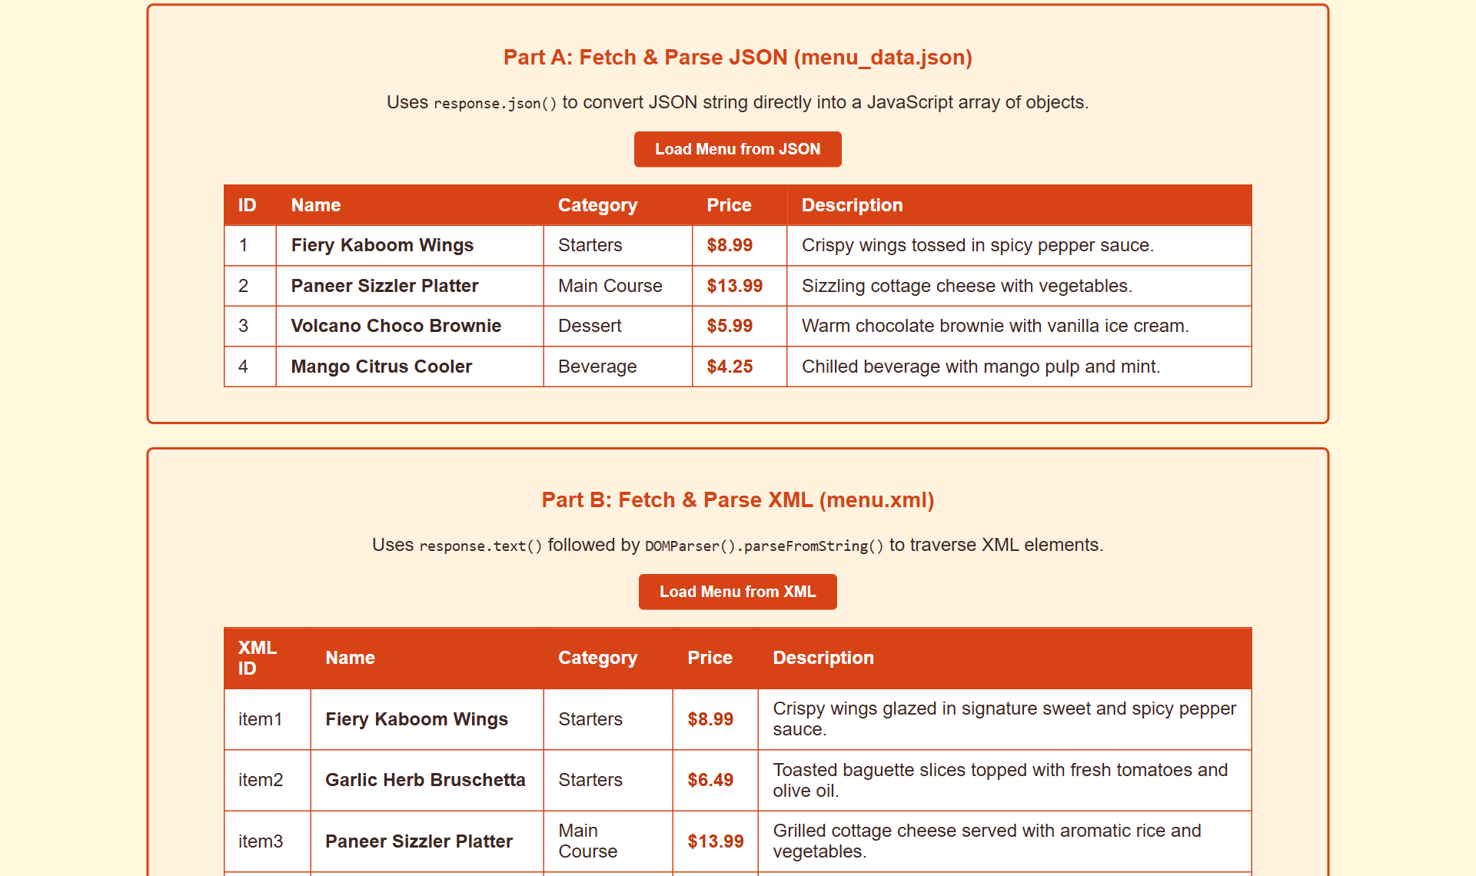
Figure 15. Part A: 4 rows built from menu_data.json
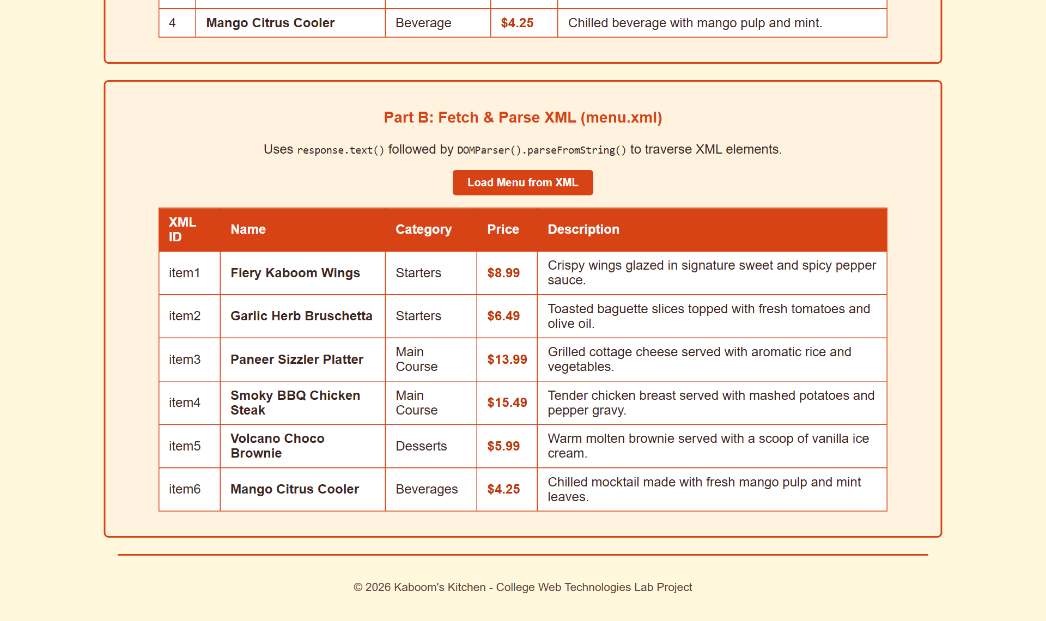
Figure 16. Part B: 6 rows parsed out of menu.xml with DOMParser (XML ID column comes from the id attribute)

Test results
Test performed | Expected | Actual result | Result
Load Menu from JSON (response.json()) | 4 rows from menu_data.json | 4 rows | PASS
Load Menu from XML (DOMParser) | 6 rows from menu.xml, id attribute read | 6 rows; first id=item1 | PASS

12. Week 10: Fetch API: sending data with POST
Syllabus says
Write an Ajax / Fetch program to send data using POST method.

Files: booking_post.html
A booking form whose data is sent to a server with fetch() using the POST method. Because the project has no backend, it posts to jsonplaceholder.typicode.com, a free public test API. It accepts the data, replies with 201 Created and a new id, but does not really store anything.

What's inside the files
var bookingData = { customerName, bookingDate, bookingTime, numberOfGuests, restaurant };

fetch("https://jsonplaceholder.typicode.com/posts", {
method: "POST",
headers: { "Content-Type": "application/json; charset=UTF-8" },
body: JSON.stringify(bookingData) // object -> JSON text
})
.then(r => r.json()) // server echoes data + new id
.then(data => /* show green success box with data.id */)
.catch(err => /* yellow box: show the payload that would have been sent */);

Flow: what happens, step by step
- e.preventDefault() stops the normal form submit.
- The four inputs are gathered into one JavaScript object; parseInt makes guests a number.
- JSON.stringify() turns the object into JSON text for the request body.
- The Content-Type header tells the server the body is JSON.
- The server replies 201 Created with the same data plus id: 101.
- The green status box shows the reservation ID and details. If offline, the yellow box shows the payload instead.

Tested screen
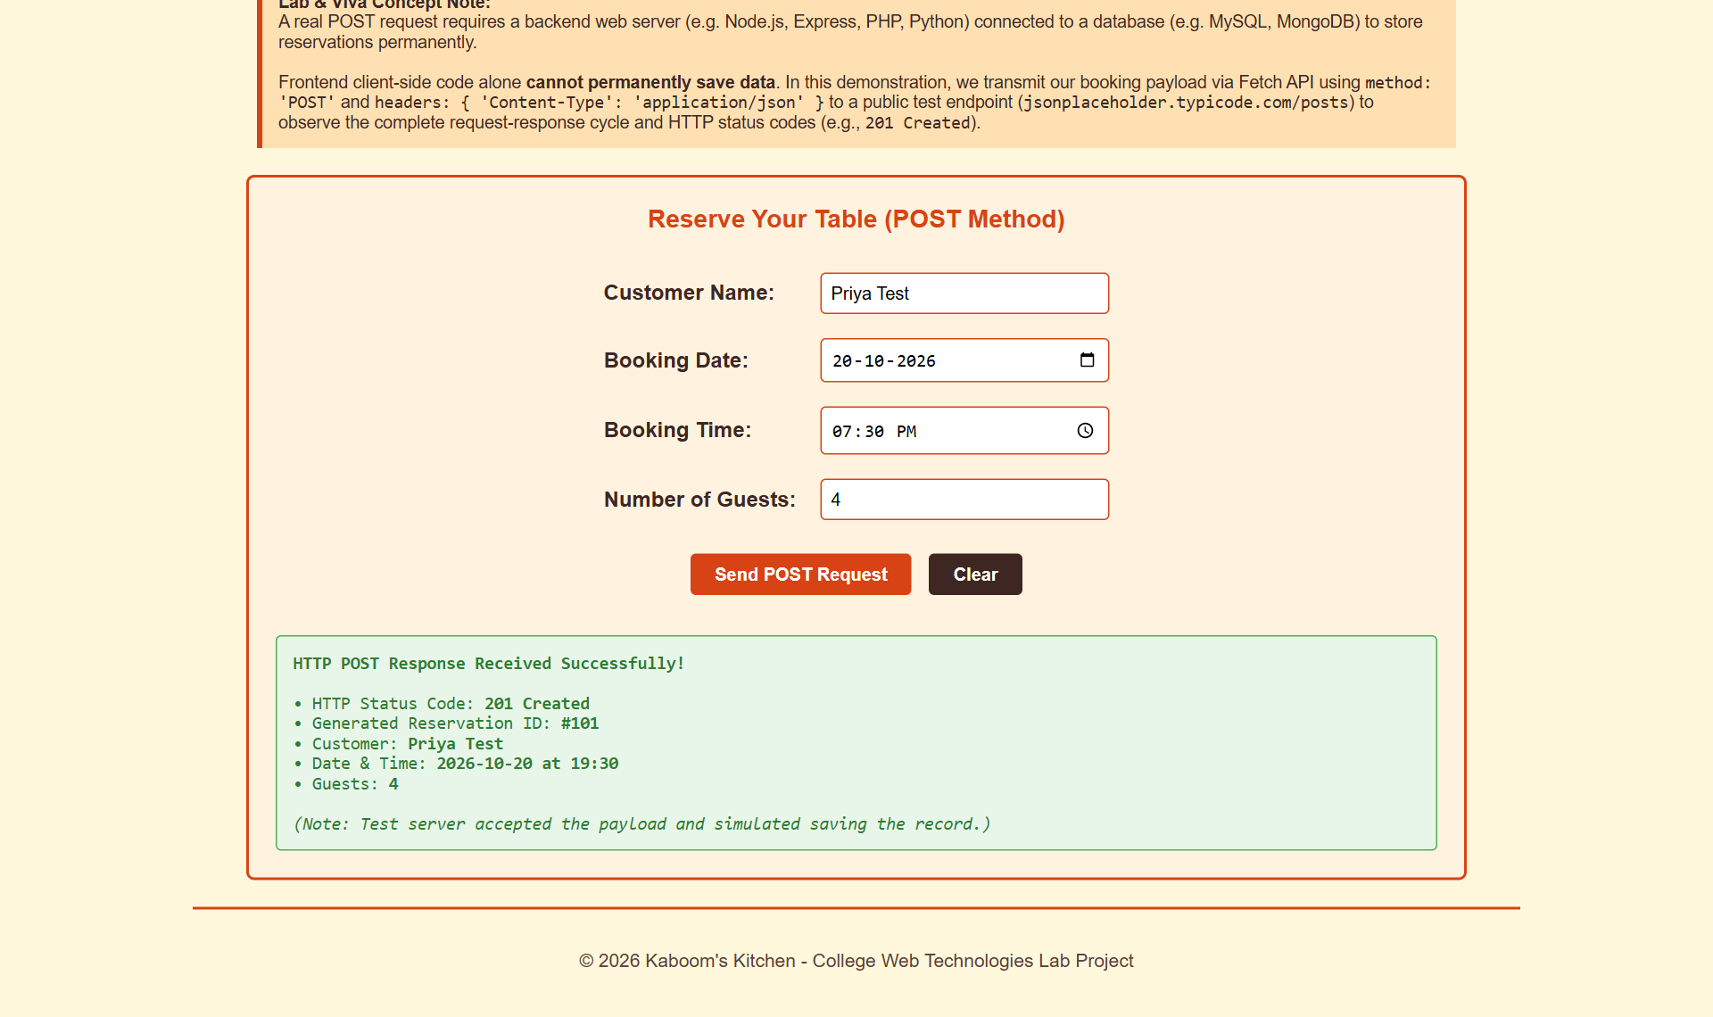
Figure 17. POST sent; server replied 201 Created with Reservation ID #101

Test results
Test performed | Expected | Actual result | Result
fetch(..., {method:"POST"}) request sent | POST with JSON body | application/json; charset=UTF-8; body={"customerName":"Priya Test","bookingDate":"2026-10-20","bookingTime":"19:30","numberOfGuests":4,"restaurant"... | PASS
Server response | HTTP 201 Created + new id | status=201; â€¢ Generated Reservation ID: #101 | PASS

Concepts to remember
- GET puts data in the URL and should only read data. POST puts data in the request body and is used to create data.
- Status codes: 200 OK, 201 Created, 400 Bad Request, 404 Not Found, 500 Server Error.
- JSON.stringify() (object → text) is the opposite of response.json() / JSON.parse() (text → object).

13. Week 11: TypeScript classes, interfaces and functions
Syllabus says
Develop TypeScript programs using classes, interfaces, and functions.

Files: menu.ts (source), menu.js (compiled), menu_ts_demo.html (demo page)
Browsers cannot run TypeScript directly. You write menu.ts, the TypeScript compiler (tsc menu.ts) checks the types and outputs plain JavaScript (menu.js), and the HTML page loads that .js file.

What's inside the files
Feature | In menu.ts | What it shows
Interface | interface MenuItem { id: number; name: string; category: string; price: number; isSpicy: boolean; } | Describes the shape an object must have
Interface | interface TableBooking { customerName; date; time; guests } | Second contract, used by a function parameter
Class | class RestaurantMenu { private items: MenuItem[]; constructor() {...} } | Data + methods together; private hides items from outside code
Methods | addItem(newItem: MenuItem): void, getAllItems(): MenuItem[], filterByCategory(name: string): MenuItem[], calculateTotal(ids: number[]): number | Typed parameters and return types; arrow functions inside filter/find
Functions | formatCurrency(amount: number): string, createBookingSummary(b: TableBooking): string | Stand-alone typed functions; the second uses a template literal

menu.js shows what the compiler produces for old (ES5) browsers: the class becomes a function with methods on its prototype, and the types disappear. The demo page loads menu.js, creates new RestaurantMenu(), and prints the item count, the filtered starters and a sample bill.

Tested screen
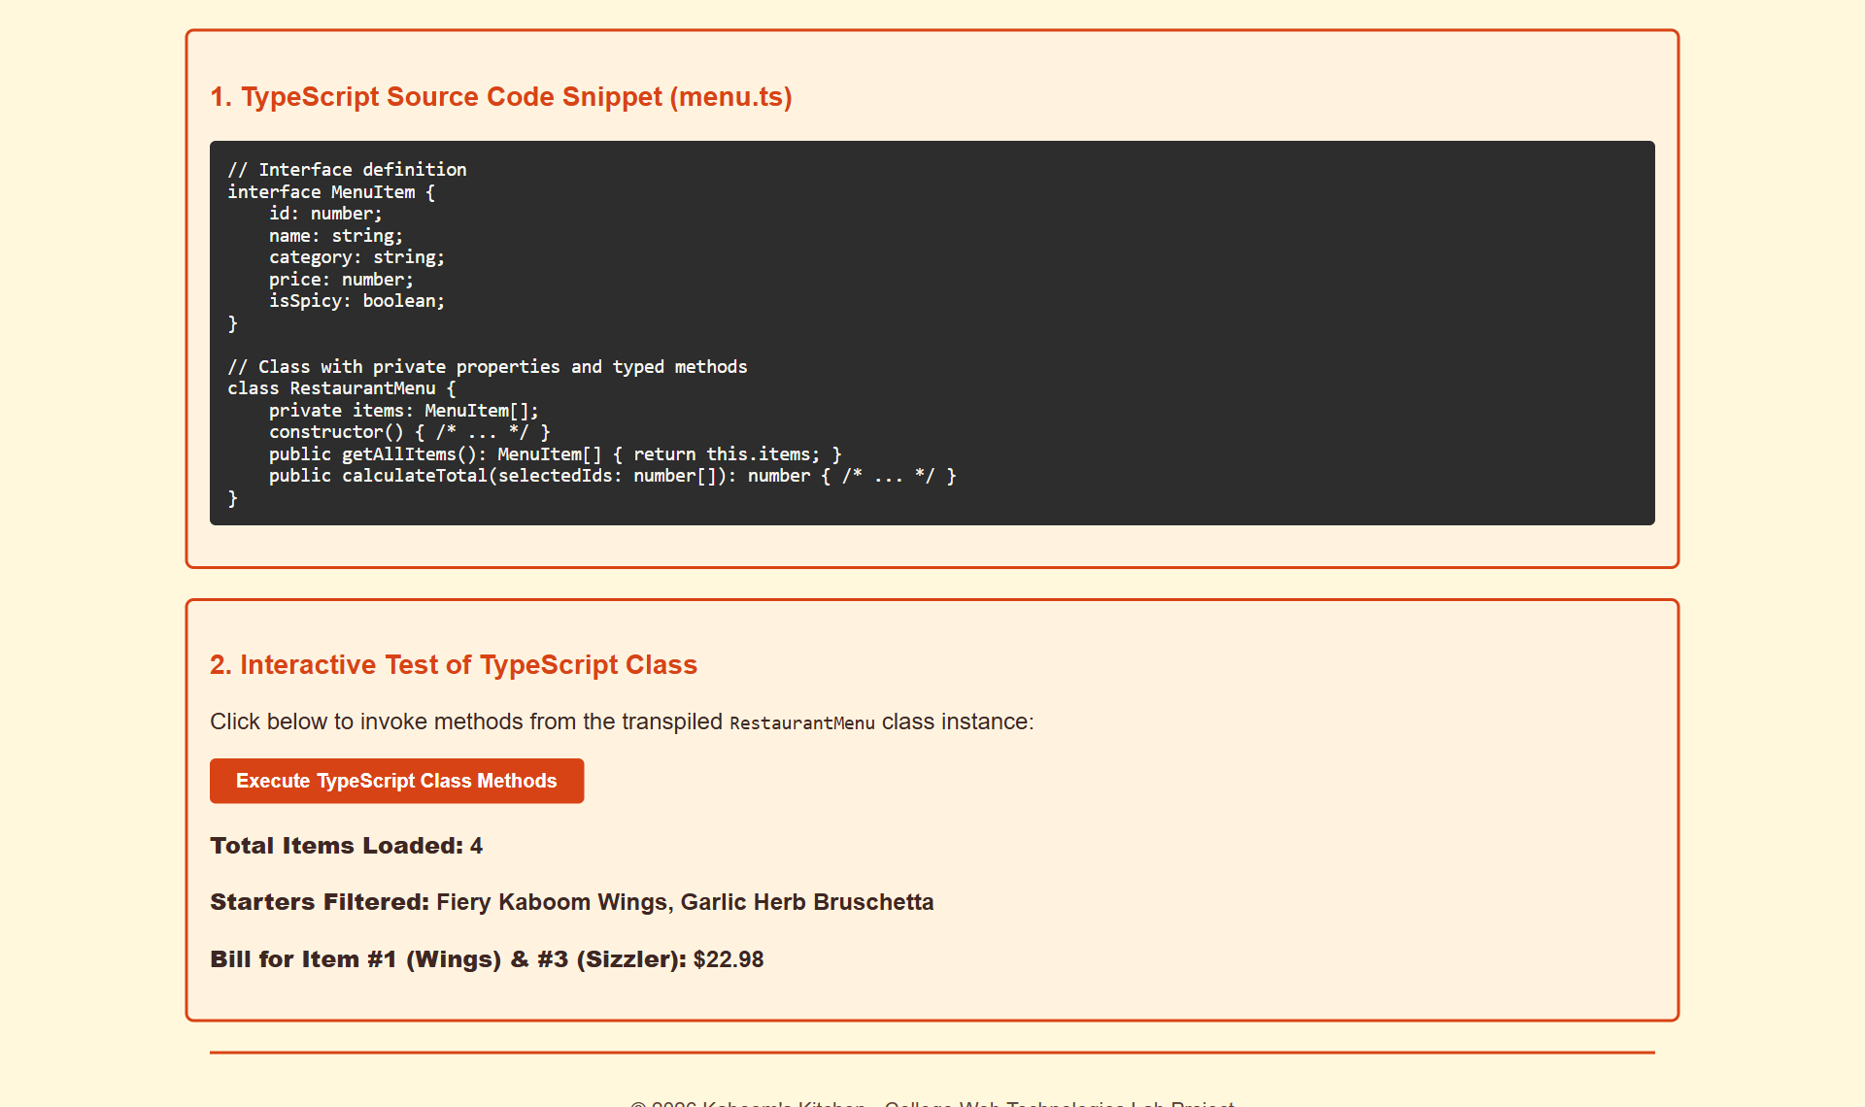
Figure 18. menu_ts_demo.html after clicking "Execute TypeScript Class Methods"

Test results
Test performed | Expected | Actual result | Result
tsc --noEmit menu.ts (TypeScript compiler type-check) | 0 type errors | 0 errors | PASS
RestaurantMenu methods (compiled menu.js) | 4 items; 2 starters; bill $22.98 | Total Items Loaded: 4 | Starters Filtered: Fiery Kaboom Wings, Garlic Herb Bruschetta | Bill for Item #1 (Wings) & #3 (Sizzler): $22.98 | PASS

Concepts to remember
- Types are checked at compile time only; at run time it is all plain JavaScript.
- If you call formatCurrency("abc"), tsc reports an error before the code ever runs. That is the main benefit.
- Access modifiers: public (default), private (inside the class only), protected (class + subclasses).

14. Weeks 12–14: Angular single-page application
Syllabus says
Week 12: Create Angular components and implement data binding, directives. Weeks 13–14: Develop Angular forms, routing, and services for a sample single-page application.

Files: angular_app.html (one file: HTML view + <script> with module, service and controller)
The app is built with AngularJS 1.8.2, loaded from a CDN, so it runs from a single HTML file with no build step. It has three "tabs" that swap in place without reloading the page.
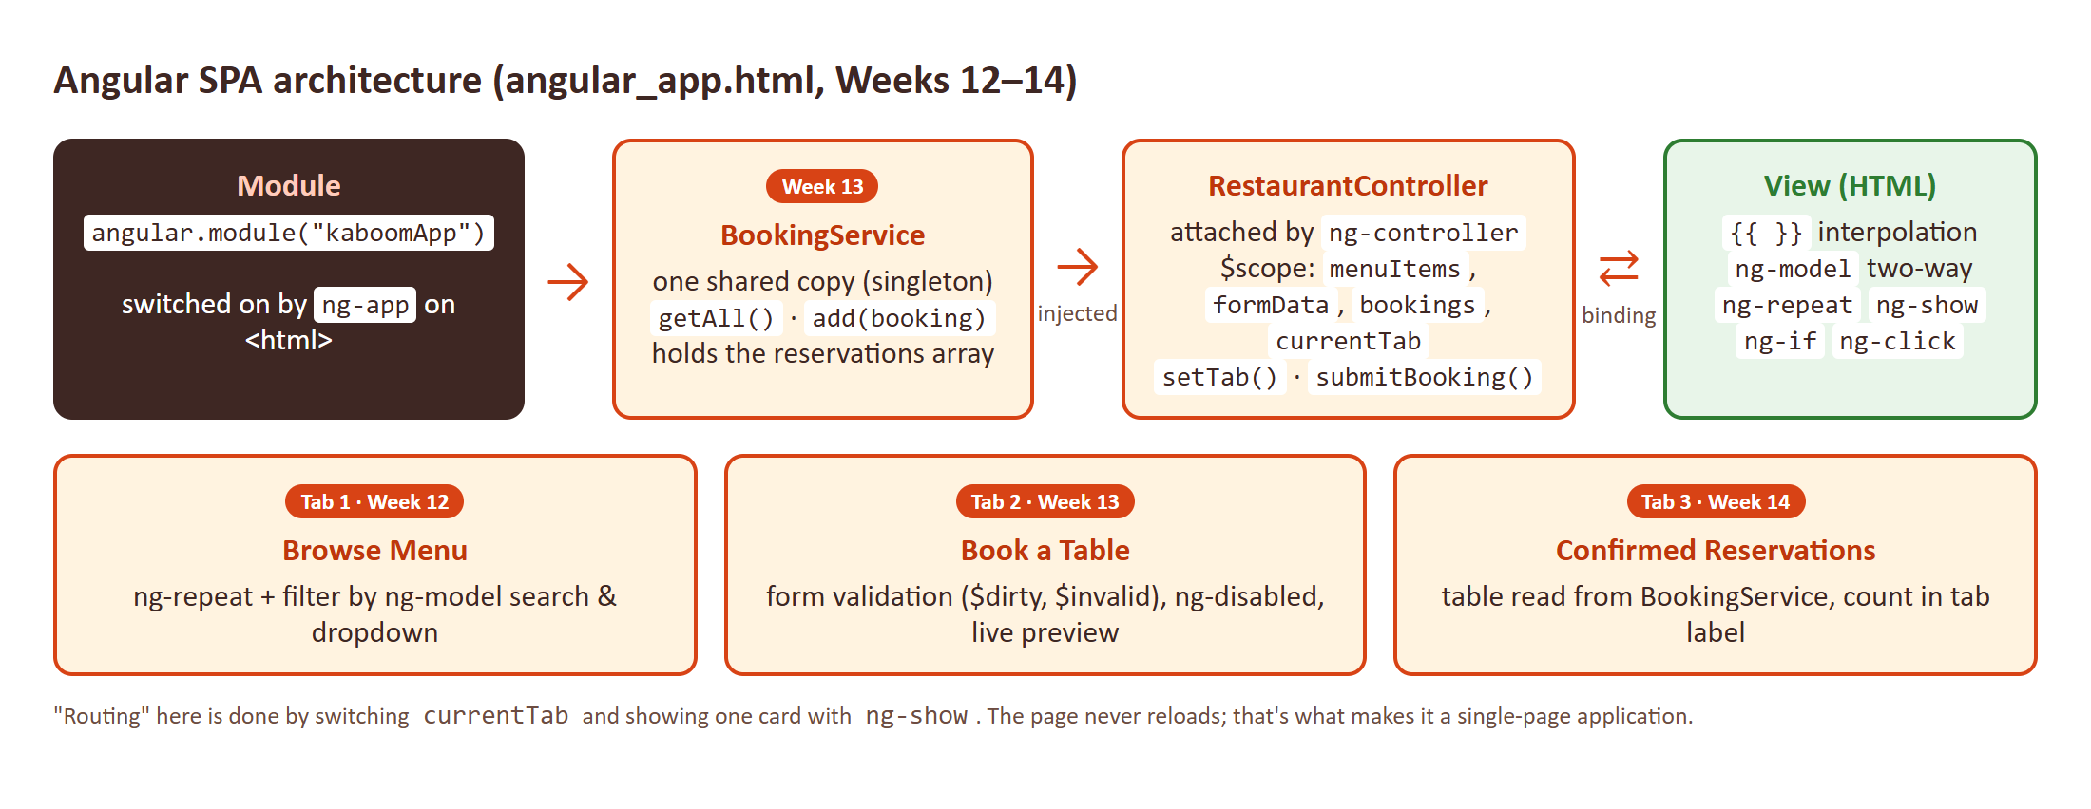
Figure 19. How the pieces of the Angular app connect

Week 12: data binding and directives (Menu tab)
- ng-app="kaboomApp" on <html> starts Angular; ng-controller="RestaurantController" on <body> connects the view to the controller.
- ng-repeat="item in menuItems | filter:categoryFilter | filter:searchQuery" creates one table row per dish and filters them live.
- ng-model on the search box and dropdown: typing updates $scope, and the filtered list updates instantly (two-way binding).
- {{ item.name }}, {{ item.price.toFixed(2) }}: interpolation (one-way, model → view).
- ng-click, ng-class, ng-show, ng-if: event handling, conditional CSS class, show/hide, add/remove from the DOM.
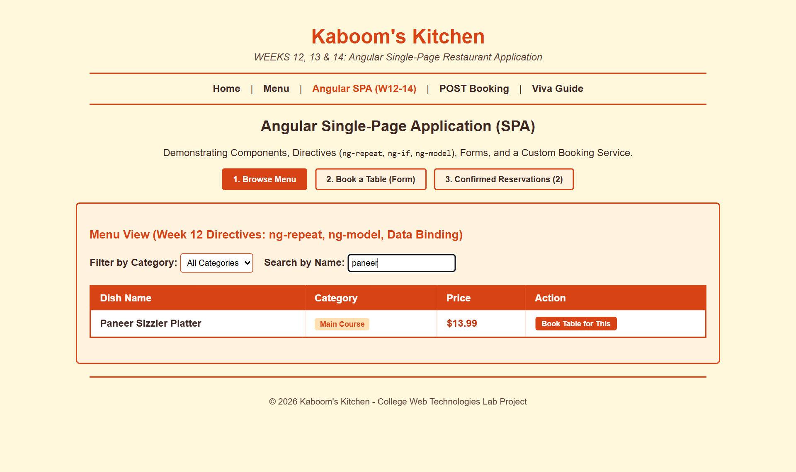
Figure 20. Typing "paneer" in the search box filters the list instantly

Week 13: forms, routing and service (Book a Table tab)
- <form name="bookingForm" novalidate ng-submit="submitBooking(bookingForm)">: novalidate turns off browser bubbles so Angular can show its own messages.
- Each input has ng-model="formData.xxx" and required. Angular tracks state flags: $dirty (user has typed), $invalid (fails a rule).
- ng-show="bookingForm.name.$dirty && bookingForm.name.$invalid" shows "Name is required!" only after the user has touched the field.
- ng-disabled="bookingForm.$invalid" keeps the Confirm button greyed out until the whole form is valid.
- A live preview box repeats the inputs as you type, which shows two-way binding.
- Routing: setTab("book") changes $scope.currentTab; each card has ng-show="currentTab === '...'". This is a lightweight stand-in for a router.
- Service: app.service("BookingService", ...) holds the reservations array with getAll() and add(). Angular injects it into the controller.
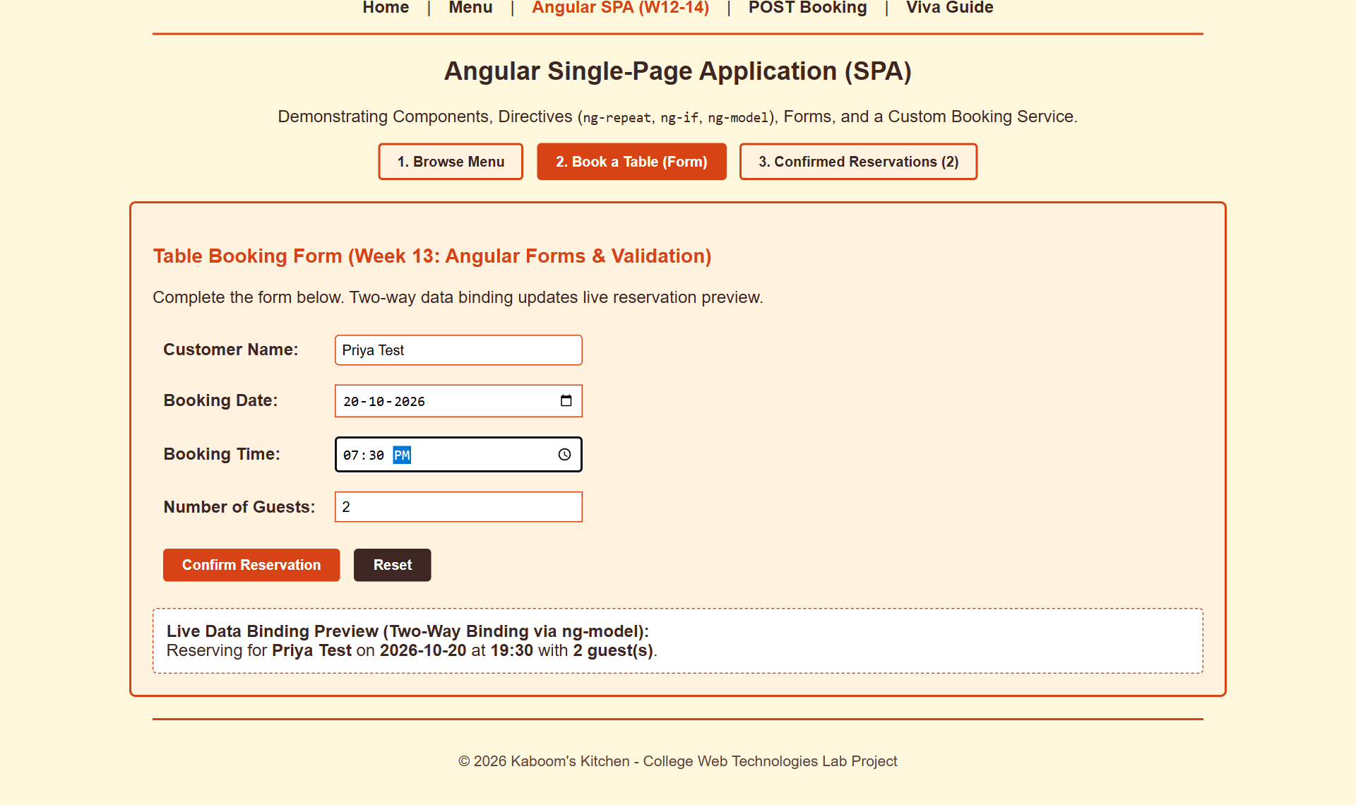
Figure 21. Booking form with live data-binding preview

Week 14: putting it together (Confirmed Reservations tab)
- submitBooking(form) checks form.$valid.
- It formats the date and time, then calls BookingService.add({...}).
- An alert confirms; resetForm(), $setPristine() and $setUntouched() clear the form and its error state.
- currentTab becomes "reservations", so the view switches tabs automatically.
- ng-repeat="b in bookings" shows the new row, and the tab label ({{ bookings.length }}) updates from 2 to 3.
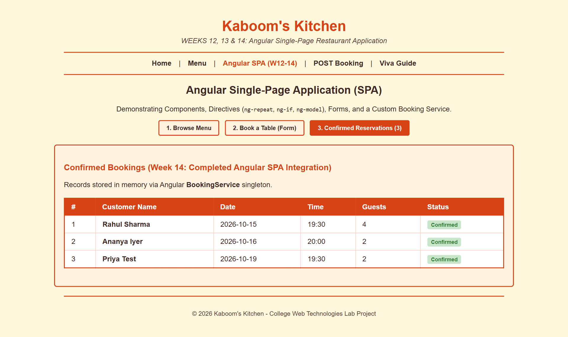
Figure 22. Reservations tab after booking. Note the date: 20 Oct was picked but 19 Oct is stored (see Section 15).

Test results
Test performed | Expected | Actual result | Result
Angular framework loaded from CDN | AngularJS 1.8.2 | 1.8.2 | PASS
ng-repeat renders menu | 6 rows | 6 | PASS
ng-model search "wings" filters live | 1 row | 1 | PASS
Category dropdown = Main Course | 2 rows | Paneer Sizzler Platter, Smoky BBQ Chicken Steak | PASS
Category dropdown = Desserts | desserts only | Volcano Choco Brownie, Mango Citrus Cooler | NOTE
Submit disabled while form invalid (ng-disabled) | disabled | disabled | PASS
$dirty && $invalid message on Name | "Name is required!" shown | shown | PASS
Two-way binding live preview | preview mirrors the inputs | Live Data Binding Preview (Two-Way Binding via ng-model): Reserving for Priya Test on 2026-10-20 at 19:30 with 2 guest(s). | PASS
Submit enabled once form valid | enabled | enabled | PASS
Submit -> BookingService.add() -> auto-switch tab | tab "reservations" + alert | tab=reservations; alert="Success! Reservation confirmed for Priya Test." | PASS
New booking appears in reservations table | 3 rows, date 2026-10-20 (date picked) | 3 rows; last = 3 | Priya Test | 2026-10-19 | 19:30 | 2 | Confirmed | BUG
Tab counter {{ bookings.length }} updates | "(3)" | 3. Confirmed Reservations (3) | PASS

Concepts to remember
- SPA = one HTML page whose content changes with JavaScript; navigation never reloads the page.
- Service = shared logic and data (singleton) that controllers get through dependency injection.
- AngularJS (1.x) vs Angular (2+): see Section 15. Be ready to explain the difference in the viva.

15. Test summary and findings
Every page was opened in headless Google Chrome from a local web server. Each check clicked, typed and submitted like a real user, captured alerts and network requests, and compared the result with what the code is supposed to do. The XML was checked with a validating parser and menu.ts with the TypeScript compiler.
Week | Checks | Pass | Bug | Note
Week 1 | 5 | 4 | – | 1
Week 2 | 5 | 5 | – | –
Week 3 | 5 | 5 | – | –
Week 4 | 8 | 8 | – | –
Week 5 | 3 | 3 | – | –
Week 6 | 5 | 5 | – | –
Week 7 | 1 | 1 | – | –
Week 8 | 2 | 2 | – | –
Week 9 | 2 | 2 | – | –
Week 10 | 2 | 2 | – | –
Week 11 | 2 | 2 | – | –
Week 12 | 5 | 4 | – | 1
Week 13 | 4 | 4 | – | –
Week 14 | 3 | 2 | 1 | –
All pages (JS errors) | 1 | 1 | – | –
Total | 53 | 50 | 1 | 2

Bug: Angular booking saves the wrong date
What happens
Book a table for 20 Oct 2026 on the Angular page. The live preview correctly says 2026-10-20, but the Reservations table stores 2026-10-19.

Why: submitBooking() formats the date with date.toISOString(). toISOString() converts to UTC time. A date picked in India is midnight IST (UTC+5:30), which in UTC is 18:30 on the previous day. So the date goes back by one.
Fix (in angular_app.html): format with Angular's date filter, which uses local time. Inject $filter into the controller and replace the formattedDate line:
app.controller("RestaurantController", function($scope, $filter, BookingService) {
...
var formattedDate = $scope.formData.date instanceof Date ?
$filter("date")($scope.formData.date, "yyyy-MM-dd") : $scope.formData.date;

Notes (not bugs, but worth knowing)
- Login uses GET. After submitting, the URL becomes login.html?username=priya&password=secret123#, so the password is visible in the address bar and browser history. This is the exact problem your own viva Q7 describes. For a real site, use method="post".
- Category data is inconsistent. In the Angular app, Mango Citrus Cooler is in "Desserts", so the Desserts filter shows a drink. Category names also differ between files: Dessert/Beverage (JSON), Desserts/Beverages (XML), Desserts for both (Angular).
- AngularJS vs Angular. The syllabus names "Angular components". This project uses AngularJS 1.8 (controllers, $scope, ng- directives), not modern Angular 2+ (TypeScript @Component classes, RouterModule routes, @Injectable services, built with the Angular CLI). The concepts map one to one (component ≈ controller + template, service ≈ service, routing ≈ tab switching), but if your examiner expects Angular CLI you may be asked to show ng new / ng generate component.
- menu.js is hand-maintained. It matches what tsc would produce for ES5, but there is no build script. If you change menu.ts, recompile it (tsc menu.ts --target es2015) or the demo page will run the old code. menu.ts itself compiles with 0 errors.
- Two pages need internet: Week 10 (jsonplaceholder) and Weeks 12–14 (AngularJS CDN). Keep a mobile hotspot handy in the lab, or save angular.min.js locally.

16. Quick revision: one line per concept
Concept | One-line meaning | Where in project
Semantic HTML | Tags that describe meaning: header, nav, main, footer | All pages
Form validation (HTML5) | Browser checks via required, type, pattern, minlength | register.html
External / Internal / Inline CSS | .css file / <style> tag / style="" attribute | style.css, every <head>, spans
CSS specificity | Inline > ID > class > tag; later rule wins on a tie | index.html .active-link
DOM | The page as a tree of objects JavaScript can read and change | script.js, every fetch page
Event handler | Function run on an event: onclick, onsubmit | menu.html, register.html
preventDefault() | Stops the browser's default action (e.g. page reload on submit) | menu.html, booking_post.html
XML / DTD | Custom-tag data / rules the data must follow | menu.xml, menu.dtd
Well-formed vs valid | Correct syntax vs correct syntax + obeys DTD | menu.xml
Asynchronous | Request runs in the background; page stays usable | fetch_text.html
Promise | Object representing a future result; .then / .catch | Weeks 8–10
JSON | Text format that looks like JS objects | menu_data.json
DOMParser | Turns an XML string into a searchable document | fetch_data.html
HTTP POST / 201 | Send data in the body / "Created" response | booking_post.html
Interface (TS) | A contract for an object's shape | menu.ts
Class (TS) | Blueprint with properties + methods | menu.ts
Transpile | Convert TS to JS (tsc) | menu.ts → menu.js
Directive | Angular attribute that adds behaviour: ng-repeat, ng-model | angular_app.html
Two-way binding | Model ↔ view stay in sync automatically | Booking preview
Service + DI | Shared singleton injected where needed | BookingService
SPA | One page; views swap without reloading | angular_app.html

