EXERCISE-1

• A simple HTML page using basic tags.

<!DOCTYPE html>

<html>

<head>

<title>My Simple HTML Page</title>

</head>

<body>

<h1>Welcome to My Simple HTML Page</h1>

<p>HTML is the standard markup language for Web pages.</p>

<p>With HTML you can create your own Website.</p>

</body>

</html>

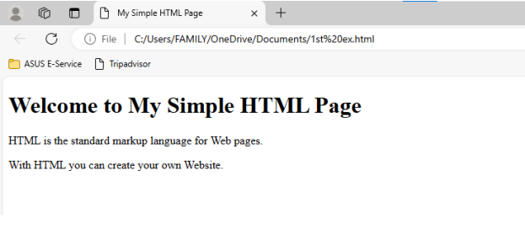

EXERCISE-2

• A web page that displays your name to the screen

<!doctype html>

<html>

<head>

<title>displaying my name</title>

</head>

<body>

<b><i><font color="blue">Tanushka Singh</b></i>

</body>

</html>

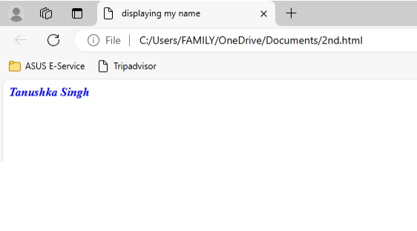

EXERCISE-3

• Create a web page and show the output from 1 to 10 in

separate lines.

<!doctype html>

<html>

<head>

<title>numbers in separate line</title>

</head>

<body>

1<br>2<br>3<br>4<br>5<br>6<br>7<br>8<br>9<br>10<br>

</body>

</html>

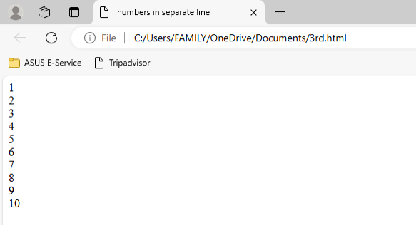

EXERCISE-4

• a web page and show the output from 1 to 10 in separate lines, each number being in different color.

<!doctype html>

<html>

<head>

<title>numbers using separate colors</title>

</head>

<body>

<font color="blue">1<br><font color="green">2<br>

<fontcolor="coral">3<br><font color="purple">4<br>

<fontcolor="orange">5<br><font color="red">6<br>

<font color="magenta">7<br><font color="brown">8<br>

<fontcolor="black">9<br><font color="yellow">10

</body>

</html>

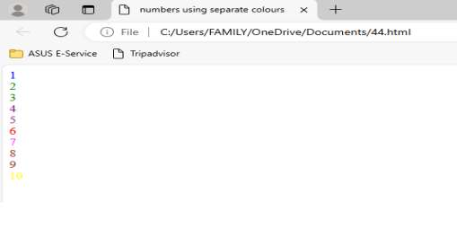

**EXERCISE-5**

• Picture as a background

<!doctype html>

<html>

<head>

<title>picture as a background</title>

</head>

<body background="C:\Users\FAMILY\Downloads\happy.jpg">

</body>

</html>

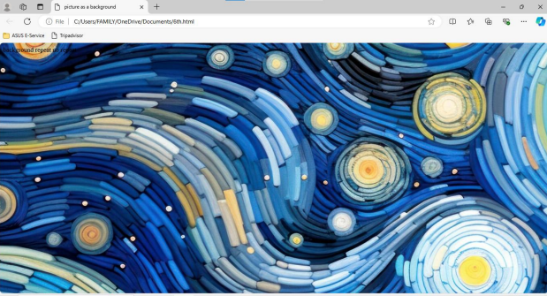

EXERCISE-6

• a web page to print a paragraph with 4-5 sentences, each sentence shall have a different font.

<!doctype html>

<html>

<head>

<title>paragraph print</title>

</head>

<body>

<font face="algerian">The journey of life may not always be smooth but we must keep going and stay positive all the times</font>.

<font face="garamond">Life is the most precious asset on this planet and must be protected irrespective of its form and appearance</font>.

<font face="cursive">Every species, not only humans, have a fundamental right to live their life, I whatever way they desire</font>.

<font face="courier">Life is a gift of God to humanity and any attempt to disrupt or damage it will have undesirable consequences</font>.

</body>

</html>

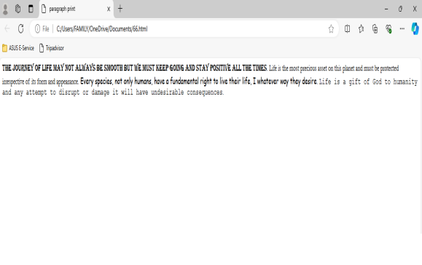

**EXERCISE-7**

• HTML code to print a paragraph that is description of

a book

<!doctype html>

<html>

<head>

<title>Description of a book</title>

</head>

<body>

<dl>

<dt><u>THE GOTHIC</u></dt>

<dd><u>The Gothic </u> Masterpiece of 19th Century

Literature by

<u>Emily Brontë</u> is a classic novel of love and loss.

This

<b><i>atmospheric</b></i> and <b><i>emotional</b></i>

tale follows the story of a young

woman who falls in love with a brooding stranger, despite

the danger and

tragedy that surrounds them.</dd>

</dl>

</body>

</html>

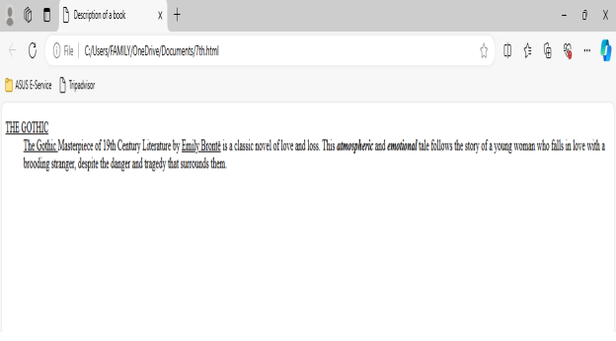

**EXERCISE-8**

• Name using different heading tags

<!doctype html>

<html>

<head>

<title>heading tag</title>

</head>

<body>

<h1>T</h1><h2>A</h2><h3>N</h3><h4>U</h4><h5>S</h5><h6>H</h

6><h1>K</h1><h

2>A</h2>

</body>

</html>

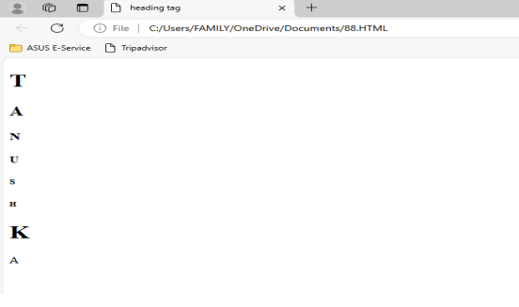

**EXERCISE-9**

• 1-20 with 2 as subscript

<!doctype html>

<html>

<head>

<title>subscript</title>

</head>

<body>

1<br>2<sub>1</sub>=2<br>3<sub>2</sub>=4<br>4<sub>3</sub>=8<b

r>5<sub>4</sub>=16

<br>6<sub>5</sub>=32<br>7<sub>6</sub>=64<br>8<sub>7</sub>=85

<br>9<sub>8</sub>=

87<br>10<sub>9</sub>=102<br>11<sub>10</sub>=112<br>12<sub>1

1</sub>=212<br>

13<sub>12</sub>=312<br>14<sub>13</sub>=412<br>15<sub>14</su

b>=482<br>16<sub>15</

sub>=666<br>17<sub>16</sub>777<br>18<sub>17</sub>=795<br>19

<sub>18</sub>=800

<br>20<sub>19</sub>=888

</body>

</html>

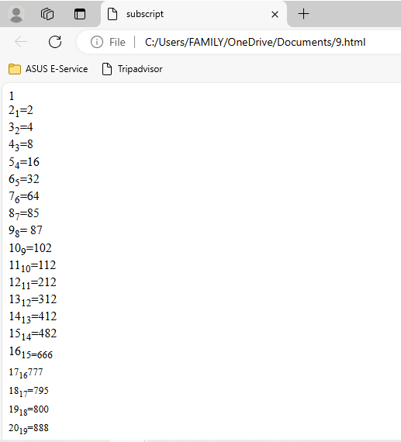

**EXERCISE-10**

• Image hanging in right of specific size

<!doctype html>

<html>

<head>

<title>picture</title>

</head>

<body>

<img

src="C:\Users\FAMILY\Downloads\images.jpg"height="200"width="200"

hspace="520"vspace="30">

</body>

</html>

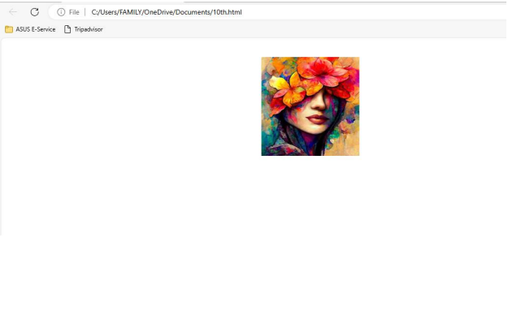

**EXERCISE-11**

**Write HTML code to create a web page with heading.The heading shall be displayed at the top-center of the page and the image shall be at the center,just below the heading.**

<html>

<head>

<title></title>

</head>

<body>

<h1 align="center">Centered Heading</h1>

<div align="center">

<img src=" https://upload.wikimedia.org/wikipedia/commons/thumb/a/ad/Vincent_van_Gogh_-_The_Church_in_Auvers-sur-Oise%2C_View_from_the_Chevet_-_Google_Art_Project.jpg/800px-Vincent_van_Gogh_-_The_Church_in_Auvers-sur-Oise%2C_View_from_the_Chevet_-_Google_Art_Project.jpg ">

<alt="Centered image">

</div>

</body>

</html>

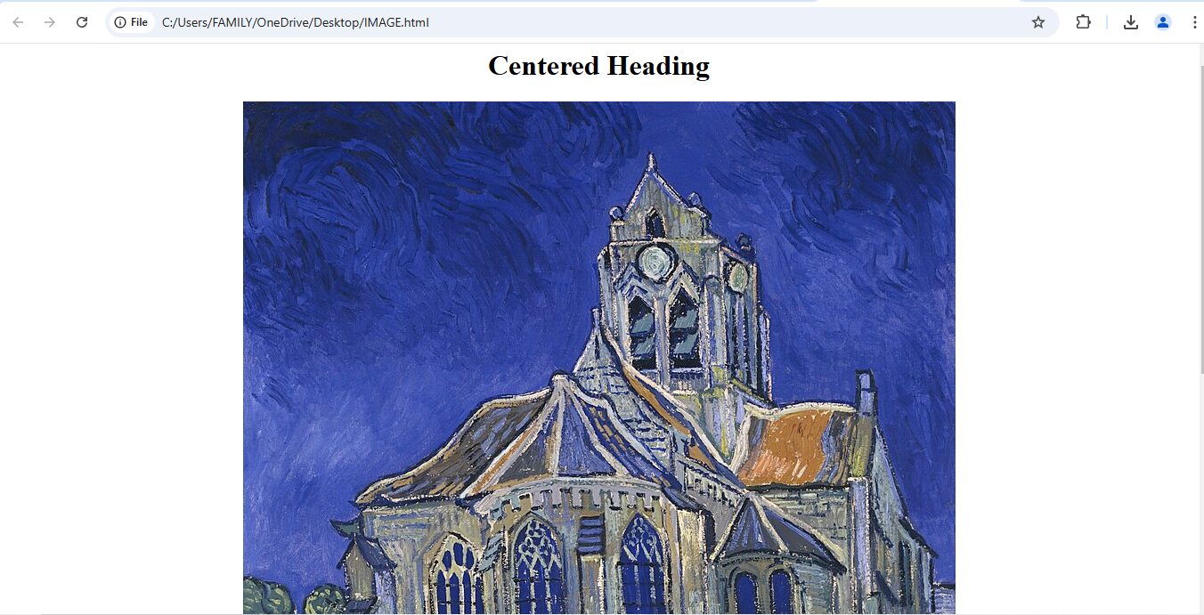

**EXERCISE-12**

**Write HTML code using multimedia tags.**

<!DOCTYPE html>

<html>

<head>

<title></title>

</head>

<body>

<h1 align="center">Multimedia Tags</h1>

<div align="center">

<h2>Image Example</h2>

<img src="https://encrypted-tbn0.gstatic.com/images?q=tbn:ANd9GcSvqzb_ogSzVGdpTxS7oSnVVg-h9xUTeJDkw0UCerpdmQ6oJI6XFP4Y4m5cpATOShQJlRg&usqp=CAU" width="300" height="150">

</div>

<div align="center">

<h2>Audio Example</h2>

<audio controls>

<source src="cow.ogg" type="audio/ogg">

<source src="cow.mp3" type="audio/mpeg">

</audio>

</div>

<div align="center">

<h2>Video Example</h2>

<video controls>

<source src="https://www.youtube.com/shorts/f2B6d_1LCDg">

</video>

</div>

</body>

</html>

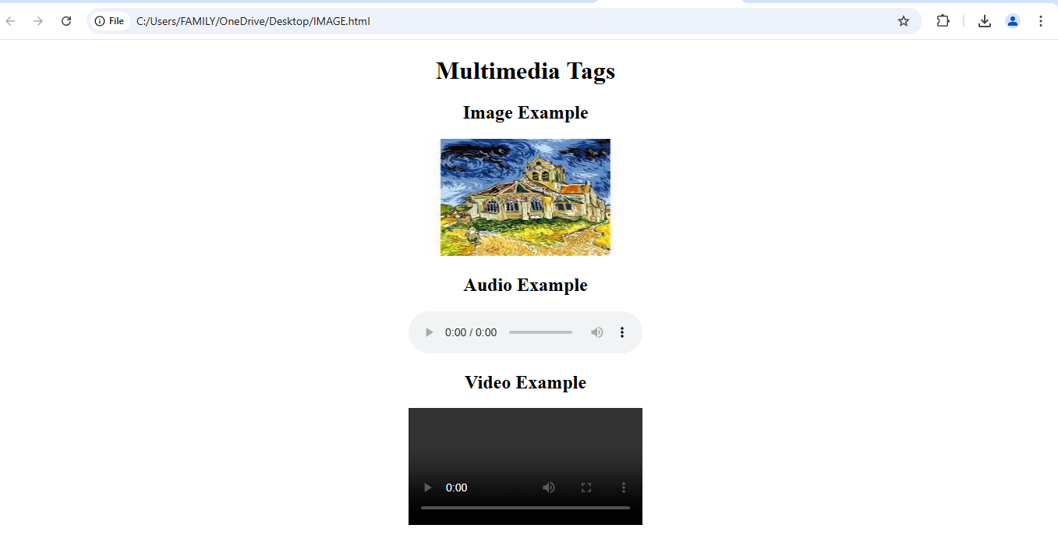

**EXERCISE-13**

**Create a table using Rowspan and Colspan taking example of Student Record.**

<html>

<head>

<title>Student Record</title>

<style>

table {

width: 50%;

border-collapse: collapse;

margin: 20px auto;

}

th, td {

border: 1px solid #000;

padding: 8px;

text-align: center;

}

th {

background-color: #f2f2f2;

}

</style>

</head>

<body>

<table>

<tr>

<th rowspan="2">Student ID</th>

<th rowspan="2">Name</th>

<th colspan="3">Grades</th>

</tr>

<tr>

<th>Math</th>

<th>Science</th>

<th>English</th>

</tr>

<tr>

<td>101</td>

<td>John Doe</td>

<td>85</td>

<td>90</td>

<td>88</td>

</tr>

<tr>

<td>102</td>

<td>Jane Smith</td>

<td>92</td>

<td>95</td>

<td>89</td>

</tr>

</table>

</body>

</html>

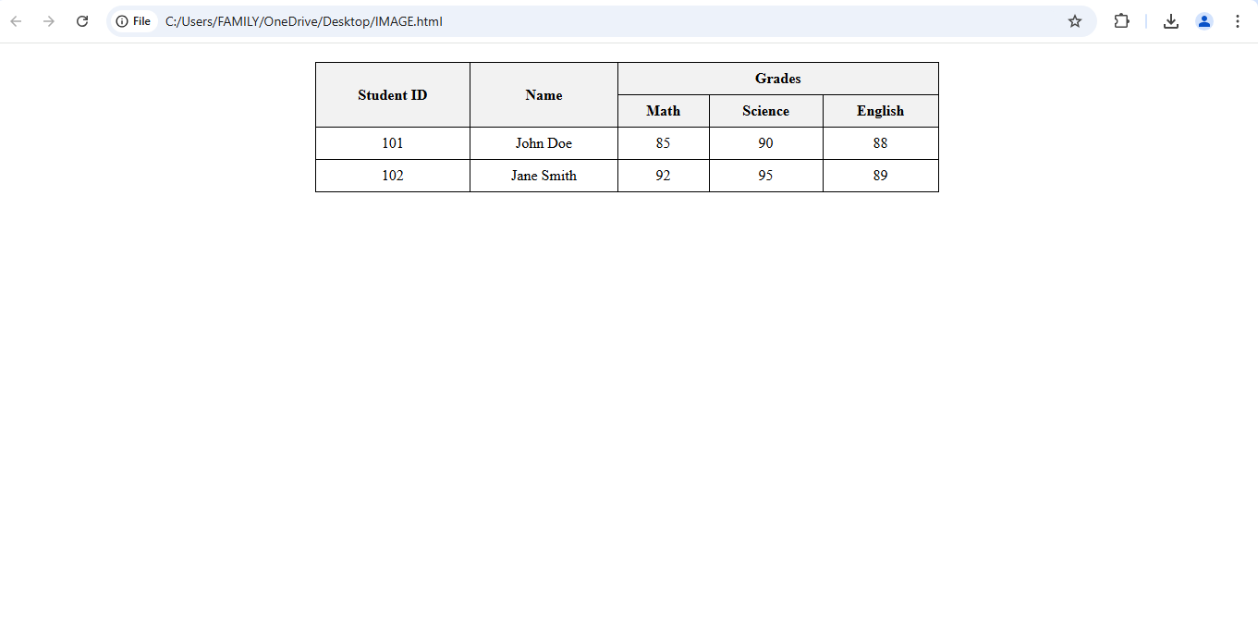

**EXERCISE-14**

**Write HTML code using table tag <table> and cell padding and cell spacing as its attributes.**

<!DOCTYPE html>

<head>

<title>Student Record</title>

<style>

table {

border: 1px solid #000;

margin: 20px auto;

}

th, td {

border: 1px solid #000;

text-align: center;

}

th {

background-color: #f2f2f2;

}

</style>

</head>

<body>

<table cellpadding="10" cellspacing="5">

<tr>

<th>Student ID</th>

<th>Name</th>

<th>Math</th>

<th>Science</th>

<th>English</th>

</tr>

<tr>

<td>101</td>

<td>John Doe</td>

<td>85</td>

<td>90</td>

<td>88</td>

</tr>

<tr>

<td>102</td>

<td>Jane Smith</td>

<td>92</td>

<td>95</td>

<td>89</td>

</tr>

<tr>

<td>103</td>

<td>Sam Brown</td>

<td>78</td>

<td>82</td>

<td>80</td>

</tr>

</table>

</body>

</html>

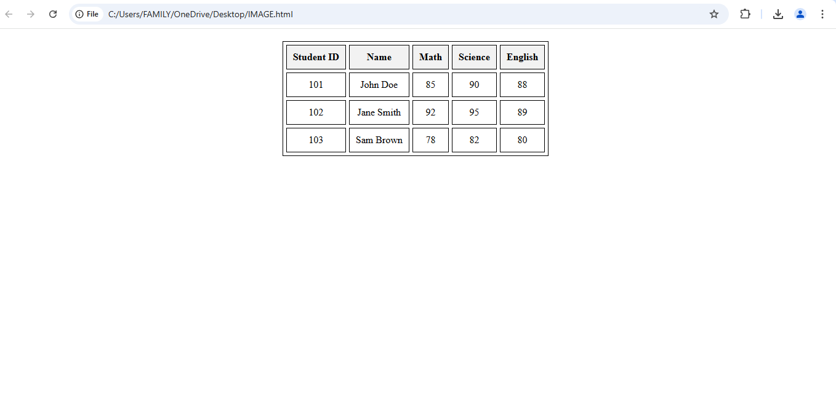

**EXERCISE-15**

**Create unordered, ordered and definition lists taking example of your subjects in MCA 1rst, 2nd and 3rd Semester.** <!DOCTYPE html>

<head>

<title>MCA Subjects</title>

<body>

<h1>MCA Subjects</h1>

<h2>MCA 1st Semester Subjects</h2>

<ul>

<li>Mathematics for Computer Science</li>

<li>Computer Programming</li>

<li>Data Structures</li>

<li>Computer Organization</li>

<li>Operating Systems</li>

</ul>

<h2>MCA 2nd Semester Subjects</h2>

<ol>

<li>Software Engineering</li>

<li>Database Management Systems</li>

<li>Web Technologies</li>

<li>Object-Oriented Programming</li>

<li>Discrete Mathematics</li>

</ol>

<h2>MCA 3rd Semester Subjects</h2>

<dl>

<dt>Advanced Java Programming</dt>

<dd>Study of advanced concepts in Java, including Java EE and frameworks.</dd>

<dt>Mobile Application Development</dt>

<dd>Introduction to developing applications for mobile platforms.</dd>

<dt>Network Security</dt>

<dd>Understanding principles and practices for securing computer networks.</dd>

<dt>Cloud Computing</dt>

<dd>Study of cloud service models and deployment strategies.</dd>

<dt>Machine Learning</dt>

<dd>Introduction to machine learning algorithms and applications.</dd>

</dl>

</body>

</html>

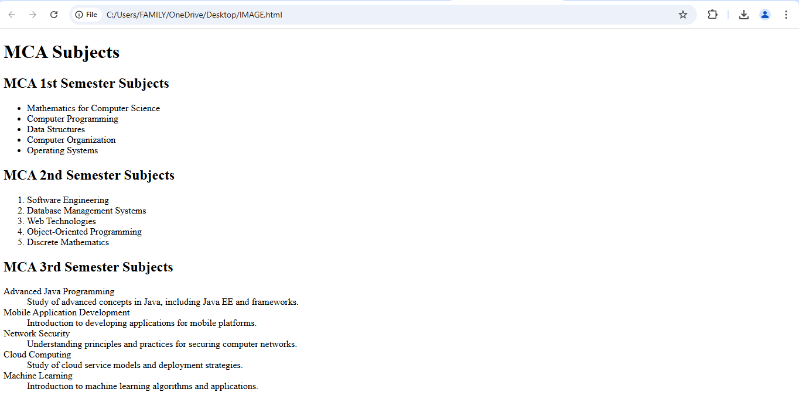

**EXERCISE-17**

**Write HTML code to design a form in HTML using controls and buttons suchas Textbox, Textarea, password, submit button, browse button, Drop-Down menu.**

<!DOCTYPE html>

<html>

<head>

<title>Sample Form</title>

</head>

<body>

<h2 align="center">Registration Form</h2>

<form action="submit_form.php" method="post">

<Text Box for Name>

<label for="Name">Name:</label><br>

<input type="text" id="name" name="name" required><br><br>

<Text Box for Email>

<label for="email">Email:</label><br>

<input type="email" id="email" name="email" required><br><br>

<Password Field>

<label for="password">Password:</label><br>

<input type="password" id="password" name="password" required><br><br>

<Text Area for Address>

<label for="address">Address:</label><br>

<textarea id="address" name="address" rows="4" cols="50"

placeholder="Enter your address here..."></textarea><br><br>

<Drop-Down Menu for Country>

<label for="country">Country:</label><br>

<select id="country" name="country">

<option value="India">India</option>

<option value="canada">Canada</option>

<option value="uk">UK</option>

<option value="australia">Australia</option>

</select><br><br>

<File Upload (Browse Button)>

<label for="resume">Upload Resume:</label><br>

<input type="file" id="resume" name="resume"><br><br>

<Submit Button>

<input type="submit" value="Submit">

</form>

</body>

</html>

**Exercise-18**

**Write a HTML code to design a Registration Form in HTML.**

<!DOCTYPE html>

<html>

<head>

<title></title>

</head>

<body>

<form>

<fieldset><h1 align="center">Registration Form</h1>

Name:

<input type:"text" placeholder="Enter your full name"/><br><br>

Photo:

<input type="file"/><br><br>

Father's Name:

<input type:"text"/><br><br>

Mother's Name:

<input type:"text"/><br><br>

Phone No:

<input type:"int" placeholder="017xxxxxxx"/><br><br>

Email:

<input type="mail" placeholder="sample@example.com"/><br><br>

Gender:

<input type="radio" name="gender"/>Male <input type="radio"

name="gender"/>Female<input type="radio" name="gender"/>Other<br><br>

Date Of Birth:

<input type="date" max length="15/10/2024"/><br><br>

<button>Submit</button>

</fieldset>

</form>

</body>

</html>

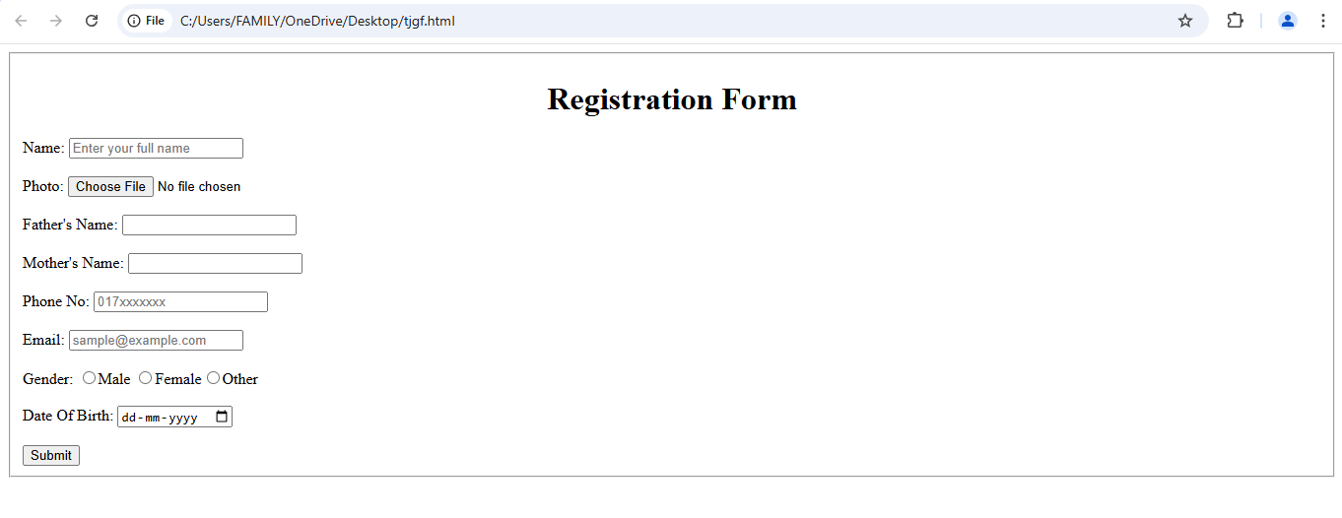

**Exercise-19**

**Create HTML code to design Student Admission Form in HTML.**

<!DOCTYPE html>

<html>

<head>

<title>Student Admission Form</title>

</head>

<body>

<h2 align="center">Student Admission Form</h2>

<form action="submit_admission.php" method="post">

<Full Name>

<label for="fullname">Full Name:</label><br>

<input type="text" id="fullname" name="fullname" required><br><br>

<Date of Birth>

<label for="dob">Date of Birth:</label><br>

<input type="date" id="dob" name="dob" required><br><br>

<Email>

<label for="email">Email:</label><br>

<input type="email" id="email" name="email" required><br><br>

<Contact Number>

<label for="contact">Contact Number:</label><br>

<input type="tel" id="contact" name="contact" required><br><br>

<Gender>

<label>Gender:</label><br>

<input type="radio" id="male" name="gender" value="male">

<label for="male">Male</label><br>

<input type="radio" id="female" name="gender" value="female">

<label for="female">Female</label><br>

<input type="radio" id="other" name="gender" value="other">

<label for="other">Other</label><br><br>

<Address>

<label for="address">Address:</label><br>

<textarea id="address" name="address" rows="4" cols="50"

placeholder="Enter your address here..." required></textarea><br><br>

<Course Selection>

<label for="course">Course Applying For:</label><br>

<select id="course" name="course" required>

<option value="bca">BCA</option>

<option value="bba">BBA</option>

<option value="bcom">B.Com</option>

<option value="ba">BA</option>

<option value="bsc">B.Sc</option>

</select><br><br>

<Educational Qualifications>

<label for="qualification">Educational Qualifications:</label><br>

<textarea id="qualification" name="qualification" rows="3" cols="50"

placeholder="Enter your qualifications..." required></textarea><br><br>

<Terms and Conditions>

<input type="checkbox" id="terms" name="terms" required>

<label for="terms">I agree to the terms and conditions</label><br><br>

<Submit Button>

<input type="submit" value="Submit Admission Form">

</form>

</body>

</html>

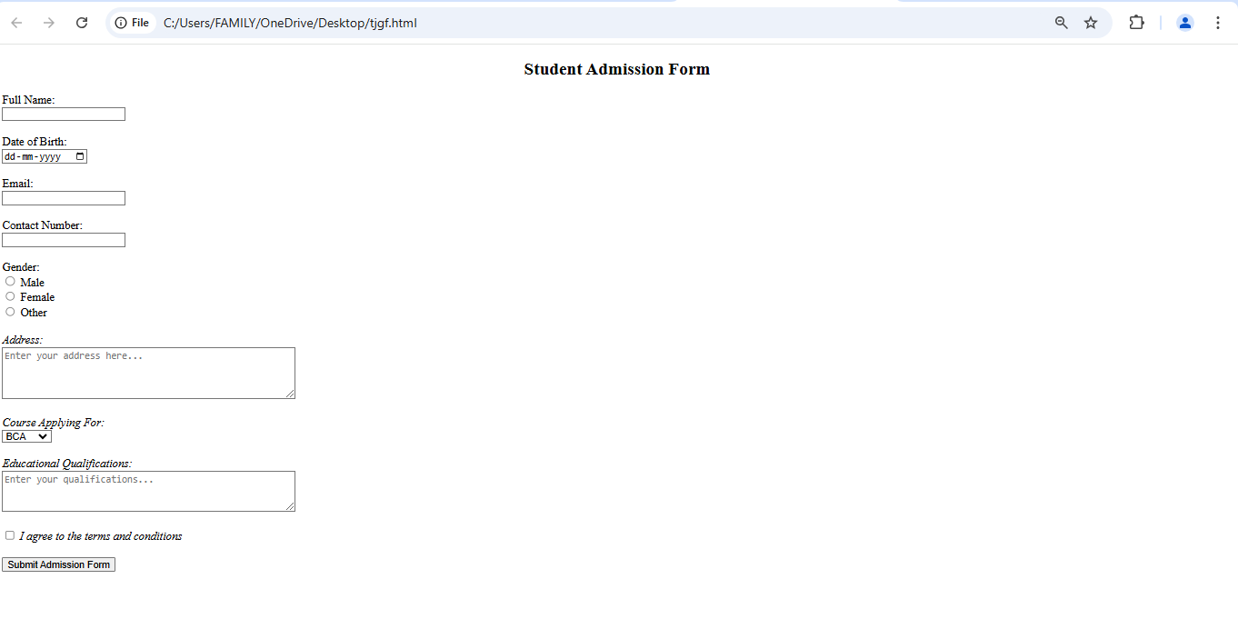

**EXERCISE-20**

Create a proper homepage of your own using any components and style.

<!DOCTYPE html>

<head>

<title>My Personal Homepage</title>

</head>

<body style="font-family: Arial, sans-serif; color: #333;">

<!-- Header Section -->

<header style="background-color: #A52A2A; padding: 20px; text-align: center;

color:White;">

<h1>Welcome to My Homepage</h1>

<p>Everything about me:)</p>

</header>

<!-- Navigation Menu -->

<nav style="margin-top: 10px; text-align: center;">

<a href="#about" style="margin: 0 15px; text-decoration: none; color:

#013220;">About Me</a>

<a href="#portfolio" style="margin: 0 15px; text-decoration: none; color:

#013220;">Portfolio</a>

<a href="#contact" style="margin: 0 15px; text-decoration: none; color:

#013220;">Contact</a>

</nav>

<!-- About Me Section -->

<section id="about" style="padding: 20px; background-color: #f9f9f9;">

<h2>About Me</h2>

<p>Hello! I'm Tanushka.I am currently pursuing BCA from Manav rachna international institute of research and studies.</p>

<p>I am new to this stream and i am so eager to learn coding with so much

interest and passion.</p>

</section>

<!-- Portfolio Section -->

<section id="portfolio" style="padding: 20px;">

<h2>My Portfolio</h2>

<p>Check out some of the projects I’ve worked on:</p>

<ul style="list-style-type: none; padding: 0;">

<li style="margin: 5px 0;">- Project 1: Personal Website</li>

<li style="margin: 5px 0;">- Project 2: Simple Calculator using Kotlin</li>

</ul>

</section>

<!-- Contact Section -->

<section id="contact" style="padding: 20px; background-color: #f9f9f9;">

<h2>Contact Me</h2>

<p>I'd love to connect with you! Reach out via email.</p>

<p>Email: <a href="mailto:your-tanushkasingh092@gmail.com" style="color:

#4CAF50;">tanushkasingh@gmail.com</a></p>

</section>

<!-- Footer -->

<footer style="text-align: center; padding: 10px; background-color: #333; color:

white; margin-top: 20px;">

<p>&copy; 2024 My Personal Homepage. All rights reserved.</p>

</footer>

</body>

</html>

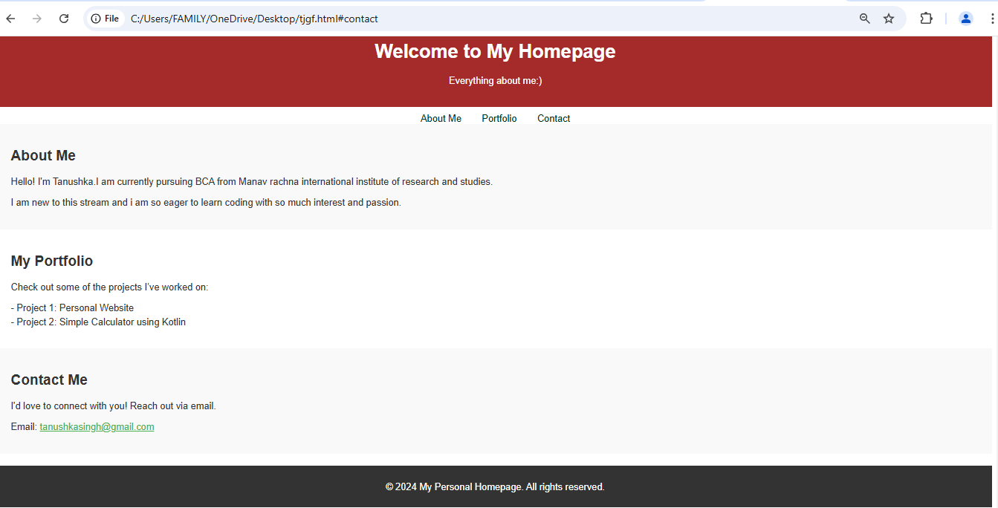

**EXERCISE-21**

**Write HTML code for including local hyperlink in a web page.**

<!DOCTYPE html>

<head>

<title>Local Hyperlink Example</title>

</head>

<body>

<h1>Welcome to My Web Page</h1>

<p>This is a paragraph with a local hyperlink to another page.</p>

<a href="C:\Users\FAMILY\OneDrive\Desktop">Go to Page2</a>

</body>

</html>

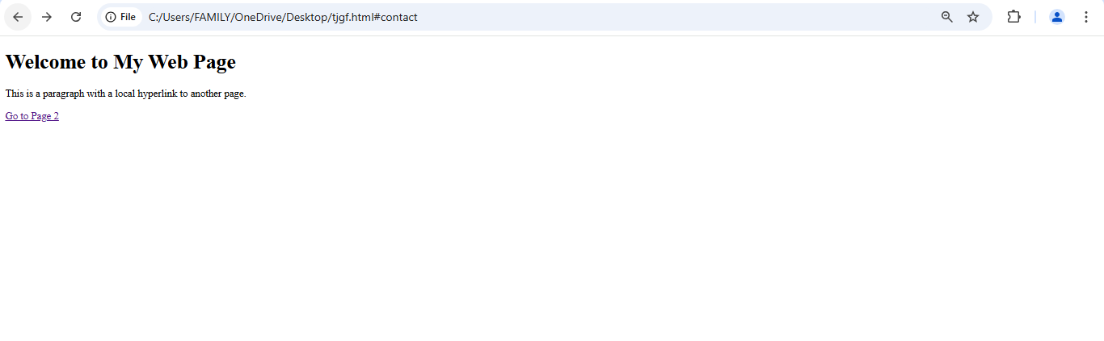

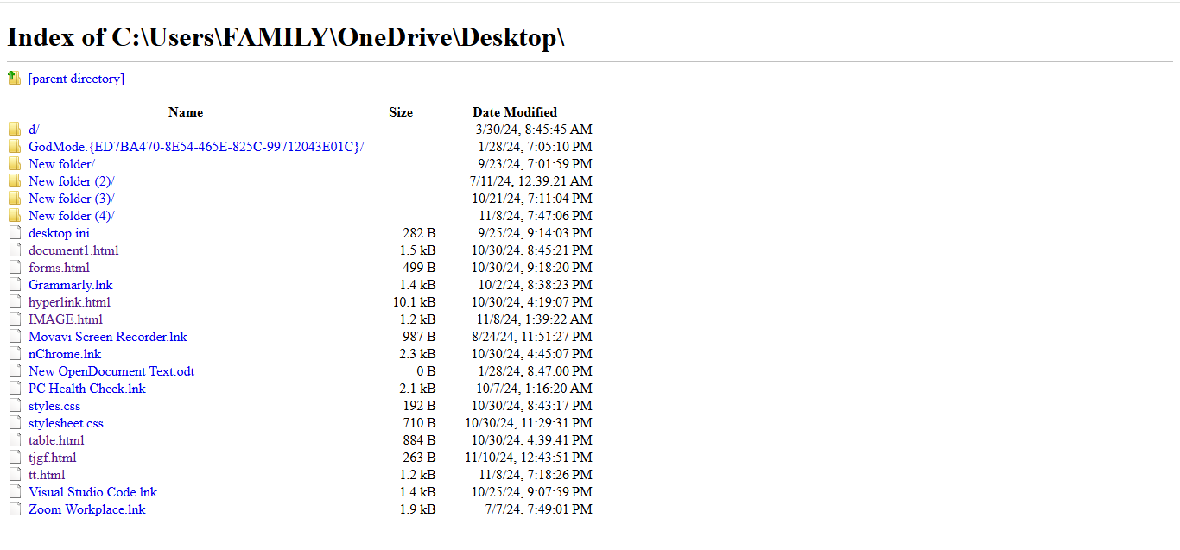

**EXERCISE-22**

**Write HTML code for including inter hyperlink in a web page.**

<!DOCTYPE html>

<html>

<head>

<title>Internal Hyperlink Example</title>

<style>

body {

font-family: Arial, sans-serif;

}

section {

margin: 50px 0;

}

</style>

</head>

<body>

<h1>Internal Hyperlink Example</h1>

<nav>

<ul>

<li><a href="#section1">Go to Section 1</a></li>

<li><a href="#section2">Go to Section 2</a></li>

<li><a href="#section3">Go to Section 3</a></li>

</ul>

</nav>

<section id="section1">

<h2>Section 1</h2>

<p>This is the content of Section 1.</p>

</section>

<section id="section2">

<h2>Section 2</h2>

<p>This is the content of Section 2.</p>

</section>

<section id="section3">

<h2>Section 3</h2>

<p>This is the content of Section 3.</p>

</section>

</body>

</html>

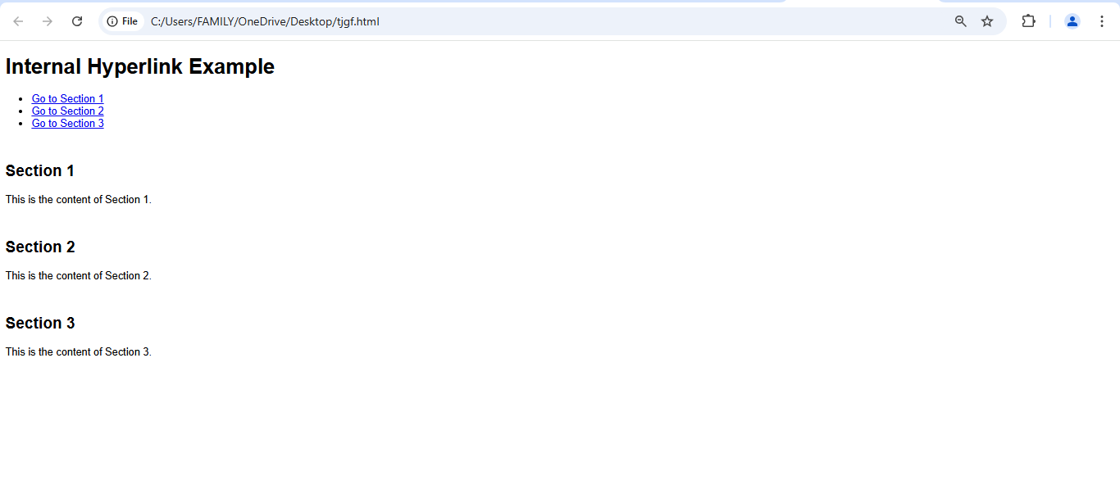

**EXERCISE-23**

**Write HTML code for including External hyperlink in a web page**.

<!DOCTYPE html>

<html lang="en">

<head>

<title>External Hyperlink Example</title>

</head>

<body>

<h1>Visit Open YouTube</h1>

<p>Click the link below to visit Open YouTube:</p>

<a href="https://www.youtube.com/" target="_blank">Open YouTube

Website</a>

</body>

</html>

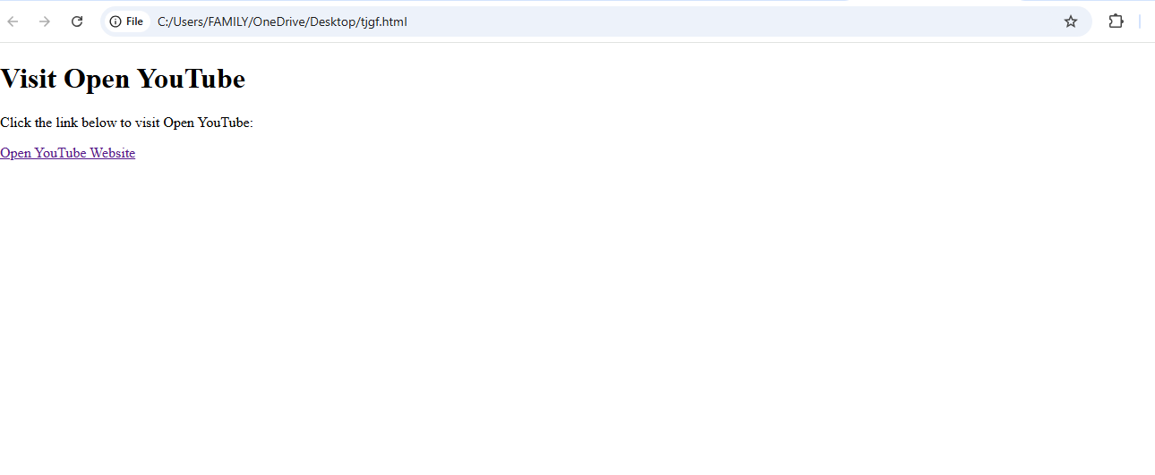

**EXERCISE-24**

**Write code to show external CSS with HTML code.**

<!DOCTYPE html>

<head>

<title>External CSS Example</title>

<link rel="stylesheet" href="styles.css">

</head>

<body>

<h1>Hello! This is Tanushka.</h1>

<p>This is an example of using external CSS.</p>

</body>

</html>

