Assignment No: 4
Student Details
Name: Tanushka Patil
PRN / Roll No: 123B1B036
Class: BTech
Division: A
Subject: DevOps
Title
Create or Migrate an Application to Docker – Containerizing a Node.js Web Application
Aim
To create a simple Node.js web application, run it directly on the host machine, and then migrate it to Docker by writing a Dockerfile, building an image and running the application as a container.
Theory
Why Migrate Applications to Docker?
Traditionally an application is installed directly on a server together with its runtime (Node.js, Python, Java) and libraries. Differences between developer laptops, test servers and production servers then cause the classic “it works on my machine” problem. Docker solves this by packaging the application, its runtime and all dependencies into a portable image that runs identically on any machine with Docker installed.
- Image: a read-only, layered template containing the application and everything it needs to run.
- Container: a running instance of an image, isolated from other processes by Linux namespaces and cgroups.
- Dockerfile: a text file with step-by-step instructions used by docker build to create an image.
- Registry: a store for images, e.g. Docker Hub, from which images are pushed and pulled.
- Layer caching: each Dockerfile instruction creates a layer; unchanged layers are reused, so builds are fast.
Important Dockerfile Instructions
- FROM – base image (here node:20-alpine, a small Linux image with Node.js).
- WORKDIR – working directory inside the image.
- COPY – copies files from the build context into the image.
- RUN – executes a command at build time (npm install).
- ENV / EXPOSE – sets environment variables and documents the listening port.
- USER – runs the container as a non-root user for better security.
- HEALTHCHECK – lets Docker check whether the application is healthy.
- CMD – default command executed when the container starts.
Migration Steps
- Run and test the application on the host (before migration).
- Write a Dockerfile and a .dockerignore file.
- Build the image with docker build.
- Run the container with port mapping and environment variables.
- Test the containerized application and inspect logs, processes and image layers.
- Stop and remove the container.
Code / Implementation
Step 1: Application source code
Assignment4_Docker/
├── package.json
├── server.js
├── public/
│ └── index.html
├── Dockerfile
└── .dockerignore
server.js – Express web server with a REST API
const express = require("express");
const os = require("os");
const app = express();
const PORT = process.env.PORT || 3000;
const APP_ENV = process.env.APP_ENV || "local";
app.use(express.json());
app.use(express.static("public"));
const tasks = [
{ id: 1, title: "Write Dockerfile", done: true },
{ id: 2, title: "Build Docker image", done: true },
{ id: 3, title: "Run container", done: false },
];
app.get("/api/health", (req, res) => {
res.json({ status: "UP", environment: APP_ENV, host: os.hostname() });
});
app.get("/api/tasks", (req, res) => res.json(tasks));
app.post("/api/tasks", (req, res) => {
const task = { id: tasks.length + 1, title: req.body.title, done: false };
tasks.push(task);
res.status(201).json(task);
});
app.listen(PORT, () => {
console.log(`Student Task Tracker running on port ${PORT} (env: ${APP_ENV})`);
});
package.json
{
"name": "student-task-tracker",
"version": "1.0.0",
"description": "Simple task tracker web app used for the Docker migration assignment",
"main": "server.js",
"scripts": {
"start": "node server.js"
},
"dependencies": {
"express": "^4.19.2"
}
}
Step 2: Run the application on the host (before migration)
npm install
node server.js
curl.exe http://localhost:3000/api/health
Step 3: Write the Dockerfile
Dockerfile
# ---- Base image ----
FROM node:20-alpine
# Set working directory inside the container
WORKDIR /usr/src/app
# Install dependencies first (better layer caching)
COPY package*.json ./
RUN npm install --omit=dev
# Copy application source
COPY server.js ./
COPY public ./public
# Runtime configuration
ENV PORT=3000 \
APP_ENV=docker
EXPOSE 3000
# Run as the non-root "node" user
USER node
# Container health check
HEALTHCHECK --interval=30s --timeout=3s \
CMD wget -qO- http://localhost:3000/api/health || exit 1
CMD ["npm", "start"]
.dockerignore – keeps node_modules and Git files out of the image
node_modules
npm-debug.log
.git
Dockerfile
.dockerignore
Step 4: Build, run and test the container
docker build -t student-tasks:1.0 .
docker images student-tasks
docker run -d --rm --name student-tasks -p 8081:3000 student-tasks:1.0
docker ps
curl.exe http://localhost:8081/api/health
curl.exe http://localhost:8081/api/tasks
docker logs student-tasks
docker exec student-tasks sh -c "whoami && node --version"
docker history student-tasks:1.0
docker stop student-tasks
Output
1. Application running directly on the host with Node.js (before migration):
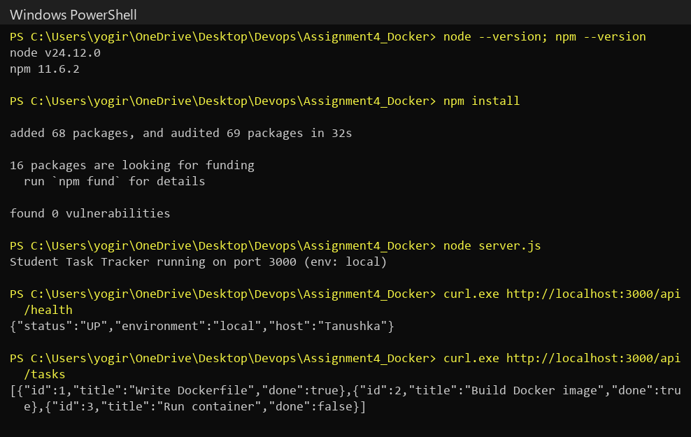
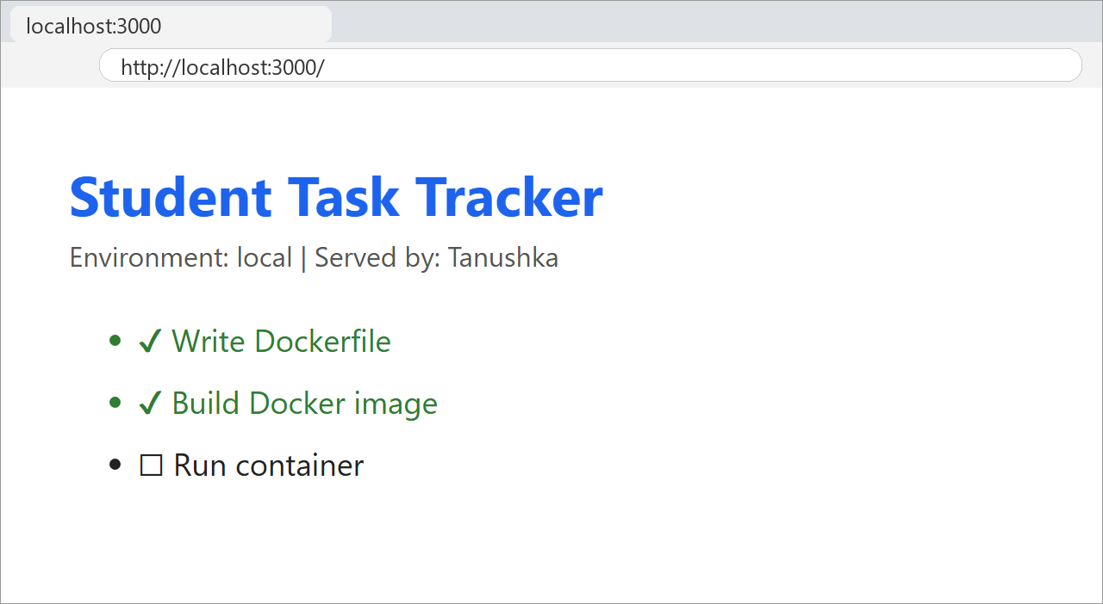
2. Building the Docker image from the Dockerfile:
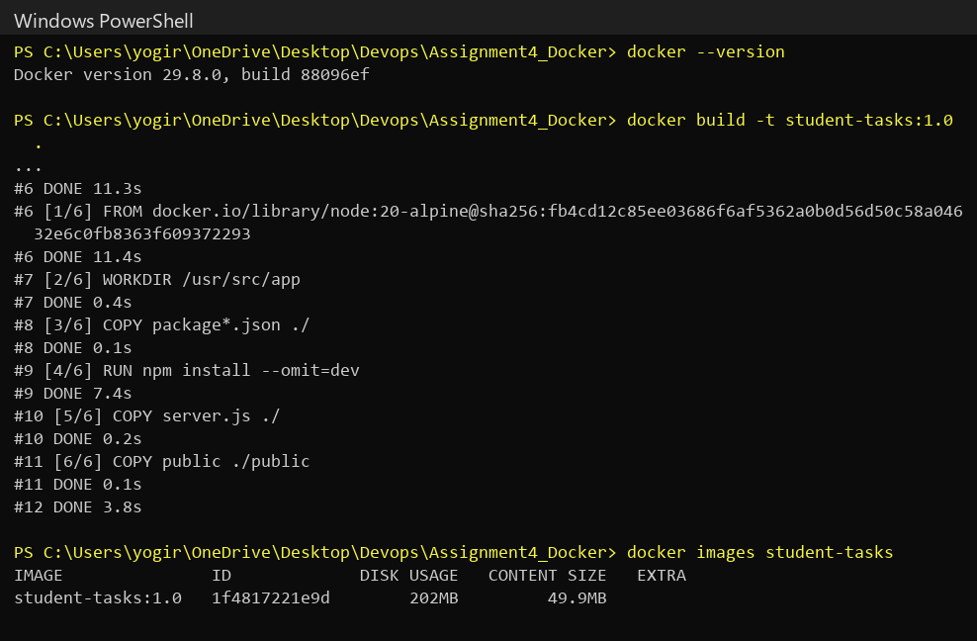
3. Running the container (host port 8081 → container port 3000) and testing the REST API:
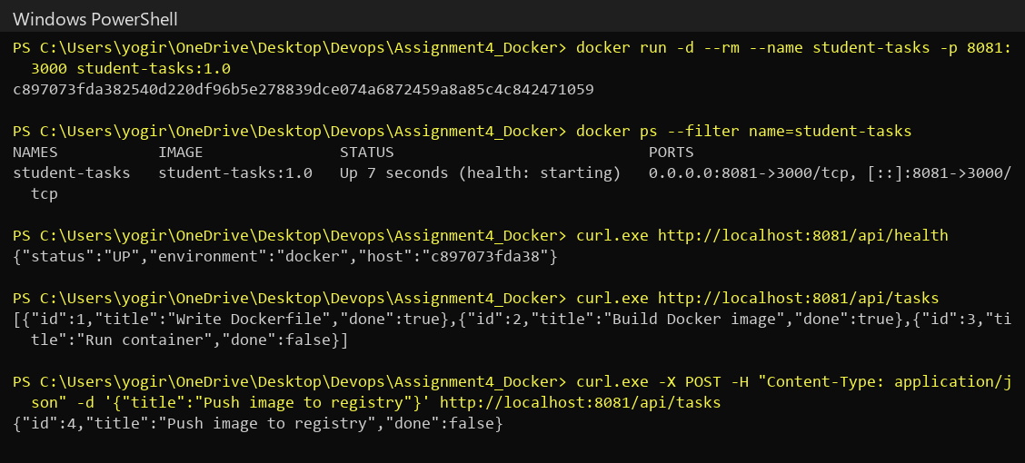
4. The same application now served from the container – note the environment is docker and the host is the container ID:
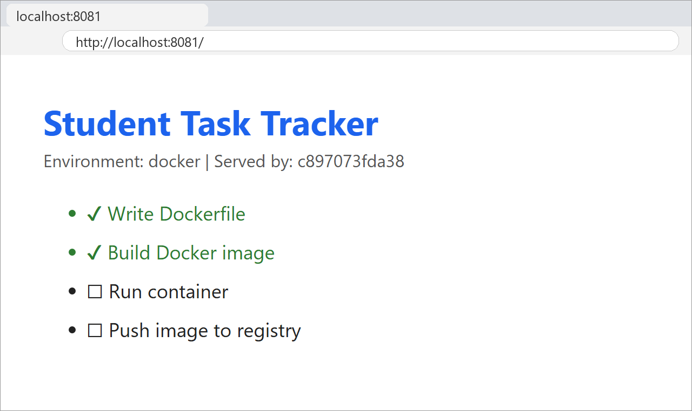
5. Container logs, running as the non-root node user, and health status:
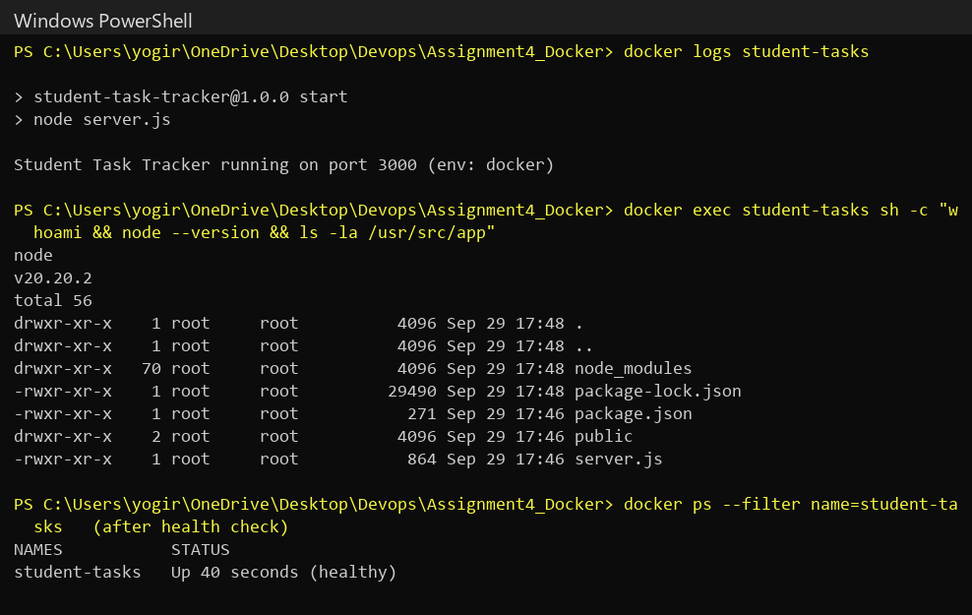
6. Image layers created by the Dockerfile instructions:
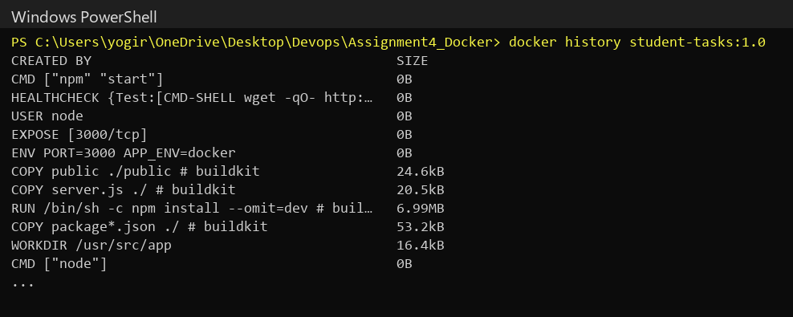
7. Stopping the container (started with --rm, so it is removed automatically):
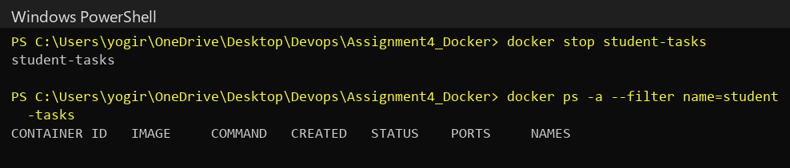
Conclusion
In this assignment, I learned about migrating an application to Docker. I first ran a Node.js web application directly on the host, then wrote a Dockerfile using FROM, WORKDIR, COPY, RUN, ENV, EXPOSE, USER, HEALTHCHECK and CMD, built an image, and ran the same application as a container with port mapping. The containerized app behaved exactly like the original but no longer depends on software installed on the host, which makes it portable and consistent across environments.
References
1. Dockerfile Reference – https://docs.docker.com/reference/dockerfile/
2. Docker Build Overview – https://docs.docker.com/build/concepts/overview/
3. Containerize a Node.js Application – https://docs.docker.com/guides/nodejs/
4. Node.js Official Docker Image – https://hub.docker.com/_/node
5. Express.js Documentation – https://expressjs.com/
Submission Links
GitHub Repository Link: https://github.com/tanushkapatil/DevOps/tree/main/Assignment4_Docker
Hosted / Output Link: http://localhost:8081 (local output – container stopped after testing)

