Assignment No: 6
Student Details
Name: Tanushka Patil
PRN / Roll No: 123B1B036
Class: BTech
Division: A
Subject: DevOps
Title
Integrate Jenkins with a Git Repository and Automate Source Code Retrieval from GitHub
Aim
To configure Jenkins with a GitHub repository and automate the process of pulling source code from the repository for Continuous Integration.
Theory
Objectives
- Understand the role of Jenkins in CI/CD.
- Install and configure the Git plugin in Jenkins.
- Connect Jenkins with a GitHub repository.
- Create a Jenkins job for automatic source code checkout.
- Execute a simple build through Jenkins.
Continuous Integration and Jenkins
Continuous Integration (CI) is the practice of frequently merging code changes into a shared repository, where every change is automatically built and tested. Jenkins is an open-source automation server written in Java that implements CI and Continuous Delivery (CD) pipelines. Its functionality is extended through plugins – the Git and GitHub plugins let Jenkins clone repositories, and the Pipeline plugin allows the build process to be written as code in a Jenkinsfile.
Developer → GitHub Repository → Jenkins → Build / Test → Build Result
- Job / Project: a configured task that Jenkins runs, e.g. a Freestyle project or a Pipeline.
- Source Code Management (SCM): where Jenkins gets the code from – here Git with the GitHub repository URL and branch */main.
- Workspace: the directory on the Jenkins agent where the repository is cloned and the build runs.
- Build step: a command executed after checkout, such as compiling code or running tests.
- Console Output: the complete log of a build, including checkout and build results.
- Jenkinsfile: a declarative pipeline with stages such as Checkout, Build and Test.
Prerequisites
- Jenkins installed and running (run here as a Docker container, image jenkins/jenkins:lts-jdk17).
- Git and Java/JDK (included in the Jenkins image).
- GitHub account and repository: https://github.com/tanushkapatil/DevOps
- Sample application – the Python app from Assignment 5 in the same repository.
Code / Implementation
Step 1: GitHub repository
The public repository https://github.com/tanushkapatil/DevOps contains the sample application (Assignment5_MultiContainer/web/app.py), a README.md and the other assignment folders. Because the repository is public, no credentials are required.
Step 2: Install Jenkins with the Git, GitHub and Pipeline plugins
Jenkins was run as a Docker container. The plugins were installed with jenkins-plugin-cli (equivalent to Manage Jenkins → Plugins → Available Plugins → Install) and Jenkins is bound to 127.0.0.1 so it is reachable only from this machine.
Dockerfile – Jenkins with required plugins
FROM jenkins/jenkins:lts-jdk17
USER root
# Git and Python are needed by the build steps
RUN apt-get update && apt-get install -y --no-install-recommends python3 git && rm -rf /var/lib/apt/lists/*
USER jenkins
# Required plugins: Git, GitHub, Pipeline (+ stage view)
RUN jenkins-plugin-cli --plugins git github workflow-aggregator pipeline-stage-view
# Skip the setup wizard for this local lab instance
ENV JAVA_OPTS="-Djenkins.install.runSetupWizard=false"
COPY init.groovy.d/ /usr/share/jenkins/ref/init.groovy.d/
compose.yaml
services:
jenkins:
build: .
container_name: jenkins
ports:
- "127.0.0.1:8090:8080" # reachable from this machine only
volumes:
- jenkins_home:/var/jenkins_home
volumes:
jenkins_home:
docker compose build
docker compose up -d
# Jenkins UI: http://127.0.0.1:8090
Step 3: Create a Jenkins job
- Open the Jenkins Dashboard → New Item.
- Enter the job name GitHub-Jenkins-Demo.
- Select Freestyle project and click OK.
Step 4: Configure Source Code Management
- Source Code Management → Git.
- Repository URL: https://github.com/tanushkapatil/DevOps.git
- Credentials: none (public repository).
- Branch Specifier: */main
Step 5: Configure the build step
Build Steps → Add build step → Execute shell:
echo "=== Workspace contents ==="
ls -la
echo "=== Latest commits ==="
git log --oneline -3
echo "=== Build: compile Python app ==="
python3 --version
python3 -m py_compile Assignment5_MultiContainer/web/app.py && echo "app.py compiled successfully"
Step 6: Build the job
Click Build Now, then open the build and select Console Output to verify the checkout and build.
Optional: Jenkins Pipeline
A second job, GitHub-Jenkins-Pipeline (type Pipeline), uses the following Jenkinsfile:
Jenkinsfile
pipeline {
agent any
stages {
stage('Checkout') {
steps {
git branch: 'main',
url: 'https://github.com/tanushkapatil/DevOps.git'
}
}
stage('Build') {
steps {
echo 'Building application...'
sh 'python3 -m py_compile Assignment5_MultiContainer/web/app.py'
sh 'ls -la'
}
}
stage('Test') {
steps {
echo 'Running tests...'
sh 'test -f README.md && echo "README found"'
sh 'git log --oneline -3'
}
}
}
}
Output
1. Jenkins container running, with Git, Java and Python available:
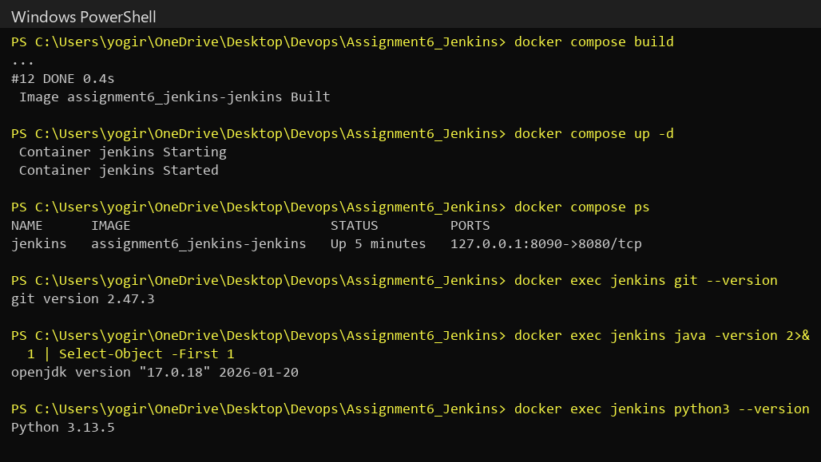
2. Git, GitHub and Pipeline plugins installed and active:
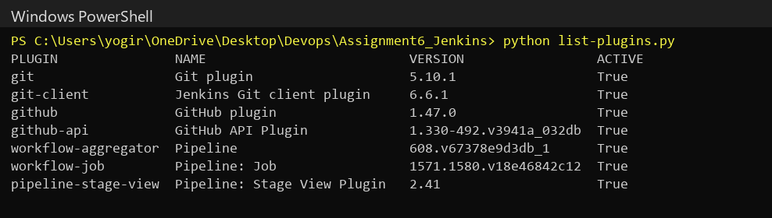
3. Jenkins dashboard showing both jobs with successful builds:
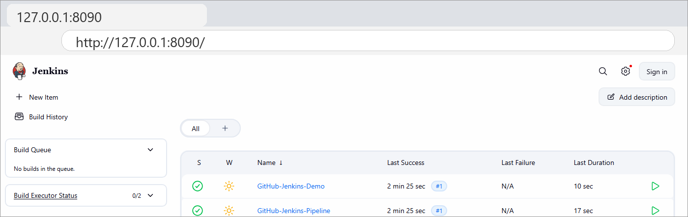
4. Source Code Management configuration of GitHub-Jenkins-Demo (Git, repository URL, branch */main):
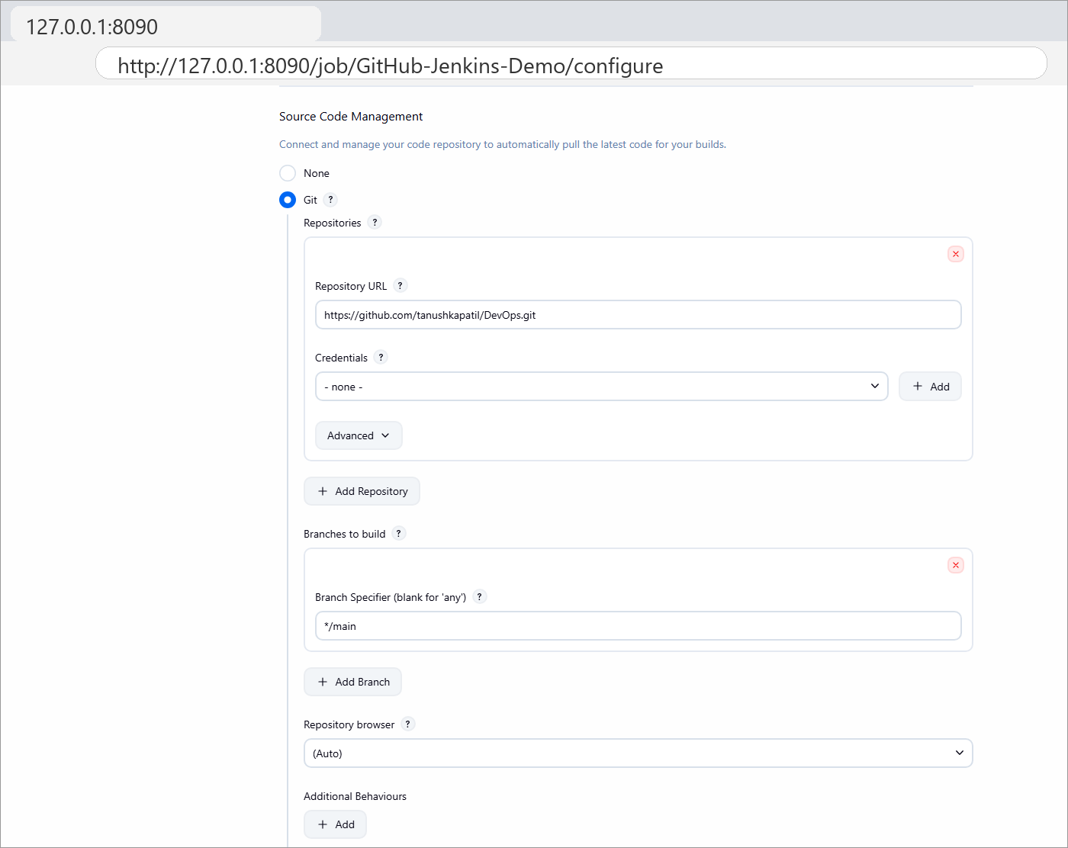
5. Console Output of build #1 – repository cloned from GitHub, latest commit checked out, build step executed, Finished: SUCCESS:
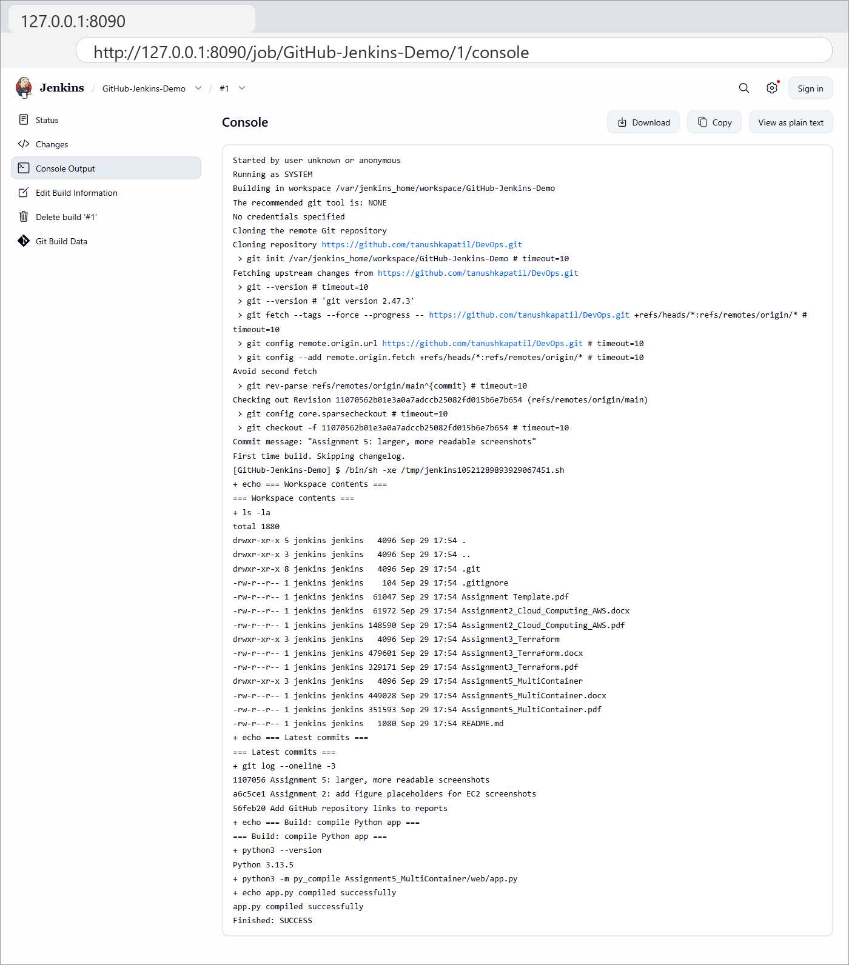
6. Workspace containing the latest source code pulled from GitHub:
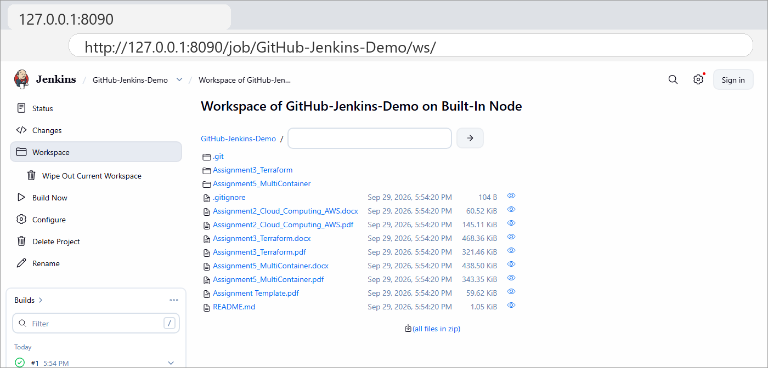
7. Pipeline job – Stage View showing the Checkout, Build and Test stages completed successfully:
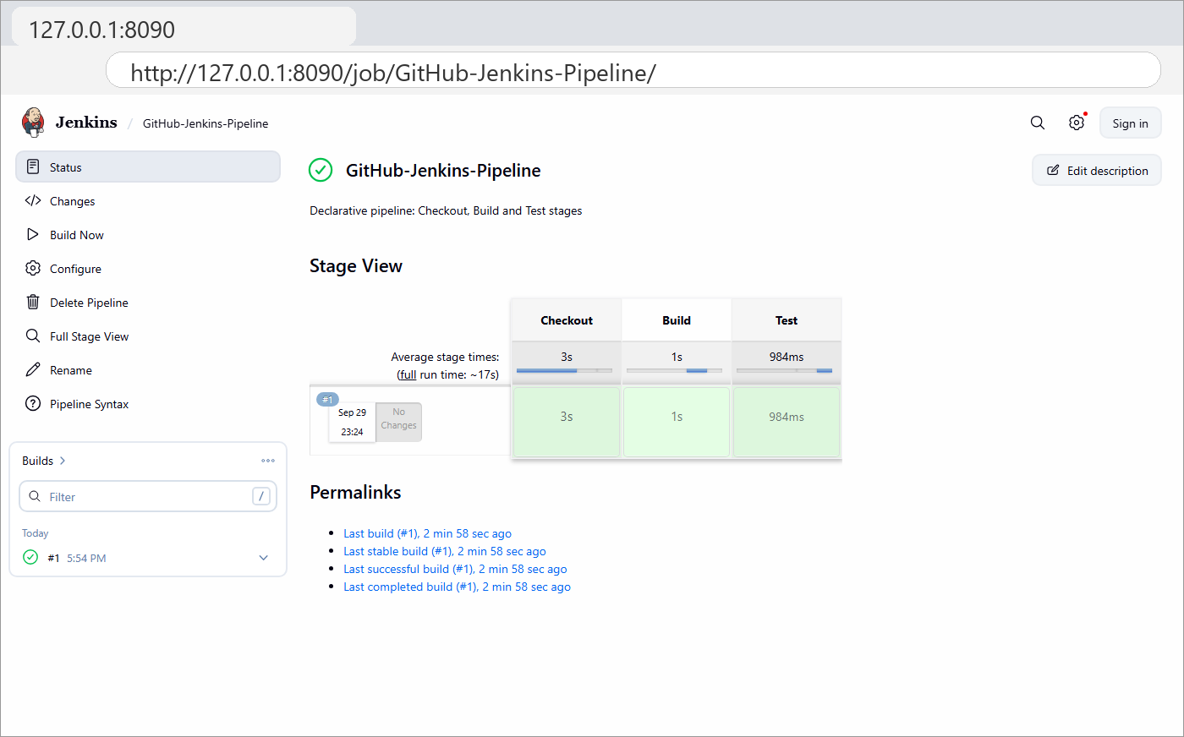
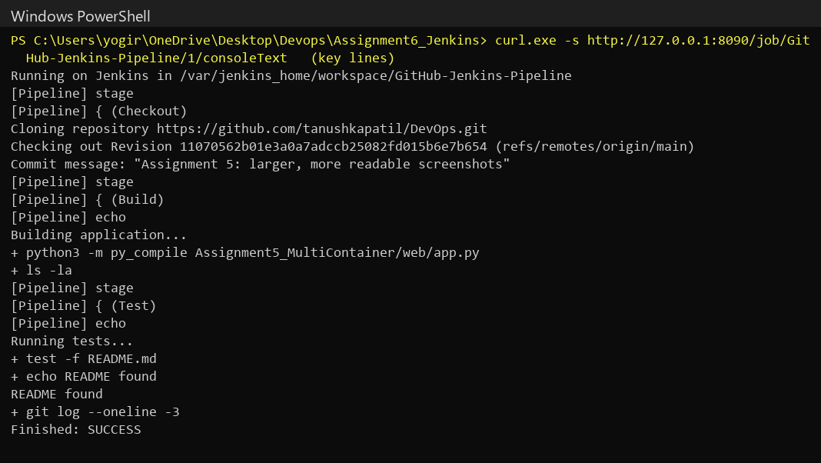
Conclusion
In this assignment, I learned about integrating Jenkins with GitHub for Continuous Integration. I ran Jenkins with the Git, GitHub and Pipeline plugins, created a Freestyle job that checks out the main branch of my GitHub repository and runs a build step, and verified in the console output and workspace that the latest source code was retrieved and built successfully. I also created a declarative pipeline with Checkout, Build and Test stages, which shows how every code change can flow automatically through a CI/CD workflow.
References
1. Jenkins User Documentation – https://www.jenkins.io/doc/
2. Jenkins Git Plugin – https://plugins.jenkins.io/git/
3. Pipeline Syntax – https://www.jenkins.io/doc/book/pipeline/syntax/
4. Jenkins Docker Image – https://github.com/jenkinsci/docker/blob/master/README.md
5. GitHub Repository used – https://github.com/tanushkapatil/DevOps
Submission Links
GitHub Repository Link: https://github.com/tanushkapatil/DevOps/tree/main/Assignment6_Jenkins
Hosted / Output Link: http://127.0.0.1:8090 (local Jenkins instance)

