Assignment No: 7
Student Details
Name: Tanushka Patil
PRN / Roll No: 123B1B036
Class: BTech
Division: A
Subject: DevOps
Title
Explore Kubernetes Container Orchestration and Deploy an Application Using Helm
Aim
To study Kubernetes architecture and understand the structure and commands of Helm for managing Kubernetes applications.
Theory
Objectives
- Understand container orchestration.
- Study Kubernetes architecture.
- Identify Kubernetes control-plane and worker-node components.
- Understand Helm and Helm charts.
- Create a basic Helm chart.
- Perform Helm install, upgrade, template and uninstall operations.
Part A: Kubernetes Architecture
Kubernetes is a container orchestration platform that automates the deployment, scaling, networking, service discovery, load balancing and recovery of containerized applications. A Kubernetes cluster consists of a control plane that makes decisions and worker nodes that run the application containers.
Kubernetes Cluster
+---------------------------+
| Control Plane |
|---------------------------|
| API Server |
| Scheduler |
| Controller Manager |
| etcd |
+-------------+-------------+
|
+---------+---------+
| |
+-------------+ +-------------+
| Worker Node | | Worker Node |
|-------------| |-------------|
| kubelet | | kubelet |
| kube-proxy | | kube-proxy |
| Containers | | Containers |
+-------------+ +-------------+
- API Server: entry point for all Kubernetes API requests (kubectl, Helm).
- etcd: key-value store holding the cluster configuration and state.
- Scheduler: assigns new Pods to suitable worker nodes.
- Controller Manager: runs controllers that keep the actual state equal to the desired state.
- kubelet: agent on each node that starts and monitors Pods and containers.
- kube-proxy: implements Service networking and load balancing on each node.
- Container Runtime: executes the containers (containerd in this cluster).
In this practical a single-node k3s cluster (a lightweight, certified Kubernetes distribution) was used. k3s runs the API server, scheduler, controller manager, kubelet and kube-proxy inside one process and uses containerd as the container runtime; CoreDNS, the metrics server and a local-path storage provisioner run as Pods in the kube-system namespace.
Part B: Helm
Helm is the package manager for Kubernetes. A Helm chart is a reusable package of templated Kubernetes manifests. Installing a chart creates a release; every upgrade creates a new revision that can be listed, inspected and rolled back.
- Chart.yaml: chart metadata – name, description, chart version and appVersion.
- values.yaml: default configuration values (replica count, image, service type) that can be overridden with --set or -f.
- templates/: Kubernetes YAML templates (Deployment, Service, ConfigMap, Ingress…) rendered with the values.
- charts/: dependent sub-charts.
Helm Commands
helm version # check Helm version
helm create myapp # create a chart
helm template myrelease ./myapp # render YAML without deploying
helm install myrelease ./myapp # install chart as a release
helm list # list releases
helm upgrade myrelease ./myapp # upgrade the release
helm status myrelease # view release status
helm history myrelease # view revisions
helm uninstall myrelease # remove the release
Code / Implementation
Step 1: Kubernetes cluster and tools
A single-node k3s cluster was started in Docker, and kubectl and Helm were run from a toolbox container (alpine/k8s) connected to the cluster:
docker run -d --name k3s --privileged -p 127.0.0.1:30080:30080 rancher/k3s:v1.31.4-k3s1 server --disable=traefik
docker run -d --name toolbox --network container:k3s -v <assignment-folder>:/work/a7 alpine/k8s:1.31.4 sleep infinity
Step 2: Create the Helm chart
helm create myapp
Step 3: Customise the chart
Chart.yaml (comments removed)
apiVersion: v2
name: myapp
description: Sample Kubernetes application
type: application
version: 0.1.0
appVersion: "1.0"
values.yaml – changed values
replicaCount: 2
image:
repository: nginx
pullPolicy: IfNotPresent
tag: "1.27-alpine"
service:
type: NodePort
port: 80
# Fixed node port so the app is reachable at http://localhost:30080
nodePort: 30080
# Text shown on the web page (served from a ConfigMap)
page:
message: "Deployed with Helm - DevOps Assignment 7"
templates/configmap.yaml – web page generated from values
apiVersion: v1
kind: ConfigMap
metadata:
name: {{ include "myapp.fullname" . }}-page
labels:
{{- include "myapp.labels" . | nindent 4 }}
data:
index.html: |
<html>
<body style="font-family: Arial; text-align: center; margin-top: 60px;">
<h1>{{ .Values.page.message }}</h1>
<p>Release: {{ .Release.Name }} | Revision: {{ .Release.Revision }} | Replicas: {{ .Values.replicaCount }}</p>
<p>Chart: {{ .Chart.Name }}-{{ .Chart.Version }} | Image: {{ .Values.image.repository }}:{{ .Values.image.tag }}</p>
</body>
</html>
templates/service.yaml was extended to set nodePort when the service type is NodePort, and templates/deployment.yaml mounts the ConfigMap as the nginx web root and adds a checksum annotation so that pods are rolled when the page changes.
Step 4: Validate, render, install, upgrade and uninstall
helm lint ./myapp
helm template myrelease ./myapp -s templates/service.yaml -s templates/configmap.yaml
helm install myrelease ./myapp
helm list
kubectl get pods
kubectl get deployments
kubectl get services
helm upgrade myrelease ./myapp --set replicaCount=3 --set page.message='Upgraded with Helm - DevOps Assignment 7'
helm history myrelease
helm status myrelease
helm uninstall myrelease
Output
1. Kubernetes cluster information, node and kube-system components:
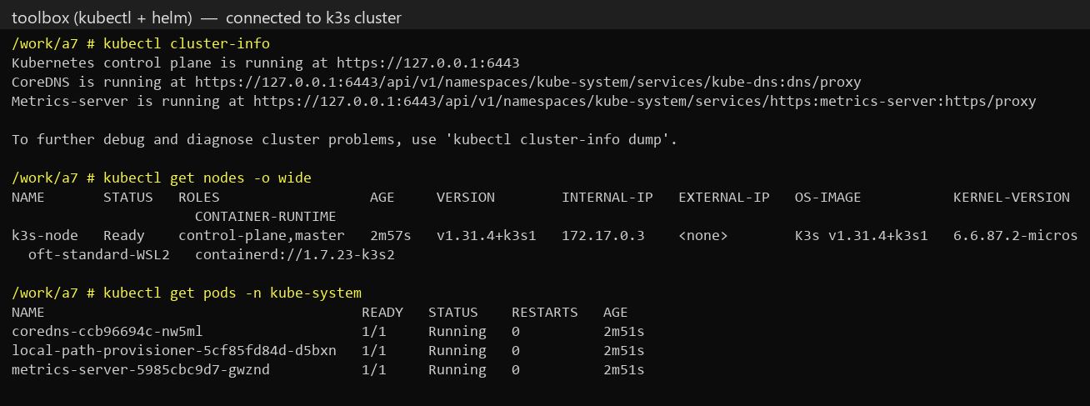
2. Creating the Helm chart and its file structure:
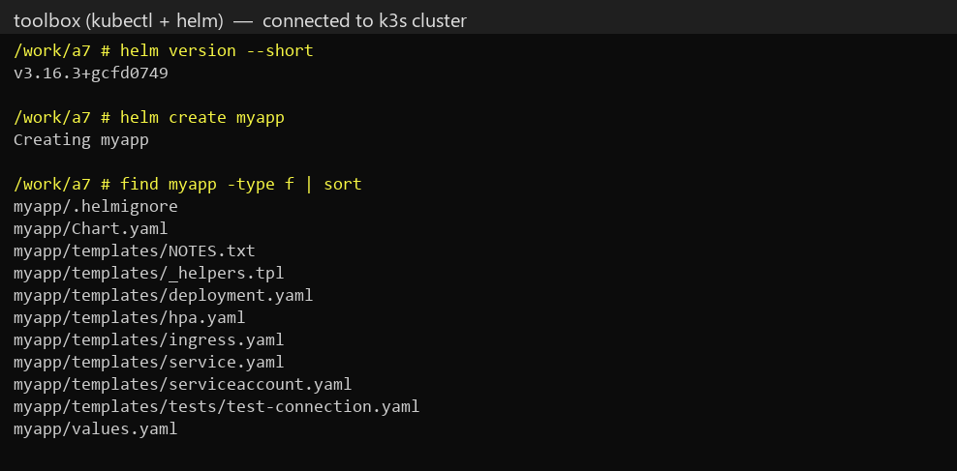
3. Customised Chart.yaml and values.yaml, and helm lint result:
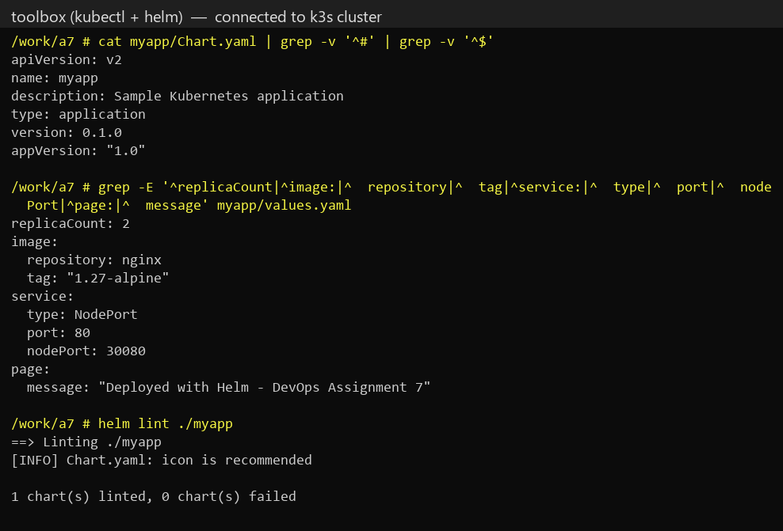
4. helm template – Kubernetes YAML generated without deploying:
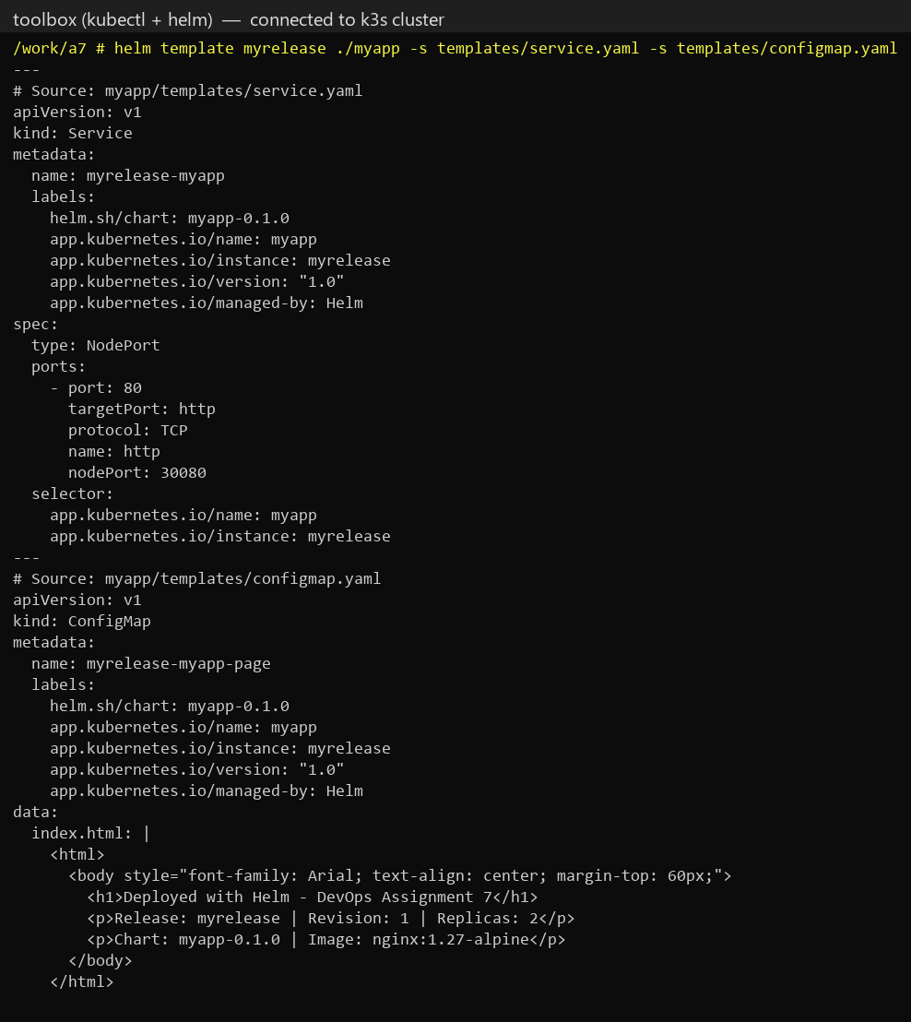
5. helm install and helm list – release myrelease deployed (revision 1):
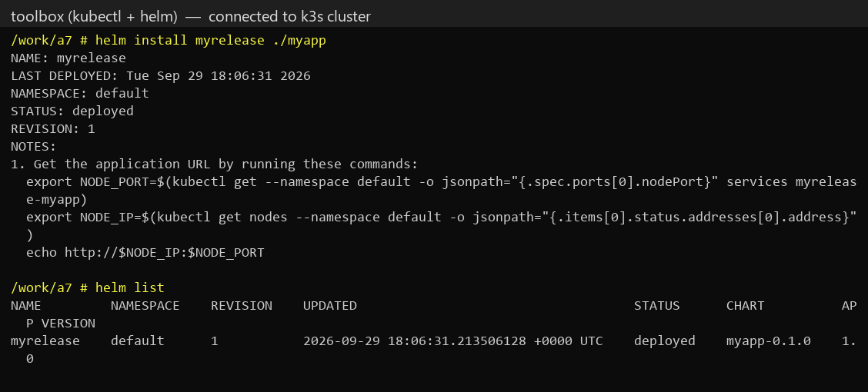
6. Verification with kubectl – 2 Pods, Deployment and NodePort Service, and the page served by the application:
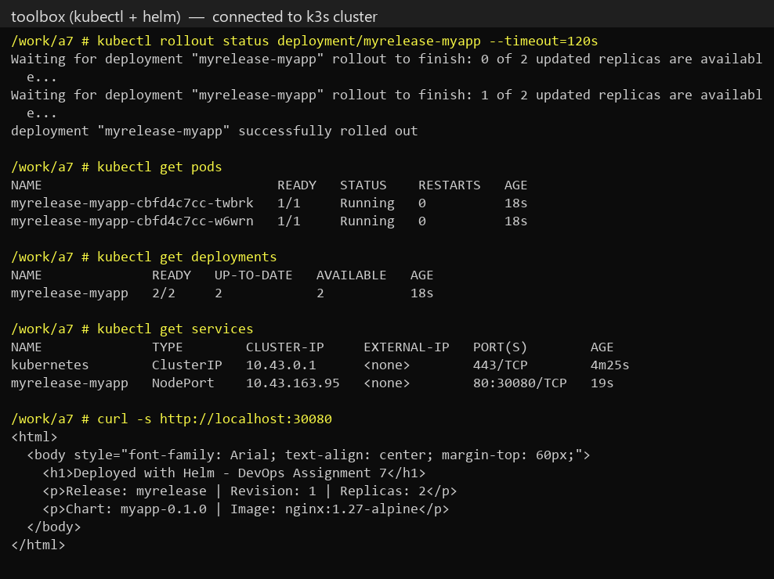
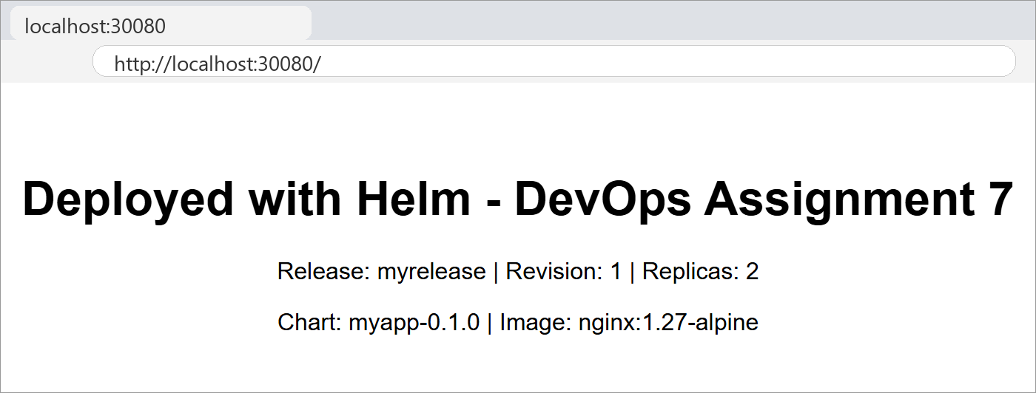
7. helm upgrade – replicas increased to 3 and message changed, rolling update to revision 2:
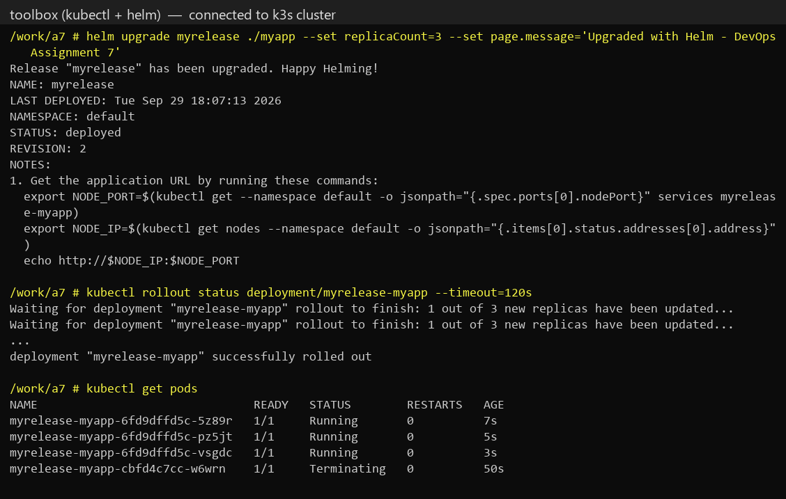
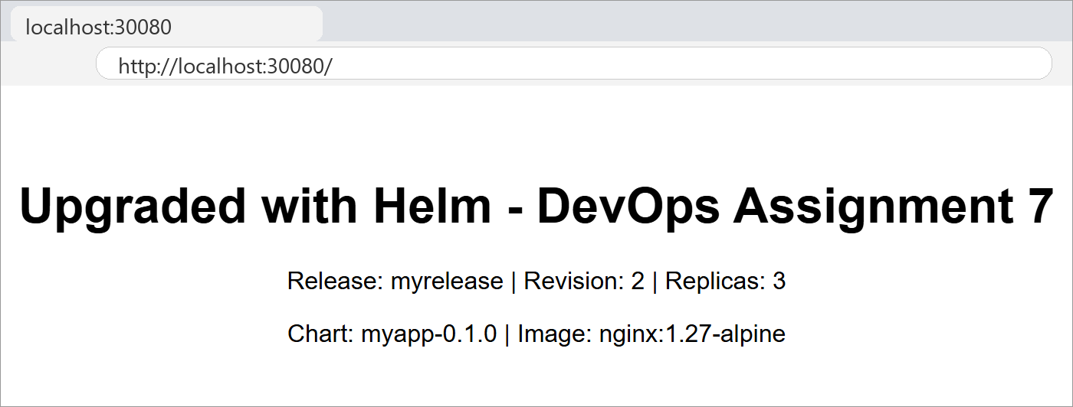
8. helm list, helm history and helm status after the upgrade, and the 3 running Pods:
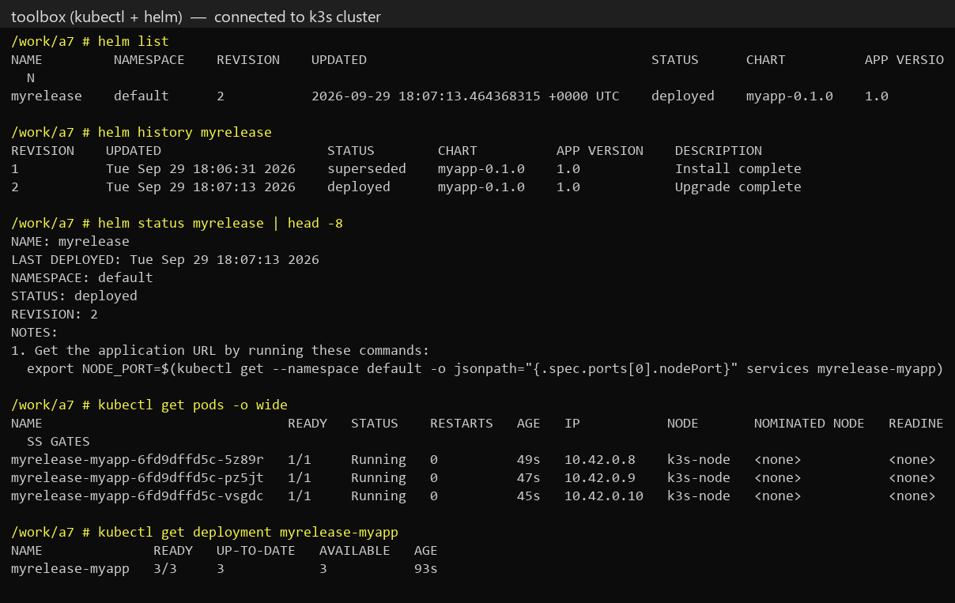
9. helm uninstall – release and all its Kubernetes resources removed:
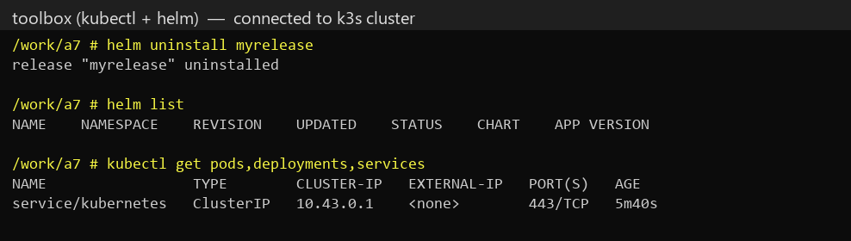
Conclusion
In this assignment, I learned about Kubernetes architecture – the control-plane components (API Server, etcd, Scheduler, Controller Manager) and node components (kubelet, kube-proxy, container runtime) – and about Helm as the package manager for Kubernetes. I created a Helm chart, customised Chart.yaml, values.yaml and the templates, rendered it with helm template, installed it as a release, upgraded it to 3 replicas with a new message (revision 2) through a rolling update, inspected it with helm list, status and history, and finally removed it with helm uninstall.
References
1. Kubernetes Components – https://kubernetes.io/docs/concepts/overview/components/
2. Helm Documentation – https://helm.sh/docs/
3. Helm Chart Template Guide – https://helm.sh/docs/chart_template_guide/
4. K3s Documentation – https://docs.k3s.io/
5. kubectl Reference – https://kubernetes.io/docs/reference/kubectl/
Submission Links
GitHub Repository Link: https://github.com/tanushkapatil/DevOps/tree/main/Assignment7_K8s_Helm
Hosted / Output Link: http://localhost:30080 (local NodePort – release uninstalled after testing)

