Assignment No: 8
Student Details
Name: Tanushka Patil
PRN / Roll No: 123B1B036
Class: BTech
Division: A
Subject: DevOps
Title
Explore Kubernetes Objects and Services and Demonstrate Configuration Management Using Ansible
Aim
To study important Kubernetes objects and networking services and demonstrate the use of Ansible for automated configuration management.
Theory
Part A: Kubernetes Objects
- Pod: the smallest deployable unit; one or more containers sharing network and storage.
- Deployment: manages a set of identical Pod replicas and performs rolling updates.
- Service: gives a stable IP/DNS name and load balancing for a set of Pods selected by labels.
- Namespace: logical separation of resources inside a cluster (e.g. dev, test, prod).
- ConfigMap: stores non-sensitive configuration such as APP_ENV.
- Secret: stores sensitive data (passwords, tokens) base64-encoded; dummy credentials are used in the lab.
- PersistentVolume (PV) / PersistentVolumeClaim (PVC): storage that exists independently of Pod lifecycles; a Pod uses a PVC, which is bound to a PV.
PersistentVolume ←bound→ PersistentVolumeClaim ←mounted by→ Pod
Kubernetes Service Types
- ClusterIP: default type; reachable only inside the cluster, used for internal communication.
- NodePort: exposes the service on a static port (30000–32767) of every node: <Node-IP>:<NodePort>.
- LoadBalancer: exposes the service through an external load balancer (cloud provider, or k3s ServiceLB locally).
- ExternalName: maps a service name to an external DNS name using a CNAME record.
Part B: Ansible – Configuration Management
Ansible is an agentless automation tool. A control node connects to managed nodes over SSH and executes tasks described in YAML playbooks. Modules such as apt, service and copy are idempotent: they only make a change when the system is not already in the desired state.
Ansible Control Node
|
SSH Connection
/ | \
server1 server2 server3
- Inventory: list of managed hosts and groups (inventory.ini).
- Module: unit of work, e.g. ping, apt, service, copy, shell.
- Playbook: YAML file with plays and tasks applied to a group of hosts.
- become: privilege escalation (sudo) for administrative tasks.
Case Study: Automated Installation and Configuration of Nginx
Problem: an organisation needs the same web-server environment on several Linux machines. Manual installation leads to configuration inconsistencies, human errors, longer deployment time and difficult maintenance. Solution: an Ansible playbook installs Nginx, starts it and deploys the same web page on all servers from one control node.
Code / Implementation
Part A – Step 1: Cluster
The same single-node k3s Kubernetes cluster as in Assignment 7 was used, with kubectl run from the toolbox container.
Step 2: Pod and Deployment
k8s/pod.yaml
apiVersion: v1
kind: Pod
metadata:
name: nginx-pod
labels:
app: nginx-pod
spec:
containers:
- name: nginx
image: nginx:1.27-alpine
ports:
- containerPort: 80
k8s/deployment.yaml
apiVersion: apps/v1
kind: Deployment
metadata:
name: nginx-deployment
spec:
replicas: 3
selector:
matchLabels:
app: nginx
template:
metadata:
labels:
app: nginx
spec:
containers:
- name: nginx
image: nginx:1.27-alpine
ports:
- containerPort: 80
kubectl apply -f k8s/pod.yaml
kubectl get pods
kubectl apply -f k8s/deployment.yaml
kubectl get deployments
kubectl expose deployment nginx-deployment --type=NodePort --port=80
Step 3: Namespace, ConfigMap and Secret
kubectl create namespace dev
kubectl get namespaces
kubectl create configmap app-config --from-literal=APP_ENV=production -n dev
kubectl create secret generic db-secret --from-literal=username=admin --from-literal=password=admin123 -n dev # dummy lab credentials
k8s/config-pod.yaml – Pod that consumes the ConfigMap and Secret
# Pod that reads the ConfigMap and Secret as environment variables
apiVersion: v1
kind: Pod
metadata:
name: config-demo
namespace: dev
spec:
containers:
- name: app
image: busybox:1.36
command: ["sh", "-c", "echo APP_ENV=$APP_ENV DB_USER=$DB_USER && sleep 3600"]
env:
- name: APP_ENV
valueFrom:
configMapKeyRef:
name: app-config
key: APP_ENV
- name: DB_USER
valueFrom:
secretKeyRef:
name: db-secret
key: username
Step 4: PersistentVolume and PersistentVolumeClaim
k8s/storage.yaml
# PersistentVolume -> PersistentVolumeClaim -> Pod
apiVersion: v1
kind: PersistentVolume
metadata:
name: demo-pv
spec:
capacity:
storage: 1Gi
accessModes:
- ReadWriteOnce
storageClassName: manual
hostPath:
path: /tmp/demo-pv
---
apiVersion: v1
kind: PersistentVolumeClaim
metadata:
name: demo-pvc
spec:
accessModes:
- ReadWriteOnce
storageClassName: manual
resources:
requests:
storage: 500Mi
---
apiVersion: v1
kind: Pod
metadata:
name: storage-pod
spec:
containers:
- name: app
image: busybox:1.36
command: ["sh", "-c", "echo 'Data stored on a PersistentVolume' > /data/message.txt && sleep 3600"]
volumeMounts:
- name: data
mountPath: /data
volumes:
- name: data
persistentVolumeClaim:
claimName: demo-pvc
Step 5: Service types
k8s/services.yaml – ClusterIP, NodePort, LoadBalancer and ExternalName
# The four Kubernetes Service types, all pointing at the nginx Deployment
apiVersion: v1
kind: Service
metadata:
name: nginx-clusterip
spec:
type: ClusterIP
selector:
app: nginx
ports:
- port: 80
targetPort: 80
---
apiVersion: v1
kind: Service
metadata:
name: nginx-nodeport
spec:
type: NodePort
selector:
app: nginx
ports:
- port: 80
targetPort: 80
nodePort: 30081
---
apiVersion: v1
kind: Service
metadata:
name: nginx-loadbalancer
spec:
type: LoadBalancer
selector:
app: nginx
ports:
- port: 8088
targetPort: 80
---
apiVersion: v1
kind: Service
metadata:
name: external-service
spec:
type: ExternalName
externalName: example.com
Part B – Step 6: Ansible lab environment
Three Ubuntu 24.04 containers with SSH were used as managed web servers, and a separate container with ansible-core as the control node, all on one Docker network. The control node authenticates with an SSH key; the ansible user has passwordless sudo.
ansible/compose.yaml
# Lab environment: 1 Ansible control node + 3 Ubuntu web servers
services:
control:
build: { context: ., dockerfile: Dockerfile.control }
container_name: ansible-control
volumes:
- ./:/ansible
networks: [lab]
server1:
build: { context: ., dockerfile: Dockerfile.node }
container_name: server1
hostname: server1
ports: ["127.0.0.1:8181:80"]
networks: [lab]
server2:
build: { context: ., dockerfile: Dockerfile.node }
container_name: server2
hostname: server2
networks: [lab]
server3:
build: { context: ., dockerfile: Dockerfile.node }
container_name: server3
hostname: server3
networks: [lab]
networks:
lab:
ansible/inventory.ini
[webservers]
server1
server2
server3
[webservers:vars]
ansible_user=ansible
ansible_ssh_private_key_file=/root/.ssh/ansible_lab_key
ansible_python_interpreter=/usr/bin/python3
ansible/install-nginx.yml – playbook
---
- name: Configure Web Servers
hosts: webservers
become: yes
tasks:
- name: Install Nginx
apt:
name: nginx
state: present
update_cache: yes
- name: Start Nginx
service:
name: nginx
state: started
enabled: yes
- name: Deploy Web Page
copy:
content: |
<h1>Web Server Configured Using Ansible</h1>
<p>Host: {{ inventory_hostname }}</p>
dest: /var/www/html/index.html
Step 7: Run Ansible
ansible all -i inventory.ini -m ping
ansible-playbook -i inventory.ini install-nginx.yml
curl http://server1
ansible-playbook -i inventory.ini install-nginx.yml # second run – idempotency
Output
Part A: Kubernetes Objects and Services
1. Pod created and running:
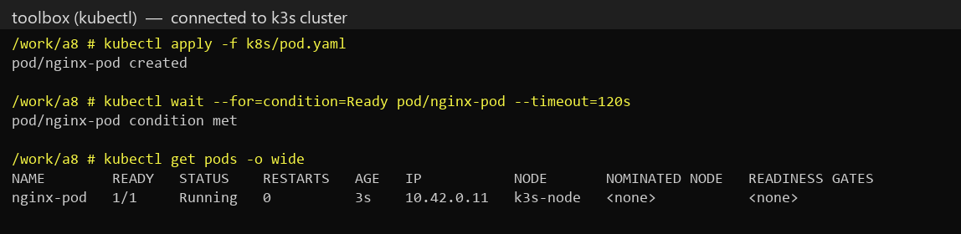
2. Deployment with 3 replicas, and exposed as a NodePort Service:
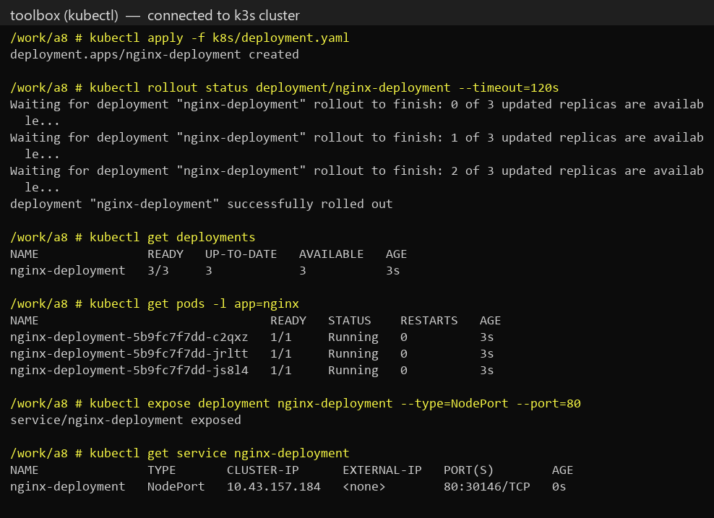
3. Namespace, ConfigMap and Secret created, and consumed by a Pod as environment variables:
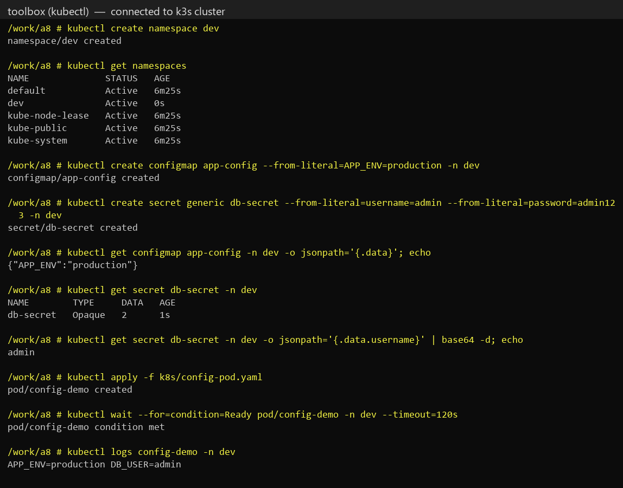
4. PersistentVolume and PersistentVolumeClaim bound, and data written by the Pod to the volume:
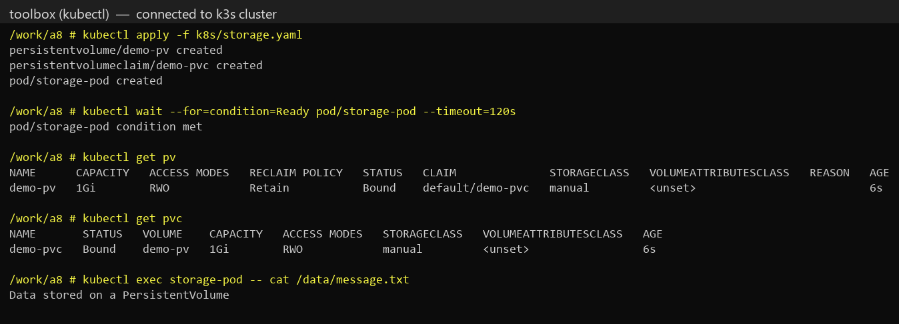
5. All four Service types created (the LoadBalancer received an external IP from k3s ServiceLB):
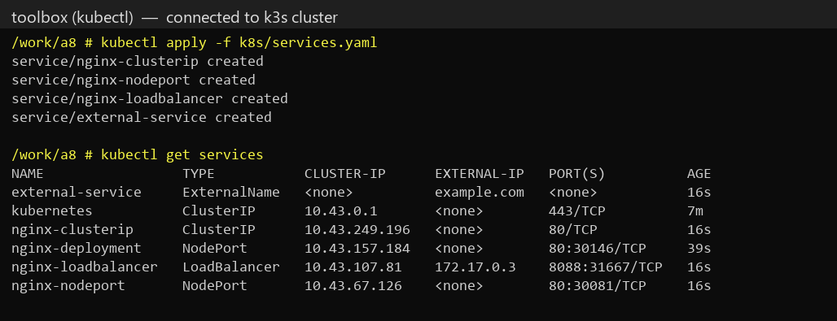
6. Testing each Service type – ClusterIP from inside the cluster, NodePort, LoadBalancer, and ExternalName DNS resolving to example.com:
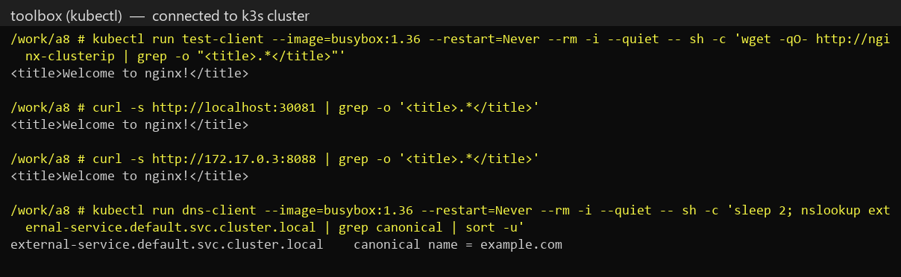
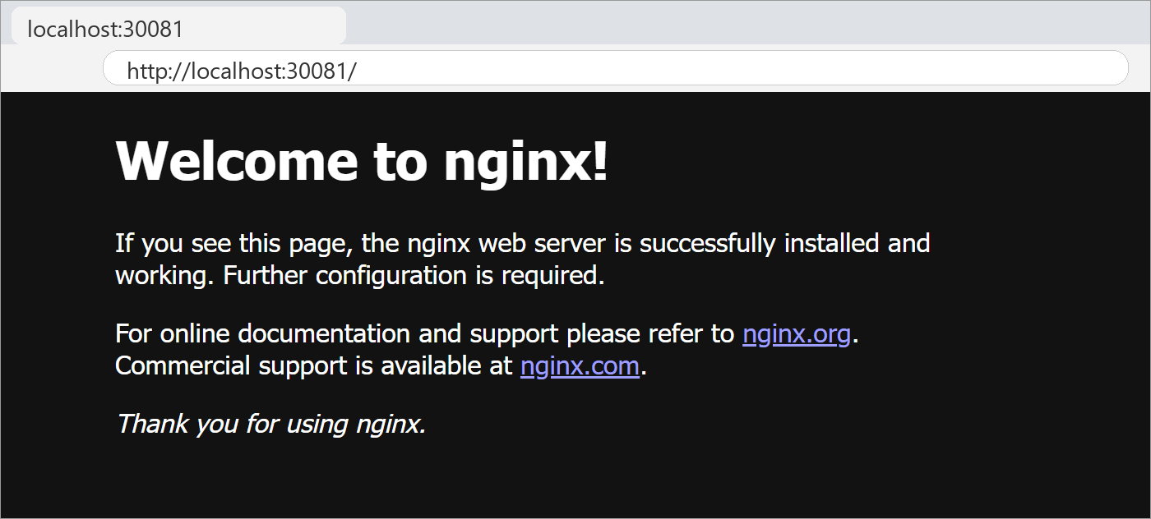
Part B: Ansible Case Study
7. Lab environment – control node and three web servers running:
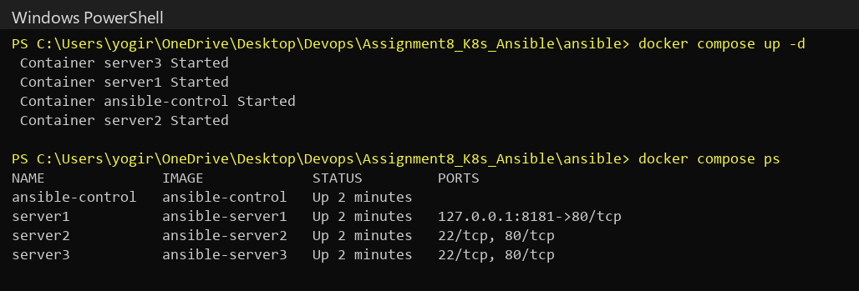
8. Inventory and connectivity test – all servers reply pong:
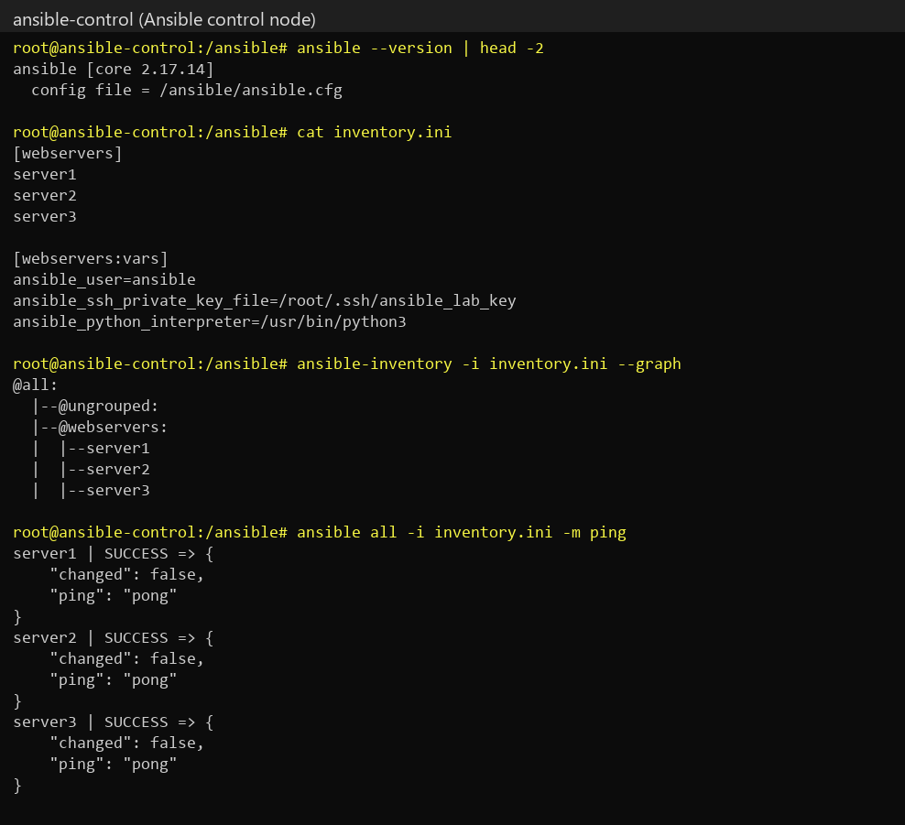
9. Playbook run – Nginx installed, started and web page deployed on all three servers (changed=3):
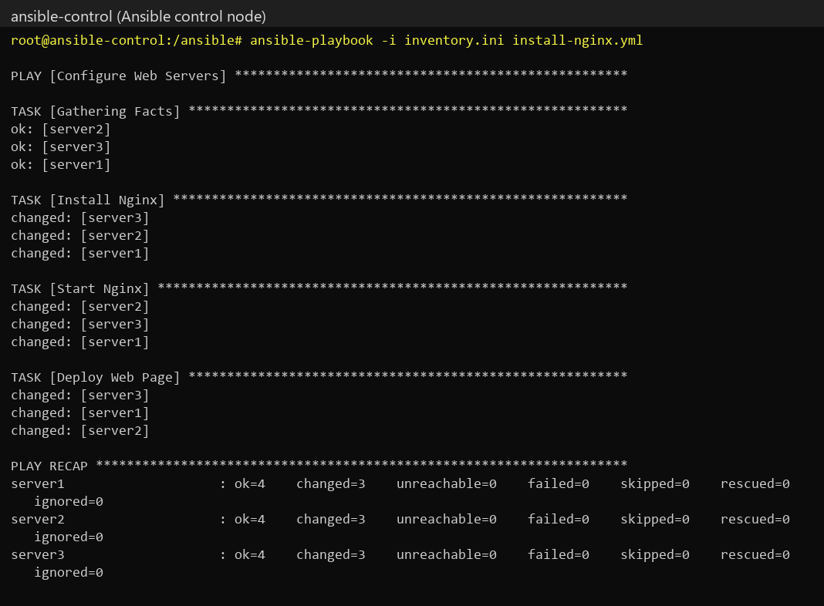
10. Verification – every server returns the page, and Nginx is running:
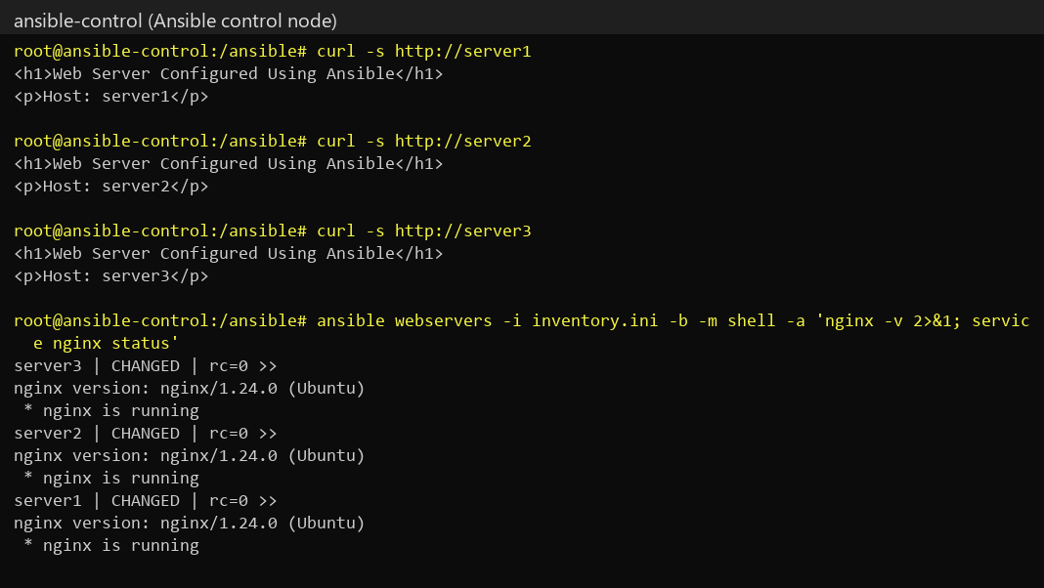
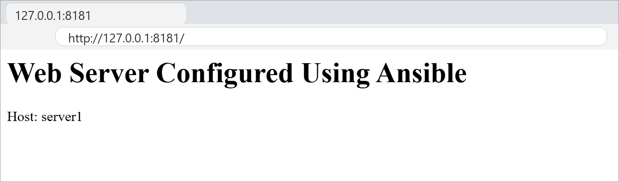
11. Second playbook run – changed=0 on every server, demonstrating idempotent configuration:
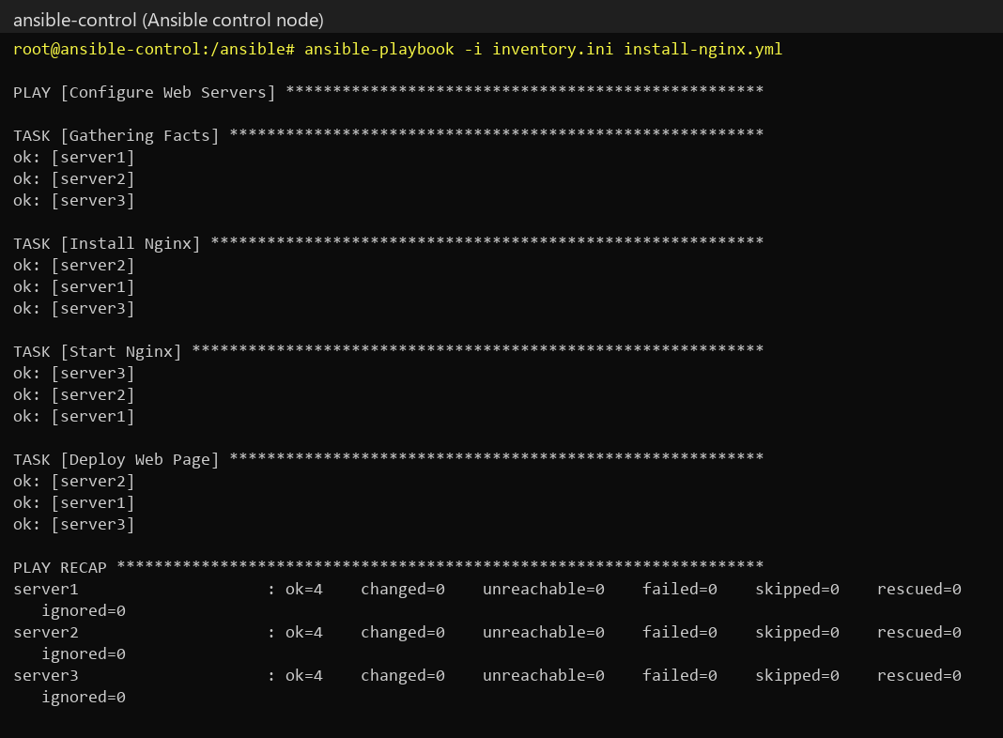
Combined DevOps Workflow
Developer → GitHub → Jenkins → Build / Test → Containerized Application (Docker)
→ Kubernetes → Helm Deployment → Application Services → Ansible Infrastructure Configuration
Conclusion
In this assignment, I learned about the main Kubernetes objects – Pod, Deployment, Service, Namespace, ConfigMap, Secret, PersistentVolume and PersistentVolumeClaim – and the differences between ClusterIP, NodePort, LoadBalancer and ExternalName services, all of which I created and tested on a real cluster. In the Ansible case study I automated the installation and configuration of Nginx on three servers from a single control node using an inventory and a playbook; the second run changed nothing, which demonstrated idempotent, repeatable, agentless configuration management.
References
1. Kubernetes Workloads – https://kubernetes.io/docs/concepts/workloads/
2. Kubernetes Services – https://kubernetes.io/docs/concepts/services-networking/service/
3. Kubernetes Persistent Volumes – https://kubernetes.io/docs/concepts/storage/persistent-volumes/
4. ConfigMaps and Secrets – https://kubernetes.io/docs/concepts/configuration/
5. Ansible Documentation – https://docs.ansible.com/
6. Ansible Playbook Guide – https://docs.ansible.com/ansible/latest/playbook_guide/
Submission Links
GitHub Repository Link: https://github.com/tanushkapatil/DevOps/tree/main/Assignment8_K8s_Ansible
Hosted / Output Link: http://127.0.0.1:8181 (local – lab removed after testing)

