Assignment No: 5
Student Details
Name: Tanushka Patil
PRN / Roll No: 123B1B036
Class: BTech
Division: A
Subject: DevOps
Title
Multi-Container Application using Docker Compose (Flask Web App + Redis)
Aim
To explore and create a multi-container application consisting of a simple web application and a database service, and configure services, ports, environment variables, volumes and networking using a compose.yaml file.
Theory
Containers and Multi-Container Applications
A container packages an application together with its libraries and dependencies so it runs the same way on any machine. Real applications usually consist of several components – a web front end, an API, a database, a cache – and best practice is to run each component in its own container. Such a set of cooperating containers is called a multi-container application.
Docker Compose
Docker Compose is a tool for defining and running multi-container applications. All services are described in a single YAML file (compose.yaml), and the whole stack is started or stopped with one command.
- services: each container in the application (image or build context, command, restart policy).
- ports: maps a host port to a container port (HOST:CONTAINER), e.g. "8000:5000".
- environment: passes configuration values such as hostnames, credentials or app settings to a container.
- volumes: persistent storage that survives container removal; named volumes are managed by Docker.
- networks: user-defined networks; containers on the same network reach each other by service name through Docker's built-in DNS.
- depends_on: controls start-up order between services.
- build: builds an image from a Dockerfile instead of pulling one.
Application Architecture
The application has two services on a shared bridge network (app_net): a Python Flask web service (flask_web) that listens on port 5000 inside the container and is published on host port 8000, and a Redis database service (redis_db) that stores a visit counter. Redis data is persisted in the named volume redis_data, so the count survives restarts.
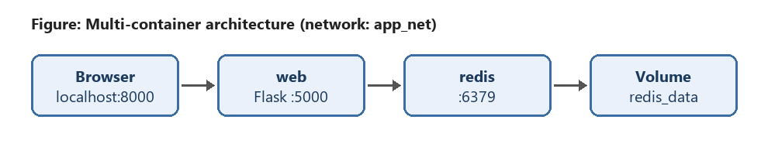
Code / Implementation
Step 1: Prerequisites
docker --version
docker compose version
Step 2: Project structure
Assignment5_MultiContainer/
├── compose.yaml
└── web/
├── app.py
├── requirements.txt
└── Dockerfile
web/app.py – Flask web application
import os
from flask import Flask
import redis
app = Flask(__name__)
cache = redis.Redis(host=os.environ.get("REDIS_HOST", "redis"),
port=int(os.environ.get("REDIS_PORT", 6379)))
@app.route("/")
def index():
visits = cache.incr("visits")
name = os.environ.get("APP_NAME", "Multi-Container App")
return f"<h1>{name}</h1><p>This page has been visited {visits} times.</p>"
if __name__ == "__main__":
app.run(host="0.0.0.0", port=5000)
web/requirements.txt
flask==3.0.3
redis==5.0.8
web/Dockerfile
FROM python:3.12-slim
WORKDIR /app
COPY requirements.txt .
RUN pip install --no-cache-dir -r requirements.txt
COPY app.py .
EXPOSE 5000
CMD ["python", "app.py"]
compose.yaml – Services, ports, environment, volumes and networks
services:
web:
build: ./web
container_name: flask_web
ports:
- "8000:5000"
environment:
- APP_NAME=DevOps Multi-Container Demo
- REDIS_HOST=redis
- REDIS_PORT=6379
depends_on:
- redis
networks:
- app_net
restart: unless-stopped
redis:
image: redis:7-alpine
container_name: redis_db
command: ["redis-server", "--appendonly", "yes"]
volumes:
- redis_data:/data
networks:
- app_net
restart: unless-stopped
volumes:
redis_data:
networks:
app_net:
driver: bridge
Step 3: Build and run the application
cd Assignment5_MultiContainer
docker compose up -d --build
docker compose ps
docker compose logs web
Step 4: Verify networking, volumes and environment variables
# Web app response (open http://localhost:8000 in a browser too)
curl http://localhost:8000
# Networks and volumes created by Compose
docker network ls
docker network inspect assignment5_multicontainer_app_net
docker volume ls
# Environment variables inside the web container
docker compose exec web env | findstr "APP_NAME REDIS"
# Query the database directly
docker compose exec redis redis-cli GET visits
Step 5: Test data persistence and clean up
docker compose down # removes containers and network, keeps volume
docker compose up -d # counter continues from previous value
docker compose down -v # removes containers, network AND volume
Output
1. Building the web image and starting both containers with docker compose up (Compose creates the network, the volume and the two containers):
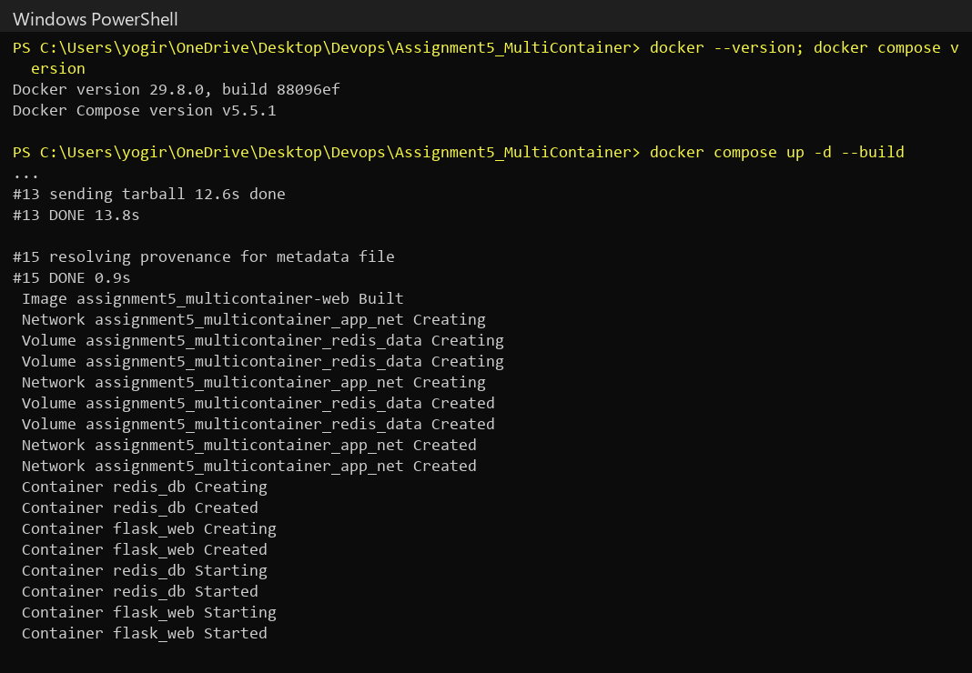
2. Both services running, with host port 8000 mapped to container port 5000. Each request increments the counter stored in Redis:
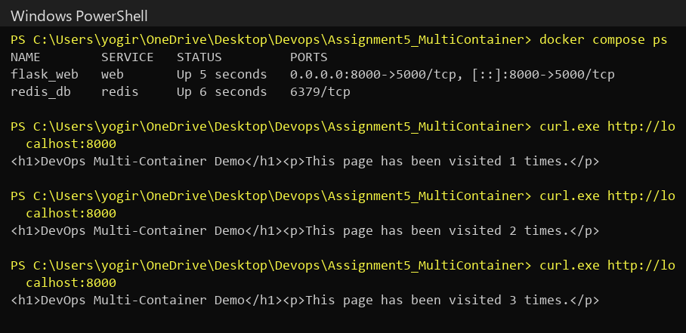
3. Web application opened in the browser at http://localhost:8000:
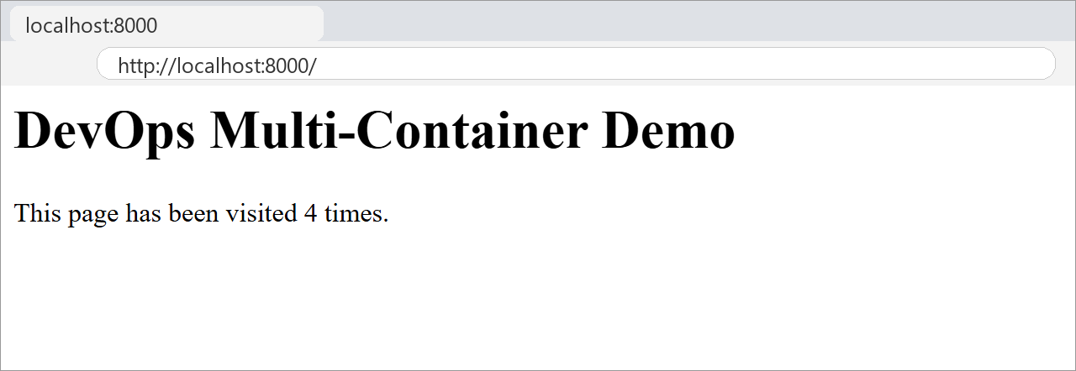
4. Networking and volumes: the user-defined bridge network app_net connects both containers, and the named volume redis_data is created:
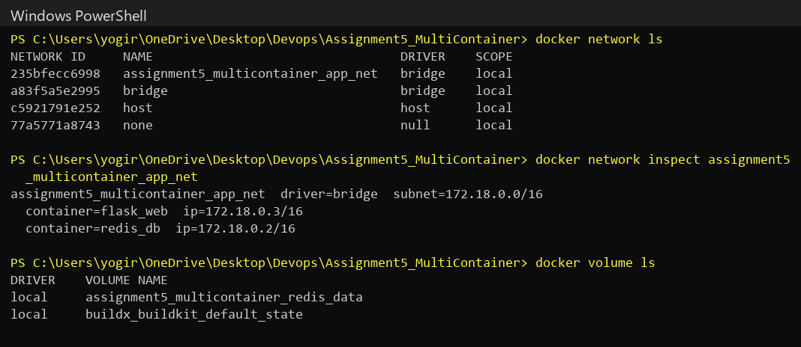
5. Environment variables passed to the web container and the visit counter stored in the Redis database:
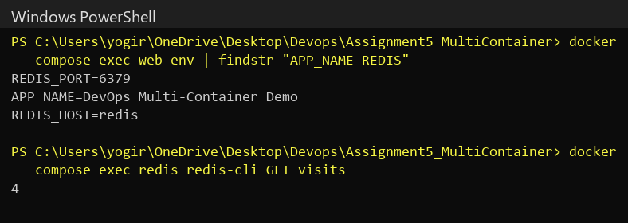
Web service logs showing the requests handled by the Flask container:
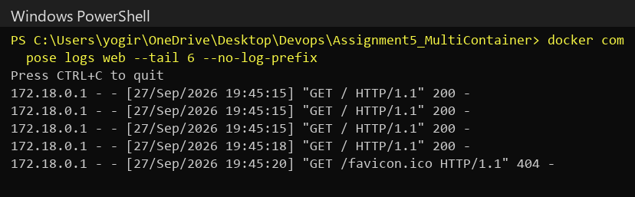
6. Data persistence: after docker compose down and up the containers are recreated, but the visit counter continues from the previous value because it is stored in the redis_data volume:
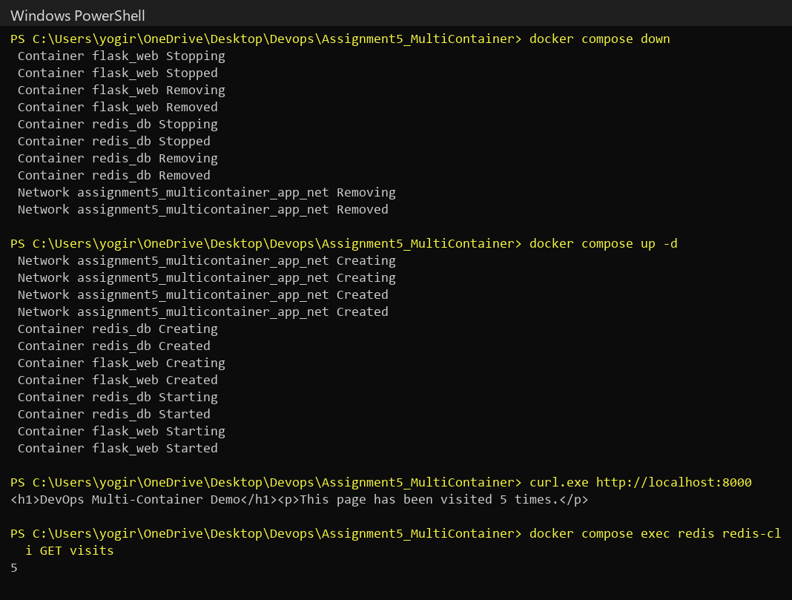
7. Final cleanup: docker compose down -v removes the containers, the network and the volume, leaving nothing running:
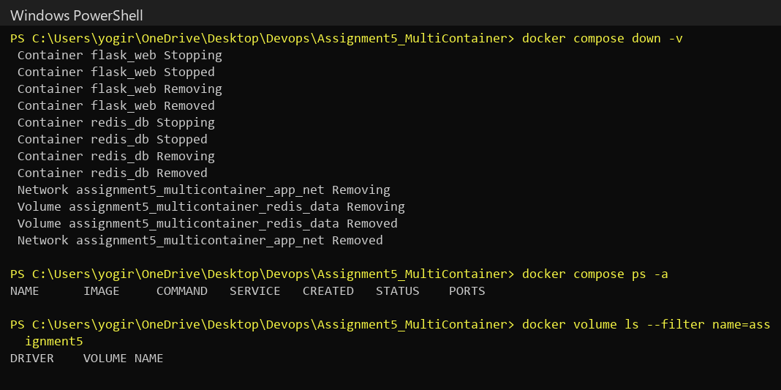
Conclusion
In this assignment, I learned about building a multi-container application with Docker Compose. I created a Flask web service and a Redis database service and configured them in a single compose.yaml file using port mapping, environment variables, a named volume for persistent data and a user-defined bridge network, which lets the containers talk to each other by service name. I also saw how the whole stack can be built, started, inspected and removed with a few simple commands.
References
1. Docker Compose Documentation – https://docs.docker.com/compose/
2. Compose File Reference – https://docs.docker.com/reference/compose-file/
3. Docker Networking Overview – https://docs.docker.com/engine/network/
4. Docker Volumes – https://docs.docker.com/engine/storage/volumes/
5. Flask Documentation – https://flask.palletsprojects.com/
6. Redis Docker Official Image – https://hub.docker.com/_/redis
Submission Links
GitHub Repository Link: https://github.com/tanushkapatil/DevOps/tree/main/Assignment5_MultiContainer
Hosted / Output Link: http://localhost:8000 (local output – runs on the local machine via Docker Compose)

