Assignment No: 3
Student Details
Name: Tanushka Patil
PRN / Roll No: 123B1B036
Class: BTech
Division: A
Subject: DevOps
Title
Infrastructure as Code using Terraform – Provisioning an AWS EC2 Instance and a Docker Web Server
Aim
To study the concepts and workflow of Infrastructure as Code (IaC), install and configure Terraform, and develop Terraform configurations to provision an AWS EC2 instance and a local Docker web server using provider, resource, variable and output configurations.
Theory
Infrastructure as Code (IaC)
Infrastructure as Code is the practice of managing and provisioning infrastructure (servers, networks, databases, load balancers) through machine-readable configuration files instead of manual console clicks. IaC makes infrastructure repeatable, version-controlled, reviewable and easy to reproduce across environments (dev, test, prod).
- Declarative vs Imperative: declarative tools (Terraform, CloudFormation) describe the desired end state; imperative tools (scripts) describe the steps to reach it.
- Benefits: consistency, speed, automation, version control with Git, fewer human errors, and infrastructure that documents itself.
- Idempotency: applying the same configuration multiple times produces the same result.
Terraform
Terraform, by HashiCorp, is a cloud-agnostic IaC tool. Configurations are written in HCL (HashiCorp Configuration Language) in files ending with .tf. Terraform keeps a state file (terraform.tfstate) that maps the configuration to real resources, so it can calculate what needs to change.
- Provider: a plugin that lets Terraform talk to a platform's API (aws, azurerm, google, docker).
- Resource: an infrastructure object to create, e.g. aws_instance, aws_security_group.
- Variable: an input parameter that makes the configuration reusable (variable blocks, terraform.tfvars, -var flag).
- Output: a value printed after apply, such as an instance's public IP.
- Data source: reads existing information, e.g. the latest AMI ID.
- State: the record of managed resources, stored locally or remotely (S3, HCP Terraform).
Terraform Workflow
- Write – author the .tf configuration files.
- terraform init – initialise the working directory and download provider plugins.
- terraform fmt / validate – format code and check syntax.
- terraform plan – preview the changes Terraform will make.
- terraform apply – create or update the infrastructure.
- terraform destroy – remove all resources managed by the configuration.
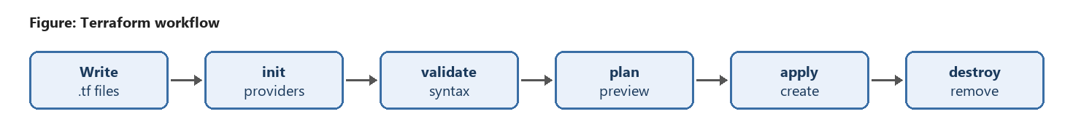
Code / Implementation
Step 1: Install Terraform
On Windows (using winget or Chocolatey), or download the binary from developer.hashicorp.com and add it to PATH:
winget install Hashicorp.Terraform
# or
choco install terraform
terraform -version
Step 2: Configure AWS credentials
Create an IAM user with programmatic access (EC2 permissions), install the AWS CLI and configure it. Terraform's AWS provider reads these credentials automatically.
aws configure
# AWS Access Key ID : <your-access-key>
# AWS Secret Access Key : <your-secret-key>
# Default region name : ap-south-1
# Default output format : json
Step 3: Project structure
Assignment3_Terraform/
├── provider.tf # Terraform + AWS provider configuration
├── variables.tf # Input variables
├── main.tf # Resources (security group, EC2 instance)
├── outputs.tf # Output values
├── terraform.tfvars # Variable values
└── local_docker_demo/ # Same workflow using the Docker provider
├── provider.tf
├── variables.tf
├── main.tf
└── outputs.tf
provider.tf – Provider configuration
terraform {
required_version = ">= 1.5.0"
required_providers {
aws = {
source = "hashicorp/aws"
version = "~> 5.0"
}
}
}
provider "aws" {
region = var.aws_region
}
variables.tf – Variable configuration
variable "aws_region" {
description = "AWS region to deploy resources in"
type = string
default = "ap-south-1"
}
variable "instance_type" {
description = "EC2 instance type"
type = string
default = "t2.micro"
}
variable "instance_name" {
description = "Value of the Name tag for the EC2 instance"
type = string
default = "terraform-demo-ec2"
}
variable "key_name" {
description = "Name of an existing EC2 key pair for SSH access"
type = string
default = "devops-key"
}
variable "ssh_allowed_cidr" {
description = "Public IP allowed to SSH into the instance, in CIDR form (e.g. 203.0.113.10/32)"
type = string
validation {
condition = can(cidrhost(var.ssh_allowed_cidr, 0))
error_message = "ssh_allowed_cidr must be a valid CIDR block such as 203.0.113.10/32."
}
}
main.tf – Resource configuration
# Latest Amazon Linux 2023 AMI
data "aws_ami" "amazon_linux" {
most_recent = true
owners = ["amazon"]
filter {
name = "name"
values = ["al2023-ami-*-x86_64"]
}
}
# Security group allowing SSH and HTTP
resource "aws_security_group" "web_sg" {
name = "terraform-web-sg"
description = "Allow SSH and HTTP inbound traffic"
ingress {
description = "SSH from my IP only"
from_port = 22
to_port = 22
protocol = "tcp"
cidr_blocks = [var.ssh_allowed_cidr]
}
ingress {
description = "HTTP"
from_port = 80
to_port = 80
protocol = "tcp"
cidr_blocks = ["0.0.0.0/0"]
}
egress {
from_port = 0
to_port = 0
protocol = "-1"
cidr_blocks = ["0.0.0.0/0"]
}
}
# EC2 instance with a simple web server
resource "aws_instance" "web" {
ami = data.aws_ami.amazon_linux.id
instance_type = var.instance_type
key_name = var.key_name
vpc_security_group_ids = [aws_security_group.web_sg.id]
user_data = <<-EOF
#!/bin/bash
dnf install -y httpd
echo "<h1>Provisioned with Terraform</h1>" > /var/www/html/index.html
systemctl enable --now httpd
EOF
tags = {
Name = var.instance_name
}
}
outputs.tf – Output configuration
output "instance_id" {
description = "ID of the EC2 instance"
value = aws_instance.web.id
}
output "public_ip" {
description = "Public IP address of the EC2 instance"
value = aws_instance.web.public_ip
}
output "public_dns" {
description = "Public DNS name of the EC2 instance"
value = aws_instance.web.public_dns
}
terraform.tfvars – Variable values
aws_region = "ap-south-1"
instance_type = "t2.micro"
instance_name = "terraform-demo-ec2"
key_name = "devops-key"
# Replace with your own public IP (find it at https://checkip.amazonaws.com) followed by /32
ssh_allowed_cidr = "203.0.113.10/32"
SSH access is restricted to a single IP address through the ssh_allowed_cidr variable (set in terraform.tfvars to your own public IP followed by /32), while HTTP stays open so the web page can be viewed.
Step 4: Run the Terraform workflow
cd Assignment3_Terraform
terraform init
terraform fmt
terraform validate
terraform plan
terraform apply -auto-approve
terraform output
terraform show
# Override a variable from the command line
terraform apply -var="instance_type=t3.micro"
# Clean up
terraform destroy -auto-approve
Step 5: Practical run on the local machine using the Docker provider
The same Terraform workflow was executed end-to-end on the local machine using the kreuzwerker/docker provider. This configuration pulls the nginx image and runs a web server container that serves a custom page on port 8080.
local_docker_demo/provider.tf
terraform {
required_version = ">= 1.5.0"
required_providers {
docker = {
source = "kreuzwerker/docker"
version = "~> 3.0"
}
}
}
provider "docker" {
host = var.docker_host
}
local_docker_demo/variables.tf
variable "docker_host" {
description = "Docker daemon address (Docker Desktop on Windows)"
type = string
default = "npipe:////./pipe/docker_engine"
}
variable "container_name" {
description = "Name of the web server container"
type = string
default = "terraform-web"
}
variable "external_port" {
description = "Host port on which the web page is published"
type = number
default = 8080
}
local_docker_demo/main.tf
# Pull the nginx web server image
resource "docker_image" "nginx" {
name = "nginx:alpine"
keep_locally = false
}
# Run a web server container with a custom page
resource "docker_container" "web" {
name = var.container_name
image = docker_image.nginx.image_id
ports {
internal = 80
external = var.external_port
}
upload {
file = "/usr/share/nginx/html/index.html"
content = "<h1>Provisioned with Terraform</h1><p>DevOps Assignment 3 - Tanushka Patil</p>"
}
}
local_docker_demo/outputs.tf
output "container_id" {
description = "ID of the web server container"
value = docker_container.web.id
}
output "container_name" {
description = "Name of the web server container"
value = docker_container.web.name
}
output "url" {
description = "URL of the deployed web page"
value = "http://localhost:${var.external_port}"
}
cd Assignment3_Terraform\local_docker_demo
terraform init
terraform validate
terraform plan
terraform apply -auto-approve
terraform output
curl.exe http://localhost:8080
terraform destroy -auto-approve
Output
Output of terraform -version and terraform init (provider plugin downloaded and working directory initialised):
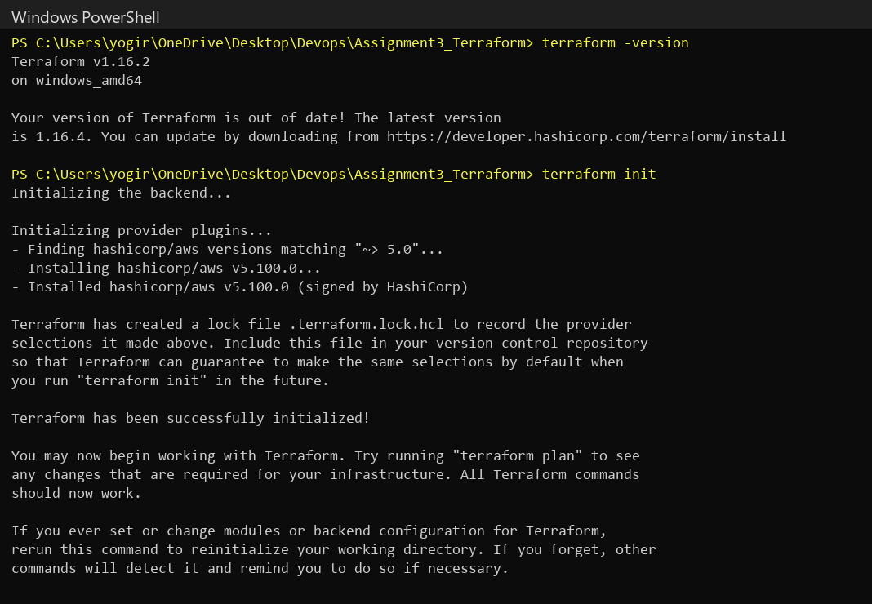
Output of terraform fmt, terraform validate and terraform providers (configuration is correctly formatted and valid):
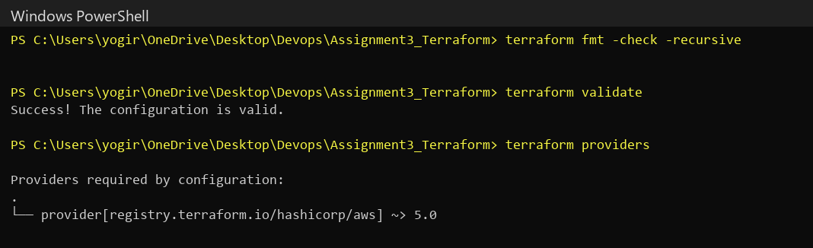
Practical run with the Docker provider
terraform plan – shows the 2 resources to be created (docker_image.nginx and docker_container.web) and the outputs:
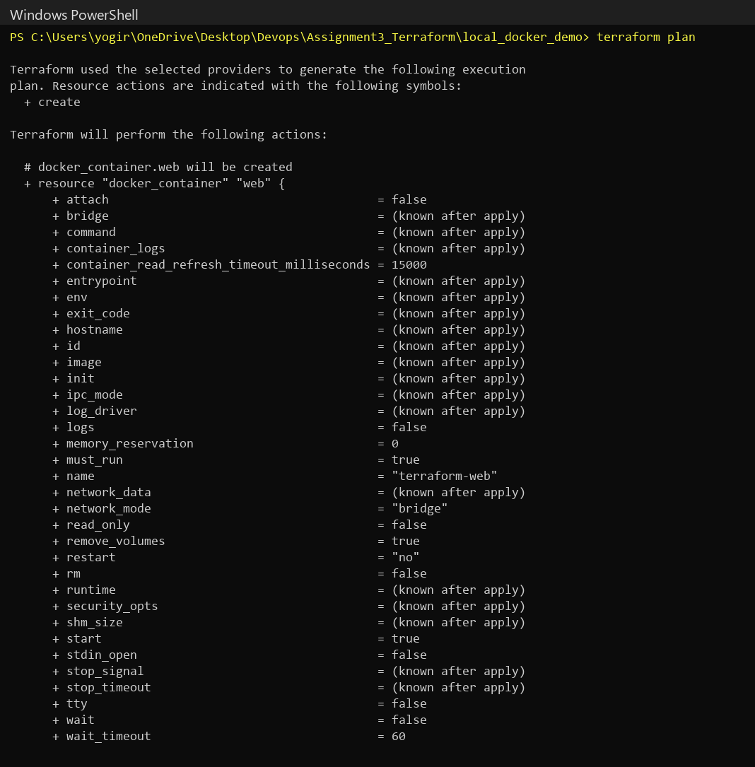
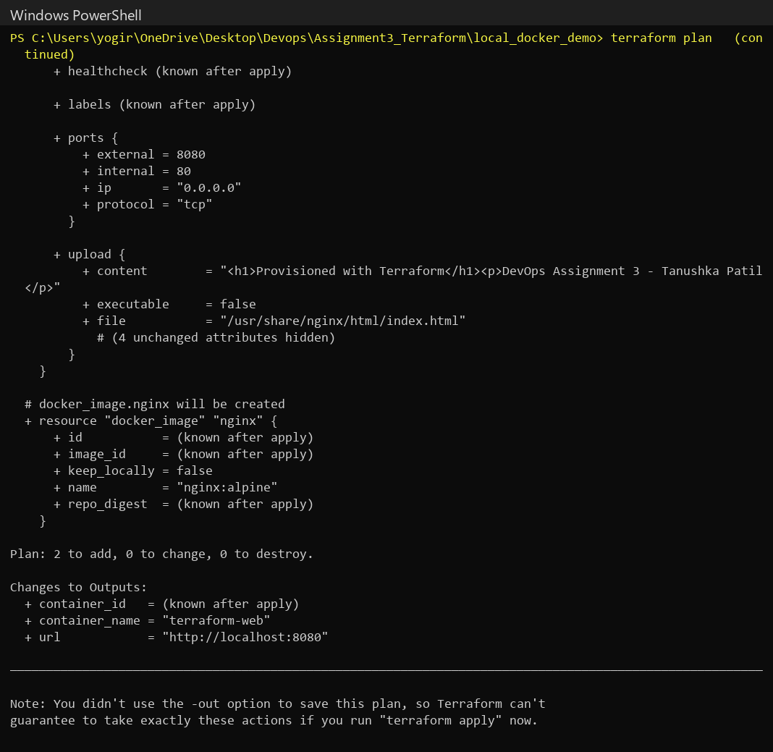
terraform apply – resources created successfully:
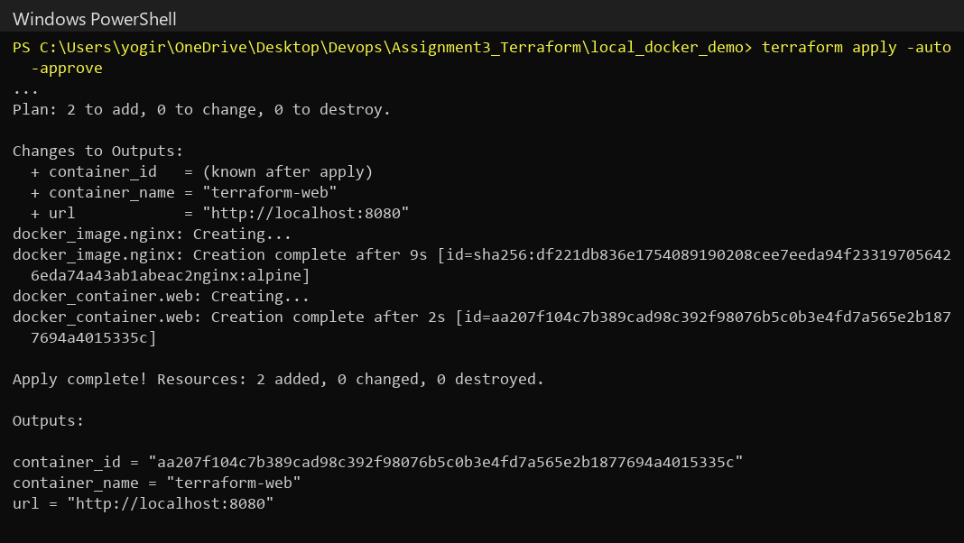
terraform output – output values, the running container and the page response:
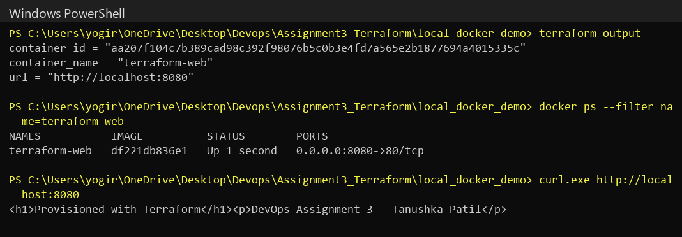
Deployed web page opened in the browser at http://localhost:8080:
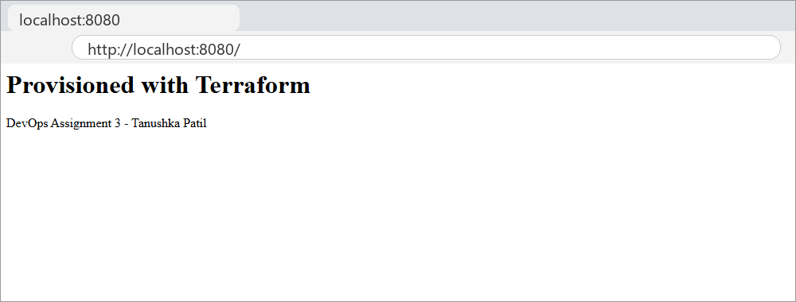
terraform destroy – all resources removed and no container left running:
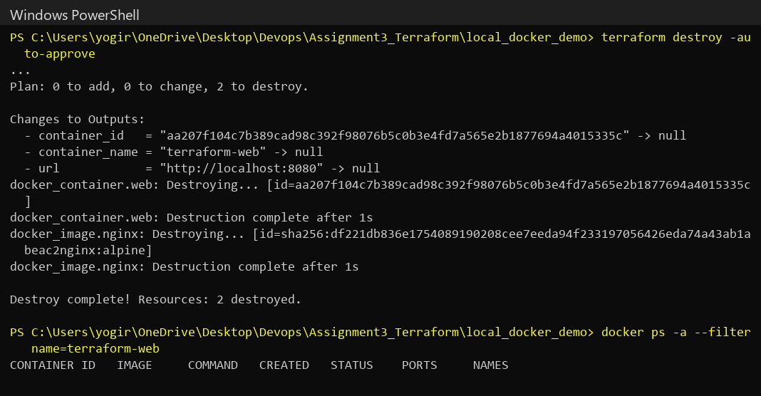
Conclusion
In this assignment, I learned about the concepts of Infrastructure as Code and the Terraform workflow (write, init, plan, apply, destroy). I installed Terraform and wrote a modular AWS configuration using a provider block, resources (a security group with SSH restricted to my IP, and an EC2 instance), input variables with validation, and outputs. I also executed the complete workflow with the Docker provider, where Terraform planned, created, reported and destroyed a web server container. This showed how infrastructure can be provisioned, changed and removed in a repeatable, version-controlled way instead of through manual console steps.
References
1. Terraform Documentation – https://developer.hashicorp.com/terraform/docs
2. Terraform Docker Provider (kreuzwerker/docker) – https://registry.terraform.io/providers/kreuzwerker/docker/latest/docs
3. Terraform AWS Provider – https://registry.terraform.io/providers/hashicorp/aws/latest/docs
4. Terraform Tutorials: Get Started – AWS – https://developer.hashicorp.com/terraform/tutorials/aws-get-started
5. AWS CLI Configuration – https://docs.aws.amazon.com/cli/latest/userguide/cli-chap-configure.html
Submission Links
GitHub Repository Link: _______________________________
Hosted / Output Link: http://localhost:8080 (local output – removed after terraform destroy)

