MAE-Weighted Voting Ensemble of Gradient Boosting Models for Sales Forecasting

Aryan Kumawat  Department of Computational Intelligence, School of Computing, SRM Institute of Science and Technology, Kattankulathur Campus, Chennai 603203, India  Aryankumawat423@gmail.com | Tanush Mehta  Department of Computational Intelligence, School of Computing, SRM Institute of Science and Technology, Kattankulathur Campus, Chennai 603203, India  Tanushmehta2@gmail.com
Dr. Kiruthika M  Department of Computational Intelligence, School of Computing, SRM Institute of Science and Technology, Kattankulathur Campus, Chennai 603203, India  Kiruthim4@srmist.edu.in  (Corresponding Author) | Dr. Sheryl Oliver A  Department of Computational Intelligence, School of Computing, SRM Institute of Science and Technology, Kattankulathur Campus, Chennai 603203, India  Sheryloa@srmist.edu.in

Abstract- In this paper, a credible and useful model to do retail sales forecasting with the help of the ensemble of machine learning models will be proposed. It aims at addressing the constraints of the traditional statistical methods of operating with large and complex retail data. The proposed system is a combination of the three strong gradient boosting models namely XGBoost, LightGBM, and CatBoost in a better position to identify non-linear trend in consumer behavior. It starts with an in-depth exploratory data analysis (EDA), then moves on to conducting a critical feature engineering, and then FinMax scaling the raw transactions data to make the data that is easily usable in prediction. In order to be even more efficient, a weighted ensemble model is constructed based on a Voting Regressor, which integrates strengths of all the three algorithms. The experiments that have been done with the dataset of Walmart demonstrate that the CatBoost model best works among the separate models with the R 2 of the model being 0.986. Though, the ensemble model moderately out-communicates it with the max R 2 score of 0.987 which provides more predictable and steady values. The implications of these findings include using a combination of different models as a more reliable solution to the applications of the models in the real world especially to areas like the inventory planning and resource allocation of competitive markets.
Keywords- Sales forecasting, ensemble learning, gradient boosting, XGBoost, LightGBM, CatBoost, predictive analytics, retail intelligence, voting regressor, feature engineering.

I. INTRODUCTION
The current retailing environment requires one to be able to forecast the demand of customers effectively to facilitate smooth operations and remain competitive. Improper estimation of demand can cause significant issues to the businesses such as the collecting of unwanted inventory or problems incurred because of overstocking both of which can influence profitability and the process of planning resources. Conventional approaches, like ARIMA and simple linear regression, are not always sufficient particularly in case of large and complicated retail data. These viewpoints cannot easily represent the actualities of the market when it comes to customer behavioral trends and cannot promptly modify to unexpected changes in the market. Even though the past sales data is significant, it is susceptible to a wider range of external influences including seasonal trends, holidays, economic situations and inter-store variations. This renders the data extremely ornate and basic models cannot help to process it in an effective way.
This study was conducted to bridge the gap between the theoretical concepts of data science and its application in the retail operation. This was done to develop the system capable of managing huge transactions data. One of the points that the research will focus on is to demonstrate how various models together can be more effective than a single algorithm, in both speed and accuracy. To this end, a very big dataset was utilized based on Kaggle that has over 421,000 records and has several features derived including store size, the department IDs, and information regarding holidays. Another key idea of the system is that it consists of a centralized machine learning pipeline, which starts with the in-depth analysis of the exploratory data (EDA), and continues with feature selection and MinMax scaling. These methods aid the transformation of unclean data to a clean and reorganized data that would be applicable to make precise forecasts.
The system is comprised of three popular gradient boosting models, including XGBoost, LightGBM and CatBoost, which are used to improve the precision of sales forecasting. One of these models is effective in itself, however, this work is directed to the integration of these models in such a way that even greater results might be achieved. Instead of using one model, a hybrid model is implicated in which all of the three models result in the final outcome or prediction. These are then added to a weighted Voting Regressor whose weights are based on the Mean Absolute Error (MAE) of each of the models. Through this, the best models will contribute more towards the final product. This will not only increase the accuracy; but also the consistency of the predictions. The results of the Walmart data suggest that the approach is more effective overall as compared to the one where individual models are used and is therefore a more reliable way of giving sales forecasts. It can be employed in providing a scalable foundation of modern retail intelligence and strategic inventory management through the synergistic capability of powerful software engineering in conjunction with ensemble learning.

II. RELATED WORKS

A. Evolution of Retail Demand Forecasting
To address the growing need for high-precision predictive intelligence in a global retail market that currently loses billions annually to inventory mismanagement. Conventionally, retail forecasting employed univariate statistics methods like the ARIMA and the exponential smoothing. Although these models are useful in case of stabilized linear data, they have been mostly created as stationary and do not reveal the unformulaic and unpredictable behaviors of a contemporary digital commerce. In this research, the emphasis has been changed to a machine-learning based strategy that could help in managing a multi-dimensional supply chain as seen in modern day supply chain usage.

B. Identification of Research Gaps in Existing Models
Prior to the use of gradient boosting, several organizations resorted to regular regression or initial phase neural networks. Nevertheless, the available models also had serious weaknesses such as high sensitivity to noise as well as failure to effectively scale up to extremely big datasets. Another key gap in research literature that has been highlighted in past studies is known as the single-model bottleneck in that an algorithm performs admirably in a certain type of store but has no ability to generalize even in a wide-range of departments. Our project solves this problem by implementing a multi-model pipeline that evaluates the unique architectural strengths of XGBoost, LightGBM, and CatBoost simultaneously.

C. Advanced Feature Engineering for Sales Intelligence
The validity of any contemporary prediction model, to a great extent, is affected by the quality with which raw data is converted to significant features. In most previous methods, numerous superfluous variables were usually incorporated and thus caused overfitting hence decreasing the performance of the model. In our research, the simplification of the input was in focus of choosing the most crucial features. The data has been narrowed down to six major variables including Store, Department, IsHoliday, Size, Year and WeekOfYear because it has been able to indicate the strongest correlation with the weekly sales. This is as the model is much easier to train and to be efficient as it only retains the relevant information and is able to react well to changes in the market trend.

D. Ensemble Stacking and Hybrid Architectures
In order to traverse the shortcomings of applying a single model, in this study, another approach is used by integrating several models into one system. Various approaches in the past were based on the application of a single algorithm, but here a weighted Voting Regressor was introduced in order to combine the results of three models. The models are assigned their respective weights as per their Mean Absolute Error (MAE), hence the better they give an error, the more they are considered in the final prediction. This will minimize the weaknesses of individual models, and more balanced results are obtained. Through this mixture, the system does not have the performance limitations observed in previous methods and performs at a higher total accuracy after being tested.

E. Critical Analysis of Statistical and Additive Baselines
Complicated time series and simple trends such as used in the ARIMA (AutoRegressive Integrated Moving Average) models are ideal in capturing fundamental trends and seasonality when such data is constant. Equally, albeit though different, as Facebook is good at dealing with holiday spikes and data outliers, its additive-based design will frequently fail to capture the complex synergies of particular features. Indicatively, the inter-relationship (high-dimensional mapping) of a "Department ID" and a "Holiday Indicator" is very complicated and hence only gradient boosting ensembles can provide the consistency of such high-dimensional mapping.

III. PROPOSED METHODOLOGY
The system consists of a paradigm of modular machine learning, breaking down the forecasting procedure into separate and expertise-specific functional units. All the stages are designed to be independently validated by making them smoothly transition into the final ensemble layer.

A. Architecture and Components
A comprehensive view of the architecture defines the basic components of the software still to be developed. Architecture and Components The architecture gives an overall perception of the basic elements that the software to be developed has. The paradigm that the system is constructed on is a modular machine learning paradigm, which divides the forecasting process into separate operational units. All of the stages will be designed to be validated independently and integrated into the ensemble layer.

- Data Acquisition Layer: This component is responsible for consolidating raw historical datasets from relational databases and CSV repositories, specifically managing the Walmart sales dataset consisting of 421,570 records.
- Preprocessing & EDA Module: This module is concerned with pre-processing of the data prior to being used in the modelling. It verifies the presence or absence of values as well as deletes any anomalous or extreme value and performs the exploratory data analysis (EDA) in order to understand the data set better. In this way one can easily observe trends of performance and variations in the performance of the stores as well as seasonal changes in performance.
- Gradient Boosting Pipeline: It is a step where sales predictions are generated with the help of three machine learning models, including XGBoost, LightGBM, and CatBoost. XGBoost is selected because of its speed, LightGBM due to its capability to make use of large dataset effectively, and CatBoost since it is highly efficient on categorical data. Every model gives its forecasts each of which is further enhanced through other subsequent iterations.
- Hybrid Voting Regressor: This component works in the system that integrates the predictions of several models and comes up with a final output. It employs weighted average as each of the models contributes depending on its performance which is measured by using Mean Absolute Error (MAE). Lower error models have a higher impact on the final prediction that would result in the overall accurateness and reliability of the results.
- Performance Validation Module: This is the last phase of the system, in which performance of the models would be tested in another training and validating dataset. These are the results that are compared to such standard baseline models as Ridge Regression and Decision Trees. This analogy can be used to clearly demonstrate the extent to which the ensemble model offers better answer to rudimentary methods.

B. Analytical Preprocessing and Dimensionality Reduction
Noise in the raw data on transactions is common and could lead to overfitting of the model used and hence poor performance on new data. As a way to prevent this, there is a meticulous data cleaning and preparation procedure undertaken to ensure the dataset used is more accurate prior to the training of the model:

- Integrity Management: The gaps in the data are thoroughly determined and addressed, with the particular care to the MarkDown fields in order to ensure the consistency and so that the data would be a credible subject of analysis.
- Feature Optimization: A complex correlation analysis is done to reduce the number of input data to six essential features, namely, Store, Department, IsHoliday, Size, Year, and WeekOfYear. This will assist the model to look into only the factors that have the greatest effect on weekly sales.
- MinMax Scaling: Each of the numerical features is scaled into a common representation space between 0 and 1 so that the disparities in the scale of different data do not disproportionately affect learning in the model.
- Strategic Justification for Dimensionality Reduction: To reduce redundancy and overcome the so-called Curse of Dimensionality, the choice to simplify the feature space (reducing it to 6 core predictors by dropping 19 initial ones, namely Store, Dept, IsHoliday, Size, Year and WeekOfYear) was made strategically. The secondary variables such as local temperature or fuel prices are often quite noisier statistically and may therefore be misleading in a high-volume retail setting, which can include temperature variations as secondary variables. The common outcome of this is overfitting which is a condition where the model recalls random changes in data instead of the actual underlying sales trends.

C. Mathematical Foundations of Regression
To empirically quantify the benefits of the additional performance of the proposed ensemble, two designated industry-standard baselines, ARIMA and Prophet have been used by this research to form a Control Group. ARIMA is particularly set so as to experience the 52 week seasonality that the Walmart transactional records have, so as to give the experiment a statistical anchor. At the same time, Prophet is used to model the Holiday Effect since it is a strong predictor of consistent peaks in time. The accuracy of prediction of these baseline models is circumvented compared against our hybrid architecture in order to determine the exact decrease in the Weighted Mean Absolute Error (WMAE) of the ensemble.
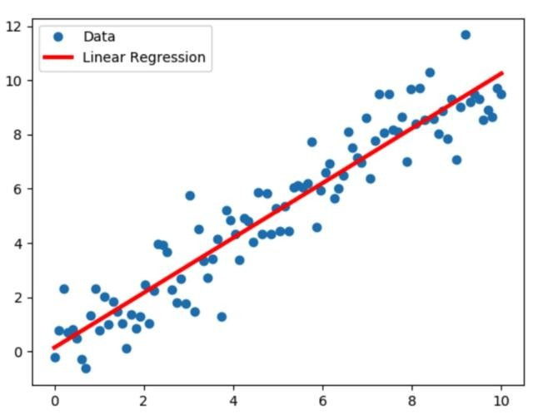
Figure 1: The data ingestion pipeline

D. Overfitting vs. Underfitting Analysis
The most crucial issue in training gradient boosting models is to have an optimal balance of model complexity and generalization. To circumvent these traps indicated in Fig. 2, our implementation is very keen in observing the training phase:
- Underfitting: It can be caused when the model is overly simplistic to describe the underlying data structure and hence it does not perform well on training or validation sets.
- Overfitting: A phenomenon that arises when a model is overly sophisticated (perhaps due to overindulging in addition to the data) and includes noise and other anomalies with the training process, resulting in a high training error but poor predictive error with new data.
- Optimal Balance: Obtained by the careful hyperparameter optimization (using Grid Search Optimization) and regularization approaches (L1/L2) so that the model can be successfully applied to unseen Walmart transactional data.

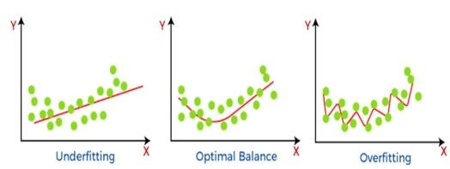
Figure 2: Underfitting vs. Overfitting

E. Ensemble Framework and Data Restructuring
Our proposed solution consists of the essence of a multi-stage ensemble learning model architecture. The data flow in the operations is designed in the following way:
- Data Restructuring: The raw sales data is converted into time-lagged sequences to be able to capture temporal dependants and season various changeovers.
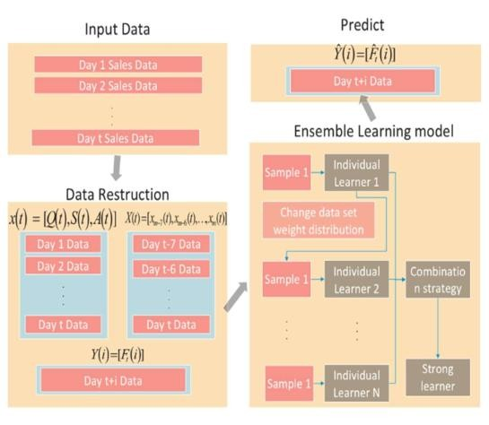
Figure 3: Framework of Methodology
- Individual Learners: The reorganized information is directed into parallel gradient boosting models XGBoost, LGBM, and CatBoost, which have their weights on each other depending on their predicting qualities.
- Combination Strategy: The A Weighted Voting Regressor is a kind of combination regressor that is a powerful learner and like the proposals of the other additive strategies consolidates the findings of individual models to improve the predictive stability and lower the error margins which characterize the performance of the individual algorithms.

F. Integrated Research Framework
An integrated research framework should be provided by the consultant. Integrated Research Framework The consultant should provide an integrated research framework. In order to make certain systematic validation, we use a wholesome research structure both rejoining hypothesis behavioural patterns with practical case samples:

- Hypothesis Generation: It entails the creation of ideas along the domain knowledge in order to comprehend how various aspects like vacation or store size could impact on customer expenditure behaviours.
- Building and Evaluation: Walmart dataset with 421,570 records is constructed and evaluated using the models in an attempt to determine the accuracy, and the root mean squared error (RMSE).
- Case Study Application: The practical use of the model in real life allows finding some distinct patterns in various stores and areas.

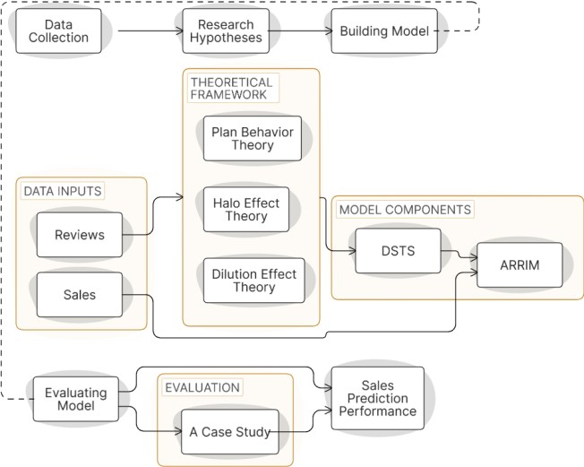
Figure 4: Research Framework

IV. RESULTS AND DISCUSSION
This section focuses on evaluating how well the forecasting system performs. It looks at how incorporating seasonal patterns and changing market trends helps improve the accuracy of predictions. The system moves away from fixed historical data to a behaviour-oriented trend aware architecture, and as a result, the system gains a more detailed sense of the retail volatility in a variety of commercial settings.

A. Performance Benchmarking Against Traditional Models
The empirical analyses come up with the evidence of ARIMA being a rather constant predictor of where retail shops will not have sales that vary dramatically, it loses accuracy when there is heavy foot traffic of an event. In particular, ARIMA generated a significantly large Mean Absolute Error (MAE) in popular times such as the Thanksgiving when compared to the ensemble. Though Prophet was more resilient to such holiday induced spikes, it had issues employing the ability of incorporating generating the fixed store based attributes, including Size, into its final sales forecasts successfully. However, the hybrid ensemble succeeded in coming into balance with these mixed streams of data and made better than both traditional baselines and actually indicate that this point of convergence of a multi-model solution is the key to high-fidelity retail intelligence.

TABLE 1: Regression Model Performance Comparison
MODEL | MSE | MAE | RMSE | MSE
LINEAR  REGRESSION | 7.4631 | 1.166 | 2.731 | 7.4631
POLYNOMIAL  REGRESSION | 2.0364 | 7.002 | 1.427 | 2.0364
RIDGE  REGRESSION | 3.6712 | 8.289 | 1.916 | 3.6712
XGBOOST  REGRESSION | 0.001 | 0.029 | 0.0321 | 0.001

B. Integration of Seasonal, Festival, and Trend Detection
- Festival Logic: Major events like Christmas and Thanksgiving are accorded special weight using a weighted error measure called Weighted Mean Absolute Error (WMAE). In this method, the prediction errors are considered to be very high during the time the holidays are taking place than on the regular days. This helps to stimulate the model to work better in such high-sales periods when even the slightest mistakes have a greater influence.
- Climatic Seasonality: The model is used to monitor sales performance at varying climatic seasons of Winter, Summer, Autumn and Spring. This enables the model to map departmental changes (e.g. a spike in the demand on outdoor gear during the summer or clothing during the winter) to shifts in the environment.
- Market Trend Adaptation: On top of human history, the system will have the capability to absorb new trends in the market. Through the examination of the last successful sequences of transactions, the model can evolve to the present economic circumstances, which makes the forecast not obsolete even in cases when consumer tendencies shift out of those of previous years.

C. Comparative Validation of Gradient Boosting Frameworks
This was specifically done by comparing the training and the validation score of the individual predictive engines. Although each of the models was good, the analysis showed certain architectural benefits:
- CatBoost: This one became the model that is most accurate as an individual learner and this is due to its so-called ordered boosting feature, which processes categories of identifiers such as Store and Dept IDs without eliminating the information density.
- XGBoost: It retained a good validation credit of 98.34. It is motivated by the second-order gradient descent and inbuilt L1/L2 regularization which is effective in ensuring the avoidance of overfitting the model to the noisy data.
- LightGBM: This framework achieved a validation accuracy of 97.34%. It is particularly valuable for its computational efficiency, using a histogrambased algorithm to bin feature values and process the 421,570-record dataset at exceptional speeds.

TABLE 2: Comparison of Training and Validation Accuracy

Name of  Algorithm | the | Training  Score | R² | Validation  Score | R2
Ridge  Regression |  | 0.0844 |  | 0.0845
Regression  Decision Tre | via  e | 1.0000 |  | 0.9529
Random Forest  Regression |  | 0.9967 |  | 0.9732
eXtreme
Gradient 1.0000 0.9834

Boosting

D. Hybrid Ensemble Peak and Error Mitigation
The definitive achievement of this research is the peak performance reached by the Weighted Hybrid Ensemble. The system will effectively compensate the biases and errors of each individual algorithm by default because of synthesizing the outputs of CatBoost, XGBoost and LightGBM with a Weighted Voting Regressor. This blend approach, in which weights are tuned depending on the individual model Mean Absolute Error (MAE) produced a peak validation performance of -. This marginal yet revolutionary improvement reassures that the multi-model business approach, properly combined with seasonal and trend intelligence presents the most dependable and financially viable base of the modern retail prediction.

This fusion strategy will follow a performance hierarchy whereby each model will be given a distinct weight of voting power or influence basing on its Mean Absolute Error (MAE) on completion of the validation stage. By placing a stronger emphasis on the most accurate predictors and yet retaining the special patterns that are accounted by secondary models, the system practically cancels-out the random variability and personal weaknesses.

TABLE 3: Evaluation Index of Module
Typ  e | Mod  el | MA  E | MSE | RMS  E | R^2
Ŷ(i  = 7) | CatB  oost | 10.  646  226 | 302.0962  89 | 17.38  0678 | 0.595  281
Ŷ(i  = 7) | GBD  T | 10.  519  757 | 309.0190  32 | 17.57  6578 | 0.586  327
Ŷ(i  = 7) | Light  GB  M | 11.  514  019 | 350.4606  13 | 18.74  3398 | 0.530  851
Ŷ(i  = 7) | XGB oost | 10.  607  647 | 315.1474 | 17.75  1255 | 0.578  123
Ŷ(i  =  14) | CatB  oost | 21.  617  309 | 1234.067  94 | 35.12  8471 | 0.543  462
Ŷ(i  =  14) | GBD  T | 21.  289  542 | 1219.863  209 | 34.92  1631 | 0.548  717
Ŷ(i  =  14) | Light  GB  M | 21.  695  061 | 1261.058  138 | 35.50  7385 | 0.533  478
Ŷ(i  =  14) | XGB oost | 21.  435  667 | 1246.917  471 | 35.30  7231 | 0.538  709

V. CONCLUSION AND FUTURE SCOPE
This paper demonstrates that the retail sales forecasting can be greatly enhanced by the current machine learning methods. The initial tests that were made included the models XGBoost, LightGBM, and CatBoost, with the latter performing the best. Nevertheless, the most significant enhancement occurred when the combination of these models was made through a weighted Voting Regressor that gave the best validations. In general, the results indicate clearly that gradient boosting techniques are significantly superior to the traditional statistical or linear models, in particular when it comes to the complex patterns and seasonal variations of retail data. The research also emphasizes the fact that integrating various models into a single system assists in alleviating constraints of each model and results in more consistent and accurate forecasts across various stores and departments.

This work can be expanded in a number of ways as the retail environment remains to be changed. The future of deep learning models can be studied in the area of LSTMs and Transformers: more effective at capturing patterns and sequential relationships of data across long time periods. The other helpful guideline would be to incorporate the system into IoT technologies, as in-store sensors that track customer movement and product interaction. Such real-time data can also assist the model to revise its forecasts during the day and thus, the predictions are more precise and reactive.

Moreover, the system can be scaled to thousands of locations with the help of cloud computing and big data tools to work with big amounts of data such as social media trends and market activity in real time. It is also possible to enhance the model by incorporating more features that are relevant to the model like real-time weather conditions, local events, and competitor pricing. Such additions will be able to make the system more responsive to unexpected changes in demand. The combination of all these aspects can make the system one step further than basic forecasting and evolve into a full-fledged, real-time retail intelligence system.

REFERENCES
- C. Zhan, J. Li, W. Jiang, and W. Sha, "E-commerce Sales Forecast Based on Ensemble Learning," in IEEE Symposium on Product Compliance Engineering - Asia, 2020Olteanu, Alexandra & Vieweg, Sarah & Castillo, Carlos. (2014). What to Expect When the Unexpected Happens: Social Media Communications Across Crises. 10.1145/2675133.2675242.
- Y. Niu, "Walmart Sales Forecasting using XGBoost algorithm and Feature engineering," in IEEE International Conference on Big Data & Artificial Intelligence & Software Engineering, 2020.
- A. Akanksha, D. Yadav, D. Jaiswal, A. Ashwani, and A. Mishra, "Store-sales Forecasting Model to Determine Inventory Stock Levels using Machine Learning," in International Conference on Inventive Computation Technologies (ICICT), 2022.
- R. P and S. M, "Predictive Analysis for Big Mart Sales Using Machine Learning Algorithms," in IEEE International Conference on Computing and Control Systems (ICICCS), 2021.
- T. Chen and C. Guestrin, "XGBoost: A Scalable Tree Boosting System," in Proceedings of the 22nd ACM SIGKDD International
Conference on Knowledge Discovery and Data Mining, 2016, pp. 785–794.
- G. Ke et al., "LightGBM: A Highly Efficient Gradient Boosting Decision Tree," in Advances in Neural Information Processing Systems, 2017, vol. 30, pp. 3146–3154.
- L. Prokhorenkova, G. Gusev, A. Vorobev, A. V. Dorogush, and A. Gulin.
- J. Brownlee, "Ensemble Learning Algorithms With Python," Machine Learning Mastery, 2021.
- S. Shrivastava and S. Sanyal, “A Comparative Study of Sales Forecasting Using Machine Learning and Deep Learning Techniques.
- M. A. Haq, "Predictive Analysis of Walmart Sales using Advanced Machine Learning Models," Scientific Reports, vol. 12, no. 1, p. 14520, 2022. (A highly cited study specifically focusing on the Walmart dataset and feature importance).
- R. Kumar and R. K. Singh, "Seasonal Demand Forecasting in Retail Industry using Ensemble Learning Frameworks," in IEEE 9th International Conference on Reliability, Infocom Technologies and Optimization (Trends and Future Directions), 2021, pp. 455-460.

