
PAYLOAD Electronics Task-4
Tanushree Trivedi
(240902106)

Study first order RC , LC circuits and second order RLC circuits and LC oscillations .

- RC CIRCUITS
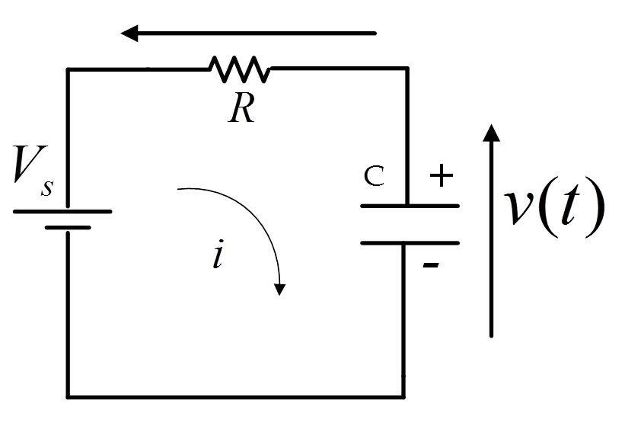
A first-order RC circuit is a simple electric circuit that contains a single resistor and capacitor, and is the simplest type of RC circuit
It is called "first-order" because its behavior is governed by a first-order differential equation.

- When connected to a voltage source, the capacitor charges over time.
- During discharge, the capacitor releases its stored energy through the resistor.

Time Constant (τ):
- τ=R⋅C
- It represents the time taken for the voltage across the capacitor to change significantly, which is about 63% of the total change.
- Transient Response:
- It describes how the circuit evolves from one steady state to another when a step input is applied.

- Applications:
- Signal filtering, timing circuits, smoothing in power supplies.

- LC circuits
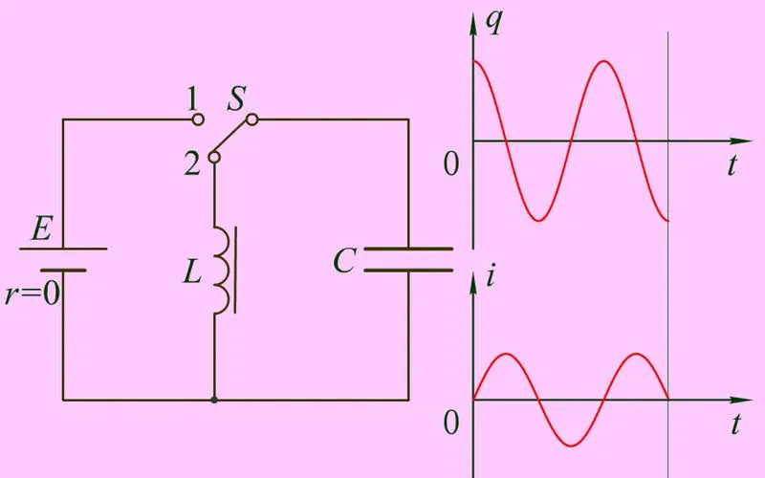

Relation between charge and time in a LC circuit-
- An LC circuit consists of an inductor and a capacitor connected together, forming an oscillating system. It is also known as a resonant circuit because it exhibits resonance at a particular frequency.
- The capacitor stores energy in the form of an electric field.
- The inductor stores energy in the form of a magnetic field.

- Oscillatory Behavior:

- When charged, the capacitor discharges, transferring energy to the inductor.
- The inductor resists the change in current and transfers energy back to the capacitor.
- This back-and-forth energy exchange creates oscillations in current and voltage.

- Second-order RLC circuit.
A second-order RLC circuit consists of a resistor, an inductor and a capacitor connected in series or parallel.
- Series-

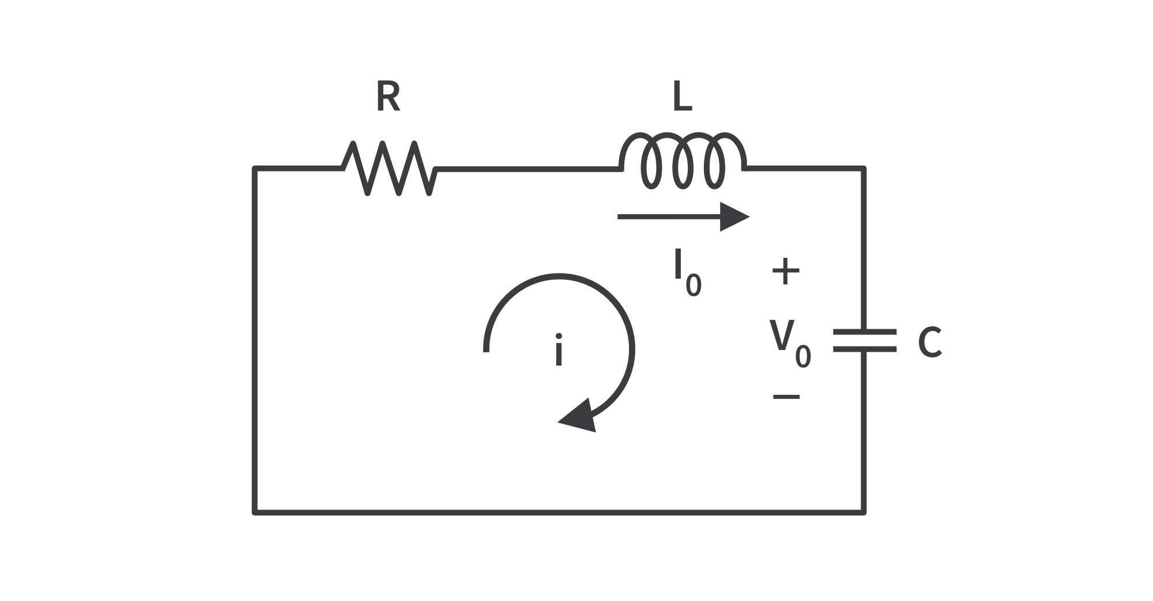
Total impedance: Z=R+jωL−j/ωCZ
- Parallel-
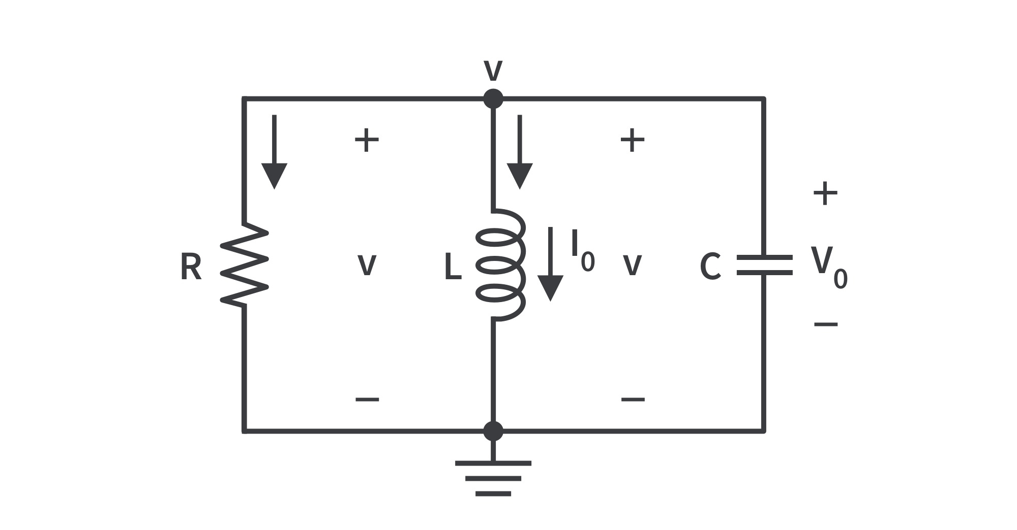
Total admittance: Y=1/R+jωC−j/ωL

- The capacitor stores energy in its electric field.
- The inductor stores energy in its magnetic field.
- Damping:
- Depending on the resistance, the circuit's oscillations can be:
  - Underdamped: Oscillations gradually die out.
  - Critically damped: Returns to a steady state as quickly as possible without oscillating.
  - Overdamped: Slowly returns to a steady state without oscillating.
​

Run a RC transient analysis on LT Spice and submit the schematic.
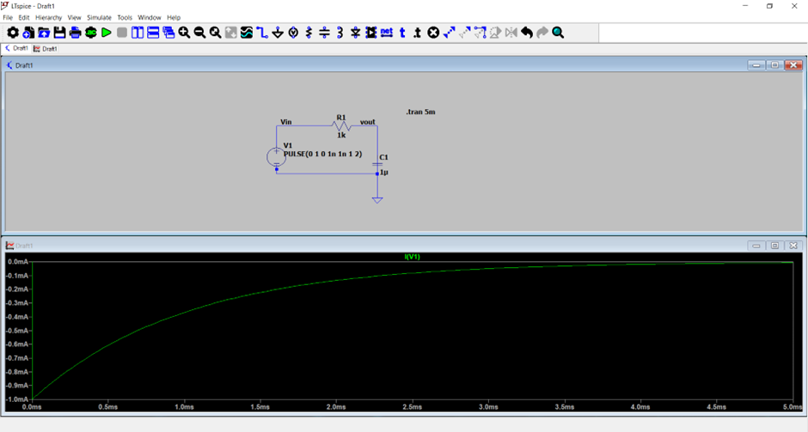
IV graph of the transient. It is an RC charging circuit, so there is an incrase and then it goes into steady state.

    - DC Analysis of a Resistor Circuit on Lt spice:
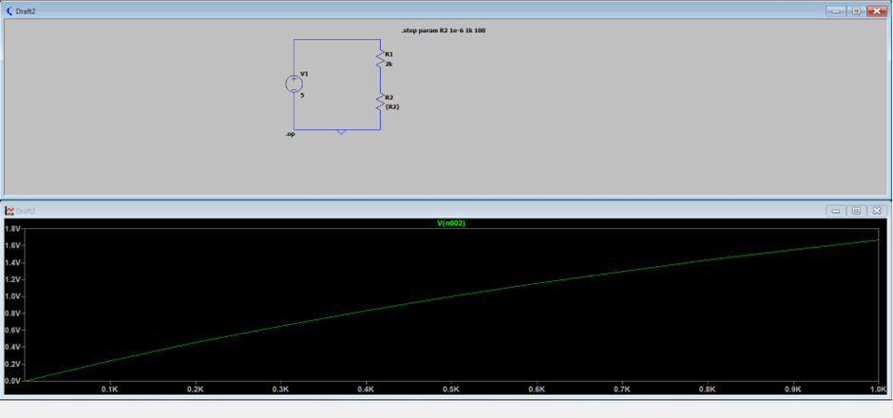

2. AC Analysis of a Passive Filter:

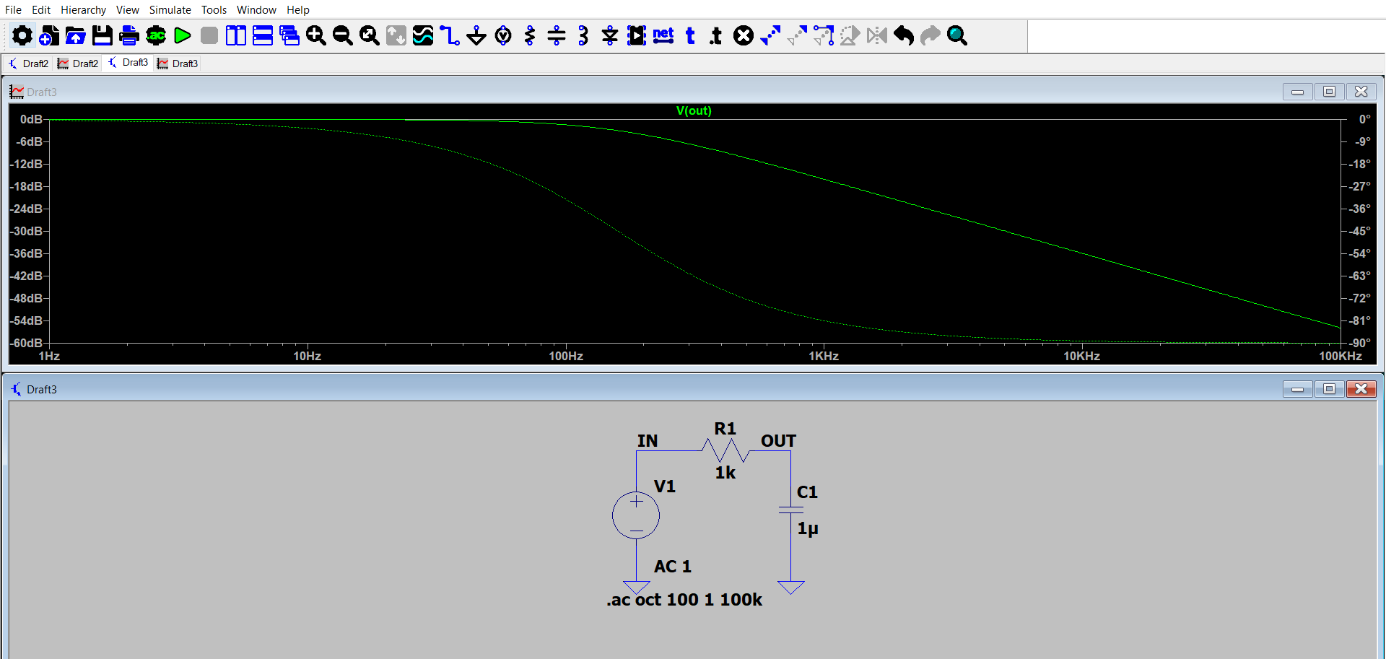

Here, the solid line represents the amplitude, and the dotted line represents the phase. The magnitude and phase shift of the output signal vary with frequency, showing how effectively the filter passes different frequencies.

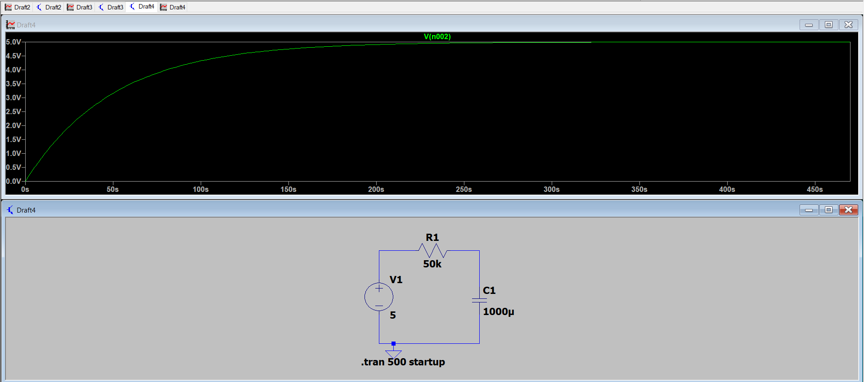
3. Transient Analysis of an RC Charging Circuit:

Here, an RC charging circuit is plotted, with time constant of 500.
The capacitor voltage increases exponentially from 0 to the supply voltage
The charging current decreases exponentially over time as the capacitor builds voltage

- Op-Amp Inverting and Non-Inverting Amplifiers
Inverting Vin:

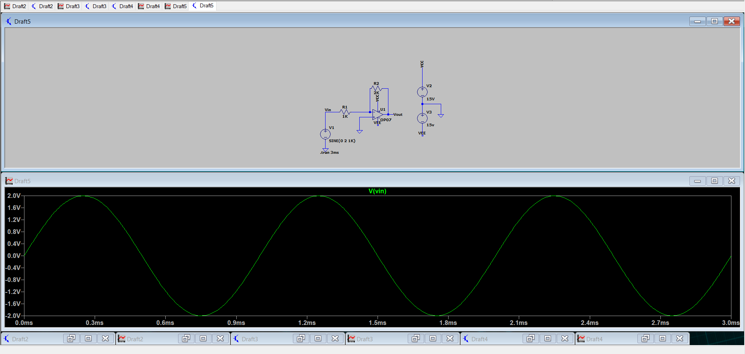
the output is an amplified and inverted version of the input voltage.

Inverting V out:
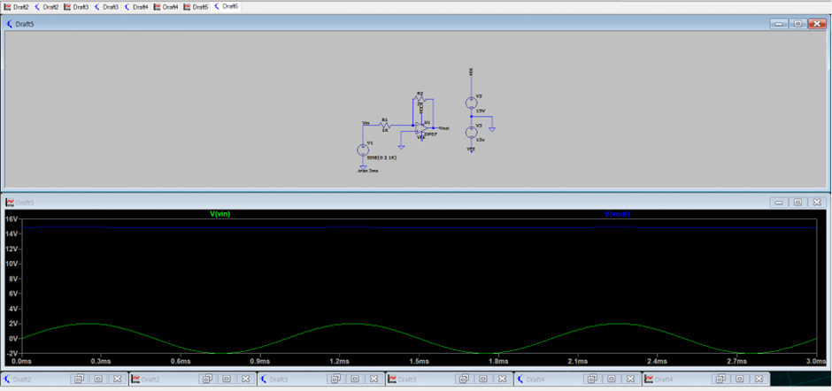

- Simulation of a Full-Wave Rectifier:

The rectified output waveform consists only of the positive half-cycles of the input, doubling the frequency of the original AC source

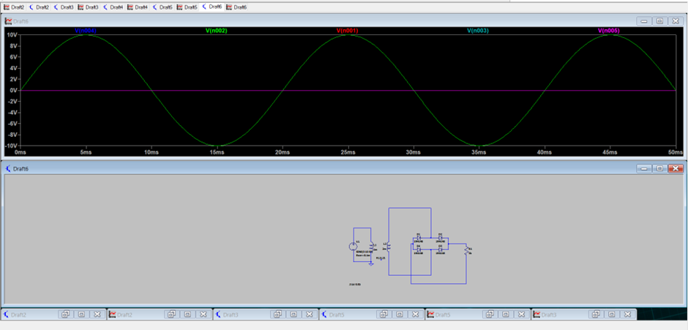

- Transient Response of a Second-Order System

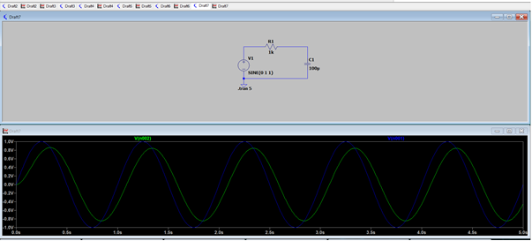

8. Frequency Response of an Amplifier

BJT amplifier

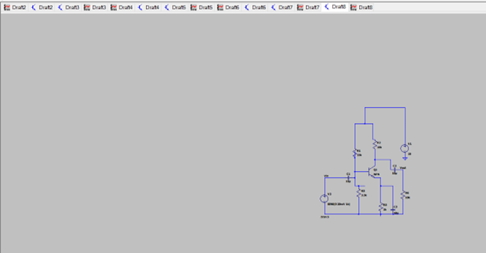

9. Simulation of a Wien Bridge Oscillator

IE

It is a a two-stage RC coupled amplifier circuit that has good stability at its resonant frequency, low distortion. It is very easy to tune making it a popular circuit as an audio frequency oscillator. Still, the phase shift of the output signal is considerably different from the previous phase shift RC oscillator.

The V output is shown as-
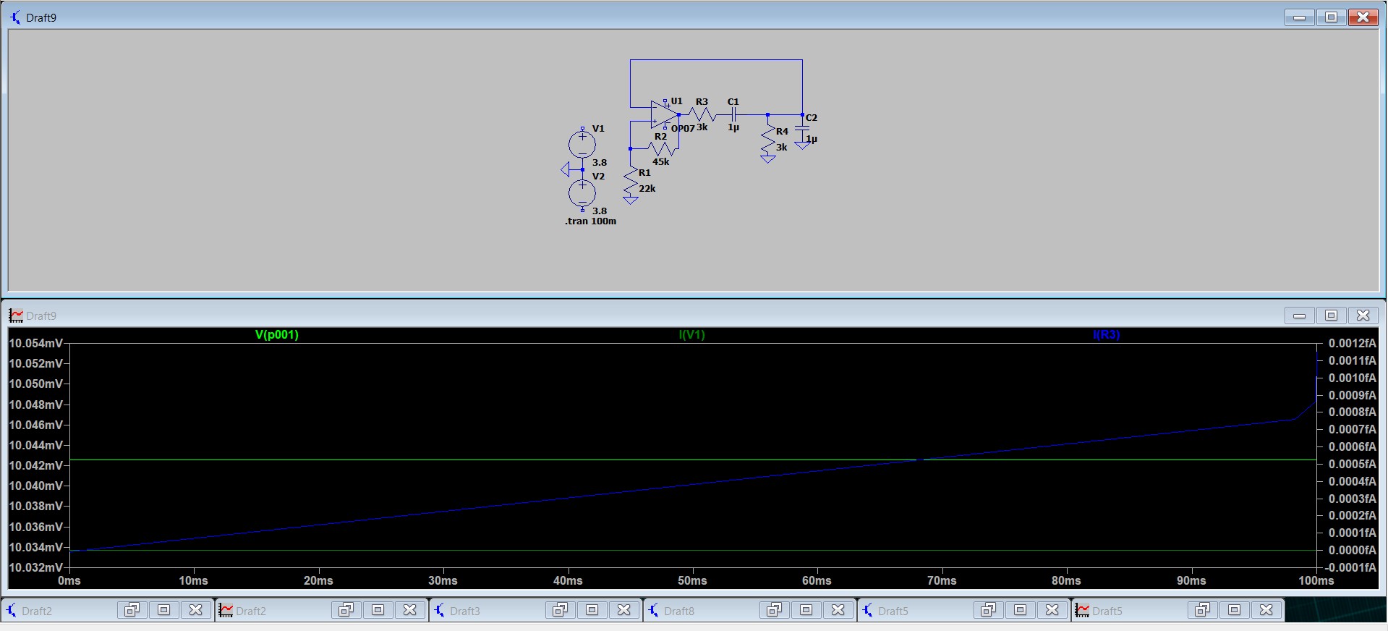

10. Analysis of a Voltage Divider

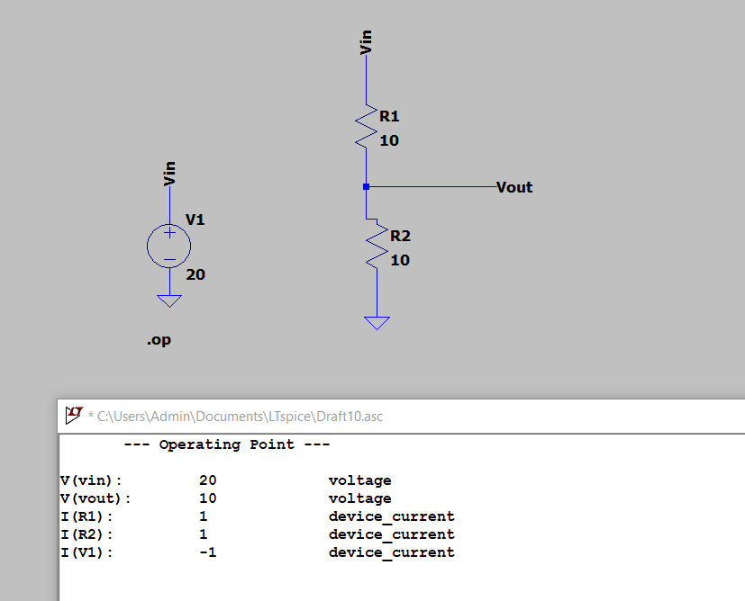

We suggest that you use a text box to insert a graphic (which is ideally a 300 dpi TIFF or EPS file, with all fonts embedded) because, in an MSW document, this method is somewhat more stable than directly inserting a picture.
To have non-visible rules on your frame, use the MSWord “Format” pull-down menu, select Text Box > Colors and Lines to choose No Fill and No Li

ne.

