AIAC LAB -11.1
Task Description #1 – Stack Implementation
Task: Use AI to generate a Stack class with push, pop, peek, and is_empty methods.
Sample Input Code:
class Stack:pass
Expected Output:
• A functional stack implementation with all required methods and docstrings.
#code:
class Stack:
"""A simple implementation of a Stack using a Python list."""

def __init__(self):
"""Initialize an empty stack."""
self.items = []

def push(self, item):
"""Add an item to the top of the stack."""
self.items.append(item)

def pop(self):
"""Remove and return the top item from the stack."""
if self.is_empty():
return None
return self.items.pop()

def peek(self):
"""Return the top item without removing it."""
if self.is_empty():
return None
return self.items[-1]

def is_empty(self):
"""Return True if the stack is empty, otherwise False."""
return len(self.items) == 0

# Example usage
stack = Stack()

stack.push(10)
stack.push(20)
stack.push(30)

print("Top element:", stack.peek())
print("Popped element:", stack.pop())
print("Is stack empty?", stack.is_empty())

output:
Top element: 30
Popped element: 30
Is stack empty? False
Task Description #2 – Queue Implementation
Task: Use AI to implement a Queue using Python lists.
Sample Input Code:
class Queue: pass
Expected Output:
• FIFO-based queue class with enqueue, dequeue, peek, and size methods.
#code:
class Queue:
"""A simple Queue implementation using a Python list."""

def __init__(self):
"""Initialize an empty queue."""
self.items = []

def enqueue(self, item):
"""Add an item to the rear of the queue."""
self.items.append(item)

def dequeue(self):
"""Remove and return the front item from the queue."""
if self.is_empty():
return None
return self.items.pop(0)

def peek(self):
"""Return the front item without removing it."""
if self.is_empty():
return None
return self.items[0]

def size(self):
"""Return the number of items in the queue."""
return len(self.items)

def is_empty(self):
"""Return True if the queue is empty."""
return len(self.items) == 0

# Example usage
queue = Queue()

queue.enqueue(10)
queue.enqueue(20)
queue.enqueue(30)

print("Front element:", queue.peek())
print("Dequeued element:", queue.dequeue())
print("Queue size:", queue.size())

output:
Front element: 10
Dequeued element: 10
Queue size: 2
Task Description #3 – Linked List
Task: Use AI to generate a Singly Linked List with insert and display methods.
Sample Input Code:
class Node: pass
class Linked List: pass
Expected Output:
• A working linked list implementation with clear method documentation.
#code:
class Node:
"""Represents a single node in the linked list."""

def __init__(self, data):
"""Initialize a node with data and a reference to the next node."""
self.data = data
self.next = None

class LinkedList:
"""A simple singly linked list."""

def __init__(self):
"""Initialize an empty linked list."""
self.head = None

def insert(self, data):
"""Insert a new node at the end of the linked list."""
new_node = Node(data)

if self.head is None:
self.head = new_node
return

current = self.head
while current.next is not None:
current = current.next

current.next = new_node

def display(self):
"""Display all elements of the linked list."""
current = self.head

while current is not None:
print(current.data, end=" -> ")
current = current.next

print("None")

# Example usage
linked_list = LinkedList()

linked_list.insert(10)
linked_list.insert(20)
linked_list.insert(30)

print("Linked List:")
linked_list.display()

output:
Linked List:
10 -> 20 -> 30 -> None
Task Description #4 – Binary Search Tree (BST)
Task: Use AI to create a BST with insert and in-order traversal methods.
Sample Input Code:
class BST: pass
Expected Output:
• BST implementation with recursive insert and traversal methods.
#code:
class Node:
"""Represents a node in the Binary Search Tree."""

def __init__(self, data):
"""Initialize a node with data."""
self.data = data
self.left = None
self.right = None

class BST:
"""A Binary Search Tree implementation."""

def __init__(self):
"""Initialize an empty BST."""
self.root = None

def insert(self, root, data):
"""Recursively insert a value into the BST."""
if root is None:
return Node(data)

if data < root.data:
root.left = self.insert(root.left, data)
elif data > root.data:
root.right = self.insert(root.right, data)

return root

def inorder(self, root):
"""Recursively perform an in-order traversal of the BST."""
if root is not None:
self.inorder(root.left)
print(root.data, end=" ")
self.inorder(root.right)

# Example usage
bst = BST()

values = [50, 30, 70, 20, 40, 60, 80]

for value in values:
bst.root = bst.insert(bst.root, value)

print("In-order Traversal:")
bst.inorder(bst.root)

output:
In-order Traversal:
20 30 40 50 60 70 80
Task Description #5 – Priority Queue
Task: Use AI to implement a priority queue using Python’s heapq module.
Sample Input Code:
class Priority Queue: pass
Expected Output:
• Implementation with enqueue (priority), dequeue (highest priority), and display methods.
#code:
import heapq

class PriorityQueue:
"""A priority queue implemented using the heapq module."""

def __init__(self):
"""Initialize an empty priority queue."""
self.queue = []

def enqueue(self, item, priority):
"""Add an item to the queue with a given priority."""
heapq.heappush(self.queue, (priority, item))

def dequeue(self):
"""Remove and return the item with the highest priority."""
if not self.queue:
return None

priority, item = heapq.heappop(self.queue)
return item

def display(self):
"""Display all items and their priorities."""
for priority, item in sorted(self.queue):
print("Item:", item, "Priority:", priority)

# Example usage
pq = PriorityQueue()

pq.enqueue("Task A", 3)
pq.enqueue("Task B", 1)
pq.enqueue("Task C", 2)

print("Priority Queue:")
pq.display()

print("\nDequeued item:", pq.dequeue())

print("\nAfter Dequeue:")
pq.display()

output:
Priority Queue:
Item: Task B Priority: 1
Item: Task C Priority: 2
Item: Task A Priority: 3
Dequeued item: Task B
After Dequeue:
Item: Task C Priority: 2
Item: Task A Priority: 3
Task Description #6 – Deque
Task: Use AI to implement a double-ended queue using collections.deque.
Sample Input Code:
class Deque DS: pass
Expected Output:
• Insert and remove from both ends with docstrings.
#code:
from collections import deque

class DequeDS:
"""A double-ended queue implemented using collections.deque."""

def __init__(self):
"""Initialize an empty deque."""
self.deque = deque()

def insert_front(self, item):
"""Insert an item at the front of the deque."""
self.deque.appendleft(item)

def insert_rear(self, item):
"""Insert an item at the rear of the deque."""
self.deque.append(item)

def remove_front(self):
"""Remove and return the item from the front."""
if not self.deque:
return None
return self.deque.popleft()

def remove_rear(self):
"""Remove and return the item from the rear."""
if not self.deque:
return None
return self.deque.pop()

def display(self):
"""Display all elements of the deque."""
print(list(self.deque))

# Example usage
d = DequeDS()

d.insert_front(20)
d.insert_front(10)
d.insert_rear(30)
d.insert_rear(40)

print("Deque:")
d.display()

print("Removed from front:", d.remove_front())
print("Removed from rear:", d.remove_rear())

print("Deque after removals:")
d.display()

output:
Deque:
[10, 20, 30, 40]
Removed from front: 10
Removed from rear: 40
Deque after removals:
[20, 30]
Q7
Task: Real-Time Application Challenge – Choose the
Right Data Structure
Scenario:
Your college wants to develop a Campus Resource Management System
that handles:
1. Student Attendance Tracking – Daily log of students
entering/exiting the campus.
2. Event Registration System – Manage participants in events with
quick search and removal.
3. Library Book Borrowing – Keep track of available books and their
due dates.

4. Bus Scheduling System – Maintain bus routes and stop
connections.
5. Cafeteria Order Queue – Serve students in the order they arrive.
Student Task:
For each feature, select the most appropriate data structure from
the list below:
o Stack
o Queue
o Priority Queue
o Linked List
o Binary Search Tree (BST)
o Graph
o Hash Table
o Deque
Justify your choice in 2–3 sentences per feature.
Implement one selected feature as a working Python program with
AI-assisted code generation.
Expected Output:
A table mapping feature → chosen data structure → justification.
A functional Python program implementing the chosen feature
with comments and docstrings.
Prompt: Create a simple Python Event Registration System using a Hash Table (dictionary). Include student registration, searching, deleting, and displaying records using Student ID. Add comments, docstrings, and sample output. Keep the code beginner-friendly and menu-driven.
Code:
"""Simple event registration system backed by a hash table (dictionary)."""

registrations = {}

def register():
"""Register or update a student's event registration."""
student_id = input("Enter Student ID: ").strip()
if not student_id:
print("Student ID cannot be empty.")
return

name = input("Enter Student Name: ").strip()
event = input("Enter Event Name: ").strip()
registrations[student_id] = [name, event]
print("Registration successful!")

def search():
"""Search for a student using Student ID."""
student_id = input("Enter Student ID: ").strip()
if student_id in registrations:
name, event = registrations[student_id]
print("Name:", name)
print("Event:", event)
else:
print("Student not found.")

def remove():
"""Remove a student's registration."""
student_id = input("Enter Student ID: ").strip()
if student_id in registrations:
del registrations[student_id]
print("Registration removed!")
else:
print("Student not found.")

def display():
"""Display all registered students."""
if not registrations:
print("No registrations found.")
return

for student_id, (name, event) in registrations.items():
print(student_id, name, event)

def main():
"""Run the event registration menu."""
while True:
print("\n1. Register")
print("2. Search")
print("3. Remove")
print("4. Display")
print("5. Exit")

choice = input("Enter choice: ").strip()
if choice == "1":
register()
elif choice == "2":
search()
elif choice == "3":
remove()
elif choice == "4":
display()
elif choice == "5":
print("Thank you!")
break
else:
print("Invalid choice")

if __name__ == "__main__":
main()
output:
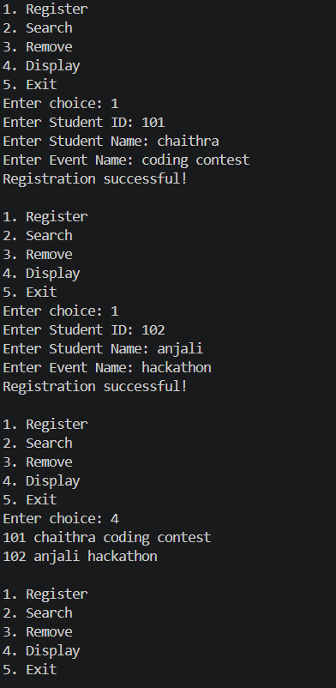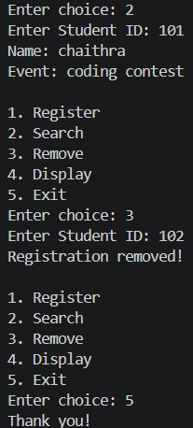
Q8
Task: Smart E-Commerce Platform – Data Structure
Challenge
An e-commerce company wants to build a Smart Online Shopping System
with:
1. Shopping Cart Management – Add and remove products
dynamically.
2. Order Processing System – Orders processed in the order they are
placed.
3. Top-Selling Products Tracker – Products ranked by sales count.

4. Product Search Engine – Fast lookup of products using product ID.
5. Delivery Route Planning – Connect warehouses and delivery
locations.
Student Task:
For each feature, select the most appropriate data structure from
the list below:
o Stack
o Queue
o Priority Queue
o Linked List
o Binary Search Tree (BST)
o Deque
Justify your choice in 2–3 sentences per feature.
Implement one selected feature as a working Python program with
AI-assisted code generation.
Expected Output:
A table mapping feature → chosen data structure → justification.
A functional Python program implementing the chosen feature
with comments and docstrings.
Prompt: Create a simple Python Smart E-Commerce System using suitable data structures. Implement shopping cart, order processing, top-selling products, product search, and delivery planning. Add comments, docstrings, and sample output.
Code:
# Smart E-Commerce System
# Data Structure: Deque

from collections import deque

cart = deque()

def add_product(product):
"""Add a product to the shopping cart."""
cart.append(product)
print(product, "added to cart.")

def remove_product():
"""Remove the last product from the shopping cart."""
if cart:
product = cart.pop()
print(product, "removed from cart.")
else:
print("Cart is empty.")

def display_cart():
"""Display all products in the cart."""
print("Shopping Cart:", list(cart))

# Main program
add_product("Laptop")
add_product("Headphones")
add_product("Mouse")

display_cart()

remove_product()

display_cart()
output:
