
AIAC LAB 9.1
Lab Experiment: DocumentationGeneration–Automatic documentation and code
comments
Name :
Tanushreejoshi
Roll No : 2503A52689
Batch No : 23

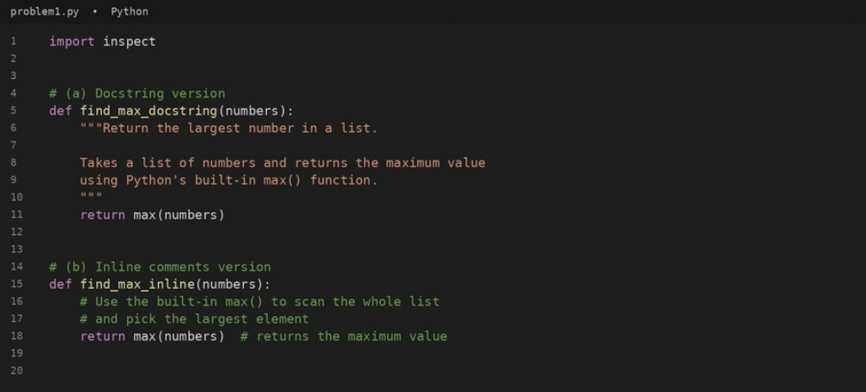
Problem 1 – Documenting find_max() in Three Styles
Question:
Consider thefollowing Pythonfunction:
def find_max(numbers):
return max(numbers)
Task: Write documentation for the function in all three formats: (a) Docstring (b) Inline comments (c) Google-style
documentation. Critically compare the three approaches. Discuss the advantages, disadvantages, and suitable use
cases of each style. Recommend which documentation style is most effective for a mathematical utilities library and
justify your answer.
Answer:
ThePython program below documents find_max() in all three formats and takes the list of numbers from the user.
#code

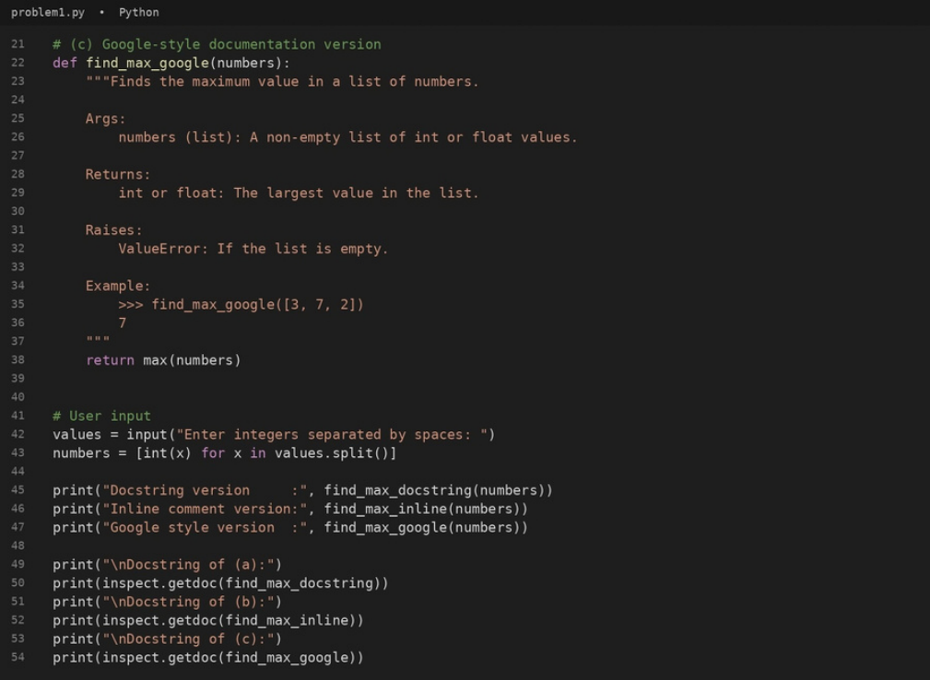


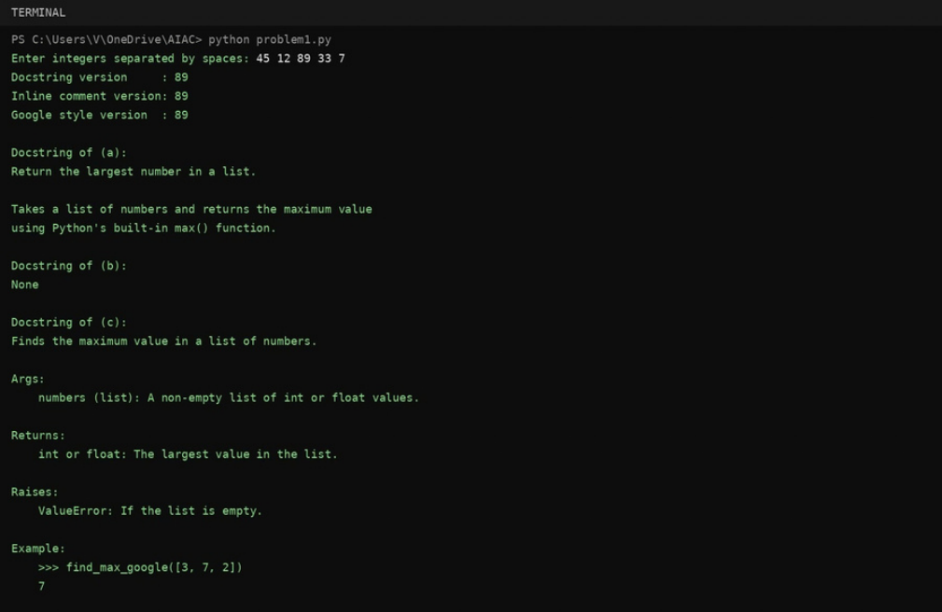
#output
#comparison of the three styles
Style | Advantages | Disadvantages | Suitable use cases

(a) Docstring | Stored with the function, so | A plain summary has no fixed | Small, simple functions that only
(a) Docstring | help(), pydoc and IDE tooltips | structure, so parameter, return | need a short description.
can show it at run time. Short and error details are easy to
and standard (PEP 257). leave out.
(b) Inline | Sit next to the exact line they | Not available through help() or | Tricky or non-obvious logic
(b) Inline | explain; good for explaining why | documentation tools; easily | Tricky or non-obvious logic
comments | something is done. | become outdated; a comment on | inside a function body, mainly for
comments | something is done. | a one-line max() call adds clutter. | maintainers reading the source.

Longer than the code it describes Public APIs, libraries and team
(c) Google- Clear Args / Returns / Raises /
style | Example sections; easy to read | for tiny functions; must be | projects where other people call

as plain text; Sphinx (napoleon) | updated whenever behaviour | the function without reading its

and IDEs can parse it; examples | changes. | code.
can run as doctests.
Recommendation: Google-styledocstrings are the most effective for a mathematical utilities library. Mathematical
functions need precise contracts:the expected input types, what happens in edge cases (an empty list raises
ValueError), the return type andaworked example. The Args / Returns / Raises / Example sections capture all of this
in a fixed structure, the examplesdouble as doctests, and tools such as help(), pydoc, IDE tooltips and Sphinx can
turn them into reference pagesforthe library's users. Inline comments should only supplement them where a line of
logic is not obvious.

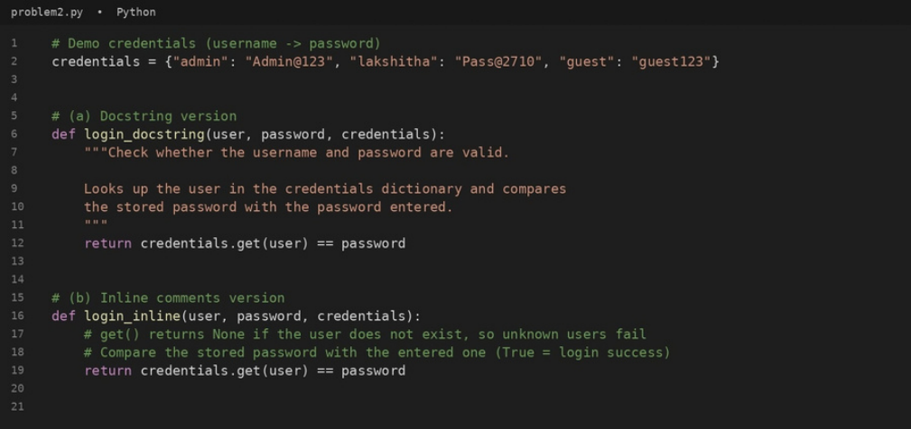
Problem 2 – Documenting login()
Question:
Consider the followingPython function:
def login(user, password, credentials):
return credentials.get(user) == password
Task: Write documentation in all three formats. Critically compare the approaches. Recommend which style would be
most helpful for new developers onboarding a project, and justify your choice.
Answer:
ThePython program below documents login() in all three formats and takes the username and password from the
user.
#cod e

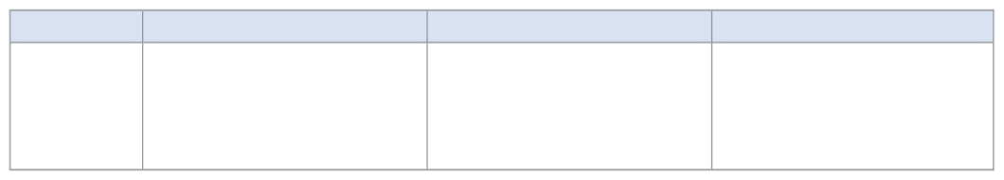
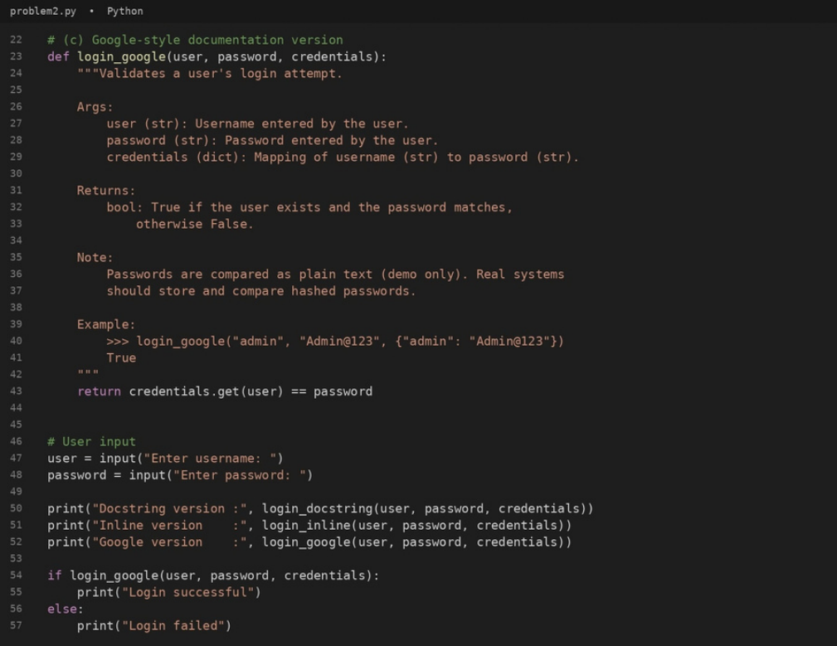
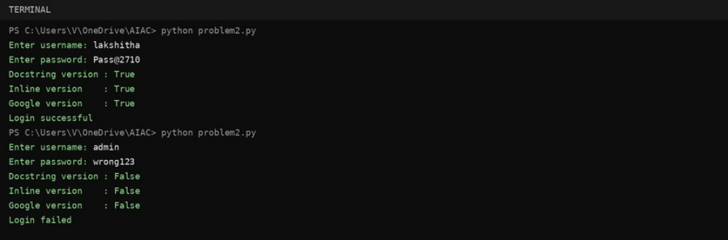
#output
#comparison of the three styles
Style | Advantages | Disadvantages | Suitable use cases

(a) Docstring | Explains the purpose of login() in | A short summary does not say | Quick description of small helper
(a) Docstring | help(login) with very little effort. | what shape credentials must | functions.
have or what is returned for an
unknown user unless the writer
adds it.


Style | Advantages | Disadvantages | Suitable use cases

(b) Inline | Explain details such as get() | A newcomer only sees them after | Clarifying tricky lines for people
comments | returning None for unknown users | opening the source file; not | already working inside the file.
comments | exactly where the logic sits. | shown by help() or generated | already working inside the file.

Args, Returns, Note and Example documentation.
(c) Google- | tell a developer what to pass in |  |  | Takes longer to write and must | Shared or public functions in a
(c) Google- | (including | the | credentials | be kept in sync with the code. | Shared or public functions in a
style | dictionary format) and what to |  |  | be kept in sync with the code. | team codebase, especially for
style | expect, without reading the body. |  |  | be kept in sync with the code. | onboarding.

Same layout across the project.
Recommendation: Google-style docstrings are the most helpful for new developers onboarding a project. A
newcomer can call login() correctly just by reading its docstring: it shows the type of every argument, the structure of
the credentials dictionary, that the result is a bool (False for an unknown user), a runnable example and a security
note about plain-text passwords. The same text appears in help(), IDE tooltips and generated HTML documentation,
so nobody has to open the source. Inline comments are a good supplement for one specific line, but they are
invisible to documentation tools.

Problem 3 – Calculator (Automatic Documentation Generation)
Question:
Task:Design a Python module named calculator.py and demonstrate automatic documentation generation.
Instructions: Create a Python module calculator.py that includes the following functions, each written with appropriate
docstrings:
add(a, b) – returns the sum of two numbers
subtract(a, b) – returns the difference of two numbers
multiply(a, b) – returns the product of two numbers
divide(a, b) – returns the quotient of two numbers
Display the module documentation in the terminal using Python’s documentation tools. Generate and export the
module documentation in HTML format using the pydoc utility, and open the generated HTML file in a web browser to
verify the output.
Answer:
Themodule calculator.py below contains add(), subtract(), multiply() and divide(), each with a docstring. A main block
takesthe numbers and the operation from the user when the file is run directly.
#cod e

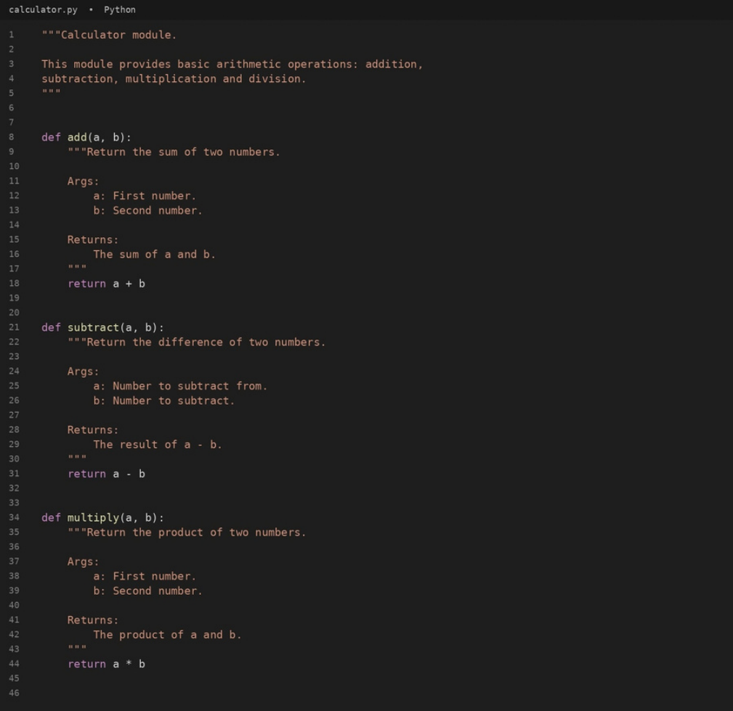

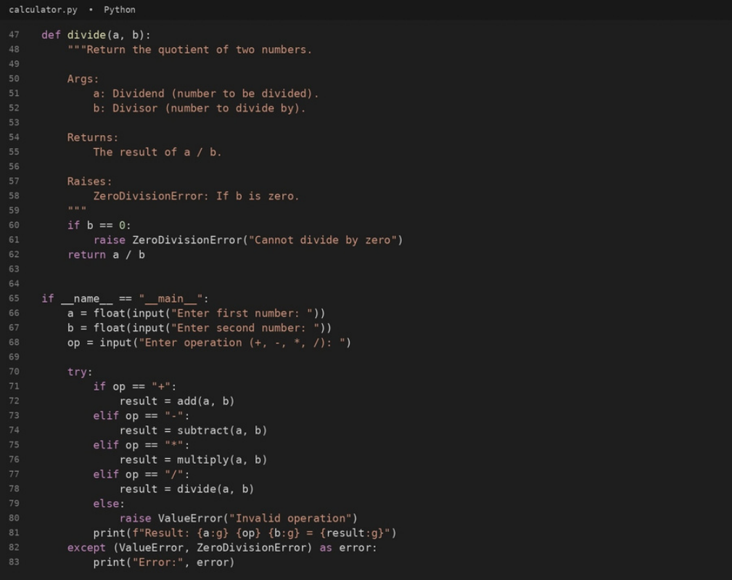
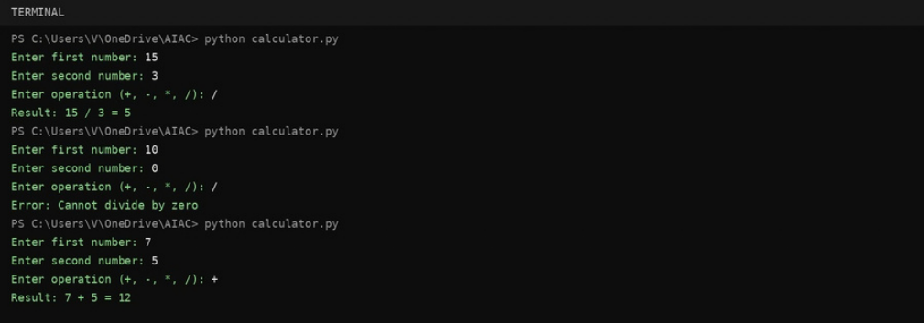
#output

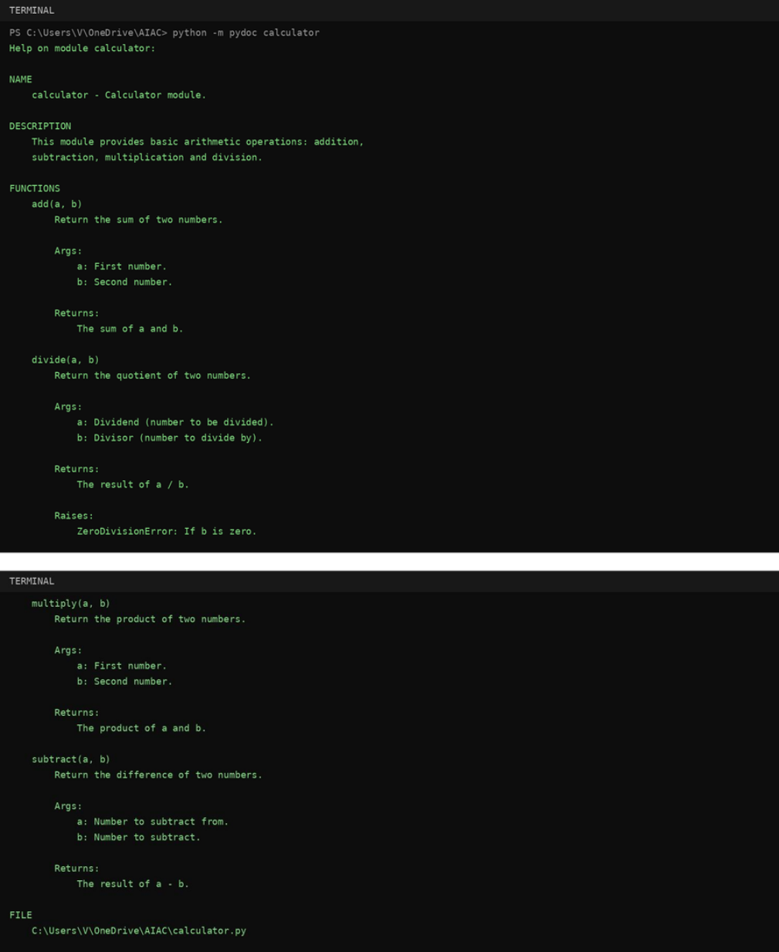
#documentation in the terminal (python -m pydoc calculator)

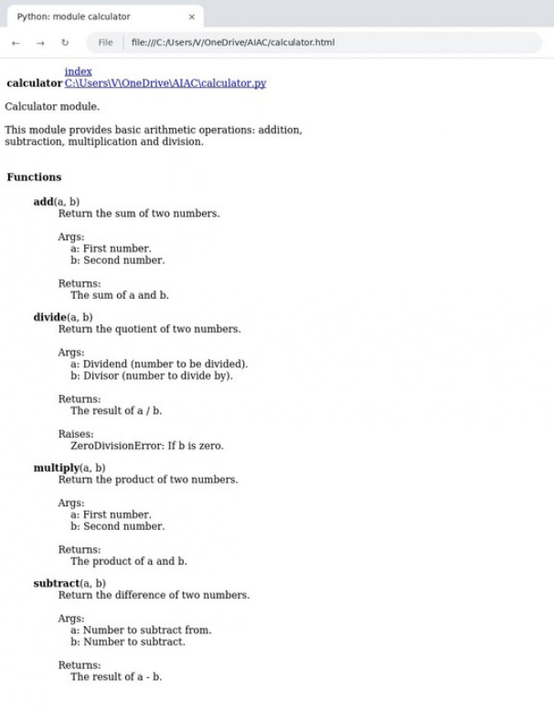
#export documentation as HTML (python -m pydoc -w calculator)
#calculator.html opened in a web browser

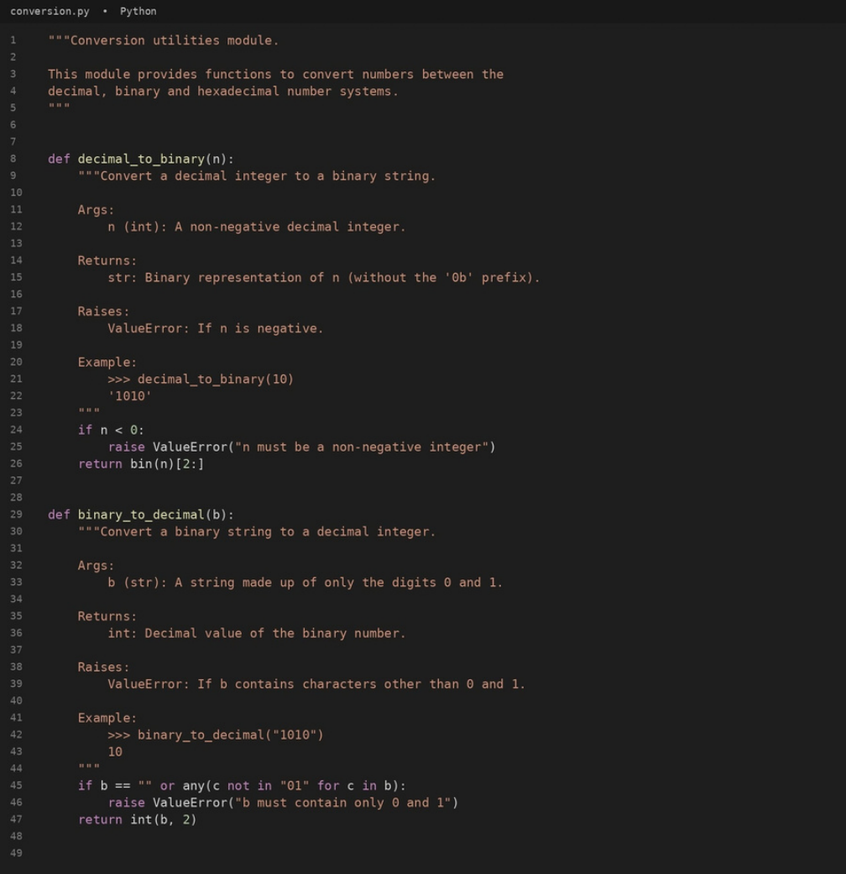
Problem 4 – Conversion Utilities Module
Question:
Task: Write a modulenamed conversion.py with functions: decimal_to_binary(n), binary_to_decimal(b),
decimal_to_hexadecimal(n).
Use Copilot for auto-generating docstrings. Generate documentation in the terminal. Export the documentation in
HTML format and open it in a browser.
Answer:
The module conversion.py below contains the three conversion functions, each with a docstring. A main block asks
the userwhich conversion to perform and reads the number to convert.
#cod e

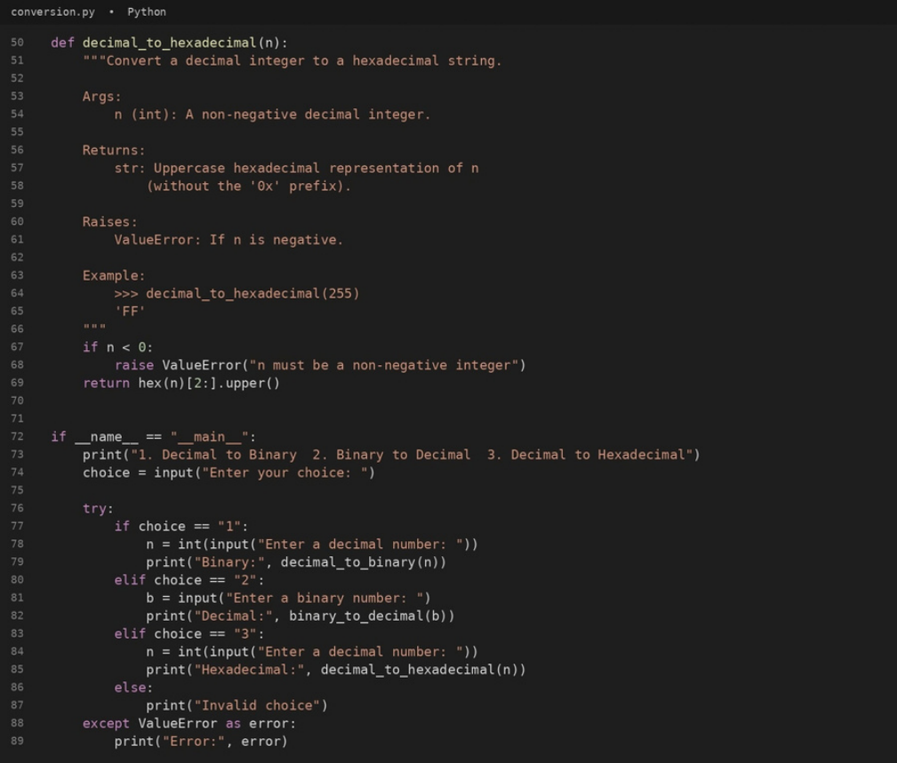
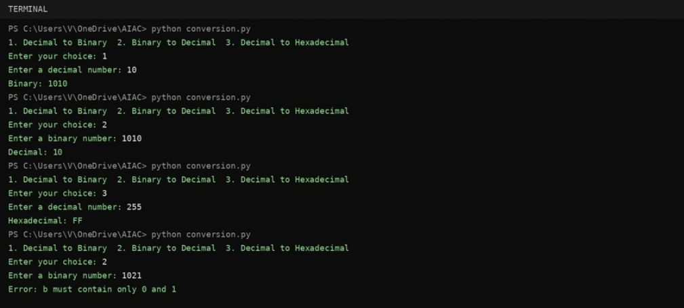
#output

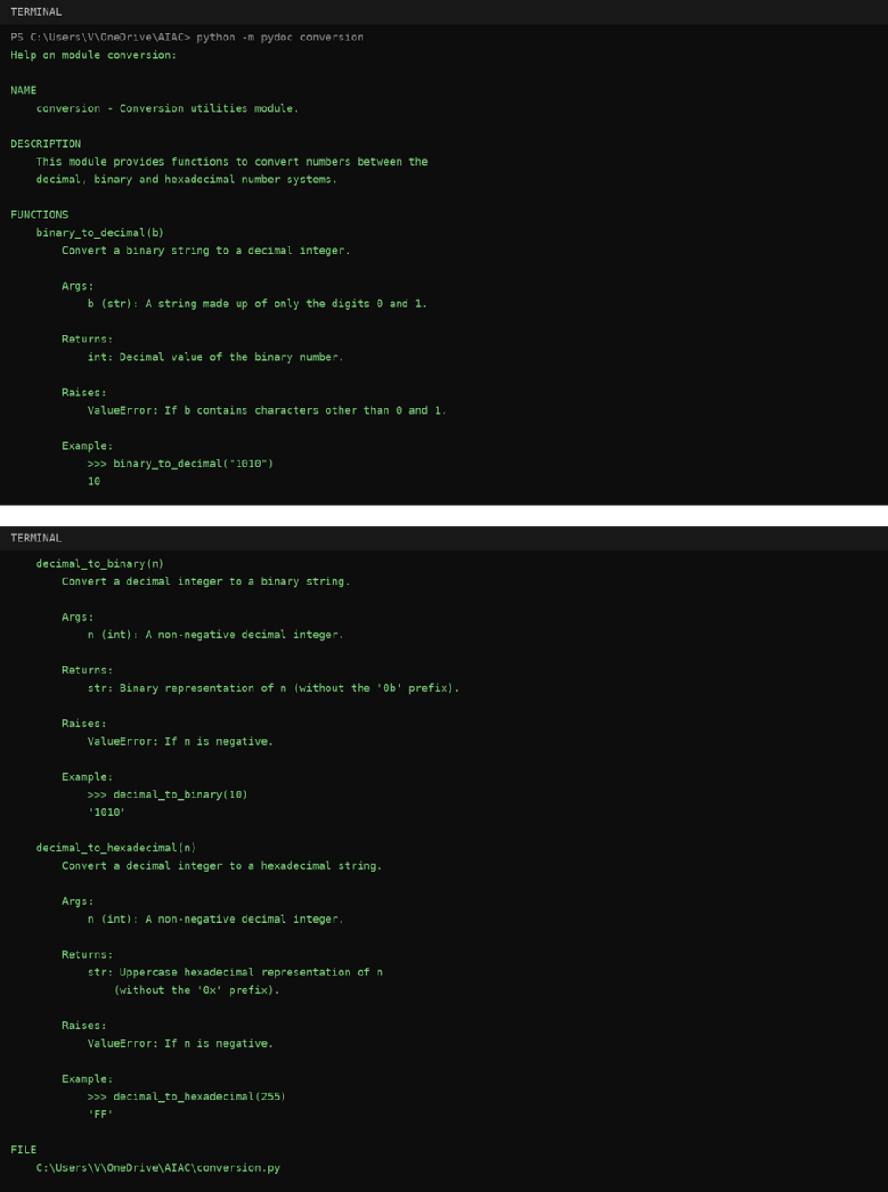
#documentation in the terminal (python -m pydoc conversion)

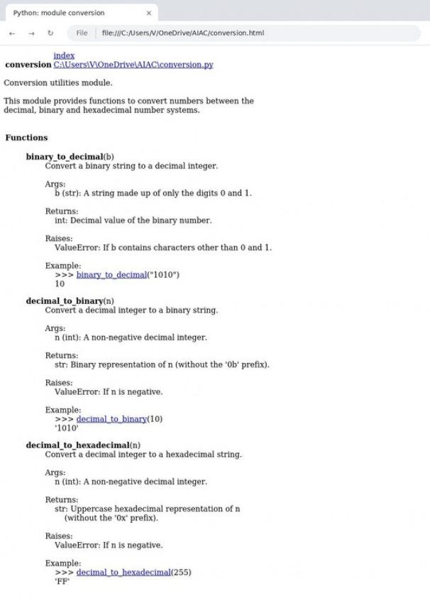
#export documentation as HTML (python -m pydoc -w conversion)
#conversion.html opened in a web browser

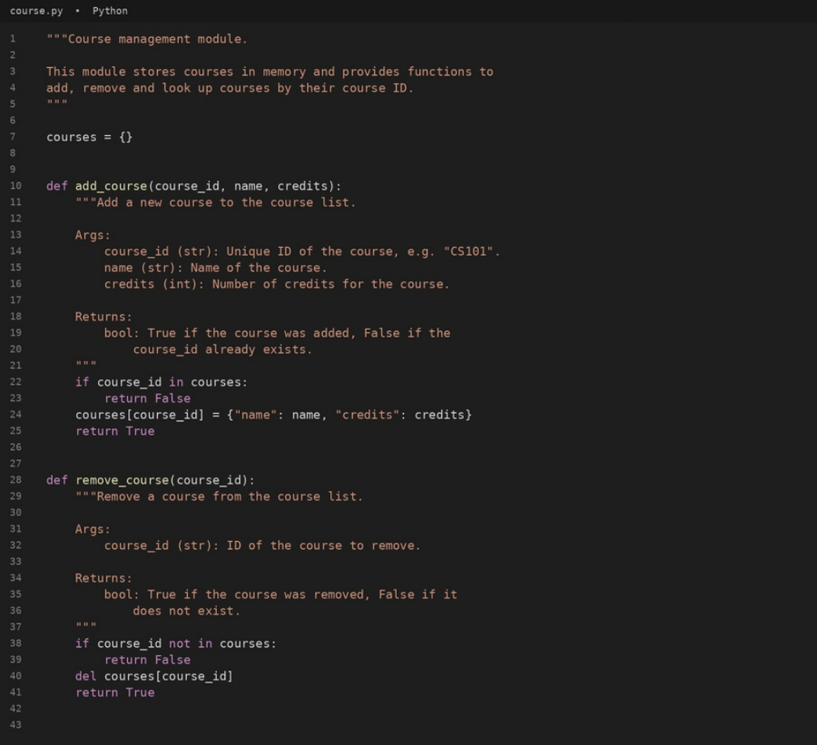
Problem 5 – Course Management Module
Question:
Task: Createa module course.pywith functions: add_course(course_id, name, credits), remove_course(course_id),
get_course(course_id).
Add docstrings with Copilot. Generate documentation in the terminal. Export the documentation in HTML format and
open it in a browser.
Answer:
Themodule course.py below stores courses in memory and provides add_course(), remove_course() and
get_course(), each with a docstring. A menu-driven main block takes the course details from the user.
#code

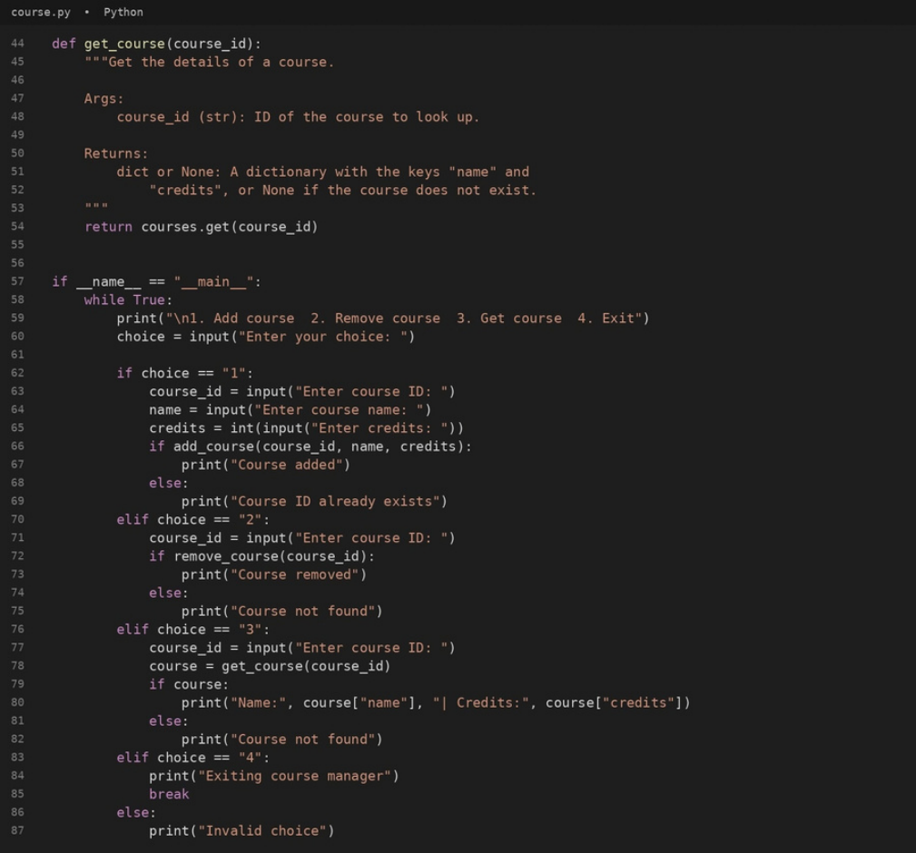

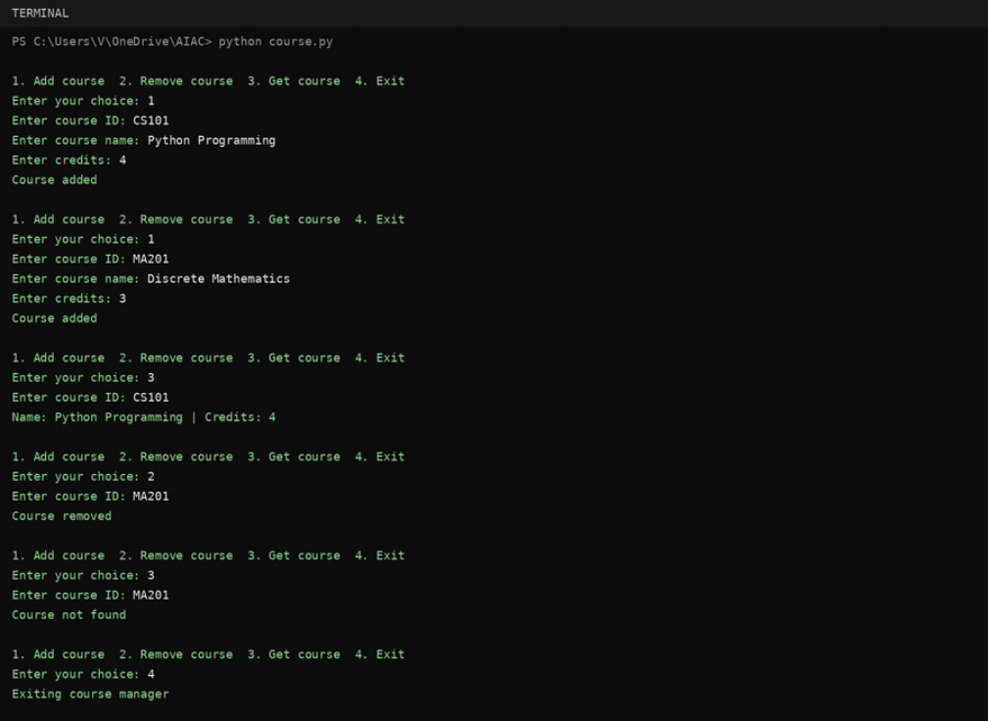
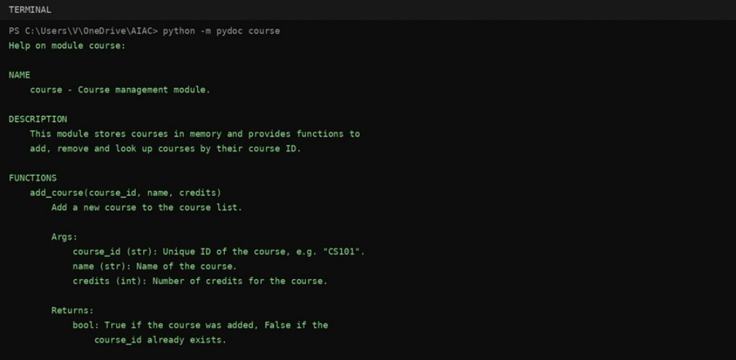
#output
#documentation in the terminal (python -m pydoc course)

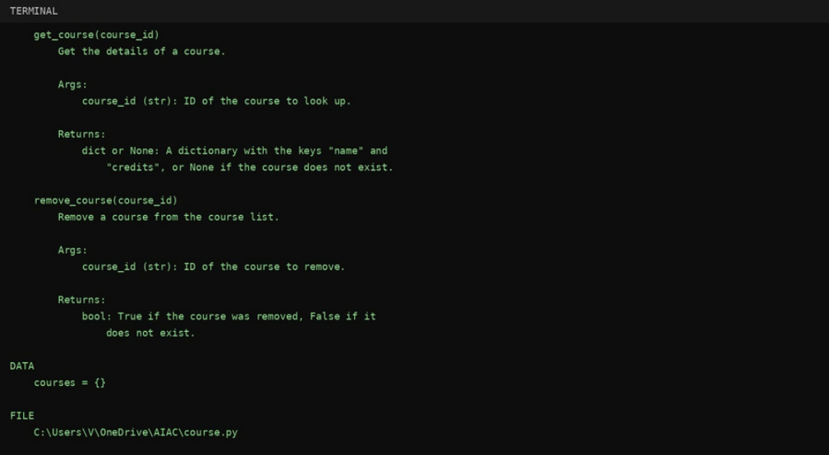
#export documentation as HTML (python -m pydoc -w course)

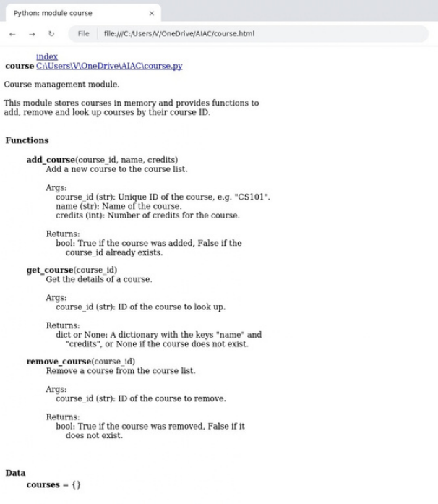
#course.html opened in a web browser

Conclusion
All five problems were completed. find_max() and login() were documented using docstrings, inline comments and
Google-style documentation and the styles were compared. The modules calculator.py, conversion.py and course.py
were documented with docstrings, viewed in the terminal with pydoc, exported as HTML pages with pydoc -w and
verified in a web browser, as required in Lab 9.1.

