**A**

**Project Report**

**On**

**"Med +"**

**Prepared by**

Tanushree Kurup(18DIT030)

Priyal Ramani(D19DIT082)

**Under the guidance of**

Prof. Dipak Ramoliya

A Report Submitted to

Charotar University of Science and Technology

For Partial Fulfillment of the Requirements for the

5th Semester Summer Internship-I (IT346)

**Submitted at**



**Department of Information Technology**

**Devang Patel Institute of Advance Technology and Research**

**At: Changa, Dist: Anand – 388421**

**June 2020**



**CERTIFICATE**

This is to certify that the report entitled “**Med +**” is a bonafide work carried out by **Ms. Tanushree Kurup(18DIT030), Ms. Priyal Ramani(D19DIT082)** under the guidance and supervision of **Prof. Dipak Ramoliya** the subject **IT346 Summer Internship-I** of 5thSemester of Bachelor of Technology in **Department of Information Technology, DEPSTAR** at Faculty of Technology & Engineering – CHARUSAT, Gujarat.

To the best of my knowledge and belief, this work embodies the work of candidate himself, has duly been completed, and fulfills the requirement of the ordinance relating to the B.Tech. Degree of the University and is up to the standard in respect of content, presentation and language for being referred to the examiner.

|  |  |
| --- | --- |
| Prof. Dipak Ramoliya  Assistant Professor  Department of Information Technology  DEPSTAR, CHARUSAT, Changa, Gujarat. |  |
| Dr. Amit Nayak  I/C Head of Department  Department of Information Technology  DEPSTAR, CHARUSAT, Changa, Gujarat | Dr. Amit Ganatra  Principal, DEPSTAR  Dean, FTE  CHARUSAT, Changa, Gujarat. |

**Devang Patel Institute of Advance Technology And Research At:Changa, Ta.Petlad, Dist.Anand, PIN: 388 421. Gujarat**

**Acknowledgement**

We take this opportunity to express our profound gratitude and deep regards to our guide Prof. Dipak Ramoliya for his exemplary guidance, monitoring and constant encouragement throughout the course of this project. The blessing, help and guidance given by his time to time shall carry me a long way in the journey of life on which I am about to embark.

We also take this opportunity to express a deep sense of gratitude to Dr. Amit Nayak. H.O.D of Information Technology department for his cordial support, valuable information and guidance, which helped us in completing this task through various stages.

We are obliged to staff members of IT department, for the valuable information provided by them. We are grateful for their cooperation during the period of our project.

Lastly, we thank almighty, my parents, brothers, sisters and friends for their constant encouragement without which this assignment would not be possible.

**Abstract**

The era of mobile technology opens the windows to the android apps. The websites are vanishing and mobile phones are emerging so its time to change from conventional websites to mobile application. Android is the most widely used mobile platform. In recent years, we have observed an unfathomable growth of mobile users across the world. Smartphone have accomplished billions of people. There is increased penetration of smart phones in the market which means there is a vast scope for mobile apps. People are now using mobile apps for an excess of purposes such as entertainment, shopping, daily planning, booking movie tickets etc. Mobile apps have become a vital portion of the daily lives of the people. These apps modernize the work process of industries too. They assist in the management of employees and the teams. Mobile apps have a wide range of usage in various industries. Among the majority used mobile apps, Android apps are the ones. Android has occupied an important market share in the app market. Many of the users and businesses are using Android apps for a variety of purposes. As a business, it is now essential to have an app. The android app remains to be the top option among the businesses.

A well-designed mobile app can perform actions much quicker than a mobile website. Apps usually store their data locally on mobile devices, in contrast to websites that generally use web servers. For this reason, data retrieval happens swiftly in mobile apps. Apps can further save users’ time by storing their preferences, and using them to take proactive actions on users’ behalf.

There is also a technical justification as to why mobile apps can work faster. Mobile websites use javascript code to perform most of their functions. And the framework that mobile apps use can run almost five times faster than a javascript code.

**Table of Contents**

**Acknowledgement iii**

**Abstract iv**

**Chapter 1 Introduction 7**

1.1 Project definition 7

1.2 Description 8

**Chapter 2 Requirements and Modules 9**

2.1 Hardware and software requirements 9

2.2 Modules ...............................................................................................................10

**Chapter 3 System Design 11**

3.1 Major Functionality 11

3.2 Flow chart 12

3.3 Screenshots……………………………………………………………………...13

**Chapter 4 Constraints and Future Enhancement 22**

4.1 Limitations 22

4.2 Future Enhancement 22

4.3 Outcome………………………………………………………………………………23

**Conclusion………………………………………………………………………......24**

**References………………………………………………………………………......25**

**List of Figures**

**Fig 3.1 Flow Chart 12**

**Fig 3.2 Home page 13**

**Fig 3.3 List of cities 14**

**Fig 3.4 Search bar to search for city 15**

**Fig 3.5 List of medical stores 16**

**Fig 3.6 Search bar to search for medical store 17**

**Fig 3.7 Search bar also shows the previous search history 18**

**Fig 3.8 Add new Medical shop 19**

**Fig 3.9 Crop Photo 20**

**CHAPTER 1: INTRODUCTION**

* 1. **PROJECT DEFINITION:**

People who are new to the state find it difficult to search for the shops and often get confused among the streets, also in time of medical emergency like getting a specific medication urgently it’s helpful if you find the shops as early as possible.

Med + is the android application that allows the user to search for a particular city in Gujarat and also the medical stores in them. It also provides the information like the complete address, phone number and websites if any medical store proves one.

It contains a database attached containing the full name ,address and website link to order medicines online if the shops have one. User can also add new medical shops in the database and can also crop the picture. With the help of the phone number provided the user can make a call and check for the availability of the medicines before rushing to the shops. The user can also identify the nearest shops .It also does not require any internet connection one’s installed as it contains the database within so also helpful in case of network issues .

The application is easy to use and saves a lot of time as compared to using the websites.

**1.2 DESCRIPTION:**

On launching the application the user gets the home page containing the application name and a start button.

On clicking the start button the user is directed to a new page containing a list of cities from Gujarat. The list here is created by the list view. This page also contains a search bar wherein the user can search for a city, using SearchView widget as an item in the preferred way to provide search.

On selecting a city the user is again directed to a new page which is linked with the database table containing the list of the medical stores in the particular city. The database is prepared using SQLite database browser. The database contains a separate table each for a separate city. And each table contains different attributes like name of the shop as primary key , address of the shop , Phone number of the shop and website link. This page also contains a search bar to search for the medical stores, and this search bar also shows the previous search history to make it user friendly.Here we have used RecyclerView for enhancing the user experience and also CardView to bind the name , address , phone number and the website link attributes together.The user can anytime go back to the previous page and select a new city.

The same page contains a button that directs the user to a page where the user can add new stores to the database. The user can also add photo of the store. The picture can be added from the gallery or can take a new picture from camera.On clicking on Add Info button the information gets stored in the database.

**CHAPTER 2: REQUIREMENTS AND MODULES**

**2.1 HARDWARE AND SOFTWARE REQUIREMENTS:**

**Hardware Requirement for Android Studio**

* Intel(R) core(TM) i3-3220
* 3.00 GB RAM
* 2 GB of available disk space minimum

.

**Software Requirement**

* Operating System: Windows 7
* Development Language: android

**Requirements of the android device:**

* 6 MB storage space in device for installation
* Minimum SDK: API 21:Android 5.0(Lollipop)

**2.2 MODULES:**

* **The main modules used in the project are listed below:**
* **ListView:**

Android ListView is a view which groups several items and display them in vertical scrollable list. The list items are automatically inserted to the list using an Adapter that pulls content from a source such as an array or database. In this application we have used the ListView for the list of the cities .

* **RecyclerView:**

RecyclerView is an advanced and flexible version of ListView and GridView. It is a container used for displaying large amount of data sets that can be scrolled very efficiently by maintaining a limited number of views. Here we have used the RecyclerView in the list of cities.

* **CardView:**

CardView wraps a layout and will often be the container used in a layout for each item within a ListView or RecyclerView. Here we have used the CardView in wraping the information like name , address , phone number and link of each shop in the list.

* We have also created a database using SQLite database browser , containing a separate table for each city, and each of the table contains the name ,address and phone number of the shops.
* The application also contains a launching icon as shown below created using adobe creative cloud.
* **Adapter:** In Android, Adapter is a bridge between UI component and data source that helps us to fill data in UI component. It holds the data and send the data to an Adapter view then view can takes the data from the adapter view and shows the data on different views like as ListView, GridView, Spinner etc.

**CHAPTER 3: SYSTEM DESIGN**

**3.1 MAJOR FUNCTIONALITY:**

1. **Medical Store Module:** All the details related to medical stores, their locations, their highlights will be shown in this module. Filtering feature is also available which helps the user to fine relevant store of their own requirement.
2. **User Module:**User can access each and everything available in this system using this module.User can add new information using this module.
3. **Database Module:** All the data, information and text documents will be maintained in this module. This module will also execute queries for activating some particular kind of commands. This module maintains every information present in the system.

**3.2 FLOW CHART:**

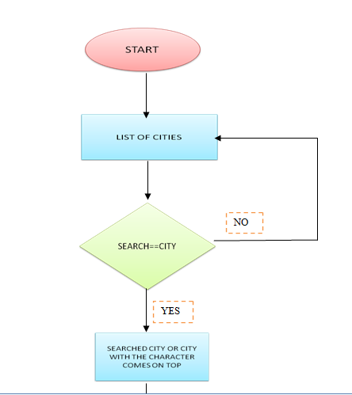

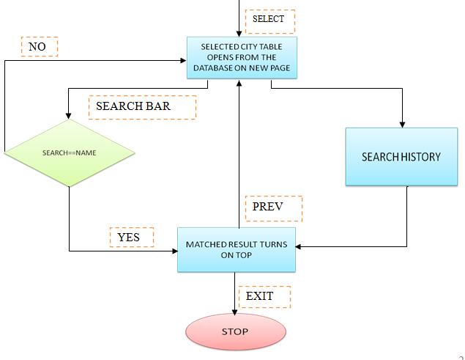

**Fig 3.1 Flow Chart**

**3.3 SCREENSHOTS:**

**1)Home page:**

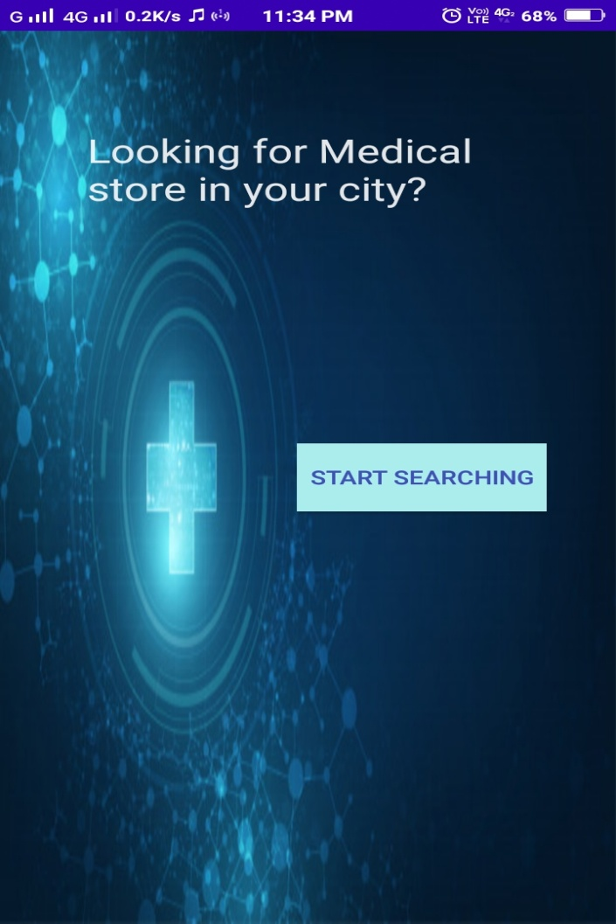

**Fig 3.2 Home page**

**2)List of Cities:**

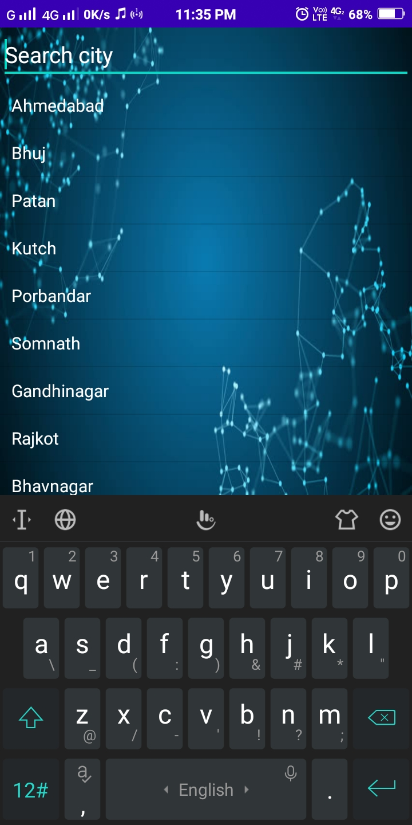

**Fig 3.3 List of cities**

**3)Search bar to search for city:**

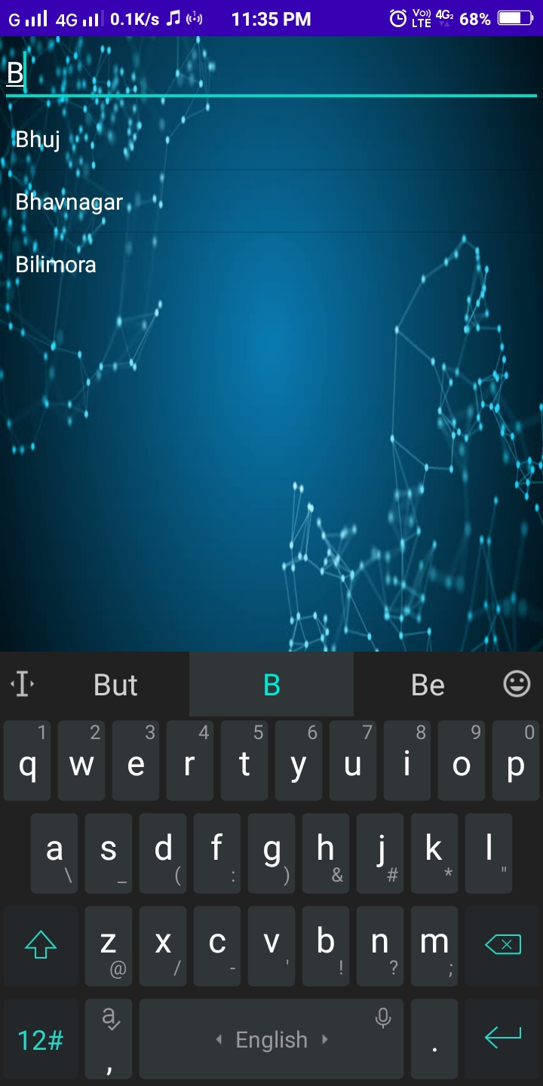

**Fig 3.4 Search bar to search for city**

**4)List of medical stores:**

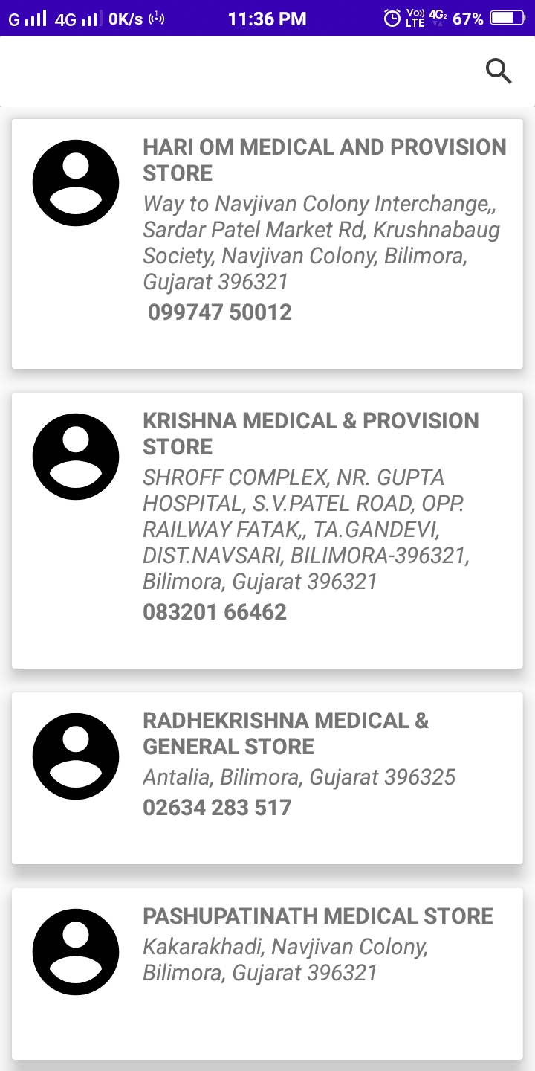

**Fig 3.5 List of medical stores**

**5) Search bar to search for medical store:**

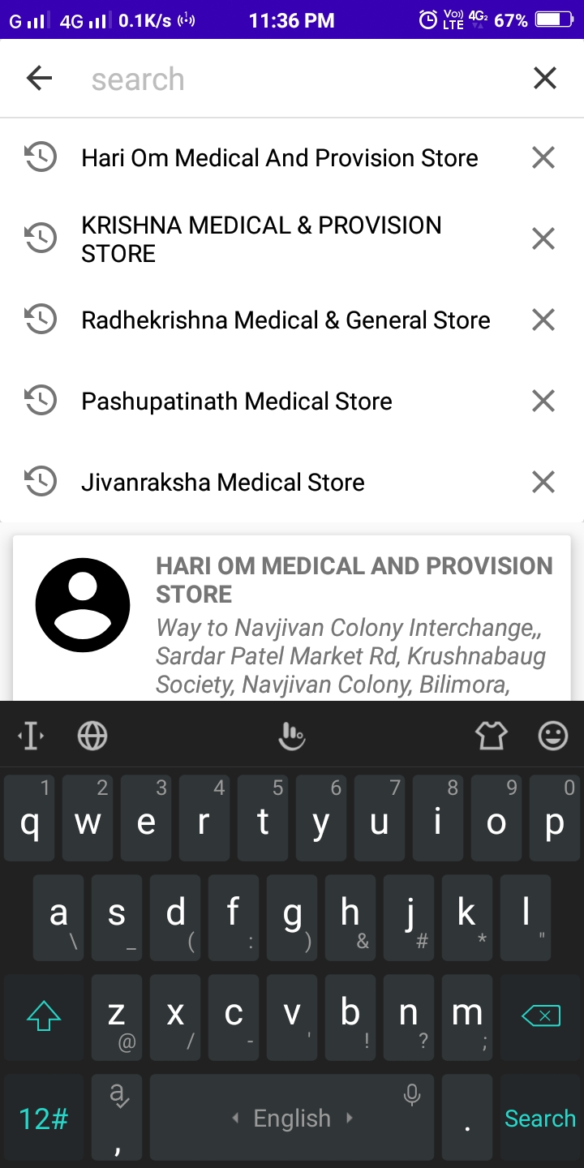

**Fig 3.6 Search bar to search for medical store**

**6)** **Search bar also shows the previous search history:**

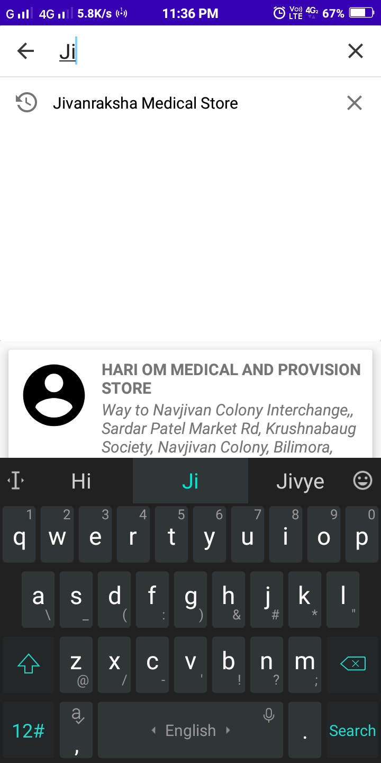

**Fig 3.7 Search bar also shows the previous search history**

**7) Add new Medical shop:**

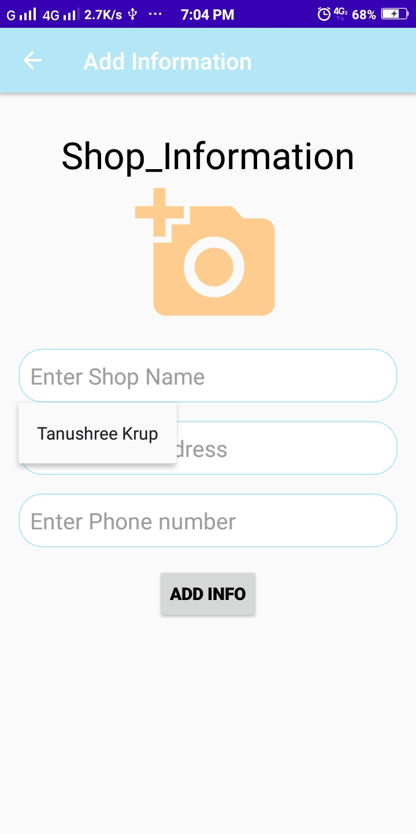

**Fig 3.8 Add new Medical shop**

**8) Crop Photo:**

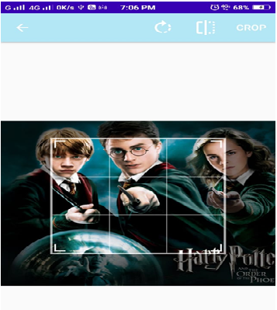

**Fig 3.9 Crop Photo**

**CHAPTER 4: CONSTRAINTS AND FUTURE ENHANCEMENT**

**4.1 LIMITATIONS OF PROJECT**

* The application provides only limited options of cities .
* The application does not support google map services
* IT does not contain any login activity so any user can access the database and make changes to it.

**4.1 FUTURE ENHANCEMENT**

* Med + application provides limited options of cities.
* Login activity can be attached so that only authorized user can make changes to the database and not all.
* Google maps can be attached with the application to enhance user experience.
* The application could filter out the shops nearest to the location of user.
  1. **OUTCOME:**

If the user is new in the city and looking for medical shops the application provides great support.Even if the user don’t have a network connection he or she can easily use the application and find the nearest medical shops near hos or her place .New records can also be added and it also allws to add pictures of the shops so that user can easily find the shops.New pictures can be added by capturing a new picture from the camera or directly from the phone’s gallery enhancing the user’s experience.Easy to search from the list of cities and also through the database using the search bar.It is more helpful than the conventional websites when the application is already installed in the mobile phone.So in an era where everyone is so busy it is more effective to get all the posiible information of a medical store on asingle click.

**CONCLUSION**

* We have learn to create an efficient application by incorporating many new modules like recylerview, cardview and listview,the differences between these views and how too use them efficiently.
* We have also learnt to make some attractive app icons in a way that describes the application effectively,and using these icons in the android studio.
* Hence we have got a deep understanding of android studio.
* Finally we would conclude that our application will be helpful to the people who are new in Gujarat and so would have minimum knowledge of the stores around them.
* So they do not have to waste their energies searching for the medical shops in emergencies as the Med+ app will provide the the entire list in one click without even the internet connection.

**REFERENCES**

**[1] List of Web Reference:**

* [**https://developer.android.com/guide/topics/ui/layout/recyclerview**](https://developer.android.com/guide/topics/ui/layout/recyclerview)
* [**https://guides.codepath.com/android/using-the-cardview**](https://guides.codepath.com/android/using-the-cardview)
* [**https://datacarpentry.org/sql-socialsci/02-db-browser/index.html**](https://datacarpentry.org/sql-socialsci/02-db-browser/index.html)
* [**https://www.youtube.com/watch?v=KvpulitmjbM**](https://www.youtube.com/watch?v=KvpulitmjbM)
* [**https://projectsgeek.com/2016/05/medical-search-engine-android-project.html**](https://projectsgeek.com/2016/05/medical-search-engine-android-project.html)

**[2] List of Text Reference:**

1. Android App Development

**Author**: Hemant Oza

1. Software Engineering

**Author:** Ian Sommerville