Express-validator 🡪 <https://flaviocopes.com/express-validate-input/>

MIDDLEWARE 🡪 <https://blog.webdevsimplified.com/2019-12/express-middleware-in-depth/>

Passing props though route (protected route) 🡪 <https://dev.to/cesareferrari/using-the-route-render-prop-in-react-k5a>

code:

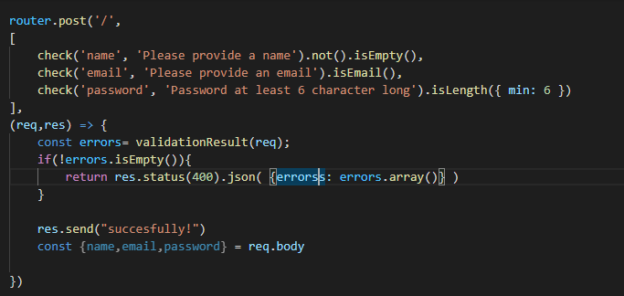

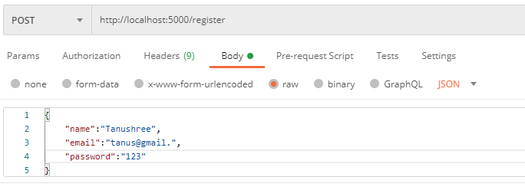

Output:

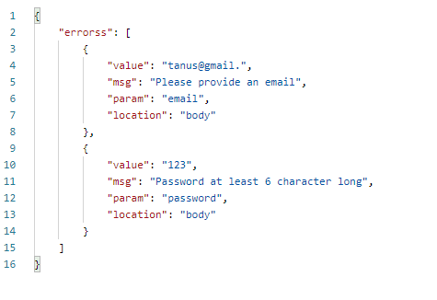

USER AFTER HASHING PASSWORD WITH BCRYPT

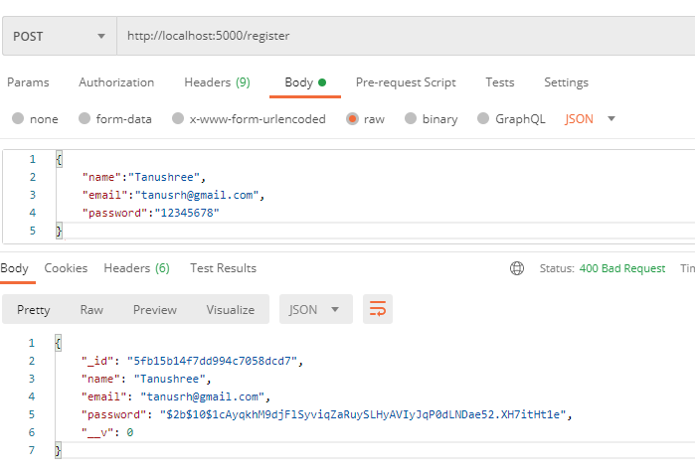

user.id gives same result as user._id

code:

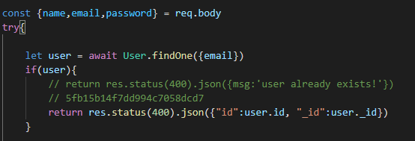

Output:

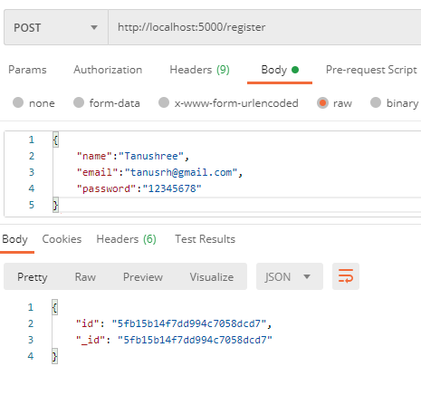

Protected route 🡪 files : middleware-auth.js AND routes-login.js

Login/register to get token

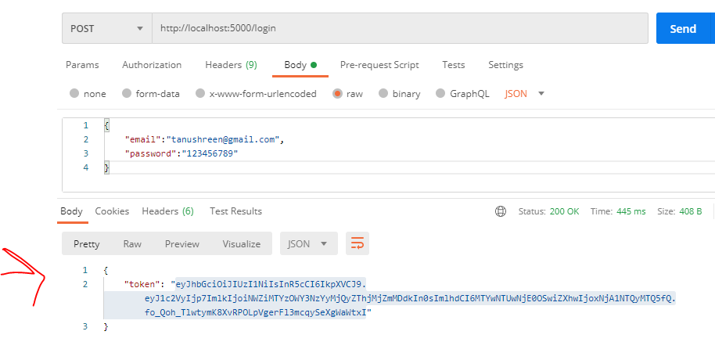

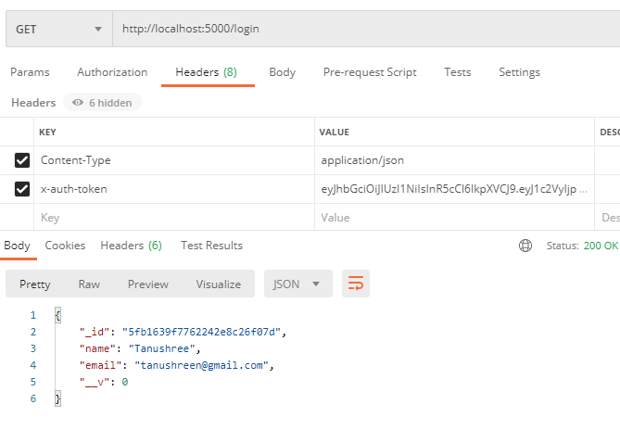

ADD NEW GUESTS

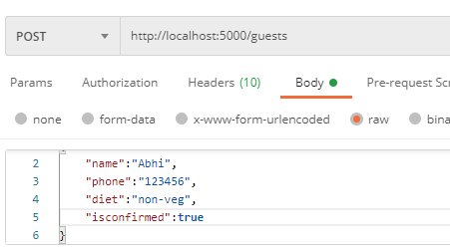

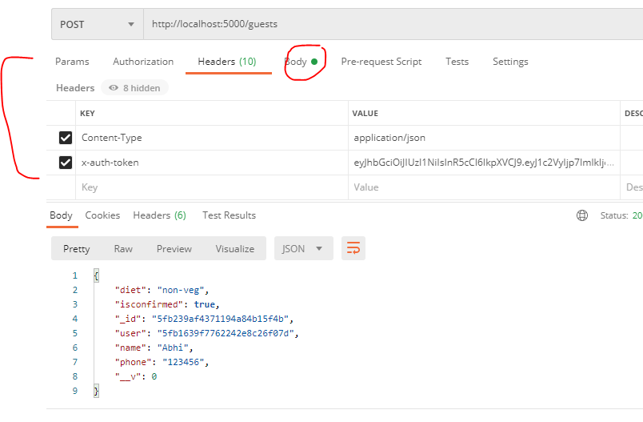

GET ALL GUESTS OF THAT USER

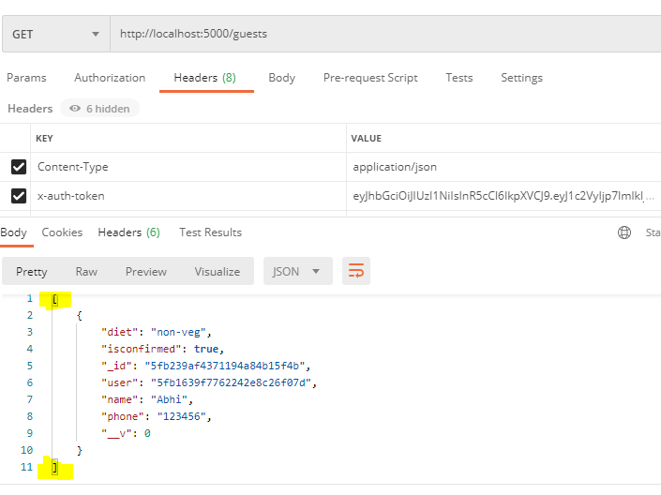

// ,

//     "proxy":"http://localhost:5000"

DEL of guests:

