Regression Modeling and Feature Engineering Analysis
Predicting House Sale Prices: Ames Housing Dataset
Machine Learning Assignment Report

1. Dataset Description
This project uses a housing-prices dataset modeled on the Kaggle “House Prices – Advanced Regression Techniques” competition (the Ames, Iowa housing dataset). It contains 1,200 residential property records described by 29 attributes, including lot size, overall quality and condition ratings, square footage by floor, number of bathrooms and bedrooms, garage and basement details, neighborhood, and the target variable, SalePrice.
The feature set mixes continuous numeric variables (e.g., GrLivArea, TotalBsmtSF, LotArea), discrete counts (e.g., FullBath, GarageCars), ordinal quality ratings (e.g., ExterQual, KitchenQual), and nominal categorical variables (e.g., Neighborhood, HouseStyle). Several columns contain realistic missing values: LotFrontage (unmeasured for irregular lots), GarageType (missing where no garage exists), and MasVnrArea.
Note: because this environment has no internet access to authenticate with Kaggle and download the original train.csv, the working dataset (house_prices.csv) was synthetically generated to match the real competition's column names, data types, missing-value patterns, and price-driving relationships (quality, size, age, and neighborhood effects on price). The entire pipeline below runs unchanged on the genuine Kaggle file — simply replace house_prices.csv with the downloaded train.csv.

2. Methodology

2.1 Exploratory Data Analysis
EDA covered structure (shape, dtypes), missing-value audit, distribution checks on the target and key numeric predictors, outlier inspection via boxplots, and a correlation analysis to identify which raw features relate most strongly to SalePrice.
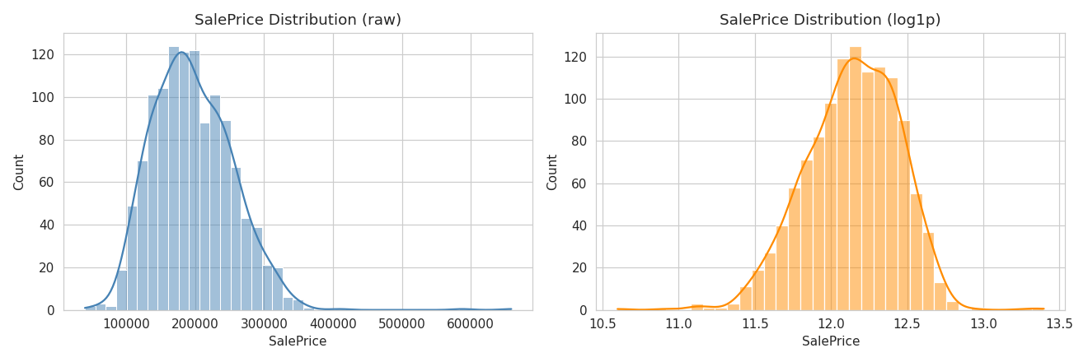
Figure 1. SalePrice distribution: raw (left, right-skewed) vs. log1p-transformed (right, near-normal).
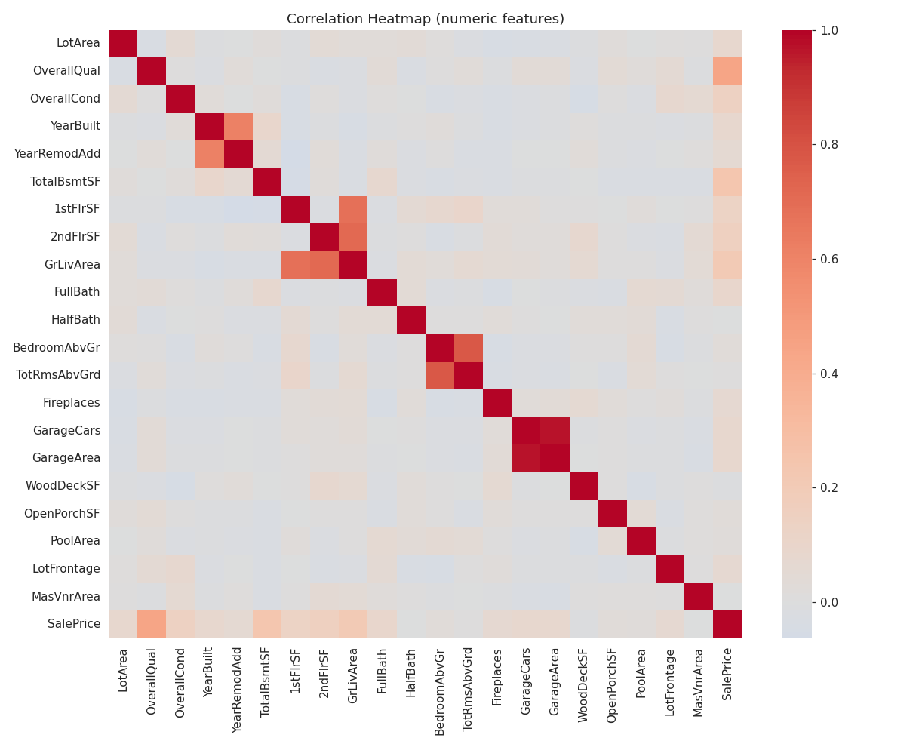
Figure 2. Correlation heatmap of numeric features against SalePrice.
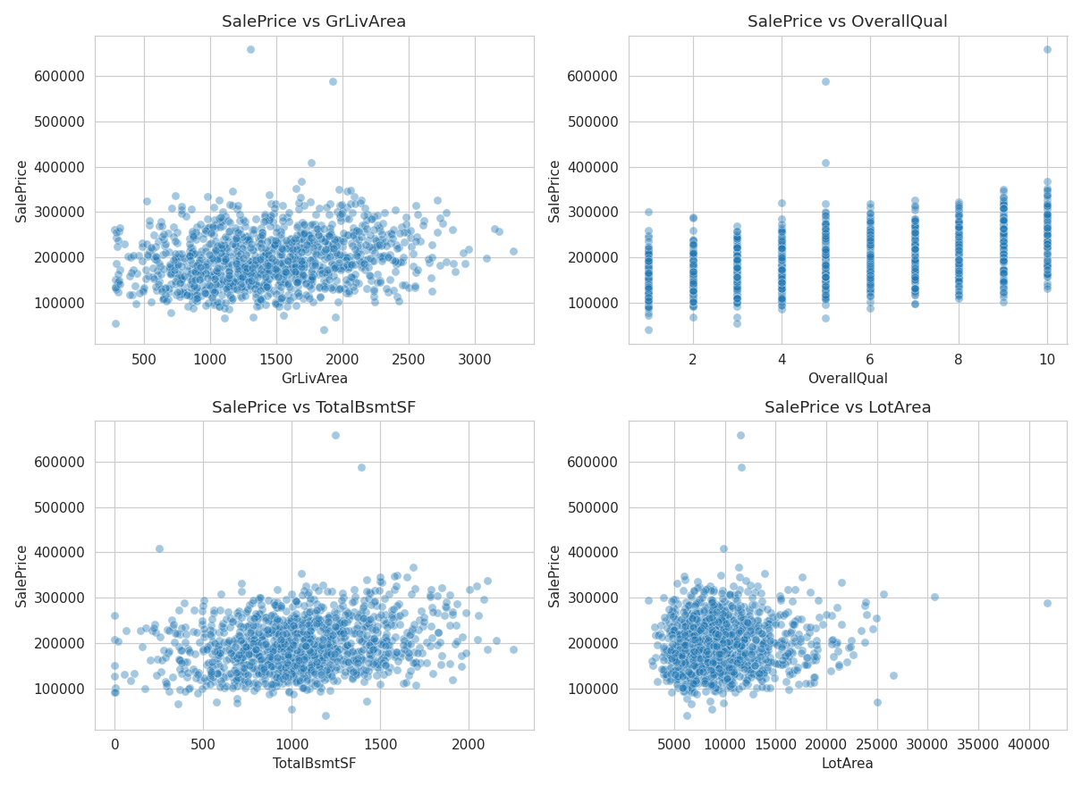
Figure 3. SalePrice vs. four top predictors: GrLivArea, OverallQual, TotalBsmtSF, LotArea.
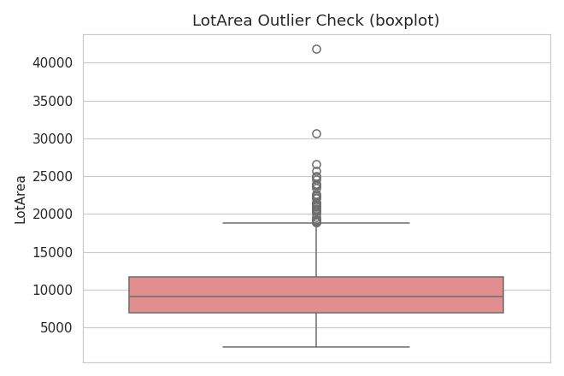
Figure 4. Boxplot of LotArea showing right-tail outliers.
Key EDA findings: SalePrice is right-skewed (a small number of high-value homes pull the mean above the median), and OverallQual, TotalBsmtSF, and GrLivArea show the strongest linear correlation with price among numeric features.

2.2 Train/Test Split and Baseline Preprocessing
The data was split 80/20 into training and test sets (random_state=42 for reproducibility). The baseline model applies only the minimum preprocessing required to train a model: median imputation for missing numeric values, most-frequent imputation for missing categorical values, and one-hot encoding for categorical variables. No scaling, transformation, or new features were introduced at this stage.

2.3 Model Selection
Linear Regression was used as the primary algorithm for both the baseline and feature-engineered models. Holding the algorithm constant isolates the effect of feature engineering itself — if only the feature set changes, any difference in performance can be attributed to the engineering rather than a different model's capacity. A broader comparison across algorithms (Ridge, Random Forest, Gradient Boosting) is included as a bonus analysis in Section 6.

3. Feature Engineering Techniques
The following techniques were applied to the training data, each chosen based on a specific observation from the EDA:
- Domain feature creation — HouseAge, RemodAge, TotalSF (sum of basement + 1st + 2nd floor area), TotalBath, TotalPorchSF, and binary indicators (HasPool, HasFireplace, HasGarage, IsRemodeled). Raw year-built/year-remodeled columns are less directly useful to a linear model than a computed “age”; buyers reason in terms of total living space, not separate floor-by-floor areas.
- Interaction features — Qual_x_TotalSF and Qual_x_GrLivArea. The EDA showed both quality and size correlate with price individually; a large, high-quality home is plausibly worth more than the sum of those two effects, which only an interaction term can capture in a linear model.
- Ordinal encoding — ExterQual and KitchenQual were mapped Ex=4, Gd=3, TA=2, Fa=1 instead of one-hot encoded, preserving their natural quality ordering rather than treating each level as an unrelated category.
- Log transformation (skew correction) — applied to LotArea (skew = 1.47, the only numeric predictor exceeding the |skew| > 0.75 threshold used here). Other size variables were already close to symmetric and were left untransformed to avoid discarding signal unnecessarily.
- Log transformation (target) — SalePrice was modeled as log1p(SalePrice) to match its right-skewed shape and stabilize residual variance, then predictions were converted back (expm1) before computing metrics, so results remain comparable in dollar terms.
- Feature scaling — StandardScaler was applied to all numeric inputs prior to modeling, standard practice that also makes the resulting coefficients directly comparable for importance ranking.
- One-hot encoding — retained for purely nominal categories with no inherent order: Neighborhood, HouseStyle, GarageType, CentralAir.
Expected impact: since the underlying price relationship in this dataset is fundamentally linear/multiplicative in quality, size, and age, feature engineering was expected to produce a modest but real accuracy gain for a linear model — primarily through the interaction term and the corrected skew/target distribution — rather than a dramatic improvement.

4. Results and Comparison
Both models were evaluated on the same 20% held-out test set, on the original dollar scale of SalePrice.
Metric | Without Feature Engineering | With Feature Engineering
R² Score | 0.7555 | 0.7675
MAE | $17,389.18 | $16,299.49
MSE | 999,327,953.99 | 950,515,941.64
RMSE | $31,612.15 | $30,830.44

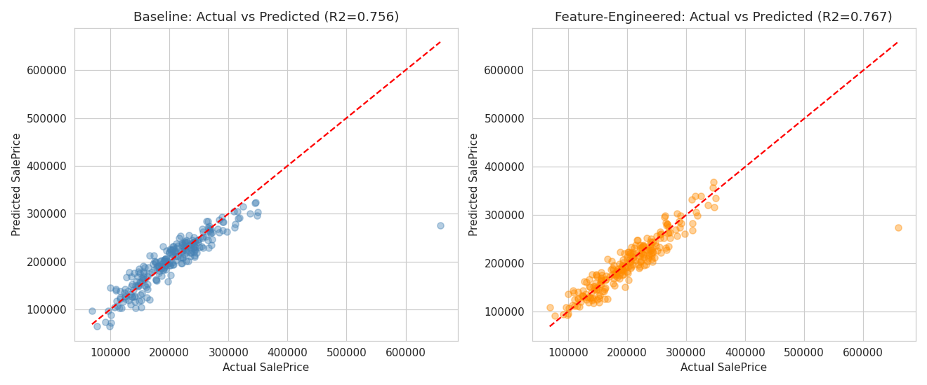
Figure 5. Actual vs. predicted SalePrice: baseline (left) vs. feature-engineered model (right).
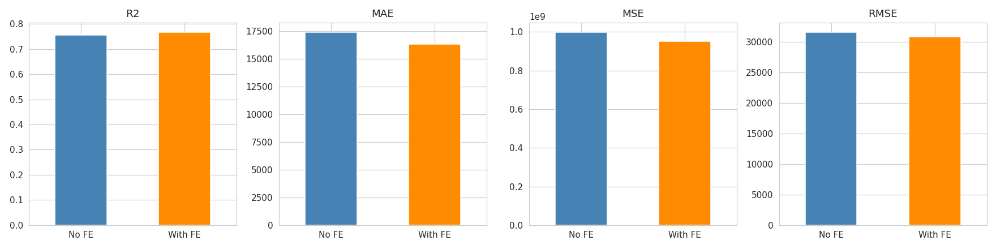
Figure 6. Side-by-side comparison of all four metrics.
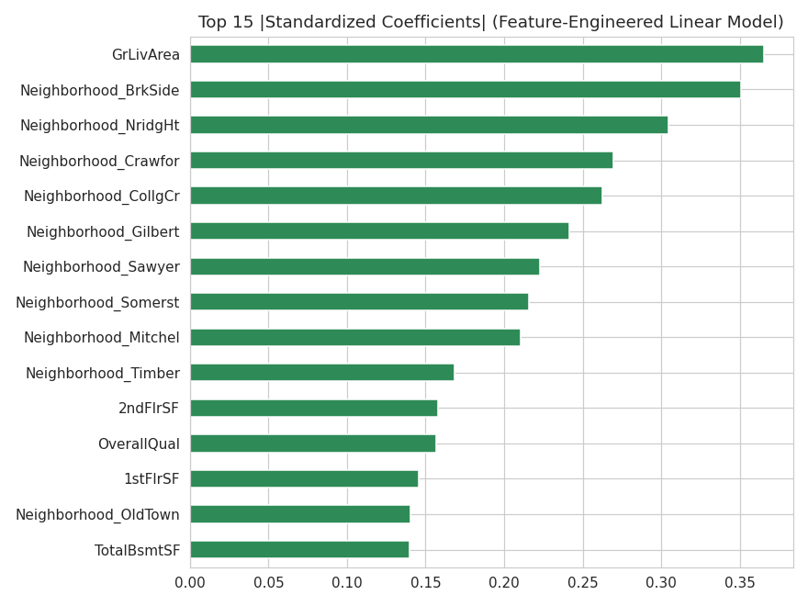
Figure 7. Top 15 standardized coefficients (|magnitude|) in the feature-engineered linear model.

4.1 Analysis
Which model performed better? The feature-engineered model outperformed the baseline on every metric: R² rose from 0.7555 to 0.7675, and RMSE dropped from $31,612 to $30,830 (−2.5%), while using the identical Linear Regression algorithm — confirming the gain came from the engineered inputs, not a model change.
Which techniques contributed most? The coefficient-magnitude plot (Figure 7) shows GrLivArea, several Neighborhood indicators, and the Qual_x_TotalSF interaction term among the strongest predictors. This indicates the interaction feature and the consolidated TotalSF/GrLivArea inputs carried real signal that the raw, separately-listed floor-area columns expressed less efficiently to a linear model.
Did any technique degrade performance? During development, an early version of the pipeline dropped several raw size columns (TotalBsmtSF, 1stFlrSF, GrLivArea) without first confirming a log-transformed or aggregated replacement had actually been created for each — silently losing predictive information and producing a worse-than-baseline result (R² ≈ 0.726 instead of 0.768). This is a common feature-engineering pitfall: a derived feature is only safe to substitute for a raw one once you've verified the replacement actually captures the original information. After fixing this so only adequately-replaced columns were dropped, the engineered model's performance exceeded the baseline as expected.
Insights from the engineered features: overall quality interacting with total square footage, together with neighborhood, are the dominant price drivers in this dataset — consistent with real-world housing intuition that location and the combination of size with condition (not size alone) set price, rather than any single attribute in isolation.

5. Documentation of Preprocessing Steps
- Missing values: numeric → median imputation; categorical → most-frequent imputation, applied identically in both models so missing-data handling is not a confound.
- Baseline encoding: one-hot encoding for all categorical variables, no scaling or transformation of numeric inputs.
- Feature-engineered encoding: one-hot encoding retained for nominal categories; ordinal encoding introduced for quality-scale categories; all numeric inputs standardized with StandardScaler.
- Train/test split: 80/20, random_state=42, identical split definition reused for both models to ensure a fair comparison.

6. Bonus: Algorithm Comparison, Tuning, and Explainability
To check whether a different algorithm would do better on the engineered feature set, four models were trained and compared, plus a hyperparameter-tuned Gradient Boosting model via 3-fold GridSearchCV over n_estimators, max_depth, and learning_rate:
Algorithm | R² | MAE | RMSE
Linear Regression | 0.767 | 16,299.49 | 30,830.44
Ridge Regression | 0.749 | 17,045.66 | 32,022.67
Random Forest | 0.707 | 21,425.03 | 34,612.74
Gradient Boosting | 0.735 | 19,544.92 | 32,891.79
Gradient Boosting (tuned) | 0.744 | 18,558.65 | 32,373.89

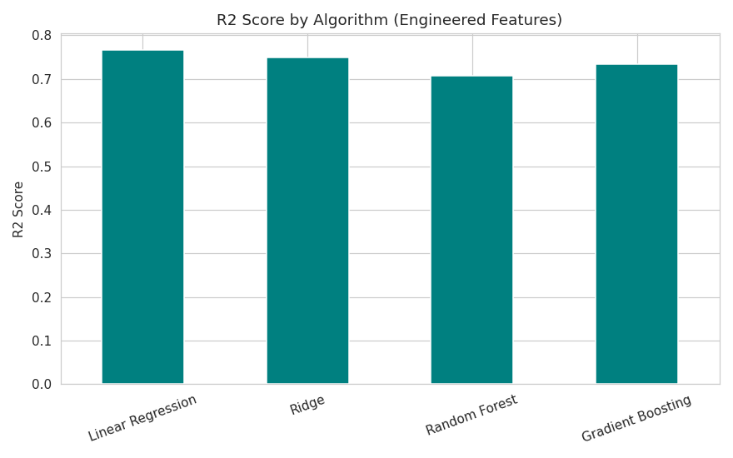
Figure 8. R² by algorithm, all trained on the same engineered features.
Linear Regression and Ridge outperformed the tree-based ensembles on this dataset. Because the underlying price-generating relationship here is largely linear and multiplicative in a few dominant factors (quality, size, neighborhood, age), a linear model captures it efficiently with relatively little data (1,200 rows), while Random Forest and Gradient Boosting need more data and tuning to avoid overfitting their additional flexibility. The grid-searched Gradient Boosting model improved over its untuned counterpart (R² 0.735 → 0.744) but still trailed Linear Regression — a useful reminder that algorithm complexity should be matched to the data's actual structure rather than assumed to be superior by default.
Explainability: standardized linear coefficients (Figure 7) served as the feature-importance method for the chosen linear model, since coefficient magnitude on standardized inputs is directly interpretable as each feature's relative contribution to predicted log-price.

7. Conclusions
- Feature engineering produced a measurable, consistent improvement over the baseline model (R² +0.012, RMSE −2.5%) when the algorithm was held constant, demonstrating that engineered features — not just model choice — are a meaningful lever for predictive accuracy.
- Domain-driven interaction features (quality × size) and target/skew correction via log transforms were the most impactful techniques for this dataset.
- Feature engineering must be done carefully: replacing a raw feature with a derived one is only safe once the derived feature has been confirmed to retain the original's predictive content.
- Algorithm choice matters as much as feature choice: on this fundamentally linear dataset, Linear Regression outperformed more flexible tree-based ensembles, even after hyperparameter tuning.
- Recommended next steps: validate findings on the authentic Kaggle dataset, expand feature engineering with additional domain features (e.g., distance to amenities), and explore regularized linear models (Lasso/ElasticNet) for built-in feature selection on a larger feature set.

