Predictive Modeling and Optimization in Logistics Systems
Submitted by: Tanushree

1. Introduction
Logistics operations depend on reliable delivery estimates, efficient shipping methods, and timely identification of potential delays. Predictive analytics can help organizations understand the factors associated with shipment duration and make better operational decisions. This task uses the DataCo Smart Supply Chain dataset to build and evaluate machine-learning regression models for predicting actual shipping duration.

2. Problem Definition and Dataset
The problem is to estimate the actual number of days required to ship an order. The target variable is “Days for shipping (real)”. Candidate input features include scheduled shipping duration, shipping mode, product category, customer segment, sales, order country, product price, order-item quantity, department, and market. The dataset is a publicly available supply-chain dataset and contains operational and order-related fields. The analysis is performed on the local CSV file DataCoSupplyChainDataset.csv.
Data preparation includes selecting relevant features, separating the target from predictors, handling categorical and numeric columns through preprocessing, and splitting the data into training and test sets. Any model evaluation should be interpreted in the context of the selected features and the limitations of the dataset.

3. Model Selection and Methodology
Regression was selected because shipping duration is a numeric target. Decision Tree Regression provides a non-linear baseline that can represent rule-like relationships. Random Forest Regression combines multiple decision trees and can capture more complex relationships while reducing the variance of a single tree. The script selected Random Forest because it produced the lower test RMSE among the compared models, then applied a small three-fold RandomizedSearchCV search to tune its hyperparameters.
The tuning search selected 120 trees, a minimum leaf size of 5, max_features of 0.7, and a maximum tree depth of 10. The model was then evaluated on the held-out test set.

4. Evaluation Metrics and Results
Metric | Observed result
Selected model | Tuned Random Forest Regressor
MAE | 0.9848 days
RMSE | 1.2674 days
R² score | 0.3907 (approximately 39.1%)
Mean Absolute Error (MAE) is the average absolute difference between actual and predicted shipping duration. The observed MAE of approximately 0.985 days means that the typical absolute prediction error is close to one day on this test set. Root Mean Squared Error (RMSE) is approximately 1.267 days and penalizes larger errors more heavily. The R² score of 0.391 indicates that the model explains about 39.1% of the variation in the target on the test set. This is a moderate, limited level of explanatory performance; the model should not be treated as a highly accurate operational forecasting system yet.

5. Visualization 1: Feature Importance
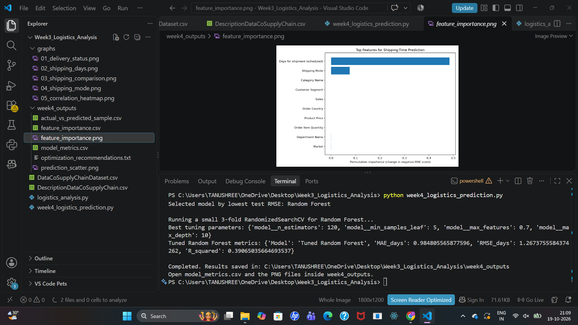
The permutation-importance chart shows that scheduled shipping duration is the most influential feature in the current model. Shipping mode is the next most influential feature, while the remaining shown variables have relatively small importance. This suggests that the delivery schedule and shipping method contain useful information for estimating actual shipping duration. However, importance reflects this model and dataset; it does not prove that a feature causes delays.

6. Visualization 2: Actual vs. Predicted Shipping Time
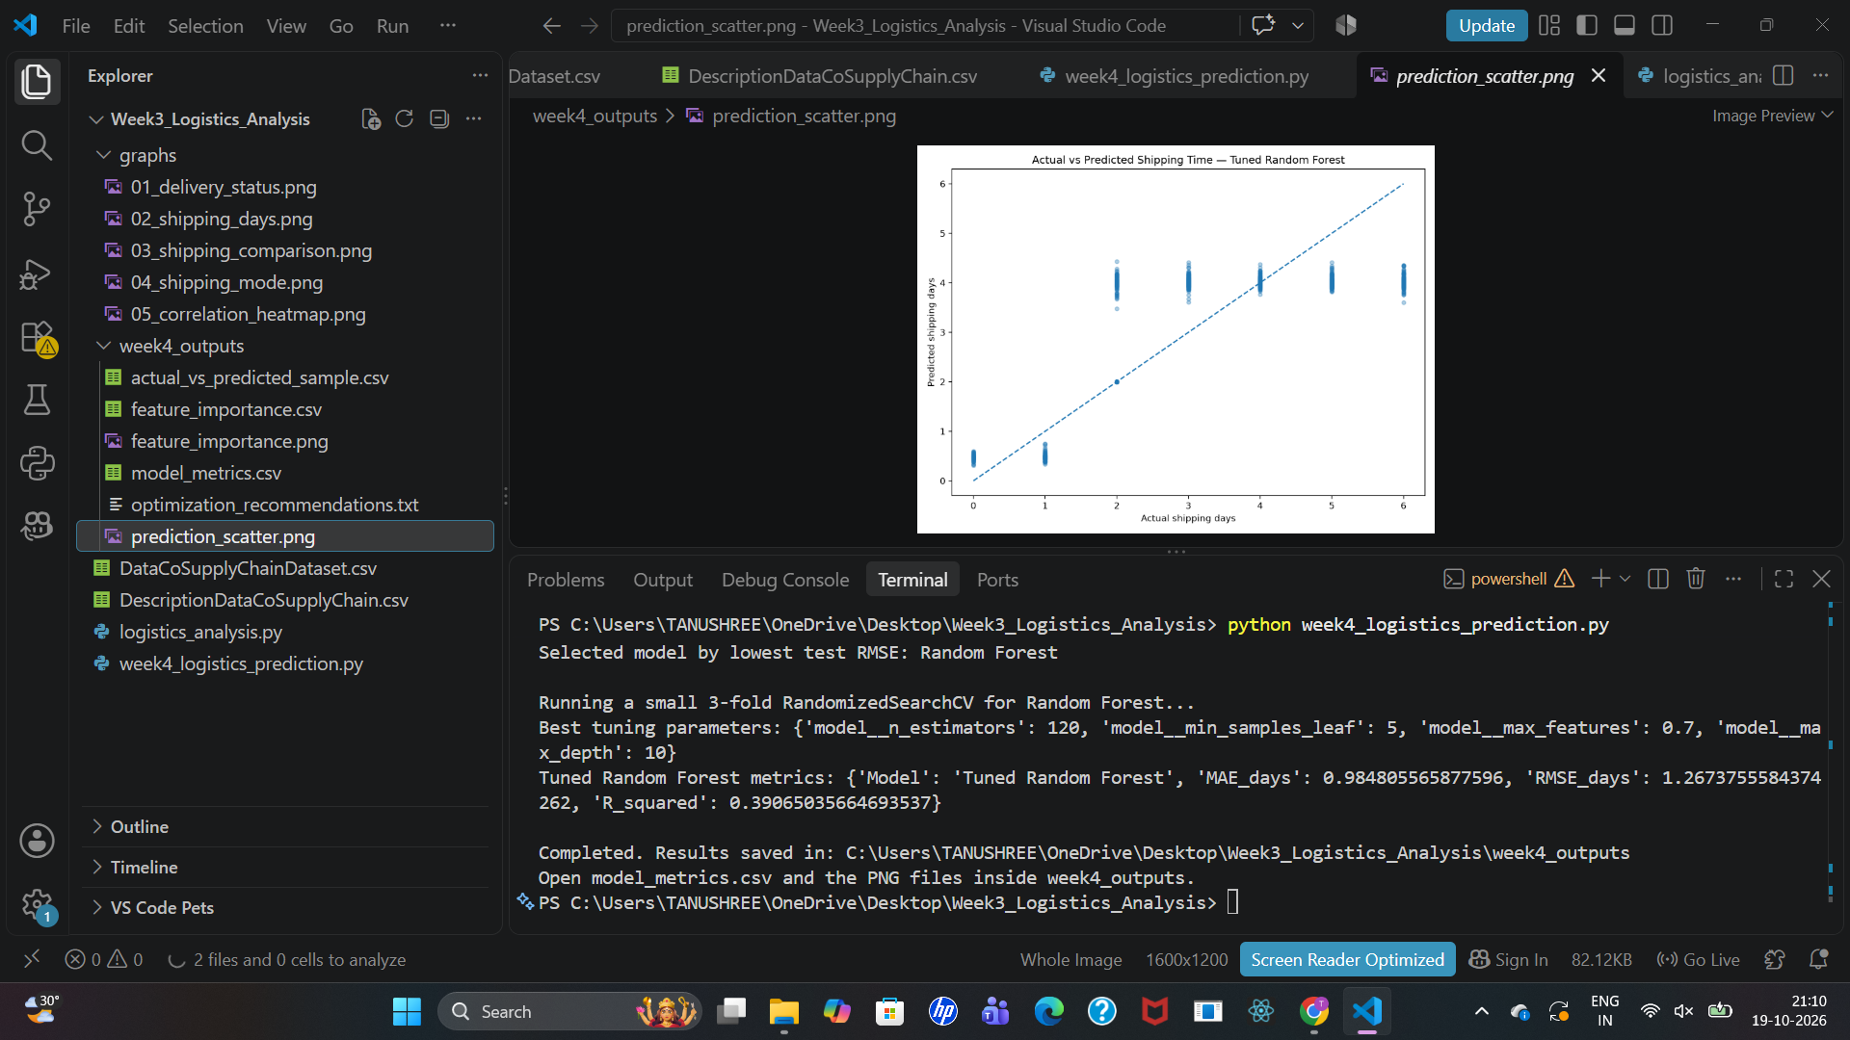
The dashed diagonal represents perfect predictions. Points close to the diagonal indicate smaller errors, while points far from it indicate larger errors. In the displayed plot, many predictions cluster around similar values even when actual shipping duration differs. This indicates that the model does not separate all shipment-duration groups well, which is consistent with the R² score. More informative features and further validation are needed before using predictions for live decisions.

7. Python Implementation
The analysis is implemented in week4_logistics_prediction.py using pandas for data handling, scikit-learn for preprocessing, regression, model selection, and evaluation, and matplotlib for plots. The main workflow is:
- Load DataCoSupplyChainDataset.csv and select the target and candidate predictors.
- Preprocess numeric and categorical data.
- Split the data into training and test sets.
- Train and compare regression models using test RMSE.
- Tune the selected Random Forest with a three-fold randomized search.
- Calculate MAE, RMSE, and R² on the test set.
- Save the metrics, sample predictions, feature importance, and plots to week4_outputs.
Command used to run the script:
python week4_logistics_prediction.py

8. Optimization Recommendations
- Review shipments with large prediction errors and investigate whether they share common routes, markets, shipping modes, or order characteristics.
- Use scheduled shipping duration and shipping mode as initial segmentation variables when reviewing delivery performance.
- Compare actual and scheduled durations by shipping mode and market to identify areas that may need process review.
- Avoid treating feature importance as proof of causation; validate operational changes with controlled pilots or before-and-after measurement.
- Improve model inputs with reliable route distance, dispatch time, carrier, warehouse, traffic, weather, and peak-season indicators when available.
- Validate using time-aware or group-aware splits if the intended deployment predicts future shipments or unseen routes. Monitor MAE and RMSE after deployment and retrain when performance drifts.

9. Limitations
The model's R² score shows that substantial variation in shipping duration remains unexplained. The dataset may contain variables that are unavailable at the time a real prediction would be made, so the feature list should be reviewed for data leakage before deployment. Results also depend on the particular train-test split and preprocessing choices. The reported scores are test-set results from the current script and should not be generalized to all logistics operations without additional validation.

10. Conclusion
This task demonstrated an end-to-end predictive analytics workflow for logistics. A tuned Random Forest was selected, with MAE of 0.9848 days, RMSE of 1.2674 days, and R² of 0.3907 on the test set. The feature importance plot highlights scheduled shipping duration and shipping mode, while the prediction plot shows that the model still struggles to distinguish several actual-duration groups. The results provide a useful starting point for logistics analysis, but further feature engineering, leakage checks, and validation are recommended before operational use.

Appendix: Output Files
The script saves its outputs in the week4_outputs folder, including model_metrics.csv, actual_vs_predicted_sample.csv, feature_importance.csv, feature_importance.png, prediction_scatter.png, and optimization_recommendations.txt.

