The three different instructions given
<Decks> has been put in place of letters used for game as these differ (not changed in original file

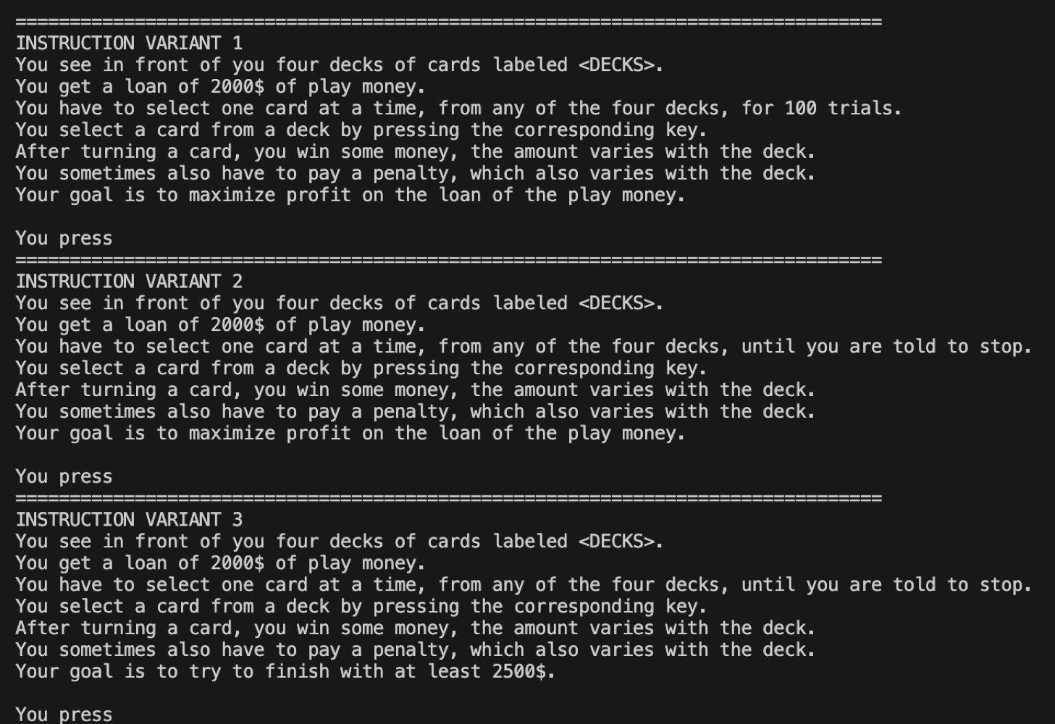

Files Extracted
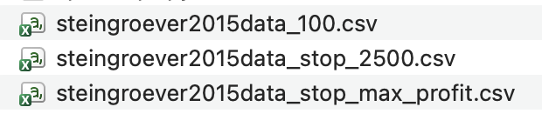

- 100 file - Instruction variant 1, stops game at 100 trials, told to maximise profit
- Stop_2500 - Instruction variant 3, told when to stop, told to finish with at least 2500
- Stop_max_profit - Instruction variant 2, told when to stop, told to maximise profit

