**LAB ASSIGNMENT 1**

1. **WAP which will format console output using '\n', '\t', '\b' within printf statement**.

**INPUT**

#include<stdio.h>

int main()

{

printf("NEW LINE\n");

printf("TABSPACE \t");

printf("BACKSPACE \b");

return 0;

}

**OUTPUT**

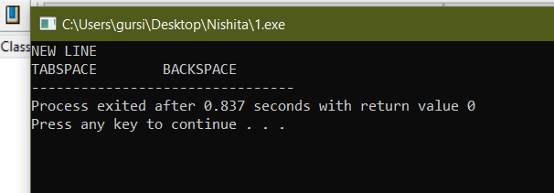

**2.WAP to print ‘See C is Sea’ five times on the console.**

**INPUT**

#include<stdio.h>

int main()

{

printf("See C is Sea\n");

printf("See C is Sea\n");

printf("See C is Sea\n");

printf("See C is Sea\n");

printf("See C is Sea\n");

return 0;

}

**OUTPUT**

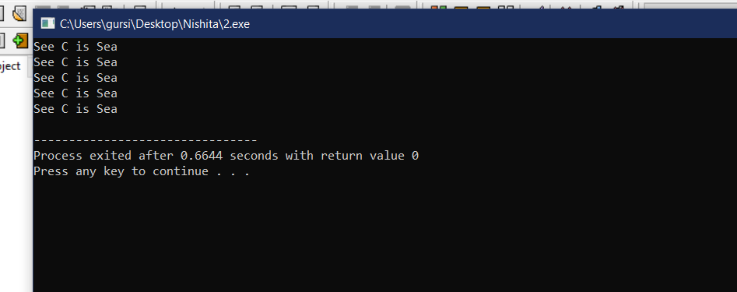

**3. WAP which will accept an integer, a decimal number, a character and a string from the keyboard and display them one per line.**

**INPUT**

#include<stdio.h>

#include<string.h>

int main()

{

int a;

float b;

char c,d[10];

printf("Enter an integer\n");

scanf("%d",&a);

printf("Enter a decimal number\n");

scanf("%f",&b);

printf("Enter a character\n");

scanf(" %c",&c);

printf("Enter a string\n");

scanf(" %s",&d);

printf("Integer-%d\nDecimal Number-%f\nCharacter-%c\nString-%s",a,b,c,d);

return 0;

}

**OUTPUT**

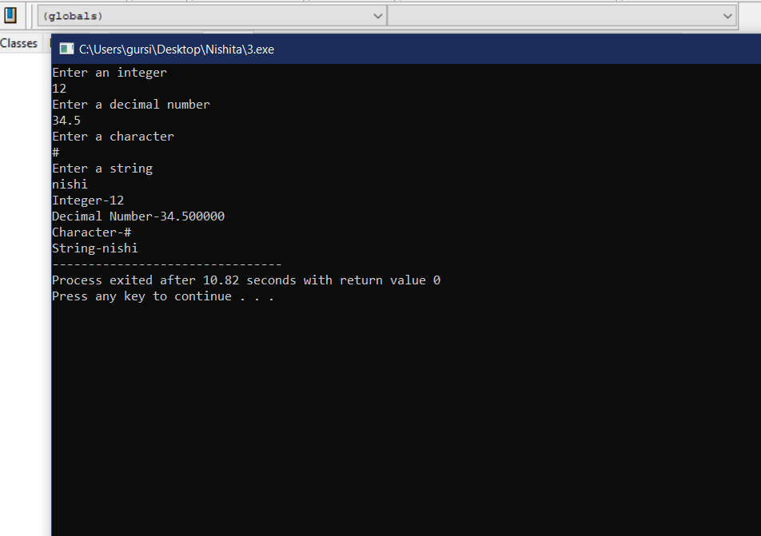

**4. WAP that will print your mailing address in the following format**

**First line : Your Name**

**Second line : House No, Street**

**Third line : City**

**Fourth line : State, Pin code**

**INPUT**

#include<stdio.h>

int main()

{

char city[15],name[15],state[15],street[20];

int pincode,houseno;

printf("Enter the following Details\n");

printf("Enter your:\nName\nHouse Number\nStreet\nCity\nState\n");

scanf("%s%d %s %s %s",&name,&houseno,&street,&city,&state);

printf("Enter your 6 digit pincode\n");

scanf("%d",&pincode);

printf("Name\t\t\t:\t%s\nHouse Number,Street\t:\t#%d,%s\nCity\t\t\t:\t%s\nState,Pincode\t\t:\t%s,%d",name,houseno,street,city,state,pincode);

return 0;

}

**OUTPUT**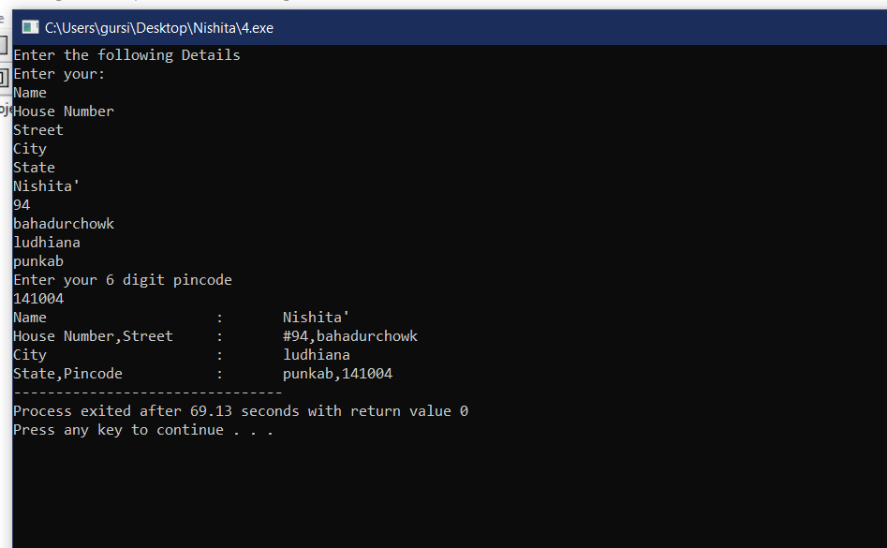

**5. WAP which will accepts two integers (a and b) from the input device and display the results of**

**their sum, difference, product, division and mod on the console by assuming a simple arithmetic**

**calculator.(INTEGER**)

**INPUT**

#include<stdio.h>

int main()

{

int a,b,mod,sum,diff,pro,div;

printf("Enter two numbers\n");

scanf("%d%d",&a,&b);

sum=a+b;

diff=a-b;

pro=a*b;

div=a/b;

mod=a%b;

printf("Sum=%d\nDifference=%d\nProduct=%d\nDivision=%d\nModulus=%d",sum,diff,pro,div,mod);

return 0;

}

**OUTPUT**

**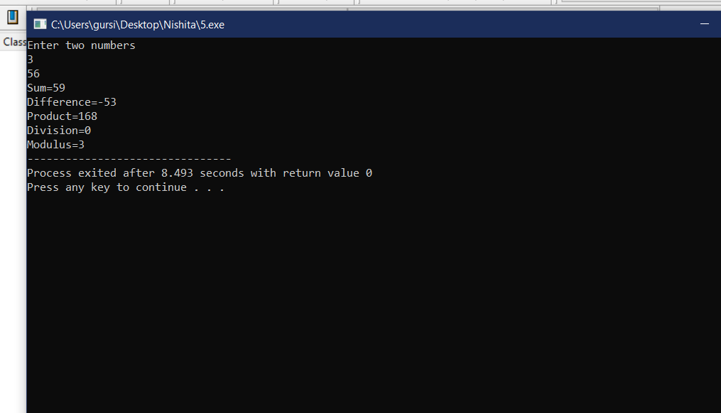  
5. WAP which will accepts two integers (a and b) from the input device and display the results of**

**their sum, difference, product, division and mod on the console by assuming a simple arithmetic**

**calculator.(DECIMAL)**

**INPUT**

#include<stdio.h>

int main()

{

float a,b,sum,diff,pro,div;

printf("Enter two numbers\n");

scanf("%f%f",&a,&b);

sum=a+b;

diff=a-b;

pro=a*b;

div=a/b;

printf("Sum=%f\nDifference=%f\nProduct=%f\nDivision=%f",sum,diff,pro,div);

return 0;

}

**OUTPUT**

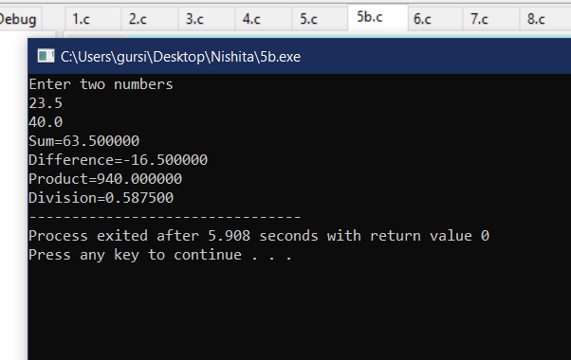

**6. WAP which will compute the simple and compound interest and display them on the console.**

***INPUT***

#include<stdio.h>

#include<math.h>

int main()

{

float SI,CI;

int P,R,T,Q;

printf("Enter Principle Amount,Rate,Time\n");

scanf("%d%d%d",&P,&R,&T);

SI=P*R*T;

Q=1+R/100;

CI=P*pow(Q,T)-P;

printf("Simple Interest=%f\nCompound Interest=%f",SI,CI);

return 0;

}

**OUTPUT**

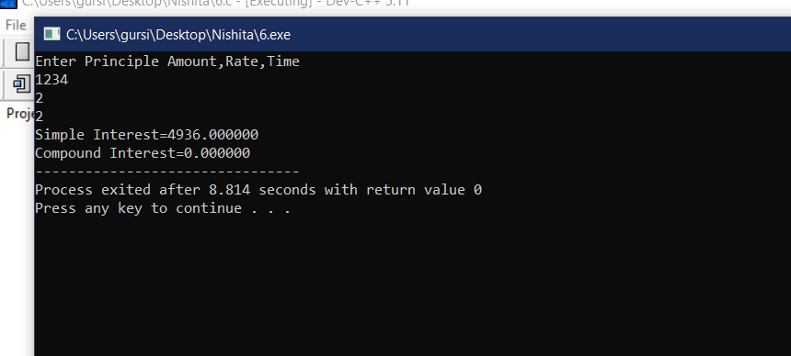

**7. WAP that reads the values of three variables a, b and c from the input device and then compute and display the value of d, where d = (a-b)/(b+c).**

**INPUT**

#include<stdio.h>

int main()

{

float a,b,c,d;

printf("Enter 3 variables\n");

scanf("%f%f%f",&a,&b,&c);

d=((a+b)/(b-c));

printf("%f",d);

return 0;

}

**OUTPUT**

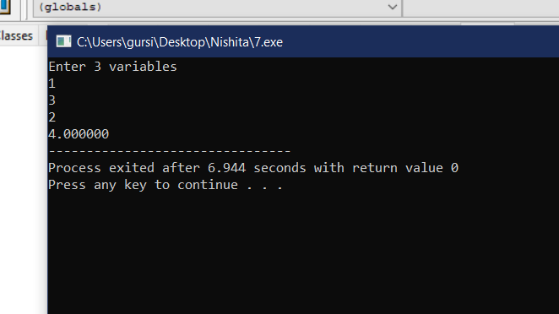

**8. Relationship between Celsius (C) and Fahrenheit (F) is governed by the following formula**

**F = 9C/5 + 32 WAP to convert the Celsius to Fahrenheit and vice versa.(C TO F)**

**INPUT**

#include<stdio.h>

int main()

{

float C,F;

printf("Enter the value of celsius scale\n");

scanf("%f",&C);

F=((9*C/5)+32);

printf("%fF",F);

return 0;

}

**OUTPUT**

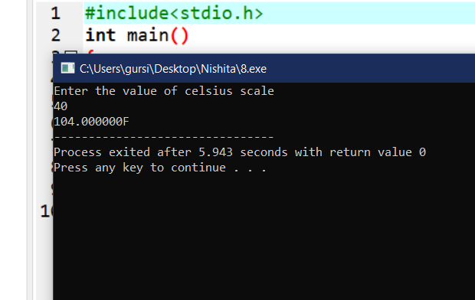

**8. Relationship between Celsius (C) and Fahrenheit (F) is governed by the following formula**

**F = 9C/5 + 32**

**WAP to convert the Celsius to Fahrenheit and vice versa.(F TO C)**

**INPUT**

#include<stdio.h>

int main()

{

float F,C;

printf("Enter the value of farenheit scale");

scanf("%f",&F);

C=((F-32)*5/9);

printf("%fC",C);

return 0;

}

**OUTPUT**

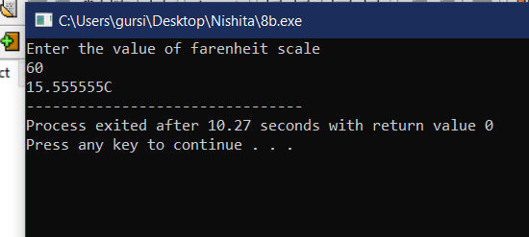

**9. Area (A) of a triangle is given by the formula = Where a, b and c are sides of the triangle and 2S = a + b + c. WAP to compute the area of the**

**triangle given the values of a, b and c.**

**INPUT**

#include<stdio.h>

#include<math.h>

int main()

{

int a,b,c;

float S,Area;

printf("Enter the sides of the triangle\n");

scanf("%d%d%d",&a,&b,&c);

S=(a+b+c)/2;

Area=sqrt(S*(S-a)*(S-b)*(S-c));

printf("Area=%f",Area);

return 0;

}

**OUTPUT**

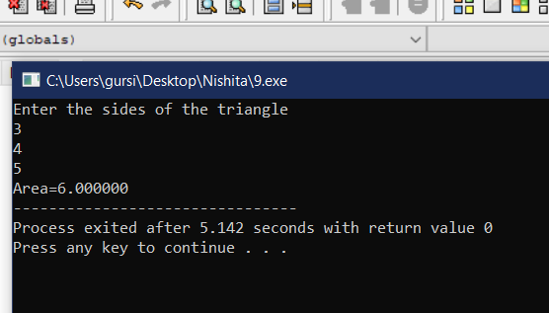

**10. The line joining the points (2, 2) and (5, 6) which lie on the circumference of a circle is the**

**diameter of the circle. WAP to compute the area and perimeter of the circle**.

**INPUT**

#include<stdio.h>

#include<math.h>

int main()

{

int x,x1,x2,y,y1,y2;

float cir,area,dia,rad;

printf("Enter the x axis end points of diameter\n");

scanf("%d%d",&x1,&x2);

printf("Enter the y axis end points of diameter\n");

scanf("%d%d",&y1,&y2);

x=x2-x1;

y=y2-y1;

dia=sqrt(pow(x,2)+pow(y,2));

rad=dia/2;

area=M_PI*pow(rad,2);

cir=2*M_PI*rad;

printf("Area=%f\nCircumference=%f",area,cir);

return 0;

}

**OUTPUT**

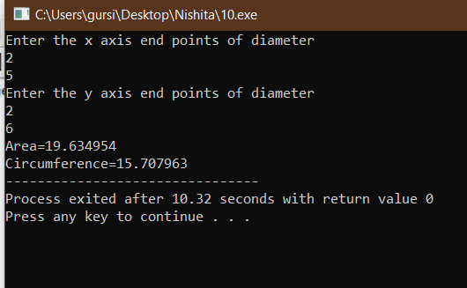

**END**