**LAB ASSIGNMENT 2**

**1. WAP to compute the gross salary of an employee whose details are given below:**

**Basic pay: Rs.50, 000, dearness allowance: 50% of Basic pay, house rent allowance: 20% of Basic**

**pay, vehicle allowance: 10% of the Basic pay.**

**INPUT**

#include<stdio.h>

int main()

{

int bp;

float da,hra,va,gs;

bp=50000;

da=0.5*bp;

hra=0.2*bp;

va=0.1*bp;

printf("Basic Pay=50,000\nDearness Allowance=%f\nHouse Rent Allowance=%f\nVehicle Allowance=%f\n",da,hra,va);

gs=bp+da+hra+va;

printf("Gross Salary=%f",gs);

return 0;

}

**OUTPUT**

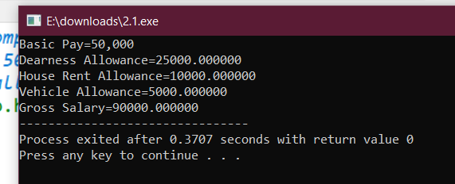

**2. The price of one pen is Rs.10, one pencil is Rs. 5, and one sharpener is Rs. 2. You purchased 2**

**pens, 3 pencils and 1 sharpener. Compute the total price as per the following format.**

**\*\*\*\*\*\* LIST OF ITEMS \*\*\*\*\*\***

**Item Price (Rs.) Total (Rs.)**

**Pen 10 20**

**Pencil 5 15**

**Sharpener 2 2**

**Grand Total (Rs.) 17 37**

**INPUT**

#include<stdio.h>

int main()

{

int pen=10,pencil=5,sharp=2,p,pi,s,to,t;

p=2*pen;

pi=3*pencil;

s=1*sharp;

t=pen+pencil+sharp;

to=p+pi+s;

printf("Item\t\t Price(Rs.)\tTotal(Rs.)\nPen\t\t%d\t\t%d\nPencil\t\t%d\t\t%d\nSharpner\t%d\t\t%d\nGrand Total(Rs.)%d\t\t%d",pen,p,pencil,pi,sharp,s,t,to);

return 0;

}

**OUTPUT**

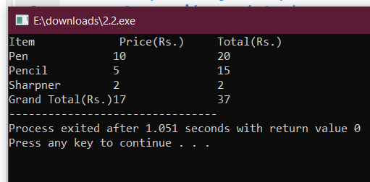

**3. WAP which will print the ‘$’ symbol in the following format. (Hint: No need to use any loops)**

**$**

**$ $**

**$ $ $**

**$ $ $**

**$ $ $**

#include<stdio.h>

int main()

{

printf("$\n");

printf("$\t$\n");

printf("$\t$\t$\n");

printf("$\t$\t$\n");

printf("$\t$\t$\n");

return 0;

}

**OUTPUT**

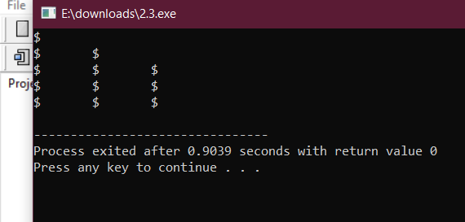

**4. WAP which will accept two floating point numbers, assign their sum to an integer variable and**

**then output the values of all three variables.**

**INPUT**

#include<stdio.h>

int main()

{

float a,b;

int c;

printf("Enter the values for summation\n");

scanf("%f%f",&a,&b);

c=a+b;

printf("%f+%f=%d",a,b,c);

return 0;

}

**OUTPUT**

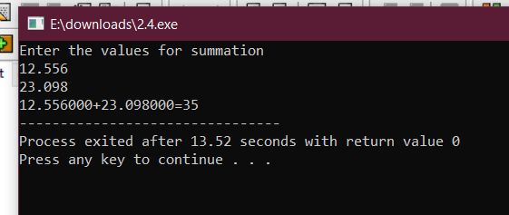

**5. WAP to swap two numbers using and without using a third variable.(WITHOUT THIRD VARIABLE)**

**INPUT**

#include<stdio.h>

int main()

{

int a,b;

printf("Enter the two numbers\na=");

scanf("%d",&a);

printf("b=");

scanf("%d",&b);

a=a+b;

b=a-b;

a=a-b;

printf("After Swapping\na=%d\nb=%d",a,b);

return 0;

}

**OUTPUT**

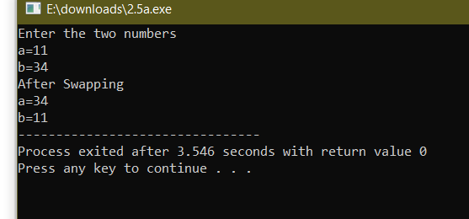

**5. WAP to swap two numbers using and without using a third variable.(USING THIRD VARIABLE)**

**INPUT**

#include<stdio.h>

int main()

{

int a,b,c;

printf("Enter the numbers:\na=");

scanf("%d",&a);

printf("b=");

scanf("%d",&b);

c=a;

a=b;

b=c;

printf("Numbers after swapping:\na=%d\nb=%d",a,b);

return 0;

}

**OUTPUT**

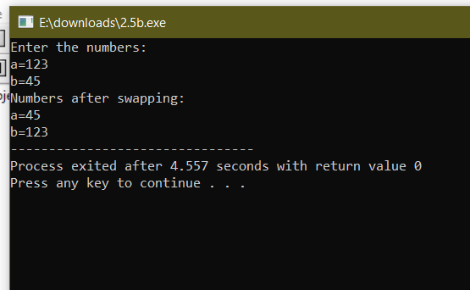

**6. Extend the above program for three variables a, b, and c such that a holds the value of c, b holds**

**the value of a, and c holds the value of b using and without using a third variable.(WITHOUT VARIABLE)**

**INPUT**

**OUTPUT**

**6. Extend the above program for three variables a, b, and c such that a holds the value of c, b holds**

**the value of a, and c holds the value of b using and without using a third variable.(WITH THIRD VARIABLE)**

**INPUT**

**OUTPUT**

**7. WAP which will accept a three digits integer number and display the sum and product of all the**

**digits of that number. (Hint: Use / and % operators)**

**INPUT**

#include<stdio.h>

int main()

{

int a,b,c,sum,pro;

printf("Enter a 3 digit number");

scanf("%d",&a);

b=a/100;

a=a%100;

c=a/10;

a=a%10;

sum=a+b+c;

pro=a*b*c;

printf("Sum=%d\nProduct=%d",sum,pro);

return 0;

}

**OUTPUT**

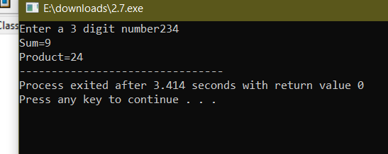

**8. WAP to find the size of various primitive data types used in C such as int, float, double and char.**

**INPUT**

#include<stdio.h>

main()

{

int a;

float b;

double c;

char d;

printf("Enter a integral number\n");

scanf("%d",&a);

printf("Enter a floating number\n");

scanf("%f",&b);

printf("Enter a double number\n");

scanf("%lf",&c);

printf("Enter a char \n");

scanf(" %c",&c);

printf("Int=%d\n",sizeof(a));

printf("Float=%d\n",sizeof(b));

printf("Double=%d\n",sizeof(c));

printf("Char=%d\n",sizeof(d));

return 0;

}

**OUTPUT**

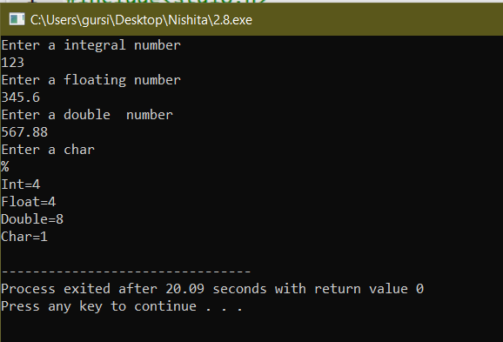

**END**