BE Program First Year

Course: Experiential Learning Center

## CALCULATOR

by

**Tanveer Singh**

(Roll No:102216133)



**Department of Computer Science Engineering**

**School of Computer Science Engineering**

**Faculty of Engineering**

**Thapar Institute of Engineering and Technology, India**

February 2023

# Certificate

This is to certify that the project titled **“Calculator”** is a of the bona fide work done by  **Tanveer Singh (102216133)** & submitted for the partial fulfilment of the requirements for the completion of the Experiential Learning course in the Department of **Computer Science Engineering** of Thapar institute of Engineering and Technology, during the academic session September-December 2023.

**My App’s name is “Easy Calculator”**

# Abstract

* It is a simple mathematical tool
* This app can be easily assessable by both old people and children.
* The main purpose of a calculator app is to solve mathematical problems.

# Methodology

# Used Java for backend of app.

# Used Android Studio App for Designing And making the App.

# Results and Discussions

# Applying all these methodologies we hereby are successful in creating the calculator app.

# The Calculator has all the necessary functions.

# References

# [www.youtube.com](http://www.youtube.com/)

# [www.coursera.org](http://www.coursera.org/)

* <https://developer.android.com/training/basics/firstapp>
* <https://www.geeksforgeeks.org/>
* Some books

# Acknowledgements

I would like to thank my teachers for their expert advice and encouragement through this difficult project. I would also like to thank my friends who always encouraged me throughout this period with support and manpower.

**LOGO**

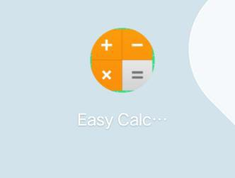

# 

**APP’s Screenshot**

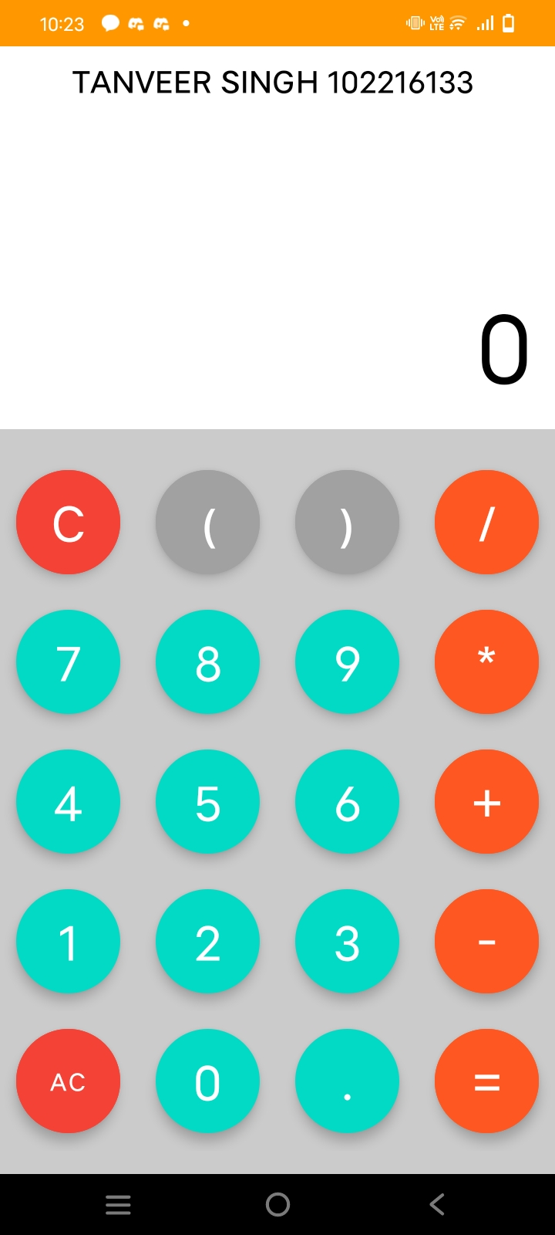

THANK YOU