Q1: Calculate the Total Sales using DAX

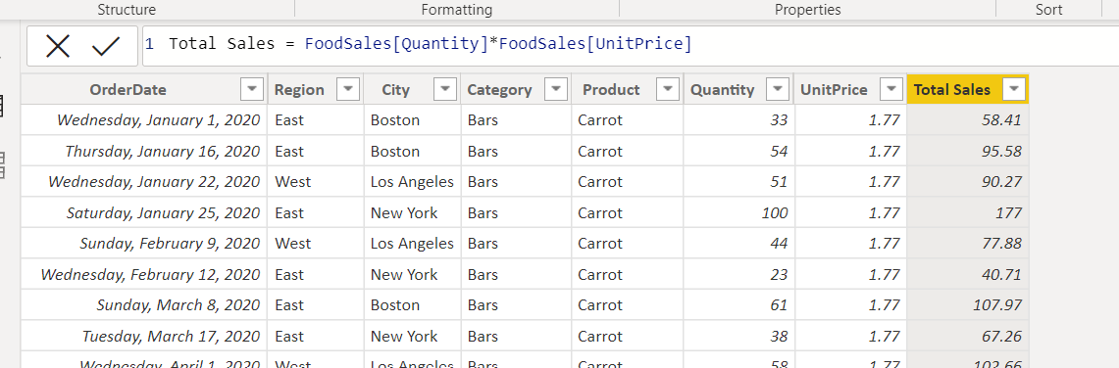

Q2. Prefix the sales in US$
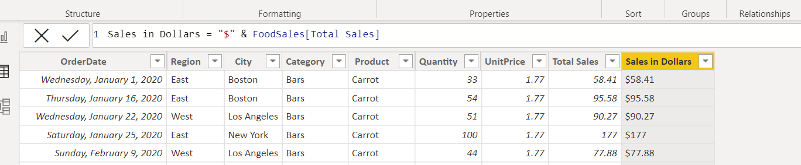

Q3. Create a year column using DAX.
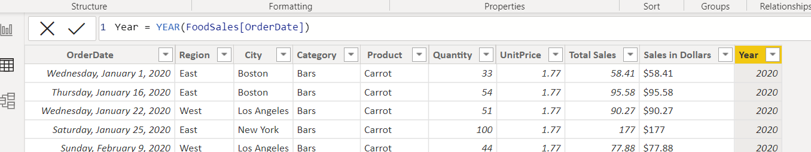

Q4. Create name of the day column
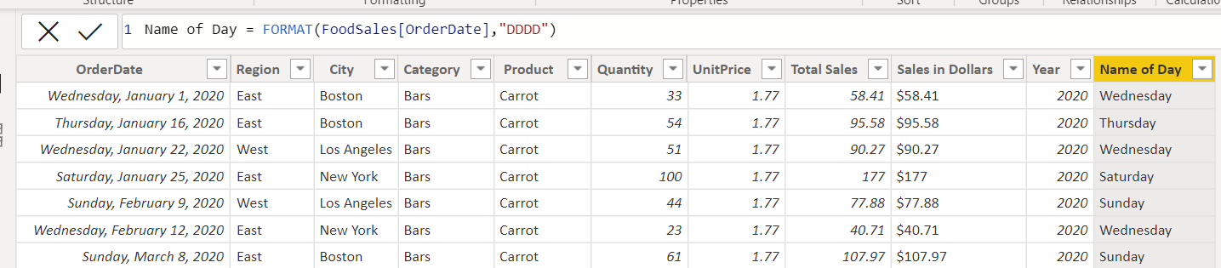c
Q5. Create Weekdays (name of the day) using DAX
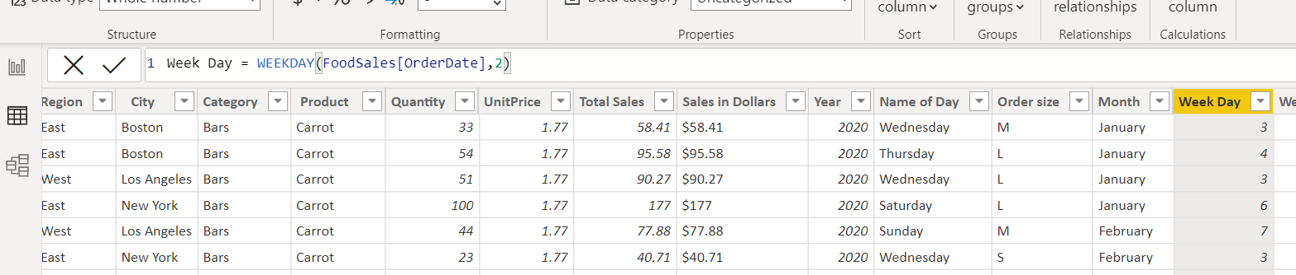

Q6. Create measure Number Weekdays using DAX
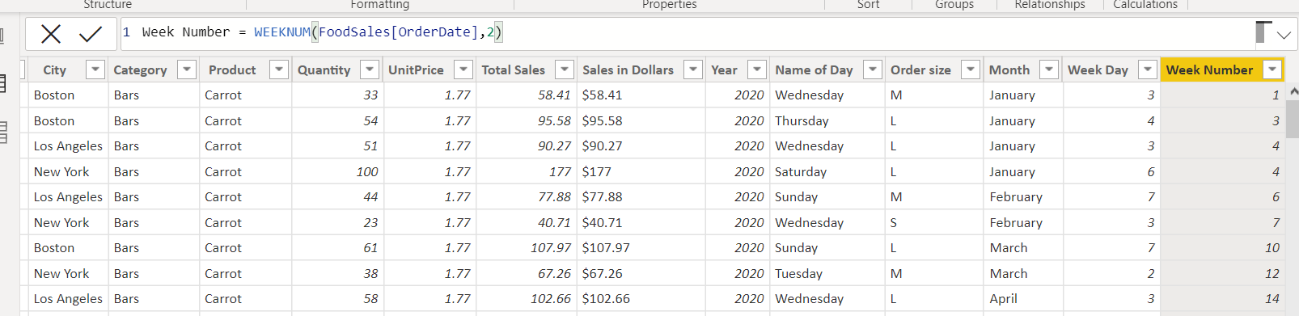

Q7. Calculate Order size using following condition if units is less than or equal to 25, it is small, less
than or equal to 50 its Medium, else large.
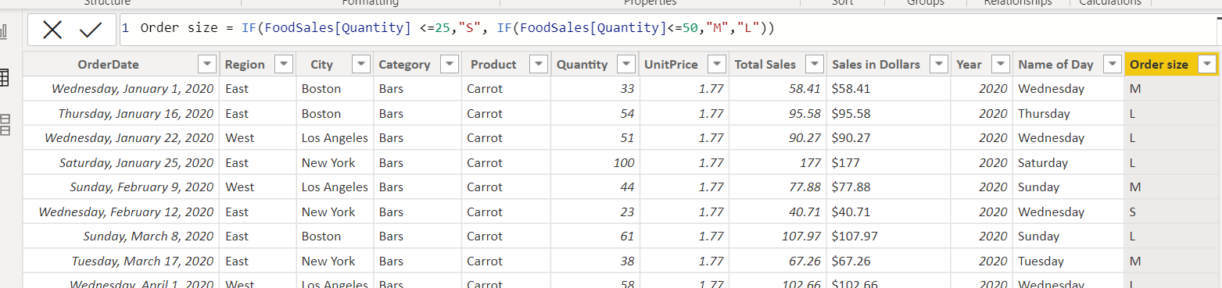
Q8. Visualize sum of sales based on order size (year, month) 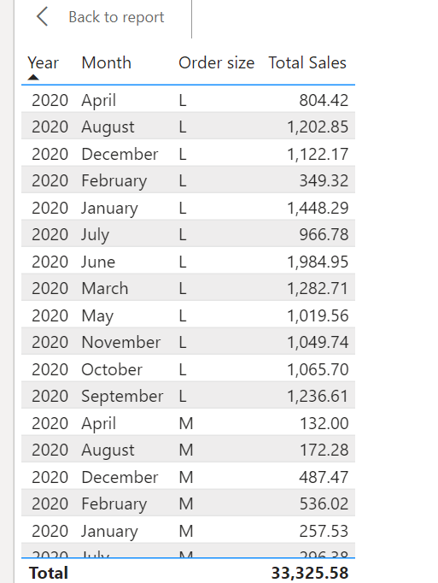

Q9. Create new measure as Order Count of sales
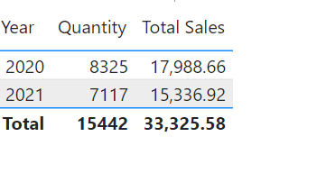

Q10. Visualise regionwise and item wise order count.

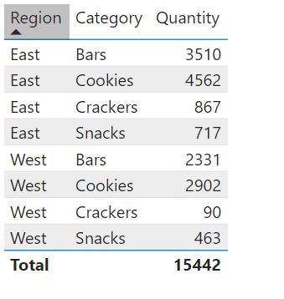
Prepare Sales Report
- Put a slicer for order size
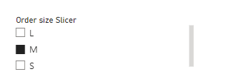
- Slicer for region
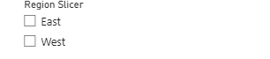
- Visualize the line chart by year by sales and rename the file as Sales Trend

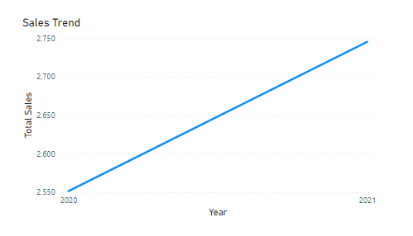
- Visualize the scatter plot by Units versus Sales by Rep.
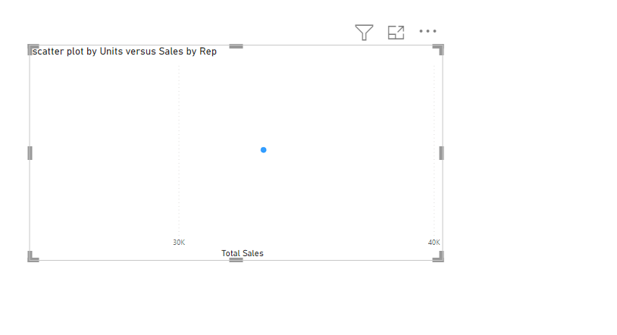
5. Visualise Stacked colum charts, plot Sales by size by weekdays number
