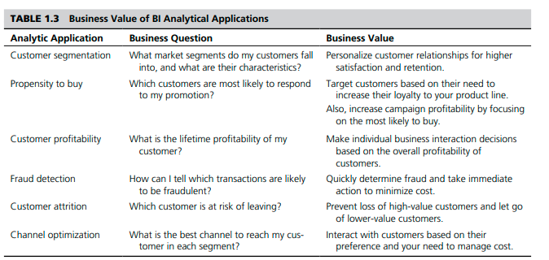

The Knowledge-Based Management Subsystem
The knowledge-based management subsystem can support any of the other subsystems or
act as an independent component. It provides intelligence to augment the decision maker’s
own. It can be interconnected with the organization’s knowledge repository (part of a knowledge management system [KMS]), which is sometimes called the organizational knowledge base. Knowledge may be provided via Web servers. Many artificial intelligence methods have been implemented in Web development systems such as Java and are easy to integrate into the other DSS components. One of the most widely publicized knowledge based DSS is IBM’s Watson computer system. It is described in Application Case 2.4.

Big Data
Our brains work extremely quickly and are efficient and versatile in processing large amounts of all kinds of data: images, text, sounds, smells, and video. We process all different forms of data relatively easily. Computers, on the other hand, are still finding it hard to keep up with the pace at which data is generated—let alone analyze it quickly. We have the problem of Big Data. So what is Big Data? Simply put, it is data that cannot be stored in a single storage unit. Big Data typically refers to data that is arriving in many different forms, be they structured, unstructured, or in a stream. Major sources of such data are clickstreams from Web sites, postings on social media sites such as Facebook, or data from traffic, sensors, or weather. A Web search engine like Google needs to search and index billions of Web pages in order to give you relevant search results in a fraction of a second. Although this is not done in real time, generating an index of all the Web pages on the Internet is not an easy task. Luckily for Google, it was able to solve this problem. Among other tools, it has employed Big Data analytical techniques. There are two aspects to managing data on this scale: storing and processing. If we could purchase an extremely expensive storage solution to store all the data at one place on one unit, making this unit fault tolerant would involve major expense. An ingenious solution was proposed that involved storing this data in chunks on different machines connected by a network, putting a copy or two of this chunk in different locations on the network, both logically and physically. It was originally used at Google (then called Google File System) and later developed and released as an Apache project as the Hadoop Distributed File System (HDFS). However, storing this data is only half the problem. Data is worthless if it does not provide business value, and for it to provide business value, it has to be analyzed. How are such vast amounts of data analyzed? Passing all computation to one powerful computer does not work; this scale would create a huge overhead on such a powerful computer. Another ingenious solution was proposed: Push computation to the data, instead of pushing data to a computing node. This was a new paradigm, and it gave rise to a whole new way of processing data. This is what we know today as the MapReduce programming paradigm, which made processing Big Data a reality. MapReduce was originally developed at Google, and a subsequent version was released by the Apache project called Hadoop MapReduce. Today, when we talk about storing, processing, or analyzing Big Data, HDFS and MapReduce are involved at some level. Other relevant standards and software solutions have been proposed. Although the major toolkit is available as open source, several companies have been launched to provide training or specialized analytical hardware or software services in this space. Some examples are HortonWorks, Cloudera, and Teradata Aster. Over the past few years, what was called Big Data changed more and more as Big Data applications appeared. The need to process data coming in at a rapid rate added velocity to the equation. One example of fast data processing is algorithmic trading. It is the use of electronic platforms based on algorithms for trading shares on the financial market, which operates in the order of microseconds. The need to process different kinds of data added variety to the equation. Another example of the wide variety of data is sentiment analysis, which uses various forms of data from social media platforms and customer responses to gauge sentiments. Today Big Data is associated with almost any kind of large data that has the characteristics of volume, velocity, and variety. Application Case 1.7 illustrates one example of Big Data analytics.

