* **Step 1**

**Download Kafka**

<https://www.apache.org/dyn/closer.cgi?path=/kafka/3.2.0/kafka_2.13-3.2.0.tgz>

JDK 64 bit is required to avoid any error while kicking up the Kafka

* **Step 2**

Start the zookeeper

Go to the kafka folder and run below command

.\bin\windows\zookeeper-server-start.bat .\config\zookeeper.properties

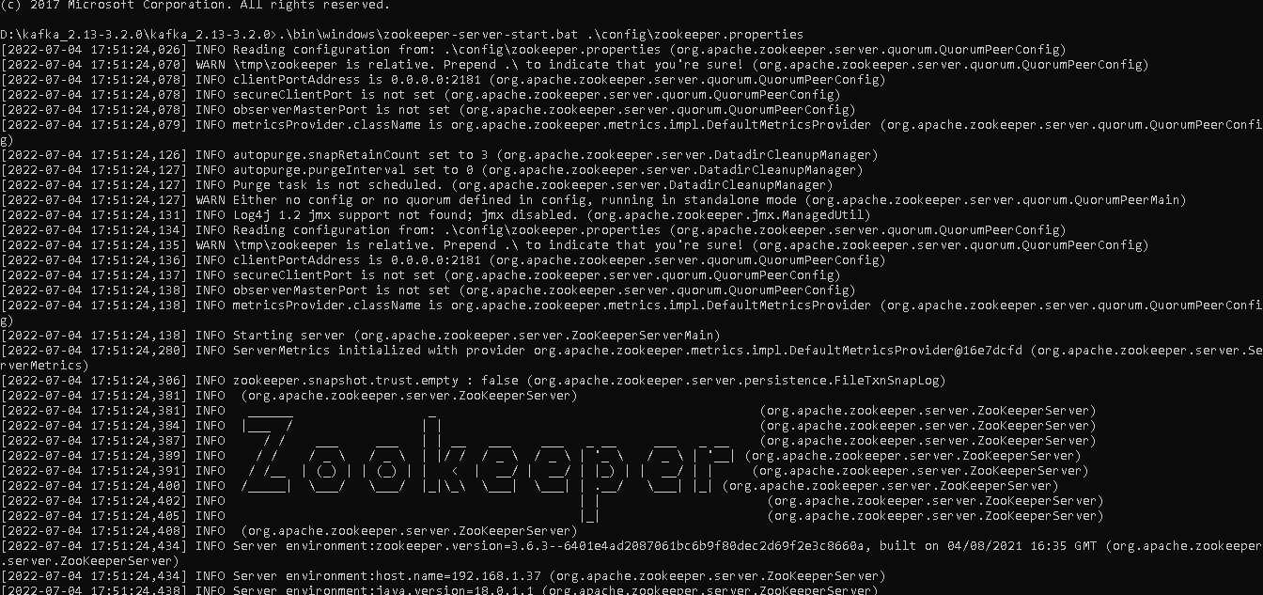

* **Step 3**

Start the Kafka

.\bin\windows\kafka-server-start.bat .\config\server.properties

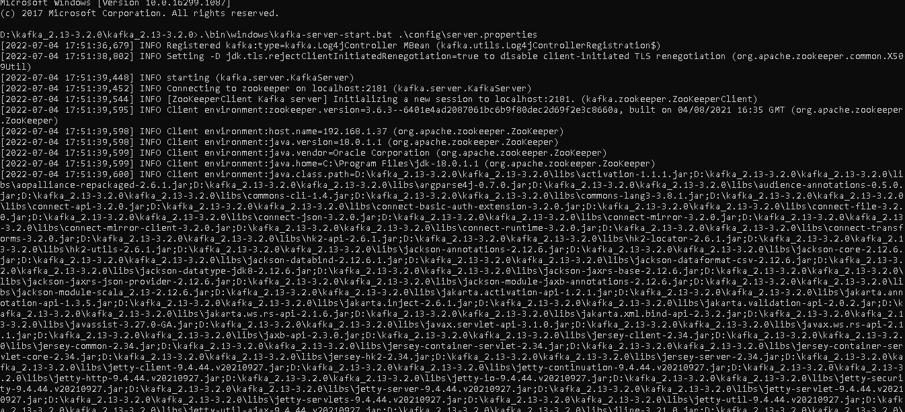

* **Step 4**

Create Topic (you can create through code as well)

.\bin\windows\kafka-topics.bat --create –bootstrap-server localhost:9092 --replication-factor 1 --partitions 1 --topic my-kafka-topic

You are done ☺

Go to code repos

<https://github.com/tanveerbobade91/spring-boot-kafka-producer.git>

https://github.com/tanveerbobade91/spring-boot-kafka-consumer.git