Web Analytics

Traffic, Engagement & Channel Performance Analysis

Dataset: Google Analytics Export — web_data_analysis.csv Kaggle Notebook Analysis Report

Table of Contents

- Import Libraries
- Load & Inspect the Dataset
- Data Cleaning & Preprocessing
  - Fix Header Row
  - Rename Columns
  - Parse DateHour Column
  - Convert Numeric Columns & Extract Hour
  - Schema & Descriptive Statistics
- Exploratory Data Analysis (EDA)
  - Sessions & Users Over Time
  - Total Users by Channel
  - Average Engagement Time by Channel
  - Engagement Rate Distribution by Channel
  - Engaged vs Non-Engaged Sessions
  - Traffic Heatmap — Hour x Channel
  - Engagement Rate vs Sessions Over Time
- Key Insights & Recommendations

Import Libraries

We begin by importing all necessary Python libraries for analysis and visualization:

NumPy — numerical computations and aggregation functions Pandas — data loading, manipulation, and transformation Matplotlib — base plotting engine
Seaborn — high-level statistical visualizations built on Matplotlib

Code:
import numpy as np import pandas as pd
import matplotlib.pyplot as plt import seaborn as sns

print("Libraries imported successfully.")
Output:

Libraries imported successfully.

Explanation: These four libraries form the standard Python data analysis stack. NumPy handles fast numerical operations. Pandas provides the DataFrame structure used throughout this analysis. Matplotlib is the underlying chart renderer while Seaborn wraps it with cleaner statistical plot functions.

Load & Inspect the Dataset

The dataset is a Google Analytics export containing hourly traffic data broken down by Channel Group (e.g. Organic Search, Direct, Referral). Each row represents a specific channel's activity for a given hour.

Code:
df = pd.read_csv("/kaggle/input/datasets/tanveerkhan2134/mydata123/web_data_analysis.csv") df.head()
Output — Raw Data (first 5 rows):

# | Session primary c | hDaantnee+l ghrourp | Users | Sessions | Engaged se | sAsviognesng tim | eEng rate
0 | Direct | 2024041623 | 237 | 300 | 144 | 47.53 | 0.48
1 | Organic Social | 2024041719 | 208 | 267 | 132 | 32.10 | 0.49
2 | Direct | 2024041723 | 188 | 233 | 115 | 39.94 | 0.49
3 | Organic Social | 2024041718 | 187 | 256 | 125 | 32.16 | 0.49
4 | Organic Social | 2024041720 | 175 | 221 | 112 | 46.92 | 0.51

Observation: The raw file has the actual column names stored in the first data row, not in the header. This is a common issue with Google Analytics CSV exports. The data needs cleaning before analysis.

Data Cleaning & Preprocessing

Raw exports from analytics platforms often require several cleaning steps before analysis can begin.

Step 3.1 — Fix the Header Row

The first row of data contains the true column names. We promote it to the header and drop it from the data.

Code:
# Promote first row to column names df.columns = df.iloc[0]
df = df.drop(index=0).reset_index(drop=True) df.head()

Step 3.2 — Rename Columns for Clarity

The exported Google Analytics data has inconsistent or overly complex column names. We rename them to simpler, standardised names for easier analysis.

Code:
df.columns = [ "Channel Group", "DateHour", "Users", "Sessions",
"Engaged Sessions",
"Avg Engagement Time Per session", "Engaged Session Per User", "Events Per Session",
"Engagement Rate", "Event Count"
]
df.head()
Output — Renamed Columns (first 5 rows):

Channel Group | DateHour | Users | Sessions | Engaged Sessions | Avg Eng Time/s | Eng/User | Events/ Session | Eng Rate | Events
Direct | 2024041623 | 237 | 300 | 144 | 47.53 | 0.61 | 4.67 | 0.48 | 1402
Organic Social | 2024041719 | 208 | 267 | 132 | 32.10 | 0.63 | 4.30 | 0.49 | 1147
Direct | 2024041723 | 188 | 233 | 115 | 39.94 | 0.61 | 4.59 | 0.49 | 1069
Organic Social | 2024041718 | 187 | 256 | 125 | 32.16 | 0.67 | 4.08 | 0.49 | 1044
Organic Social | 2024041720 | 175 | 221 | 112 | 46.92 | 0.64 | 4.53 | 0.51 | 1001

Explanation: Renaming columns to short, consistent names makes subsequent groupby, filter, and plot calls much easier to read and maintain throughout the notebook.

Step 3.3 — Parse the DateHour Column

The DateHour field is stored as an integer in YYYYMMDDHH format (e.g. 2024010109 = Jan 1 2024, 09:00). We parse it into a proper datetime object so we can work with it as a time series.

Code:
df["DateHour"] = pd.to_datetime( df["DateHour"].astype(str), format="%Y%m%d%H", errors="coerce"
)
df.head()
Output — Parsed DateHour (sample):

Channel Group | DateHour (parsed) | Users | Sessions | Engaged Sessions | Eng Rate
Direct | 2024-04-16 23:00:00 | 237 | 300 | 144 | 0.48
Organic Social | 2024-04-17 19:00:00 | 208 | 267 | 132 | 0.49
Direct | 2024-04-17 23:00:00 | 188 | 233 | 115 | 0.49
Organic Social | 2024-04-17 18:00:00 | 187 | 256 | 125 | 0.49
Organic Social | 2024-04-17 20:00:00 | 175 | 221 | 112 | 0.51

Step 3.4 — Convert Numeric Columns & Extract Hour

All metric columns (Users, Sessions, Engagement Rate, etc.) were loaded as strings. We convert them to numeric types, coercing any invalid values to NaN. We also extract the hour of day as a separate feature for the hourly heatmap.

Code:
numeric_cols = df.columns.drop(["Channel Group", "DateHour"]) df[numeric_cols] = df[numeric_cols].apply(pd.to_numeric, errors='coerce') df["hour"] = df["DateHour"].dt.hour
df.head()

Explanation: Google Analytics exports always stringify numeric fields. Coercing to numeric with errors='coerce' replaces any malformed cells with NaN rather than crashing. The extracted 'hour' column (0–23) is critical for the heatmap in Section 4.6.

Step 3.5 — Schema & Descriptive Statistics

We inspect data types and check for any obvious issues like nulls or unexpected ranges.

Code — df.info():
df.info()
Output:

0 Channel Group | 3182 | non-null |  | object
1 DateHour | 3182 | non-null |  | datetime64[ns]
2 Users | 3182 | non-null |  | float64
3 Sessions | 3182 | non-null |  | float64
4 Engaged Sessions | 3182 | non-null |  | float64
5 Avg Engagement Time Per session | 3182 | non-null |  | float64
6 Engaged Session Per User | 3182 | non-null |  | float64
7 Events Per Session | 3182 | non-null |  | float64
8 Engagement Rate | 3182 | non-null |  | float64
9 Event Count | 3182 | non-null |  | float64
10 hour | 3182 | non-null |  | int64
Code — df.describe():

<class 'pandas.core.frame.DataFrame'> RangeIndex: 3182 entries, 0 to 3181 Data columns (total 11 columns):
# Column Non-Null Count Dtype
df.describe()
Output — Descriptive Statistics:

Statistic | Users | Sessions | Engaged Sessions | Avg Eng Time (s) | Eng Rate | Event Count | hour
count | 3182 | 3182 | 3182 | 3182 | 3182 | 3182 | 3182
mean | 41.94 | 51.19 | 28.33 | 66.64 | 0.503 | 242.27 | 11.81
std | 29.58 | 36.92 | 20.65 | 127.20 | 0.228 | 184.44 | 6.89
min | 0 | 1 | 0 | 0 | 0 | 1 | 0
25% | 20 | 24 | 13 | 32.10 | 0.443 | 103 | 6
50% | 42 | 51 | 27 | 49.02 | 0.545 | 226 | 12
75% | 60 | 71 | 41 | 71.49 | 0.633 | 339 | 18
max | 237 | 300 | 144 | 4525 | 1.0 | 1402 | 23

Observations: Engagement Rate is expected between 0 and 1 — the max of 1.0 is valid but should be verified. Avg Engagement Time has a max of 4525 seconds which is an outlier and likely indicates a session left open. 3182 rows with no null values confirms a clean dataset ready for analysis.

Exploratory Data Analysis (EDA)

Sessions & Users Over Time

This line chart shows how Sessions and Users vary over time on an hourly basis. It helps us understand overall traffic trends, spot sudden spikes or drops, and observe the gap between Sessions and Users — indicating users visiting the site multiple times.

Code:
sns.set(style="whitegrid") plt.figure(figsize=(12, 5))
df.groupby("DateHour")[["Sessions", "Users"]].sum().plot( ax=plt.gca(),
color=["green", "orange"]
)
plt.title("Sessions and Users Over Time", fontsize=15, fontweight='bold') plt.xlabel("Date & Hour")
plt.ylabel("Count") plt.tight_layout() plt.show()
Chart Output:
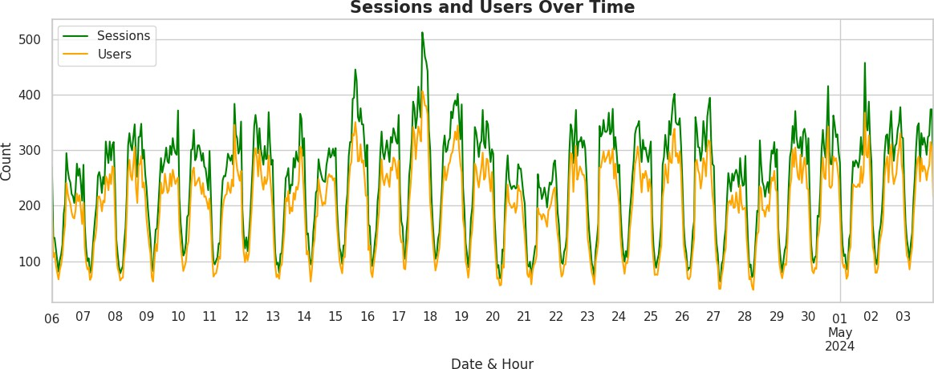

Insight: When Sessions consistently exceed Users by a large margin, individual users are returning multiple times — a positive signal for content stickiness. Sharp peaks indicate either a traffic campaign or viral moment, while sudden drops may point to tracking outages or seasonality effects.

Total Users by Channel

This bar chart compares the total user volume brought in by each traffic channel. It directly answers: Which channel drives the most visitors to the site? Understanding channel contribution helps teams prioritize marketing spend and SEO efforts.

Code:
plt.figure(figsize=(9, 5)) sns.barplot(
data=df, x="Channel Group", y="Users", estimator=np.sum, palette="viridis"
)
plt.title("Total Users by Channel", fontsize=15, fontweight='bold') plt.xlabel("Channel Group")
plt.ylabel("Total Users") plt.xticks(rotation=30, ha='right') plt.tight_layout()
plt.show()
Chart Output:
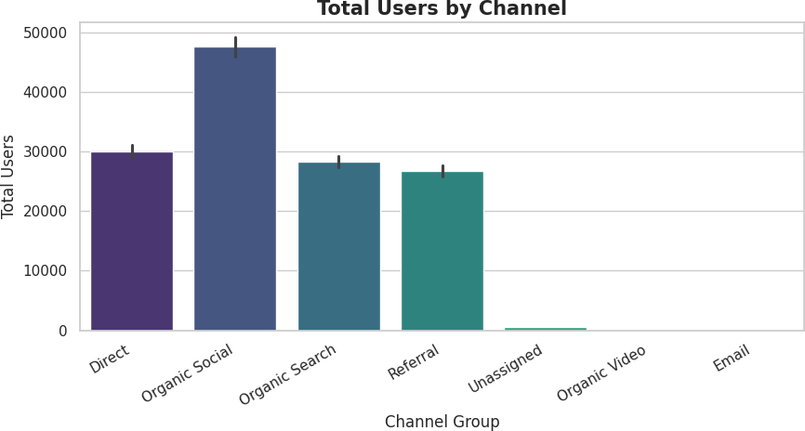

Insight: The tallest bars reveal dominant acquisition channels. A channel with high user volume but low engagement may be driving low-quality traffic — quantity is not equal to quality. Organic Search typically dominates healthy websites, while heavy reliance on Direct traffic may indicate strong brand recall.

Average Engagement Time by Channel

Volume alone does not tell the full story. This chart measures the average time users spend per session for each channel, revealing quality of traffic rather than quantity. A channel that sends fewer users but keeps them engaged longer is often more valuable than a high-volume, low-engagement source.

Code:
plt.figure(figsize=(9, 5)) sns.barplot(
data=df, x="Channel Group",
y="Avg Engagement Time Per session", estimator=np.mean,
palette="magma"
)
plt.title("Average Engagement Time per Session by Channel", fontsize=15, fontweight='bold') plt.xlabel("Channel Group")
plt.ylabel("Avg Engagement Time (seconds)") plt.xticks(rotation=30, ha='right') plt.tight_layout()
plt.show()
Chart Output:
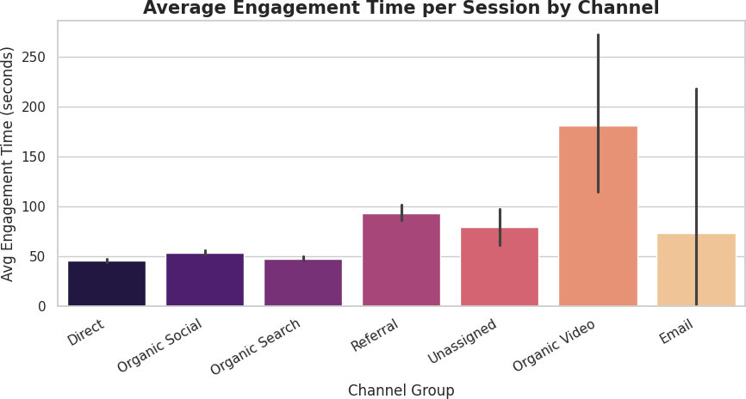

Insight: Channels like Email or Organic Search often show higher engagement times because users arrive with intent. Channels like Display Ads or Paid Social may have high user counts but low time-on-site, suggesting mismatched landing pages or broad targeting.

Engagement Rate Distribution by Channel

A boxplot shows the distribution of Engagement Rate across hours for each channel — not just the average. This reveals consistency vs variability in how engaged users are across different time windows.

Code:
plt.figure(figsize=(9, 5)) sns.boxplot(
data=df, x="Channel Group",
y="Engagement Rate", palette="magma"
)
plt.title("Engagement Rate Distribution by Channel", fontsize=15, fontweight='bold') plt.xlabel("Channel Group")
plt.ylabel("Engagement Rate") plt.xticks(rotation=30, ha='right') plt.tight_layout()
plt.show()
Chart Output:
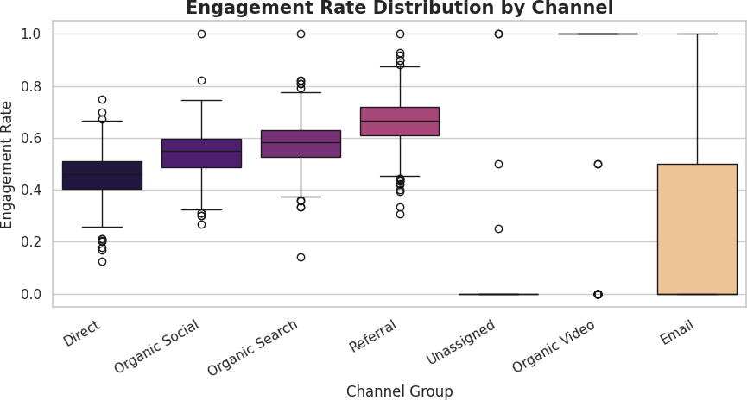

Insight: A narrow box (low IQR) means engagement is consistent across hours — predictable and reliable. A wide box means engagement fluctuates across time slots, suggesting the channel has both strong and weak performing periods. Outliers (dots beyond whiskers) represent exceptionally good or poor hours.

Engaged vs Non-Engaged Sessions

This grouped bar chart shows, for each channel, how many sessions were Engaged vs Non-Engaged. Engaged Sessions are those where the user actively interacted (scrolled, clicked, stayed 10+ seconds). This metric is critical because it directly correlates with conversion potential.

Code:
session_df = df.groupby("Channel Group")[["Sessions", "Engaged Sessions"]].sum().reset_index() session_df["Non Engaged"] = session_df["Sessions"] - session_df["Engaged Sessions"] session_df_melted = session_df.melt(
id_vars="Channel Group",
value_vars=["Engaged Sessions", "Non Engaged"]
)
plt.figure(figsize=(9, 5)) sns.barplot(
data=session_df_melted,
x="Channel Group", y="value", hue="variable", palette=["steelblue", "salmon"]
)
plt.title("Engaged vs Non-Engaged Sessions by Channel") plt.tight_layout()
plt.show()
Chart Output:
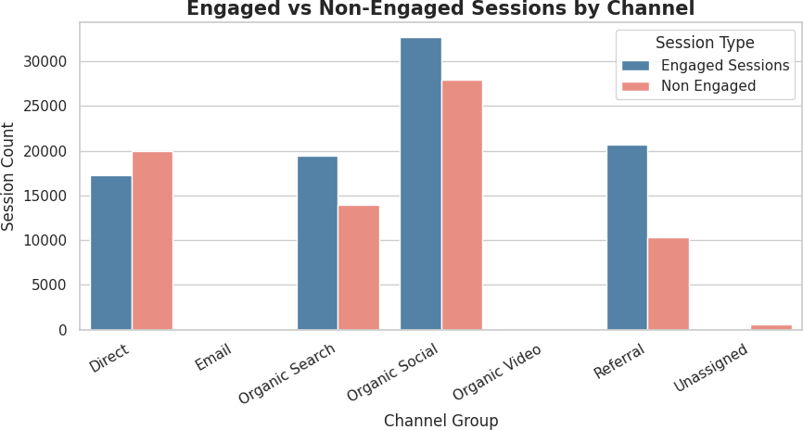

Insight: Channels with a high ratio of Non-Engaged sessions contribute to a poor user experience metric. If Paid Social has more Non-Engaged than Engaged sessions, the ads are likely reaching the wrong audience or landing on irrelevant pages. Focus UX improvements on high-non-engagement channels first.

Traffic Heatmap — Hour x Channel

A heatmap shows traffic intensity (total Sessions) broken down by hour of the day (rows) and Channel Group (columns). This reveals not just which channels are busy but WHEN they are busiest, which is critical for scheduling content and ad campaigns.

Code:
heatmap_data = df.groupby(["hour", "Channel Group"])["Sessions"].sum().unstack().fillna(0)

plt.figure(figsize=(13, 7)) sns.heatmap(
heatmap_data, linewidths=0.5, annot=True, fmt='.0f', cmap="YlOrRd"
)
plt.title("Sessions Heatmap — Hour of Day x Channel Group") plt.xlabel("Channel Group")
plt.ylabel("Hour of Day (0 = Midnight)") plt.tight_layout()
plt.show()
Chart Output:
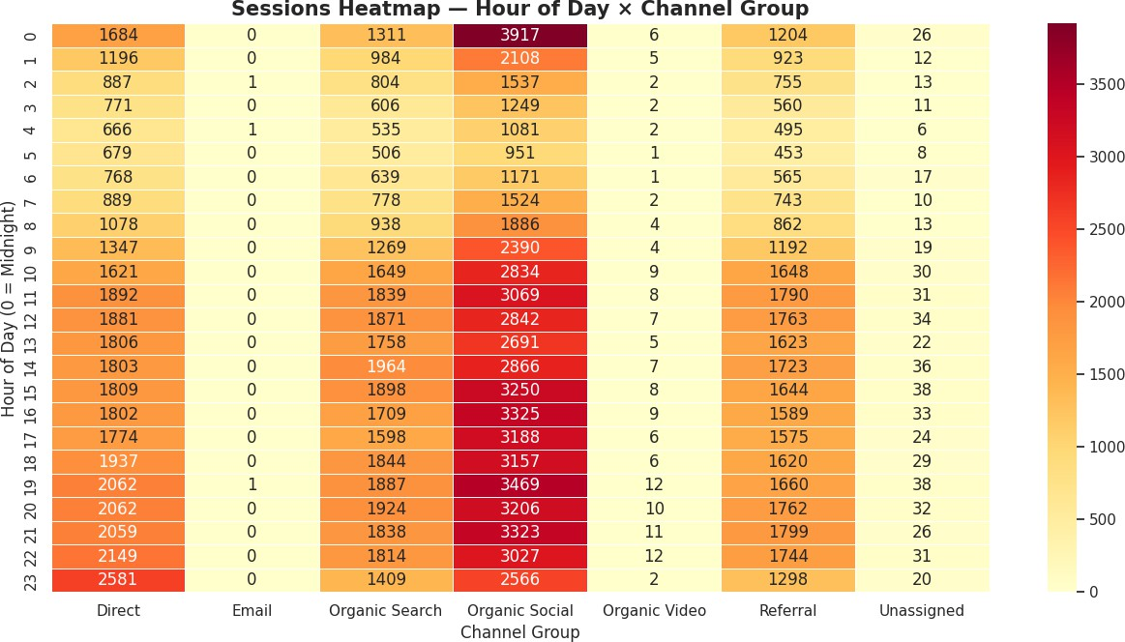

Insight: Dark (high-value) cells identify peak traffic windows for each channel. If Organic Search peaks at 10–11 AM while Direct traffic peaks in evenings, each channel has its own user behaviour pattern and should be treated independently in scheduling. Midnight hours with near-zero traffic can be used for maintenance windows.

Engagement Rate vs Sessions Over Time

This dual-line chart overlays Engagement Rate (quality signal) against Sessions (volume signal). By plotting both on the same axis, we can see whether traffic growth comes with a corresponding improvement or deterioration in user quality.

Code:
df_plot = df.groupby("DateHour")[["Engagement Rate", "Sessions"]].mean().reset_index()

plt.figure(figsize=(12, 5))
plt.plot(df_plot["DateHour"], df_plot["Engagement Rate"], label="Engagement Rate", color="green", linewidth=1.5)
plt.plot(df_plot["DateHour"], df_plot["Sessions"], label="Sessions", color="red", linewidth=1.5)
plt.title("Engagement Rate vs Sessions Over Time") plt.xlabel("Date & Hour")
plt.ylabel("Value") plt.legend() plt.grid(True) plt.tight_layout() plt.show()
Chart Output:
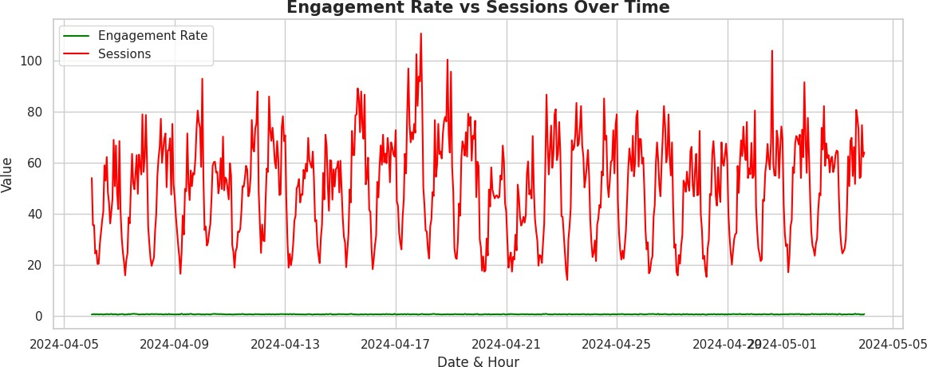

Insight: When sessions increase but engagement rate drops, it indicates low-quality or low-intent traffic — common during paid campaigns or viral spikes. A positive correlation — where both sessions and engagement rise together — is ideal. If this gap continues after a campaign ends, it signals poor traffic quality that needs audience targeting refinement.

Key Insights & Recommendations

Summary of Findings

erve higher el
# | Observation | Implication
1 | Traffic volume varies significantly by channel | Not all channels are equal — focus investment on high-performing ones
2 | Engagement time differs by channel despite similar | uVsoelrucmoeunistsnot Quality; channels with fewer but more engaged users des
3 | Engagement Rate distribution shows variability withi | nCcehrtaanin ehlosurs or periods drive poor-quality sessions even within a chann
4 | Non-engaged sessions are a significant fraction for | sIonmdiecactheasnpnoetlesntial landing page mismatch or irrelevant ad targeting
5 | Hourly heatmap reveals distinct peak windows per | chCaonnntelnt publishing and ad scheduling should align with channel-specific
6 | Engagement Rate can move inversely to session sp | iTkerasffic campaigns may dilute session quality — pair volume campaigns

peak hours

Actionable Recommendations
- Reallocate budget toward high-engagement channels — Even if their user volume is lower, they deliver better downstream conversion rates.
- Audit landing pages for high-bounce channels — The non-engaged session chart pinpoints exactly which channels need UX attention.
- Schedule content and campaigns at channel peak hours — Identified from the heatmap analysis — each channel has its own optimal window.
- Monitor Engagement Rate during campaign bursts — If it drops sharply during a traffic spike, refine audience targeting immediately.
- Investigate anomalous spikes in the time-series — These often reveal campaign wins or tracking errors worth documenting.
with UX impr

End of Report — Web Analytics: Traffic, Engagement & Channel Performance Analysis

