CSS(Cascading style sheet)
- CSS is the language we use to style and align our HTML elements.
- CSS was introduced in 1994 by Haykon wium lie.
- First version of CSS was introduced in 1996(CSS1)
- CSS2-1998
- Current version of CSS is CSS3-1999
- It is style sheet language which is used to describe the look and formatting of documents written in markup language.
- It is generally used with html to change the style of web pages and UI.
- Commenting in CSS:-- /*-----*/

How to add CSS to HTML
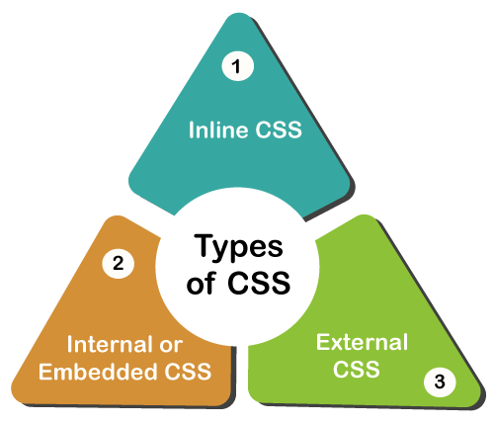

1.Inline style sheet :
- We will use style attribute in the tagline itself
<p style : ” color: red”>Hello CSS</p>

2.Internal style sheet :
- We have to use <style > tag in the <head> section of HTML documnet
Example:
<style>
p{color : value}
</style>

3.External style sheet :
- We have to create external file with .css extension and we need to link that CSS file to HTML file using <link> tag
<link rel=”stylesheet” href=”./style.css”/>
@import
- @import rule is used to link one CSS within another CSS..
Syntax:- @import url(“cssfilepath”)
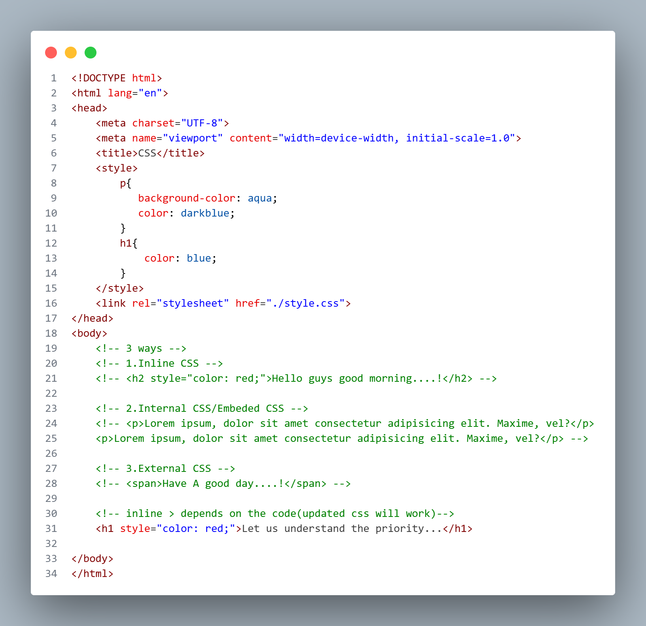

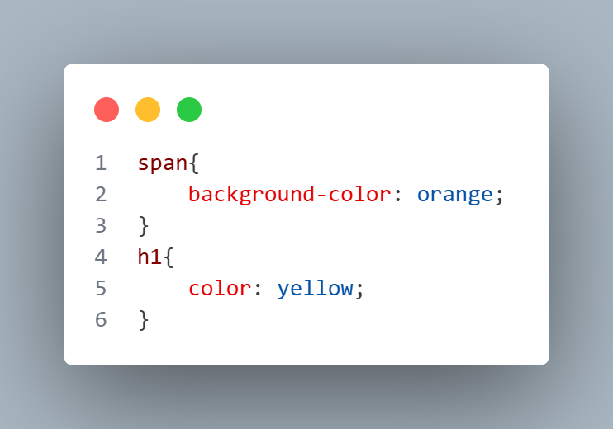

Selectors
Selectors are used to target the HTML elements
A CSS selector selects the HTML element(s) you want to style.
Syntax :
Selector{
property: value;
property: value;
}

Types of CSS Selectors
- Simple Selector
- Combinator Selector
- Attribute Selector
- Pseudo class Selector
- Pseudo Element Selector

1.Simple Selectors
- Id selector (#)
- Class selector (.)
- Universal Selector (*)
- Element Selector (tag)
- Grouping Selector(,)

1.ID SELECTOR (#)
- Unique id attribute within the page is selected
- Core attribute selector
- Selected by symbol “#” followed by id name
- SYNTAX: #id_name{
css properties

}
2. CLASS SELECTOR (.)
- Core attribute selector ,with specific class.
- The character to access in css file “ . “
- Multiple class name can be called using comma
SYNTAX: . class _ name{
/* css properties*/
}
3. UNIVERSAL SELECTOR(*)
- Select all elements in html page.
- All the elements within a body tag.
- Symbol of selector: “ * “
SYNTAX:
*{
properties
}

4. TYPE/ ELEMENT SELECTOR(tagname)
- Selects particular element with specified tagname.
- Call by type of tag.
SYNTAX:
element name{
properties
}
5. GROUPING SELECTOR(,)
- We can group the multiple selectors and we can do styling
#heading,.para,button{
Properties
}
NOTE: PRIORITY ORDER =====
{ “ ID > CLASS > TYPE/ELEMENT >UNIVERSAL “}
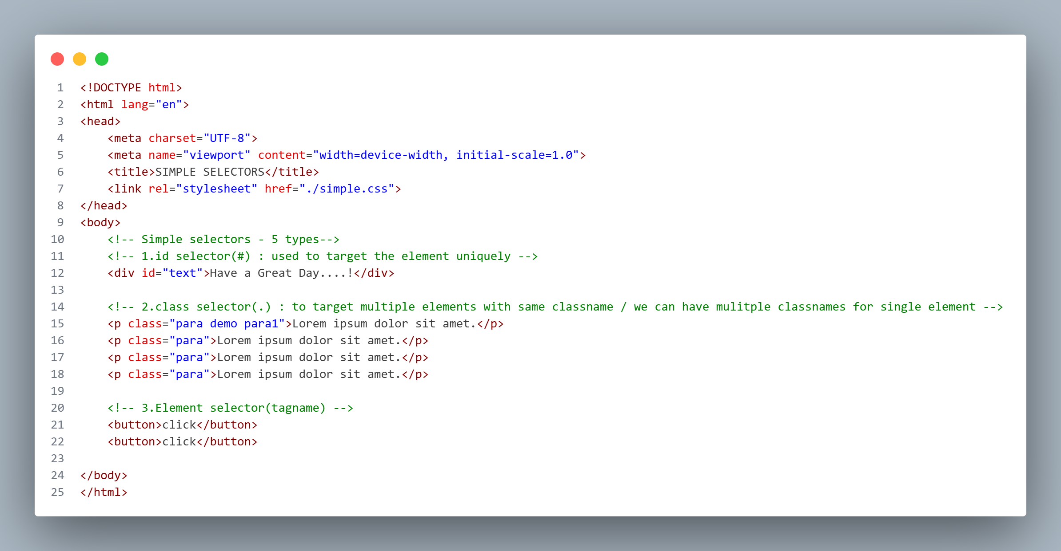
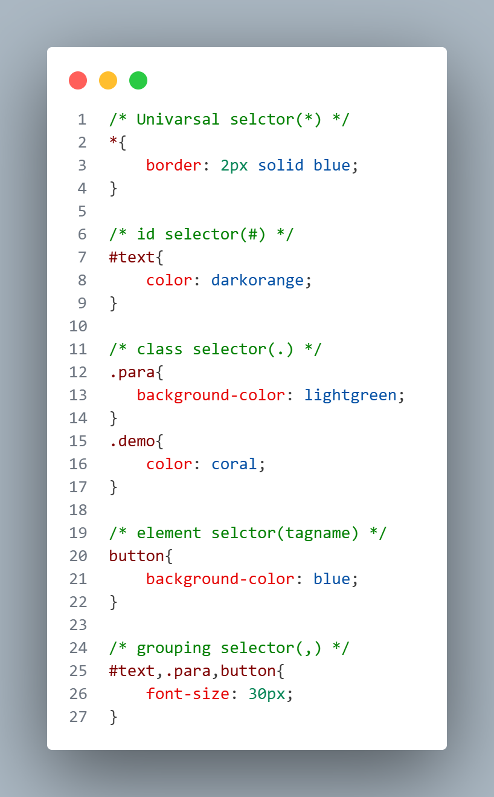

Combinator Selectors
- We will combine and target the elements
Types of combinator selectors
- Descendent selector(space)
- Child selector(>)
- Adjacent sibling selector(+)
- General sibling selector(~)

1.DESCENDENT SELECTOR (space)
- A CSS selector can contain more than one simple selector. Between the simple selector we can use combinator
- Combines two selectors are such that elements are matched by second selector are selected if they have ancestor.
- (parent,parents’s parent, parent’s parents’s parent)
- Selector utilities a descendents combinator are called descendent selectors.
Syntax: Selector1_Selector2{property declaration}
Div p{ prop:val;}

2.Child selector(>)
- The child selector selects all the elements that are the children of a specified element
- It is placed between 2 CSS selectors,matches only those elements matched by second selector and direct child.
Syntax:
selector 1 > selector 2 { properties }
Ex:
Div>p{prop : val}

3. Adjacent sibling selector (+)
- The adjacent sibling selector is used to select an element that is directly after another specific element.
- Sibling elements must have the same parent element, and "adjacent" means "immediately following".
Syntax :
former_element + target_element {style properties }

4. General sibling selector(~)
- The general sibling selector selects all elements that are next sibling of a specified element.
- The general sibling combinator (~) separates two selectors.

Syntax :
former_element ~ target_element {
style properties
}
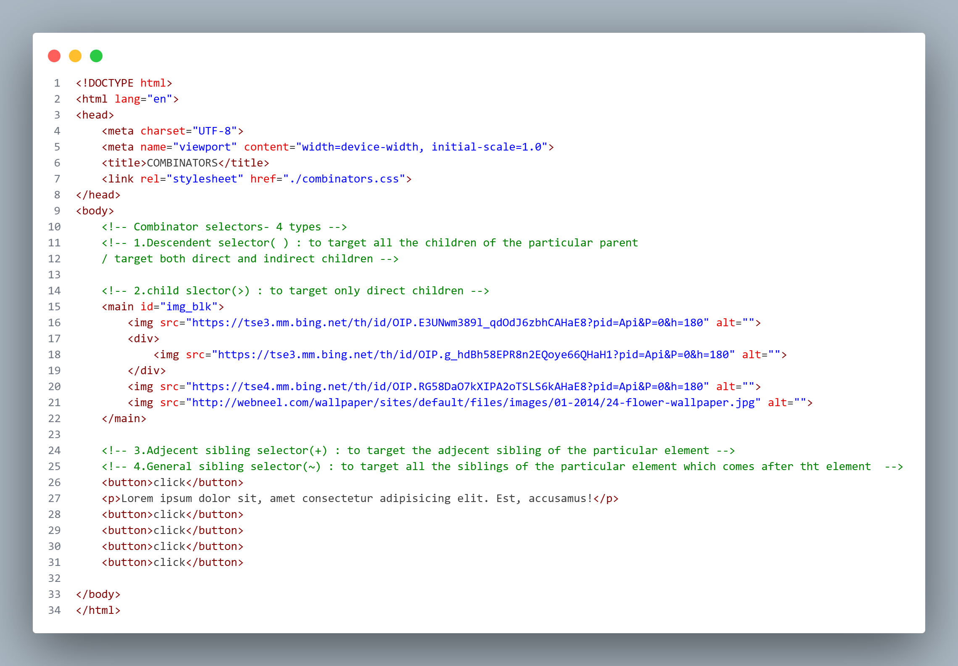

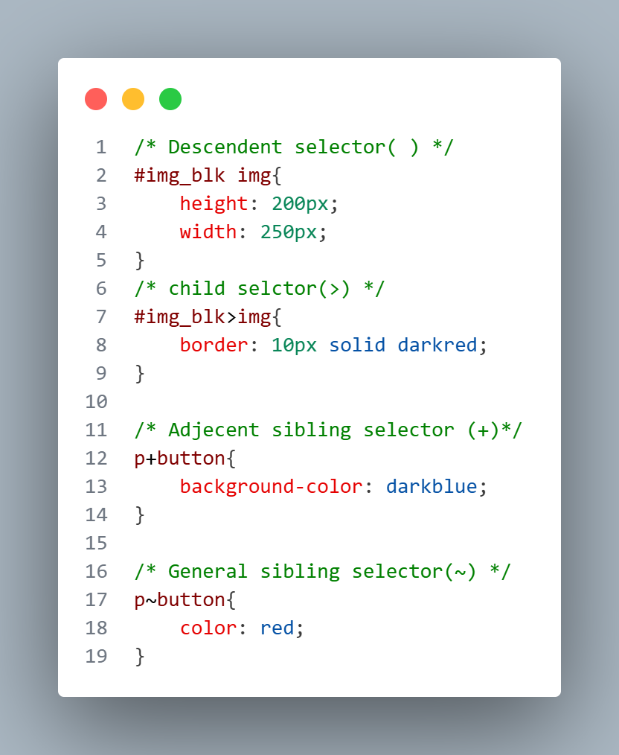

Pseudo classes
A CSS pseudo-class is a keyword added to a selector that specify a special state of the selected element.
For Example: It can be used to
- Style an element when a user mouses over it
- Style visited and unvisited links differently
- Style an element when it gets focus
- Symbol for pseudo class selector is ‘:’
Selector:pseudo-class{
property:value;
}
In pseudo class selectors we have 2 types
1.structural pseudo class selectors
- Link: used to style the unvisited link
- Visited: used to style the visited link
- Active: used to style the active link
- Focus: used to style the text filed when we focus that
- Hover: used to style the element when mouse hover on the element

a:hover - style the element when mouse hover on the element
a:link - style the unvisited link
a:visited - style the unvisited link
a:active – style the active link
input:focus – style the focused text field

2.dynamic pseudo class selectors
- first-child
- last-child
- nth-child
The :first-child pseudo-class matches a specified element that is the first child of another element.
The :last-child pseudo-class matches a specified element that is the last child of another element.
The :nth-child(n) selector matches every element that is the nth child of its parent.
We can target only even children using nth-child() by passing even or 2n in parenthesis
We can target only odd children using nth-child() by passing odd or 2n+1 in parenthesis
Selector:nth-child(even){ Selector:nth-child(even){
Property Property
} }

n can be a number, a keyword (odd or even), or a formula (like an + b).
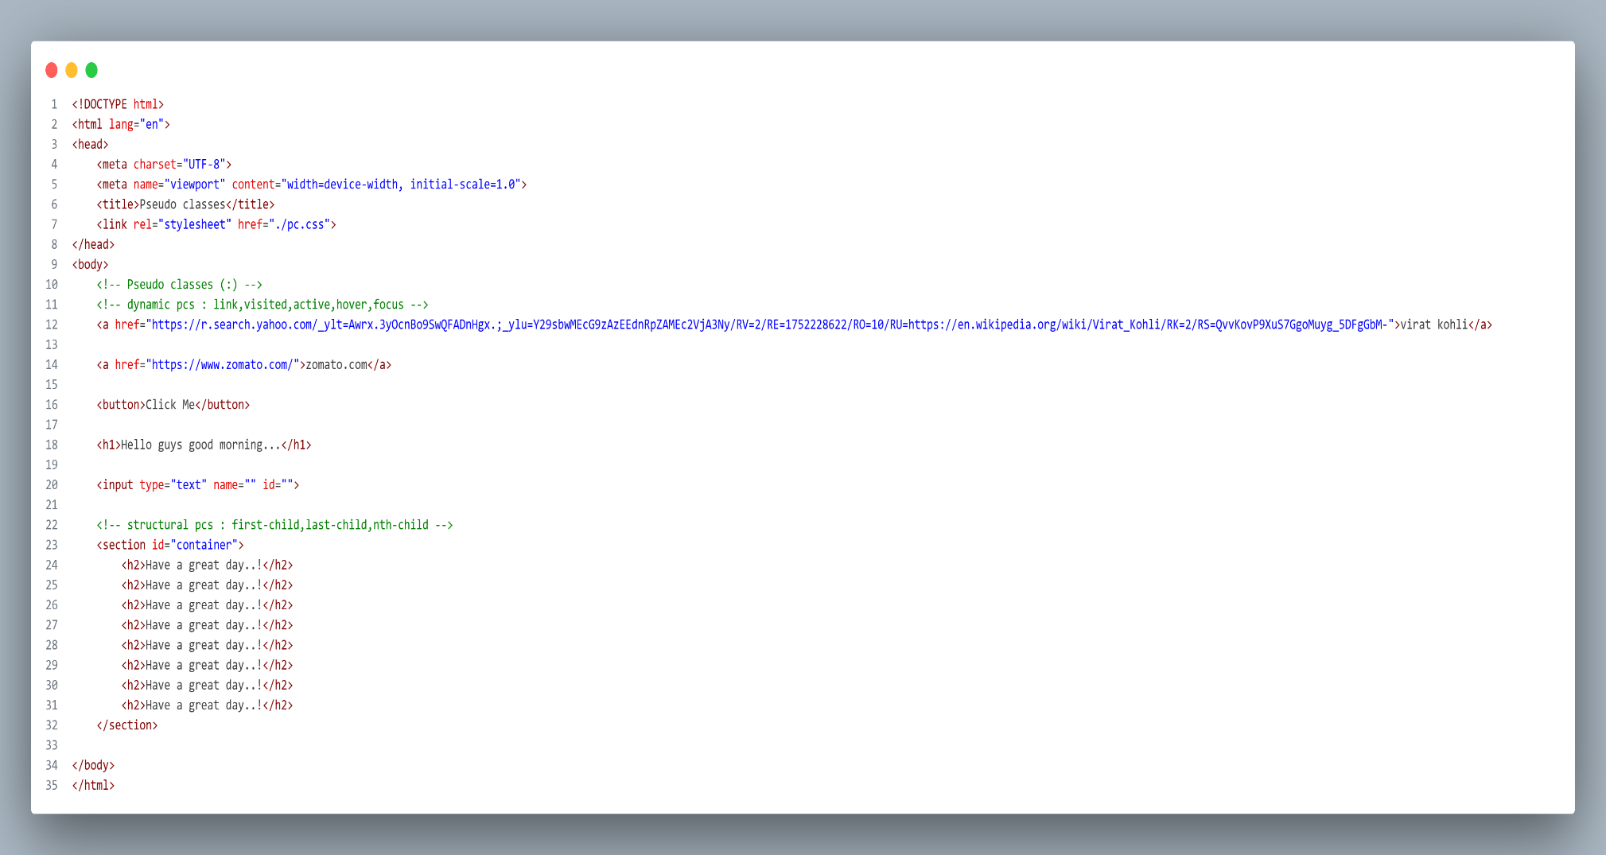
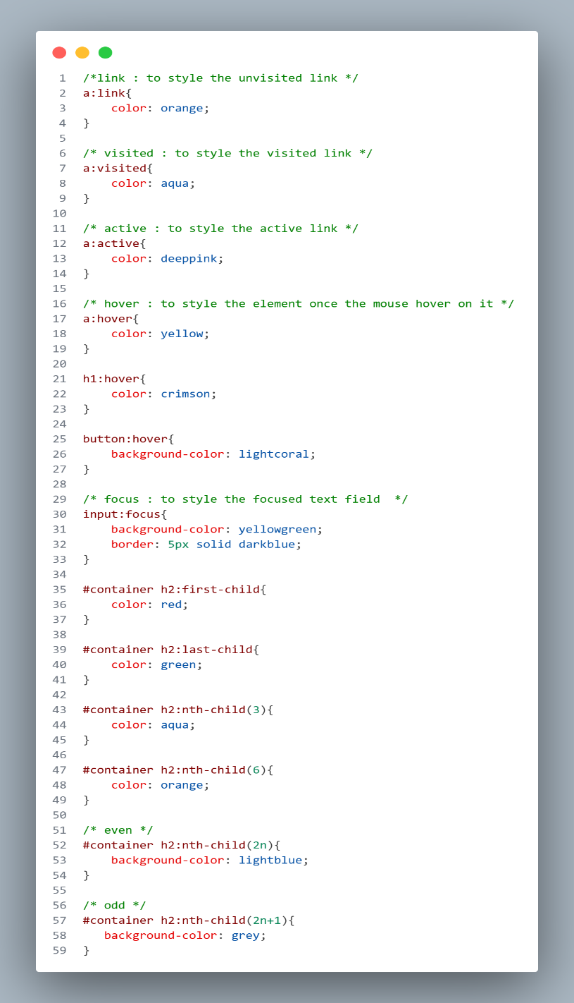

Pseudo Elements
A CSS pseudo-element is used to style specified parts of an element.
Symbol for pseudo element selector is ‘::’
For example, it can be used to:
  - Style the first letter, or line, of an element
  - Insert content before, or after, the content of an element
selector::pseudo-element{
property:value;
}
:: first-line : styles the first letter of the element
:: first-letter: styles the first line of the element
::before : adds the content before the actual content
::after: adds the content after the actual content
::marker: style the list style type
::selection : style the selected content on the webpage

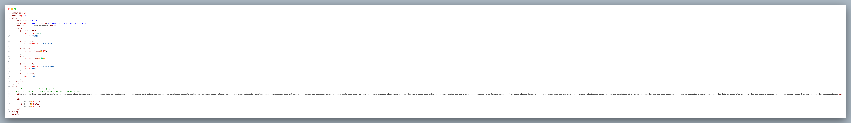

Attribute selector
- Attribute provides extra information to the tag.
- In this attribute selector we are targeting the elements based on attributes

Targeting using attribute name
Selector[attribute]{
property}:value
}

Targeting using attribute name and value
Selector[attribute=“value”]{
Property:value
}
