CSS Typography

Text Properties in CSS
color : property is used to set the color of the text
- a color name - like "red"
- a HEX value - like "#ff0000"
- an RGB value - like "rgb (255,0,0)"
- An RGB color value represents red, green, blue.
- Each parameter (red, green, and blue) defines the intensity of the color between 0 and 255.
- For example, rgb(255, 0, 0) is displayed as red, because red is set to its highest value (255) and the others are set to 0.
- To display black, set all color parameters to 0, like this: rgb(0, 0, 0).
- To display white, set all color parameters to 255, like this: rgb(255, 255, 255).
- In rgba (red,green,blue,alpha).alpha means opacity of the color.
- The alpha value is a number between 0.0 means full transparent and 1.0 not transparent.
- Color:rgb(255,255,0)
- Color:rgba(160,200,100,0.4)

text-align : property is used to set the horizontal alignment of a text.
- A text can be left or right aligned, centered, or justified.
text-transform: property is used to specify uppercase and lowercase letters in a text.
- It can be used to turn everything into uppercase or lowercase letters, or capitalize the first letter of each word:
text-shadow: property adds shadow to text
- In its simplest use, you only specify the horizontal shadow (2px) and the vertical shadow (2px) (text-shadow: 2px 2px;)
- add a color (red) to the shadow ( text-shadow: 2px 2px red;)
- add a blur effect (5px) to the shadow( text-shadow: 2px 2px 5px red)
letter-spacing: property is used to specify the space between the characters in a text.
word-spacing: property is used to specify the space between the words in a text.
text-indention: property is used to specify the indentation of the first line of a text
text-decoration :
- text-decoration-line : property is used to add a decoration line to text.(overline,underline,line-through)
- text-decoration-color: property is used to set the color of the decoration line(red).
- text-decoration-style: property is used to set the style of the decoration line(solid,dashed,double,dotted,wavy).
- text-decoration-thickness: property is used to set the thickness of the decoration line(2px).
- text-decoration: It is a shorthand property for all these four properties
text-decoration-line (required)
text-decoration-color (optional)
text-decoration-style (optional)
text-decoration-thickness (optional)
line-height:- The line-height property specifies the height of a line. we pass values in px, deg, decimal.
box-shadow:- The CSS box-shadow property is used to apply one or more shadows to an element.
This property will accept five values. h-shadow v-shadow blur-radius spread-radius color of the shadow.
*Default shadow color is text-color. we can pass negative values too.

Background Property: -
background-color: property sets the background color of an element.
- background-image : url (“image.jpg”)
  - property sets one or more background images for an element.
  - By default, a background-image is placed at the top-left corner of an element, and repeated both vertically and horizontally.
- background-repeat : no-repeat/repeat-x/Y
- property sets if/how a background image will be repeated.
- By default, a background-image is repeated both vertically and horizontally.
- background-size : cover/100%
- property specifies the size of the background images.
- background-Position : right/left/center
- property sets the starting position of a background image.
- background-attachment : scroll/fixed
- property sets whether a background image scrolls with the rest of the page, or is fixed.

Gradient
CSS gradients is used to display smooth transitions between two or more specified colors.
- Linear-gradient(direction,color-stop1,color-stop2);
- Radial-gradient(shape size at position, start-color,…,last-color);

Height and Width Property:-
The height and width properties are used to set the height and width of an element.
The height and width properties may have the following values:
- auto - This is default.
- length - The height/width.
- % - The height/width in percent of the containing block
- initial – Automatically set the height/width to its default value
- inherit - The height/width will be inherited from its parent
max-width:px, max-height:px, min-width:px, min-height:px, width:px, height:px

Font Properties
CSS fonts control how text appears on a webpage.
Font-size: large/smaller/medium/small/x-small/xx-small/x-large/xx-large/px/deg.
Font-weight: bold/bolder/lighter/normal/100 to 900
Font-style: italic/normal/oblique

Font-family: font styles

Box Model:-
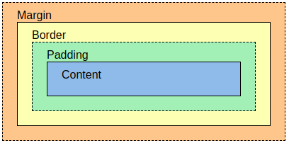
• The CSS box model is essentially a box that wraps around every HTML element. It consists of: margins, borders, padding, and the actual content. The image illustrates the box model:
• Content - The content of the box, where text and images appear
• Padding - Clears an area around the content. The padding is transparent no negative values.
• Border - A border that goes around the padding and content
• Margin - Clears an area outside the border. The margin is transparent.negative values will be accepted.
• Margin-style
• Margin-top
• Margin-bottom
• Margin-left
• Margin-right
• Padding-style
• Padding-left
• Padding-right
• Padding-top
• Padding-bottom
• Border-style
• Border-color: Color of the border. Default color will be text color(this property is optional)
• Border-width: Thickness of border. Default thickness will be 2px(this property is optional)
• Border-style: dotted/double/groove/dashed/solid(this property is mandatory )
• Border-radius: Convert sharp edges to curve shape.
Ex:-border-radius:px/deg.

Position Property:-
The position property specifies the type of positioning method used for an element.
You must specify at least one of top, right, bottom or left for positioning to work.
- Static:-Default value for position property
- Relative:-Moves the element from its current position
- Fixed:-It will be fixed in particular place. which means it always stays in the same place even if the page is scrolled
- Absolute:- Is positioned relative to the nearest positioned ancestor.if no ancestor then it uses document body.
- Sticky:- It is positioned based on the user's scroll. Toggles between relative and fixed.

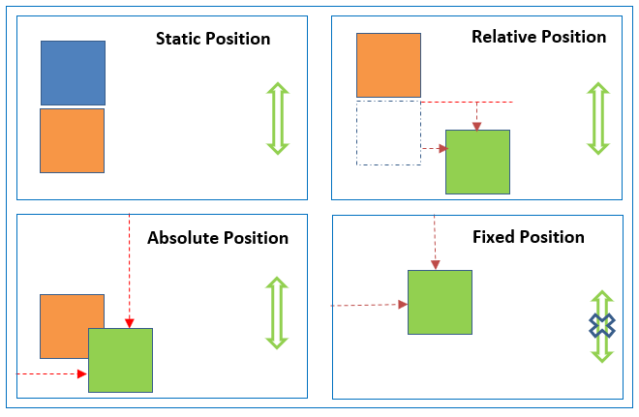

Display properties:-
Inline :- Displays an element as an inline element (like <span>). Any height and width properties will have no effect
Block :- Displays an element as a block element (like <p>). It starts on a new line, and takes up the whole width
Inline-block :-Displays an element as an inline-level block container. The element itself is formatted as an inline element, but you can apply height and width values
Flex :-Displays an element as a block-level flex container

Flex-box properties
Display :- flex
Flex-direction:- specifies the display-direction of flex items in the flex container. Values are row/column/row-reverse/colomn-reverse
Flex-wrap:- specifies whether the flex items should wrap or not. values are wrap/no-wrap/wrap-reverse
Justify-content:- property is used to align the flex items in horizontally. values are flex-start/flex-end/center/space-around/space-between/baseline
Align-items:- property is used to align the flex items in vertically. values are flex-start/flex-end/center
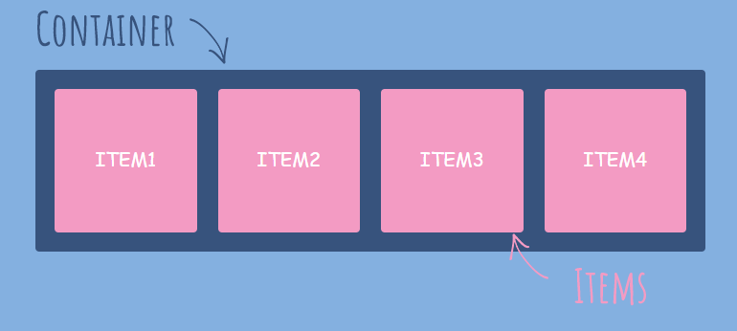

CSS Grid Layout
The Grid Layout Module offers a grid-based layout system, with rows and columns.
The Grid Layout Module allows developers to easily create complex web layouts.

Grid Container
The rows and columns of a grid is defined with the grid-template-rows and the grid-template-columns properties (or the shorthand grid or grid-template properties).
grid-template-columns: property defines the number of columns in your grid layout, and it can define the width of each column.
grid-template-rows: property defines the height of each row.

Grid Items
grid-column: property defines on which column(s) to place an item.
You define where the item will start, and where the item will end.
grid-row: property defines on which row to place an item.
You define where the item will start, and where the item will end.
grid-area: property can be used as a shorthand property for the grid-row-start, grid-column-start, grid-row-end and the grid-column-end properties.

Transition:
- Transition allows you to change property value smoothly, over a given duration.
- Transition-property: The CSS property you want to add an effect
- Transition-duration: The duration of the effect
- Transition-timing-function: speed curve of the transition effect.
- ease - specifies a transition effect with a slow start, then fast, then end slowly (this is default)
- linear - specifies a transition effect with the same speed from start to end
- ease-in - specifies a transition effect with a slow start
- ease-out - specifies a transition effect with a slow end
- ease-in-out - specifies a transition effect with a slow start and end

- Transition-delay : The transition-delay property specifies a delay (in seconds) for the transition effect.
- Transition(shorthand property)
- transition: width 2s linear 1s

2D and 3D Transforms
Transforms allow you to move, rotate, scale, skew, element.
- The transform property applies a 2D or 3D transformation to an element. This property allows you to rotate, scale, move, skew, etc., elements.
- It is used to change behavior of an element
2D transform :
translate()
rotate()
scaleX()
scaleY()
scale()
skewX()
skewY()
skew()
3D transform :
rotateX()
rotateY()
rotateZ()
1.translate()-moves an element from its current position.
2.rotate()-rotate an element clockwise/counter-clockwise according to degree.
Using negative values will rotate the element counter-clockwise.
3.scale()- increases/decreases the size of an element.
4.scaleX()-increases or decreases the width of an element.
5.scaleY()- increases or decreases the height of an element.
6.skew()-skews an element along the X and Y-axis by the given angles.
7.skewX()-skews an element along the X-axis by the given angle.[degree 0-360]
8.skewY()-skews an element along the Y-axis by the given angle.
9.matrix()- 6 parameters mathematical function
- matrix(scaleX(),skewY (),skewX(),scaleY(),translateX(),translateY())
- transform: matrix (1, -0.3, 0, 1, 0, 0);
3D Transforms:-
- rotateX()- rotates an element around its X-axis.rotateY()-rotates an element around its Y-axis.
- rotateZ()-rotates an element around its Z-axis.

Animations
- CSS allows animation of HTML elements without using JavaScript
- An animation lets an element gradually change from one style to another.
- You can change as many CSS properties you want, as many times as you want.
- To use CSS animation, you must first specify some keyframes for the animation.
- Keyframes hold what styles the element will have at certain times.
- @keyframes:-
- When you specify CSS styles inside the @keyframes rule, the animation will gradually change from the current style to the new style at certain times.
To get an animation to work, you must bind the animation to an element.
- EXAMPLE :
- @keyframes example {
from {background-color: red;}
to {background-color: yellow;}
}
/* The element to apply the animation to */
div {
width: 100px;
height: 100px;
background-color: red;
animation-name: example;
animation-duration: 4s;
}

animation-name :Name of the animation
animation-duration: This property defines how long an animation should take to complete, If the animation-duration property is not specified, no animation will occur, because the default value is 0s (0 seconds)
animation-delay : Property specifies a delay for the start of an animation.
animation-iteration-count : property specifies the number of times an animation should run.
animation-direction : property specifies whether an animation should be played forwards, backwards or in alternate cycles.
normal - The animation is played as normal (forwards). This is default
reverse - The animation is played in reverse direction (backwards)
alternate - The animation is played forwards first, then backwards
alternate-reverse - The animation is played backwards first, then forwards
animation-timing-function: property specifies the speed curve of the animation

Media queries
- Media query is a CSS technique introduced in CSS3.
- It uses the @media rule to include a block of CSS properties only if a certain condition is true.
- In this example, the only keyword is used to target only screens.
- Example
- If the browser window is 600px or smaller, the background color will be lightblue:
- @media only screen and (max-width: 600px) {
body {
background-color: lightblue;
}
}

