Basics of web-technology
HTML : Hyper text markup language
To create the structure of the webpage
CSS : Cascading style sheet
Used for styling and alignment of HTML elements on the webpage
JS: JavaScript
Used to add the functionality
Terminologies
- WEB : The world wide web is also called as web and it is interconnection of public websites which can be accessible through internet
- INTERNET : It is system of interconnected computer networks that allows users to access and share the information
- CLIENT : User
- BROWSER : It is a standalone application through which we can access data with a help of internet
- SERVER : It is a combination of software and hardware that receives request and response to a request over a network
- WEBPAGES : It is document that is accessible by browser and it contains text,images,hyperlinks and these are also called as building blocks of websites
- WEBSITES : It is collection of related or interconnected webpages

How Web Works
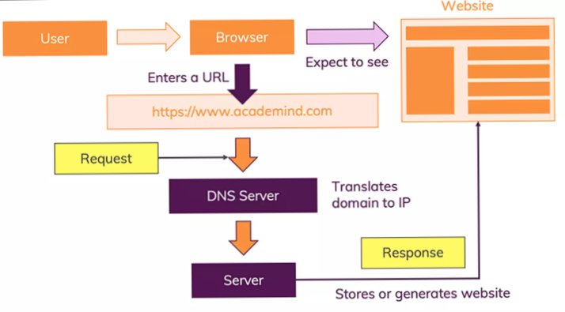

Structure of URL

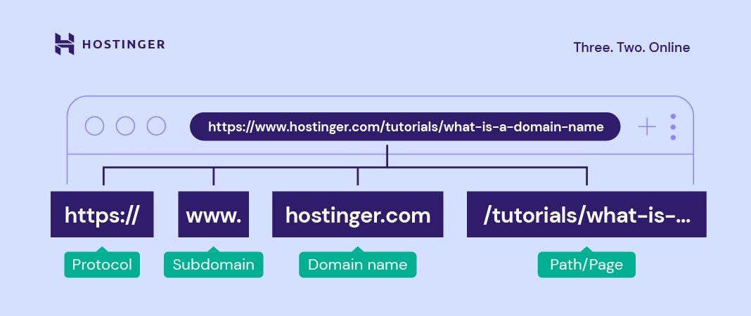

HTML
- HTML stands for Hyper Text Markup Language.
- A reference / link created by developers to provide the data / information to the users which is designed by pre-defined tags and it comunicatable with browsers.
- This will be first page to rendered on the browsers.
- HTML is not case sensitive.
- .html/.htm are the extensions for HTML.
- HTML was introduced in 1991 by Tim Berners Lee
- First version of HTML is released in 1993—html 1.0
- Html 2.0----1995
- Html 3.2----1997
- Html 4.02----1999
- Html 5.0----2014
- Current version of html means now we are using html 5.0

Structure of HTML Document

<!DOCTYPE html>
<html Lang="en">
<head>
<meta charset="UTF-8">
<meta http-equiv="X-UA-Compatible" content="IE=edge">
<meta name="viewport" content="width=device-width, initial- scale=1.0">
<title>JAVASCRIPT</title>
</head>
<body>

</body>
</html>

HTML Tags

TAG: Tag is predefined word or keyword which is enclosed within angular braces
<html> </html>
Types of Tags
1) Paired Tags: These are the tags that will have an opening and closing tags
Ex: <p> </p>, <head> </head> etc….
2) Unpaired tags: These are the tags that will not having any closing tags and these are also called as self-closing tags
Ex: </br>, <hr>,<input>,<img> etc….

STRUCTURE OF HTML
- <!DOCTYPE HTML>--Represents the version of html
- <html>--Root element of the html page
- <head>--Contains meta information about the html page
- <title>--It will give the title for the webpage
- <body>--It is a document’s body and it is the container for all the visible contents such as headings,paragraphs,images etc.

Basic HTML Tags

HTML Documents:
- All HTML documents must start with a document type declaration: <!DOCTYPE html>.
- The HTML document itself begins with <html> and ends with </html>.
- The visible part of the HTML document is between <body> and </body>.

HTML Headings:
- HTML headings are defined with the <h1> to <h6> tags.
- <h1> defines the most important heading. <h6> defines the least important heading
<h1>Heading 1</h1>
<h2>Heading 2</h2>
<h3>Heading 3</h3>
<h4>Heading 4</h4>
<h5>Heading 5</h5>
<h6>Heading 6</h6>

HTML Paragraphs:
- HTML paragraphs are defined with the <p> tag

HTML Elements
An HTML element is defined by a start tag, some content, and an end tag.
Tags along with the content is known as element
Ex: <h1>Hello World</h1>
- BLOCK LEVEL ELEMENTS: It will take entire width of the browser and these are starts from new line
Ex:<div>, <table>, <form>, <nav><nav>
- INLINE ELEMENTS: It will take only content width
These are starts from the same line means next to each other
Ex:<span>, <b>, <i>, <u>

HTML Attributes
- HTML attributes provide additional information to HTML tags.
- All HTML elements can have attributes
- Attributes are always specified in the start tag/opening tag
- Attributes usually come in name/value pairs like: name="value“.
- Values of an attributes are case sensitive

Core Attributes:
- Id: It is used to target a particular element uniquely.
- Class: The class attribute specifies one or more classnames for an element
- Title: The title attribute gives a suggested title for the element. It is used to give tooltip for the element.
- Style : It specifies an inline style for an element.
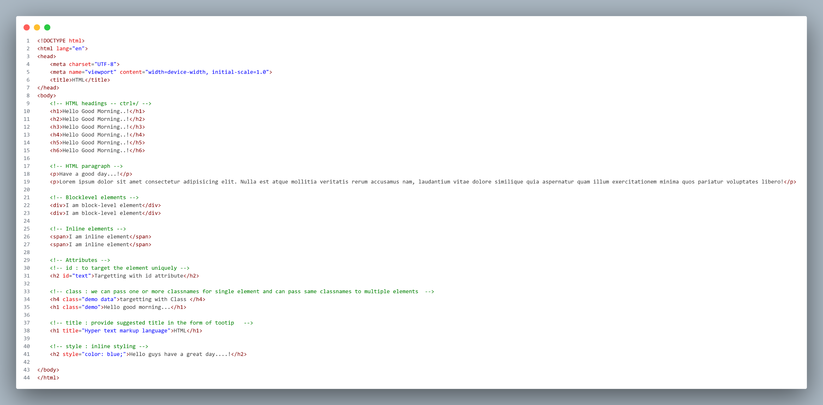

HTML Formatting
Formatting elements were designed to display special types of text
- <b> - to display bold text
- <strong> - display bold text and according to browser it has extra importance
- <i> - display Italic text
- <em> - display Emphasized(italic) text
- <u> - display underlined text
- <ins> - very similar to <u>, according to browser it will be inserted text
- <strike> - display striked text
- <del> - very similar to <strike>, according to browser it will be deleted text
- <mark> - display highlighted text
- <sub> - display subscript text
- <sup> - display superscript text

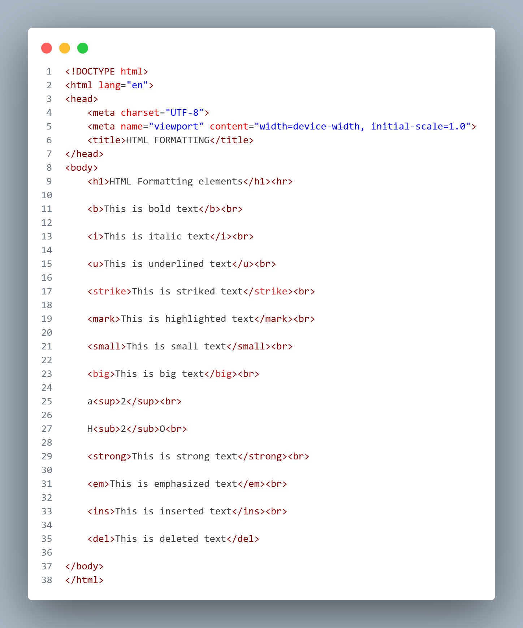

Sectioning Elements / Semantic Elements
- A semantic element clearly describes its meaning to both the browser and the developer.
- Examples of semantic elements: <form>, <table>, and <article> - Clearly defines its content.
- Examples of non-semantic elements: <div> and <span> - Tells nothing about its content.
- Semantic elements represent their meaning to both the browser and developer.
- All semantic elements are block level
- HDAMNSTAFF
- H HEADER
- D DETAILS
- A ASIDE
- M MAIN
- N NAV
- S SUMMARY AND SECTION
- T TABLE
- A ARTICLE
- F FIGURE
- F FIGCAPTION/FOOTER

HTML Lists
1.Unordered HTML List:
- An unordered list starts with the <ul> tag. Each list item starts with the <li> tag.
- The list items will be marked with bullets (small black circles) by default
- Attributes
  - Type : square,circle,none
2.Ordered HTML List:
- An ordered list starts with the <ol> tag. Each list item starts with the <li> tag.
- The list items will be marked with numbers by default
- Attributes:
  - Type : numbers,alphabets(lower,upper),roman(lower,upper)
  - Start: number
  - reverse
3.Description Lists:
- A description list is a list of terms, with a description of each term.
- The <dl> tag defines the description list, the <dt> tag defines the term (name), and the <dd> tag describes each term
Nested Lists:
- List inside another list is called as nested list.
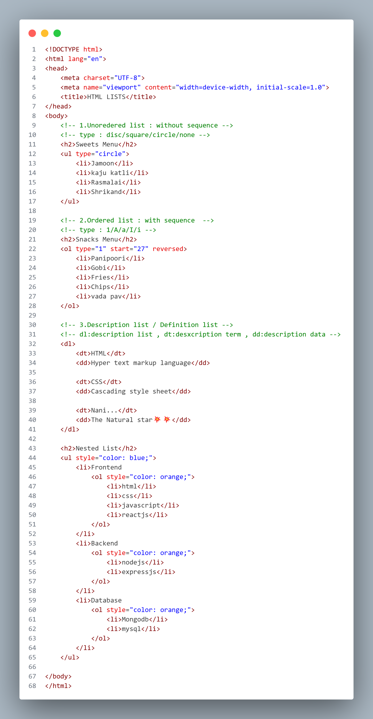

HTML Image
- <img> tag is used to insert an image in webpage
- Image is inline-block element
Attributes
- src: It is an attribute of img tag, inside this we will pass the path of the image.
- alt: It is used give the alternative name for the image
- When the image is not displaying on webpage this alternative name will be displayed
- height: It is used give the height for the image
- width: It is used give the width for the image
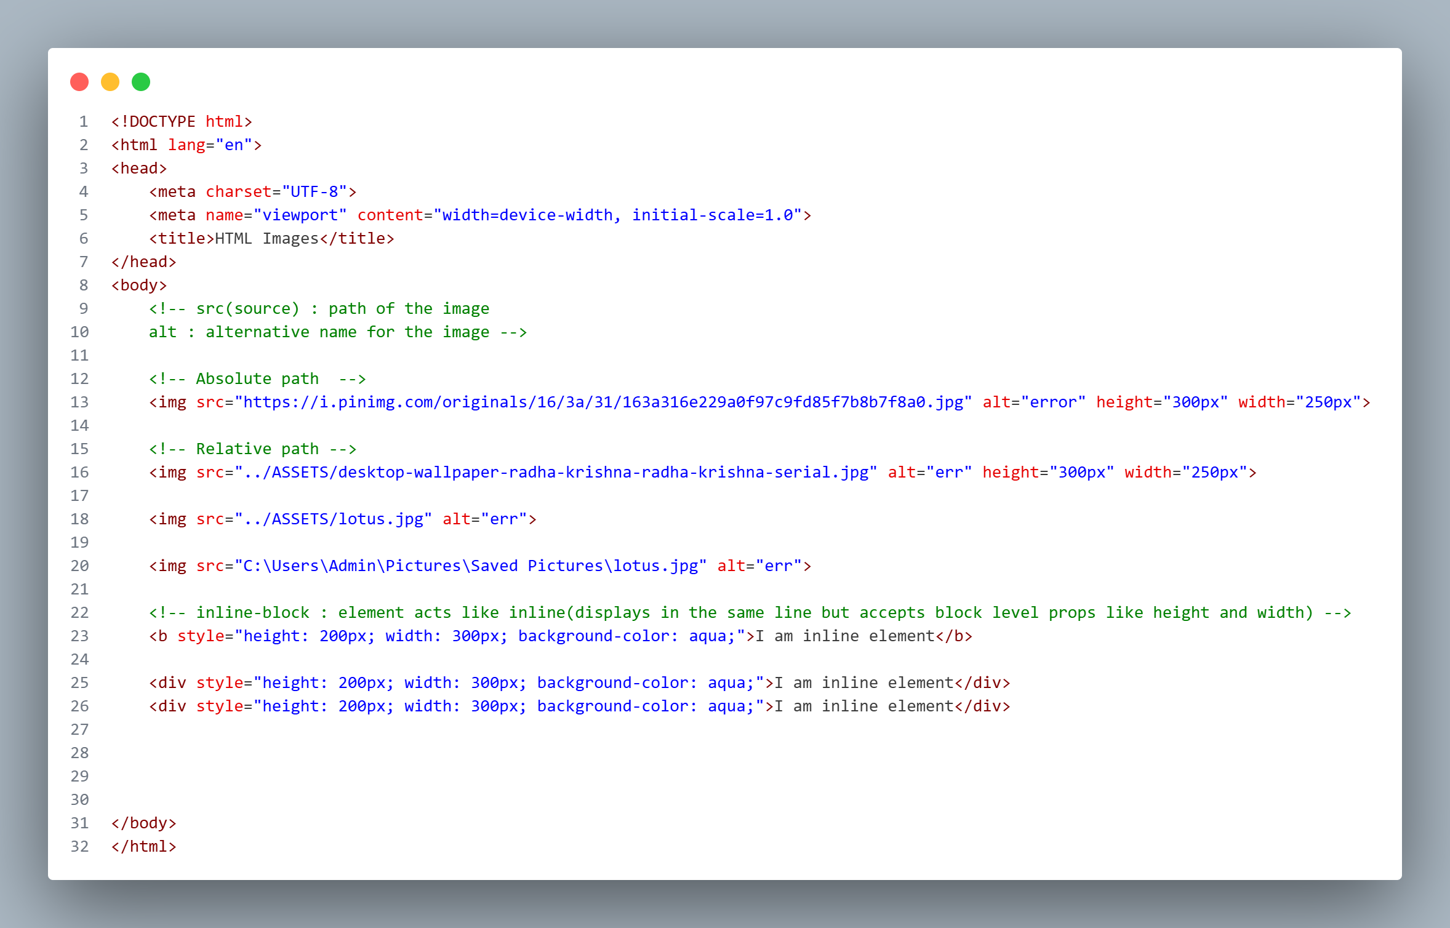

Anchor tag / Hyperlinks
- The <a> tag defines a hyperlink, which is used to link from one page to another.
- The most important attribute of the <a> element is the href (hyper reference) attribute, which indicates the link's destination.
- By default, links will appear as follows in all browsers:
- An unvisited link is underlined and blue
- A visited link is underlined and purple
- An active link is underlined and red
Text as a Link
- To use a text as a link, just write the text inside the <a> tag with href attribute
Image as a Link
- To use an image as a link, just put the <img> tag inside the <a> tag
Button as a Link
- To use a button as a link, just put the <button> tag inside the <a> tag
Absolute URL v/s Relative URL

Absolute URL | Relative URL
- a full web address in the href attribute.  - <p><a href="https://www.w3.org/">W3C</a></p> | - A local link (a link to a page within the same website) is specified with a relative URL (without the "https://www" part):  - <p><a href="html_images.asp">HTML Images</a></p>

The target Attribute in <a> tag
- By default, the linked page will be displayed in the current browser window. To change this, you must specify another attribute that is target for the link.
- The target attribute specifies where to open the linked document.
- The target attribute can have one of the following values:
_self - Default. Opens the document in the same window/tab as it was clicked
_blank - Opens the document in a new window or tab
_parent - Opens the document in the parent frame
_top - Opens the document in the full body of the window

