IT13: ADBMS
Practical Assignment 2 Solution Template
Roll No:- 2601103
Name: - Tanvi Jagdish Khedekar
_____________________________________________________________________________
Practical 2: Implementation of different types of functions with suitable examples.
- Number Function
- Aggregate Function
- Character Function
- Conversion Function
- Date Function
LAB PRACTICE ASSIGNMENT:
Create a table EMPLOYEE with the following schema:
(Emp_no, E_name, E_address, E_ph_no, Dept_no, Dept_name,Job_id, Designation, Salary)
create database company;
use company;

create table employee (
emp_no int primary key,
e_name varchar(20),
e_address varchar(100),
e_ph_no varchar(15),
dept_no int,
dept_name varchar(50),
job_id varchar(10),
designation varchar(20),
salary int
);
insert into employee values(1,'Janvi','Pune',9309744141, 1,'Finance',111,'Team leader',35000);
insert into employee values(2,'Gyahesh','Satara',1485213365, 3, 'Retail',112,'HR',15000);
insert into employee values(3,'Mahesh','Akola',9752336598, 2, 'Marketing',113,'Team leader',32000);
insert into employee values(4,'Ashok','Satara',8533625447, 1,'Finance',114,'Manager',49000);
insert into employee values(5,'Shailesh','Amravati',456665975, 2,'Marketing',115,'Clerk',9000);
insert into employee values(6,'Amey','Pune',5426663257, 3,'Retail',116,'Analyst',18000);
insert into employee values(7, 'Ganu', 'Latur', 4566666655, 1, 'Finance', 117, 'President', 150000);
insert into employee values(8, 'Ganesh', 'Sangli', 4586214595, 2, 'Marketing', 118, 'Clerk', 8500);
insert into employee values(9, 'Priti', 'Latur', 6599889985, 3, 'Retail', 119, 'HR', 15500);

select * from employee;
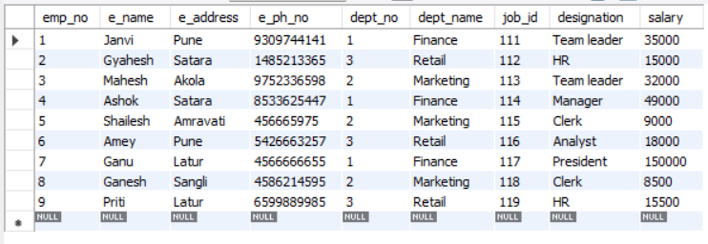

Write SQL statements for the following queries.
- List the E_no, E_name, Salary of all employees working for MANAGER.

select emp_no,E_name,salary from employee where Designation='Manager';
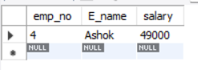

- Display all the details of the employee whose salary is more than 10000.

select * from employee where salary>10000;
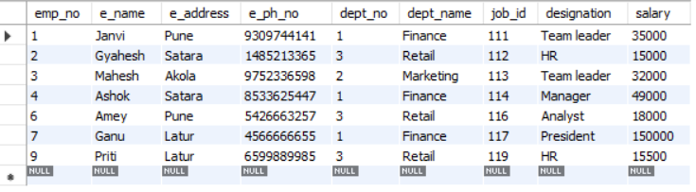

- List the employees in ascending order of Designations of those who joined after 1981.

select * from employee where join_date >= '1982-01-01' order by designation asc;
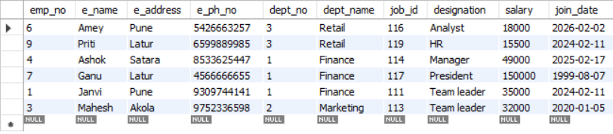
- List the employees along with their Experience and Daily Salary.

select e_name,experience,salary/30 as daily_salary from employee;
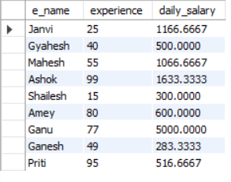
- List the employees who are either ‘CLERK’ or ‘ANALYST '.

select * from employee where designation in('clerk','analyst');
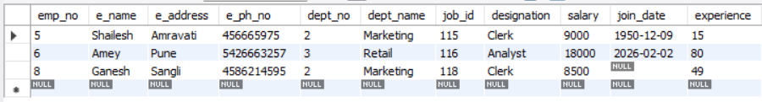

- List the employees who joined on 1-MAY-1981, 3-DEC-1981, 17-DEC-1981, 19-JAN-1980.

select * from employee where join_date in ('1981-05-01', '1981-12-03', '1981-12-17', '1980-01-19');
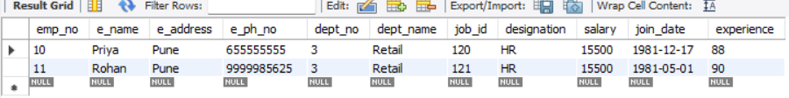

- List the employees who are working for Deptno 10 or20.

select * from employee where dept_no in (10, 20);

- List the Enames that start with ‘S’.

select * from employee where e_name like 's%';

- Write a SQL query to find the highest salary. Return the highest salary

select max(salary) as Highest_salary from employee;
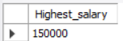

- Display the name and the first five characters of the name starting with ‘H’. List all the employees except ‘PRESIDENT’ & ‘MGR” in ascending order of Salaries.

select e_name, substring(e_name, 1, 5) as name_first_five from employee where e_name like 'H%' and upper(designation) not in('president', 'mgr') order by salary asc;


- Display the minimum and maximum salary and Experience of the employee

select min(salary) as min_salary, max(salary) as max_salary, min(experience) as min_experience, max(experience) as max_experience from employee;
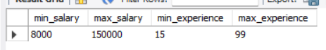

12. Display the total salary of all employees.
select sum(salary) from employee;
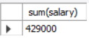

13. Write a query to display the average salary of employees working in IT department.

select avg(salary) from employee where dept_name='it';
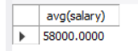

14. Display the Distinct salary of an employee.
select distinct salary from employee;
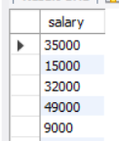

15. Drop the database.
drop database company;

