Tanvi Rasam

Home Page

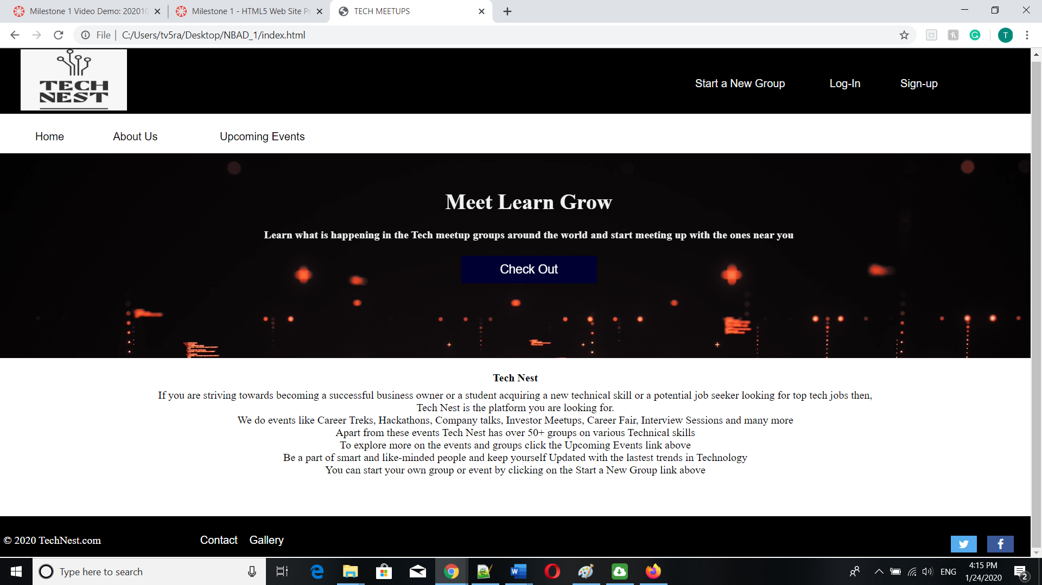

Additional Features:

* I have added video inside a div on the homepage to make it look better
* For the Upcoming events page I have listed the events with images to look better
* I tried using Media queries to adapt to conditions such as screen resolution but have done that only for the user specific links ie. the header

Status : Complete, I checked on Firefox as well as Chrome the rendering is almost same

Challenges:

* Dealing with In-line
* The header was the most tricky but enjoyed doing it and got cleared with my CSS basics
* Divisition of pages using % rather than px
* I used the inspect tool of the browser to understand better where I am going wrong

Note:

* Have linked the not-specified links to the home Page

References:

* <https://www.w3schools.com/>

