**DATA ANALYTICS** (Assignment - 4)

**(FIFA)**

import pandas as pd

from matplotlib import pyplot as plt

import seaborn as sns

fifa=pd.read_csv('players_20.csv')

fifa.head()

**Output:**

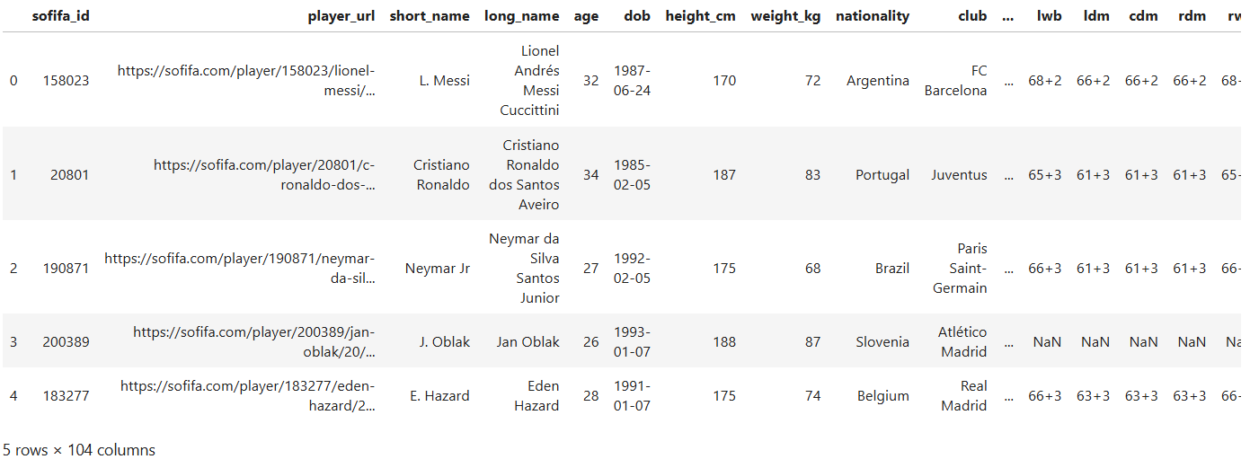

for col in fifa.columns:

print(col)

**Output:**

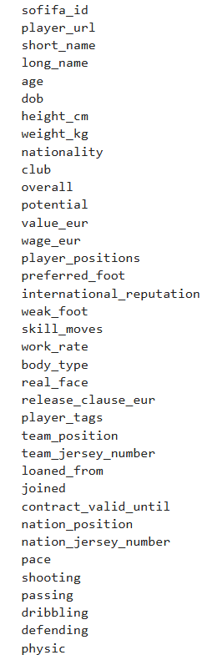

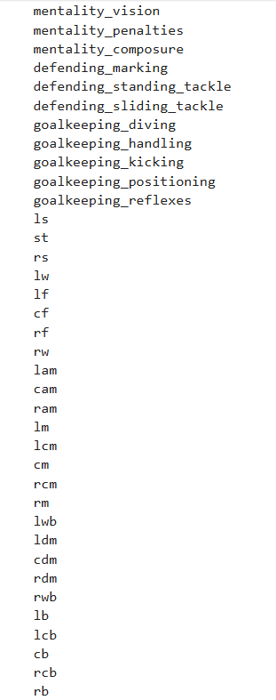

fifa.shape

**Output:**



18278*104

1667/18278

fifa['nationality'].value_counts()

**Output:**

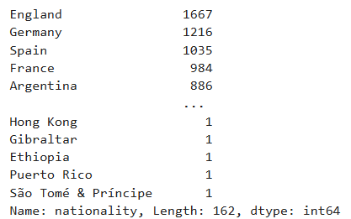

fifa['nationality'].value_counts()[0:10]

**Output:**

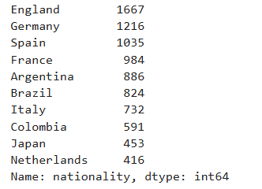

fifa['nationality'].value_counts()[0:5].keys()

**Output:**



fifa['nationality'].value_counts()[0:5]

**Output:**

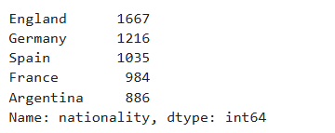

plt.figure(figsize=(5,5))

plt.bar(list(fifa['nationality'].value_counts()[0:5].keys()),list(fifa['nationality'].value_counts()[0:5]),color="g")

plt.show()

**Output:**

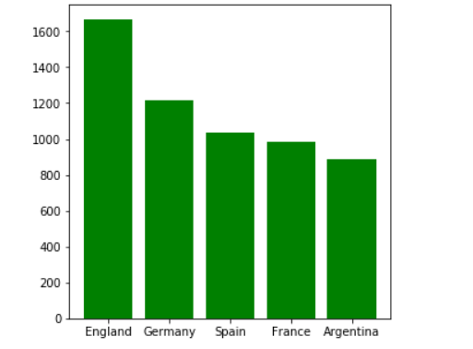

player_salary = fifa[['short_name','wage_eur']]

player_salary.head()

**Output:**

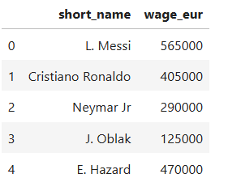

plt.figure(figsize=(8,5))

plt.bar(list(player_salary['short_name'])[0:5],list(player_salary['wage_eur'])[0:5],color=["blue","green","red","pink","orange"])

plt.show()

**Output:**

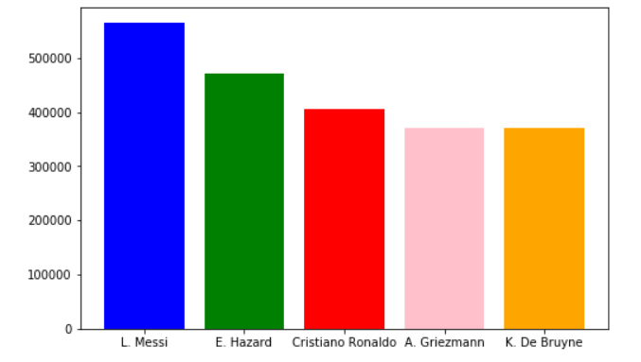

fifa['nationality']=='Germany'

**Output:**

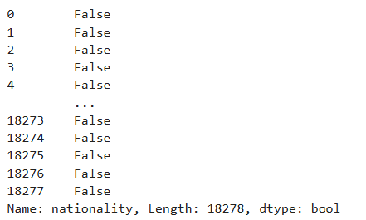

**#Germany**

Germany=fifa[fifa['nationality']=='Germany']

Germany.head(10)

**Output:**

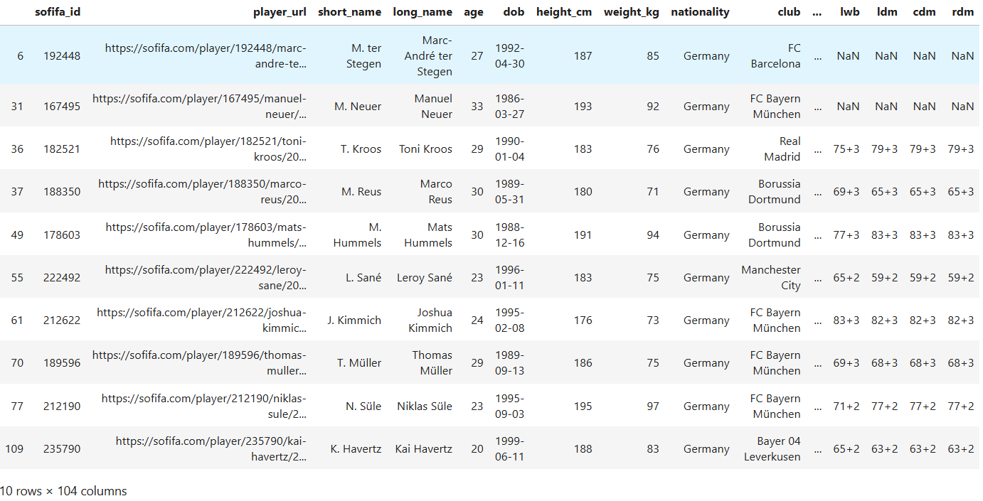

Germany.sort_values(by=['height_cm'],ascending=False).head()

**Output:**

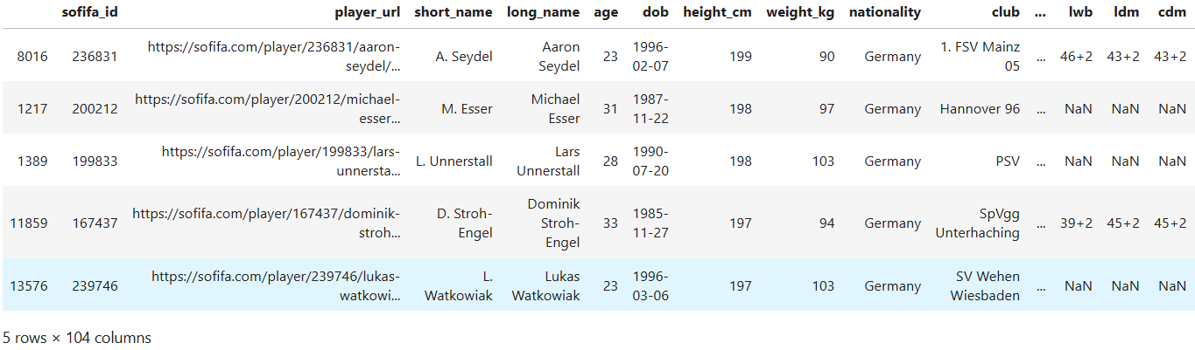

Germany.sort_values(by=['weight_kg'],ascending=False).head()

**Output:**

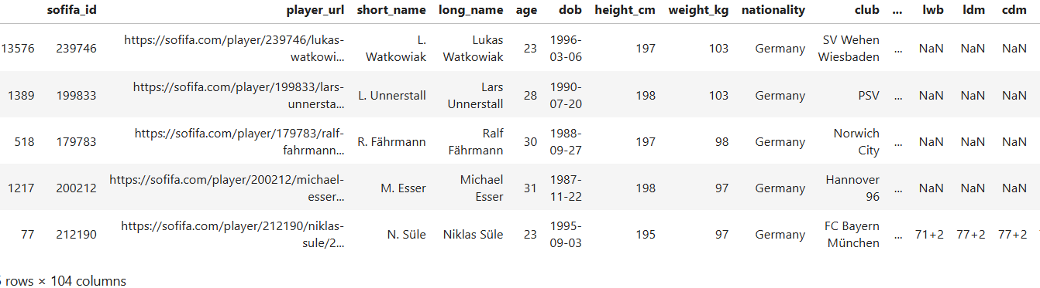

Germany.sort_values(by=['wage_eur'],ascending=False).head()

**Output:**

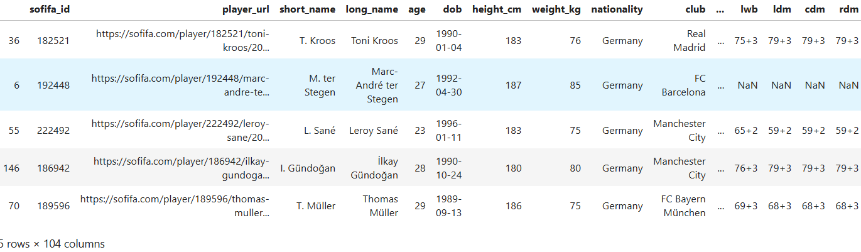

Germany[['short_name','wage_eur']].sort_values(by=['wage_eur'],ascending=False).head()

**Output:**

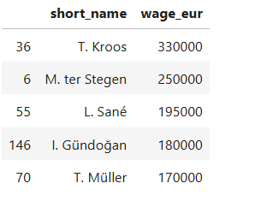

**#Shooting**

Player_shooting= fifa[['short_name','shooting']]

player_shooting.sort_values(by=['shooting'],ascending=False).head()

**Output:**

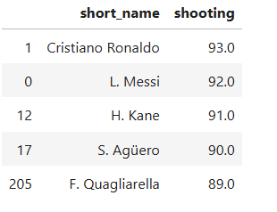

**#defending**

player_defending= fifa[['short_name','defending','nationality','club']]

player_defending.sort_values(by=['defending'],ascending=False).head()

**Output:**

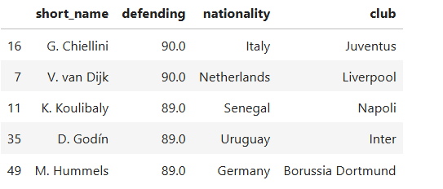

real_madrid=fifa[fifa['club']=='Real Madrid']

real_madrid.sort_values(by=['wage_eur'],ascending=False).head()

**Output:**

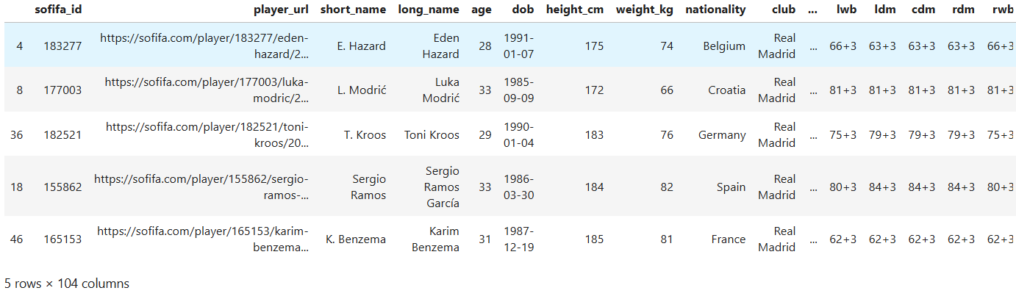

real_madrid.sort_values(by=['shooting'],ascending=False).head()

**Output:**

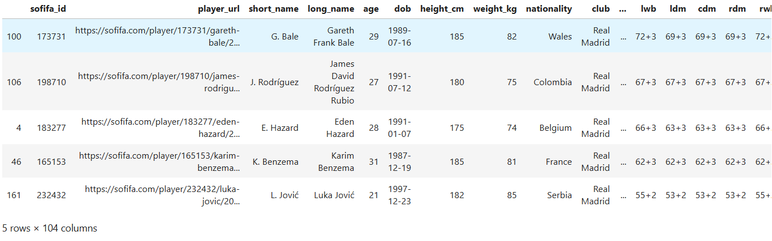

real_madrid.sort_values(by=['defending'],ascending=False).head()

**Output:**

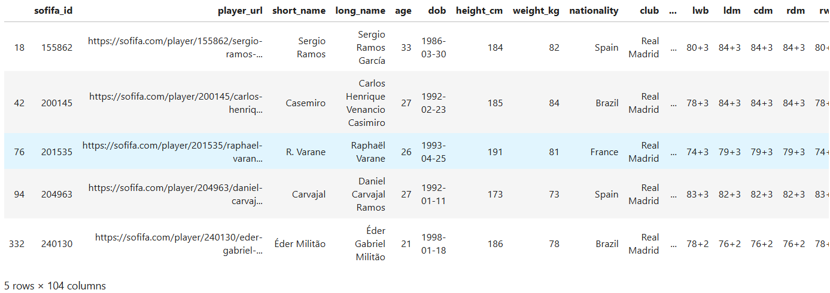

real_madrid['nationality'].value_counts()

**Output:**

