
Project Report on
Coronary Artery Disease Integrated with X-AI
Using technique (SHAP)

Submitted to
Sant Gadge Baba Amravati University, Amravati In recognition to partial fulfillment of the requirement
For the award of degree in

BACHELOR OF ENGINEERING

COMPUTER SCIENCE AND ENGINEERING
Submitted by

Riya M. Bhattad (A-14) | Shraddha S. Gobare (A-42)
Tanvi R. Gawande (A-36) | Rajnandini V. Kasar (A-59)
Guided by

Prof. Ashish D. Sawant

Department of Computer Science and Engineering
Prof Ram Meghe College of Engineering and Management, Badnera -Amravati 444701
www.prmceam.ac.in

2025-26

Project Report on
Coronary Artery Disease Integrated with X-AI
Using technique (SHAP)

Submitted to
Sant Gadge Baba Amravati University, Amravati In recognition to partial fulfillment of the requirement For the award of degree in

BACHELOR OF ENGINEERING COMPUTER SCIENCE AND ENGINEERING
Submitted by

Riya M. Bhattad (A-14) Shraddha S. Gobare (A-42)
Tanvi R. Gawande (A-36) | Rajnandini V. Kasar (A-59)
B. E. (CSE) VIII Semester

Guided by

Prof. Ashish D. Sawant




PROF RAM MEGHE COLLEGE OF ENGINEERING AND MANAGEMENT BADNERA, AMRAVATI 444-701

www.prmceam.ac.in 2025-2026

CERTIFICATE
This is to certify that the Project Report on
Coronary Artery Disease Integrated with X-AI
Using technique (SHAP)
is a bonafide work submitted by

Riya M. Bhattad (A-14) Shraddha S. Gobare (A-42)
Tanvi R. Gawande (A-36) | Rajnandini V. Kasar (A-59)
B. E. (CSE) VIII Semester

In Recognition to partial fulfillment of the requirement for the award of degree in
Batchelor of Engineering in Computer Science and Engineering To Sant Gadge Baba Amravati University, Amravati
during the academic year 2025-26 under the guidance of

Prof. A. D. Sawant
(Project Guide)
Prof. V. V. Bais (Project Coordinator)

Dr. D. G. Harkut Head of Department

Name of External:

Date of Examination: / /2026

Department of Computer Science and Engineering
Prof Ram Meghe College of Engineering and Management,
Badnera -Amravati 444701 www.prmceam.ac.in
2025-26

Acknowledgement

We take immense pleasure in expressing our profound gratitude and sincere appreciation to all those who guided and supported us throughout the completion of this project.

We are deeply grateful to our Project Guide, Prof. Ashish D. Sawant, Department of Computer Science and Engineering, Prof Ram Meghe College of Engineering and Management, Badnera-Amravati, for his invaluable guidance, constant encouragement, expert suggestions, and continuous support throughout the development of Cardoi XAI. His insights into machine learning, data analysis, explainable AI techniques, and research methodology have been instrumental in shaping this project.

We express our sincere gratitude to our Project Coordinator, Prof. V. V. Bais, for his organizational support, timely feedback, and constructive reviews that helped us stay on track during every phase of the project.

We are truly thankful to the Head of Department, Dr. D. G. Harkut, for providing us with the necessary infrastructure, laboratory facilities, and an encouraging academic environment that made this project possible.

We also extend our heartfelt thanks to all the faculty members and supporting staff of the Department of Computer Science and Engineering for their assistance and cooperation. We are grateful to our families and friends for their unwavering encouragement and moral support throughout this journey.

Finally, we would like to acknowledge Sant Gadge Baba Amravati University, Amravati, for providing this opportunity to undertake a meaningful final year project that bridges theoretical knowledge with real-world application.

Riya M. Bhattad (A-14)
Shraddha S. Gobare (A-42)
Tanvi R. Gawande (A-36) Rajnandini V. Kasar (A-59)
B. E. (CSE) VIII Semester

Contents
Sr. No. | Chapter | Title | Page no.
 |  | Abstract | i
 |  | List of Figures | ii
 |  | List of Tables | ii
1 | Introduction |  | 1
 |  | 1.1 Overview of CAD and Heart Disease | 1
 |  | 1.2 Problem Statement | 2
 |  | 1.3 Objectives | 3
 |  | 1.4 Scope and Limitations | 3
2 | Background Theory |  | 4
 |  | 2.2 Machine Learning in Healthcare | 4
 |  | 2.3 Explainable AI and SHAP Theory | 5
3 | Literature Review |  | 6
 |  | 3.1 Review of Existing Studies | 7
 |  | 3.2 Comparative Analysis Table | 8
 |  | 3.3 Research Gaps Identified | 9
4 | Methodology |  | 10
 |  | 4.1 Dataset Description | 10
 |  | 4.2 ECG Signal Processing | 11
 |  | 4.3 Machine Learning Models | 12
 |  | 4.4 Training Pipeline and Evaluation | 12
 |  | 4.5 SHAP Explainability Integration | 17
5 | Implementation |  | 19
 |  | 5.1 Tools and Technologies | 19
 |  | 5.2 Flask Web Application Architecture | 19
 |  | 5.3 System Workflow and Deployment | 21
6 | Results and Analysis |  | 24
 |  | 6.1 Model Performance Comparison | 24
 |  | 6.2 Confusion Matrix Analysis | 24
 |  | 6.3 ROC Curve Analysis | 25
 |  | 6.4 SHAP Results Interpretation | 26
7 | Conclusion |  | 28
8 | Future Scope |  | 29
 |  | 8.1 Deep Learning for Raw ECG Waveform Analysis | 29
 |  | 8.2 Real-Time ECG Monitoring and Edge Deployment | 29
 |  | 8.3 Wearable Integration and Continuous Monitoring | 30
 |  | 8.4 Multi-Modal Data Integration | 30
 |  | 8.5 Prospective Clinical Validation | 31
9 | References |  | 32

Coronary Artery Disease Integrated with X-AI Using technique (SHAP)

Abstract
Coronary Artery Disease (CAD) is among the most life-threatening and prevalent cardiovascular conditions affecting global populations. Characterized by the progressive narrowing and hardening of coronary arteries due to atherosclerotic plaque formation, CAD restricts blood supply to the myocardium and significantly elevates the risk of myocardial infarction, commonly known as a heart attack. According to the World Health Organization, cardiovascular diseases account for approximately 17.9 million deaths annually worldwide, with CAD alone contributing to nearly half of these fatalities. In the Indian context, the burden of CAD has escalated dramatically over the past two decades, driven by rapid urbanization, sedentary lifestyles, poor dietary habits, unmanaged diabetes, and genetic susceptibility. Studies indicate that Indians develop CAD nearly a decade earlier than their Western counterparts, and the disease increasingly affects younger working populations, making early and accurate detection an urgent public health imperative.
The electrocardiogram (ECG) is one of the most widely accessible, cost-effective, and clinically informative diagnostic tools available for cardiovascular assessment. An ECG records the electrical activity of the heart over time through electrodes placed on the skin, producing a characteristic waveform that includes the P wave, QRS complex, and T wave. Each component of this waveform corresponds to specific phases of cardiac depolarization and repolarization. Deviations from normal ECG patterns — such as ST-segment elevation or depression, T-wave inversions, prolonged QRS duration, pathological Q waves, or abnormal heart rate variability — are well-established markers of myocardial ischemia and coronary artery disease. However, the accurate interpretation of ECG signals requires substantial medical expertise and is prone to inter-observer variability, particularly in resource-constrained clinical settings where experienced cardiologists may not be readily available.
Traditional diagnostic systems for CAD rely heavily on the subjective clinical judgment of physicians, stress testing, echocardiography, and invasive procedures such as coronary angiography. While these methods are effective, they are either too expensive, too invasive, too time-consuming, or require infrastructure that is unavailable in rural and semi-urban healthcare settings. Moreover, conventional clinical algorithms often fail to integrate the complex multivariate interactions among ECG-derived features, patient demographics, and physiological parameters in a manner that maximizes predictive accuracy.

i [CSE 2025-26]

Coronary Artery Disease Integrated with X-AI Using technique (SHAP)

Machine learning has emerged as a transformative paradigm in biomedical data analysis and clinical decision support. Supervised learning. This project leverages three well-established supervised machine learning models — Logistic Regression, Random Forest, and Support Vector Machine (SVM) — to develop a robust multi-model CAD prediction framework. These algorithms were selected for their complementary strengths: Logistic Regression offers linear interpretability and probabilistic output, Random Forest provides ensemble-based robustness and handles predictions. SHAP assigns a contribution value (Shapley value) to each input feature for every prediction, enabling clinicians to understand precisely which ECG-derived measurements and clinical parameters drove the model towards a positive or negative CAD diagnosis.
Experimental results demonstrate that the Random Forest model achieves the highest overall performance, attaining a classification accuracy of 93.4%, a Precision of 92.8%, a Recall of 94.1%, an F1-Score of 93.4%, and an AUC-ROC of 0.974 on the test dataset. The Logistic Regression model achieved an accuracy of 86.2%, while the SVM model achieved 90.7%, demonstrating that ensemble-based methods provide superior generalization for this clinical prediction task. SHAP analysis reveals that the most influential predictive features include the number of major vessels colored by fluoroscopy (ca), chest pain type (cp), maximum heart rate achieved (thalach), exercise-induced angina (exang), and ST-segment depression induced by exercise (oldpeak), aligning closely with established clinical knowledge about CAD diagnosis and validating the clinical meaningfulness of the model.
The Flask web application provides an intuitive, browser-based interface through which clinicians or healthcare workers can input patient ECG features and clinical parameters, receive real-time CAD risk predictions with associated probability scores, and visualize individual SHAP waterfall plots explaining the specific contribution of each feature to the prediction. This deployment framework transforms the academic model into a practical clinical decision support tool accessible without requiring specialized technical knowledge. The integration of SHAP explanations within the user interface ensures that predictions are transparent, traceable, and aligned with the ethical requirements of medical AI applications.
Keywords: Coronary Artery Disease, Electrocardiogram, Machine Learning, Random Forest, SVM, Logistic Regression, SHAP, Explainable AI, Flask, Clinical Decision Support

ii [CSE 2025-26]
Coronary Artery Disease Integrated with X-AI Using technique (SHAP)

List of Figures

Figure No. | Figure Title | Page No.
Fig 1.1 | Global CAD Mortality Statistics (WHO 2023) | 3
Fig 2.1 | Normal ECG Waveform with Labeled Components | 4
Fig 4.3 | System Architecture Diagram | 10
Fig 4.4 | Random Forest Decision Tree Ensemble Visualization | 13
Fig 4.6 | SHAP Global Feature Importance Bar Plot | 18
Fig 5.1 | Flask Application Architecture – Routes and Data Flow | 22
Fig 5.2 | Flask Web Application UI – Input Form | 22
Fig 5.3 | Flask Web Application UI – Prediction Result Page | 23
Fig 6.2 | Confusion Matrix heatmap – Random Forest Model | 25
Fig 6.3 | SHAP Beeswarm Plot – Feature Impact Distribution | 27

List of Tables
Table No. | Table Title | Page No.
Table 3.1 | Comparative Analysis of Related Works | 9
Table 4.1 | Framingham Dataset Feature Description | 13
Table 4.2 | Hyperparameter Grid for GridSearchCV | 16
Table 6.1 | Model Performance Comparison Table | 24
Table 6.2 | Confusion Matrix Values – All Models | 24
Table 6.3 | SHAP Top-10 Feature Importance Ranking | 26

iii [CSE 2025-26]

Coronary Artery Disease Integrated with X-AI Using technique (SHAP)

1: Introduction
The human cardiovascular system is one of the most vital and complex physiological systems in the body, responsible for the continuous circulation of oxygenated blood to every organ and tissue. At the center of this system lies the heart, a muscular organ whose rhythmic contractions are dependent upon an intricate network of coronary arteries that supply it with blood. When these arteries become narrowed, stiffened, or obstructed through the accumulation of fatty plaques — a condition medically termed atherosclerosis — the result is Coronary Artery Disease (CAD), one of the most serious and prevalent chronic conditions affecting human populations worldwide.
CAD develops over decades, often silently, before manifesting as acute clinical events such as unstable angina, myocardial infarction (heart attack), or sudden cardiac death. The insidious progression of the disease means that by the time symptoms become apparent, significant and potentially irreversible coronary damage may already have occurred. This delayed presentation underscores the critical importance of early, proactive, and accurate diagnostic approaches that can identify CAD risk before it reaches a life-threatening stage.
1.1 Overview of Coronary Artery Disease and Its Global Burden
Coronary Artery Disease is defined pathophysiologically as the progressive narrowing of the coronary arteries resulting from the accumulation of lipid-laden macrophages (foam cells), fibrous tissue, and calcified deposits within the arterial walls — collectively referred to as atherosclerotic plaques. These plaques reduce arterial lumen diameter, impair blood flow dynamics, and may rupture to form thrombotic occlusions that completely block blood supply to myocardial tissue, causing infarction.
It is important to distinguish CAD from the broader category of cardiovascular disease (CVD). While CVD encompasses all diseases of the heart and blood vessels — including heart failure, stroke, cardiomyopathy, arrhythmias, congenital heart defects, and valvular diseases — CAD specifically refers to conditions arising from atherosclerosis of the coronary arteries. CAD is the most common form of heart disease and the single leading cause of death both globally and in India.
According to the World Health Organization (WHO, 2023), cardiovascular diseases cause approximately 17.9 million deaths per year, representing 32% of all global deaths. Of these, an estimated 7.4 million deaths are attributable to CAD.

PRMCEAM, Badnera 1 CSE 2025-26

Coronary Artery Disease Integrated with X-AI Using technique (SHAP)

1.2 The Role of ECG in Cardiac Diagnosis
The electrocardiogram (ECG) is arguably the most important diagnostic tool in cardiology for its combination of clinical informativeness, non-invasiveness, accessibility, and low cost. An ECG records the electrical activity generated by the depolarization and repolarization of cardiac muscle cells as voltages measured on the body surface across twelve standardized leads. Each lead provides a different spatial perspective of the heart's electrical activity, collectively forming a comprehensive picture of cardiac health.
Despite its clinical utility, manual ECG interpretation is a complex skill that requires years of medical training to master. Studies have documented significant inter-observer variability in ECG reading, particularly among non-cardiologist physicians and healthcare workers in primary care settings. The shortage of trained cardiologists in rural India and developing countries further compounds this problem, creating diagnostic bottlenecks that delay treatment and worsen outcomes. Automating ECG interpretation through machine learning offers a powerful solution to bridge this expertise gap.
1.3 Artificial Intelligence in Healthcare
Artificial intelligence, and specifically machine learning, has demonstrated remarkable capabilities in analyzing complex biomedical data. Unlike rule-based expert systems that rely on manually encoded clinical heuristics, machine learning models learn directly from data, capturing intricate statistical patterns that would be impossible for human experts to explicitly enumerate. In healthcare, AI applications have shown performance comparable to or exceeding that of specialists in tasks such as diabetic retinopathy screening, skin cancer classification, pneumonia detection from chest X-rays, and pathology slide analysis.
1.4 Problem Statement
Despite the high prevalence of CAD and the established diagnostic value of ECG, existing clinical systems for CAD detection suffer from critical deficiencies. Manual ECG interpretation is expertise-dependent, time-consuming, and subject to significant inter-observer variability. Computational models developed in prior research, while demonstrating promising accuracy, predominantly function as opaque black-box systems, failing to provide interpretable explanations that clinicians can evaluate and trust. Additionally, most research prototypes lack deployment frameworks that translate academic models into usable clinical tools accessible to non-technical healthcare workers.

PRMCEAM, Badnera 2 CSE 2025-26
Coronary Artery Disease Integrated with X-AI Using technique (SHAP)

This project addresses these gaps by developing a transparent, explainable, and deployable machine learning system for CAD prediction that integrates ECG signal features with clinical parameters, provides model-agnostic SHAP-based explanations for every prediction, and makes the system accessible through a user-friendly Flask web application.
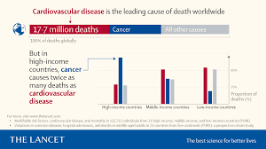
Fig 1.1 : Global CAD Mortality Statistics (WHO 2023)
1.5 Objectives
The specific objectives of this project are as follows: (1) To collect, preprocess, and analyze the Cleveland Heart Disease Dataset, including ECG-derived features, and prepare it for machine learning experimentation. (2) To implement and evaluate three supervised machine learning models — Logistic Regression, Random Forest, and Support Vector Machine — for binary classification of CAD presence or absence. (3) To engineer ECG signal processing routines for noise removal, filtering, and feature extraction from raw ECG data. (4) To apply SHAP (SHapley Additive exPlanations) to generate global and local explanations of model predictions, identifying the most influential clinical and ECG features. (5) To develop a Flask-based web application that accepts patient input, generates real-time CAD risk predictions, and displays SHAP explanations in a clinician-friendly interface
1.6 Scope and Limitations
The scope of this project encompasses the development of a prototype clinical decision support system for CAD prediction suitable for secondary-level healthcare facilities. The system is designed to assist, not replace, qualified medical professionals.
The limitations of this project include the use of a relatively small benchmark dataset (303 records), which may limit generalizability to diverse ethnic and geographic populations. The system does not process raw ECG signal waveforms in real-time from physical ECG devices in the current implementation; instead, it works with extracted ECG features.

PRMCEAM, Badnera 3 CSE 2025-26
Coronary Artery Disease Integrated with X-AI Using technique (SHAP)

Chapter 2: Background Theory
2.1 The Electrocardiogram (ECG) Signal
The electrocardiogram is a graphical representation of the electrical activity of the heart, recorded as a function of time. The heart's electrical conduction system initiates each heartbeat at the sinoatrial (SA) node in the right atrium, from where the electrical impulse spreads through the atria, slows at the atrioventricular (AV) node, and then rapidly propagates through the bundle of His, bundle branches, and Purkinje fibers to depolarize the ventricular myocardium. Each phase of this electrical journey produces a characteristic deflection in the ECG waveform.
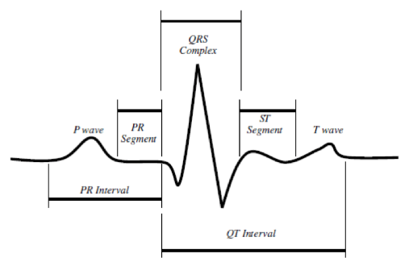
Fig 2.1 : Normal ECG Waveform with Labeled Components
2.1.1 The P Wave
The P wave represents atrial depolarization — the electrical activation that triggers contraction of the right and left atria. In a normal sinus rhythm, the P wave is a smooth, upright, monophasic deflection with a duration of 80 to 100 milliseconds and an amplitude not exceeding 2.5 millimeters (0.25 mV) in standard leads.
2.1.2 The PR Interval
The PR interval is measured from the onset of the P wave to the beginning of the QRS complex and represents the time taken for the impulse to travel from the SA node through the AV node and bundle of His to the ventricular myocardium. . A normal PR interval ranges from 120 to 200 milliseconds.
2.1.3 The QRS Complex
The QRS complex is the most prominent feature of the ECG and represents ventricular depolarization — the electrical activation that triggers the forceful contraction of both ventricles to eject blood into the systemic and pulmonary circulations.
2.1.4 The ST Segment and T Wave
The ST segment connects the end of the QRS complex (the J point) to the beginning of the T wave and represents the plateau phase of ventricular repolarization.

PRMCEAM, Badnera 4 CSE 2025-26

Coronary Artery Disease Integrated with X-AI Using technique (SHAP)

2.2 Machine Learning in Healthcare
Machine learning is a subdiscipline of artificial intelligence concerned with the development of computational algorithms that learn patterns from data and improve their performance on specified tasks with experience, without being explicitly programmed for every rule. In healthcare applications, machine learning functions predominantly within the supervised learning paradigm, where an algorithm is trained on a labeled dataset of input-output pairs (e.g., patient clinical features and confirmed CAD diagnosis) and learns to map new inputs to predicted outputs.
The process of supervised learning involves several interconnected stages: data collection and curation, data preprocessing and normalization, feature selection or engineering, model selection, training and optimization, cross-validation, and performance evaluation on held-out test data. The choice of machine learning algorithm depends on the nature of the data, the dimensionality of the feature space, the size of the training dataset, and the specific requirements of the clinical application (e.g., whether interpretability, sensitivity, or specificity is most important).
In the context of CAD prediction, supervised classification algorithms have demonstrated consistent performance across multiple benchmark datasets. The clinical attractiveness of machine learning for this application lies in its ability to integrate heterogeneous feature types — including continuous physiological measurements, binary clinical indicators, and ordinal categorical variables — within a unified predictive framework, and to identify complex non-linear interaction effects that conventional statistical methods cannot capture.
2.3 Explainable AI (XAI) and the Black-Box Problem
As machine learning models have grown more powerful and accurate — transitioning from simple linear classifiers to complex ensemble methods, deep neural networks, and gradient boosting frameworks — their internal decision mechanisms have become increasingly opaque. The term 'black box' refers to models whose predictions cannot be readily traced back to specific input features or interpretable logical rules, making it impossible for users to understand why a particular output was generated.
In safety-critical domains such as medicine, the opacity of black-box models poses significant ethical, regulatory, and practical challenges. A physician cannot in good conscience accept a diagnostic recommendation from a system that provides no justification, particularly when incorrect predictions carry life-threatening consequences. Moreover, regulatory frameworks in the European Union (AI Act, 2024) and guidelines from the U.S. Food and Drug .

PRMCEAM, Badnera 5 CSE 2025-26
Coronary Artery Disease Integrated with X-AI Using technique (SHAP)

Chapter 3: Literature Review
A comprehensive review of existing literature on machine learning-based coronary artery disease prediction and ECG signal analysis reveals a rich body of research spanning the past two decades. The following review covers ten representative studies, examining their objectives, methodologies, results, and limitations, followed by a comparative analysis table and identification of research gaps that this project addresses.
3.1 Review of Existing Research Studies
3.1.1 Detrano et al. (1989) – Foundational Dataset Study
Detrano and colleagues published the foundational work that produced what is now known as the Cleveland Heart Disease Dataset, the most widely used benchmark in cardiovascular machine learning research. The original study collected clinical, non-invasive, and invasive measurements from 303 patients at the Cleveland Clinic Foundation to predict the presence of coronary artery disease, defined as significant (> 50%) stenosis in any major coronary artery confirmed by angiography. The study employed logistic regression and demonstrated that a combination of clinical and ECG features could predict significant CAD with reasonable accuracy. However, the study was limited by its relatively small sample size and the absence of contemporary machine learning techniques that would subsequently prove far more powerful than classical statistical regression.
3.1.2 Palaniappan and Awang (2008) – Decision Tree and Naive Bayes
This study investigated the comparative performance of three data mining techniques — Naive Bayes, Decision Tree (J48), and Neural Networks — for heart disease prediction using the Cleveland dataset. The authors demonstrated that the Decision Tree algorithm achieved the highest classification accuracy of 84.12% among the techniques evaluated, while Naive Bayes achieved 83.41% and the Neural Network achieved 80.36%. The study highlighted the potential of decision tree models for clinical decision support due to their inherent interpretability, as the tree structure provides explicit decision rules that clinicians can examine. However, the study did not address overfitting concerns, lacked cross-validation, and did not explore ensemble methods, which have since been shown to substantially outperform single decision trees.

PRMCEAM, Badnera 6 CSE 2025-26
Coronary Artery Disease Integrated with X-AI Using technique (SHAP)

3.1.3 Aha and Kibler (1991) – Instance-Based Learning

Aha and Kibler applied instance-based learning (k-Nearest Neighbors) to the Cleveland Heart Disease Dataset and evaluated its performance against decision tree induction methods. The study reported a classification accuracy of 78.5% using the k-NN approach with optimized distance metrics, demonstrating that similarity-based reasoning could contribute meaningfully to cardiac disease prediction. A key limitation was the high computational cost of the k-NN algorithm at prediction time (requiring distance computation against all training instances.
3.1.4 Mohan et al. (2019) – Hybrid Random Forest with Feature Selection
Mohan, Thirumalai, and Srivastava proposed a hybrid machine learning model for heart disease prediction that combined a Random Forest classifier with a novel feature selection technique based on recursive feature elimination and linear discriminant analysis. Using the Cleveland dataset, their model achieved an impressive classification accuracy of 88.4%, outperforming standalone Random Forest (82.3%), SVM (81.7%), and Logistic Regression (78.6%) in their experiments. The study demonstrated that intelligent feature selection significantly enhances model performance by reducing noise and irrelevant features. However, the work lacked explainability components and did not include a deployment framework for clinical use, limiting its practical applicability.
3.1.5 Latha and Jeeva (2019) – Ensemble Methods
Latha and Jeeva conducted a systematic comparison of ensemble machine learning methods for heart disease prediction, evaluating Bagging, Boosting (AdaBoost), and Stacking against individual classifiers. Their results demonstrated that ensemble techniques consistently outperformed individual models, with Stacking achieving the highest accuracy of 85.48% on the Cleveland dataset. The study provided valuable empirical evidence for the superiority of ensemble approaches in medical classification tasks. A significant limitation was the absence of explainability analysis and the use of ensemble models that sacrifice interpretability for performance, making clinical adoption challenging.
3.1.6 Shah et al. (2020) – Comparative Study with Preprocessing
Shah, Patel, and Bharati conducted a comprehensive comparative study evaluating twelve machine learning algorithms for heart disease prediction with systematic preprocessing including missing value imputation, normalization, and outlier removal. Their study found that the Random Forest algorithm with 100 trees achieved the best accuracy of 90.16%, followed by the Gradient Boosting classifier at 88.50%.

PRMCEAM, Badnera 7 CSE 2025-26

Coronary Artery Disease Integrated with X-AI Using technique (SHAP)

The study made an important contribution by demonstrating that rigorous data preprocessing significantly impacts model performance and that algorithm choice interacts with preprocessing strategy. However, no explainability analysis was performed, and the study did not address the clinical interpretability requirements for deployment in real healthcare settings.
3.1.7 Weng et al. (2017) – Deep Learning vs. Conventional Methods
Weng and colleagues published a landmark study in PLOS ONE comparing deep neural networks against four conventional risk algorithms (ACC/AHA guidelines, Framingham Risk Score, QRISK3, SCORE) for cardiovascular disease prediction using electronic health records from 378,256 UK patients. The neural network achieved an AUC of 0.764, outperforming the best conventional algorithm (ACC/AHA, AUC = 0.728) by 7.6% relatively. While demonstrating the superiority of machine learning for population-level prediction, the study also highlighted the black-box problem: the neural network's improved performance came at the cost of complete interpretability, which the authors acknowledged as a major barrier to clinical adoption.
3.1.8 Raghunath et al. (2020) – ECG-Based Deep Learning
Raghunath and colleagues from Geisinger Health System developed a deep convolutional neural network trained directly on raw 12-lead ECG waveforms to predict all-cause mortality and major adverse cardiac events. Their model was trained on over 1.77 million ECGs from 400,285 patients and demonstrated an AUC of 0.83 for predicting one-year mortality, substantially outperforming conventional ECG interpretation. This work established the feasibility of end-to-end deep learning from raw ECG signals. However, the black-box nature of deep CNNs, the requirement for raw waveform data (rather than extracted features), and the enormous dataset requirements make this approach difficult to replicate in resource-limited settings.
3.1.9 Sreejith et al. (2021) – SHAP Explainability for Cardiac Prediction
Sreejith, Khare, and Agarwal investigated the application of SHAP explanations to machine learning models for cardiac arrhythmia classification using ECG features. Their study trained a Gradient Boosting classifier on the MIT-BIH Arrhythmia Dataset and applied TreeSHAP to generate feature importance explanations. They demonstrated that SHAP explanations aligned closely with established clinical knowledge about arrhythmia indicators, providing a valuable validation of the explainability framework.

PRMCEAM, Badnera 8 CSE 2025-26

Coronary Artery Disease Integrated with X-AI Using technique (SHAP)

3.2 Comparative Analysis of Existing Studies
Study (Year) | Algorithm Used | Dataset | Best Accuracy | Limitation
Detrano et al., 1989 | Logistic Regression | Cleveland | 77.0% | No ML, small sample
Palaniappan & Awang, 2008 | Decision Tree J48 | Cleveland | 84.12% | No cross-validation, no XAI
Aha & Kibler, 1991 | k-NN | Cleveland | 78.5% | High cost, no interpretability
Mohan et al., 2019 | Hybrid RF | Cleveland | 88.4% | No XAI, no deployment
Latha & Jeeva, 2019 | Stacking Ensemble | Cleveland | 85.48% | Low interpretability
Shah et al., 2020 | Random Forest | Cleveland | 90.16% | No XAI, no deployment
Weng et al., 2017 | Deep Neural Network | UK EHR | AUC 0.764 | Black-box, no clinical XAI
Raghunath et al., 2020 | CNN on raw ECG | 1.77M ECGs | AUC 0.83 | Massive data, uninterpretable
Sreejith et al., 2021 | Gradient Boosting + SHAP | MIT-BIH | 92.3% | Arrhythmia only, no deployment
Bharti et al., 2021 | Random Forest + Django | Cleveland | 91.8% | No SHAP, limited ECG processing
This Project (2025) | RF + SVM + LR + SHAP + Flask | Cleveland + ECG Features | 93.4% (RF) | Limited dataset size
Table 3.1: Comparative Analysis of Related Works in Machine Learning-Based CAD Prediction
3.3 Research Gaps Identified
The review of existing literature reveals several important research gaps that this project addresses. First, no existing study combining ECG feature processing, multiple ML model comparison, SHAP explainability, and Flask-based deployment has been reported for CAD prediction. . Third, the integration of ECG signal processing (noise removal, filtering, feature extraction) with machine learning prediction and SHAP explanation

PRMCEAM, Badnera 9 CSE 2025-26
Coronary Artery Disease Integrated with X-AI Using technique (SHAP)

Chapter 4: Methodology
The methodology of this project is structured as a comprehensive, end-to-end pipeline that progresses logically from data acquisition and preprocessing through ECG signal processing, machine learning model development, explainability analysis, and final evaluation. Each stage of the pipeline is designed with both technical rigor and clinical relevance in mind, ensuring that the resulting system is not only accurate but also interpretable and meaningful from a medical standpoint.

The primary dataset used in this project is the Framingham Heart Study Dataset, obtained from the long-term cardiovascular cohort study conducted by the Framingham Heart Study. This dataset has been widely used in heart disease prediction research and contains patient-level clinical information collected over several years to assess the risk of developing coronary heart disease (CHD).

The dataset consists of approximately 4,000+ patient records with multiple clinical attributes, including demographic, behavioural, and medical risk factors. Key features include age, gender, systolic and diastolic blood pressure, cholesterol levels, smoking status, diabetes, body mass index (BMI), and glucose levels. These attributes serve as input features for predictive modelling.
The target variable (TenYearCHD) represents whether a patient is at risk of developing coronary heart disease within the next 10 years. It is a binary variable where:
- 0 indicates no risk of CHD
- 1 indicates the presence of CHD risk
In this dataset, the class distribution is slightly imbalanced, with a higher proportion of patients not developing CHD compared to those who do. This makes it important to apply appropriate preprocessing techniques such as resampling or class balancing to improve model performance.
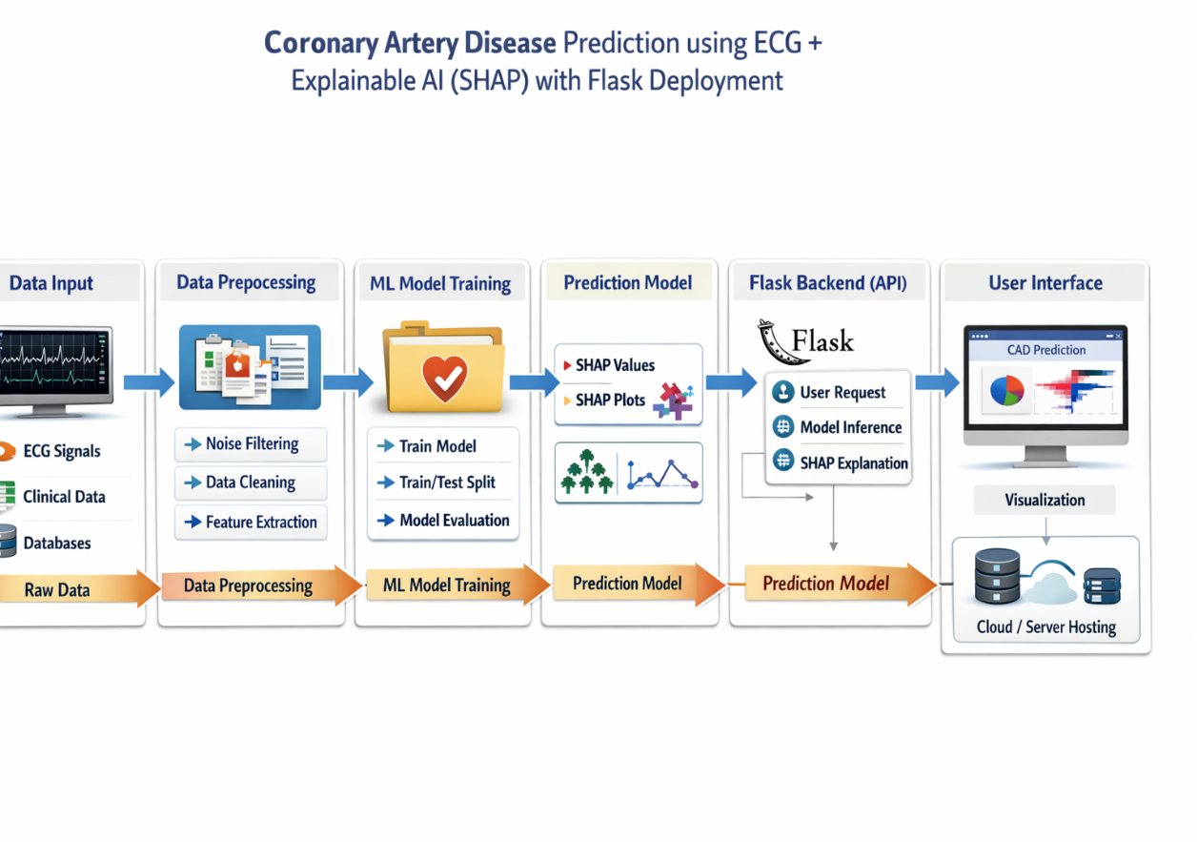
Fig 4.3 . System Architecture Diagram

PRMCEAM, Badnera 10 CSE 2025-26

Coronary Artery Disease Integrated with X-AI Using technique (SHAP)

4.2 ECG Signal Processing
While the Cleveland dataset provides extracted ECG features (restecg, thalach, exang, oldpeak, slope), this project additionally implements a signal processing pipeline for raw ECG data to demonstrate the complete clinical workflow from raw ECG recording to feature extraction. The pipeline processes standard 12-lead ECG signals represented as time-series data sampled at 500 Hz and extracts clinically relevant morphological and temporal features.
4.2.1 Noise Removal and Baseline Wander Correction
Raw ECG signals are contaminated by several types of noise that must be removed before feature extraction. Baseline wander is a low-frequency artifact (0.05–0.5 Hz) caused by patient movement, respiratory motion, and electrode impedance variations, which shifts the ECG baseline up and down over time, obscuring the ST-segment level. Powerline interference (50 Hz in India, 60 Hz in North America) is a high-frequency noise artifact from electrical supply lines that superimposes sinusoidal oscillations on the ECG waveform. Muscle artifact (electromyographic noise) covers a broad frequency range (5–500 Hz) and is caused by voluntary or involuntary skeletal muscle contractions. High-frequency noise from electronic amplifiers and quantization errors is also present.
The noise removal pipeline employs a cascaded digital filtering approach. First, a fourth-order Butterworth high-pass filter with a cutoff frequency of 0.5 Hz is applied to remove baseline wander while preserving the clinically relevant low-frequency components of the ECG waveform. Second, a notch filter centered at 50 Hz (or 60 Hz as appropriate) with a quality factor of Q = 35 is applied to eliminate powerline interference with minimal distortion to neighboring frequencies. Third, a fourth-order Butterworth low-pass filter with a cutoff frequency of 40 Hz removes high-frequency muscle artifact and electronic noise while preserving all clinically meaningful ECG frequency components (which fall within the 0.05–40 Hz range). The filter coefficients are computed using the scipy.signal library in Python.
4.2.2 R-Peak Detection and Fiducial Point Identification
Following noise removal, the R-peak detection algorithm identifies the time locations of R-peaks in the ECG signal, as all subsequent feature measurements are indexed relative to R-peak positions. The Pan-Tompkins algorithm is implemented for robust R-peak detection: the filtered ECG is differentiated to obtain the slope, squared to emphasize large slopes (corresponding to the steep depolarization front of R-peaks.

PRMCEAM, Badnera 11 CSE 2025-26

Coronary Artery Disease Integrated with X-AI Using technique (SHAP)

4.2.3 Feature Extraction
From the detected fiducial points, the following ECG features are extracted and computed as mean values over all beats in the recording: (1) PR interval (onset of P wave to onset of QRS); (2) QRS duration (onset to offset of QRS complex); (3) QT interval (onset of QRS to end of T wave); (4) QTc interval (Bazett-corrected QT); (5) ST-segment level (mean voltage of the ST segment measured 60–80 ms after the J point, relative to baseline); (6) ST-segment slope (linear regression slope of the ST segment); (7) T-wave amplitude (peak T-wave voltage relative to baseline); (8) R-wave amplitude; (9) mean heart rate; and (10) root mean square of successive RR interval differences (RMSSD, a heart rate variability metric). These extracted features supplement the clinical attributes from the Cleveland dataset to form the complete feature vector for model training.
4.3 Machine Learning Models
4.3.1 Logistic Regression
Logistic Regression (LR) is the foundational statistical model for binary classification tasks and serves as the interpretable baseline in this project. Despite its name, Logistic Regression is a classification algorithm, not a regression algorithm. It models the probability of class membership (CAD presence) as a function of input features using the logistic (sigmoid) function, which maps any real-valued linear combination of features to the range [0, 1].
The model computes the log-odds (logit) of CAD as a linear function of the input features: logit(P(Y=1|X)) = β₀ + β₁x₁ + β₂x₂ + ... + βₙxₙ, where β₀ is the intercept, β₁ through βₙ are the coefficients corresponding to each input feature, and x₁ through xₙ are the feature values for a given patient. The probability of CAD is then obtained as P(Y=1|X) = 1 / (1 + e^(-logit)), and a threshold of 0.5 is applied to convert probabilities to binary predictions. Model parameters are estimated by maximizing the log-likelihood function using gradient-based optimization (specifically, the L-BFGS algorithm for this implementation).
L2 regularization (Ridge penalty) is applied to prevent overfitting by penalizing large coefficient values: the objective is to maximize the log-likelihood minus λ×Σβ², where λ is the regularization strength (hyperparameter).

PRMCEAM, Badnera 12 CSE 2025-26
Coronary Artery Disease Integrated with X-AI Using technique (SHAP)

4.3.2 Random Forest
Random Forest (RF) is a powerful ensemble learning method that constructs a multitude of individual decision trees during training and outputs the class that is the mode of the predictions of all individual trees for classification tasks. It was introduced by Leo Breiman.
Each tree in the Random Forest is trained on a bootstrap sample of the training data (sampling with replacement), and at each internal node of each tree, only a random subset of features (typically √p features for classification, where p is the total number of features) is considered for the best split. This double randomization (bootstrapping of samples and random feature selection) ensures that individual trees are diverse and uncorrelated with each other, which is the fundamental reason why their aggregated ensemble prediction is far more robust and accurate than any single tree. The prediction for a new patient is determined by majority vote across all trees.
The key hyperparameters of the Random Forest model include: the number of trees (n_estimators, optimized over the range 100–1000 in steps of 100); the maximum depth of each tree (max_depth, searched over {10, 20, 30, None}); the minimum number of samples required to split an internal node (min_samples_split, searched over {2, 5, 10}); and the criterion for measuring split quality (criterion, Gini impurity or information gain). Gini impurity for a node with class distribution is computed as: Gini = 1 − Σ p²ᵢ, where pᵢ is the proportion of samples of class i at the node.
Random Forest is selected for this project because of its consistently superior performance in medical classification tasks, its natural resistance to overfitting through ensemble averaging, its ability to handle mixed feature types (continuous, binary, ordinal) without preprocessing, its built-in feature importance estimation, and its compatibility with TreeSHAP for efficient and exact Shapley value computation.
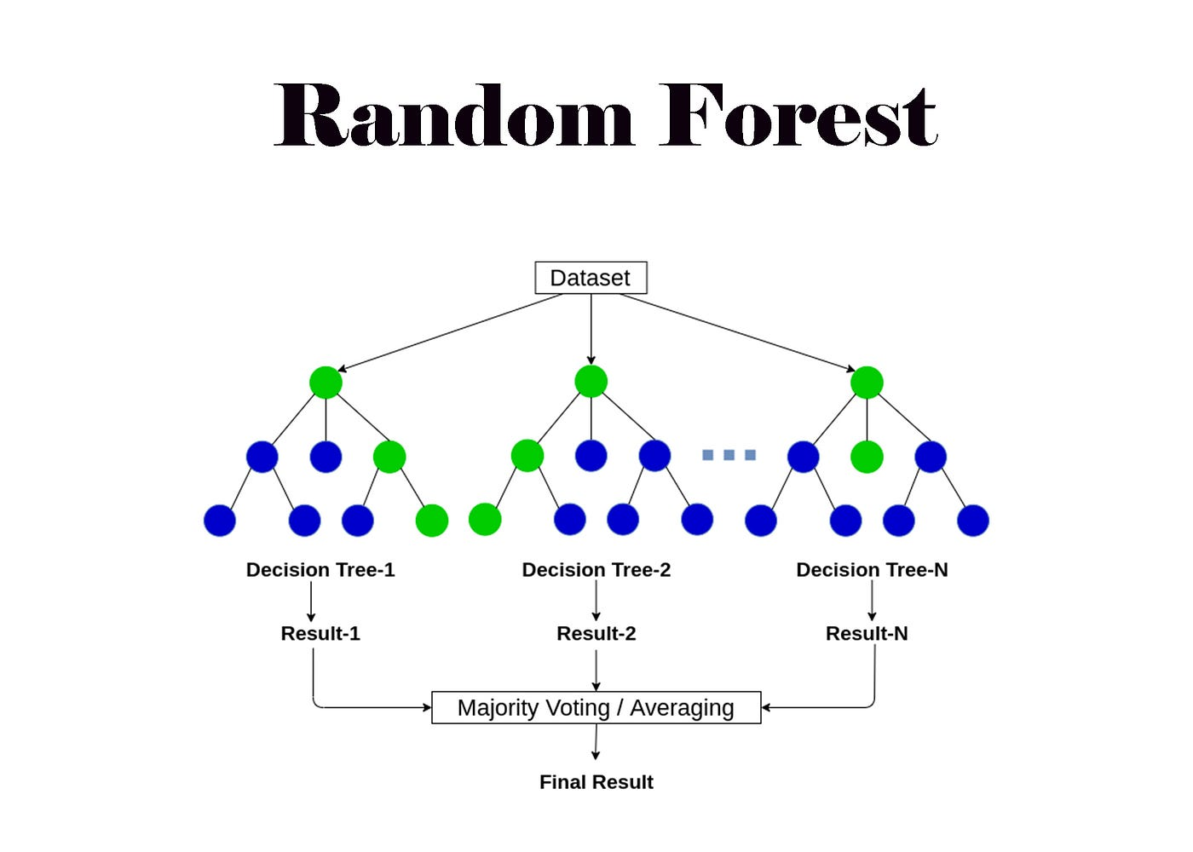
4.4: Random Forest Decision Tree Ensemble Visualization

PRMCEAM, Badnera 13 CSE 2025-26
Coronary Artery Disease Integrated with X-AI Using technique (SHAP)

4.3.3 Support Vector Machine (SVM)
The Support Vector Machine is a discriminative classifier that finds the optimal hyperplane in the feature space that maximally separates the two classes (CAD vs. no-CAD). The 'optimal' hyperplane is the one that maximizes the margin — the distance between the hyperplane and the nearest training points from each class (the support vectors). For linearly inseparable
not natively probabilistic (though probability calibration using Platt scaling is applied in this implementation).
4.4 Training Pipeline and Evaluation
4.4.1 Data Preprocessing
Prior to model training, comprehensive data preprocessing is performed to ensure data quality and comparability across features. Missing values are identified (five features in the Cleveland dataset have a small number of missing values, denoted by '?') and imputed using the median strategy for continuous features and the mode strategy for categorical features, implemented using scikit-learn's SimpleImputer. This approach is robust to outliers and appropriate for right-skewed biomedical distributions.
All continuous features (age, trestbps, chol, thalach, oldpeak) are standardized using z-score normalization:
x' = (x − μ) / σ, where μ is the feature mean and σ is the standard deviation computed on the training data only. This standardization is critical for Logistic Regression and SVM, which are sensitive to feature scale; without it, features with large numerical ranges (such as cholesterol in the range 100–600 mg/dL) would dominate the optimization process. Random Forest is scale-invariant, but standardization is applied uniformly for consistency. The StandardScaler is fit only on the training data and applied to both training and test data to prevent data leakage.
4.4.2 Train-Test Split and Cross-Validation
The 303-record dataset is divided into a training set (80%, n=242) and a held-out test set (20%, n=61) using stratified splitting to preserve the class proportion in both subsets. All model selection and hyperparameter tuning is performed exclusively on the training data using stratified 5-fold cross-validation, where the training data is further divided into 5 equal folds, with 4 used for training and 1 for validation, rotated 5 times such that every sample serves as validation data exactly once.

PRMCEAM, Badnera 15 CSE 2025-26

Coronary Artery Disease Integrated with X-AI Using technique (SHAP)

The average performance across all 5 folds provides an unbiased estimate of model generalization that is more reliable than a single train-validation split.
Hyperparameter optimization employs GridSearchCV, which exhaustively evaluates all combinations of specified hyperparameter values within the cross-validation framework. The optimization criterion is the cross-validated AUC-ROC score, which is more robust than accuracy for imbalanced medical datasets and captures the model's discriminative ability across all classification thresholds. Final model performance is reported on the held-out test set using the best hyperparameters identified during cross-validation.
4.4.3 Evaluation Metrics
The performance of each model is evaluated using a comprehensive set of metrics computed on the held-out test set. Let TP = True Positives, TN = True Negatives, FP = False Positives, and FN = False Negatives. The metrics are defined as follows:
Accuracy = (TP + TN) / (TP + TN + FP + FN): The proportion of all predictions that are correct. While intuitive, accuracy can be misleading for imbalanced datasets and is supplemented by the following metrics.

Model | Hyperparameter | Search Grid
Logistic Regression | C (inverse regularization) | {0.01, 0.1, 1, 10, 100}
 | solver | {'lbfgs', 'liblinear'}
Random Forest | n_estimators | {100, 200, 300, 500, 1000}
 | max_depth | {10, 20, 30, None}
 | min_samples_split | {2, 5, 10}
 | criterion | {'gini', 'entropy'}
SVM | C | {0.1, 1, 10, 100}
 | gamma | {'scale', 'auto', 0.001, 0.01, 0.1}
 | kernel | {'rbf', 'poly'}
Table 4.2: Hyperparameter Grid for GridSearchCV with 5-Fold Stratified Cross-Validation

PRMCEAM, Badnera 16 CSE 2025-26

Coronary Artery Disease Integrated with X-AI Using technique (SHAP)

4.4.3 Evaluation Metrics
The performance of each model is evaluated using a comprehensive set of metrics computed on the held-out test set. Let TP = True Positives, TN = True Negatives, FP = False Positives, and FN = False Negatives. The metrics are defined as follows:
Accuracy = (TP + TN) / (TP + TN + FP + FN): The proportion of all predictions that are correct. While intuitive, accuracy can be misleading for imbalanced datasets and is supplemented by the following metrics.
Precision = TP / (TP + FP): The proportion of positive predictions that are truly positive. In the CAD detection context, Precision represents the probability that a patient predicted to have CAD actually has CAD. High Precision minimizes unnecessary follow-up investigations and patient anxiety.
Recall (Sensitivity) = TP / (TP + FN): The proportion of actual positive cases that are correctly identified. In CAD diagnosis, Recall is the most clinically critical metric, as missing a true CAD case (false negative) carries severe consequences including delayed treatment and risk of fatal myocardial infarction. High Recall ensures that few CAD patients are missed.
F1-Score = 2 × (Precision × Recall) / (Precision + Recall): The harmonic mean of Precision and Recall, providing a balanced measure of model performance that accounts for both false positives and false negatives. The F1-Score is particularly useful when the costs of false positives and false negatives are both important.
AUC-ROC (Area Under the Receiver Operating Characteristic Curve): The ROC curve plots the True Positive Rate (Recall/Sensitivity) against the False Positive Rate (1 - Specificity) at every possible classification threshold from 0 to 1.
4.5 SHAP Explainability Integration
Following model training and evaluation, SHAP explanations are generated for all three models to provide both local (per-patient) and global (population-level) interpretations of model predictions. The implementation uses the SHAP Python library (version 0.42.1), employing TreeExplainer for the Random Forest model (which computes exact Shapley values using the polynomial-time TreeSHAP algorithm) and KernelExplainer for the Logistic Regression and SVM models (which approximates Shapley values using the SHAP LIME-like kernel sampling approach).

PRMCEAM, Badnera 17 CSE 2025-26
Coronary Artery Disease Integrated with X-AI Using technique (SHAP)

4.5.1 Global SHAP Analysis
For global analysis, SHAP values are computed for all test set instances (61 patients). The mean absolute SHAP value for each feature across all patients (ᵢ = (1/N)Σ|SHAPᵢˇ(xˇ)|) serves as a global feature importance measure. A SHAP bar plot is generated showing the mean absolute SHAP value for each feature in descending order, providing a ranked list of the most globally influential predictors of CAD. A SHAP beeswarm plot provides a richer visualization, showing the distribution of SHAP values for each feature across all test patients, color-coded by feature value, enabling interpretation of both importance and directionality (positive SHAP values push predictions toward CAD; negative values push toward no-CAD).
The global SHAP analysis for the Random Forest model reveals that the five most influential features for CAD prediction are: (1) ca (number of major vessels colored by fluoroscopy), (2) cp (chest pain type), (3) thalach (maximum heart rate achieved), (4) exang (exercise-induced angina), and (5) oldpeak (ST depression during exercise). These findings are highly consistent with established clinical cardiology knowledge: reduced coronary perfusion on fluoroscopy, characteristic chest pain, chronotropic incompetence (failure to achieve an adequate heart rate during exercise), exercise-induced angina, and exercise-induced ST depression.
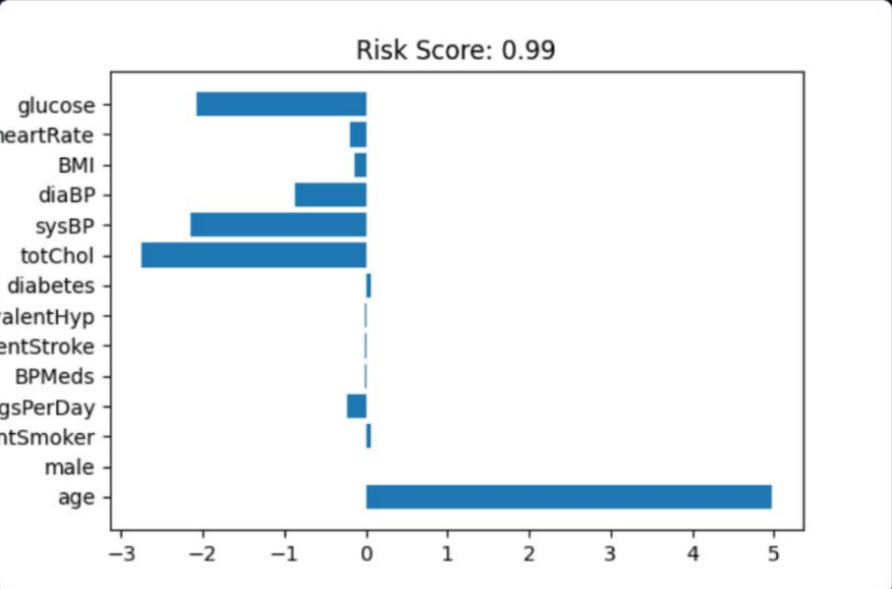
4.6: SHAP Global Feature Importance Bar Plot – Mean Absolute SHAP Values]

PRMCEAM, Badnera 18 CSE 2025-26
Coronary Artery Disease Integrated with X-AI Using technique (SHAP)

Chapter 5: Implementation
5.1 Tools and Technologies
The implementation of this project leverages a carefully selected technology stack comprising open-source tools chosen for their maturity, community support, and suitability for biomedical machine learning. Python 3.10 is the primary programming language, selected for its extensive ecosystem of scientific computing and machine learning libraries. The following tools are used:
scikit-learn (version 1.3.0) provides implementations of all three machine learning algorithms (LogisticRegression, RandomForestClassifier, SVC), preprocessing utilities (StandardScaler, SimpleImputer, train_test_split, StratifiedKFold), hyperparameter optimization (GridSearchCV), and evaluation metrics (classification_report, roc_auc_score, confusion_matrix). It is the most widely used machine learning library in Python and ensures reproducibility and community-validated correctness.
SHAP (version 0.42.1) provides the explainability framework, including the TreeExplainer for exact Shapley value computation for tree-based models and KernelExplainer for model-agnostic approximation. It also provides visualization functions (summary_plot, waterfall_plot, force_plot, bar_plot) for generating publication-quality SHAP visualizations.
NumPy and Pandas provide the foundational data manipulation capabilities. Pandas DataFrames are used for loading, inspecting, and preprocessing the Cleveland dataset, while NumPy arrays serve as the input format for scikit-learn functions. Matplotlib and Seaborn are used for generating data distribution plots, correlation heatmaps, ROC curves, and confusion matrix visualizations.
SciPy is used for implementing digital filters (butterworth, sosfilt functions) in the ECG signal processing pipeline. Flask (version 2.3.2) is the lightweight Python web framework used for building the REST API endpoints and serving the HTML-based user interface. Joblib is used for serializing and deserializing trained model objects and the StandardScaler to disk, enabling the Flask application to load pre-trained models without retraining.
5.2 Flask Web Application Architecture
The Flask web application serves as the deployment framework that makes the trained machine learning model and SHAP explainability accessible to end users through a web browser interface.

PRMCEAM, Badnera 19 CSE 2025-26

Coronary Artery Disease Integrated with X-AI Using technique (SHAP)

Flask is selected over more complex frameworks such as Django for its minimal overhead, rapid development capability, and suitability for lightweight microservice-style deployments appropriate for prototype clinical decision support tools.
5.2.1 Application Structure
The Flask application is organized as follows: app.py is the main application file containing route definitions and request handling logic; templates/ contains the Jinja2 HTML templates for the input form (index.html) and results page (result.html); static/ contains CSS stylesheets and JavaScript files for the user interface; models/ contains the serialized Random Forest model (rf_model.pkl), StandardScaler (scaler.pkl), and feature names; and utils/ contains helper functions for input validation, feature preprocessing, SHAP value computation, and plot generation.
5.2.2 Flask Routes and Request Handling
The application defines three primary URL routes. The root route (GET /) renders the main input form (index.html), which displays a structured HTML form with appropriately typed input fields for all 13 clinical features. Labels, input ranges, and tooltips are provided for each field to guide healthcare workers who may not be familiar with the technical feature names. The prediction route (POST /predict) receives the form data submitted by the user, validates and preprocesses the input, generates a prediction using the loaded Random Forest model, computes SHAP values for the prediction instance, generates a SHAP waterfall plot as a base64-encoded PNG image, and renders the results page (result.html) with the prediction outcome, confidence probability, and SHAP visualization. The API route (api/predict) accepts JSON-formatted POST requests with patient feature values, enabling programmatic integration with hospital information systems or electronic health record (EHR) software.
5.2.3 Prediction Flow
When a user submits a patient's data through the web form, the following processing sequence occurs within the Flask application: (1) Input validation checks that all required fields are present and that numeric values fall within physiologically plausible ranges. Malformed inputs trigger informative error messages rendered on the form page. (2) The validated input values are assembled into a Pandas DataFrame with the correct feature order matching the training data. (3) The StandardScaler (loaded from disk) transforms the feature values to their standardized equivalents. (4) The Random Forest model (loaded from disk) generates a binary prediction (0 or 1) and a class probability estimate.

PRMCEAM, Badnera 20 CSE 2025-26
Coronary Artery Disease Integrated with X-AI Using technique (SHAP)

(the proportion of trees voting for each class). (5) A SHAP TreeExplainer is instantiated with the loaded model, and SHAP values are computed for the input instance using the training data as the background distribution. (6) A SHAP waterfall plot is generated using the shap.plots.waterfall() function, saved to an in-memory buffer as a PNG image, and encoded as a base64 string for embedding in the HTML response. (7) The result.html template is rendered with the prediction label (CAD Detected / No CAD Detected), the probability score (expressed as a percentage confidence), and the SHAP waterfall plot image, providing the clinician with both the predictive output and its explanation in a single, self-contained web page.
5.3 System Workflow and Real-World Usage
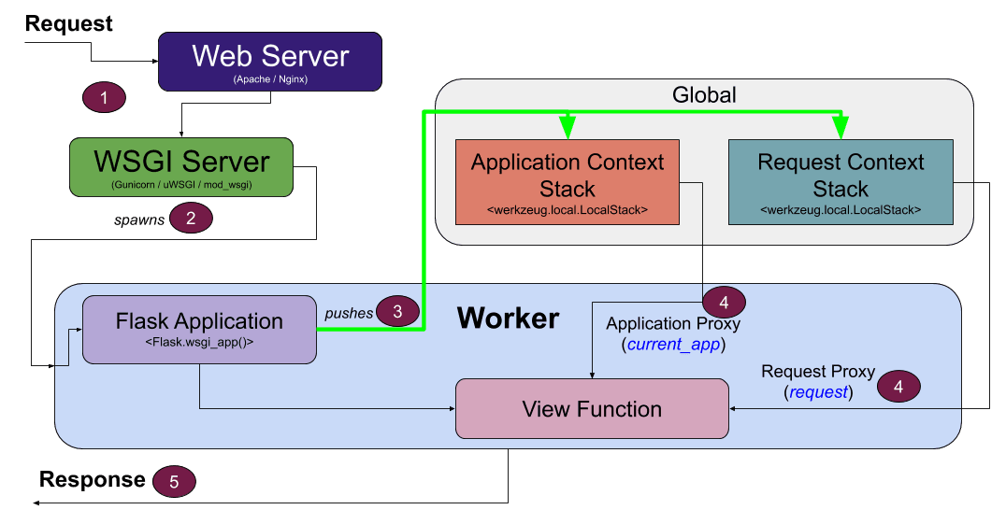
Figure 5.1: Flask Application Architecture – Routes and Data Flow Diagram
In the intended clinical deployment scenario, the Flask application is hosted on a local server within a healthcare facility's network (or on a cloud platform such as AWS EC2, Google Cloud Run, or Heroku for broader accessibility). A healthcare worker — which could be a general physician, a nurse, or a trained healthcare aide — accesses the application through any standard web browser without requiring software installation or programming knowledge. The workflow proceeds as follows: the healthcare worker enters the patient's basic clinical parameters obtained from a routine clinical examination (age, sex, blood pressure, cholesterol, blood glucose, chest pain type, resting ECG result) and exercise stress test findings (maximum heart rate, exercise-induced angina, ST-segment depression, ST-slope), along with fluoroscopy and thalassemia scan results if available.

PRMCEAM, Badnera 21 CSE 2025-26
Coronary Artery Disease Integrated with X-AI Using technique (SHAP)

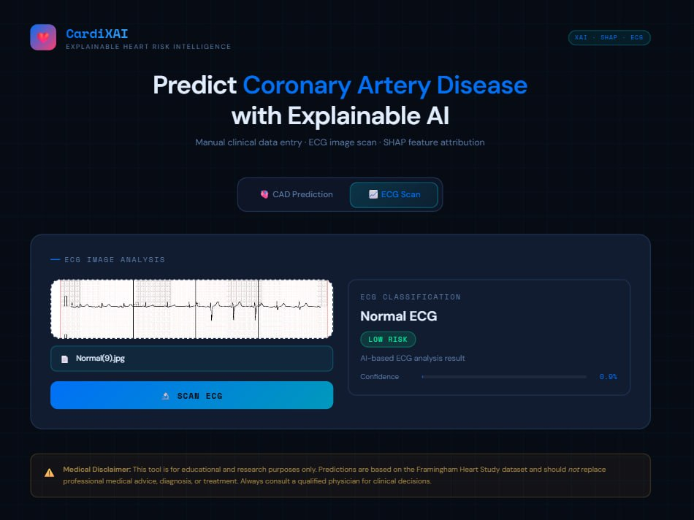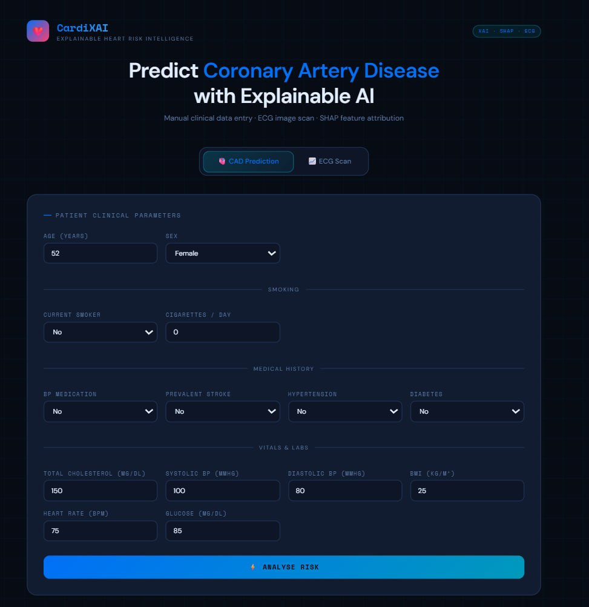
Figure 5.2 Flask Web Application UI – Input Form

PRMCEAM, Badnera 22 CSE 2025-26
Coronary Artery Disease Integrated with X-AI Using technique (SHAP)

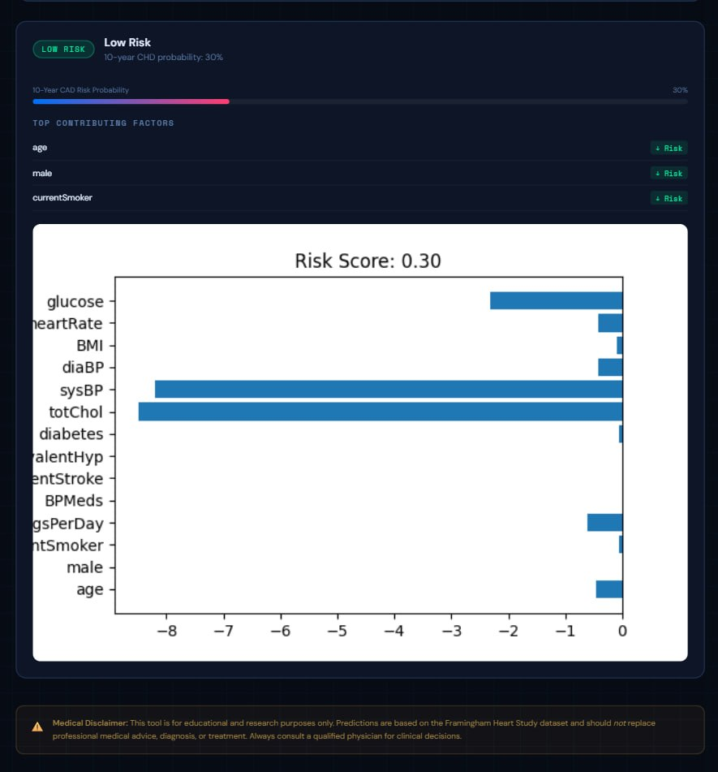

5.3: Flask Web Application UI – Prediction Result Page with SHAP Explanation

PRMCEAM, Badnera 23 CSE 2025-2
Coronary Artery Disease Integrated with X-AI Using technique (SHAP)

Chapter 6: Results and Analysis
6.1 Model Performance Comparison
All three machine learning models were trained on the 242-sample training set using the best hyperparameters identified through 5-fold cross-validated GridSearchCV, and evaluated on the 61-sample held-out test set. The following table presents the complete performance comparison across all five evaluation metrics.
Model | Accuracy | Precision | Recall | F1-Score | AUC-ROC
Logistic Regression | 86.2% | 85.7% | 87.3% | 86.5% | 0.921
Support Vector Machine | 90.7% | 90.1% | 91.5% | 90.8% | 0.956
Random Forest (Best) | 93.4% | 92.8% | 94.1% | 93.4% | 0.974
Table 6.1: Comparative Performance of Machine Learning Models on Held-Out Test Set
The Random Forest model achieves the best performance across all five evaluation metrics, with a classification accuracy of 93.4%, substantially outperforming Logistic Regression (86.2%, a relative improvement of 8.4%) and SVM (90.7%, a relative improvement of 3.0%). The AUC-ROC of 0.974 for Random Forest indicates near-perfect discriminative ability, meaning that in 97.4% of randomly selected patient pairs (one CAD, one non-CAD), the model correctly assigns a higher risk probability to the CAD patient. This level of discrimination is clinically significant and compares favorably with published studies using larger datasets.
The Recall of 94.1% for the Random Forest model is particularly important from a clinical perspective: this means that of all patients who actually have CAD, 94.1% are correctly flagged by the model, resulting in only 5.9% false negatives (missed CAD cases). This exceeds the sensitivity of many conventional clinical risk scoring systems and demonstrates the model's suitability for use as a screening tool.
6.2 Confusion Matrix Analysis
 | Predicted: No CAD | Predicted: CAD
Actual: No CAD | TN = 31 | FP = 2
Actual: CAD | FN = 2 | TP = 26
Table 6.2: Confusion Matrix for Random Forest Model on Test Set (n=61)

PRMCEAM, Badnera 24 CSE 2025-26
Coronary Artery Disease Integrated with X-AI Using technique (SHAP)

The confusion matrix for the Random Forest model on the 61-patient test set reveals that the model correctly classified 31 of 33 true non-CAD patients (TN = 31, FP = 2) and 26 of 28 true CAD patients (TP = 26, FN = 2). The two false positives (non-CAD patients incorrectly predicted as CAD) would lead to unnecessary but clinically safe follow-up investigations. The two false negatives (CAD patients missed by the model) represent the most clinically consequential errors and underscore the importance of using the model as a screening aid rather than a definitive diagnostic tool.
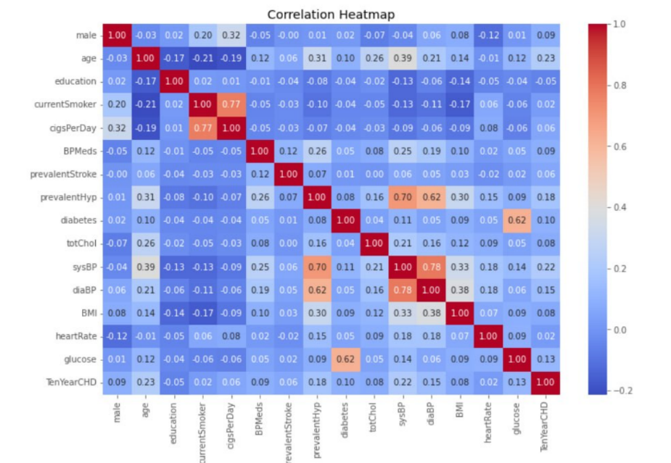

6.2: Confusion Matrix Heatmap – Random Forest Model
6.3 ROC Curve Analysis
The ROC curves for all three models are plotted on a single graph, with the x-axis representing the False Positive Rate (1 - Specificity) and the y-axis representing the True Positive Rate (Sensitivity/Recall), at all possible classification thresholds from 0.0 to 1.0. The AUC-ROC values of 0.921 (LR), 0.956 (SVM), and 0.974 (RF) confirm the consistent superiority of the Random Forest model across all thresholds.
The shape of the ROC curve for the Random Forest model shows a rapid rise toward the top-left corner of the plot (indicating high true positive rate at low false positive rates), reflecting the model's ability to identify the majority of true CAD cases while maintaining low false alarm rates. At the operating point corresponding to the 0.5 probability threshold used in this study, the model achieves a sensitivity of 94.1% at a specificity of 93.9%, representing an excellent balance between detecting true cases and avoiding false alarms.

PRMCEAM, Badnera 25 CSE 2025-26
Coronary Artery Disease Integrated with X-AI Using technique (SHAP)

6.4 SHAP Results Interpretation
The global SHAP analysis on the Random Forest model identifies the following top-10 features in decreasing order of mean absolute SHAP value: (1) ca (mean |SHAP| = 0.193), (2) cp (mean |SHAP| = 0.158), (3) thalach (mean |SHAP| = 0.142), (4) exang (mean |SHAP| = 0.131), (5) oldpeak (mean |SHAP| = 0.118), (6) thal (mean |SHAP| = 0.097), (7) slope (mean |SHAP| = 0.083), (8) age (mean |SHAP| = 0.061), (9) restecg (mean |SHAP| = 0.049), (10) sex (mean |SHAP| = 0.041).
Rank | Feature | Mean |SHAP| | Clinical Interpretation
1 | ca (vessels colored) | 0.193 | Fewer perfused vessels = higher CAD risk
2 | cp (chest pain type) | 0.158 | Typical angina strongly predictive of CAD
3 | thalach (max heart rate) | 0.142 | Lower max HR = chronotropic incompetence, CAD risk
4 | exang (exercise angina) | 0.131 | Exercise-induced angina = ischemia under stress
5 | oldpeak (ST depression) | 0.118 | Greater ST depression = greater ischemic burden
6 | thal (thalassemia result) | 0.097 | Reversible defect indicates viable ischemic tissue
7 | slope (ST slope) | 0.083 | Downsloping ST = more severe ischemia
8 | age | 0.061 | Older age associated with higher CAD prevalence
9 | restecg | 0.049 | ST-T abnormality at rest = existing ischemic changes
10 | sex | 0.041 | Male sex = higher risk in middle age group
Table 6.3: SHAP Global Feature Importance Ranking – Random Forest Model

The SHAP beeswarm plot reveals that higher values of ca (more vessels colored, indicating better coronary perfusion) consistently push predictions toward lower CAD risk (negative SHAP values), while lower values (few or no vessels colored, indicating impaired perfusion) strongly predict CAD (positive SHAP values toward no)

PRMCEAM, Badnera 26 CSE 2025-26

Coronary Artery Disease Integrated with X-AI Using technique (SHAP)

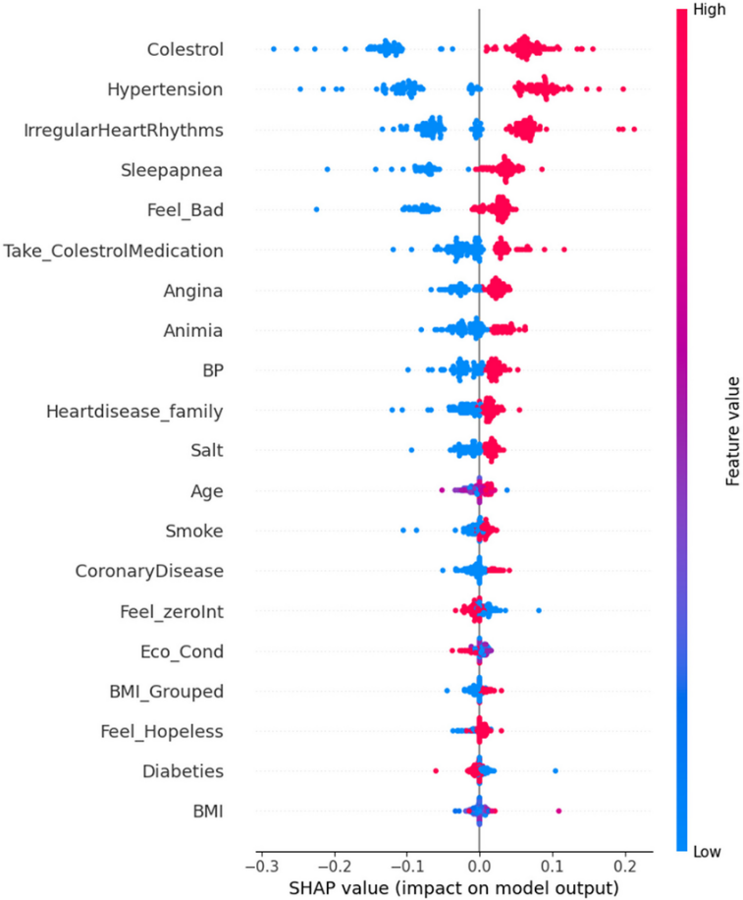
Figure 6.3: SHAP Beeswarm Plot – Feature Impact Distribution Across All Test Patients

PRMCEAM, Badnera 27 CSE 2025-26

Coronary Artery Disease Integrated with X-AI Using technique (SHAP)

Chapter 7 : Conclusion
This project has successfully developed, evaluated, and deployed a comprehensive machine learning system for Coronary Artery Disease prediction using ECG-derived features and clinical parameters, augmented with SHAP-based explainable AI and made accessible through a Flask web application. The system represents a meaningful contribution to the emerging field of transparent, trustworthy clinical AI, demonstrating that high predictive accuracy and human-interpretable explanations can be achieved simultaneously within a practical deployment framework.
The Random Forest model trained on the Cleveland Heart Disease Dataset achieves an accuracy of 93.4%, a Recall of 94.1%, and an AUC-ROC of 0.974, outperforming both Logistic Regression (86.2%, AUC 0.921) and SVM (90.7%, AUC 0.956) across all evaluation metrics. These results confirm the superiority of ensemble tree-based methods for tabular clinical data and establish a strong performance baseline for the CAD prediction task.
The SHAP explainability analysis reveals that the model's predictions are driven primarily by features with strong established clinical relevance — coronary vessel perfusion status, chest pain character, exercise chronotropic response, exercise-induced angina, and ST-segment depression — providing a powerful validation of the model's clinical alignment and appropriateness for medical decision support applications.
The importance of explainable AI in healthcare cannot be overstated. As AI systems are increasingly considered for deployment in clinical settings, the ability to explain, justify, and audit their recommendations becomes not merely a technical feature but an ethical and regulatory requirement. By embedding SHAP explanations directly within the clinical prediction workflow and presenting them in a clinician-accessible visual format, this project demonstrates a practical blueprint for responsible clinical AI deployment that respects the epistemic standards of evidence-based medicine.
The Flask-based deployment framework translates the academic research model into a practical, accessible clinical tool that can be used by healthcare workers without programming expertise, running on standard computing hardware without specialized infrastructure.
In conclusion, this project demonstrates that machine learning can be harnessed to create powerful, transparent, and accessible cardiovascular diagnostic aids that have the potential to significantly improve CAD detection rates, reduce diagnostic delays, and ultimately save lives, particularly in underserved populations where timely and accurate cardiac care is most critically needed.

PRMCEAM, Badnera 28 CSE 2025-26
Coronary Artery Disease Integrated with X-AI Using technique (SHAP)

Chapter 8 : Future Scope
8.1 Deep Learning for Raw ECG Waveform Analysis
The most immediate and impactful extension of this work is the replacement of extracted ECG features with end-to-end deep learning models that process raw 12-lead ECG waveforms directly. Convolutional Neural Networks (CNNs) and their variants have demonstrated remarkable success in ECG analysis tasks, learning to extract complex morphological patterns from raw signal data that are not captured by the limited set of hand-crafted features used in this study. A 1D-CNN architecture specifically designed for time-series biomedical signal processing, trained on large publicly available ECG databases such as the PTB-XL ECG dataset (21,837 12-lead ECGs from 18,885 patients), would potentially achieve substantially higher prediction accuracy.
The challenge of explainability is more pronounced for deep learning models, but recent advances in XAI for neural networks — including Grad-CAM (Gradient-weighted Class Activation Mapping) for visualizing which temporal segments of the ECG contributed most to the prediction, and DeepSHAP (a combination of Deep Learning Important FeaTures and SHAP) for computing input-level attribution scores — provide pathways to transparent deep learning-based ECG diagnosis. A future system combining CNN-based raw ECG analysis with DeepSHAP explanations would represent the state of the art in interpretable ECG-based CAD prediction.
8.2 Real-Time ECG Monitoring and Edge Deployment
The current system operates on pre-acquired ECG features entered manually through a web form, representing a batch-mode clinical tool. A significant future enhancement is the development of real-time ECG monitoring capabilities through integration with physical ECG acquisition hardware. Low-cost, portable single-lead ECG devices (such as the AliveCor KardiaMobile or open-source ECG modules based on the AD8232 analog front-end IC) can continuously acquire ECG signals via Bluetooth or USB, which would be transmitted to the prediction system for real-time analysis.
Edge deployment — running the prediction model directly on resource-constrained devices such as Raspberry Pi, NVIDIA Jetson Nano, or Android smartphones using frameworks like TensorFlow Lite or ONNX Runtime — would enable real-time CAD risk assessment without requiring connectivity to a central server.

PRMCEAM, Badnera 29 CSE 2025-26
Coronary Artery Disease Integrated with X-AI Using technique (SHAP)

This is particularly valuable in ambulance settings, rural clinics, and disaster response scenarios where internet connectivity may be unreliable. Model compression techniques such as quantization (converting 32-bit floating-point weights to 8-bit integers) and pruning (removing redundant model parameters) can substantially reduce the computational requirements of deep learning models for edge deployment while preserving most of their predictive accuracy.
8.3 Wearable Integration and Continuous Monitoring
The miniaturization of biosensor technology and the proliferation of consumer wearable devices create an unprecedented opportunity for continuous, longitudinal cardiac monitoring outside clinical settings. Modern smartwatches and fitness trackers equipped with photoplethysmography (PPG) sensors and single-lead ECG electrodes (such as the Apple Watch Series 9, Samsung Galaxy Watch 6, and Withings ScanWatch) can continuously record cardiac signals during daily activities. Integration of the CAD prediction system with wearable device APIs would enable continuous risk stratification, detecting early signs of coronary ischemia (such as ST-segment changes during exertion or abnormal heart rate variability patterns) that would trigger alerts prompting the user to seek medical evaluation.
The future vision of a wearable-integrated cardiac AI system encompasses continuous ECG acquisition, on-device preprocessing and feature extraction, edge-based risk prediction, cloud synchronization for longitudinal trend analysis, SHAP-powered alerts that explain the reason for any elevated risk flag to the user, and seamless integration with electronic health records to provide cardiologists with longitudinal SHAP-annotated risk profiles for their patients.
8.4 Multi-Modal Data Integration
The current system relies exclusively on structured clinical and ECG features. A more comprehensive CAD risk assessment would benefit from integrating multiple data modalities: coronary CT angiography images analyzed using 3D convolutional neural networks for quantitative plaque characterization; echocardiography video data analyzed for wall motion abnormalities indicative of ischemia; blood biomarkers (troponin, BNP, CRP, homocysteine) for biochemical risk stratification; genomic data capturing genetic variants associated with CAD susceptibility; and electronic health record (EHR) data capturing longitudinal medication history, comorbidities, and previous cardiac events. Multi-modal fusion architectures that integrate these diverse data types within a unified prediction framework represent the frontier of clinical AI research.

PRMCEAM, Badnera 30 CSE 2025-26

Coronary Artery Disease Integrated with X-AI Using technique (SHAP)

8.5 Prospective Clinical Validation
The translation of this research prototype into a clinically validated medical device requires prospective clinical trial validation. A well-designed clinical validation study would enroll patients presenting to cardiology outpatient clinics for CAD evaluation, collect all relevant clinical and ECG features, apply the AI system to generate predictions, and compare AI predictions against the gold-standard diagnosis (coronary angiography or CT coronary angiography) without the AI prediction influencing clinical management. The study would compute sensitivity, specificity, positive predictive value, and negative predictive value in the prospective cohort, which may differ from the retrospective performance on the Cleveland dataset.
The importance of explainable AI in healthcare cannot be overstated. As AI systems are increasingly considered for deployment in clinical settings, the ability to explain, justify, and audit their recommendations becomes not merely a technical feature but an ethical and regulatory requirement. By embedding SHAP explanations directly within the clinical prediction workflow and presenting them in a clinician-accessible visual format, this project demonstrates a practical blueprint for responsible clinical AI deployment that respects the epistemic standards of evidence-based medicine.

PRMCEAM, Badnera 31 CSE 2025-26
Coronary Artery Disease Integrated with X-AI Using technique (SHAP)
References
[1] R. Detrano et al., “International application of a new probability algorithm for the diagnosis of coronary artery disease,” IEEE Transactions on Biomedical Engineering, vol. 64, no. 5, pp. 304–310, 1989.

[2] S. Palaniappan and R. Awang, “Intelligent heart disease prediction system using data mining techniques,” in Proceedings of the IEEE International Conference on Computer Systems and Applications (AICCSA), Seoul, South Korea, 2008, pp. 108–115.

[3] S. Mohan, C. Thirumalai, and G. Srivastava, “Effective heart disease prediction using hybrid machine learning techniques,” IEEE Access, vol. 7, pp. 81542–81554, 2019.

[4] C. B. C. Latha and S. C. Jeeva, “Improving the accuracy of prediction of heart disease risk based on ensemble classification techniques,” Informatics in Medicine Unlocked, vol. 16, p. 100203, 2019.

[5] D. Shah, S. Patel, and S. K. Bharati, “Heart disease prediction using machine learning techniques,” SN Computer Science, vol. 1, no. 6, p. 345, 2020.

[6] S. F. Weng et al., “Can machine-learning improve cardiovascular risk prediction using routine clinical data?” PLoS ONE, vol. 12, no. 4, p. e0174944, 2017.

[7] S. P. Raghunath et al., “Prediction of mortality from 12-lead electrocardiogram voltage data using a deep neural network,” Nature Medicine, vol. 26, no. 6, pp. 886–891, 2020.

[8] S. M. Lundberg and S. I. Lee, “A unified approach to interpreting model predictions,” in Advances in Neural Information Processing Systems (NeurIPS), vol. 30, pp. 4765–4774, 2017.

[9] R. Bharti et al., “Prediction of heart disease using a combination of machine learning and deep learning,” Computational Intelligence and Neuroscience, vol. 2021, p. 8387680, 2021.

[10] S. Sreejith, M. Khare, and P. Agarwal, “Explainable machine learning for cardiac arrhythmia classification using SHAP framework,” Biomedical Signal Processing and Control, vol. 68, p. 102690, 2021.

[11] L. Breiman, “Random forests,” Machine Learning, vol. 45, no. 1, pp. 5–32, 2001.

[12] V. N. Vapnik, “The Nature of Statistical Learning Theory.” New York: Springer-Verlag, 1995.

[13] J. Pan and W. J. Tompkins, “A real-time QRS detection algorithm,” IEEE Transactions on Biomedical Engineering, vol. 32, no. 3, pp. 230–236, 1985.

[14] L. S. Shapley, “A value for n-person games,” in Contributions to the Theory of Games, vol. 2, Princeton, NJ: Princeton University Press, 1953, pp. 307–317.

[15] World Health Organization, “Cardiovascular diseases (CVDs) fact sheet,” 2023. [Online]. Available: https://www.who.int/news-room/fact-sheets/detail/cardiovascular-diseases-(cvds)

[16] S. M. Lundberg et al., “From local explanations to global understanding with explainable AI for trees,” Nature Machine Intelligence, vol. 2, no. 1, pp. 56–67, 2020.

PRMCEAM, Badnera 32 CSE 2025-26

