|  |  |
| --- | --- |
|  | **2015** |
|  | INVENTRUST |

|  |
| --- |
| **NeuRal Implants** |
| PATENT INTELLIGENCE REPORT for 2015 by |

*Disclaimer*

*Entire contents ©2015 InvenIt Inc. All rights reserved. Reproduction of this publication in any form without prior written permission is forbidden. The information contained herein has been obtained from data sources believed to be reliable. InventIt disclaims all warranties as to the accuracy, completeness or adequacy of such information. The results identified are only up to the date specified in this document. No opinion, unless clearly stated otherwise, is expressed or implied other than the comments stated herein. InventIt is not a law firm and does not provide any legal advice or legal opinion.*

**CONTENTS**

**Introduction**

**Patenting Activity Trends**

**Leading Companies**

**Publication Trends of Leading Companies**

**Priority Countries**

**Worldwide Geographical Coverage**

**Prolific Inventors – Overall in the Cluster**

**Prolific Inventors at leading companies**

**Most Cited Patents**

## **Introduction**

**Welcome to the 2015 ‘Neural Implants’ Intelligence report!**

Neural Implants often referred to as Brain Implants are medical devices that are used to connect with a human brain. Neural Implants may be placed on the surface of the brain or deep within the brain based on subject’s requirements. Neural Implants may involve creating interfaces between brain and computer chips known as Brain-Computer Interfaces which is relatively a new area of research. Neural Implants for the purpose of brain or nerve stimulation such as deep brain stimulation and vagus nerve stimulation are increasingly being used to treat a number of diseases such as depression, Parkinson, other neurological diseases etc.

There is a huge potential for study and research in the area of brain implants from developing systems to treat typical brain disorders and diseases in a better way to make a meaningful impact on patients’ life to developing interfaces for understanding mysteries of the brain such as through brain computer interfaces and solving complex brain matters for a better understanding about how brain functions and thinks and so on as the brain is still considered a huge black box that no one understands. Over the next half-century, neural implants have the potential of substantially enhancing the brain’s functionality and ultimately changing the human condition. Scientists predict that neural implants will dramatically expand the capabilities of the human brain. Various cross technology applications such as increases in speed and power of computer processors can greatly affect capabilities of the future brain implants. With the use of more powerful computers and miniaturization of computing devices, neural implants have a great potential. The next generation of brain implants therefore can create more targeted stimulation systems that yield better and safer results without affecting health of patients. The next generation of brain implants can perhaps be capable of coding, decoding, recoding, and transmitting of electrical signals to the brain and monitor or control or tell the brain about what to do in case a patient suffers some brain disease. The next generation of brain implants can perform sophisticated functions of the brain in case a particular brain tissue is damaged or not working properly. In short, the next generation neural implants can have the capability to enhance functioning of the brain substantially.

According to International OCD Foundation, in 2012, nearly 2 to 3 million adults suffered from obsessive compulsive disorder (OCD) in the U.S. In addition, approximately 2.3% of the global population suffers from OCD every year and has been estimated that this number is expected to increase. Moreover, increasing adoption for technologies by patients as well as by physicians will also support the growth of brain implants market. According to Transparency Research, North America accounted for the largest share by revenue in 2013 and is likely to grow at a steady CAGR. This is due to the presence of a large number of manufacturers of brain implants in the region coupled with high disposable income of the population that increases their affordability for the uptake of brain implants. Europe accounted for the second largest share of the global brain implants market. Improving reimbursement scenario in the countries such as China and India is expected to propel the growth of brain implants market in Asia-Pacific region at the highest CAGR. Some of the major players operating in the neural implants market include Boston Scientific Corporation, Medtronic Inc., Sapiens, Advanced Neuromodulation Sys, amongst other significant players. The patenting activity has increased in the last two decades with more than 1,500 patent families published in this cluster so far.

## **Patenting Activity Trends**

There is a sharp increase in patenting activity in the last two decades. In December 1995, there were 91 patent families that related to Neural Implants, with only 4 families published in year 1995. In December 2014, the total number has increased to 1,516 patent families. Only in the year 2014, a total of 414 unique patent families were published which shows more than 73% growth as compared to publications in the preceding year 2013.

The first few patents that are identified in this report were filed in 60s and 70s. A few of these are listed below:

US Patent 3115140 published in 1963 and assigned to Baltimore Instr. Company teaches an apparatus for use in implantation of subcortical electrodes in the brain of a patient. More particularly, the present invention relates to an apparatus wherein an electrode may be implanted into the human brain and accurately positioned to treat desired brain cells.

US Patent 3850161 published in 1974 relates to biomedical detecting and control apparatus wherein electrical signals in the brain of mammals are continuously monitored by electrodes implanted in certain critical places in the brain wherein excess electrical energy is manifest during epileptic seizure conditions as well as during psychic storms of some types of mental illness. The probes may be near the surface of the brain or deep set in the brain depending upon the area affected.

US Patent US3918461A published in 1975 and assigned to Cooper Irving S relates to apparatus for electrically stimulating human brain and includes applying electrodes directly to the cerebellum and feeding electrical impulses to such electrodes to aid individuals suffering from intractable hypertonia, epilepsy etc.

**Figure 1 - Patent Publishing Trends for Neural Implants**

**Figure 2 - Patent Filing Trends for Neural Implants**

**Figure 3 - Priority Trends for Neural Implants**

## **Leading Companies**

As noted in the graph, Medtronic holds the most number of patent families with a total portfolio of 158 families in Neural Implants cluster of patents. Compared to the overall portfolio in this technology cluster, Medtronic’s holding represents 10.01%. Boston Scientific follows Medtronic with 97 patent families assigned to it. Other major companies are Advanced Neuromodulation Sys, Cyberonics, Neuropace Inc., and Sapiens.

Medtronic started filing patents in early 90s. Boston Scientific’s patents can be traced after 2005 while initial filings of Advanced Neuromodulation can be noted after 2000. Both Cyberonics and Neuropace filed their initial patents in 90s.

Analysis of recent patents in this cluster by Medtronic reveals that the patents relate to applying electric currents by contact electrodes for stimulation of devices such as implantable devices, electrodes for implantation or insertion into the body, arrangements in connection with implantation of stimulators, arrangements or circuits for monitoring, protecting, controlling or indicating for a specific type of device, etc.

One of the major developments in the last decade is the emergence of late entrant Boston Scientific in this cluster of patents and is now positioned on number second after Medtronic in terms of total patent holdings.

**Figure 4 - Leading Companies**

|  |  |
| --- | --- |
| Assignees | Percentage of total Patent Families (%) |
| Medtronic Inc. | 10.01 |
| Boston Scientific | 6.15 |
| Advanced Neuromodulation Sys | 2.4 |
| Cyberonics Inc. | 2.34 |
| Neuropace Inc. | 2.02 |

**Figure 5 – Top 5 Companies Percentage Holdings**

## **Publishing Trends of Leading Companies**

Figure 6E – Neuropace inc.

Figure 6F – Sapiens Steering

Figure 6C – Advanced Neuromodulation Sys

Figure 6D – Cyberonics inc.

Figure 6A – Medtronic Inc.

Figure 6B – Boston scientific

## **Priority Countries**

United States of America is ranked on top in conceptualization of Neural Implant-based technologies. As many as 1,226 patent families worldwide developed and originated from the United States. These 1226 patent families published worldwide take priority from a US patent publication. The US is followed by WIPO from where more than 300 patent families originated. WIPO is followed by China, EPO and Germany.

There are at least 100 assignees who have filed for patents that consider United States as the priority country. Medtronic Inc., Boston Scientific, Cyberonics, Advanced Neuromodulation Sys, Neuropace Inc., Second Sight, Sapiens Steering, University of California, and Cordis are a few of them.

Figure 7 - Priority Countries for Neural Implants

## **Worldwide Geographical Coverage**

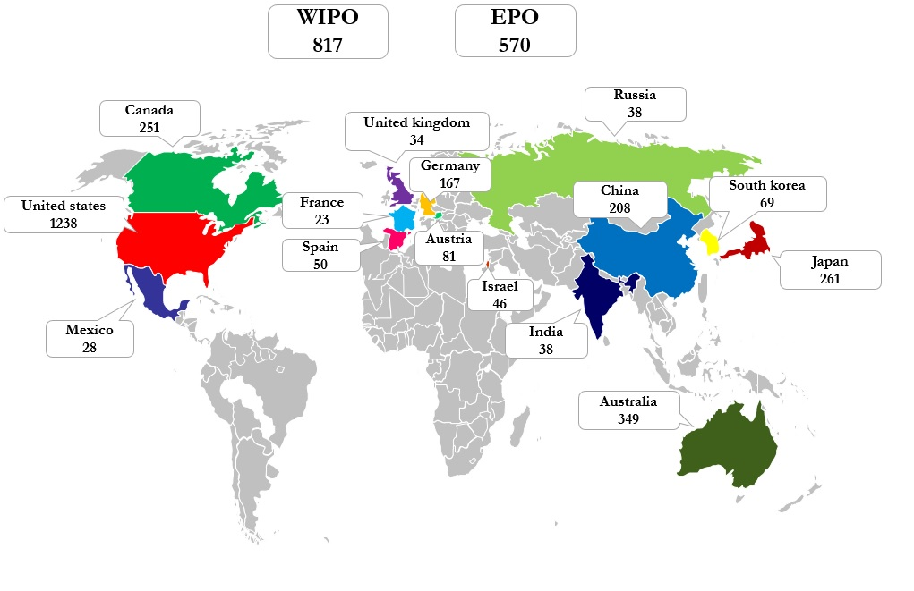

Figure 8 - Worldwide Patenting Activity

The global map (Figure 9) illustrates patenting activity worldwide across top 17 jurisdictions. Numbers in the map represent unique patent families in Neural Implants technology. United States clearly leads other jurisdictions followed by PCT applications, European Patent Publications, Australia, Japan, Canada, and China.

Figure 10 below illustrates leading companies across major jurisdictions. Some of the companies that have actively filed for patents in most of the key jurisdictions are Boston Scientific, Medtronic, Cleveland Clinic Foundation, and Cyberonics.

As depicted in Figure 11 below, there is seen an increase in patenting activity in the recent years. United States records a total of 530 patent families filed in the last five years which is much higher than any other jurisdiction in the same period. This is followed by PCT applications (226 patent families).

**EPO**

**WIPO**

**EPO**

**WIPO**

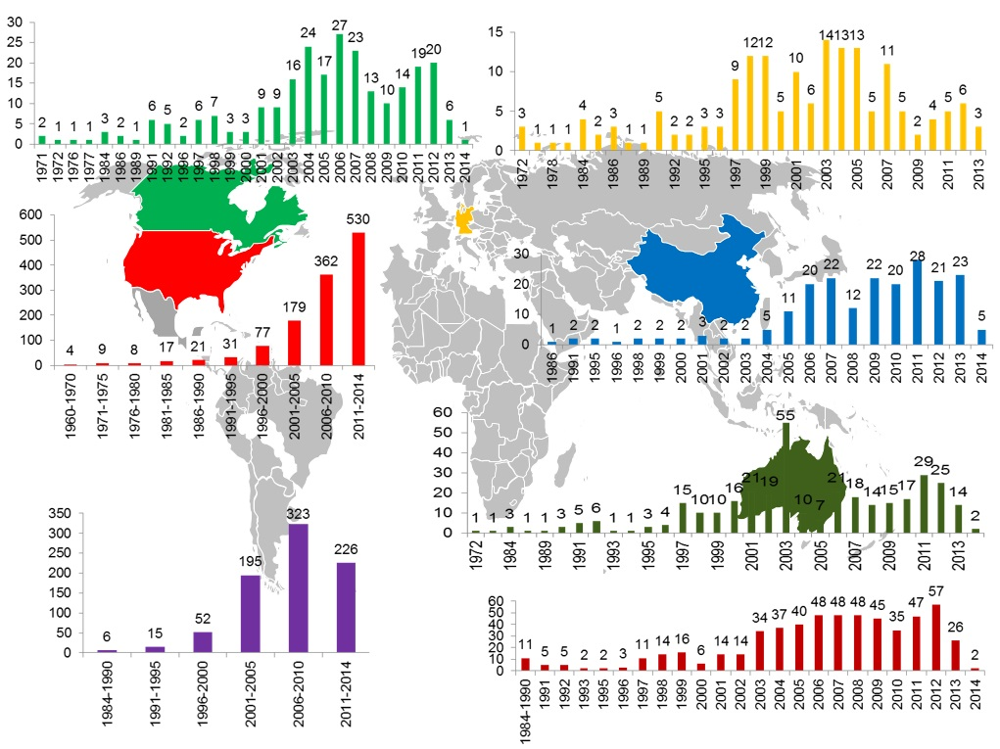

Figure 10 - Patent Filing Trends Across Key Jurisdictions

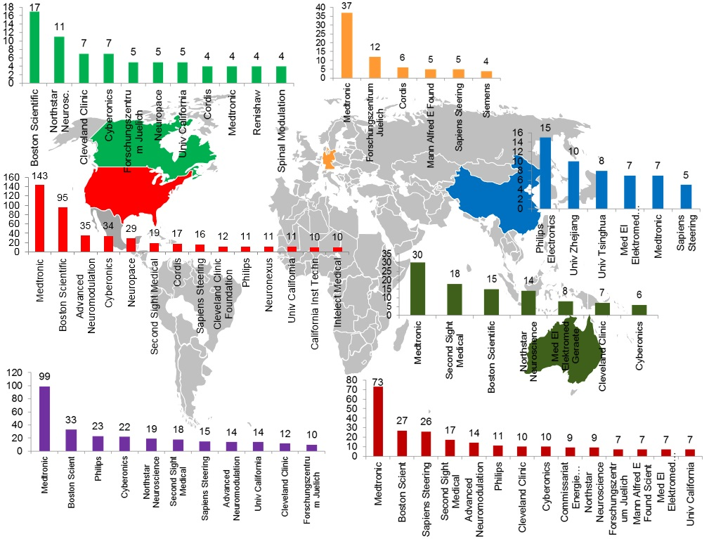

Figure 9 - Leading Companies Across Key Jurisdictions

## **Prolific Inventors – Overall**

The data shows that the topmost inventor holds 29 patent families followed by inventors with 20, 17, and 16 patent families in their names. There are 89 inventors who are named on 5 or more patent families in the Neural Implants patent cluster. A large number of inventors have one or two patents in their names. Approximately 3,000 inventors have contributed to Neural Implants entire portfolio.

Greenberg, Robert J. who holds the maximum number of patent families is affiliated with Second Sight Medical Products.

Figure 11 - Prolific Inventors in Neural Implants

**Prolific Inventors at Leading Companies**

Figure 12a – Prolific Inventors at Medtronic Inc.

Figure 12b – Prolific Inventors at Boston Scientific

Figure 12c - Prolific Inventors at Advanced Neuromodulation sys

Figure 12d - Prolific Inventors at Cyberonics Inc.

## **Most Cited Patents**

The following graph shows patent publications that are cited the most by other patent publications.

Figure 13 - Most Cited Patent Publications

|  |  |  |  |  |
| --- | --- | --- | --- | --- |
| **Publication** | **Title** | **Assignee** | **Inventor** | **Application Year** |
| US5299569A | Treatment of neuropsychiatric disorders by nerve stimulation | Cyberonics Inc | Wernicke, Joachim F. | Terry, Jr., Reese S. | Zabara, Jacob | 1991 |
| US5540734A | Cranial nerve stimulation treatments using neurocybernetic prosthesis |  | Zabara, Jacob | 1994 |
| US5358514A | Implantable microdevice with self-attaching electrodes | Mann Alfred E Found Scient Res | Schulman, Joseph H. | Strojnik, Primoz | Meadows, Paul | 1993 |
| US6463328B1 | Adaptive brain stimulation method and system |  | John, Michael Sasha | 2000 |
| US5330515A | Treatment of pain by vagal afferent stimulation | Cyberonics Inc | Rutecki, Paul | Wernicke, Joachim F. | Terry, Jr., Reese S. | 1992 |
| US5342409A | Position-responsive neuro stimulator | Medtronic Inc | Mullett, Keith R. | 1991 |
| US5269303A | Treatment of dementia by nerve stimulation | Cyberonics Inc | Wernicke, Joachim F. | Terry, Jr., Reese S. | 1991 |
| US5025807A | Neurocybernetic prosthesis |  | Zabara, Jacob | 1989 |
| US6731976B2 | Device and method to measure and communicate body parameters | Medtronic Inc | Penn, Richard D. | Miesel, Keith Alan | Stylos, Lee | Christopherson, Mark A. | Nagavarapu, Sudha | Roline, Glenn M. | 2001 |
| US4852573A | Implantable neural electrode |  | Kennedy, Philip R. | 1987 |
| US5282468A | Implantable neural electrode | Medtronic Inc | Klepinski, Robert J. | 1992 |
| US5941906A | Implantable, modular tissue stimulator | Medtronic Inc | Barreras, Sr., Francisco J. | Echarri, Roberto | Echarri, Guillermo | 1997 |
| US6735475B1 | Fully implantable miniature neurostimulator for stimulation as a therapy for headache and/or facial pain | Advanced Bionics Corp | Whitehurst, Todd K. | McGivern, James P. | Woods, Carla Mann | Meadows, Paul M. | Kuzma, Janusz A. | 2002 |
| US5735887A | Closed-loop, RF-coupled implanted medical device | Exonix Corp | Barreras, Sr., Francisco Jose | Echarri, Robert | 1996 |
| US6115636A | Telemetry for implantable devices using the body as an antenna | Medtronic Inc | Ryan, Terence G. | 1998 |
|  |  |  |  |  |

|  |  |  |  |  |
| --- | --- | --- | --- | --- |
| US4328813A | Brain lead anchoring system | Medtronic Inc | Ray, Charles D. | 1980 |
| US5464446A | Brain lead anchoring system | Medtronic Inc | Dreessen, Chrit | Gubbels, Paul A. | Adams, Paul | 1993 |
| US6473639B1 | Neurological event detection procedure using processed display channel based algorithms and devices incorporating these procedures | Neuropace Inc | Fischell, David R. | Harwood, Jonathan | Pless, Benjamin D. | 2000 |
| US4127110A | Implantable pressure transducer | Huntington Inst Of Applied Med | Bullara, Leo A. | 1976 |
| US5913882A | Neural stimulation techniques with feedback | Medtronic Inc | King, Gary William | 1998 |
| US6171239B1 | Systems, methods, and devices for controlling external devices by signals derived directly from the nervous system | Univ Emory | Humphrey, Donald R. | 1998 |
| US6006124A | Means and method for the placement of brain electrodes | Neuropace Inc. | Fischell, Robert E. | North, Richard B. | 1998 |
| US3850161A | Method and apparatus for monitoring and counteracting excess brain electrical energy to prevent epileptic seizures and the like |  | Liss, Saul | 1973 |