**CONTENTS**

**Introduction**

**Patenting Activity Trends**

**Leading Companies**

**Publication Trends of Leading Companies**

**Prolific Inventors – Overall in the Sector**

**Inventors Clustering**

**Prolific Inventors at leading companies**

**Prolific Inventors-Assignee Mapping Sheet**

**Printing Technologies**

**Most Cited Patents**

## **Introduction**

**Welcome to the 2015 3D Printing Intelligence report!**

3D printing or additive manufacturing (AM) refers to any of the various processes for printing a three-dimensional object. Additive processes of manufacturing are used in 3D printing, in which successive layers of material are laid down under computer control. These objects can be of almost any shape or geometry, and are produced from a 3D model or other electronic data source. A 3D printer may be considered a type of industrial robot.

In the year 2014, a series of patents filed by Carl Deckard in the 1990s for selective laser sintering (SLS) — a high-quality 3D-printing technology — expired. With this technology back in play, people started to see big things for 3D printing coming up fast on the horizon. SLS takes in powdered material, rather than plastic filament and uses a laser to bind it and create a solid structure. SLS printers can work using metal, glass, and ceramic materials.

And so, in the latter part of 2013, researchers and analysts began predicting a coming explosion in 3D printing technologies. There was a near consensus about how great this was going to be. The Economist mused about the boom. Quartz intimated in July that it was good as a done deal. Techcrunch called the day the SLS patents expired “a great day for makers.” A roadblock between the current day and the future was being removed.

As an example, MakerBot Industries built a 3D printer and bought out a line of affordable consumer printers. By 2013, MakerBot was worth enough that 3D-printing giant Stratasys acquired it up for $403 million. Big manufacturers like United Technologies Corp. and Boeing Co. are using 3-D printing to make some metal components, and are looking for ways to expand its use. Meanwhile, medical researchers are working on ways to print living human tissues, such as body parts. Consequently, there is seen a dramatic increase in patenting activity in the last few years as can be noticed in the report below.

## **Patenting Activity Trends**

There is a dramatic increase in patenting activity in the last few years. In December 2012, there were 144 patents related to 3D printing or additive manufacturing. In the last 2 years, this has increased to 1213 patent publications. In the year 2014, a series of patents filed by Carl Deckard in the 1990s for selective laser sintering (SLS) — a high-quality 3D-printing technology — expired. With this technology back in play, people had started to see big things for 3D printing coming up fast on the horizon. And so, in the latter part of 2013, researchers and analysts began predicting a coming explosion in 3D printing.

The first few patents that are identified in this report were filed in the year 1989. A few of these are listed below:

PCT application 1990003893A1 that teaches three-dimensional object production from computer generated image using energy beam to produce laminated layers from powder layers by Feygin Michael.

Canadian patent CA1338954C that teaches curing of partially polymerised stereo-lithographically produced parts by immersing part in liq. medium e.g. water and curing the immersed part e.g. by electro-magnetic, ultraviolet or visible radiation assigned to 3D Systems

US Patent 5133987A that teaches stereoscopic lithographic apparatus to produce 3-dimensional articles and having electromagnetic energy beam generator, assigned to 3D Systems.

Several of the first few published patents discuss stereo-lithographic techniques.

**Figure 1 - Patent Publishing Trends for 3D Printing Technology Sector**

**Figure 2 - Patent Filing Trends for 3D Printing Technology Sector**

**Figure 3 - Average Time in Grant of Patents**

## **Leading Companies**

3D Systems and Stratasys are the two major companies and have filed their earliest patents tracked by this report in 1989.

Analysis of ‘3D Systems’ patents reveal that it has actively patented stereo-lithography techniques and apparatuses since beginning of its patenting activity. At least 25 such patents have been filed by 3D Systems that relate to stereo-lithography.

Analysis of patents by Stratasys reveal that most of the patents filed recently relate to shaping techniques such as moulding, sintering, compression, etc.

One of the major developments in the past few years is the emergency of Chinese Acad. Institute. Chinese Acad. Institute started patenting activity in 2011 and has so far amassed 41 unique patent families. Interestingly, all the patents are filed only in China.

Hewlett Packard filed its initial patents in 2003 and has since then amassed 37 patent families relating to freeform fabrication systems and techniques, stereo-lithographic techniques, rapid prototyping etc.

Xi An Zhongkemaite Electronic Tech, another leading company, owns 12 patent families, all published in 2014.

**Figure 4 - Leading Companies**

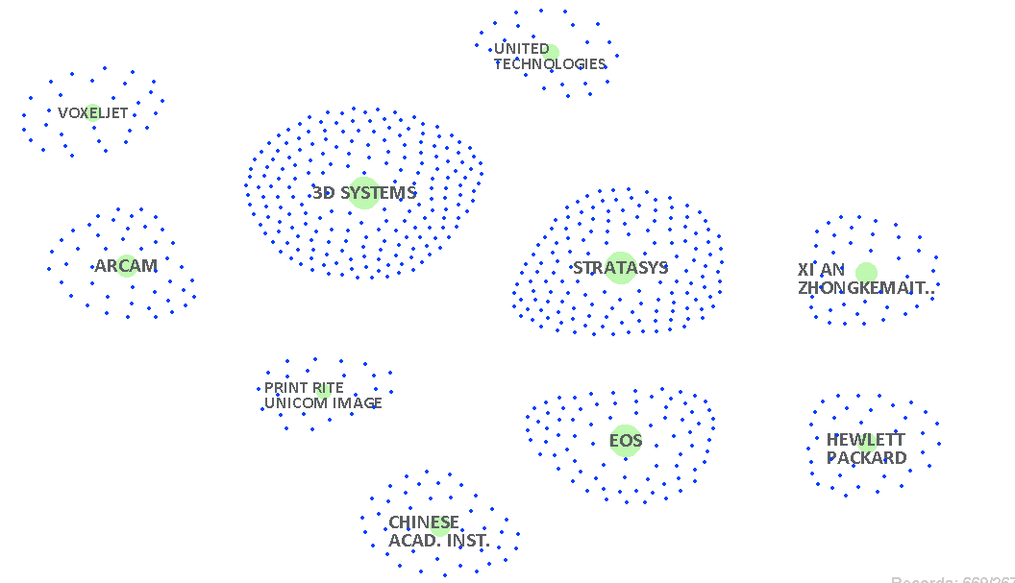**Figure 5 - Clustering of Patents by Leading Companies**

Figure 6 - Assignee Innovation Timelines

**Publication Trends of Leading Companies**

The leading companies 3D Systems and Stratasys published their first patents in 1992 and 1996 respectively in this sector. But it was only in the recent years that a surge in their patenting activity can be noticed. In 2014 only, a total of 38 patents of 3D Systems were published which is more than 200% of the patents published in 2013.

Stratasys got 54 patent families published in the year 2014 which is 234% of patent families published in the year 2013.

A comparison of patenting activity of year 2014 reveals that Stratasys got 42% more patent families published than the biggest player – 3D Systems. Interestingly, Stratasys seems to be aggressively active only in the last 5-6 years as far as patenting is concerned; however 3D Systems has been relatively more active for the last one and a half decade and has amassed 199 patent families so far.

Figure 7a - 3D Systems

Figure 7b – Stratasys

Figure 7c - EOS

EOS, another leading company, is active since 1992, however increased number of filings only in the recent few years. In year 2014, 21 patent families of EOS were published which is 162% of its patent families published in 2013.

One of the most interesting facts is that Xi An Zhongkemaite Electronic Tech., a recent entrant and a leading company, got all its patents published in the year 2014 only. A total of 43 patent families are published in 2014. No patent is noticed before this.

Like most other leading companies, Arcam is also active for the last few years and a major surge is seen in 2014 when 15 unique patent families are published which is more than 200% of patent families published in the previous year 2013 and 300% of families published in 2012.

Figure 7d - Arcam

Figure 7e - Xi An Zhongkemaite Electronic Tech.

When we observe the trends of top five leading companies, we notice that most of the companies show a surge in patenting activity in the last one decade. 3D Systems and Stratasys are the two largest players and are clearly the driving force in this sector and the data shows that both companies have been filing patents since early 90s.

## **Prolific Inventors – Overall**

The data shows that the most prolific five inventors hold 38 patent families in their name followed by inventors with 34, 28, and 24 patent families in their name. There are 32 inventors who are named on 11 or more patent families. A large number of inventors have one or two patents in their name.

The five most prolific inventors are affiliated with Chinese Acad. Inst. and are co-inventors on these 38 patent families. It is clear from the data that several of the most prolific inventors are based out in China and have filed patents only with China Patent Office.

Figure 8 - Prolific Inventors in 3D Printing Sector

## **Inventors Clustering**

The following graph shows number of inventors that are engaged in patenting activity in various years.

The data shows that there is a sharp increase in the number of inventors active in this sector. The number of inventor whose patents were published in 2014 is almost seven times the number of inventors active in 2012. As the chart indicates, there were only 57 inventors in 1999 and the number increased to 2042 in next 15 years. Given a drastic increase in the number of persons actively filing patents in this sector in the last 2-3 years and a positive attitude towards growth in the sectors, and recent mergers and acquisitions, it can be easily inferred that the clustering of inventors will increase further in the coming years.

Figure 9 - Clustering of Inventors

**Prolific Inventors at Leading Companies**

Figure 10a – Prolific Inventors at 3D Systems

Figure 10b - Prolific Inventors at Stratasys

Figure 10c - Prolific Inventors at EOS

Figure 10d - Prolific Inventors at Arcam

Figure 10e - Prolific Inventors at Xi An Zhongkemaite Electronic Tech.

## **Prolific Inventor-Assignee Mapping Chart**

**The following graph shows association of prolific inventors and leading companies**

|  |  |  |  |  |  |  |  |  |  |  |  |  |
| --- | --- | --- | --- | --- | --- | --- | --- | --- | --- | --- | --- | --- |
| ASIGNEE  INVENTOR | TOTAL | 3D SYSTEMS | ARCAM | CHINESE ACAD. | HEWLETT PACKARD | PRINT RITE UNICOM | STRATASYS | UNIV JIANGSU | UNIV JINAN | VOXELJET | XI AN SHANGSHANG | XI AN ZHONGKEMAITE |
| **TOTAL** | 207 | 15 | 1 | 38 | 13 | 20 | 32 | 12 | 14 | 14 | 21 | 27 |
| SUN, WEN-HUA | 38 |  |  | 38 |  |  |  |  |  |  |  |  |
| MA, YONG-MEI | 38 |  |  | 38 |  |  |  |  |  |  |  |  |
| LIN, XUE-CHUN | 38 |  |  | 38 |  |  |  |  |  |  |  |  |
| LI, CHUN-CHENG | 38 |  |  | 38 |  |  |  |  |  |  |  |  |
| DONG, JIN-YONG | 38 |  |  | 38 |  |  |  |  |  |  |  |  |
| FU, WEN-XIN | 34 |  |  | 34 |  |  |  |  |  |  |  |  |
| XU, JIAN | 28 |  |  | 28 |  |  |  |  |  |  |  |  |
| MA, SHU-BO | 24 |  |  |  |  |  |  |  |  |  |  | 24 |
| SWANSON, WILLIAM J. | 20 |  |  |  |  |  | 20 |  |  |  |  |  |
| LI, FENG | 19 |  |  |  |  |  |  |  |  | 19 |  |  |
| BATCHELDER, J. SAMUEL | 17 |  |  |  |  |  | 17 |  |  |  |  |  |
| ZHAO, NING | 16 |  |  | 16 |  |  |  |  |  |  |  |  |
| WANG, LE-MIN | 15 |  |  |  |  |  |  |  |  | 15 |  |  |
| LI, XIAO-PING | 15 |  |  |  |  |  |  | 12 |  |  |  | 3 |
| HULL, CHARLES W. | 15 | 15 |  |  |  |  |  |  |  |  |  |  |
| HE, YONG-GANG | 15 |  |  |  |  | 15 |  |  |  |  |  |  |
| WEI, DE-MIN | 14 |  |  |  |  |  |  |  | 14 |  |  |  |
| LAMBRIGHT, TERRY M. | 14 |  | 1 |  | 13 |  |  |  |  |  |  |  |
| EDERER, INGO | 14 |  |  |  |  |  |  |  |  | 14 |  |  |
| SU, JIAN-QIANG | 13 |  |  |  |  | 13 |  |  |  |  |  |  |

## **Printing Technologies**

|  |  |
| --- | --- |
| Technology | Patent Families |
| Rapid Prototyping | 211 |
| Stereo-lithography | 200 |
| Laser Sintering | 118 |
| Freeform Fabrication | 79 |
| Fused Deposition Modeling | 71 |

Figure 11 - Technology Evolution

Rapid prototyping techniques are disclosed in at least 211 patents. The patents chiefly cover shaping techniques for printing 3D objects. The data shows that patenting activity in the field of rapid prototyping using 3D printing started around mid 90s and number of filings has increased continually.

Patents related to stereo-lithography have been filed since the 3D printing technology started developing in around 1989. Some of the initial patents in this sector are related to stereo-lithography processes and devices. There are at least 200 patents covering various aspects of stereo-lithographic technologies published so far.

Freeform Fabrication related 3D printing technology evolved around late 90s and has so far amassed 79 patent families. In 2014 only, at least 15 patent families were published in the area of freeform fabrication.

Fused Deposition Modeling is yet another technology for which patents were published in mid 90s and onwards chiefly. It has amassed at least 71 patent families so far. The technology was developed by S. Scott Crump in the late 1980s and was commercialized in 1990s by Stratasys. With the expiration of the initial patents on this technology there is now a large open-source development community. This has led to two orders of magnitude price drop since this technology's creation.

Laser sintering such as selective laser sintering (SLS) evolved in early 90s and has amassed at least 118 patent families till date. In the year 2014, a series of patents filed by Carl Deckard in the 1990s for selective laser sintering (SLS) — a high-quality 3D-printing technology — expired. With this technology back in play, people started to see big things for 3D printing coming up fast on the horizon. SLS takes in powdered material, rather than plastic filament and uses a laser to bind it and create a solid structure. SLS printers can work using metal, glass, and ceramic materials.

## **Most Cited Patents**

The following graph shows patent publications having maximum number of citing patents.

## 

Figure 11 - Most Cited Patent Publications

|  |  |  |  |  |
| --- | --- | --- | --- | --- |
| **Publication** | **Title** | **Assignee** | **Inventor** | **Application Year** |
| US5545367A | Rapid prototype three dimensional stereolithography | Soane Technologies Inc. | Bae, Young C. | Soane, David S. | Crocker, Charles | 1993 |
| US5823778A | Imaging method for fabricating dental devices | US AIR FORCE | Schmitt, Stephen M. | Chance, David A. | 1997 |
| US5352405A | Thermal control of selective laser sintering via control of the laser scan | DTM Corporation | Beaman, Joseph J. | McGrath, Joseph C. | Prioleau, Frost R. R. | 1992 |
| WO1990003893A1 | An improved apparatus and method for forming an integral object from laminations |  | FEYGIN Michael | 1989 |
| US5287435A | Three dimensional modeling | Cubital Ltd. | Cohen, Nissan | Barequet, Gill | Barnea, Daniel | Ben Ezra, Barry | Dollberg, Yehoshua | Gilad, Shalev | Herskowits, Varda | Meininger, Herbert | Pomerantz, Itzik | Sas, Benjamin | Sheinman, Yehoshua | Shlick, Mark | Wasserstein, Michael | Yeshurun, Nachshon | 1990 |
| US5900207A | Solid freeform fabrication methods | UNIV RUTGERS | STRATASYS INC | Danforth, Stephen C. | Agarwala, Mukesh | Bandyopadghyay, Amit | Langrana, Noshir | Jamalabad, Vikram R. | Safari, Ahmad | van Weeren, Remco | Priedeman, Jr., William R. | 1997 |
| US6405095B1 | Rapid prototyping and tooling system | Nanotek Instruments Inc. | Jang, Borzeng | Duan, Jun | Chen, Kerbin | Lu, Xin | Ma, Erjian | 1999 |
| US5431967A | Selective laser sintering using nanocomposite materials | UNIV TEXAS | Manthiram, Arumugam | Marcus, Harris L. | Bourell, David L. | 1993 |
| US5753344A | In-line printing production of three dimensional image products incorporating lenticular transparent material |  | JACOBSEN; GARY A | 1996 |
| US5939008A | Rapid prototyping apparatus | Stratasys Inc. | Comb, Jim | Dockter, Steven E. | Berens, Paul A. | 1998 |
| US5447822A | Apparatus and related method for forming a substantially flat stereolithographic working surface | 3D Systems | Hull, Charles W. | Cohen, Adam L. | Spence, Stuart L. | Lewis, Charles W. | 1994 |
| US5133987A | Stereolithographic apparatus and method | 3D Systems | Spence, Stuart T. | Lewis, Charles W. | Lewis, Mark A. | 1989 |
| US5096530A | Resin film recoating method and apparatus | 3D Systems | Cohen, Adam L. | 1990 |
| US6283997B1 | Controlled architecture ceramic composites by stereolithography | UNIV PRINCETON | ETHICON INC | Garg, Rajeev | Prud'Homme, Robert K. | Aksay, Ilhan A. | Janas, Victor F. | TenHuisen, Kevor S. | Huxel, Shawn T. | 1998 |
| US6054077A | Velocity profiling in an extrusion apparatus | Stratasys | Comb, James W. | Leavitt, Paul J | Rapoport, Edward | 1999 |