**CONTENTS**

**Introduction**

**Patenting Activity Trends**

**Leading Companies**

**Publication Trends of Leading Companies**

**Priority Countries**

**Worldwide Geographical Coverage**

**Prolific Inventors – Overall in the Cluster**

**Prolific Inventors at leading companies**

**Most Cited Patents**

## **Introduction**

**Welcome to the 2015 ‘Electric Vehicle Charging Infrastructure’ Intelligence report!**

Recently, there has been a growth in Electric Vehicle Technologies to solve environment and energy problems caused by the use of combustion engine vehicles. The increasing public desire to reduce carbon emissions and dependency on petroleum products is driving interest and policy to alternative fuel sources and technologies. The state of the art technology already provides satisfactory driving performance in practical use. Electric Vehicles reduce dependencies on petroleum by tapping into a source of electricity that is relatively easily available and often inexpensive. Electric Vehicle Technologies especially charging infrastructures have the potential to unlock innovation and create new advanced industries. In the long run, electric vehicle charging infrastructure provides an opportunity to develop easier, faster and more efficient ways of sourcing power to Electric Vehicles that may range from low cost batteries to innovative charging infrastructures such as one developed by ‘Better Place’ in Israel.

Typical charging infrastructure technologies include battery swapping, chasing swapping, charging stations, etc. According to a forecast report by Pike Research, EV charging stations operating worldwide are expected to grow to 11 million by 2020. Global Electric Vehicle Charger market is forecast to grow at 28.28% CAGR over the period 2013-2018, with government subsidies and incentives being one of the major market drivers according to Global Electric Vehicle Charger (EVC) Market 2014-2018 research report. The widespread use of EVs has inevitably led to a rise in the installation of EV charging stations. The markets for EV charging stations have similar prospects worldwide. In North America, Europe and Asia-Pacific they are at an introductory stage but are expected to grow at a significant rate in the coming years. The US Electric Vehicle (EV) level 2 charging stations market will surge from $67 million in 2013 to approximately $947 million by 2020.

Toyota, Mitsubishi, Nissan, Honda, Panasonic, Hyundai, Ford, and Daimler are among the leading companies as far as patenting activity is concerned. Japan, United States, China, WIPO, and EPO are the major routes and jurisdictions for patent rights protection in this cluster.

## **Patenting Activity Trends**

There is an increase in patenting activity in the last two decades with a sharp increase particularly in the last one decade. In December 2000, there were 781 patent families that related to EV charging infrastructure, with only 122 families published in year 2000. In May 2015, this has increased to 5700+ patent families. In 2014, a total of 1,073 unique patent families were published.

The first few patents that are identified in this report were filed around 1970s. These patents do not seem to closely relate to the recent technologies but certainly form a foundation for the recent patents and innovation. A few of these are listed below:

British Patent GB1377729A filed in 1973 and assigned to Messerschmitt Boelkow Blohm claims a replaceable battery arrangement for an electric vehicle. The patent provides a quick change system for electric vehicle batteries that includes batteries mounted on plastic tray forming vehicle floor and fitted with plug-in connectors.

US Patent 3904947 filed in 1973 and assigned to Crews Roy E relates to vehicle mounted battery charging system for an electric motor vehicle. The system enables batteries to be recharged from conveniently located AC power outlets.

US patent 4072540 filed in 1978 and assigned to Energy Development Associates relates to rechargeable electrical energy storage device. The energy storage system has number of cells each with normally positive and negative electrode, connected to halogen hydrate storage reservoir. The technology finds applications in several areas including electric vehicle.

**Figure 1 - Patent Publishing Trends for EV Charging**

**Figure 2 - Patent Filing Trends for EV Charging**

**Figure 3 - Priority Trends for EV Charging**

## **Leading Companies**

As noted in the graph, Toyota holds the most number of patent families with a total portfolio of 406 families in EV charging infrastructure cluster. Compared to the overall portfolio in this technology cluster, Toyota’s holding represents approximately 7%. Mitsubishi and Nissan Motors follow Toyota with 169 and 139 patent families assigned to them respectively. Other major companies are Honda, Siemens, Panasonic, Hyundai, Ford, Daimler, Hitachi, LSIS etc.

Initial patents of Toyota were published in 90s. Mitsubishi patents also can be traced around 90s while Panasonic is relatively a late entrant with its initial publications in 2007.

Analysis of recent patents in this technology reveals that the patents chiefly relate to electric propulsion with power supplied within the vehicle from primary cells, secondary cells, or fuel cells, circuit arrangements for charging or depolarising batteries or for supplying loads from batteries, methods for charging or discharging (circuits for charging), electric devices on electrically-propelled vehicles for safety purposes such as monitoring operating variables, e.g. speed, deceleration, power consumption, etc. At least, 950 patent families are identified that relate to electric propulsion with power supplied within the vehicle from primary cells, secondary cells, or fuel cells and at least 450 patent families are identified that relate to circuit arrangements for charging or depolarising batteries or for supplying loads from batteries

One of the major developments in the past few years is the emergence of Panasonic in patenting technologies in the area of EV charging infrastructures. Initial patents of Panasonic are identified to be published in 2007 and it has so far amassed more than 100 unique patent families in this area. Most of these patents seek priority from Japanese publications.

**Figure 4 - Leading Companies**

|  |  |
| --- | --- |
| Assignees | Percentage of total Patent Families (%) |
| Toyota | 7.071 |
| Mitsubishi | 2.943 |
| Nissan Motor | 2.786 |
| Honda | 2.665 |
| Siemens | 1.863 |

**Figure 5 – Top 5 Companies Percentage Holdings**

## **Publishing Trends of Leading Companies**

Figure 6A – Toyota

Figure 6C – Nissan

Figure 6B – Mitsubishi

Figure 6D – Honda

Figure 6F – Panasonic

Figure 6E – Siemens

## **Priority Countries**

Japan is ranked on top in conceptualization of EV charging technologies. As many as 1,936 patent families worldwide developed and originated from Japan. These 1,936 patent families published worldwide take priority from a Japan patent publication. It is followed by the United States and China, from where more than 1,166 and 1,032 patent families originated respectively. At least 33 countries can be located on the map which recorded priority of at least one patent family filed across the world.

Companies who have filed for patents that consider Japan as the priority country include such as Toyota Corporation, Nissan Motor Company, Honda Motor Co, Mitsubishi, Panasonic, Denso, etc. At least 300 patent families assigned to Toyota Corporation originated from Japan.

Figure 7 - Priority Countries for Electric Vehicle Charging Infrastructures

## **Worldwide Geographical Coverage**

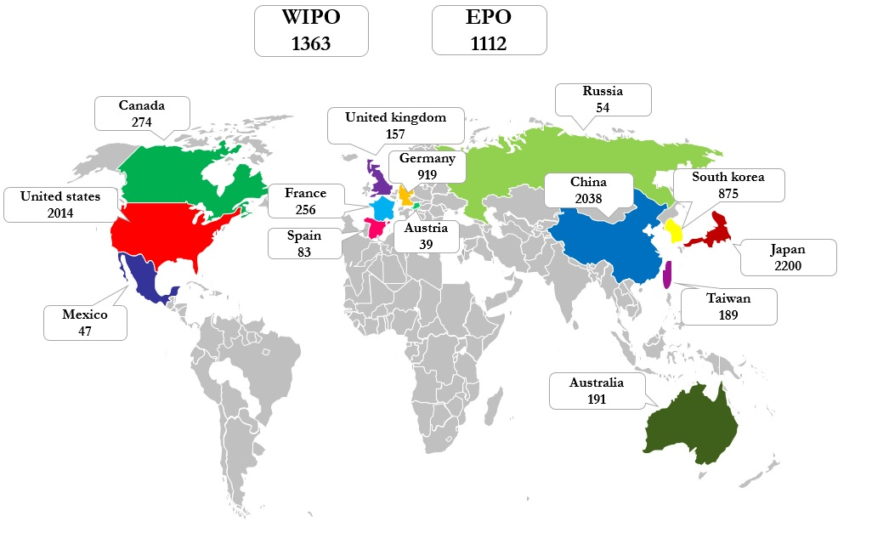

Figure 8 - Worldwide Patenting Activity

The global map (Figure 8) illustrates patenting activity worldwide across top 16 jurisdictions. Numbers in the map represent unique patent families in Electric Vehicle Charging Infrastructure technology cluster. Japan leads other jurisdictions followed closely by the United States and China. PCT and EPO are among the major filing routes.

Figure 9 below illustrates leading companies across major jurisdictions. Some of the companies that have actively filed for patents in most of the key jurisdictions are Toyota, Nissan, Panasonic, Honda etc. There is seen an increase in patenting activity in the recent years in the major jurisdictions.

**WIPO**

**EPO**

**EPO**

**WIPO**

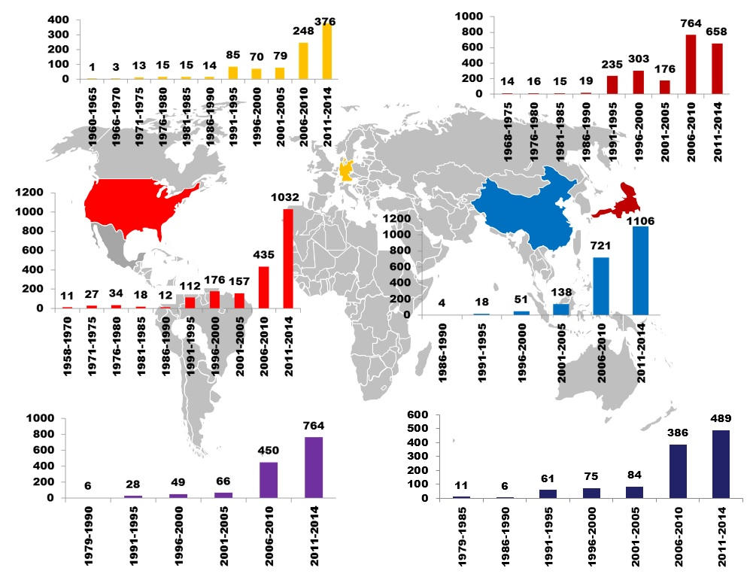

Figure 10 - Patent Filing Trends Across Key Jurisdictions

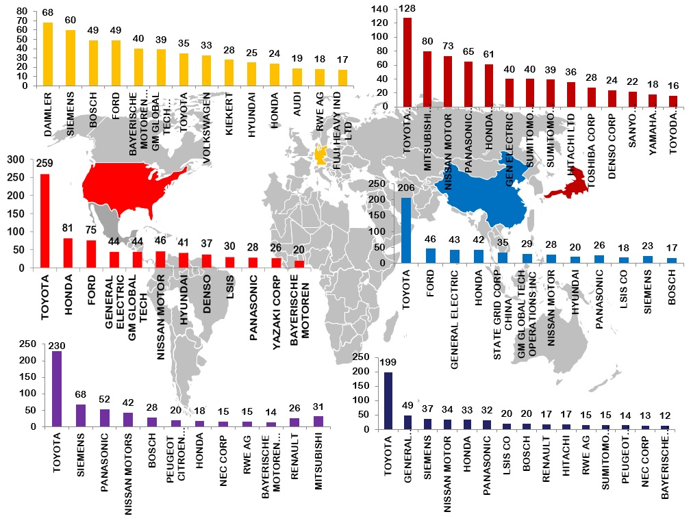

Figure 9 - Leading Companies Across Key Jurisdictions

## **Prolific Inventors – Overall**

The data shows that the most prolific inventor holds 52 patent families followed by inventors with 30+ patent families in their names. There are at least 200 inventors who are named on 5 or more patent families in the EV charging patent cluster. A large number of inventors have one or two patents in their names. More than 9,000 inventors have contributed to EV charging technology related patent portfolio.

Figure 11 - Prolific Inventors in EV Charging Infrastructures

**Prolific Inventors at Leading Companies**

Figure 12a – Prolific Inventors at Toyota

Figure 12b – Prolific Inventors at Mitsubishi

Figure 12c - Prolific Inventors at Nissan Motor

Figure 12d - Prolific Inventors at Honda

## **Most Cited Patents**

The following graph shows patent publications that are cited the most by other patent publications.

## 

Figure 13 - Most Cited Patent Publications

|  |  |  |  |  |
| --- | --- | --- | --- | --- |
| **Publication** | **Title** | **Assignee** | **Inventor** | **Application Year** |
| US4351405A | Hybrid Car With Electric And Heat Engine | Hybricon Inc | Fields, Gerald M. | Metzner, Robert G. | 1979 |
| US5815824A | Navigation System For Electric Automobile | Mitsubishi Motors Corp | Saga, Kenichi | Kawamura, Nobuyuki | 1996 |
| US5808469A | Battery Monitor For Electric Vehicles | Chrysler Corp | Kopera, John J. C. | 1997 |
| US5786640A | Generator Control System For A Hybrid Vehicle Driven By An Electric Motor And An Internal Combustion Engine | Nippon Soken | Sakai, Shoji | Onimaru, Sadahisa | Inagaki, Mitsuo | Asa, Hironori | 1996 |
| US5821728A | Armature Induction Charging Of Moving Electric Vehicle Batteries | Schwind; John P | Schwind, John P. | 1996 |
| US4588040A | Hybrid Power System For Driving A Motor Vehicle | Albright Jr Harold D | Rollins William R | Albright, Jr., Harold D. | Rollins, William R. | 1983 |
| US7462951B1 | Portable Inductive Power Station | Access Business Group Int Llc | Baarman, David W. | 2004 |
| US5820172A | Method For Controlling Energy Flow In A Hybrid Electric Vehicle | Ford Global Tech Inc | Brigham, David Richens | Giardini, Sandra | Lev, Amos | Romlein, Timothy | Tamor, Michael Alan | 1997 |
| US5315227A | Solar Recharge Station For Electric Vehicles | Pierson Mark V | Lin How T | Pierson, Mark V. | Lin, How T. | 1993 |
| US5612606A | Battery Exchange System For Electric Vehicles | Guimarin David C | Guimarin, David C. | Janik, Wayne M. | 1994 |
| US4313080A | Method Of Charge Control For Vehicle Hybrid Drive Batteries | Battery Dev Corp | Park, Robert H. | 1978 |
| JP2009136109A | Charge Control Device And Method | Toyota Motor Corp | Isshi Masahito | 2007 |
| US4254843A | Electrically Powered Vehicle | Han Joon H | Cho Tae H | Han, Joon H. | Cho, Tae H. | 1979 |
| US5280827A | Venturi Effect Charging System For Automobile Batteries | Taylor Cletus L | Taylor, Cletus L. | Mueller, Walter H. | 1992 |
| US6081205A | Electronic Parking Meter And Electric Automobile Recharging Station | Williams; Douglas J | Williams, Douglas J. | 1994 |
|  |  |  |  |  |