|  |  |
| --- | --- |
|  | **2015** |
|  | INVENTRUST |

|  |
| --- |
| **Mobile Payment Wallets** |
| PATENT INTELLIGENCE REPORT for 2015 by Inventrust |

*Disclaimer*

*Entire contents ©2015 InvenIt Inc. All rights reserved. Reproduction of this publication in any form without prior written permission is forbidden. The information contained herein has been obtained from data sources believed to be reliable. InventIt disclaims all warranties as to the accuracy, completeness or adequacy of such information. The results identified are only up to the date specified in this document. No opinion, unless clearly stated otherwise, is expressed or implied other than the comments stated herein. InventIt is not a law firm and does not provide any legal advice or legal opinion.*

**CONTENTS**

**Introduction**

**Patenting Activity Trends**

**Leading Companies**

**Publication Trends of Leading Companies**

**Priority Countries**

**Worldwide Geographical Coverage**

**Prolific Inventors – Overall in the Cluster**

**Prolific Inventors at leading companies**

**Prolific Inventors-Assignee Mapping Sheet**

**Most Cited Patents**

## **Introduction**

**Welcome to the 2015 ‘Mobile Payment Wallets’ Intelligence report!**

Mobile Payment Wallets or Digital Wallets or Electronic Wallets allow an individual to make quick and easy electronic commerce transactions with the use of a mobile device such as a cell phone, mobile phone, smart phone etc. According to a report by Graphic Arts Monthly, more than 25% of online shoppers abandon their orders due to frustration in filling in forms. Mobile wallets solve this problem by giving users an option to make payments and transfer their information securely, accurately and easily through a simplified mechanism. The technology mainly comprises of an electronic infrastructure, a software application, and an individual device. Mobile wallets involve use of contactless technologies for transactions such as Near-Filed communication, QR codes-based, Bluetooth low energy etc. Wallets enable widespread use of mobile transactions among various entities in the form of mobile payment systems and wallet applications worldwide.

According to data from Ernst & Young, mobile payments are expected to be big business, with the market reaching a massive $245 billion by 2014. Gartner estimates that smart phone sales will represent 88 percent of global mobile phone sales by 2018 — up from 66 percent in 2014. With large scale availability of smart phones and advancements in banking and financial security systems and mechanisms, there has been a widespread growth in mobile wallets-based payments and financial transactions. The transactions can include purchasing of items on-line with the use of a mobile device or purchasing at stores or at POS terminals. Mobile wallets are increasingly being used for several other purposes such as for credentials authentication. Consequently, there is seen an interest in patenting activity in the recent past across the world. As discussed in the report later, mobile wallet technologies are developing in Europe, Asia, North America and other regions. Some of the Asian countries are among the leaders in patenting of the technology. United States though has been on the top in conceptualization of the technology as well as holding the most number of patent families.

Apple, Google, Amazon, PayPal/eBay etc are threatening to disrupt the payments ecosystem by replacing traditional banks with mobile wallets. Google Wallet and Apple Pay are both widely accepted. PayPal is a huge player in online payments and in recent years, it's been working on mobile payments and wallets too. The M-PESA mobile payments system has widespread use in Kenya and Tanzania, while the MasterCard PayPass application has been adopted by a number of vendors in the U.S. and worldwide.

## **Patenting Activity Trends**

There is an increase in patenting activity in the last two decades. In December 1995, there were 34 patent families that related to mobile payment wallets, with only 13 families published in year 1995. In December 2014, this has increased to 1872 patent families. In the year 2014, a total of 310 unique patent families were published which shows more than 50% growth as compared to publications in the preceding year 2013.

The first few patents that are identified in this report were filed in mid 80s. These patents do not seem to closely relate to the recent technologies but certainly form a foundation for the recent patents and innovation. A few of these are listed below:

European Patent EP0172670A2 filed in 1985 and assigned to Technion Res & Dev Foundation teaches recording monetary transactions and discloses an apparatus for registering a present value of money therein, an apparatus for selectably adjusting the registered value to indicate a payment and receipt transaction, and an identity verification apparatus including asymmetric cryptographic apparatus coupled to the apparatus for adjusting for activation thereof. The apparatus as a whole is provided as an electronic wallet and comprises a display, a keyboard, and a connecting jack.

US Patent 4831647A filed in 1987 and assigned to Motorola Inc. relates to communicating credit card information read at a mobile radiotelephone unit and transmitting from the mobile radiotelephone unit to authorize payment of the radiotelephone call.

French patent FR2632101A1 filed in 1988 and assigned to Dassault Electronique relates to transaction system of an electronic wallet type.

**Figure 1 - Patent Publishing Trends for Mobile Payment Wallets**

**Figure 2 - Patent Filing Trends for Mobile Payment Wallets**

**Figure 3 - Priority Trends for Mobile Payment Wallets**

## **Leading Companies**

As noted in the graph, Sony Corp. holds the most number of patent families with a total portfolio of 42 families in mobile wallets-based payments. Compared to the overall portfolio in this technology cluster, Sony’s holding represents 1.51%. Sanwa Bank and Shinhan Bank follow Sony closely each with 37 patent families assigned to them. Other major companies are Fujitsu Limited, SK Telecom, Bizmodeline, and Mastercard Inc.

Initial patents of Sony were filed around late 90s. Sanwa Bank’s patents can be traced around mid 90s while Shinhan Bank is a late entrant with its initial filings in 2006. Bizmodeline and Mastercard too are late entrants and their initial filings can be tracked only after 2000.

Analysis of recent patents in this cluster by Sony reveals that the patents relate to financial servers, IC cards and terminals, financial information processing and authentication methods, and biometric-based authorizations.

One of the major developments in the past few years is the emergence of Shinhan Bank. Shinhan Bank started patent filing in 2006 and has so far amassed 37 unique patent families. Interestingly, all the patents are filed only in South Korea by Shinhan Bank.

**Figure 4 - Leading Companies**

|  |  |
| --- | --- |
| Assignees | Percentage of total Patent Families (%) |
| SONY | 1.51 |
| SANWA BANK | 1.33 |
| SHINHAN BANK | 1.33 |
| FUJITSU | 1.19 |
| SK TELECOM | 1.19 |

**Figure 5 – Top 5 Companies Percentage Holdings**

Figure 6 - Assignee Innovation Timelines

## **Publishing Trends of Leading Companies**

Figure 7E - SK Telecom

Figure 7F - Bizmodeline

Figure C - Shinhan Bank

Figure 7D - Fujitsu

Figure 7A - Sony Corporation

Figure 7B - Sanwa Bank

## **Priority Countries**

United States of America is ranked on top in conceptualization of mobile wallet technologies. As many as 671 patent families worldwide developed and originated from the United States. These 671 patent families published worldwide take priority from a US patent publication. It is followed by Japan, South Korea, and China from where more than 200 families each originated. At least 33 countries can be located on the map which recorded priority of at least one patent family filed across the world.

There are at least 50 companies who have filed for patents that consider United States as the priority country. Bank of America, Google, Mastercard, Visa, First Data Corp., Research In Motion, Sprint Communications, IBM Corp., American Express, AT&T, Barclays Bank, and Ebay are a few of them.

Figure 8 - Priority Countries for Mobile Payment Wallets Innovation

## **Worldwide Geographical Coverage**

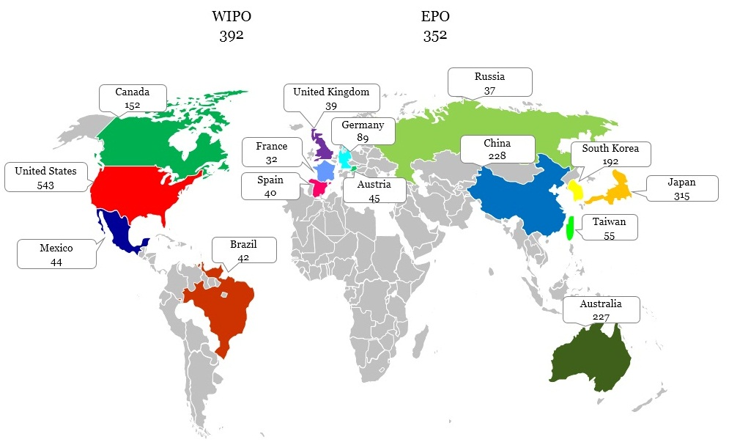

Figure 9 - Worldwide Patenting Activity

The global map (Figure 9) illustrates patenting activity worldwide across top 17 jurisdictions. Numbers in the map represent unique patent families in mobile payment wallets technology. United States clearly leads other jurisdictions followed by PCT applications, European Patent Publications, Japan, and China.

Figure 10 below illustrates leading companies across major jurisdictions. Some of the companies that have actively filed for patents in most of the key jurisdictions are Sony, Visa, Mastercard, Fujitsu, and Hitachi.

As depicted in Figure 11 below, there is seen an increase in patenting activity in the recent years especially in the United States. United States records a total of 78 families filed in the year 2014 which is higher than any other jurisdiction in the same year. This is followed by PCT applications (34 families). In the past year 2013, PCT filing activity draws a close to US filing activity with PCT and US filings as 55 and 66 families respectively. While patenting activity begins almost at the same time across the key jurisdictions, there is seen a decrease in number of filings in Australia after 2001. Australia filed for a record high number of patents in 2000 and 2001.

**EPO**

**WIPO**

**EPO**

**WIPO**

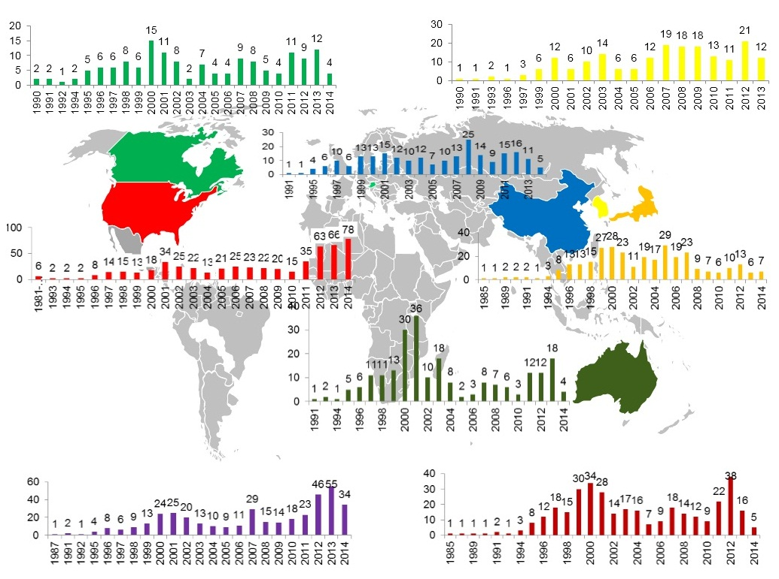

Figure 11 - Patent Filing Trends Across Key Jurisdictions

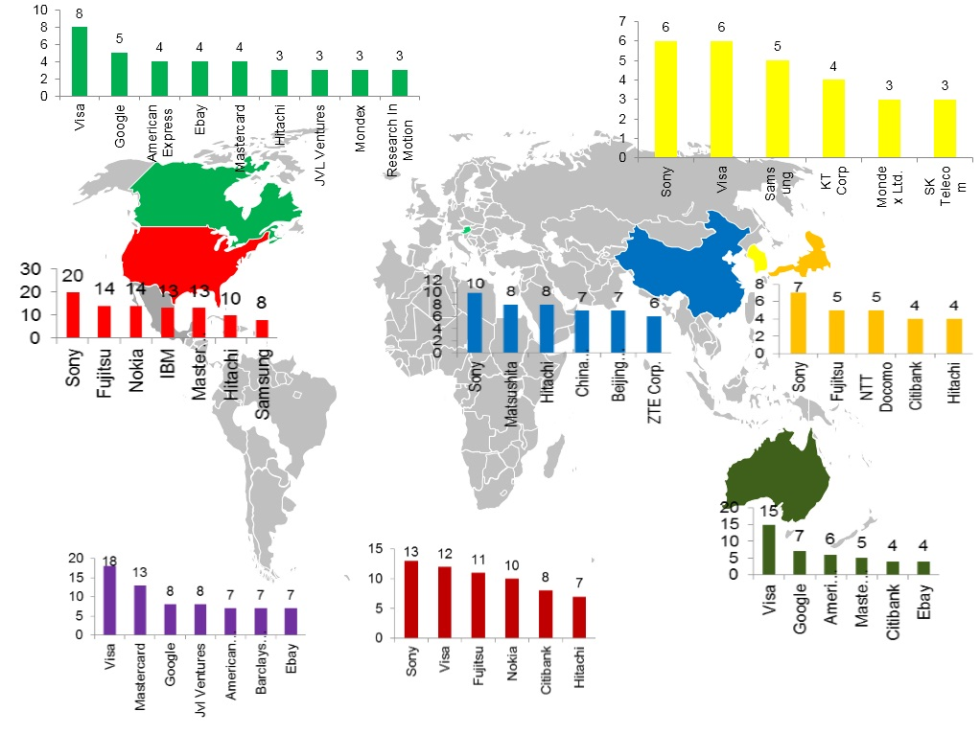

Figure 10 - Leading Companies Across Key Jurisdictions

## **Prolific Inventors – Overall**

The data shows that the most prolific inventor holds 25 patent families followed by inventors with 20, and 19 patent families in their names. There are 69 inventors who are named on 5 or more patent families in the mobile wallets cluster. A large number of inventors have one or two patents in their names. More than 3,000 inventors have contributed to mobile payment wallets entire portfolio.

The two most prolific inventors are affiliated with Bizmodeline which is one of the leading companies and are co-inventors on 20 patent families. It is noted from the data that several of the most prolific inventors are based out in South Korea or US.

Figure 12 - Prolific Inventors in mobile payment wallets

**Prolific Inventors at Leading Companies**

Figure 13a – Prolific Inventors at Sony

Figure 13b – Sanwa Bank

Figure 13c - Prolific Inventors at Shinhan Bank

Figure 13d - Prolific Inventors at Fujitsu Limited

Figure 13e - Prolific Inventors at SK Telecom

## **Prolific Inventor-Assignee Mapping Chart**

**The following graph shows association of prolific inventors and leading companies**

|  |  |  |  |  |  |  |  |  |  |  |  |  |  |
| --- | --- | --- | --- | --- | --- | --- | --- | --- | --- | --- | --- | --- | --- |
| ASIGNEE  INVENTOR | TOTAL | BITWALLET INC | BIZMODELINE | FUJITSU | HITACHI | MATSUSHITA | SANKYO | SANWA BANK | SHINHAN BANK | SK TELECOM | SONY | VISA | ZTE CORP |
| **TOTAL** | 120 | 8 | 25 | 8 | 10 | 6 | 11 | 10 | 18 | 19 | 1 | 4 | 9 |
| KIM JAE HYUNG | 25 |  | 25 |  |  |  |  |  |  |  |  |  |  |
| HONG JONG CHEOL | 20 |  | 20 |  |  |  |  |  |  |  |  |  |  |
| KIM JONG HO | 19 |  |  |  |  |  |  |  |  | 19 |  |  |  |
| UGAWA SHOHACHI | 11 |  |  |  |  |  | 11 |  |  |  |  |  |  |
| MURAYAMA TSUTOMU | 11 |  |  |  |  |  | 11 |  |  |  |  |  |  |
| TORIYAMA MASATOSHI | 10 |  |  |  |  |  | 10 |  |  |  |  |  |  |
| TANAKA AKIHIRO | 10 |  |  |  |  |  | 10 |  |  |  |  |  |  |
| ODA NAOKI | 10 |  |  |  |  |  | 10 |  |  |  |  |  |  |
| WASHIO YOSHITERU | 9 |  |  |  |  |  | 9 |  |  |  |  |  |  |
| MATSUMOTO KENJI | 9 |  |  |  | 9 |  |  | 8 |  |  |  |  |  |
| LUYOU NING | 9 |  |  |  |  |  |  |  |  |  |  |  | 9 |
| KWON BONG KI | 9 |  | 9 |  |  |  |  |  |  |  |  |  |  |
| ITO SHIGEYUKI | 9 |  |  |  | 9 |  |  | 9 |  |  |  |  |  |
| INOUE MASAYUKI | 8 |  |  |  | 8 |  |  | 8 |  |  |  |  |  |
| CHO HYUN TAE | 8 |  |  |  |  |  |  |  | 8 |  |  |  |  |
| YAMADA MAKOTO | 7 | 6 |  |  |  |  |  |  |  |  | 1 |  |  |
| TAKAMI MINORU | 7 |  |  |  | 6 |  |  | 7 |  |  |  |  |  |
| KIM DONG MYEONG | 7 |  |  |  |  |  |  |  | 7 |  |  |  |  |
| ITO KOJI | 7 | 7 |  |  |  |  |  |  |  |  |  |  |  |
| HASHIMOTO SHIGERU | 7 |  |  | 7 |  |  |  |  |  |  |  |  |  |
| TAKAYAMA HISASHI | 6 |  |  |  |  | 6 |  |  |  |  |  |  |  |
| SHIOBARA TOMOMI | 6 |  |  | 6 |  |  |  |  |  |  |  |  |  |
| MIYAZAWA KAZUMASA | 6 | 5 |  |  |  |  |  |  |  |  | 1 |  |  |
| JUNG JONG PIL | 6 |  |  |  |  |  |  |  | 6 |  |  |  |  |
| YAMAMOTO HIRONORI | 5 |  |  | 5 |  |  |  |  |  |  |  |  |  |
| NAKAMURA TAKASHI | 5 | 5 |  |  |  |  |  |  |  |  |  |  |  |
| HAMMAD AYMAN | 4 |  |  |  |  |  |  |  |  |  |  | 4 |  |

## **Most Cited Patents**

The following graph shows patent publications that are cited the most by other patent publications.

## 

Figure 11 - Most Cited Patent Publications

|  |  |  |  |  |
| --- | --- | --- | --- | --- |
| **Publication** | **Title** | **Assignee** | **Inventor** | **Application Year** |
| US5221838A | Electronic wallet | Motorola, Inc. | Jose Gutman, Jim Wright, Louis D. Finkelstein, Larry Puhl | 1992 |
| US20060165060A1 | Method and apparatus for managing credentials through a wireless network |  | Robin Dua | 2005 |
| WO1997045814A1 | Real time system and method for remote purchase payment and remote bill payment transactions and transferring of electronic cash and other required data |  | Behruz Vazvan | 1997 |
| US5748737A | Multimedia electronic wallet with generic card |  | Robert N. Daggar | 1994 |
| US5991749A | Wireless telephony for collecting tolls, conducting financial transactions, and authorizing other activities |  | Paul H. Morrill, Jr. | 1997 |
| US5420405A | Secure, automated transaction system that supports an electronic currency operating in mixed debit and credit modes |  | Norman E. Chasek | 1993 |
| US20050187873A1 | Wireless wallet | Fujitsu Limited | Yannis Labrou, Lusheng Ji, Jonathan Agre, Jesus Terriza, Wei-Lun Chen | 2005 |
| US6064990A | System for electronic notification of account activity | IBM | Kevin Scott Goldsmith | 1998 |
| US5978475A | Event auditing system | Counterpane Internet Security, Inc. | Bruce Schneier, John M. Kelsey | 1997 |
| US6873974B1 | System and method for use of distributed electronic wallets | Citibank, N.A. | Daniel Schutzer | 2000 |
| US5834756A | Magnetically communicative card | Motorola, Inc. | Jose Gutman, Michael J. DeLuca | 1996 |
| US5559312A | Gaming machine system operable with general purpose charge cards | Scotch Twist, Inc. | James L. Lucero | 1995 |
| US20080040265A1 | Methods and Systems For Making a Payment Via A Stored Value Card in a Mobile Environment | Firethorn Holdings, | Brady Lee Rackley III, Warren Derek Porter, Gregory Michael Rickman, Kyle Leighton Cochran | 2006 |
| EP949595A2 | Method and system for managing applications for a multi-function smartcard | Citicorp Dev Center Inc | Pinn Fred, Guzman Marc A., Boyd Nik, Smushkovich Yosif | 1999 |
| WO1998021679A1 | System and method for conducting commerce over a distributed network | Microsoft Corp | D Chase Franklin, Darren B Remington, Bassam Saliba, Bert Speelpenning, Michael Cockrill | 1997 |