**ASSIGNMENT 1**

1. **Install MS SQL Server**

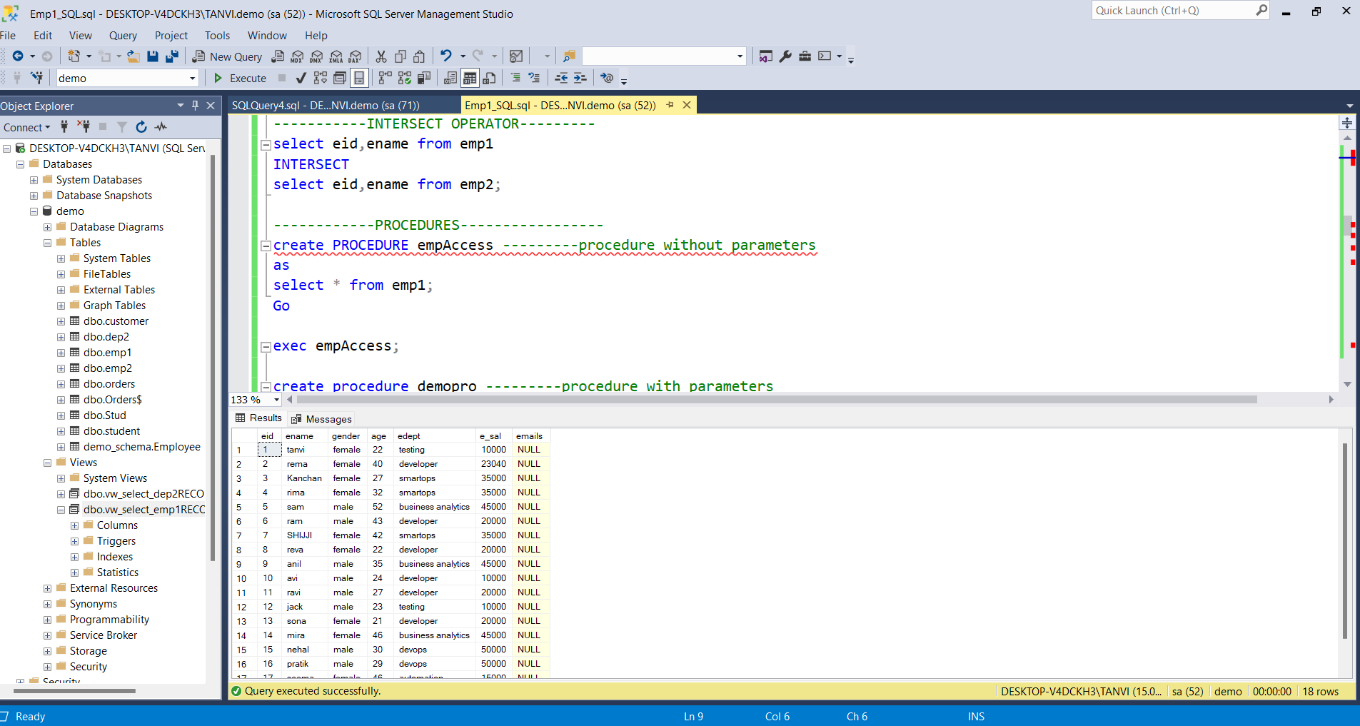

1. **Learn the Basics of Stuctured Query Language**

**Definition of SQL (STRUCTURED QUERY LANGUAGE):**

SQL is a standard language for accessing and manipulating databases.

**Data** : Data is a raw fact that can describe properties or attributes of an entity

**Tables :** Each table is identified by a name .Tables contain records with data in the form of rows.

**Database :** A database contains one or more tables.

**RDBMS :** Relational Database management system . It is a program that helps us to create , update and administer relational databases.

**SQL Language** : It is a set of instructions used to access, modify ,update or perform other tasks on the DBMS.

**Types of SQL languages :**

* **DDL (Data Definition language)**

1. Create
2. Rename
3. Alter
4. Drop
5. Truncate

* **DML (Data Manipulation Language)**

1.Insert

2.Update

3.Delete

* **TCL (Transaction Control Language)**

1.Commit

2.Rollback

3.Savepoint

* **DCL (Data Control Language)**

1.Grant

2.Revoke

* **DQL (Data Query Language)**

1.Select

2.Projection

3.Selection

4.Joins