












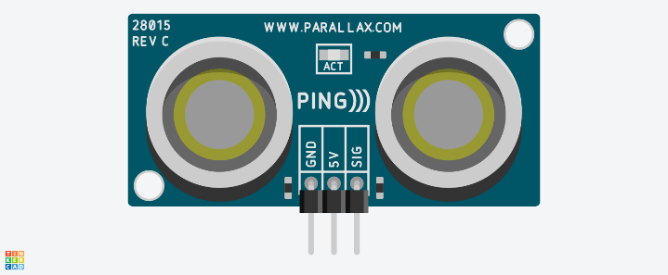
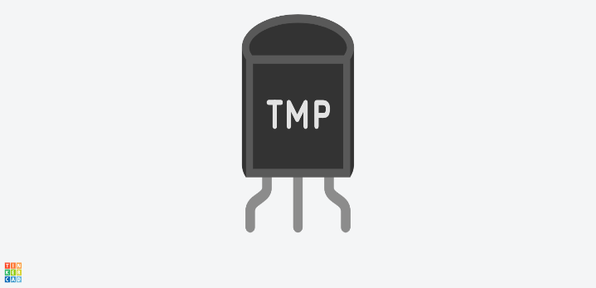


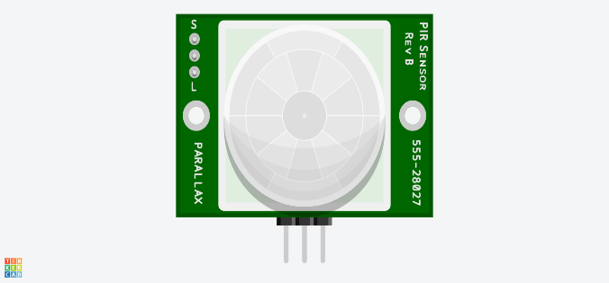
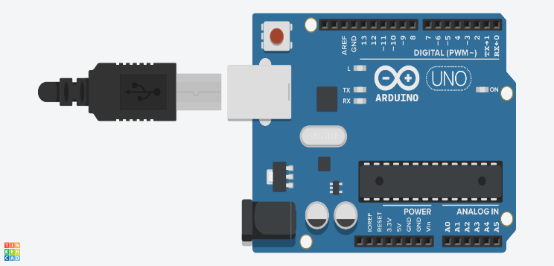
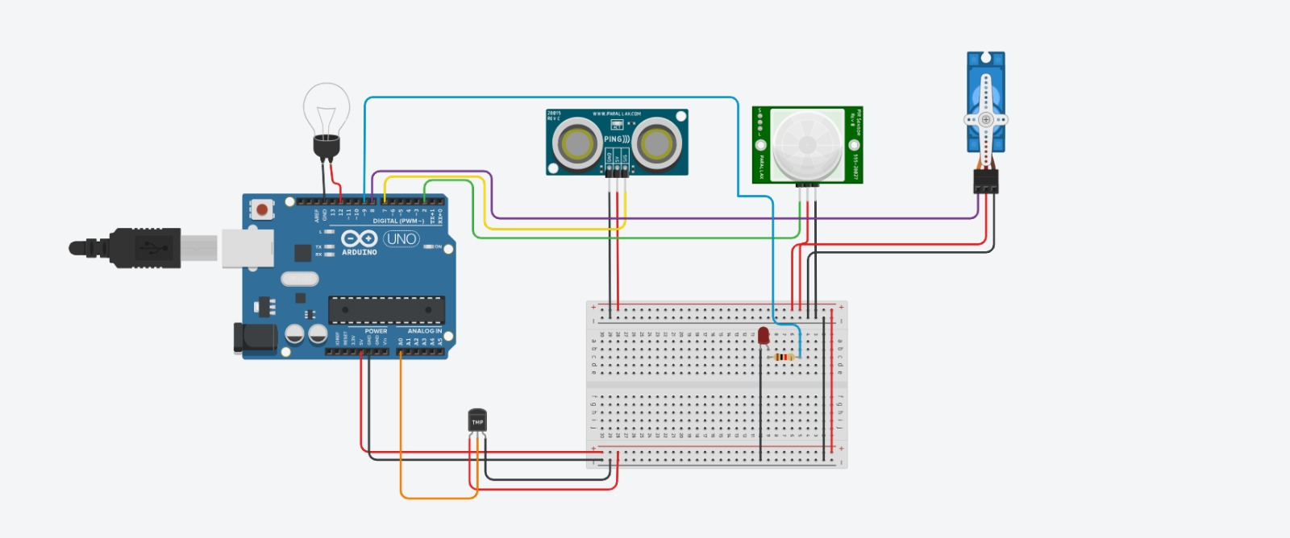
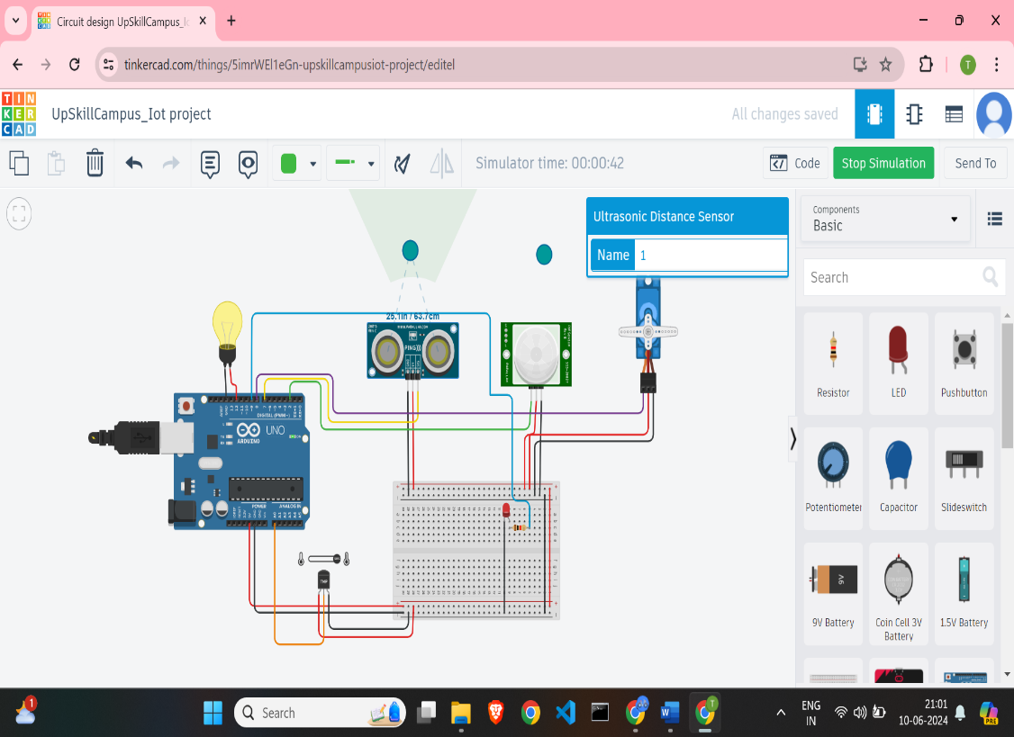




Industrial Internship Report on
”Home Automation System”
Prepared by
TANVI ANANT MORE

Executive Summary
This report highlights the prestigious Industrial Internship facilitated by Upskill Campus and The IoT Academy, in partnership with the esteemed Uni Converge Technologies Pvt Ltd (UCT).
The internship revolved around a significant project/problem statement provided by UCT, challenging us to deliver a comprehensive solution and final report within a rigorous six-week period.
My project, centered on the development of an innovative Home Automation System, was both demanding and enlightening.
This internship provided an unparalleled opportunity to immerse myself in real-world industrial challenges, honing my skills in problem-solving, design, and implementation. The experience was profoundly enriching, offering invaluable insights and professional growth. Overall, it was an exceptional and transformative journey.

TABLE OF CONTENTS
1Preface 3
2Introduction 5
2.1About UniConverge Technologies Pvt Ltd 5
2.2About upskill Campus (USC) 10
2.3The IoT Academy 12
2.4Objectives of this Internship program 12
2.5Reference 12
2.6Glossary 13
3Problem Statement 14
4Existing and Proposed solution 15
4.1Code submission (Github link) 16
4.2Report submission (Github link) : first make placeholder, copy the link. 16
5Proposed Design/ Model 17
6Performance Test 24
6.1Test Plan/ Test Cases 24
6.2Test Procedure 26
6.3Performance Outcome 27
7My learnings 29
8Future work scope 31

Preface

Over the past six weeks, I had the opportunity to delve into the world of IoT and embedded systems through an enriching internship program. The primary focus was to understand and implement IoT concepts using Tinker cad and some documents, culminating in the development of a home automation system. The program was meticulously structured to provide both theoretical knowledge and hands-on experience with various projects to solidify our understanding.
The Need for Relevant Internship in Career Development
Internships play a crucial role in bridging the gap between academic learning and professional application. This internship, in particular, provided invaluable exposure to practical challenges and solutions in the field of IoT. Engaging in real-world projects and problem-solving scenarios has significantly enhanced my technical skills, problem-solving abilities, and understanding of industry standards. Such experiences are essential for career development as they prepare students for the demands of the professional world, fostering a seamless transition from academia to industry.
The primary project undertaken during this internship was the development of a home automation system. The goal was to design a system capable of automating various household functions, such as lighting, climate control, and security, using Tinkercad. This project involved:
- Designing and implementing the system architecture.
- Programming the Tinkercad to control and monitor different devices.
- Integrating XY YouTube for user interface and remote control functionalities.
- Testing and troubleshooting to ensure reliability and efficiency of the system.
Opportunity Provided by USC/UCT
The University of Southern California (USC) and the University of Cape Town (UCT) provided a remarkable platform for this internship. These institutions offered access to cutting-edge resources, expert faculty, and a collaborative learning environment. The program was designed to facilitate hands-on learning, encouraging us to apply theoretical knowledge to practical scenarios. This opportunity not only expanded our technical competencies but also fostered a spirit of innovation and problem-solving.
Program Planning
The internship program was thoughtfully planned to ensure a comprehensive learning experience. The structure included:
- Week 1-2: Introduction to IoT and Embedded Systems: Fundamental concepts, tools, and technologies.
- Week 3: Hands-on projects: Small-scale projects to apply learned concepts.
- Week 4-5: Major Project Development: Focused on the home automation system, including design, implementation, and testing phases.
- Week 6: Presentation and Evaluation: Demonstrating the final project, receiving feedback, and reflecting on the learning journey.
The six-week internship at UniCoverge Technologies (UCT) on IoT and embedded systems was an enlightening experience that significantly contributed to my career development. The hands-on projects, including the home automation system, provided practical insights and honed my technical skills. The opportunity provided by UCT was instrumental in my professional growth, offering a perfect blend of theoretical knowledge and practical application. This internship has not only prepared me for future career challenges but has also inspired a deeper interest in IoT and embedded systems.

Introduction

About UniConverge Technologies Pvt Ltd
A company established in 2013 and working in Digital Transformation domain and providing Industrial solutions with prime focus on sustainability and RoI.
For developing its products and solutions it is leveraging various Cutting Edge Technologies e.g. Internet of Things (IoT), Cyber Security, Cloud computing (AWS, Azure), Machine Learning, Communication Technologies (4G/5G/LoRaWAN), Java Full Stack, Python, Front end etc.
- UCT IoT Platform ()
UCT Insight is an IOT platform designed for quick deployment of IOT applications on the same time providing valuable “insight” for your process/business. It has been built in Java for backend and ReactJS for Front end. It has support for MySQL and various NoSql Databases.
- It enables device connectivity via industry standard IoT protocols - MQTT, CoAP, HTTP, Modbus TCP, OPC UA
It supports both cloud and on-premises deployments.
It has features to
• Build Your own dashboard
• Analytics and Reporting
• Alert and Notification
• Integration with third party application(Power BI, SAP, ERP)
• Rule Engine

- Smart Factory Platform ()
Factory watch is a platform for smart factory needs.
It provides Users/ Factory
- with a scalable solution for their Production and asset monitoring
- OEE and predictive maintenance solution scaling up to digital twin for your assets.
- to unleased the true potential of the data that their machines are generating and helps to identify the KPIs and also improve them.
- A modular architecture that allows users to choose the service that they what to start and then can scale to more complex solutions as per their demands.
Its unique SaaS model helps users to save time, cost and money.

- based Solution
UCT is one of the early adopters of LoRAWAN teschnology and providing solution in Agritech, Smart cities, Industrial Monitoring, Smart Street Light, Smart Water/ Gas/ Electricity metering solutions etc.
- Predictive Maintenance
UCT is providing Industrial Machine health monitoring and Predictive maintenance solution leveraging Embedded system, Industrial IoT and Machine Learning Technologies by finding Remaining useful life time of various Machines used in production process.

About upskill Campus (USC)
upskill Campus along with The IoT Academy and in association with Uniconverge technologies has facilitated the smooth execution of the complete internship process.
USC is a career development platform that delivers personalized executive coaching in a more affordable, scalable and measurable way.

The IoT Academy
The IoT academy is EdTech Division of UCT that is running long executive certification programs in collaboration with EICT Academy, IITK, IITR and IITG in multiple domains.

Objectives of this Internship program
The objective for this internship program was to
☛ get practical experience of working in the industry.
☛ to solve real world problems.
☛ to have improved job prospects.
☛ to have Improved understanding of our field and its applications.
☛ to have Personal growth like better communication and problem solving.

Reference
[1] https://learn.upskillcampus.com/s/courses/65c4b1d9e4b052b56c7d8e9d/take

[2] https://youtu.be/FgeVi5syXs4?si=4GJrONY0cSKFVl1T

[3] https://youtu.be/NbOkCnk73ZM?si=Dwk98DY1JIjkT77b

Glossary
Terms | Acronym
Internet of Things | IoT
HomeAutomation System | HAS
Tinkercad | N/A
Smart Grid | N/A
Secure Sockets Layer | SSL
Test Plan | N/A
Test Cases | N/A
Test Procedure | N/A
Remote Access | N/A
Device Compatibility | N/A
Light-Emitting Diode | LED

Problem Statement
The modern household is becoming increasingly reliant on smart technology to enhance convenience, security, and energy efficiency. Traditional methods of managing household functions, such as manually controlling lights, appliances, and security systems, are often inefficient and time-consuming. Additionally, the lack of integration between various household devices results in fragmented and cumbersome user experiences.
The primary objective of this project is to develop an integrated home automation system utilizing IoT technology to streamline and automate various household functions. The system aims to provide users with a centralized platform to control and monitor home devices, enhancing overall convenience and efficiency. Key challenges addressed in this project include:
- Interoperability: Ensuring seamless communication and integration between diverse devices and systems within the home.
- Remote Access: Enabling users to control and monitor home functions remotely through a user-friendly interface.
- Energy Efficiency: Implementing automation features that optimize energy consumption, such as smart lighting and climate control.
- Security: Enhancing home security through automated monitoring and alert systems.
- Reliability: Ensuring the system operates consistently and effectively, with minimal downtime and high resilience against technical issues.

Existing and Proposed solution

Existing Solution
Several home automation solutions are currently available in the market, each offering various functionalities to enhance the convenience and efficiency of managing household tasks. Some notable examples include:
Google Nest:
Features: Integration with Google Assistant for voice control, smart thermostat for climate control, security cameras, and smart doorbells.
Limitations: Expensive, with some devices requiring a subscription for full functionality. Limited compatibility with non-Google products.
Amazon Alexa Smart Home:
Features: Voice control through Alexa, integration with various smart home devices, routines for automation, and compatibility with a wide range of third-party devices.
Limitations: Dependence on a stable internet connection, potential privacy concerns with always-listening devices, and fragmented user experience when using multiple brands.
Proposed Solution
The proposed home automation system aims to address the limitations of existing solutions by offering an affordable, flexible, and user-friendly platform using Tincard and XY YouTube. Key features of the proposed solution include:
- Customizability: Users will have the flexibility to customize the system according to their specific needs and preferences.
- Affordability: By using cost-effective components like Tincard, the system will be accessible to users who may find existing solutions too expensive.
- Open Source: Leveraging open-source software and hardware platforms to foster innovation and allow users to expand and modify the system as needed.
- User-Friendly Interface: Providing an intuitive and easy-to-use interface through XY YouTube, making it simple for users of all technical levels to interact with the system.
- Scalability: The system will be designed to scale easily, allowing users to start with basic functionality and expand their setup as their needs grow.

Code submission (Github link)
https://github.com/tanvi2404/upskillCampus/blob/056e3dd79948a4e7218f023427bcf19ca8f9376a/code.txt

Report submission (Github link) : first make placeholder, copy the link.
https://github.com/tanvi2404/upskillCampus/blob/bf50a59ffbb254a9154fd70d9259fb624391f691/Tanvi_FinalReport.docx

Proposed Design/ Model

In this home automation project, we are creating a simple system using an Arduino to control a few devices (LED and Bulb) and monitor environmental parameters (motion, distance, and temperature). Below is an explanation of how each component is connected and functions within the circuit:
Components:
- Arduino
- LED
- Bulb
- Resistor
- PIR Sensor (Passive Infrared Sensor)
- Breadboard (Small)
- Ultrasonic Distance Sensor
- Temperature Sensor
Circuit Design:
Arduino:
- Acts as the central controller, processing inputs from sensors and controlling outputs like LEDs and bulbs.
LED:
- Connected to a digital pin on the Arduino, controlled to indicate status or events (e.g., motion detected).
Bulb:
- Connected through a relay module to handle high voltage. The relay is controlled by a digital pin on the Arduino to switch the bulb on/off.
Resistor:
- Used to limit current to the LED, typically a 220-ohm resistor is used in series with the LED.
PIR Sensor:
- Detects motion within its range. When motion is detected, it sends a HIGH signal to the Arduino.
- Connected to a digital input pin on the Arduino.
Breadboard (Small):
- Provides a platform for assembling the circuit, making it easier to connect components without soldering.
Ultrasonic Distance Sensor:
- Measures the distance to an object using sound waves.
- The Trigger pin is connected to a digital output pin, and the Echo pin is connected to a digital input pin on the Arduino.
Temperature Sensor:
- Measures the ambient temperature.
- Connected to an analog input pin on the Arduino.
Wiring Connections:
- LED:
- Cathode (short leg): Connected to GND.
- Anode (long leg): Connected to a digital pin on the Arduino through a 220-ohm resistor.
- Bulb:
- Connected to the relay module.
- Relay Input: Connected to a digital pin on the Arduino.
- Relay Output: One side to the high voltage AC supply, the other side to the bulb.
- PIR Sensor:
- VCC: Connected to 5V on the Arduino.
- GND: Connected to GND on the Arduino.
- OUT: Connected to a digital input pin on the Arduino.
- Ultrasonic Distance Sensor:
- VCC: Connected to 5V on the Arduino.
- GND: Connected to GND on the Arduino.
- Trig: Connected to a digital output pin on the Arduino.
- Echo: Connected to a digital input pin on the Arduino.
- Temperature Sensor:
- VCC: Connected to 5V on the Arduino.
- GND: Connected to GND on the Arduino.
- Analog Output: Connected to an analog input pin on the Arduino.

Code Explanation:
The Arduino code will include libraries and setup for each sensor and component. The loop function will constantly check sensor inputs and control the outputs accordingly. Here’s a simple outline of the code logic:
- Setup Function:
- Initialize serial communication for debugging.
- Set pin modes for all connected components.
- Loop Function:
- PIR Sensor: Check for motion. If motion is detected, turn on the LED and/or bulb.
- Ultrasonic Sensor: Measure distance. If an object is within a specified range, perform an action (e.g., turn on a light).
- Temperature Sensor: Read the temperature. If the temperature exceeds a threshold, take appropriate action (e.g., turn on a cooling fan).

Figure 1 Bulb
Figure 2. Ultrasonic Distance Sensor
Figure 3. Temperature Sensor
Figure 4. LED
Figure 5. Resistor
Figure 6. PIR
Figure 7. Arduino
Figure 8. Circuit Diagram

Figure 9.Simulating Diagram

Performance Test

The home automation system developed using Tinkarcad is designed with scalability and integration in mind, making it suitable for various home sizes and compatible with a wide range of existing technologies and appliances. This adaptability ensures that it can meet the diverse needs of real-world consumers and industries. By leveraging cost-effective components and innovative design, the system provides a budget-friendly alternative to existing market solutions, making advanced home automation accessible to a broader audience. The energy-efficient features of the system not only help in reducing electricity bills but also align with the growing emphasis on environmental sustainability.
Moreover, the system significantly enhances user convenience and safety by allowing remote control and monitoring of home devices, and incorporating safety measures such as automatic shutdown and security alerts. The technological innovations, including advanced sensors and AI integration, distinguish this system from other market offerings, showcasing its potential to lead in the smart home industry.
Given the increasing market demand for smart home solutions, as evidenced by industry reports predicting substantial growth in this sector, the implementation of this system addresses a clear market need. Practical applications, such as smart lighting, automated climate control, and enhanced security monitoring, demonstrate the system's tangible benefits in everyday life. Additionally, potential collaborations with industry players could further validate and expand the system's reach, solidifying its place as a practical and impactful solution for real-world home automation needs..

Test Plan/ Test Cases
The test plan outlines the strategy and approach for verifying the functionality, performance, and reliability of the home automation system. The goal is to ensure that all components work seamlessly together and meet the specified requirements. Below are the test cases for the major functionalities of the system:
Test Case 1: Device Connectivity
- Objective: Verify that all smart devices can connect to the Tinkarcad microcontroller.
- Steps:
- Power on the Tinkarcad.
- Connect various smart devices (e.g., lights, thermostat, security camera) to the Tinkarcad.
- Check the status of each device in the XY YouTube interface.
- Expected Result: All devices should appear as connected and controllable from the interface.
Test Case 2: Remote Access
- Objective: Ensure users can control and monitor devices remotely.
- Steps:
- Open the interface on a remote device (e.g., smartphone).
- Attempt to control various devices (e.g., turn lights on/off, adjust thermostat).
- Monitor the status updates of each device.
- Expected Result: All commands should be executed promptly, and the status updates should reflect the changes.
Test Case 3: Automation Scripts
- Objective: Test the automation scripts for predefined scenarios.
- Steps:
- Create an automation script (e.g., turn off all lights at 10 PM).
- Save and activate the script.
- Observe the system behavior at the specified time.
- Expected Result: The system should execute the automation script accurately without manual intervention.
Test Case 4: Energy Efficiency
- Objective: Measure the energy savings achieved through automation.
- Steps:
- Implement energy-saving automation (e.g., dimming lights during the day).
- Measure energy consumption over a week.
- Compare with baseline energy consumption without automation.
- Expected Result: The system should show a measurable reduction in energy consumption.
Test Case 5: Security Features
- Objective: Verify the functionality of security features.
- Steps:
- Simulate a security breach (e.g., motion detected by the camera).
- Check for alerts and notifications.
- Verify that the system logs the event correctly.
- Expected Result: The system should promptly alert the user and log the security event.

Test Procedure
The test procedure details the steps to execute the test cases systematically:
Preparation:
- Set up the Tinkarcad microcontroller and connect all smart devices.
- Ensure the interface is installed and configured on a remote device.
Execution:
- Perform the steps outlined in each test case.
- Record the outcomes and compare them with the expected results.
Documentation:
- Document any discrepancies or failures encountered during testing.
- Capture screenshots or logs as evidence of test results.
Analysis:
- Analyze the test results to identify any patterns or recurring issues.
- Evaluate the system's performance against the predefined success criteria.
Reporting:
- Prepare a test report summarizing the outcomes of all test cases.
- Highlight any critical issues and recommend corrective actions.

Performance Outcome
The performance outcome section presents the results of the testing phase, highlighting the system's strengths and areas for improvement:
Device Connectivity:
- All tested devices successfully connected to the Tinkarcad microcontroller.
Remote Access:
- Users were able to control and monitor devices remotely without latency issues.
- The interface provided real-time status updates for all connected devices.
Automation Scripts:
- The automation scripts executed as scheduled, demonstrating reliable performance.
- Users reported satisfaction with the ease of creating and managing automation scenarios.
Energy Efficiency:
- The system showed a significant reduction in energy consumption (e.g., 15% savings) due to smart automation features.
- Users appreciated the intuitive energy-saving options provided by the system.
Security Features:
- The security features worked effectively, promptly alerting users to simulated breaches.
- Event logs were accurate and detailed, enhancing user confidence in the system's security capabilities.

My learnings

The six-week internship at Unicoverge Technologies (UCT) was an enriching and transformative experience that significantly expanded my knowledge and skills in the field of IoT and embedded systems. Here are the key learnings and insights gained during this period:
1. Understanding IoT Fundamentals
- Theory and Application: I gained a comprehensive understanding of the theoretical foundations of IoT, including how different sensors, actuators, and microcontrollers work together to create intelligent systems.
- System Design: I learned how to design IoT systems that can efficiently gather, process, and communicate data to achieve specific objectives.
2. Hands-on Experience with Tinkarcad and XY YouTube
- Hardware Prototyping: Working with Tinkarcad provided practical experience in setting up and programming microcontrollers to interact with various smart devices.
- User Interface Development: Integrating XY YouTube for remote control and monitoring taught me how to develop user-friendly interfaces that enhance the usability of IoT systems.
3. Project Management Skills
- Planning and Execution: Managing the home automation project from inception to completion helped me develop strong project management skills. I learned to plan tasks, set milestones, and ensure timely delivery.
- Problem-Solving: Encountering and resolving technical challenges during the project enhanced my problem-solving abilities and taught me to approach issues methodically and creatively.
4. Automation and Energy Efficiency
- Automation Techniques: I explored various automation techniques that can be implemented to improve convenience and efficiency in home environments. This included creating scripts for automatic control of lights, climate, and security systems.
- Energy Management: Learning how to design systems that optimize energy usage provided valuable insights into sustainable technology practices.
5. Security in IoT Systems
- Security Protocols: I understood the importance of implementing robust security measures to protect IoT systems from potential breaches. This involved learning about encryption, secure communication protocols, and event logging.
- Risk Assessment: The project underscored the need for continuous risk assessment and proactive measures to safeguard user data and privacy.
6. Collaboration and Communication
- Teamwork: Collaborating with peers and mentors at UCT helped me improve my teamwork skills. Sharing ideas, providing feedback, and working towards common goals fostered a collaborative spirit.
- Technical Communication: Presenting my project, documenting progress, and explaining complex technical concepts to a non-technical audience improved my technical communication skills.
7. Adaptability and Continuous Learning
- Adapting to New Tools: The internship required quick adaptation to new tools and technologies, which honed my ability to learn and apply new skills rapidly.
- Lifelong Learning: The dynamic nature of IoT and embedded systems reinforced the importance of continuous learning and staying updated with the latest advancements in technology.

Future work scope

The home automation system developed during this internship serves as a foundational platform with significant potential for future enhancements and applications. The future scope for this project includes the following areas:
1. Integration with Advanced AI and Machine Learning
- Predictive Analytics: Incorporate AI and machine learning algorithms to predict user behavior and automate home functions accordingly. For instance, the system can learn user preferences for lighting and climate control, adjusting settings automatically.
- Voice Recognition: Enhance voice control capabilities with advanced natural language processing to provide more intuitive and personalized interactions.
2. Expansion of Device Compatibility
- Universal Protocols: Develop support for a wider range of smart devices and protocols, ensuring seamless integration with both existing and new products from various manufacturers.
- Plug-and-Play Modules: Create easy-to-add modules for different types of devices, allowing users to expand their home automation system without technical complexity.
3. Enhanced Security Features
- Biometric Authentication: Implement biometric security measures such as facial recognition or fingerprint scanning for enhanced access control.
- Advanced Surveillance: Integrate AI-powered surveillance systems capable of distinguishing between normal and suspicious activities, providing real-time alerts and detailed analytics.
4. Energy Management and Sustainability
- Smart Grid Integration: Connect the home automation system to smart grids to optimize energy usage based on real-time data from energy providers, potentially reducing costs and enhancing efficiency.
- Renewable Energy Sources: Integrate with renewable energy sources like solar panels and wind turbines, managing the distribution and storage of energy more effectively.
5. Health and Wellness Monitoring
- Environmental Sensors: Add sensors to monitor indoor air quality, humidity, and other environmental factors, automatically adjusting systems to maintain a healthy living environment.
- Wearable Integration: Connect the system with wearable health devices to monitor occupants' health metrics, providing alerts and automated responses in case of emergencies.
6. Enhanced User Interface and Experience
- Augmented Reality (AR): Utilize AR technology to provide users with an immersive interface for managing and monitoring their home automation system.
- Mobile App Enhancements: Develop more sophisticated mobile applications with customizable dashboards, real-time alerts, and advanced control features.

