

|  |
| --- |
| **DRIVENXT** |
| * **CASE STUDY** |
| | |

**INTRODUCTION:**

**OBJECTIVE OF THE PROJECT:**

**SCHEMA DESIGN:**

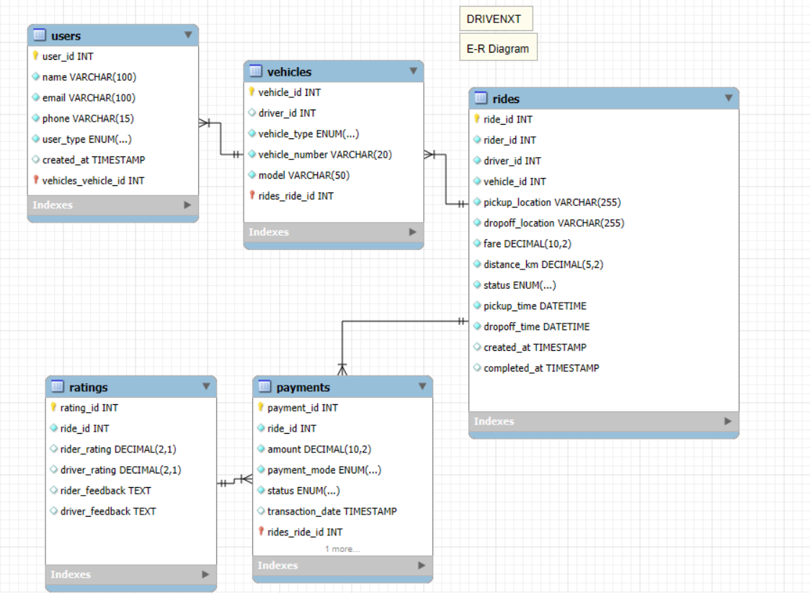

**DATA INSIGHTS:**

**BUSINESS STRATERGIES:**

1. User Acquisition & Market Penetration

* Referral and Incentive Programs: Implement a structured referral system where riders and drivers earn credits for successful referrals, driving organic growth.
* Corporate Partnerships: Establish agreements with businesses, hotels, and airports to offer exclusive ride services, expanding market reach.
* Promotional Discounts & Dynamic Pricing: Introduce first-ride discounts, seasonal promotions, and geo-based dynamic pricing to attract new users.
* Data-Driven Targeted Marketing: Leverage AI-driven analytics to execute precise digital advertising campaigns on social media and search engines.

2. Driver Onboarding & Retention

* Performance-Based Incentives: Introduce tiered reward programs for top-rated drivers, ensuring service quality while boosting driver retention.
* Operational Flexibility & Instant Payouts: Provide drivers with flexible working hours and real-time earnings withdrawals to enhance engagement.
* Driver Safety & Support Programs: Offer insurance coverage, fuel subsidies, and vehicle maintenance partnerships to improve job satisfaction.
* Optimized Fleet Management: Deploy automated driver-vehicle allocation mechanisms to reduce idle time and improve service efficiency.

3. Revenue Model & Monetization

* Dynamic & Surge Pricing Optimization: Implement machine learning algorithms to adjust ride fares based on demand, supply, and traffic conditions.
* Subscription-Based Ride Plans: Introduce monthly ride packages for frequent commuters to drive customer loyalty and predictable revenue.
* Commission-Based Earnings: Maintain a structured commission model for each ride while offering lower commissions to high-performing drivers.
* Ancillary Revenue Streams: Expand service offerings by integrating package delivery, food delivery, and advertising within the application.

4. Service Quality & Customer Experience Enhancement

* AI-Powered Ride Matching & Route Optimization: Utilize AI-driven predictive analytics to assign optimal drivers and minimize trip durations.
* Advanced Safety Mechanisms: Implement real-time ride tracking, in-app emergency alerts, and background verification for drivers.
* Customer Feedback Analytics: Deploy NLP-based sentiment analysis on customer reviews to identify areas of improvement.
* Loyalty & Reward Programs: Establish a structured loyalty program to encourage repeat rides and boost customer retention.

5. Operational Efficiency & Cost Optimization

* Predictive Maintenance & Fleet Optimization: Integrate IoT sensors in vehicles to track performance, reducing maintenance costs and downtime.
* Autonomous Dispatching System: Develop an AI-powered dispatch system to match drivers with riders efficiently, minimizing wait times.
* EV & Sustainability Initiatives: Introduce electric and hybrid vehicle programs with incentives for eco-friendly drivers to reduce operational costs.
* Geo-Fencing & Demand Forecasting: Implement geospatial analytics to predict high-demand zones and dynamically allocate resources accordingly.

6. Expansion & Future Scalability

* Inter-City & Long-Distance Rides: Develop a structured pricing model for inter-city and long-haul trips, expanding service capabilities.
* Shared & Pool Rides Integration: Optimize ride-sharing services to increase fleet utilization and reduce per-ride costs for users.
* Global Expansion Strategy: Identify high-demand international markets and implement localized expansion strategies.
* AI-Driven Predictive Analytics: Leverage big data to forecast user demand, optimize pricing strategies, and enhance operational efficiency.