Name- Tanvi Bansal

Roll no-23074029

Branch- CSE[IDD]

ITW LAB ASSIGNMENT 3

Code for creating tables and inserting data-

create database ITW2LAB111;

USE ITW2LAB111;

create table dept(

dep_id int primary key,

dep_name varchar(40),

dep_location varchar(40)

);

create table employees(

emp_id int,

emp_name varchar(40),

job_name varchar(40),

manager_id int,

hire_date date,

salary decimal(10,2),

commission decimal(8,2),

dep_id int,

foreign key(dep_id) references dept(dep_id)

);

create table salarygrade(

grade int,

min_sal int,

max_sal int

);

INSERT INTO dept (dep_id, dep_name, dep_location) VALUES

(1001, 'FINANCE', 'SYDNEY'),

(2001, 'AUDIT', 'MELBOURNE'),

(3001, 'MARKETING', 'PERTH'),

(4001, 'PRODUCTION', 'BRISBANE');

INSERT INTO salarygrade (grade, min_sal, max_sal) VALUES

(1, 800.00, 1300.00),

(2, 1301.00, 1500.00),

(3, 1501.00, 2100.00),

(4, 2101.00, 3100.00),

(5, 3101.00, 9999.00);

INSERT INTO employees (emp_id, emp_name, job_name, manager_id, hire_date, salary, commission, dep_id) VALUES

(68319, 'KAYLING', 'PRESIDENT', NULL, '2011-11-18', 6000.00, NULL, 1001),

(66928, 'BLAZE', 'MANAGER', 68319, '2011-05-01', 2750.00, NULL, 3001),

(67832, 'CLARE', 'MANAGER', 68319, '2011-06-09', 2550.00, NULL, 1001),

(65646, 'JONAS', 'MANAGER', 68319, '2011-04-02', 2957.00, NULL, 2001),

(67858, 'SCARLET', 'ANALYST', 65646, '2017-04-19', 3100.00, NULL, 2001),

(69062, 'FRANK', 'ANALYST', 65646, '2011-12-03', 3100.00, NULL, 2001),

(63679, 'SANDRINE', 'CLERK', 69062, '2010-12-18', 900.00, NULL, 2001),

(64989, 'ADELYN', 'SALESMAN', 66928, '2011-02-20', 1700.00, 400.00, 3001),

(65271, 'WADE', 'SALESMAN', 66928, '2021-02-22', 1350.00, 600.00, 3001),

(66564, 'MADDEN', 'SALESMAN', 66928, '2021-09-28', 1350.00, 1500.00, 3001),

(68454, 'TUCKER', 'SALESMAN', 66928, '2021-09-08', 1600.00, 0.00, 3001),

(68736, 'ANDREAS', 'CLERK', 67858, '2023-05-23', 1200.00, NULL, 2001),

(69000, 'JULIUS', 'CLERK', 66928, '2023-12-03', 1050.00, NULL, 3001),

(69324, 'MARKER', 'CLERK', 67832, '2023-01-23', 1400.00, NULL, 1001);

Q1.

SELECT

emp_id,

emp_name,

job_name,

hire_date,

CONCAT(YEAR(CURDATE()) - YEAR(hire_date), ' years ',

MONTH(CURDATE()) - MONTH(hire_date), ' months ',

DAY(CURDATE()) - DAY(hire_date), ' days') AS experience

FROM

Employees

WHERE

job_name = 'MANAGER';

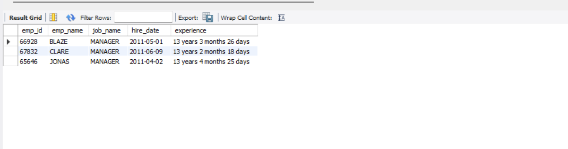

Q2.

SELECT

e.*

FROM

employees e

JOIN

salarygrade sg ON e.salary BETWEEN sg.min_sal AND sg.max_sal

WHERE

sg.grade IN (4, 5)

AND e.job_name IN ('ANALYST', 'MANAGER');

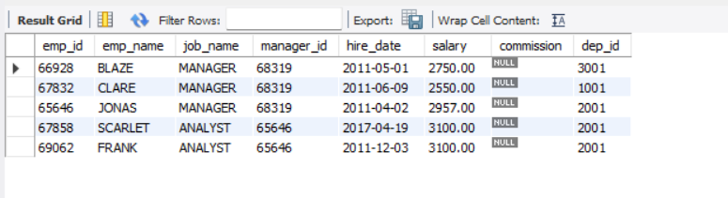

Q3.

SELECT

emp_name,

salary,

commission

FROM

Employees e1

WHERE

(salary + IFNULL(commission, 0)) >= ALL (

SELECT

salary

FROM

Employees e2

);

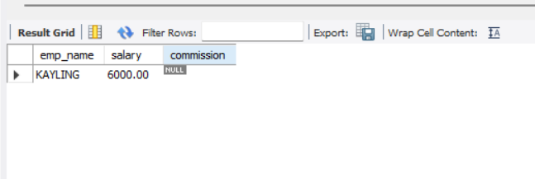

Q4.

SELECT

e.*

FROM

employees e

JOIN

dept d ON e.dep_id = d.dep_id

WHERE

d.dep_location = 'PERTH'

AND e.hire_date < (

SELECT

MIN(e2.hire_date)

FROM

employees e2

JOIN

salarygrade sg ON e2.salary BETWEEN sg.min_sal AND sg.max_sal

WHERE

sg.grade = 2

)

ORDER BY

e.salary DESC

LIMIT 1;

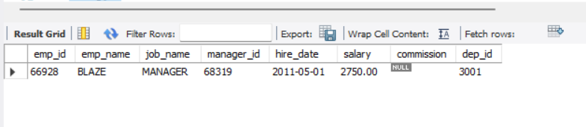

Q5.

SELECT

e.*

FROM

Employees e

JOIN

Dept d ON e.dep_id = d.dep_id

JOIN

salarygrade sg_tucker ON e.salary BETWEEN sg_tucker.min_sal AND sg_tucker.max_sal

JOIN

Employees tucker ON tucker.emp_name = 'TUCKER'

JOIN

salarygrade sg_tucker_grade ON tucker.salary BETWEEN sg_tucker_grade.min_sal AND sg_tucker_grade.max_sal

WHERE

(sg_tucker.grade = sg_tucker_grade.grade

OR e.hire_date < (SELECT hire_date FROM Employees WHERE emp_name = 'SANDRINE'))

AND d.dep_location IN ('SYDNEY', 'PERTH');

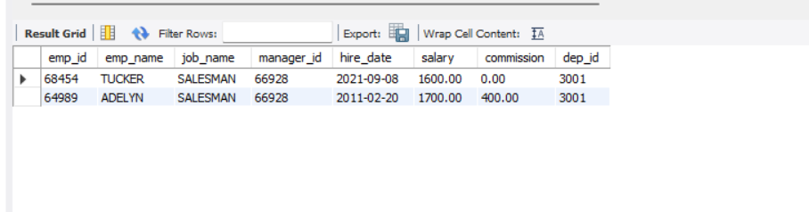

Q6.

SELECT

e.*

FROM

Employees e

JOIN

salarygrade sg_marker ON (SELECT salary FROM Employees WHERE emp_name = 'MARKER')

BETWEEN sg_marker.min_sal AND sg_marker.max_sal

JOIN

salarygrade sg_employee ON e.salary BETWEEN sg_employee.min_sal AND sg_employee.max_sal

WHERE

sg_employee.grade > sg_marker.grade;

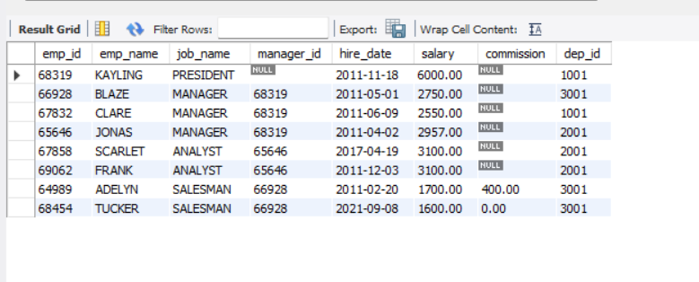

Q7.

SELECT

e.*

FROM

Employees e

WHERE

e.manager_id IN (

SELECT

manager_id

FROM

Employees

GROUP BY

manager_id

HAVING

COUNT(emp_id) = 1

);

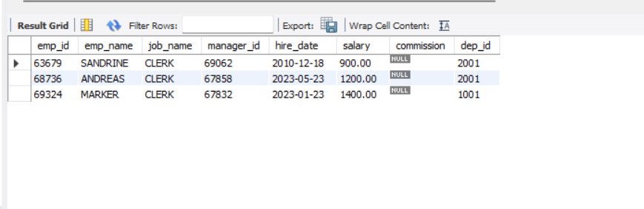

Q8.

SELECT

e.*

FROM

Employees e

WHERE

e.emp_id NOT IN (

SELECT

manager_id

FROM

Employees

WHERE

manager_id IS NOT NULL

);

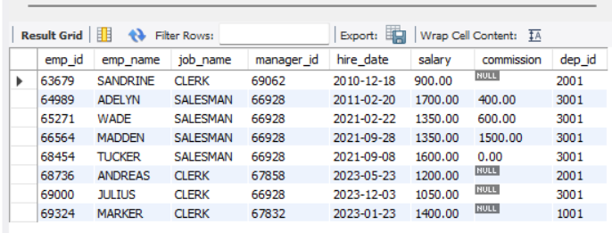

Q9.

SELECT

emp_name,

hire_date,

CASE

WHEN DATEDIFF(CURDATE(), hire_date) < 730 THEN 'New Hire'

WHEN DATEDIFF(CURDATE(), hire_date) BETWEEN 730 AND 1825 THEN 'Experienced'

ELSE 'Veterans'

END AS experience_category

FROM

Employees;

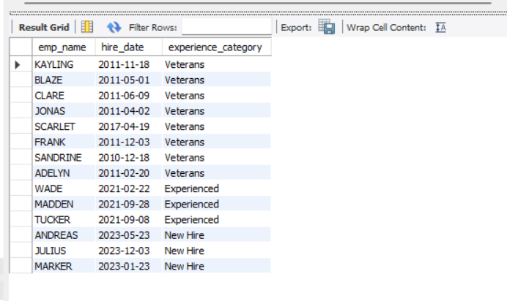

Q10.

CREATE TEMPORARY TABLE temp_manager_ids AS

SELECT

manager_id

FROM

Employees

GROUP BY

manager_id

HAVING

COUNT(emp_id) = 1;

DELETE FROM

Employees

WHERE

job_name = 'CLERK'

AND manager_id IN (SELECT manager_id FROM temp_manager_ids);

DROP TEMPORARY TABLE temp_manager_ids;