Data Structures and Algorithms Lab
Assignment 7
Experiment 7 (Hash Tables) & Experiment 8 (Graphs)
- Experiment 7: To implement hash tables with and without collision avoidance algorithms using arrays/linked lists.
- Experiment 8: To demonstrate the creation of graphs and working with graph traversal algorithms.

Instruction: Make a pdf file of the program code in C and its output.
Name: Tanvi Pathak
SAP ID:590025936
Batch: 39
Link of your GitHub Account: : https://github.com/tanvi287/Tanvi_590025936_DSA_2026
Course: B.Tech. CSE (Sem II)
Subject: DSA Lab
Date: April 21, 2026
Note: Do all the implementations in C programming.
- Write a C program to implement a hash function on student SAP-ID and categorize them in to their 10 families based on the last three digits. Example: Student with SAP-ID 5000423 belongs to family 9 and student with SAP-ID 5000425 belongs to family 2 based on last three digits.
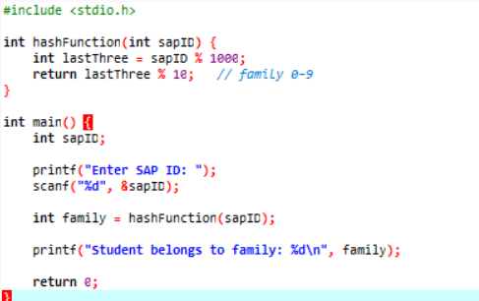
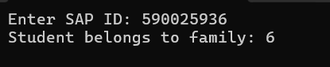

- Write a C program to implement a Hash table using arrays. Perform Insert, Delete and Search operations on the hash table using the above Hash function (S.No.1). Adopt a suitable user-defined exception handling strategy if collision occurs while inserting data.
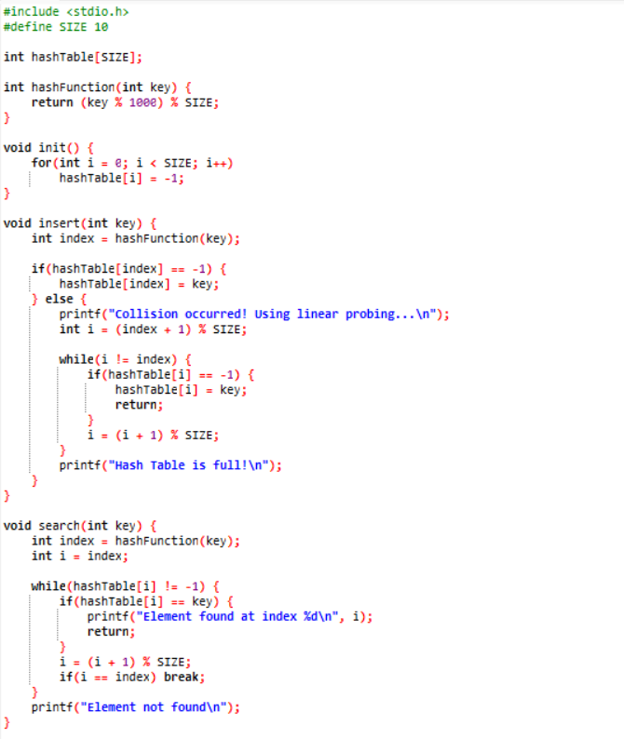
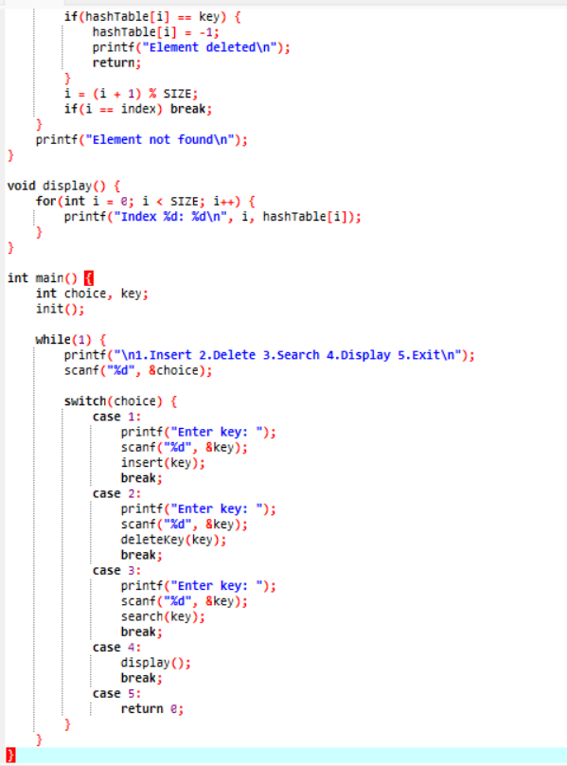
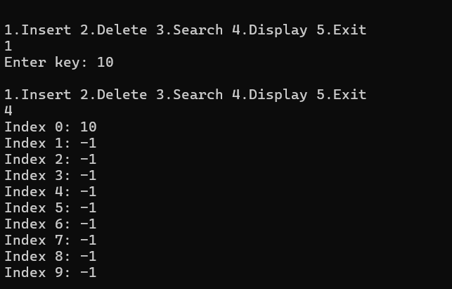

- Write a C program to accept the number of vertices and edges of a graph and represent it using an adjacency matrix. The program should:
- construct and display the adjacency matrix.
- Implement functions to calculate and print the in-degree and out-degree of a given vertex.
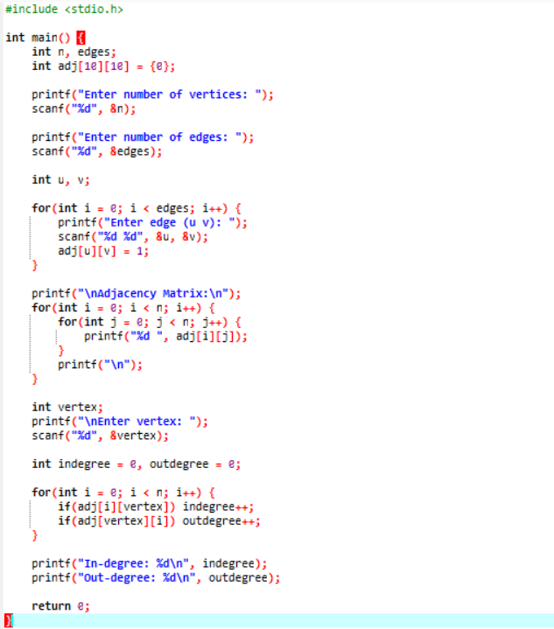
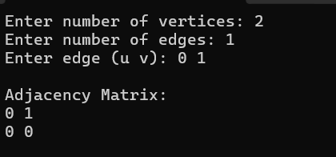

- Write a C program to accept a graph in the form of an adjacency matrix and determine whether the graph is undirected or not.
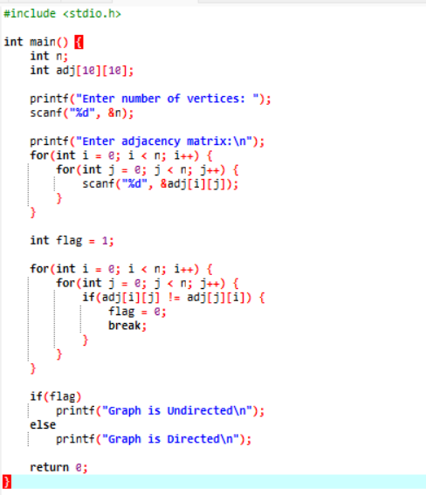
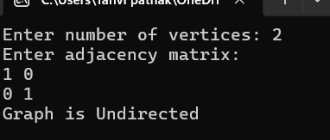

- Write a C program to represent a graph using an adjacency matrix. The program should perform Breadth First Search (BFS) traversal starting from a given source vertex. The program should:
- Accept the number of vertices n.
- Accept the adjacency matrix of the graph.
- Accept a starting vertex for traversal.
- Perform BFS traversal using a queue.
- Display the order of traversal of vertices.
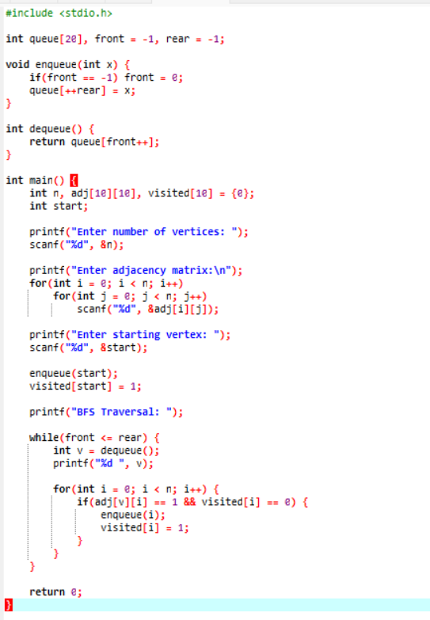
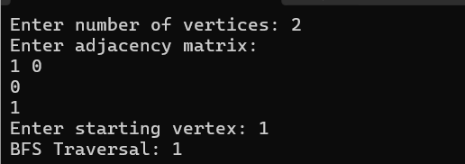

- Write a C program to represent a graph using an adjacency matrix. The program should perform Depth First Search (DFS) traversal starting from a given source vertex. The program should:
- Accept the number of vertices n.
- Accept the adjacency matrix of the graph.
- Accept a starting vertex for traversal.
- Perform DFS traversal using recursion or stack.
- Display the order of traversal of vertices.
