# **Testing on Live Application**

## Module : 3

#### What is RDBMS?

* The software used to store, manage, query, and retrieve data stored in a relational database is called a relational database management system (RDBMS).
* Relational Database Management System (RDBMS) is a more advanced version of a DBMS system that allows access to data in a more efficient way. It is used to store or manage only the data that are in the form of tables.
* The RDBMS provides an interface between users and applications and the database, as well as administrative functions for managing data storage, access, and performance.
* RDBMS supports multiple users .

#### What is SQL?

* SQL is a standard language for storing, manipulating and retrieving data in databases.
* SQL stands for Structured Query Language.
* SQL allows you to access and manipulate the databases. To use SQL in: MySQL, SQL Server, MS Access, Oracle, Sybase, Informix, Postgres, and other database systems.
* SQL is Structured Query Language, which is a computer language for
* storing, manipulating and retrieving data stored in relational database.
* It is a programming language that is used to request information from a database.
* SQL can be used to manage and share data in a relational database management system. Moreover, users can perform actions like insertion, deletion, selection, etc on the database.

#### Write SQL Commands

* SQL is a standard language for storing, manipulating and retrieving data in databases.
* These SQL Commands are mainly categorized in to five categorized :

DDL = Data Definition Language

DML = Data Manipulation Language

DCL = Data Control Language

DQL = Data Query Language

TCL = Transaction Control Language

# SQL Command

Cbx

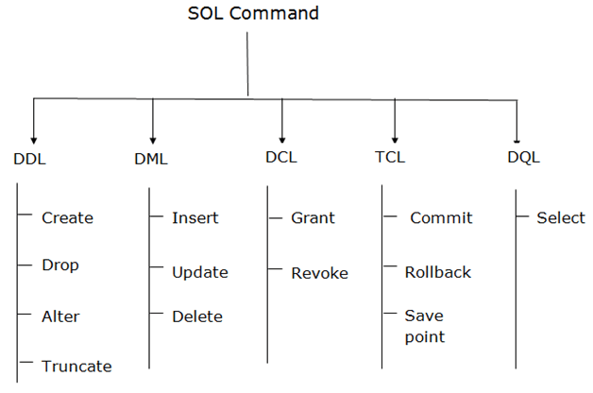

#### What is join?

* A JOIN clause is used to combine rows from two or more tables, based on a related column between them.
* The join keyword merges two or more tables and creates a temporary image of the merged table.
* Then according to the conditions provided, it extracts the required data from the image table, and once data is fetched, the temporary image of the merged tables is dumped.

#### Write type of joins.

* Different Types of SQL JOIN:
* INNER JOIN :The INNER JOIN keyword selects records that have matching values in both tables.

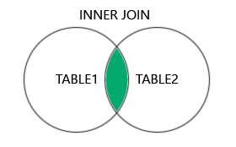

* LEFT (OUTER) JOIN: Returns all records from the left table, and the matched records from the right table.
* Rows belonging to the left-hand table as well as records available in both the tables, and not having values from the right-hand table are presented.

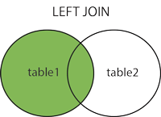

* RIGHT (OUTER) JOIN: Returns all records from the right table, and the matched records from the left table.
* Rows belonging to the right-hand table as well as records available in both the tables, and not having values from the left-hand table are presented.

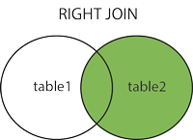

* FULL (OUTER) JOIN: Returns all records when there is a match in either left or right table.
* The full outer join (a.k.a. SQL Full Join) first adds all the rows matching the stated condition in the query and then adds the remaining unmatched rows from both tables. We need two or more tables for the join.

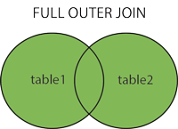

#### How Many constraint and describes it self.

* SQL constraints are used to specify rules for the data in a table.
* Constraints are used to limit the type of data that can go into a table. This ensures the accuracy and reliability of the data in the table. If there is any violation between the constraint and the data action, the action is aborted.
* The following constraints are commonly used in SQL:
* **NOT NULL** - Ensures that a column cannot have a NULL value .
* **UNIQUE** - Ensures that all values in a column are different .
* **PRIMARY KEY** - A combination of a **NOT NULL** and **UNIQUE.** Uniquely identifies each row in a table .
* **FOREIGN KEY** - Prevents actions that would destroy links between tables .
* **CHECK** - Ensures that the values in a column satisfies a specific condition
* **DEFAULT** - Sets a default value for a column if no value is specified .
* **CREATE INDEX** - Used to create and retrieve data from the database very quickly.

#### Difference between RDBMS vs DBMS

|  |  |  |
| --- | --- | --- |
| NO | RDBMS | DBMS |
| 1. | Data stored is in table format | Data stored is in the file format |
| 2. | The software and hardware requirements are higher. | The software and hardware requirements are low. |
| 3. | Data in the form of a table are linked together | No connection between data |
| 4. | Multiple data elements are accessible together | Individual access of data elements |
| 5. | RDBMS supports multiple users | DBMS supports a single user |
| 6. | Example: Oracle, SQL Server. | Example: XML, Microsoft Access. |

#### What is API Testing

* Application Programming Interface (API) is a software interface that allows two applications to interact with each other without any user intervention.
* API (Application Programming Interface) is a computing interface which enables communication and data exchange between two separate software systems.
* In API Testing, instead of using standard user inputs(keyboard) and outputs, you use software to send calls to the API, get output, and note down the system’s response.
* The purpose of API Testing is to check the functionality, reliability, performance, and security of the programming interfaces.
* API tests are very different from GUI Tests and won’t concentrate on the look and feel of an application.

#### Types of API Testing

* Application Programming Interface (API) is a software interface that allows two applications to interact with each other without any user intervention
* There are mainly 3 types of API Testing:
* **Open APIs:** These types of APIs are publicly available to use like OAuth APIs from Google. It has also not given any restriction to use them. So, they are also known as Public APIs**.**
* **Partner APIs:** Specific rights or licenses to access this type of API because they are not available to the public.
* **Internal APIs:** Internal or private. These APIs are developed by companies to use in their internal systems. It helps you to enhance the productivity of your teams.

#### What is Responsive Testing?

* A responsive web design involves creating a flexible web page that is accessible from any device, starting from a mobile phone to a tablet.
* Considering this from a quality assurance perspective, a responsive web design requires thorough evaluation using a variety of devices before it is ready to go live.
* Furthermore, a responsive web design improves users’ browsing experience.
* Software testers may find it challenging to perform responsive design testing as a variety of factors are to be looked into during the testing phase.
* Some points to be understand for Responsive Testing.
* The challenges involved in testing a responsive website
* How website testing differs from a mobile device to a computer
* Rules and guidelines to be followed during responsive design testing and
* Lastly, various tools available to perform responsive testing

#### Which types of tools are available for Responsive Testing

* A responsive web design involves creating a flexible web page that is accessible from any device, starting from a mobile phone to a tablet.
* **Responsive Testing Tools :**
* LT Browser
* Lembda Testing
* Google Resizer
* I am responsive
* Pixel tuner

#### What is the full form of .ipa, .apk

|  |  |
| --- | --- |
| * ipa | * iOS package App, international phonetic alphabet |
| * apk | * Android Application Package |

#### How to create step for to open the developer option mode ON?

* **Step 1:** Go to Settings >my Phone.
* **Step 2:** Tap Software Info > Build Number.
* **Step 3:** Tap Build Number seven times. After the first few taps, you should see the steps counting down until you unlock the developer options. You may also have to tap in your PIN for verification
* **Step 4:** Once developer options are activated, you will see a message that reads, You are now a developer.
* **Step 5:** Go back to the Settings pane, where you will now find Developer options as an entry.
* **Step 6:** Tap it and toggle (USB debugging) the switch on if it is not already, and from there, you can proceed to make adjustments to your phone.