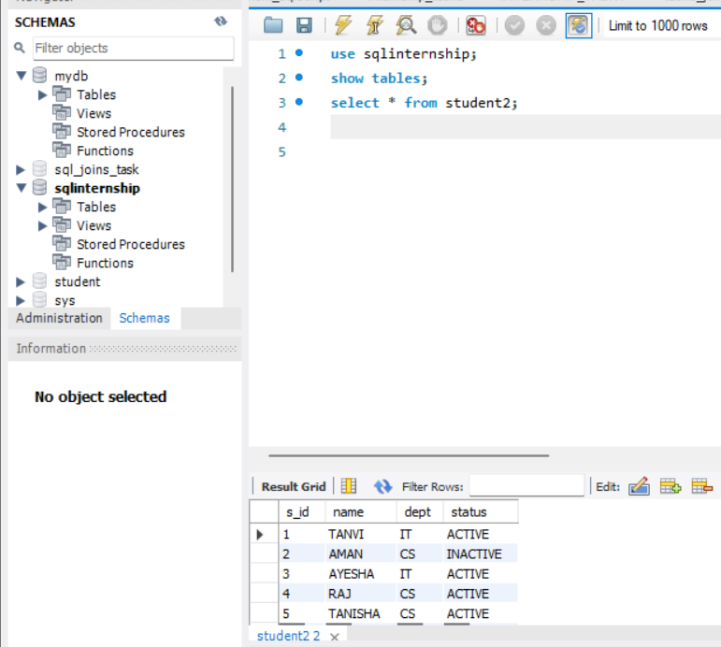

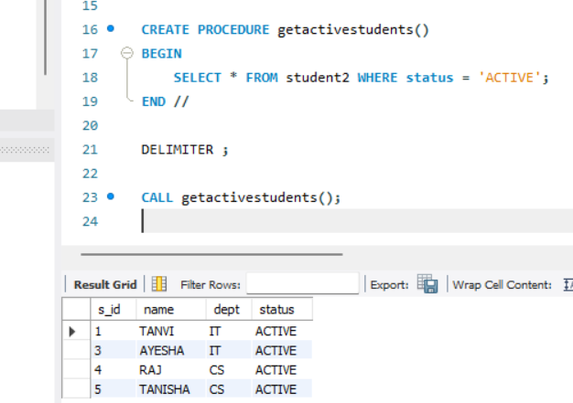

DELIMITER //

✅ Changes the default statement delimiter (;) to // so MySQL doesn't stop at the first ; inside the procedure.

• ✅ CREATE PROCEDURE getactivestudents() → Defines a new stored procedure named getactivestudents.

• ✅ BEGIN ... END → The procedure block begins and ends here.

• ✅ SELECT * FROM student2 WHERE status = 'ACTIVE'; → Retrieves only those rows from student2 where status is ACTIVE.

DELIMITER ;

✅ Resets the delimiter back to the default semicolon ;.

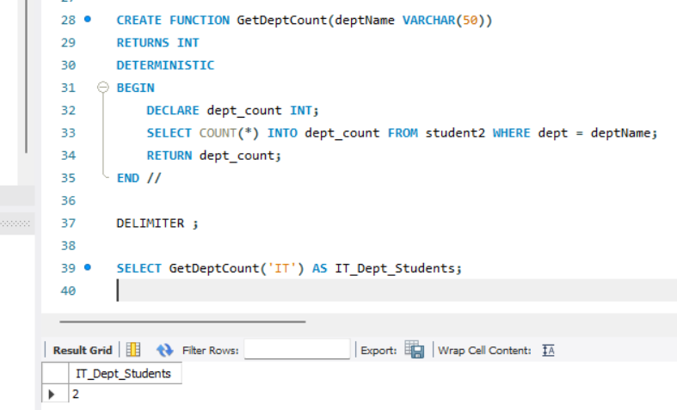

**Breakdown:**

* ✅ CREATE FUNCTION GetDeptCount(deptName VARCHAR(50))  
  → Creates a function that takes one input: deptName (e.g., 'IT' or 'CS').
* ✅ RETURNS INT  
  → The function will return an integer (number of students).
* ✅ DETERMINISTIC  
  → Means the function will return the same output for the same input.
* ✅ DECLARE dept_count INT;  
  → Declares a local variable dept_count to store the count.
* ✅ SELECT COUNT(*) INTO dept_count FROM student2 WHERE dept = deptName;  
  → Counts the number of students from the specified department and stores it in dept_count.
* ✅ RETURN dept_count;  
  → Sends the count as the function’s result.

SELECT GetDeptCount('IT') AS IT_Dept_Students;

✅ Calls the function GetDeptCount with 'IT' as input.

✅ Returns the number of students in the IT department.