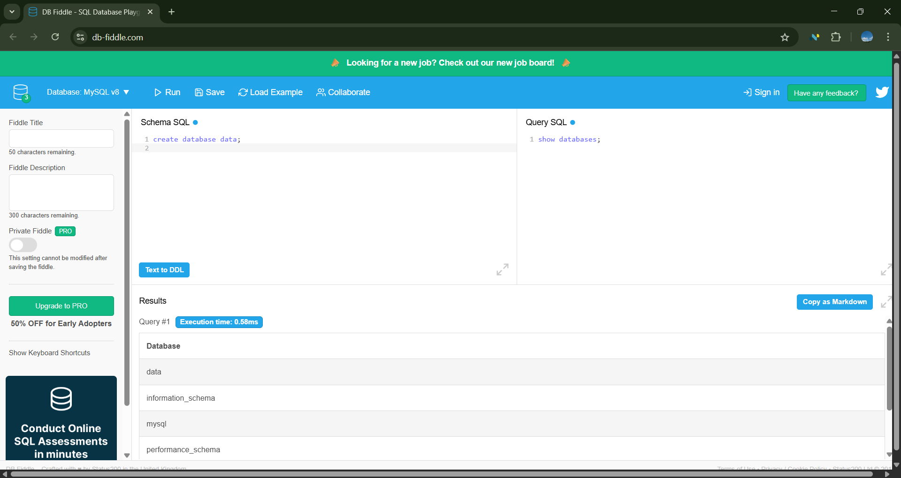

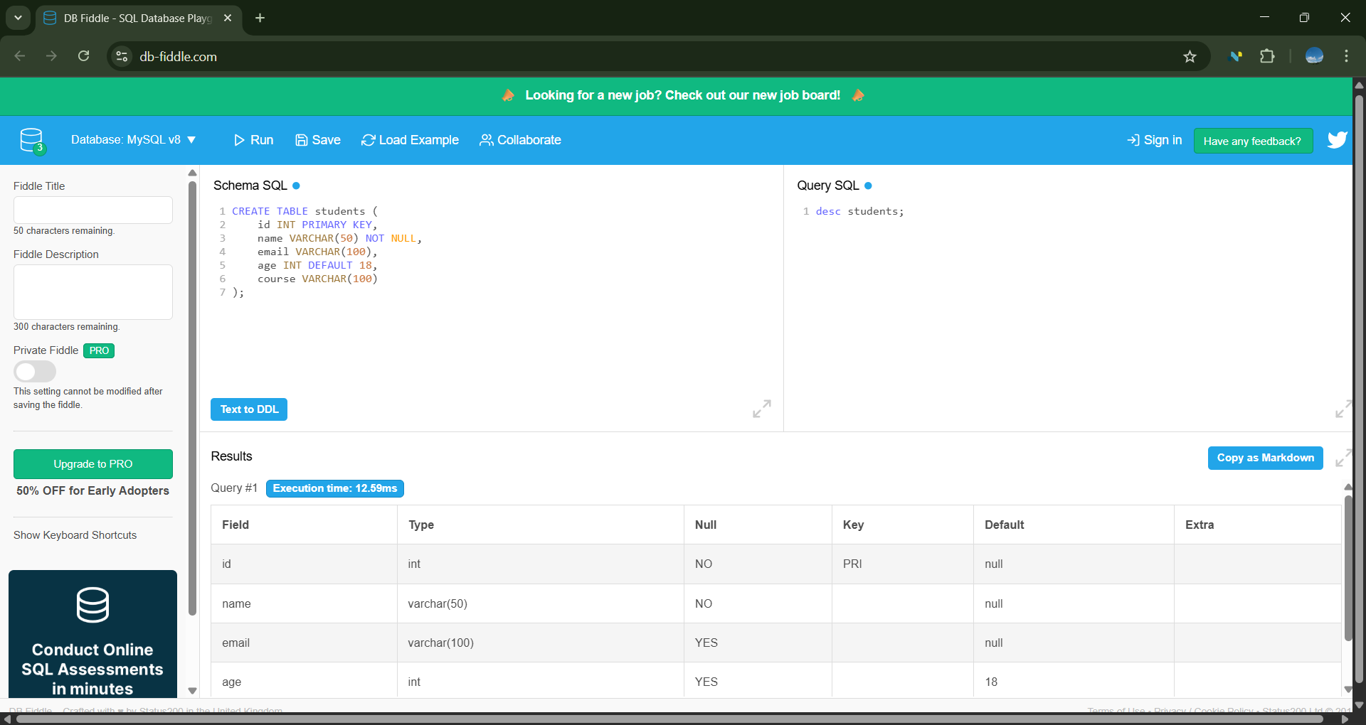

CREATE TABLE students (

id INT PRIMARY KEY,

name VARCHAR(50) NOT NULL,

email VARCHAR(100),

age INT DEFAULT 18,

course VARCHAR(100)

);

INSERT INTO students (id, name, email, age, course)

VALUES (1, 'Tanvi', 'tanvi@example.com', 21, 'SQL');

-- Insert with NULL

INSERT INTO students (id, name, email, age, course)

VALUES (2, 'Amit', NULL, 22, 'Python');

-- Insert with DEFAULT

INSERT INTO students (id, name, email, course)

VALUES (3, 'Neha', 'neha@example.com', 'Data Science');

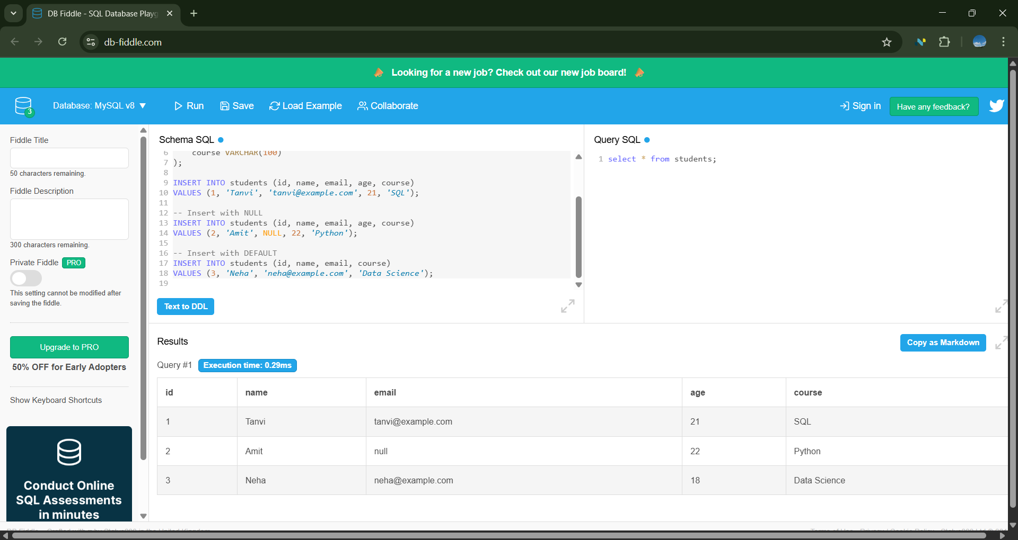

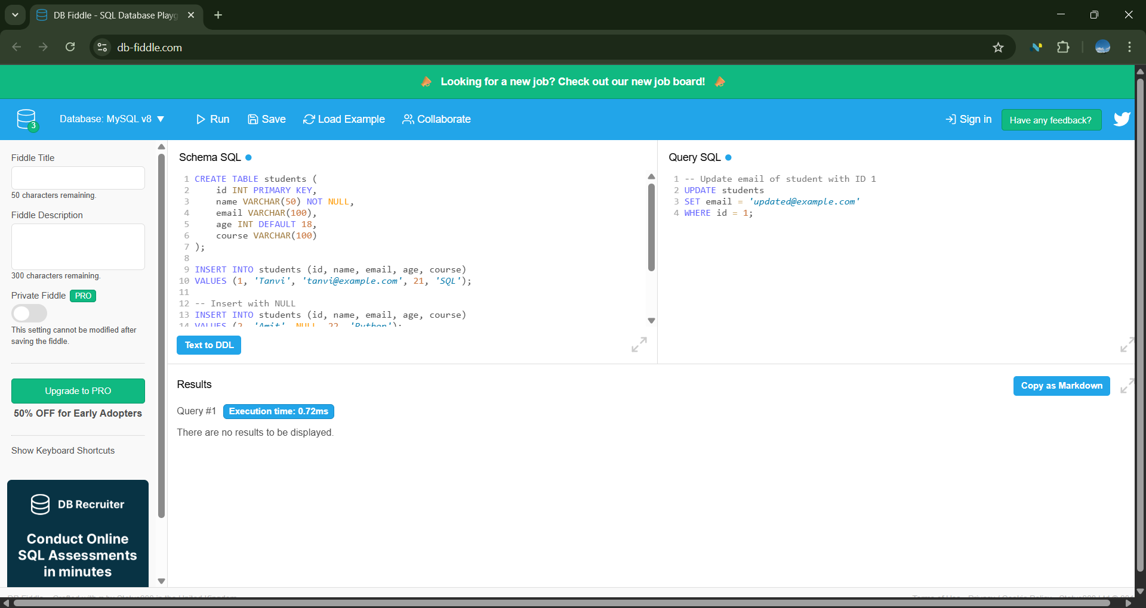

**❗ Common Mistake to Avoid**

* ❌ Don't put UPDATE, DELETE, or SELECT inside the **Schema SQL** box — it will cause an error.
* ✅ Only put CREATE and INSERT inside **Schema SQL**.

