ASSIGNMENT-4

/*1. Create a stored procedure in the Northwind database that will calculate the average
value of Freight for a specified customer.Then, a business rule will be added that will
be triggered before every Update and Insert command in the Orders controller,and
will use the stored procedure to verify that the Freight does not exceed the average
freight. If it does, a message will be displayed and the command will be cancelled.*/

--stored procedure
create proc spAvgFreightVal
@CustomerID nchar(5),
@AvgValue float output
as
begin
select @AvgValue = avg(Freight) from Orders where CustomerID = @CustomerID
end
--trigger
create trigger FreightValidationDemo
on Orders
after insert, update
as
begin
declare @avgval float,
@customerid nchar(5),
@NewFreight money

select @customerid = CustomerID from inserted
select @NewFreight = Freight from inserted

exec spAvgFreightVal @CustomerID = @customerid, @AvgValue = @avgval output

if ( @NewFreight > @avgval)
begin
RAISERROR('Freight exceeds the average freight value', 16, 1)
ROLLBACK TRANSACTION
end

end

--To verify
--Case 1:
update orders set Freight=15.10 where CustomerID = 'VINET' and freight=21.10
insert into orders (Freight, ShipName, CustomerID) values (14.00, 'vins et alcools ', 'VINET')
select *from Orders where CustomerID='VINET';

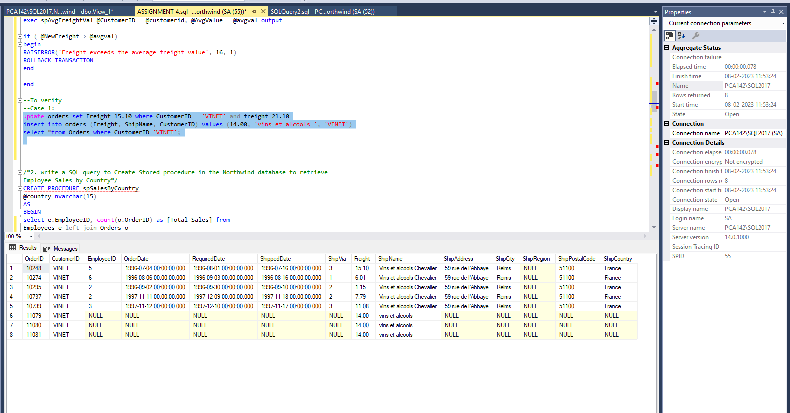

/*2. write a SQL query to Create Stored procedure in the Northwind database to retrieve
Employee Sales by Country*/
CREATE PROCEDURE spSalesByCountry
@country nvarchar(15)
AS
BEGIN
select e.EmployeeID, count(o.OrderID) as [Total Sales] from
Employees e left join Orders o
on e.EmployeeID = o.EmployeeID
where o.ShipCountry = @country
group by e.EmployeeID
END;

exec spSalesByCountry 'UK'
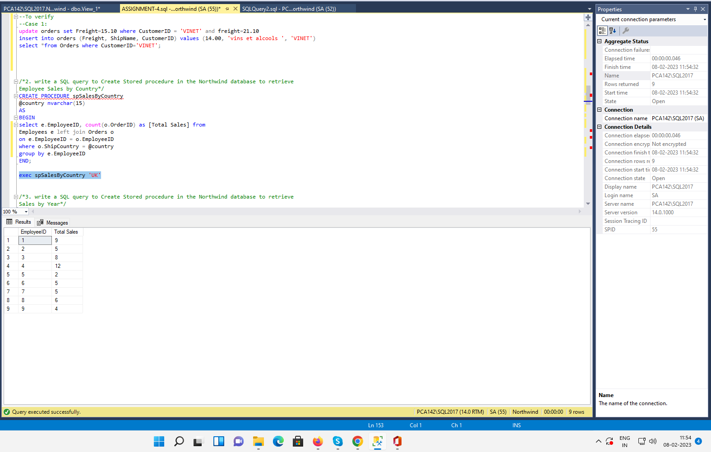

/*3. write a SQL query to Create Stored procedure in the Northwind database to retrieve
Sales by Year*/
CREATE PROCEDURE spSaleByYear
@year int
AS
BEGIN
SELECT count(OrderID) AS sales from Orders WHERE year(orderDate)= @year;
END
SELECT count(OrderID) AS sales ,year(orderDate) from Orders group by year(orderDate);
exec spSaleByYear 1997;
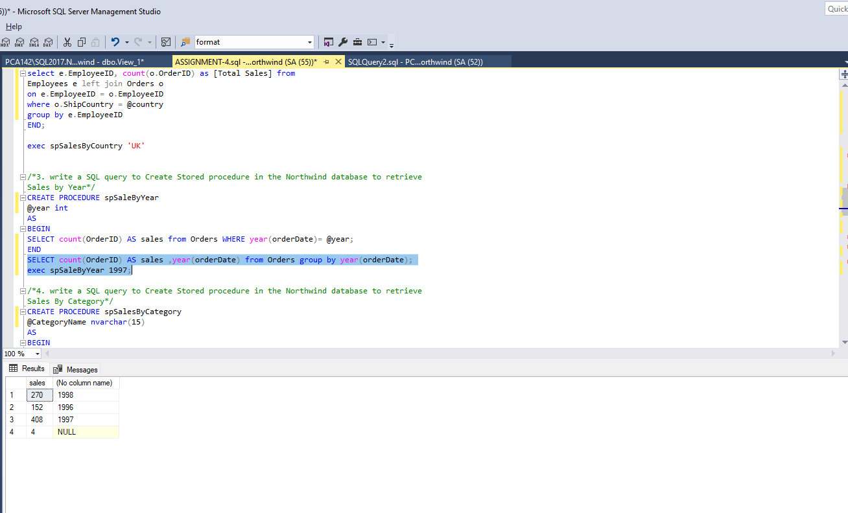

/*4. write a SQL query to Create Stored procedure in the Northwind database to retrieve
Sales By Category*/
CREATE PROCEDURE spSalesByCategory
@CategoryName nvarchar(15)
AS
BEGIN
SELECT COUNT(*) AS [TOTAL SALES] from (Categories AS C left join Products AS P on C.CategoryID=P.CategoryID) left join [Order Details] AS O on P.ProductID = O.ProductID
where CategoryName=@CategoryName;
END
SELECT c.CategoryName,COUNT(*) AS [TOTAL SALES] from (Categories AS C left join Products AS P on C.CategoryID=P.CategoryID) left join [Order Details] AS O on P.ProductID = O.ProductID
group by CategoryName;
exec spSalesByCategory Beverages;

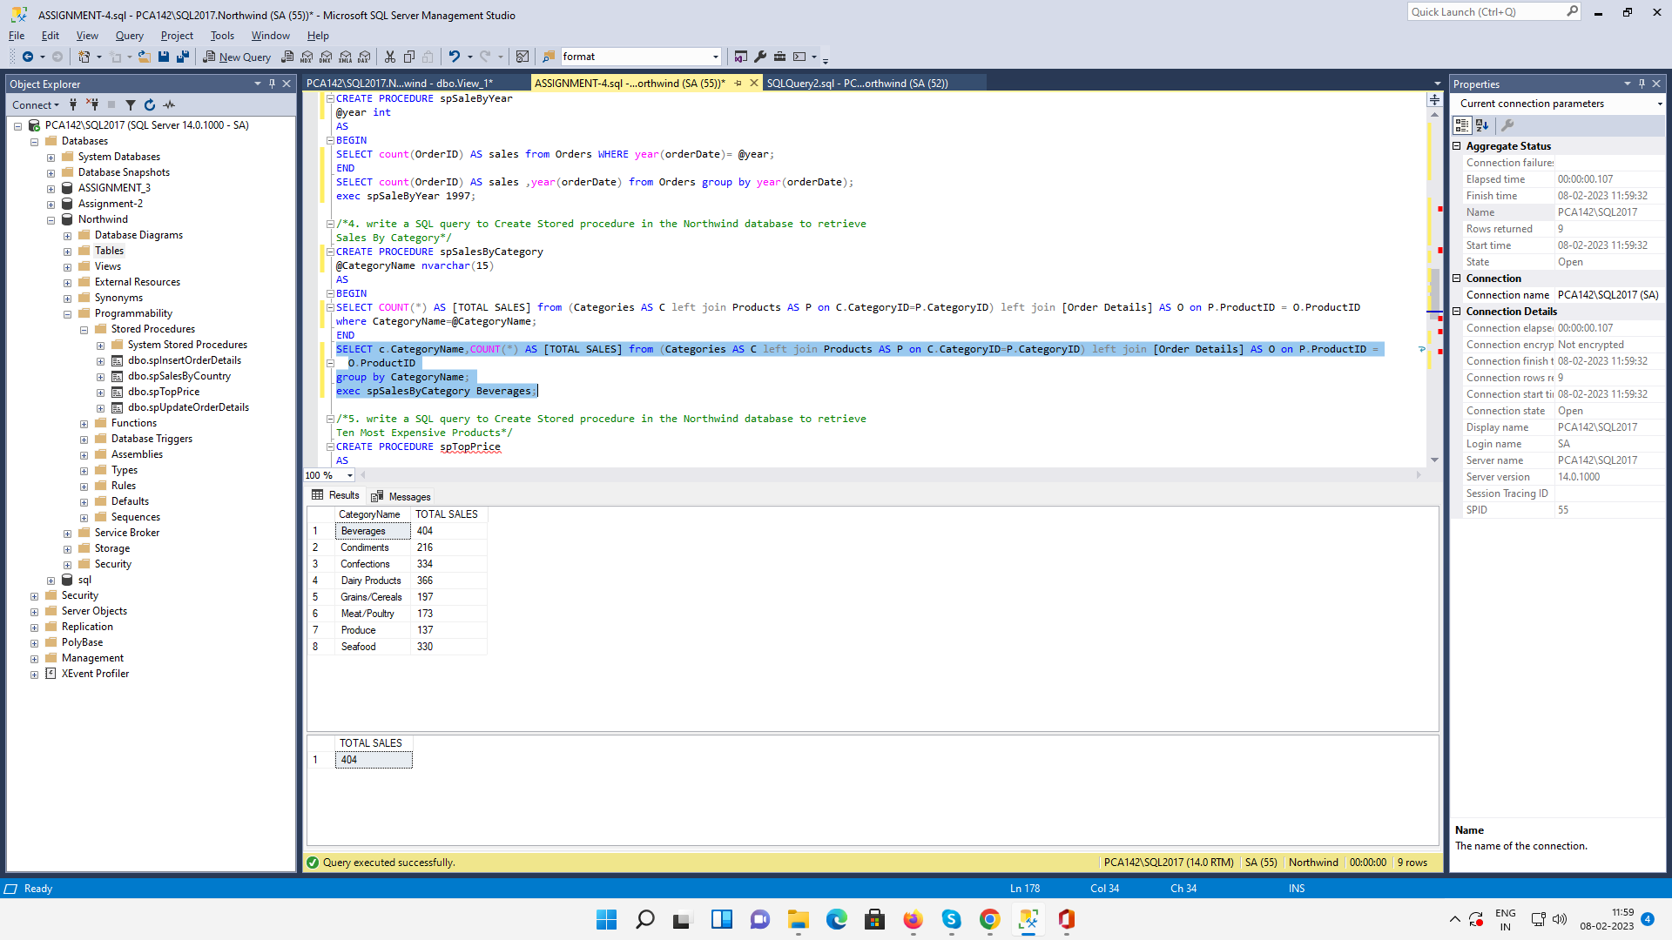

/*5. write a SQL query to Create Stored procedure in the Northwind database to retrieve
Ten Most Expensive Products*/
CREATE PROCEDURE spTopPrice
AS
BEGIN
SELECT TOP 10 ProductName, UnitPrice FROM Products ORDER BY UnitPrice DESC;
END;

exec spTopPrice

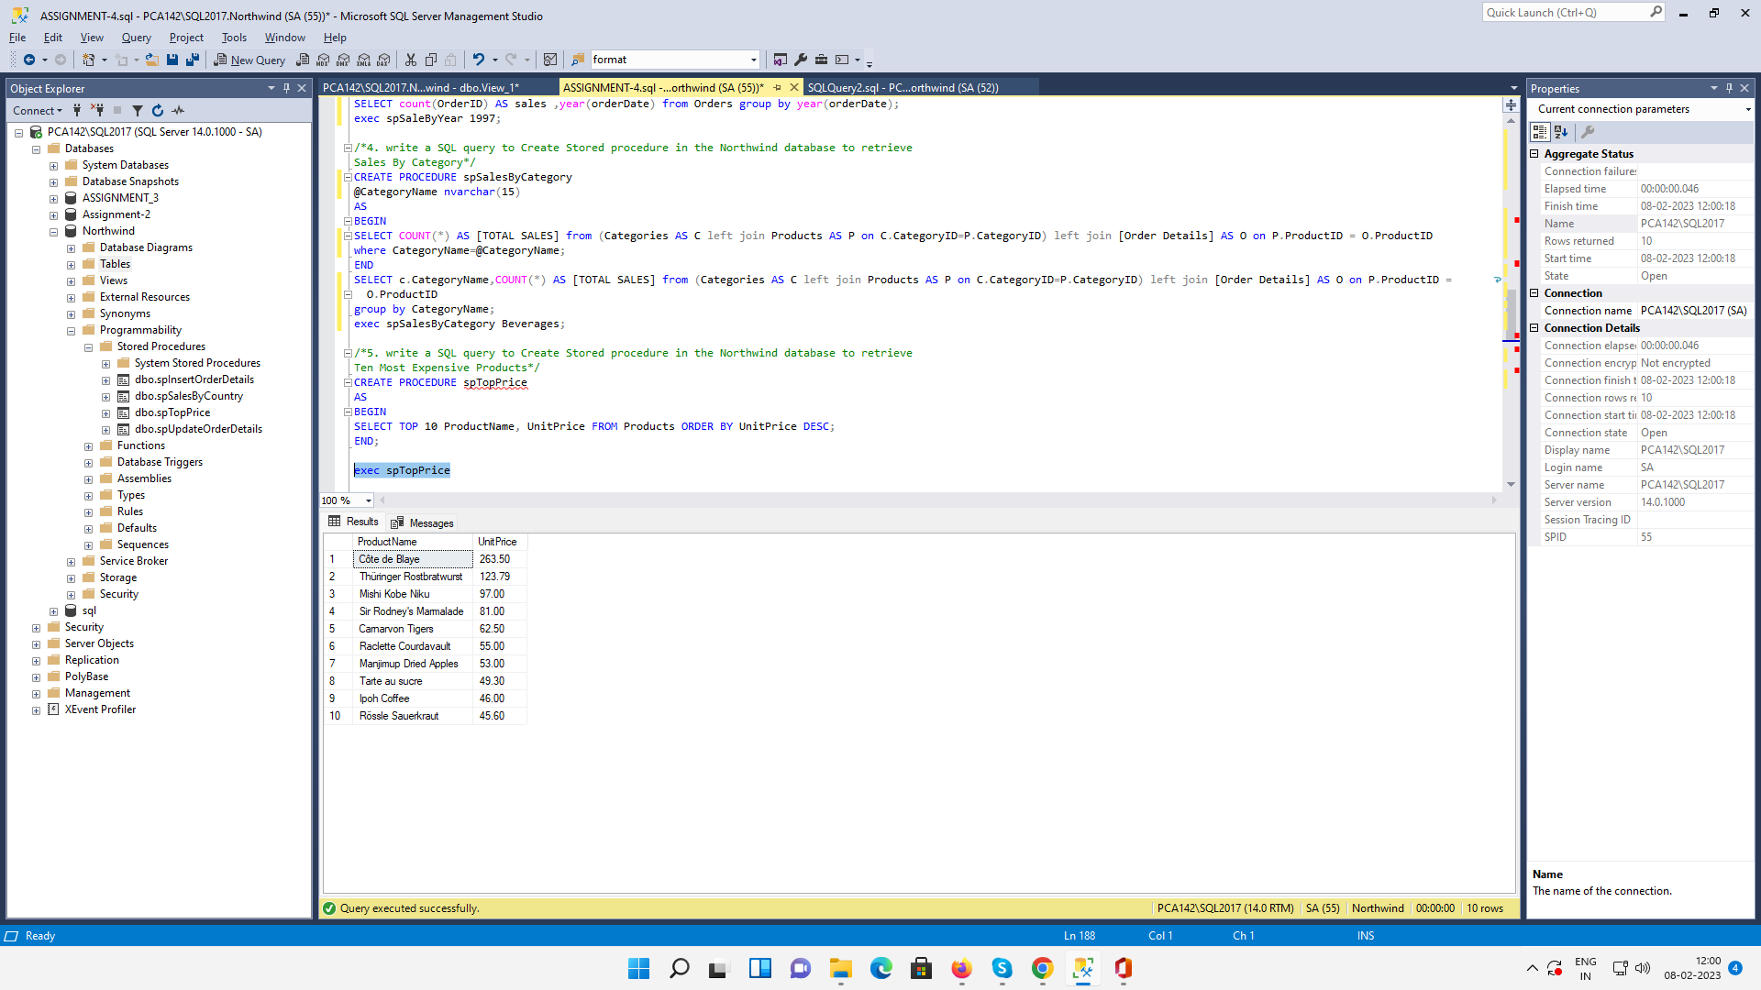

/*6. write a SQL query to Create Stored procedure in the Northwind database to insert
Customer Order Details*/

CREATE PROCEDURE spInsertOrderDetails ( @OrderID INTEGER, @ProductID INTEGER, @UnitPrice money, @Quantity Smallint, @Discount real)
AS
BEGIN
INSERT INTO [Order Details]
VALUES ( @OrderID , @ProductID,@UnitPrice,@Quantity ,@Discount )
END
EXECUTE spInsertOrderDetails 10248, 7, 30, 10, 0
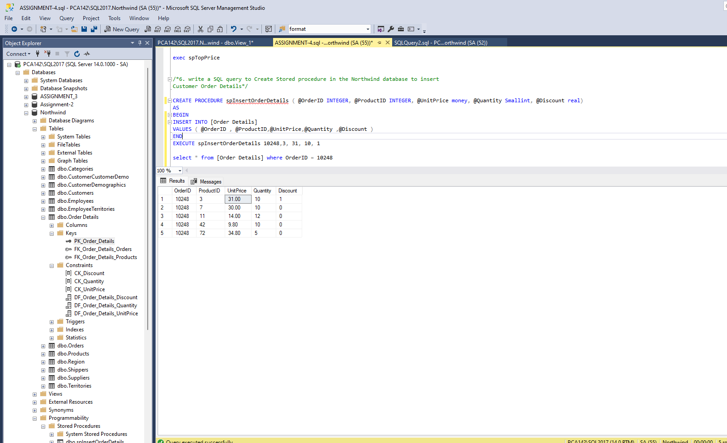

/*7. write a SQL query to Create Stored procedure in the Northwind database to update
Customer Order Details*/
CREATE PROCEDURE spUpdateOrderDetails ( @OrderID int, @ProductID int, @UnitPrice money, @Quantity smallint, @Discount real)
AS
BEGIN
UPDATE [Order Details] SET UnitPrice= @UnitPrice, Quantity= @Quantity, Discount= @Discount
where OrderID=@OrderID and ProductID = @ProductID
END

EXECUTE spUpdateOrderDetails 10280, 42,10, 10, 0.25

select * from [Order Details] where OrderID=10280 and ProductID = 42

