ASSIGNMENT-3
#TABLE
Sample table1:Department
-dept_id
-dept_name
Sample table2: Employee
-emp_id
-dept_id
-mngr_id
-emp_name
-salary
--> create table Department
(
dept_id int not null,
dept_name varchar(100) not null,

primary key (dept_id)
);
insert into Department values
(1, 'HR'),
(2, 'Developer'),
(3,'QA'),
(4,'Sales');

create table employee
(
emp_id int not null,
emp_name varchar(100) not null,
mngr_id int,
dept_id int not null,
salary money not null,
primary key (emp_id),
);
alter table employee add constraint fk_employee_dept_id foreign key (dept_id)
references Department (dept_id)
alter table employee add constraint fk_employee_mngr_id
foreign key (mngr_id)
references employee (emp_id)
insert into employee values
(1, 'Clark Mgr', null, 2,20000),
(2, 'Cameron Emp', 4, 4,15000),
(3, 'Charlie Emp', 6, 3,10000),
(4, 'Layton Emp', null, 4,25000),
(5, 'Linda Emp', 1, 2,15000),
(6, 'bring Emp', null, 3,30000),
(7, 'hetang patel', 4, 4,20000),
(8, 'rushi tanna', 4, 4,25000),
(9, 'suraj shah', 10,1,20000),
(10, 'mahesh shah', null, 1,25000),
(11, 'jiya patil', 10,1,15000);
OUTPUT:
GO
SELECT [emp_id]
,[emp_name]
,[mngr_id]
,[dept_id]
,[salary]
FROM [dbo].[employee]
GO
USE [ASSIGNMENT_3]
GO
SELECT [dept_id]
,[dept_name]
FROM [dbo].[Department]
GO
USE [ASSIGNMENT_3]

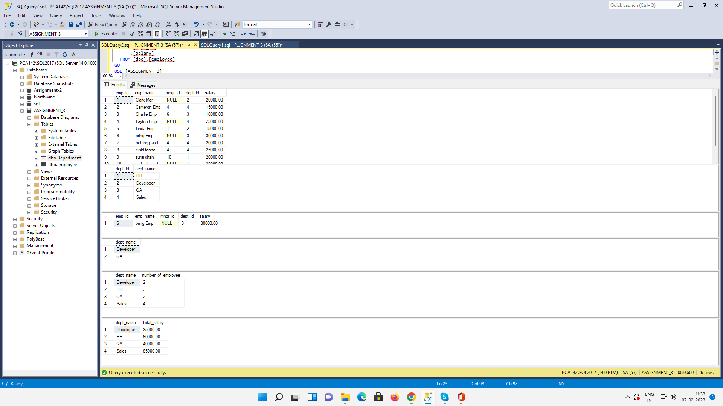

--write a SQL query to find Employees who have the biggest salary in their Department
SELECT TOP 1* FROM employee ORDER BY salary DESC;

-- write a SQL query to find Departments that have less than 3 people in it
SELECT Department.dept_name FROM Department join employee on employee.dept_id=Department.dept_id
GROUP BY Department.dept_name HAVING COUNT(*)<3;

-- write a SQL query to find All Department along with the number of people there
SELECT Department.dept_name,count(*) AS number_of_employee FROM Department join employee on employee.dept_id=Department.dept_id
GROUP BY Department.dept_name ;
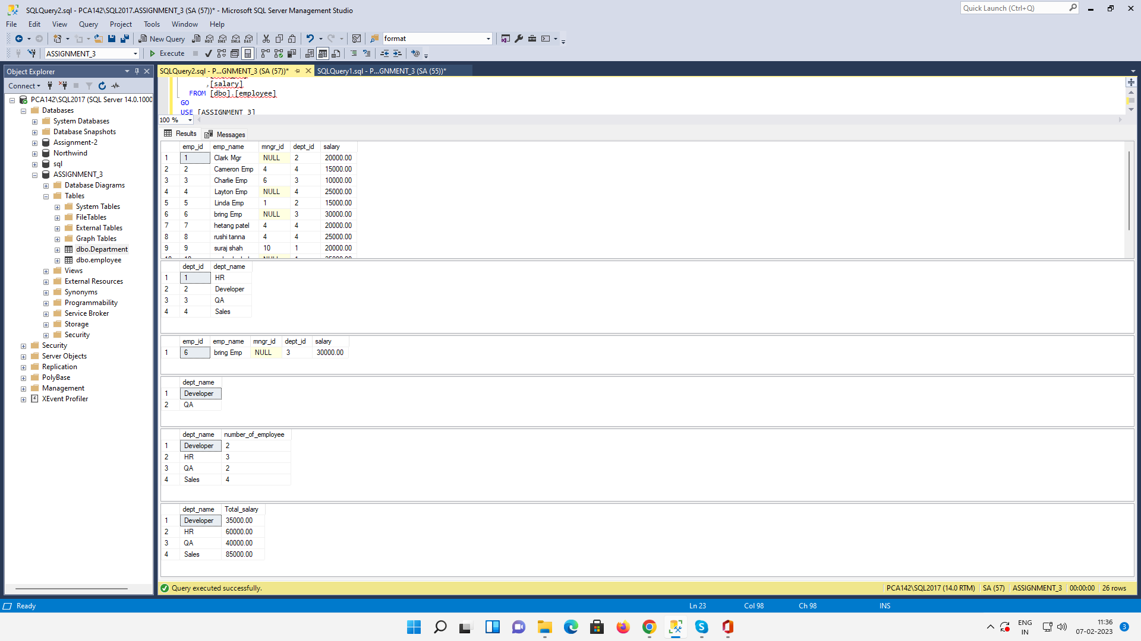
-- write a SQL query to find All Department along with the total salary there
SELECT Department.dept_name,sum(employee.salary) AS Total_salary FROM Department join employee on employee.dept_id=Department.dept_id
GROUP BY Department.dept_name ;

