Assignment 1
AIM: Simple SQL Query with a single table with where clause

--!Write a query to get a Product list (id, name, unit price) where current products cost less than $20.
SELECT ProductID, ProductName, UnitPrice
FROM Products
WHERE ((UnitPrice)<20)
ORDER BY UnitPrice ;
OUTPUT:
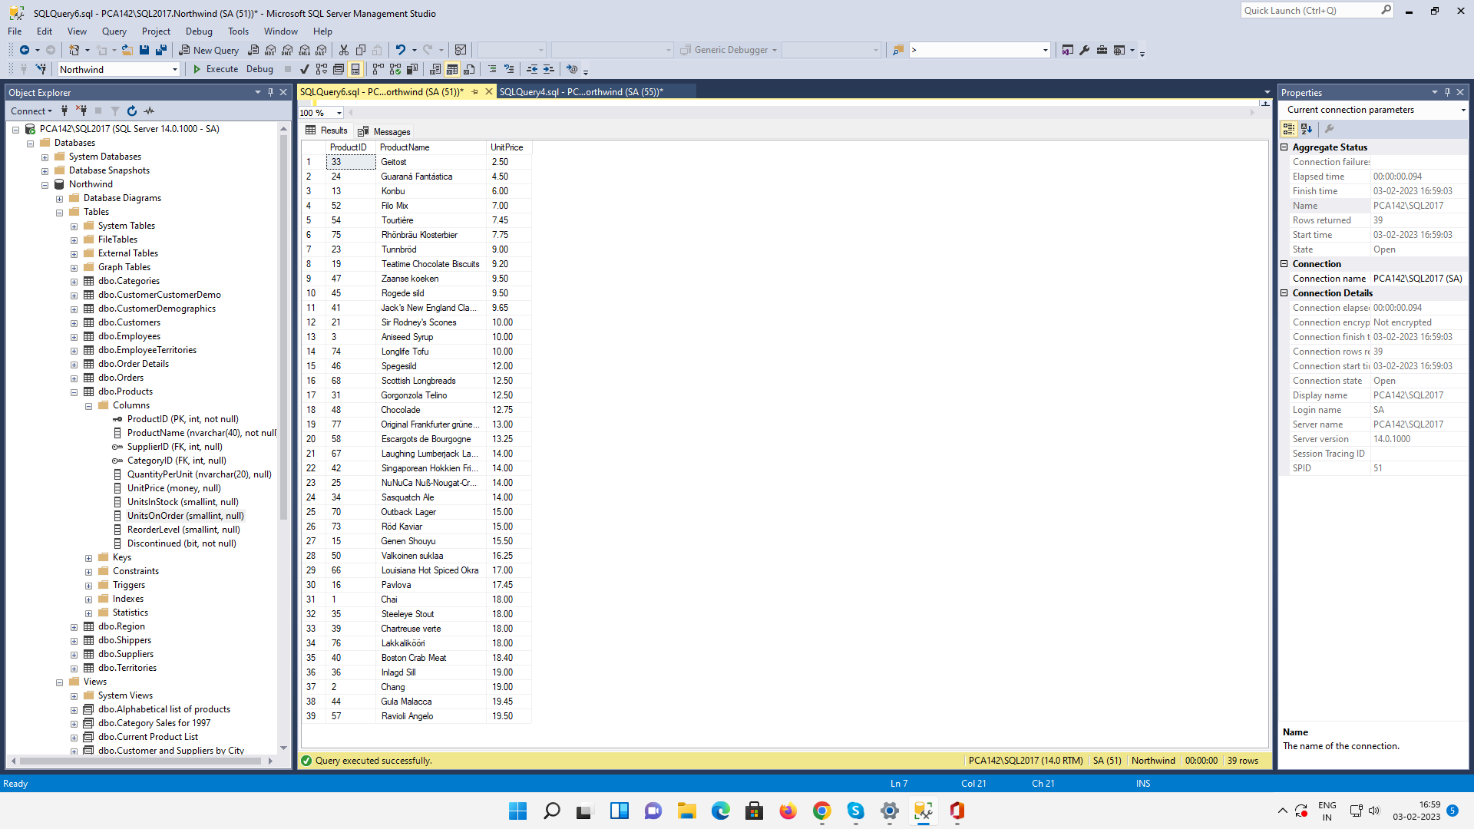

--Write a query to get Product list (id, name, unit price) where products cost between $15 and $25
SELECT ProductID, ProductName, UnitPrice
FROM Products
WHERE (((UnitPrice)>15) AND ((UnitPrice)<25))
ORDER BY UnitPrice ;

OUTPUT:
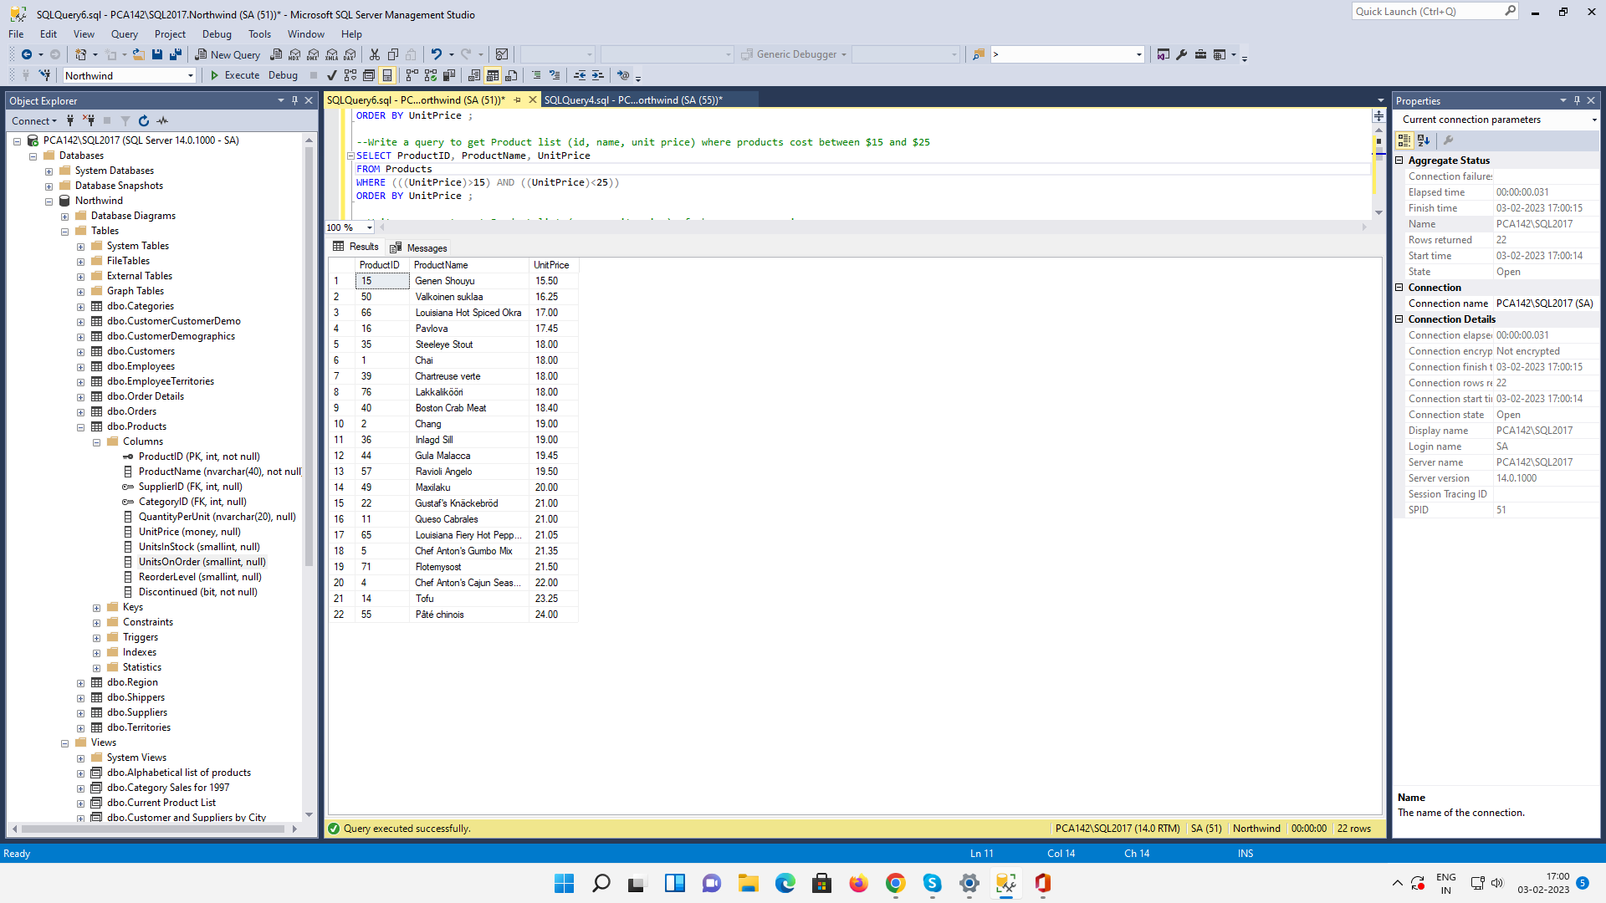

--Write a query to get Product list (name, unit price) of above average price.
SELECT ProductName, UnitPrice
FROM Products
WHERE UnitPrice > (SELECT avg(UnitPrice) FROM Products)
ORDER BY UnitPrice;

OUTPUT:
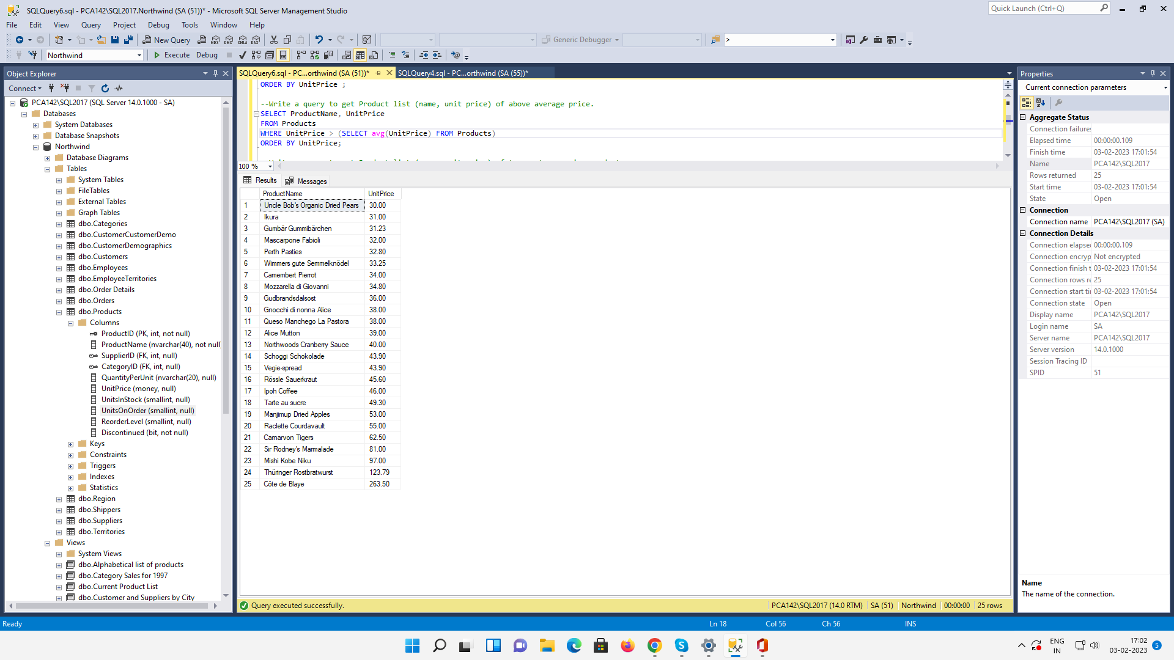

--Write a query to get Product list (name, unit price) of ten most expensive products
(SELECT MAX(UnitPrice) FROM Products)
OUTPUT:
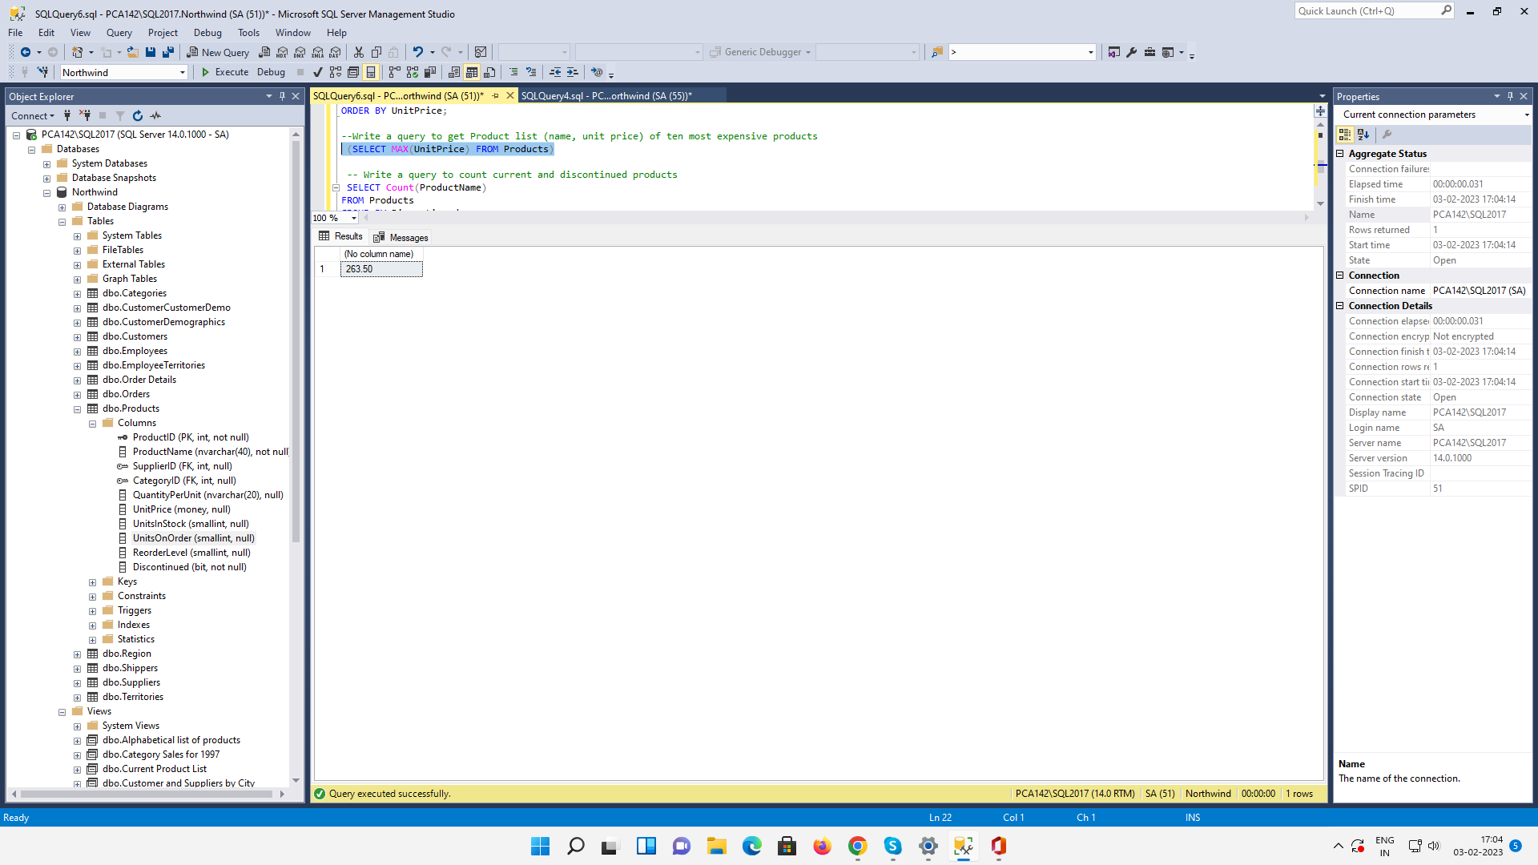

-- Write a query to count current and discontinued products
SELECT Count(ProductName)
FROM Products
GROUP BY Discontinued;
OUTPUT:

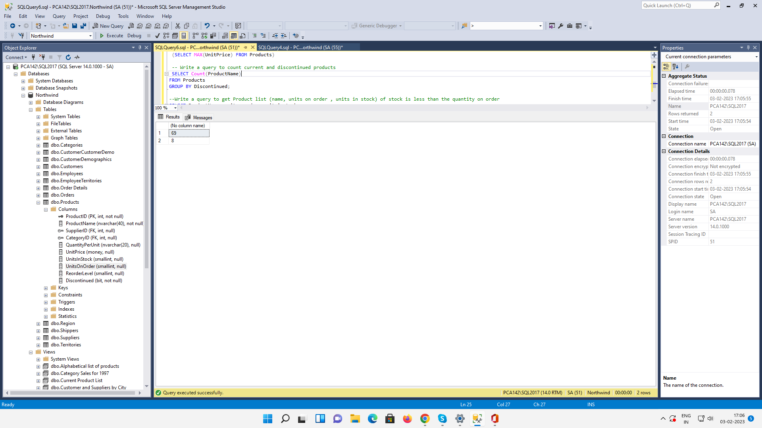

--Write a query to get Product list (name, units on order , units in stock) of stock is less than the quantity on order
SELECT ProductName, unitsonorder ,unitsinstock
FROM Products
WHERE ((unitsonorder)>(unitsinstock))
ORDER BY UnitPrice;
OUTPUT:
