AUTOMATIC LAYOUT INTO GROUPS

Software documentation

1. Enter the type of the cell in the text box labeled ‘Cell Type’
2. Select the button ‘Merge Reactions’ to merge reactions from related files and remove duplicates from the merged file.
3. Select the button ‘ Merge Compartments’ to create the file with the information of the groups of individual cell components

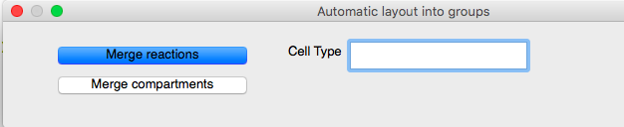

This gets the file ready to be loaded into yEd. It should be noted that the checkbox for ‘ Property Names in the First Row’ should be unchecked

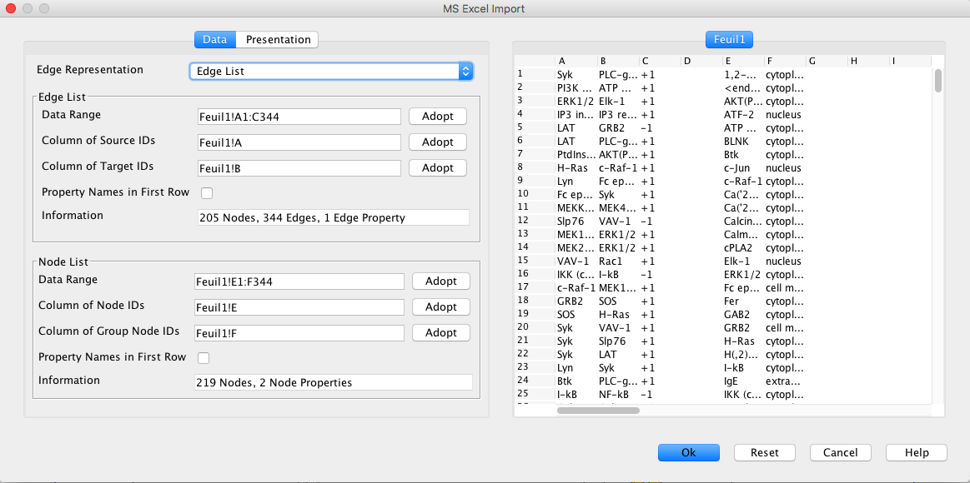

1. Finally, the layout of each cell is generated in yEd. The type of layout can be switched from one to another using the options listed in yEd.

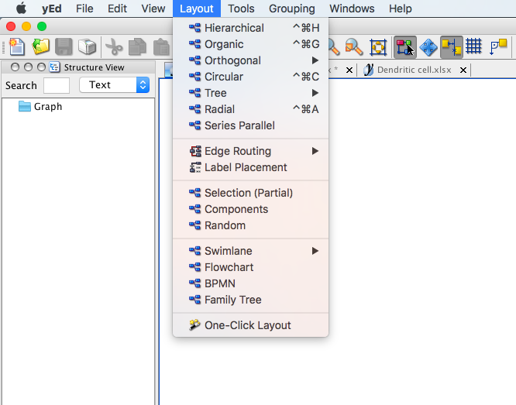

TECHNICAL DOCUMENTATION

The repository consists of two files,

* mergeForEachCell.py
* mergeGroupInfo.py
* mergeForEachCell.py
  + takes the type of cell (for which layout is to be obtained) from the input dialog box
  + generates a file merged with all the reactions from the various files, and removes duplicates
* mergeGroupInfo.py
  + compiles the compartment information for each cell from the different pathways into one file

The location for each of the new files is in the current directory. This can be modified by the filenames in the respective files.