Unlocking the power of place for marketers and developers: Introducing Pilgrim SDK by Foursquare



Starting today, the power and magic of Foursquare’s location intelligence is now available to enterprises, marketers and developers through our new software development kit, Pilgrim SDK.

Pilgrim SDK is how apps and brands can utilize Pilgrim, the proprietary location technology that we first started building years ago so our apps can proactively engage with curious travelers and explorers without them needing to open up an app or check in. It understands how mobile phones see the world and how those phones move in and out of millions of locations worldwide — no action required.

Forget about beacons: there’s no hardware required. Think geofencing, but already available for 90+ million places worldwide. It’s the first technology of its kind, and the foundation of Foursquare’s consumer and enterprise solutions. And now we’re ready to start sharing this power beyond the walls of Foursquare.

**What does Pilgrim do for Foursquare?**

When a coffee-lover visits a new neighborhood, it’s Pilgrim that recognizes the change in environment and triggers a Foursquare City Guide app notification to recommend a great local coffee shop. Pilgrim recognizes when a person has stepped into a pizza joint, so Foursquare City Guide can send a tip about the best pie to order — before they’ve even picked up a menu. Pilgrim triggers Foursquare Swarm to remind users to check into the precise restaurant, bar or diner they’re standing in. It’s what takes the heartbeat of the phone and translates signals such as WiFi, bluetooth, beacon, GPS and more into actual places. Pilgrim powers the contextually relevant computing that runs in the background of our apps.

Foursquare also uses this technology to understand societal shifts and trends on an anonymized and aggregate level. We know when Americans [start craving Filipino food](https://medium.com/foursquare-direct/what-america-ate-drank-and-saw-in-2016-de6ff820a04c#.fqak5ldix) and how [store closures impact Americans’ shopping habits](https://medium.com/foursquare-direct/how-macys-and-kmart-store-closures-will-impact-american-retailers-1c0a732c16a1#.w2jllk3t3).

**Launching Pilgrim SDK by Foursquare**

Now we’re opening up this Foursquare superpower — the ability to precisely understand where phones go in the real world in real-time — so select partners can license it for use in their own apps. The technology works seamlessly with marketing automation tools, so that brands and marketers will be armed with the ability to send messages to their users at the right time and right place, thanks to Pilgrim SDK’s contextual, real-world awareness and robust analytics. This all improves the customer journey, too, as consumers continue to expect smarter and more relevant brand experiences, always.

Imagine these scenarios: a traveler walks out of a hotel lobby, ready to explore a new city, so the hotel’s app pings them with suggestions of places they’ll love nearby (the closest yoga studio for the yogi, the local brewery for the beer-lover). A coffee chain can alert nearby loyal customers about a free latte promotion; a department store might ping its app users when they enter the store about items on-trend and on-sale; a mobile game might change based on where you play it; or a photo app can remind you to capture a photo when you’re at a popular scenic view at sunset. This is just the beginning of what’s possible when the magic of Foursquare location intelligence technology is built into other great consumer apps.

Watch the Pilgrim SDK [video](https://vimeo.com/206144904).

**Our beta partners**

Private beta users of Pilgrim SDK have already found creative uses for the technology, from smarter pings in the [Capital One](https://www.capitalone.com/) Wallet app to contextual reminders from [SnipSnap](http://www.snipsnap.it/" \t "_blank), one of the leading mobile coupon apps. It’s being used by [Raise](https://www.raise.com/?gclid=CMTC6tKhqdICFZWEswodjGMPaQ), the largest gift-card marketplace, which reminds shoppers to spend their gift cards; [Retail](https://www.retale.com/) and [The Coupons App](http://thecouponsapp.com/), both of which alert shoppers to deals in-store; and [TouchTunes](http://www.touchtunes.com/experiences/mobile/" \t "_blank), the largest in-venue interactive music platform, where Pilgrim SDK helps to encourage music fans to play their favorite songs from the TouchTunes app when they walk into one of 65,000 bars with a digital jukebox.

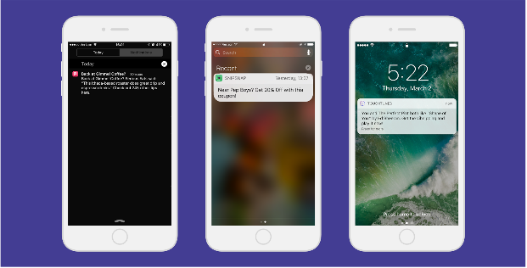

Apps today can send notifications based on external factors like time of day and breaking news. Pilgrim SDK gives marketers and developers the new ability to trigger notifications based on people’s activity in the real world — allowing them to create contextual content and pings that increase retention and engagement.

* According to Ted Mann, founder of SnipSnap: “We’ve always wanted to be able to accurately remind users of the coupons available the minute they enter a store. Pilgrim SDK gave us a method to deliver this functionality for all our users in a programmatic way. No need to manually configure geo-fences; instead we were able to know when you’d entered a location and get you the right coupon offer via a notification.” Since integrating Pilgrim SDK, SnipSnap has seen 4x higher open rates on Pilgrim-triggered notifications compared to generic notifications.
* In another example, [Wallaby](https://www.walla.by/), an app that reminds users of the right credit card to swipe for better rewards, has a feature called “Ambient Alerts,” which is powered by Pilgrim SDK. For those who receive a contextual ping, daily app sessions doubled within the 24-hour period.

These early partners have been able to better understand their users thanks to this access to primary data. Our database aggregates category, chain and visit data across the U.S., allowing marketers and analysts to identify trends and see how their audience differs from the general public (as represented by the Foursquare panel of 1M+ U.S. consumers who opted-in to our always-on research panel, normalized to the U.S. census by several demographic measures). Pilgrim SDK layers the real-world journey of app users into a company’s existing marketing cloud.

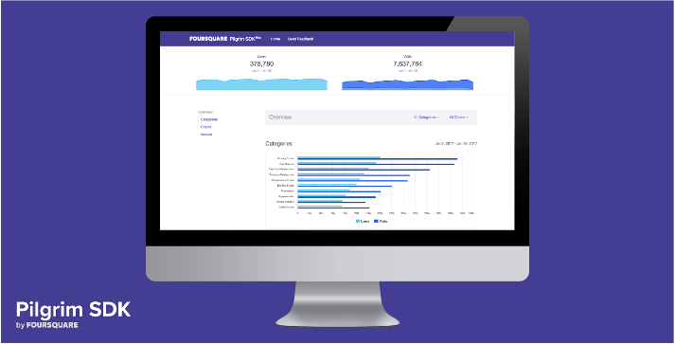

**Why Pilgrim SDK stands apart:**

* Millions upon millions of people around the world trust Foursquare’s consumer apps with their location so that they can have more fun in the cities they love. Because of this, Pilgrim is one of the most accurate background location solutions available, driven by constantly refreshed, first-party data captured via Pilgrim (always-on background awareness) and via explicit check-ins (people have checked in more than 11 billion times).
* Pilgrim SDK works in tandem with the industry-leading Foursquare [Places](https://enterprise.foursquare.com/insights" \t "_blank)database and API, which has been rigorously vetted and is used by Snapchat, Twitter, Samsung, Apple and more than 100K other developers. That’s 93 million Place Shapes, created from mobile signals — what we call our “probabilistic signal cloud.”
* Pilgrim SDK also integrates natively with some of the world’s most widely used mobile marketing automation, data and analytics tools including Urban Airship, Appboy, Localytics, mParticle and others, allowing brands to better understand and communicate with customers in our mobile-first world. This makes it easy to incorporate into any external product. Insights are delivered in an interactive dashboard.
* Importantly, there’s no need for new hardware or additional software. And it doesn’t drag on the consumer’s phone’s battery power, either.
* Foursquare is known for its best-in-class understanding of location and movement, mobile notifications, privacy protection, machine learning and so much more. We’re proud to take the fruits of our many years of R&D and begin to open it up to partners.

Since 2009, the Foursquare team has strived for a more robust understanding of cities and how we move within them. By opening up Pilgrim SDK to select innovative brands and companies with big ideas, we’ll add new and meaningful layers to our body of learning and continue to experiment. Pilgrim SDK unlocks new opportunities for creativity, futuristic thinking and magical consumer experiences at Foursquare and beyond.