**Application:**

Problem Statement: Statistics of the IPL2020

Problem Explained:

From the existing IPL2020 data (Data will be shared) design and develop web application, which helps user to understand the following:

1. IPL2020 tournament statistics:

This should give the total amount spend by each team and role wise

1. Team wise statistics:

This should give the total amount spend by team and role wise

1. Show the details of the players who are getting Max and Min amount by role

**Technology:**

UI: Angular + Bootstrap4

Server Side: Sprint Boot Version 2

Database: MongoDB use MongoDB Atlas

Unit Testing: Junit5

Duration: 2 weeks

**Deployment:**

MongoDB: MongoDB Atlas

Server App: Heroku / AWS

UI: AWS S3

**Architecture:**

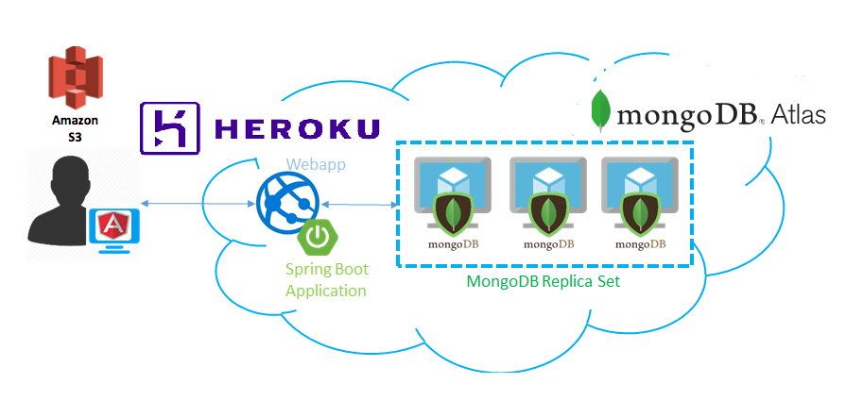

Screens 1:

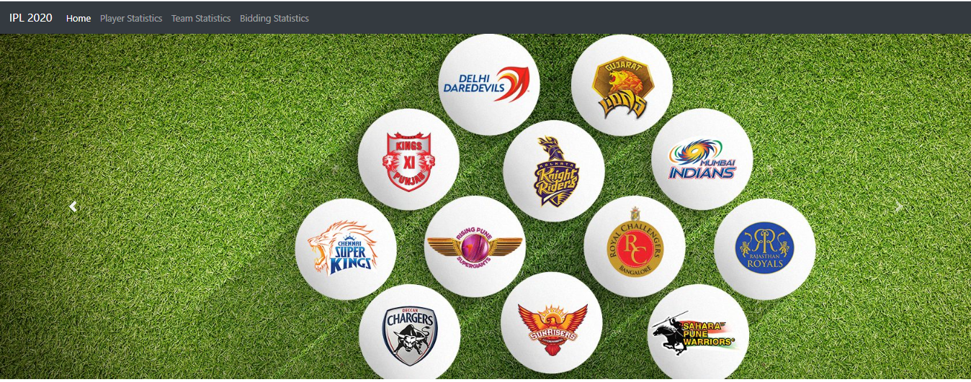

#2

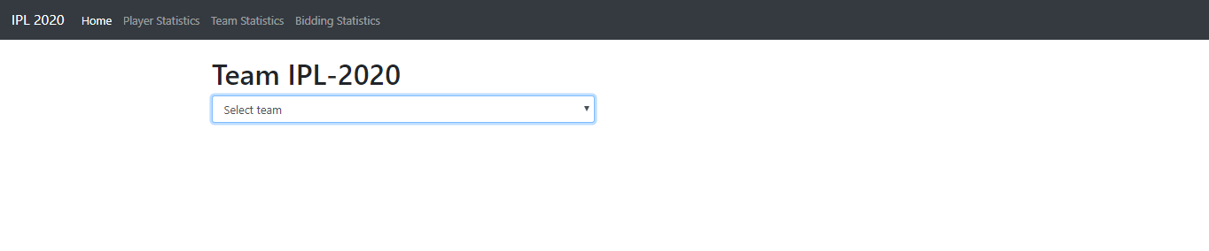

#3

All the team labels should get using API

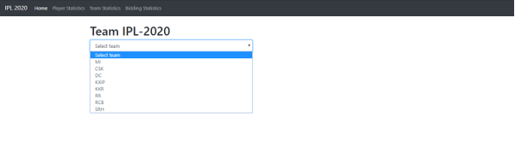

#4

On selection of the team it should display the following statistics

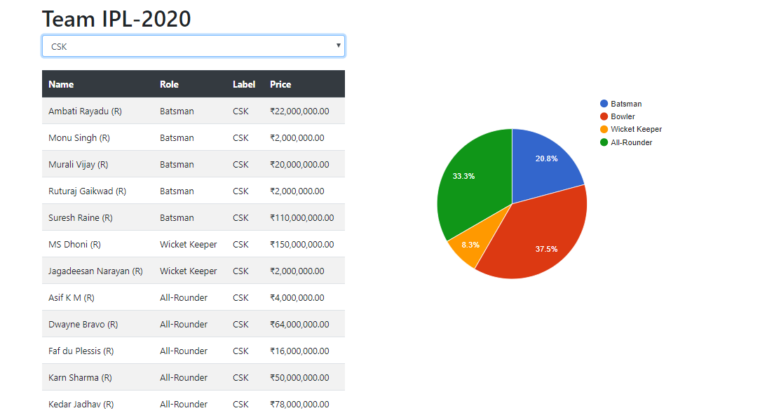

#5

On selection of pie chart, it should fetch details of the players who has selected role and display them using Table chart.

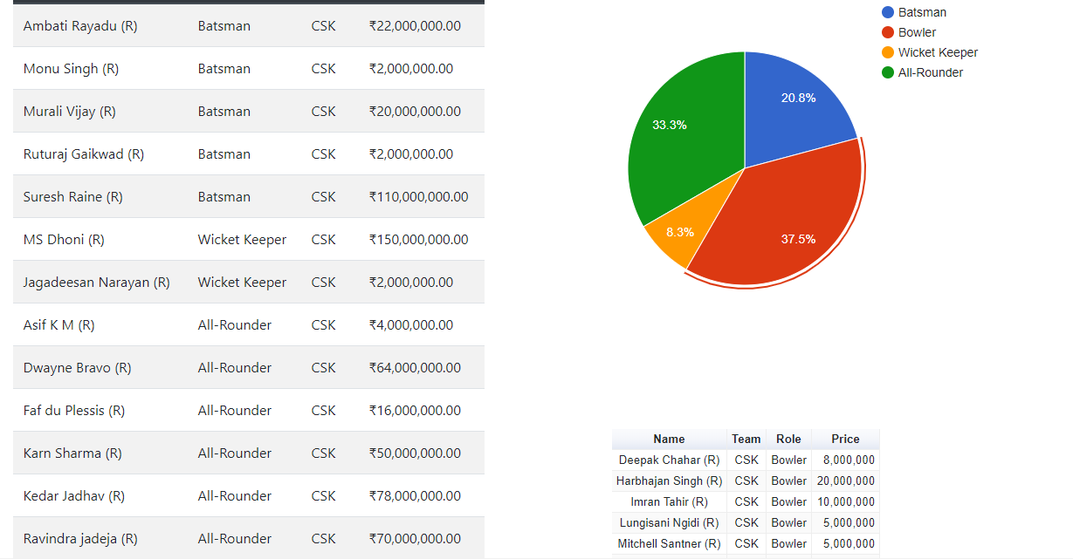

#6

On click of Team Statistics tab:

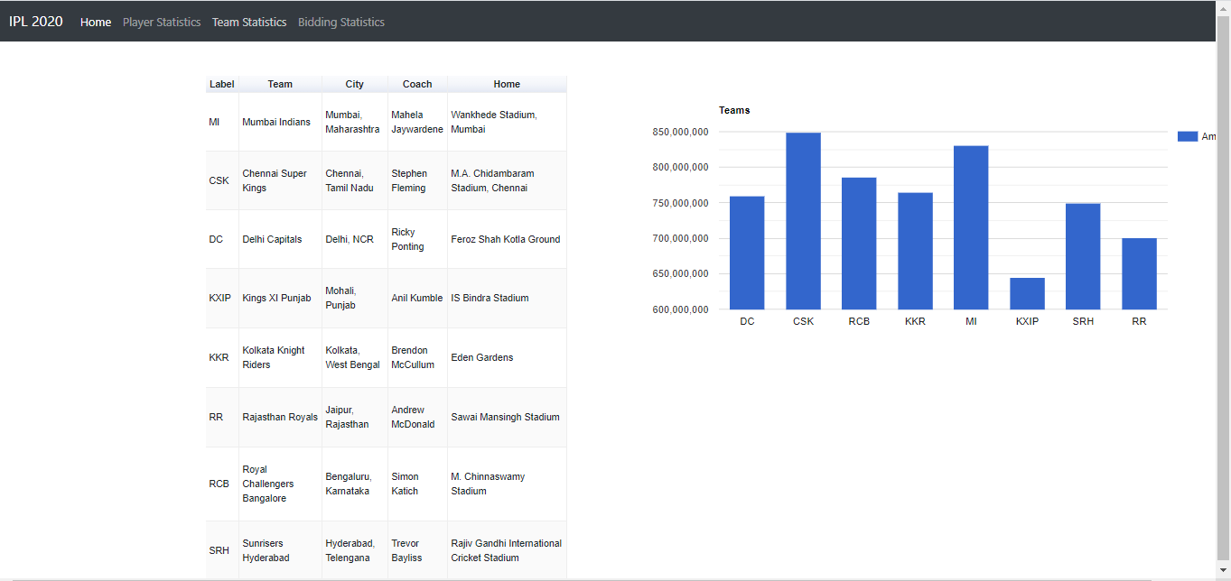

#7

On click of team, it should display amount spend by each role in the form of Pie chart

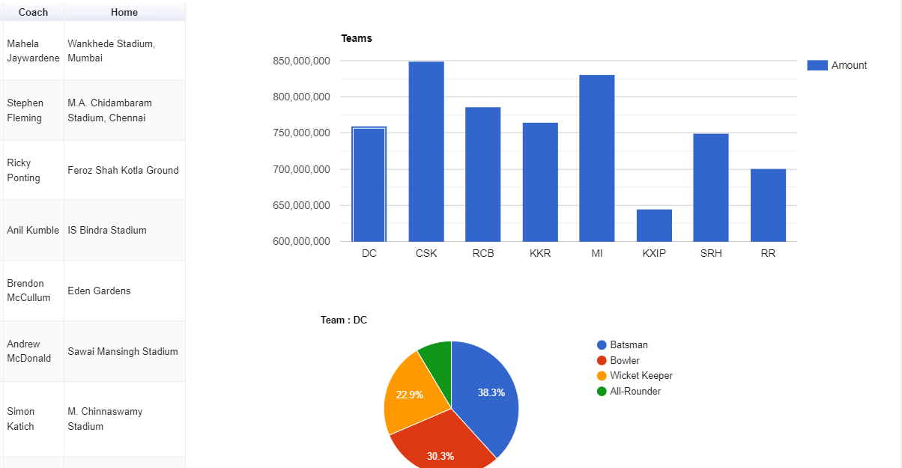

#8

On click of Bidding Statistics: (Max, Min, Amount by Role, Display all the players details by the sorting order by the amount).

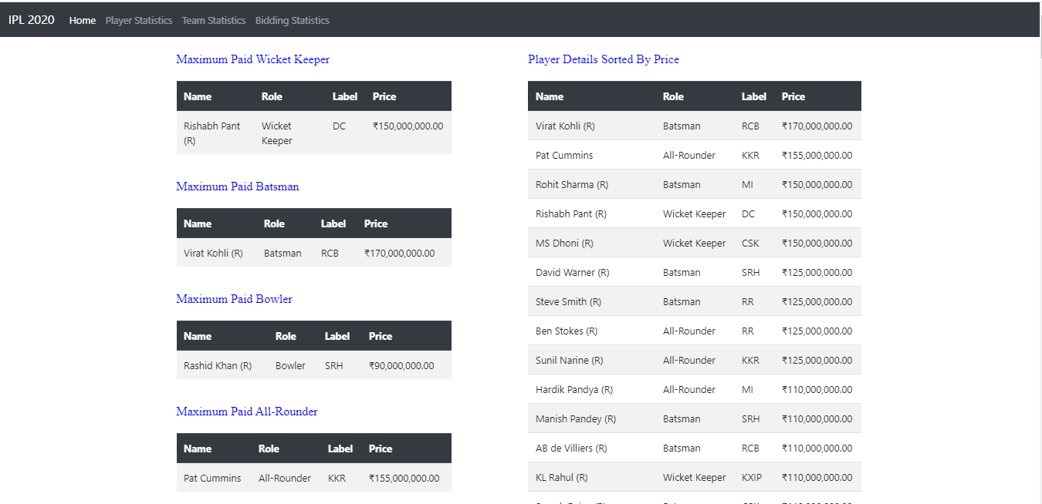

On the completion of task convert all these screens to rich UI library using angular material.