ENTERPRISE EMPLOYEE SERVICE DESK &
WORKFLOW MANAGEMENT PORTAL
Week 3 Web Development Project
Submitted by: Tanvi Bogam
Role: Web Developer Intern
Technology: HTML, CSS, JavaScript, Python Flask, MySQL
Development Tool: Visual Studio Code

1. Project Overview
The Enterprise Employee Service Desk & Workflow Management Portal is an internal enterprise web application that centralizes employee service requests for departments such as IT Support, HR, Finance, Administration, Security and Payroll. Employees can create and track requests, while executives, managers and administrators can process requests through controlled workflows, assignment, SLA monitoring, comments, notifications and audit logging.

2. Technology Stack
- Frontend: HTML5, CSS3 and JavaScript
- Backend: Python with Flask REST API
- Database: MySQL
- API communication: Fetch API
- Development: Visual Studio Code
- API testing: Postman
- Automated functional checks: Node.js built-in test runner

3. User Roles
- Employee – login, create requests, view own requests, track status and communicate through comments.
- Executive – view assigned requests, update status, add resolution information and communicate.
- Manager – view department requests, assign requests, monitor workload and SLA information.
- Admin – manage users, departments, categories and audit information.

4. Major Functional Modules
Authentication: Login, logout, token/session handling, protected APIs and role-based authorization.
Employee Dashboard: Request KPIs, recent requests, status, priority, department and updated date.
Request Creation: Title, category, department, description, priority, required date, attachment and contact details.
Request Workflow: Open, Assigned, In Progress, Pending Information, Resolved and Closed with controlled transitions and reopen handling.
Assignment: Managers can assign requests and assignment history is stored.
SLA Monitoring: Priority-based targets: Critical 4h, High 8h, Medium 24h and Low 72h.
Comments & Activity: User comments, internal notes and request history.
Search & Filters: Search, status, priority, category, department, date range and pagination.
Notifications: In-app notifications for assignment and workflow events.
Manager/Admin: Manager KPIs/workload and admin management of users, departments, categories and audit logs.
REST APIs: Flask API endpoints for authentication, requests, dashboards, comments, assignment, status, metadata and administration.

5. Database Design
The MySQL database uses relational tables with primary keys, foreign keys and indexes. Main tables include:
- users
- departments
- categories
- service_requests
- request_comments
- request_history
- notifications
- audit_logs
- request_assignments
- request_attachments
- sla_records
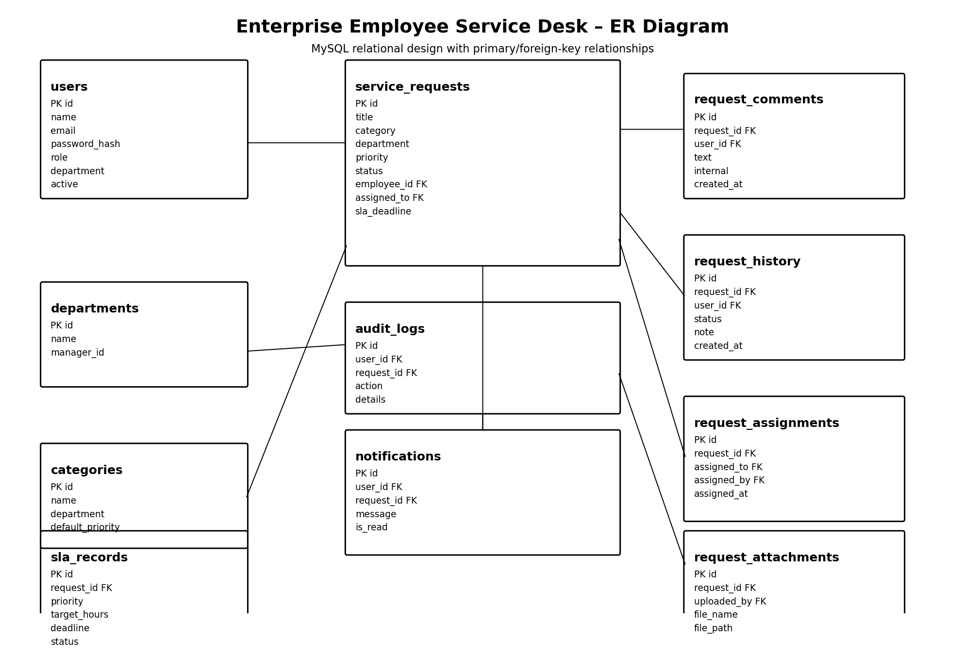

6. Application Architecture
The application follows a client–API–server–database flow. The browser UI communicates with the Flask REST API. The backend performs authentication, authorization, workflow and business logic, and persists data in MySQL.
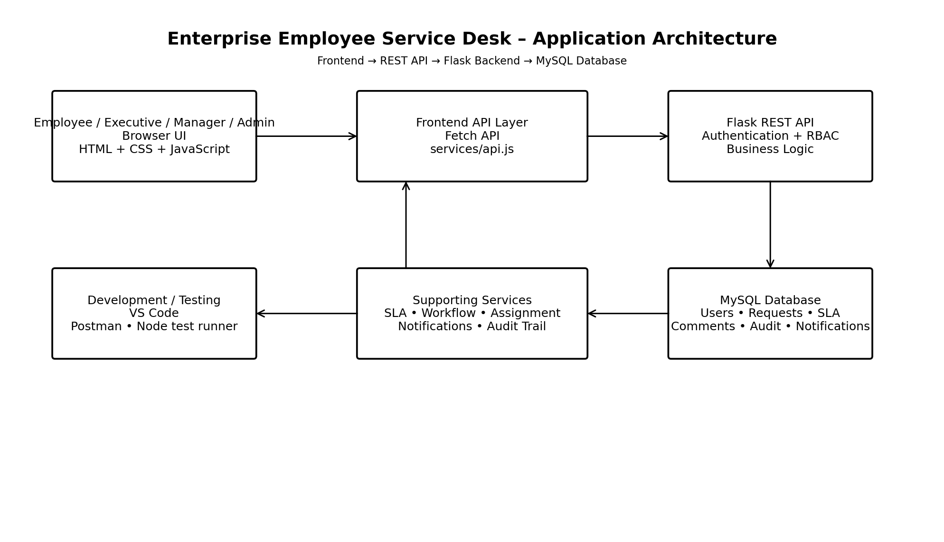

7. API Coverage
- POST /api/auth/login
- POST /api/auth/logout
- GET /api/auth/me
- GET/POST /api/requests
- GET/PUT /api/requests/<id>
- PUT /api/requests/<id>/status
- PUT /api/requests/<id>/assign
- POST /api/requests/<id>/comments
- GET /api/dashboard/employee
- GET /api/dashboard/manager
- GET /api/dashboard/admin
- GET /api/notifications
- Admin user/department/category endpoints

8. Testing
Test Case | Expected / Implemented Result
Invalid login | Invalid credentials are rejected with HTTP 401.
Employee request creation | Employee can create a service request and the request appears in the employee dashboard.
Employee authorization | Employee access to admin routes is rejected with HTTP 403.
Executive authorization | Executive cannot create/modify admin users.
Workflow control | Invalid status progression is blocked; formal reopen is used for reopening eligible requests.
Manager assignment | Manager can assign a request to a department executive.

9. Security Features
- Password hashing
- Authentication and authorization checks
- Role-protected API endpoints
- Backend input validation
- Controlled workflow transitions
- Attachment validation and size/type restrictions
- Audit logging of important activities

10. Requirement Coverage
Deliverable | Status
Complete frontend | Implemented
Backend application | Implemented with Flask
Database | Implemented with MySQL
Authentication system | Implemented
Role-based access | Implemented
Service-request workflow | Implemented
Request assignment | Implemented
SLA monitoring | Implemented
Comments/activity timeline | Implemented
Notification system | Implemented
Search/filter/pagination | Implemented
Manager dashboard | Implemented
Admin module | Implemented
REST APIs | Implemented
Postman collection | Included
Test cases | Included
Database schema | Included
ER diagram | Included in this submission pack
Application architecture diagram | Included in this submission pack
GitHub repository | To be uploaded by intern
README documentation | Included
Final project report | Included in this submission pack
Working demo | Implemented and locally runnable

11. Conclusion
The project implements the core enterprise service-desk flow from employee request creation through assignment, workflow processing, SLA monitoring, communication, resolution and administration. The application uses a Flask REST backend with a MySQL relational database and a responsive JavaScript frontend. The included documentation and diagrams support the project submission and demonstration.

